Hackathon Report

Configurable Workflow Decision Platform
- Introduction
In modern enterprise systems, business workflows such as loan approvals, claim processing, and onboarding require dynamic decision-making, auditability, and resilience. These workflows often operate under uncertain conditions, changing rules, and external dependencies.
This project presents a Configurable Workflow Decision Platform that is capable of processing structured requests, evaluating rules dynamically, executing workflow stages, and maintaining full auditability while handling failures gracefully.

- Objective
The objective of this system is to design and implement a generic and extensible decision platform that:
- Accepts structured input requests
- Evaluates configurable rules dynamically
- Executes multi-stage workflows
- Maintains lifecycle state of requests
- Provides explainable decision outputs
- Handles failures and retries robustly
- Ensures idempotency for duplicate requests

- Problem Understanding
Traditional systems often:
- Hardcode business rules
- Lack auditability
- Fail under external dependency issues
- Are difficult to modify
This system solves these problems by introducing:
- Configuration-driven design
- Separation of concerns
- Robust error handling
- Traceable decision-making

- System Architecture

4.1 High-Level Architecture
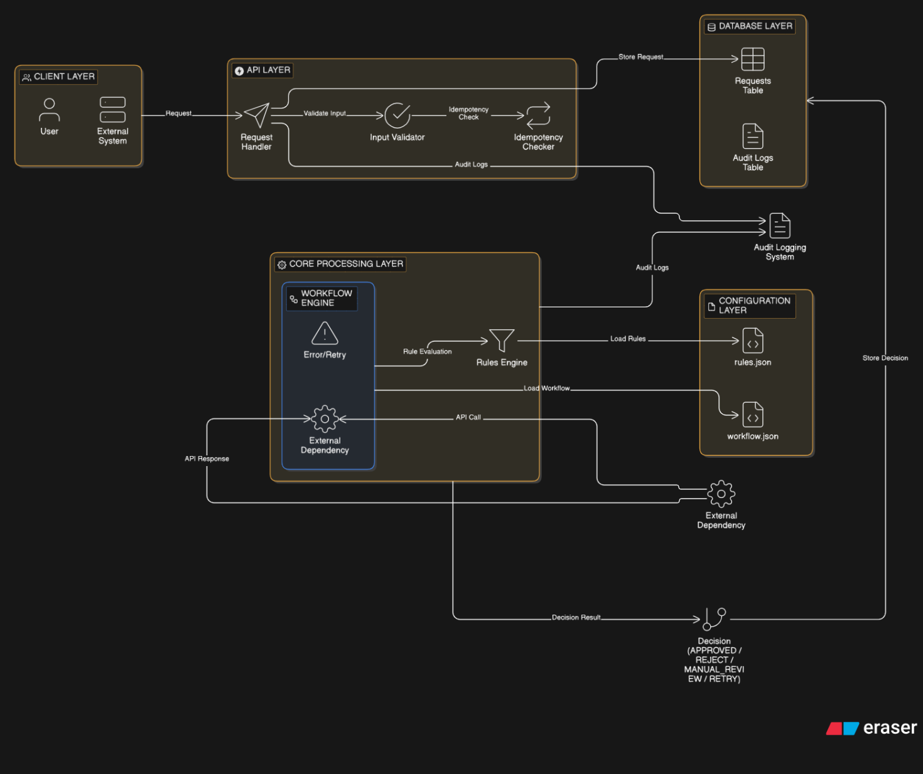

4.2 Component Description

4.2.1 API Layer (FastAPI)
- Handles incoming HTTP requests
- Validates input payload
- Ensures idempotency

4.2.2 Workflow Engine
- Controls execution flow
- Executes predefined workflow stages
- Simulates external dependencies
- Handles failure scenarios

4.2.3 Rules Engine
- Evaluates business rules from configuration
- Supports:
  - Threshold conditions
  - Conditional branching
- Produces decision outcomes

4.2.4 Database Layer
- Stores request details
- Maintains current state
- Stores audit logs

4.2.5 Audit Logging System
- Captures:
  - Rule execution trace
  - Decision reasoning
  - Timestamps

- Data Flow
- Client sends request
- API validates input
- Idempotency check is performed
- Workflow execution begins
- Rules are evaluated
- Decision is generated
- Audit logs are recorded
- Final response is returned

- Configuration-Driven Design

6.1 Rules Configuration
Rules are defined in rules.json:
- Each rule contains:
  - Rule name
  - Condition
  - Failure action
Example:
{
"name": "salary_check",
"condition": "salary > 30000",
"fail_action": "REJECT"
}

6.2 Workflow Configuration
Defined in workflow.json:
- Specifies workflow stages
- Easily extendable
Example:
START → VALIDATION → RULE_CHECK → DECISION → END

- Key Functional Features

7.1 Input Handling
- Accepts structured JSON input
- Validates required fields

7.2 Rule Evaluation
- Dynamic rule evaluation using configuration
- Supports:
  - Pass/Fail logic
  - Conditional branching

7.3 Workflow Execution
- Multi-stage processing
- Handles:
  - Success
  - Rejection
  - Manual review
  - Retry

7.4 State Management
- Tracks lifecycle:
RECEIVED → PROCESSING → APPROVED/REJECTED → COMPLETED

7.5 Auditability (Explainability)
- Each decision is traceable
- Stores:
  - Rule name
  - Result (PASS/FAIL)
  - Decision reason

7.6 Failure Handling & Retry
- Simulates external dependency failure
- System moves to RETRY state
- Ensures robustness

7.7 Idempotency
- Duplicate requests are detected
- Same response is returned
- Prevents duplicate processing

- External Dependency Simulation
- Workflow engine simulates API failure using random behavior
- Helps validate:
  - Retry logic
  - Fault tolerance

- API Design

Endpoint: POST /process

Input:
{
"request_id": "abc123",
"type": "loan",
"data": {
"salary": 40000,
"credit_score": 700
}
}

Output:
{
"status": "APPROVED",
"audit": [
{
"rule": "salary_check",
"result": "PASS"
}
]
}

- Testing Strategy
The system is tested on:
- Happy path
- Invalid input
- Duplicate request
- External dependency failure
- Retry flow
- Rule modification

- Design Decisions & Trade-offs
Decision | Reason
JSON-based configuration | Easy to modify workflows
FastAPI | Lightweight and fast development
SQLite | Suitable for prototype
eval() for rules | Simple but replaceable

- Scalability Considerations
- Can integrate:
  - Redis (for caching & retry queue)
  - Kafka (for asynchronous workflows)
- Can be extended to microservices
- Horizontal scaling possible via stateless API

- Limitations
- eval() is not secure for production use
- No graphical user interface
- Limited to single-node deployment

- Future Enhancements
- Implement safe rule parser
- Add frontend dashboard
- Introduce rule versioning
- Add distributed workflow execution
- Implement monitoring and alerting

- Conclusion
The developed system successfully demonstrates a resilient, configurable, and scalable workflow decision platform.
It effectively handles:
- Dynamic rule changes
- Failure scenarios
- Auditability requirements
- Real-world workflow complexities

16. GitHub Repository
https://github.com/ABHI-Adventure/ScoreMe_Hackthon.git

