# Detecting Insurance Fraud with Machine Learning

Insurance Fraud has been around since the beginning of insurance organizations. These are unnoticed crimes which cost the insurance industry billions a year. Insurance fraud is a grave problem with all insurance service providers. Even a small fraud can be extremely expensive. As a result, businesses must be careful while analyzing every claim during the insurance claims settlement process. And while it is not possible to verify manually every single claim, so the claim settlement process in insurance can be made easier through Artificial Intelligence.

AI-based Investigation: We will train the machine to identify whether the case is fraud or not. Many past data have been provided to Machine Learning on which basis AI helps to find the pattern and decide upon the case.

## **Machine Learning: A Big Step in Fraud Detection**

Machine learning is a part of Artificial Intelligence (AI). The idea behind AI is to create a computerized system that can engage in complex analysis and not only replace human input but improve upon it.

Machine learning gives systems the ability to learn and improve from experience, with no extra programming. To do this, the system analyzes large, labelled datasets. Labelled dataset means, with some input, features it also concludes output features. By comparing those inputs to outputs ML finds the pattern and do more complex analysis.

This article contains the following sub-topics

1. Problem Definition.

2. Data Analysis.

3. EDA Concluding Remark.

4. Pre-Processing Pipeline.

5. Building Machine Learning Models.

6. Concluding Remarks.

**Problem Definition:**

The goal of this project is to build a model that can detect auto insurance fraud. The challenge behind fraud detection in machine learning is that frauds are less common as compared to legit insurance claims. However, frauds are unethical and are a loss to the company. Building a model that can classify auto insurance fraud which can help to cut losses for the insurance company.

**Data Analysis:**

About the dataset

* Data Source: <https://raw.githubusercontent.com/FlipRoboTechnologies/ML_-Datasets/main/Insurance%20Claim%20Fraud%20Detection/Automobile_insurance_fraud.csv>

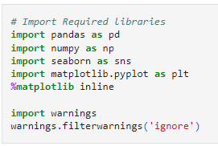

Load the dataset to our environment for analysis. In this case, we are using, Jupyter Notebook.

df = pd.read_csv('https://raw.githubusercontent.com/FlipRoboTechnologies/ML_-Datasets/main/Insurance%20Claim%20Fraud%20Detection/Automobile_insurance_fraud.csv')

The inspiration for this project was to perform classification on imbalance class data sets, in particular fraud. (Imbalanced class datasets where one type of data (target) is much more than the other)

The current data set was labelled with n=1000 records.

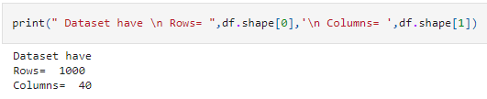

And 38 different features on which basis it decided about the 39th feature (Target feature). This dataset was found on kaggle.com, however, it is not mentioned if this data is from multiple insurance companies or just one company.

Explore the features on which basis Machine was able to predict about the label.

We have 17 integer features, 21 Object features, 1 float feature

Integer features are those who has values in integer like 1, 2, 3,….

Float features are those who has values in decimal like 1.2, 2.3,…

Object features are categorical in nature or in string format like Yes, No

df.head(12)

| **328** | **48** | **521585** | **17-10-2014** | **OH** | **250/500** | **1000** | **1406.91** | **0** | **466132** | **...** | **2** | **YES.1** | **71610** | **6510** | **13020** | **52080** | **Saab** | **92x** | **2004** | **Y** |
| --- | --- | --- | --- | --- | --- | --- | --- | --- | --- | --- | --- | --- | --- | --- | --- | --- | --- | --- | --- | --- |
| **0** | 228 | 42 | 342868 | 27-06-2006 | IN | 250/500 | 2000 | 1197.22 | 5000000 | 468176 | ... | 0 | ? | 5070 | 780 | 780 | 3510 | Mercedes | E400 | 2007 | Y |
| **1** | 134 | 29 | 687698 | 06-09-2000 | OH | 100/300 | 2000 | 1413.14 | 5000000 | 430632 | ... | 3 | NO | 34650 | 7700 | 3850 | 23100 | Dodge | RAM | 2007 | N |
| **2** | 256 | 41 | 227811 | 25-05-1990 | IL | 250/500 | 2000 | 1415.74 | 6000000 | 608117 | ... | 2 | NO | 63400 | 6340 | 6340 | 50720 | Chevrolet | Tahoe | 2014 | Y |
| **3** | 228 | 44 | 367455 | 06-06-2014 | IL | 500/1000 | 1000 | 1583.91 | 6000000 | 610706 | ... | 1 | NO | 6500 | 1300 | 650 | 4550 | Accura | RSX | 2009 | N |
| **4** | 256 | 39 | 104594 | 12-10-2006 | OH | 250/500 | 1000 | 1351.10 | 0 | 478456 | ... | 2 | NO | 64100 | 6410 | 6410 | 51280 | Saab | 95 | 2003 | Y |
| **5** | 137 | 34 | 413978 | 04-06-2000 | IN | 250/500 | 1000 | 1333.35 | 0 | 441716 | ... | 0 | ? | 78650 | 21450 | 7150 | 50050 | Nissan | Pathfinder | 2012 | N |
| **6** | 165 | 37 | 429027 | 03-02-1990 | IL | 100/300 | 1000 | 1137.03 | 0 | 603195 | ... | 2 | YES | 51590 | 9380 | 9380 | 32830 | Audi | A5 | 2015 | N |
| **7** | 27 | 33 | 485665 | 05-02-1997 | IL | 100/300 | 500 | 1442.99 | 0 | 601734 | ... | 1 | YES | 27700 | 2770 | 2770 | 22160 | Toyota | Camry | 2012 | N |
| **8** | 212 | 42 | 636550 | 25-07-2011 | IL | 100/300 | 500 | 1315.68 | 0 | 600983 | ... | 1 | ? | 42300 | 4700 | 4700 | 32900 | Saab | 92x | 1996 | N |
| **9** | 235 | 42 | 543610 | 26-05-2002 | OH | 100/300 | 500 | 1253.12 | 4000000 | 462283 | ... | 2 | ? | 87010 | 7910 | 15820 | 63280 | Ford | F150 | 2002 | N |
| **10** | 447 | 61 | 214618 | 29-05-1999 | OH | 100/300 | 2000 | 1137.16 | 0 | 615561 | ... | 2 | YES | 114920 | 17680 | 17680 | 79560 | Audi | A3 | 2006 | N |
| **11** | 60 | 23 | 842643 | 20-11-1997 | OH | 500/1000 | 500 | 1215.36 | 3000000 | 432220 | ... | 0 | NO | 56520 | 4710 | 9420 | 42390 | Saab | 95 | 2000 | N |

12 rows × 39 columns

In [5]:

df.tail(13)

Out[5]:

|  | **328** | **48** | **521585** | **17-10-2014** | **OH** | **250/500** | **1000** | **1406.91** | **0** | **466132** | **...** | **2** | **YES.1** | **71610** | **6510** | **13020** | **52080** | **Saab** | **92x** | **2004** | **Y** |
| --- | --- | --- | --- | --- | --- | --- | --- | --- | --- | --- | --- | --- | --- | --- | --- | --- | --- | --- | --- | --- | --- |
| **986** | 235 | 39 | 836349 | 01-05-2013 | IL | 500/1000 | 2000 | 1453.61 | 4000000 | 619570 | ... | 3 | ? | 60320 | 9280 | 9280 | 41760 | Chevrolet | Tahoe | 2012 | Y |
| **987** | 295 | 46 | 591269 | 09-01-1999 | IN | 100/300 | 500 | 1672.88 | 0 | 478947 | ... | 1 | NO | 60700 | 12140 | 6070 | 42490 | Honda | Civic | 1997 | N |
| **988** | 22 | 21 | 550127 | 04-07-2007 | IN | 250/500 | 1000 | 1248.05 | 0 | 443550 | ... | 2 | ? | 53280 | 5920 | 0 | 47360 | Chevrolet | Malibu | 2015 | N |
| **989** | 286 | 43 | 663190 | 05-02-1994 | IL | 100/300 | 500 | 1564.43 | 3000000 | 477644 | ... | 2 | YES | 34290 | 3810 | 3810 | 26670 | Jeep | Grand Cherokee | 2013 | N |
| **990** | 257 | 44 | 109392 | 12-07-2006 | OH | 100/300 | 1000 | 1280.88 | 0 | 433981 | ... | 1 | NO | 46980 | 0 | 5220 | 41760 | Accura | TL | 2002 | N |
| **991** | 94 | 26 | 215278 | 24-10-2007 | IN | 100/300 | 500 | 722.66 | 0 | 433696 | ... | 2 | YES | 36700 | 3670 | 7340 | 25690 | Nissan | Pathfinder | 2010 | N |
| **992** | 124 | 28 | 674570 | 08-12-2001 | OH | 250/500 | 1000 | 1235.14 | 0 | 443567 | ... | 1 | ? | 60200 | 6020 | 6020 | 48160 | Volkswagen | Passat | 2012 | N |
| **993** | 141 | 30 | 681486 | 24-03-2007 | IN | 500/1000 | 1000 | 1347.04 | 0 | 430665 | ... | 2 | YES | 6480 | 540 | 1080 | 4860 | Honda | Civic | 1996 | N |
| **994** | 3 | 38 | 941851 | 16-07-1991 | OH | 500/1000 | 1000 | 1310.80 | 0 | 431289 | ... | 1 | ? | 87200 | 17440 | 8720 | 61040 | Honda | Accord | 2006 | N |
| **995** | 285 | 41 | 186934 | 05-01-2014 | IL | 100/300 | 1000 | 1436.79 | 0 | 608177 | ... | 3 | ? | 108480 | 18080 | 18080 | 72320 | Volkswagen | Passat | 2015 | N |
| **996** | 130 | 34 | 918516 | 17-02-2003 | OH | 250/500 | 500 | 1383.49 | 3000000 | 442797 | ... | 3 | YES | 67500 | 7500 | 7500 | 52500 | Suburu | Impreza | 1996 | N |
| **997** | 458 | 62 | 533940 | 18-11-2011 | IL | 500/1000 | 2000 | 1356.92 | 5000000 | 441714 | ... | 1 | YES | 46980 | 5220 | 5220 | 36540 | Audi | A5 | 1998 | N |
| **998** | 456 | 60 | 556080 | 11-11-1996 | OH | 250/500 | 1000 | 766.19 | 0 | 612260 | ... | 3 | ? | 5060 | 460 | 920 | 3680 | Mercedes | E400 | 2007 | N |

13 rows × 39 columns

In our dataset, we have 53.8% Categorical features and 46.2% are continuous features.

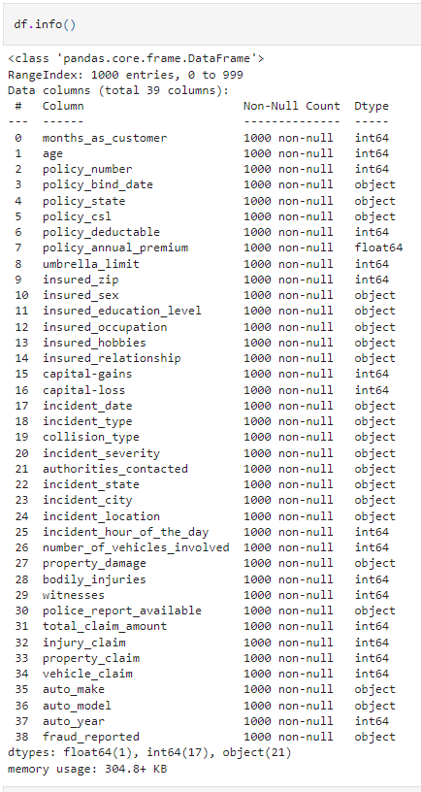

First of all, to know the authenticity of our dataset, we check for the Null values (empty entry)

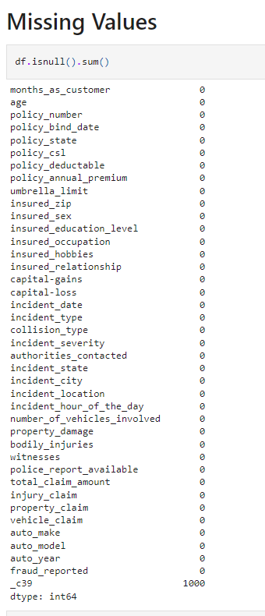

We can also visualize any null values

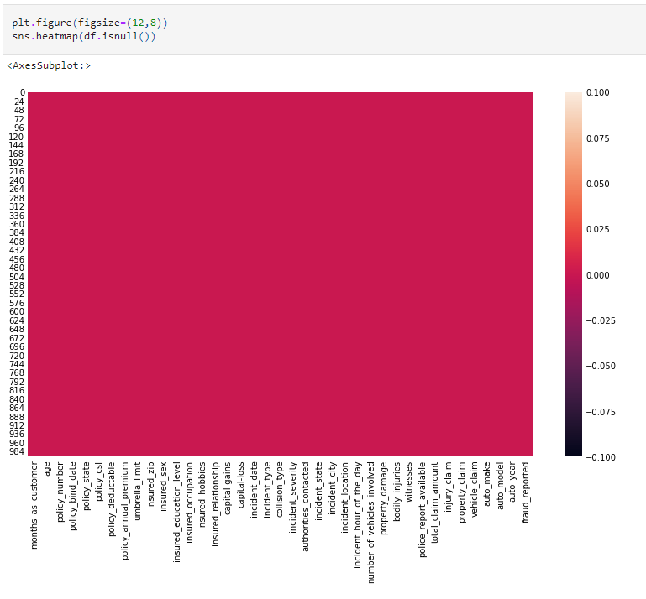

We don’t have any Null values in our dataset.Upon further investigation, we come to know that this dataset have ‘?’ instead of NaN values.

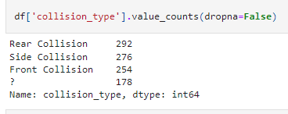

Check every Object type feature and replace ‘?’ into Nan values so that can be handled easily.

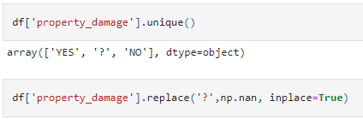

we had to impute those Null values with the meaningful entry by various methods like

Mean, Median, Mode replacement

Random Sample imputation

Capturing NaN values with a new feature

End of distribution imputation

Arbitrary Imputation

Frequent categories imputation

**EDA Concluding Remark.**

Check my GitHub for more detailed EDA

[ABHIBRO123/EVALUATION-PR-3: PHASE -3 PROJECT SOLUTION (github.com)](https://github.com/ABHIBRO123/EVALUATION-PR-3)

Dependent Variable (Target Feature)

EDA started with the dependent variable, fraud_reported. There were 247 frauds detected and 753 were genuine cases. In percentage, 24.7% of the data were with fraud details while 75.3% were with genuine case

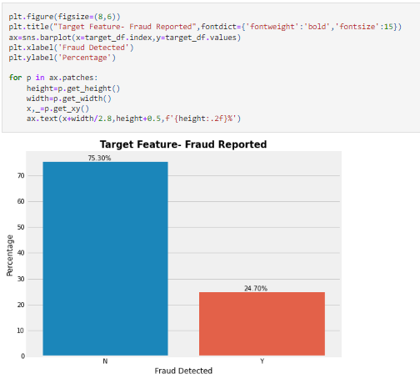

Correlation is the quantitative method to find the relationship between independent features with Target feature as well within an independent feature. If you are a beginner, let me revise that all the input features are also known as independent features and the target feature is also known as dependent features as it depends on the input variables.

1. Month_as_customer and age had.92 correlation
2. Total_claim_amount has good correlation with other claim features

Total_claim_amount – injury_claim =.81

Total_claim_amount – property_claim = .81

Total_claim_amount – vehicle_claim = .98

EDA on Independent features:

This will help to understand which features are more responsible for output prediction.

**Age**

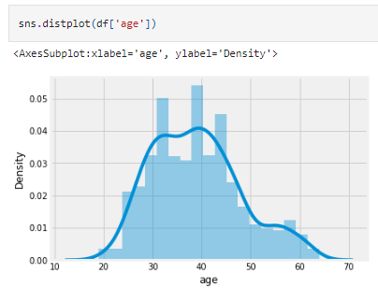

The distribution of Age data is not normally distributed, somehow right-skewed. This is the Age of Insurer.

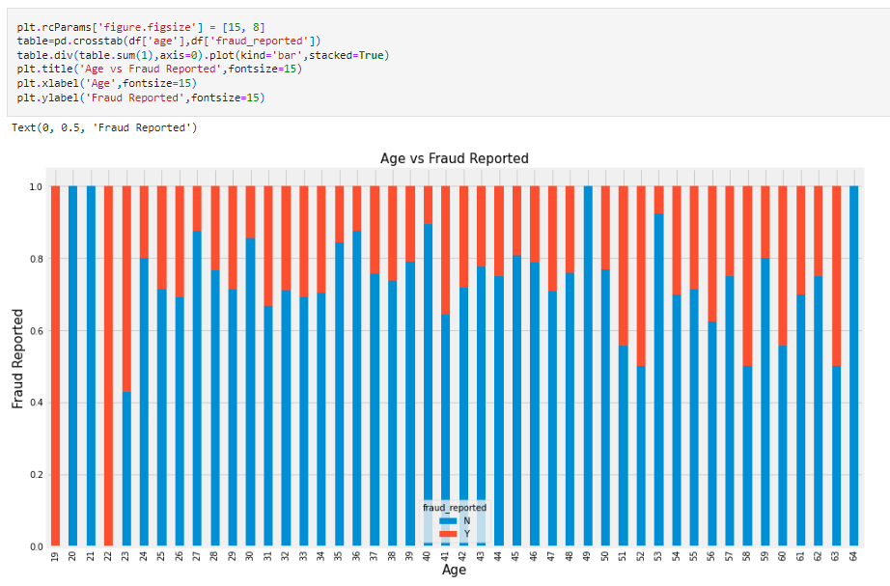

This visualization says that most cases where an insurer is 19 and 22 years old are totally fraud. Age has a very significant impact on target feature.

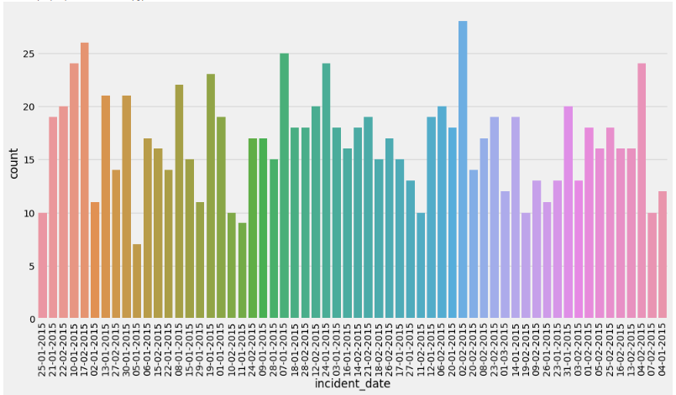

4 types of Incident file has been came for insurance.

Multi-Vehicle Collision (Most cases)

Single-Vehicle Collision

Vehicle-Theft

Parked Car

since 1995 to 2015 registered vehicles data we have among which most fraud cases came from 2004, 2007 and 2011 registered vehicles.

Let’s do some EDA on Insured person:

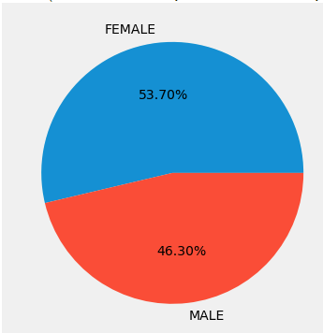

As per our data, we had almost equal cases of Male and female insurer.

53.7% are Male while 46.3% are female insurer.

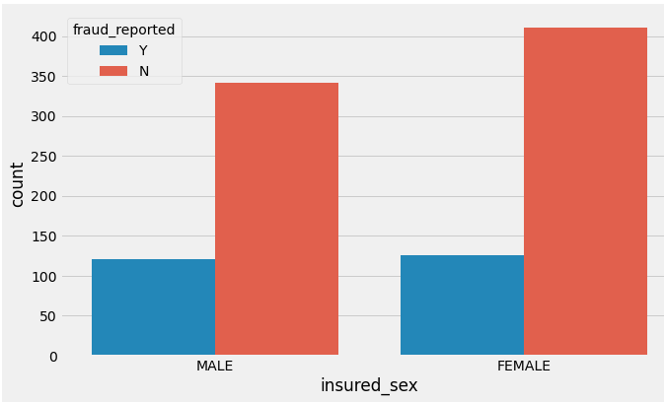

Among which chances are same for fraud case. Means fraud happening doesn’t depends on insurer sex.

**Insured_education_level**

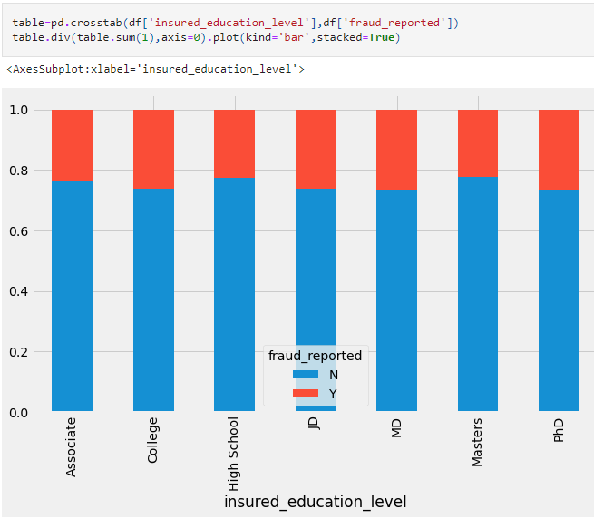

Almost chances are same for all educated insured. But specifically, College, JD, MD, PhD have done more frauds

If we go through, Insured occupation. Executive Manager have done most fraud. Insurer involved in the below occupation has done more frauds Craft-repair , farming-fishing, sales, tech-support, transport-moving

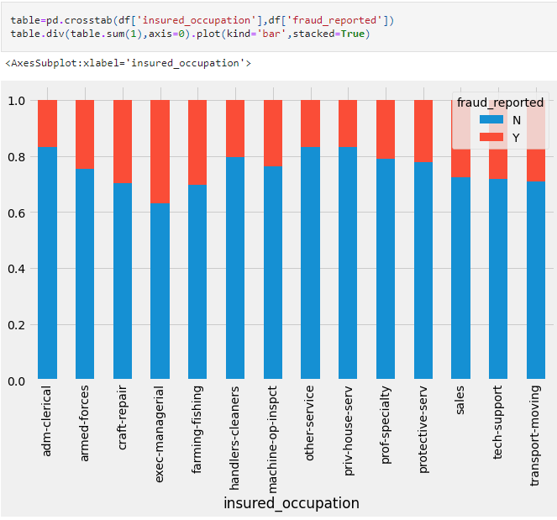

# insured_hobbies vs fraud

# Peoples having hobbies Chess and cross-fit are more crucial for insurance company because in mostly guilt cases insurer had the hobbies like chess and cross-fit.

# Below visualization clears that hobbies can tell the intension and intelligence level of the insurer.

# 

# Policy_annual_premium

# Policy annual premium seems to be having Normally distributed data. Little bit skewed on both sides.

# 

# Month_as_customer vs Age

# 

# Month_as_customer has very good positive correlation with the age of insurer. As the Age increases, months_as_customer increases with the company.

# 

# 

# Total_claim_amount is highly good correlated with other claims like injury_claim, property_claim and vehicle_claim.

# Upon investigation, we come to know that total_claim is the total of all 3 other claims. So later on we can drop this total_claim feature because its information has been covered by other 3 features.

# 

# Missing Values

# After replacing ‘?’ into Nan values now our 3 categorical features have some missing / NaN values

# Collision_type – 17.8% missing values

# Property_damage – 36% missing values

# Police_report_available - available – 34.3% missing values

# 

# After analyse, we decided to fill NaN values with most frequent category within feature.

# Wheresoever is null values, fill with Mode. This will fill all of your null values

# 

# Feature Selection

Irrelevant columns:

* policy_number is not required as it is no help in prediction fraud case
* policy_bind_date is not required as we have months_as_customer, how old is policy.
* insured_zip is not required as we have policy_state and many more details for insured like sex, education, hobby, occupation, relationship

**Feature Engineering**

# Policy_csl

# 

# We have done feature extraction here from policy_csl, we have created 2 new features csl_per_person and csl_per_sccident

# Outliers

# With the help of box plot, we can visualize if any outliers are present in our feature. Outliers are unusual values in data which are far from reality.

# We have separated our available features into category and continuous according to feature types.

# 

# Draw Boxplot with continuous features:

# Step 1: Draw box plot for all continuous datatype features available

# Step 2: check skewness in the features

# Step 3: point out those features having outliers

# Step 4: With IQR method, we can handle outliers in dataset

# 

# Feature Selection – Multi-Collinearity

# Multi-Collinearity is unavoidable issue with data. Machine Learning Algorithms assumes that all independent features are correlated with target variable only. There is no relation between independent features but in reality this is not true. Somehow independent features are also correlated within independents features. Various techniques are available to find that correlation within independent features or feature importance accordingly to some extent we can handle multi collinearity.

# Techniques like:

# VIF

# Constant Features

# Mutual Info Gain

# In this case, we are using VIF (Variance Inflation Factor) to find multicollinearity within our independent features only.

# VIF works for continuous features only, also we will not include target variable because we want to find out the multicollinearity within independent features.

# So, go ahead with continuous features with target feature.

# VIF is 1/(1-R2)

# The Variance Inflation Factor is a measure of collinearity among predictors variables within a multiple regression or

# In simple words, this matric tells you how other variables are explaining your 1 variable. If VIF is large for 1 features means that can be very well explained by other features in your dataset. We don’t require that VIF with large value.

# 

# VIF required Scaled data, so we have used StandardScaler to bring all continuous features to scaled then VIF calculated.

# VIF of total_claim_amount is very very large 47858, means this particular features can be explained by other variables and we also know that total_claim_amount is the total of all 3 claims. We can drop this features and calculate VIF again for the remaining features.

# 

# Normal accepted values for VIF is -+5, Here, age and months_as_customer is more than 6. As pwe our analysis, we know age and month_as_customer feature are highly correlated. However for insurance purposes we require the details of how old the customer is so we can drop age features here.

# Again, calculate VIF for remaining features.

# Now, after dropping 2 variables VIF are in range for all features. Along with skewness are also in control.

# Skewness accepted range is -+ .5

# 

# For complete Python file: [Click Here](https://github.com/mohittomar2008/Insurance-Claims--Fraud-Detection/blob/main/Insurance%20Claims-%20Fraud%20Detection.ipynb)

# Transformation and Standardization

# Data transformation is the process of converting raw data into a format or structure that would be more suitable for model building and also data discovery in general.

# Data standardization is the process of rescaling the attributes so that they have mean as 0 and variance as 1

# 

# Power_transform will transform the data and StandardScaler will scale down the data

# Here, we have fixed the numerical features.

# Encoding

# Machine Learning Algorithms are trained to understand digits only, ML Algos can’t work on strings or categorical data so we have to convert categorical data into numerical.

# Categorical data are of 2 types:

# Nominal 2. Ordinal

# Nominal data can be converted into numerical by get_dummy method or one-hot encoding while

# Ordinal data have order within feature according to their weightage.

# Remaining categorical are Nominal

# X= independent features

# Y= dependent feature

# Imbalance data- SMOTE

# Our data is imbalance as our target feature have 1 type of data is more than the other. Here if we process imbalanced data to the machine algorithm, it will be learning more for 1 type of data that will create bias in the target prediction.

# 

# As of now, our data have 75.3% cases of Genuine and 24.7% cases of fraud so ML will learn more about genuine cases.

# Various Techniques can be used to balance the data, here we will use SMOTE or oversampling. It will create more records to balance the target feature as per their classification.

# 

# Data is balanced now, we are ready to feed data into the machine algorithm

# Building Machine Learning Models

# Import required libraries for machine Learning

# 

# Train_test_split is used to split the complete dataset into the train and test portions. Train data will be used to train the Model then with test data we will compare the accuracy.

# We will check the accuracy of the model through metrics like accuracy_score,

# confusion_matrix,

# classification_report

# f1 score

# 

# Data split into x_train,x_test,y_train ,y_test

# 

# I have taken most of the Algos, so you can find the difference.

# Now, though the below code, fit the data with every ML one by one and calculate accuracy of the model and f1 score

# 

# 

# Cross Validation

# The goal of cross validation is to test the model’s ability to predict new data that was not used in estimating it, in order to flag problems like overfitting or section bias and to give an insight on how the model will generalize to an independent dataset.

# Like an unknown dataset, for instance from a real problem

# 

# From this code, we will get the accuracy score of all models with the train dataset along with cross validation with complete dataset.

# 

# For a generalized model, we select the model with minimum difference between accuracy of train data and the accuracy score of the complete dataset.

# As per our requirement and based on analysis, we will decide the model to go with.

# Here, we are going further with GradientBoostingClassifier

# HyperTuning

# Basically, Models work on defaults parameters, so if we can change the parameters upon our requirement we can also improve the pehrformance of the model

# For hyper tuning, we can use RandomSearchCV and GridSearchCV

# RandomSearchCV will select few parameters combinations from the options while GridSearchCV will try all parameters combinations.

# 

# We have passed 3 parameters options in the dictionary.

# CV=5 , it will cross validate 5 times

# N_jobs= -1 will use every core for this computation

# Fit with train data

# 

# GCV.best_estimator_ and GCV.best_params provides the best estimator for this cross-validation

# This is not necessary that hyper tuning will always work better, sometimes default parameters provides the best results.

# Default parameters accuracy is 89.15

# Hypertuned accuracy is 88.49

# Other Metrics to evaluate

# Confusion Matrix

# The number of cases for each class of the test set is shown in the confusion matrix below.

# The y-axis shows the actual classes while the x-axis shows the predicted classes. Percentage out of the total sample size of the test set is printed on each quadrant.

# 

# ROC AUC Curve

# The ROC curve below summarizes how well our model is at balancing between the true positive rate (sensitivity) and the false positive rate(1-specificity). Ideally, we want to have a 100% true positive rate of predicting fraud and a 100% true negative rate of predicting non-frauds (or a 0% false-positive which is 100% — 100% true negative rate). This means we have a perfect prediction for both classes. However, in imbalance class problems, this is extremely hard to achieve in the real world. On top of that, there is a trade between the true positive rate and the true negative rate and conversely the false positive rate.

# This graph summarizes how well we can distinguish between two classes at each threshold of the true positive and false positive rate. The area under curve is used as a summary percentage of this metric. In sum, the model has outperformed the baseline ROC AUC scores by a huge margin.

# Although our model performed better in predicting non-fraud cases, the model has performed very well on fraud cases as well. We have a higher false alarm than frauds escaping the detection. It is better in our case to identify more frauds than to let fraud cases escape detection. Thus, this model has succeeded in its purpose to detect fraud claims. Unlike the baseline model that sacrifices too much resources into investigations and hinder customer experience, we are also able to balance this out in this model. We can detect more fraud and we are able to balance this with correct prediction of non-fraud cases

# 

# ROC AUC= 97%

# Concluding Remarks

# This project has built a model that can detect auto insurance fraud. In doing so, the model can reduces loses for insurance companies. The challenge behind fraud detection in machine learning is that frauds are far less common as compared to legit insurance claims.

# In conclusion, the model was able to correctly distinguish between fraud claims and legit claims with high accuracy.