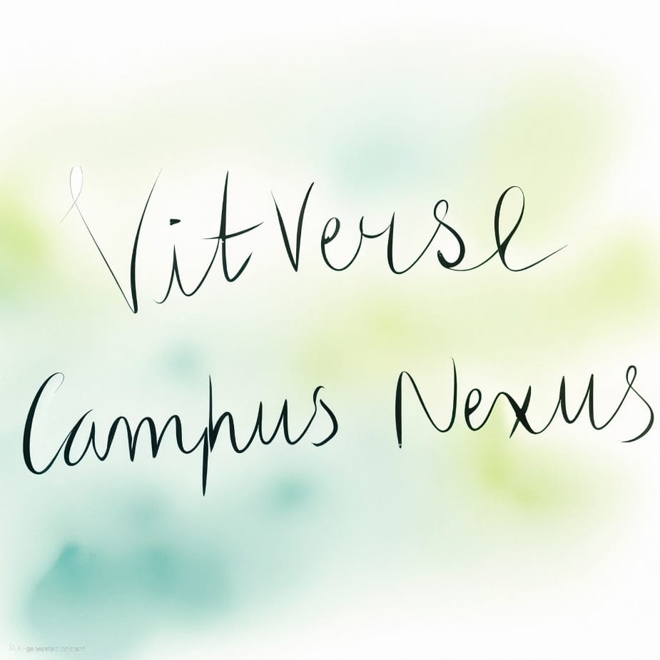

1. **Home Page**
   * **Header:**
     + VITVerse logo prominently displayed.
     + Sticky navigation bar: Home, About Us, Features, Contact, Login/Signup.
   * **Hero Section:**
     + Large banner with a tagline (e.g., "Connect. Collaborate. Trade.").
     + Background image or video showcasing campus life.
     + Call-to-action buttons: "Explore Now" and "Join Us."
   * **Features Section:**
     + Icons and descriptions for key features (Marketplace, Messaging, Events, etc.).
     + Interactive hover effects for each feature.
   * **Testimonials Section:**
     + Quotes or reviews from VIT students (mock data for now).
     + Carousel format for easy navigation through testimonials.
   * **Footer:**
     + Quick links to important pages, contact info, privacy policy, and social media icons.
     + Newsletter signup form for updates.
2. **Login Page**
   * **Form Section:**
     + Fields: Email/Username and Password.
     + Buttons: Login and "Forgot Password?" link.
   * **Social Login Options:**
     + Google, Facebook, or GitHub sign-in buttons.
   * **Footer Section:**
     + Link to "Sign Up" for new users.
     + Option to view terms of service and privacy policy.
3. **Signup Page**
   * **Form Section:**
     + Fields: Full Name, Email, Password, Confirm Password, and dropdown for role (Student/Faculty).
     + Captcha for security.
     + Checkbox for agreeing to terms and conditions.
     + Submit button with a loading indicator.
   * **Additional Section:**
     + Link to "Already have an account? Login here."
     + Option to view privacy policy.
4. **User Dashboard**
   * **Header:**
     + Welcome message with profile picture and user name.
     + Notifications and settings icons.
   * **Main Section:**
     + Cards for quick navigation: Events, Messaging, Marketplace, News, Groups.
     + Activity feed: Recent interactions or announcements.
     + Personalized recommendations based on user activity.
   * **Sidebar:**
     + Expandable menu for accessing pages like Profile, Feedback, etc.
     + Quick links to frequently accessed features.
5. **Messaging Page**
   * **Sidebar:**
     + List of recent chats and groups.
     + Search bar for contacts.
   * **Chat Section:**
     + Real-time chat interface with message timestamps.
     + Emojis, file sharing, and typing indicator.
     + Option to create group chats.
   * **Footer Section:**
     + Input box with a send button.
     + Option to attach files or images.
6. **Events Page (with Calendar)**
   * **Header:**
     + Title and filter for event types (Workshops, Seminars, Socials).
   * **Calendar Section:**
     + Interactive calendar with highlighted event dates.
     + Tooltip on hover to preview event details.
   * **Upcoming Events:**
     + List view with RSVP or "Add to Calendar" buttons.
     + Option to set reminders for events.
7. **Marketplace Page**
   * **Header:**
     + Search bar with filters (Category, Price Range, Condition).
   * **Main Section:**
     + Grid layout showing product image, name, price, and "Buy" or "Contact Seller" buttons.
     + Option to sort by newest, price, or popularity.
   * **Additional Section:**
     + "Post an Item" button for users to sell their items.
     + User ratings and reviews for products.
8. **News Page**
   * **Header:**
     + Search bar and filter by categories (Campus Life, Technology, Sports).
   * **Main Section:**
     + News cards with images, headlines, and short descriptions.
     + "Read More" button for full articles.
   * **Trending Section:**
     + List of trending topics or articles.
     + Option to share articles on social media.
9. **Profile Settings Page**
   * **Form Section:**
     + Editable fields for Name, Email, Phone, and Address.
     + Dropdown for privacy settings (Public, Friends Only, Private).
   * **Additional Options:**
     + Upload/change profile picture.
     + Reset Password button.
     + Save Changes button with confirmation message.
10. **Feedback and Suggestion Page**
    * **Form Section:**
      + Fields for Name (optional), Email, Feedback/Suggestion.
      + Dropdown for feedback type (Bug, Suggestion, Complaint, Other).
      + Submit button with a loading indicator.
    * **View Feedback Section:**
      + Display recent feedback with upvotes or comments.
      + Option for users to respond to feedback.
11. **Grouping (Create Group/Team) Page**
    * **Form Section:**
      + Fields for Group Name, Description, Add Members (by email or username).
      + Dropdown for group visibility (Public/Private).
      + Create Group button with confirmation.
    * **Groups Section:**
      + List of existing groups with "Join" or "Request to Join" options.
      + Group activity feed showing recent posts or events.

**Additional Pages to Consider:**

* **About Us Page:**
  + Describe the purpose, mission, and creators of VITVerse.
  + Include team member profiles and their roles.
* **Contact Page:**
  + A form for inquiries and FAQs.
  + Include a map for physical location (if applicable).
  + Links to support resources or help center.

**Additional Features to Enhance User Experience:**

* **Search Functionality:** Implement a global search feature across all pages to find users, events, products, and news.
* **Notifications System:** Real-time notifications for messages, event reminders, and marketplace interactions.
* **User Roles and Permissions:** Different roles (e.g., Student, Faculty, Admin) with varying permissions for content creation and management.
* **Mobile Responsiveness:** Ensure the website is fully responsive and optimized for mobile devices.
* **Accessibility Features:** Implement features to ensure usability for all students, including those with disabilities (e.g., screen reader compatibility, keyboard navigation).

Report:

**Abstract (Updated)**

**Title:** VITVerse: Campus Nexus

**Abstract:**  
VITVerse: Campus Nexus is a comprehensive platform designed to enhance connectivity, collaboration, and engagement within the VIT community. By integrating diverse features such as a marketplace for trading, real-time messaging, event management with an interactive calendar, and a personalized user dashboard, VITVerse aims to address the everyday needs of students and faculty alike. The platform ensures a seamless user experience through its intuitive design, responsive interface, and robust data management, all developed using HTML, CSS, and Bootstrap.

VITVerse adopts a modular architecture to facilitate easy navigation between various pages and functions. A secure login and signup system enables role-based access for students and faculty, ensuring data privacy. The platform also promotes transparency by offering feedback mechanisms, empowering users to share suggestions and report issues. With dynamic database integration and a user-friendly interface, VITVerse is a scalable solution that bridges communication gaps and fosters a thriving campus ecosystem.

This project showcases the application of modern web development practices and database management techniques, making it a practical and impactful initiative for the VIT community.

**2. Modules**

1. **Home Page**
   * Overview of VITVerse features and navigation options.
2. **Login Page**
   * Secure login functionality with social login options.
3. **Signup Page**
   * Registration for students and faculty with role selection.
4. **User Dashboard**
   * Personalized dashboard with quick links and recent activity.
5. **Messaging Page**
   * Real-time chat functionality with groups and file sharing.
6. **Events Page**
   * Interactive calendar and event management.
7. **Marketplace Page**
   * Platform for buying, selling, and trading items.
8. **News Page**
   * Updates on campus life, technology, and more.
9. **Profile Settings Page**
   * User profile customization and privacy settings.
10. **Feedback Page**
    * User feedback collection and display.
11. **Grouping Page**
    * Group creation and collaboration.

**3. Process Flow Diagram**

A process flow diagram shows how users interact with various modules:

* **Start:** User lands on the Home Page.
* **Login/Signup:** Authentication process.
* **Dashboard:** Access to different functionalities.
  + **Messaging:** User-to-user communication.
  + **Marketplace:** Browsing or posting items.
  + **Events:** Viewing or managing events.
  + **News:** Staying updated on current happenings.
  + **Feedback:** Sharing opinions or reporting issues.
* **End:** Logout or account deactivation.

**4. ERP Diagram and Database Tables**

**ERP Diagram**:

* **Users Table**: UserID, Name, Email, Role, Password.
* **Messages Table**: MessageID, SenderID, ReceiverID, Timestamp, Content.
* **Events Table**: EventID, Title, Date, Description, OrganizedBy.
* **Marketplace Table**: ItemID, SellerID, Name, Price, Description, Condition.
* **Feedback Table**: FeedbackID, UserID, Type, Content, Timestamp.
* **Groups Table**: GroupID, Name, Description, Visibility, CreatedBy.

**Example Table: Users**

| **UserID** | **Name** | **Email** | **Role** | **Password** |
| --- | --- | --- | --- | --- |
| 1 | John Doe | john@vit.ac.in | Student | ***** |
| 2 | Jane Smith | jane@vitfaculty.in | Faculty | ***** |

**5. Layout for Pages (with Validation)**

* **HTML/CSS/Bootstrap** is used for design.
* Add **JavaScript validation** for forms (e.g., email format, password strength, required fields).
* Ensure proper **navigation** between pages using links and buttons.
* Mobile responsiveness using Bootstrap’s grid system.

**6. Document Preparation**

**a. Abstract:** (As provided above).  
**b. Modules:** List of functionalities for each module.  
**c. Process Flow Diagram:** A graphical representation of module interactions.  
**d. ERP Diagram:** Database schema and relationships.  
**e. Sample Screenshots:** Mockups of Home Page, Login Page, Dashboard, etc.