Experiment Number: 7

Problem Statement: **Pagers Algorithm**

Name: Arnav Shah Roll No. : 21

Class : AI_C Batch : B2

1. **First In First Out :-**

import java.util.Arrays;

import java.util.HashMap;

import java.util.Map;

import java.util.Scanner;

class Replacement{

int f;

int[] runQ;

int pageF=0;

int time=0;

HashMap<Integer,Integer> map=new HashMap<>();

Replacement(int f){

this.f=f;

runQ=new int[f];

Arrays.fill(runQ,-1);

}

public void push(int m){

if(!contains(m)){

runQ[pageF%f]=m;

pageF++;

map.put(pageF,time);

System.out.println("Miss: "+m);

}else {

System.out.println("Hit: "+m);

}

time++;

System.out.println(Arrays.toString(runQ));

}

public boolean contains(int m){

for(int i=0;i< f;i++){

if(runQ[i]==m){

return true;

}

}

return false;

}

}

public class fifo {

public static void main(String[] args) {

Scanner in =new Scanner(System.in);

System.out.println("Enter string: ");

String str=in.nextLine();

int n=str.length();

int[] ref=new int[n];

for(int i=0;i<n;i++){

ref[i]=Integer.parseInt(String.valueOf(str.charAt(i)));

}

System.out.println(Arrays.toString(ref));

System.out.println("Enter number of frames");

int f= in.nextInt();

Replacement r=new Replacement(f);

for(int i=0;i<n;i++){

r.push(ref[i]);

}

System.out.println("PageFs\tTime");

for(Map.Entry<Integer,Integer> map :r.map.entrySet()){

System.out.println(map.getKey()+"\t\t"+ map.getValue());

}

}

}

**Output :-**

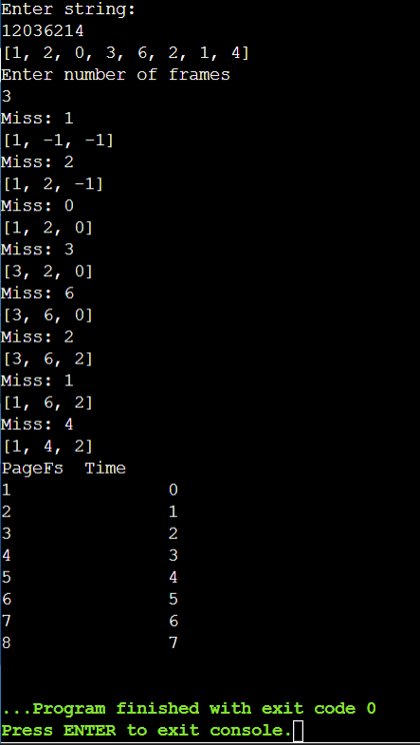

1. **LRU :-**

import java.util.*;

class ReplacementLRU {

int f;

int[] runQ;

int pageF = 0;

int time = 0;

HashMap<Integer, Integer> map = new HashMap<>();

HashMap<Integer, Integer> page = new HashMap<>();

ReplacementLRU(int f) {

this.f = f;

runQ = new int[f];

Arrays.fill(runQ, -1);

}

public void push(int m) {

if (!contains(m)) {

if (pageF < f) {

runQ[pageF % f] = m;

pageF++;

page.put(pageF,time);

} else {

pageF++;

int lruIndex = 0;

int lruTime = map.get(runQ[0]);

for (int i = 1; i < f; i++) {

if (map.get(runQ[i]) < lruTime) {

lruTime = map.get(runQ[i]);

lruIndex = i;

}

}

runQ[lruIndex] = m;

page.put(pageF,time);

}

map.put(m, time);

System.out.println("Miss: " + m);

} else {

map.put(m, time);

System.out.println("Hit: " + m);

}

time++;

System.out.println(Arrays.toString(runQ));

}

public boolean contains(int m) {

for (int i = 0; i < f; i++) {

if (runQ[i] == m) {

return true;

}

}

return false;

}

}

public class lru {

public static void main(String[] args) {

Scanner in = new Scanner(System.in);

System.out.println("Enter string: ");

String str = in.nextLine();

int n = str.length();

int[] ref = new int[n];

for (int i = 0; i < n; i++) {

ref[i] = Integer.parseInt(String.valueOf(str.charAt(i)));

}

System.out.println(Arrays.toString(ref));

System.out.println("Enter number of frames");

int f = in.nextInt();

ReplacementLRU r = new ReplacementLRU(f);

for (int i = 0; i < n; i++) {

r.push(ref[i]);

}

System.out.println("PageFs\tTime");

for (Map.Entry<Integer, Integer> page : r.page.entrySet()) {

System.out.println(page.getKey() + "\t\t" + page.getValue());

}

}

}

**Output :-**

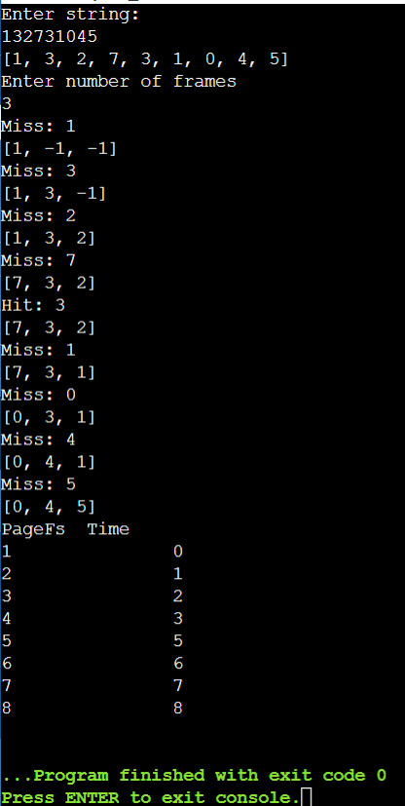

1. **Optimal :-**

import java.util.*;

class ReplacementOptimal {

int f;

int[] runQ;

int pageF = 0;

int time = 0;

HashMap<Integer, Integer> map = new HashMap<>();

ReplacementOptimal(int f) {

this.f = f;

runQ = new int[f];

Arrays.fill(runQ, -1);

}

public void push(int m, int[] futRef) {

if (!contains(m)) {

if (pageF < f) {

runQ[pageF % f] = m;

pageF++;

} else{

pageF++;

int farthest = -1;

int replaceIndex = -1;

for (int i = 0; i < f; i++) {

int currentP = runQ[i];

boolean found = false;

for (int j = time; j < futRef.length; j++) {

if (currentP == futRef[j]) {

found = true;

if (j > farthest) {

farthest = j;

replaceIndex = i;

}

break;

}

}

if (!found) {

replaceIndex = i;

break;

}

}

runQ[replaceIndex] = m;

}

map.put(pageF, time);

System.out.println("Miss: " + m);

} else {

System.out.println("Hit: " + m);

}

time++;

System.out.println(Arrays.toString(runQ));

}

public boolean contains(int m) {

for (int i = 0; i < f; i++) {

if (runQ[i] == m) {

return true;

}

}

return false;

}

}

public class optimal {

public static void main(String[] args) {

Scanner in = new Scanner(System.in);

System.out.println("Enter string: ");

String str = in.nextLine();

int n = str.length();

int[] ref = new int[n];

for (int i = 0; i < n; i++) {

ref[i] = Integer.parseInt(String.valueOf(str.charAt(i)));

}

System.out.println(Arrays.toString(ref));

System.out.println("Enter number of frames");

int f = in.nextInt();

int[] futRef = Arrays.copyOfRange(ref, 1, n);

ReplacementOptimal r = new ReplacementOptimal(f);

for (int i = 0; i < n; i++) {

r.push(ref[i], futRef);

}

System.out.println("PageFs\tTime");

for (Map.Entry<Integer, Integer> map : r.map.entrySet()) {

System.out.println(map.getKey() + "\t\t" + map.getValue());

}

}

}

**Output :-**

