Experiment Number: 1

Problem Statement: **Execution of basic Linux commands**

Name: Arnav Shah Roll No. : 21

Class : AI_C Batch : B2

1. ls command –

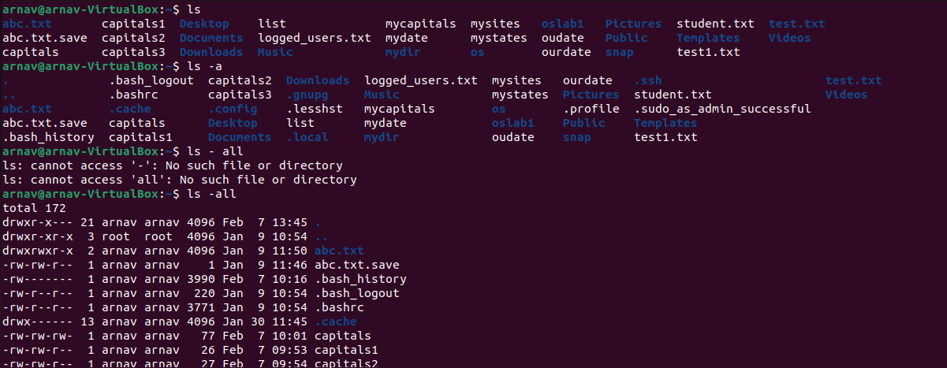

1. cat command –

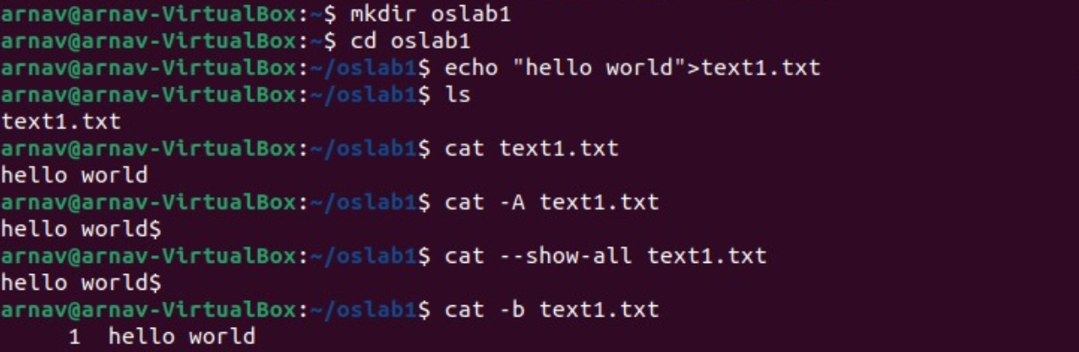

1. pwd command –

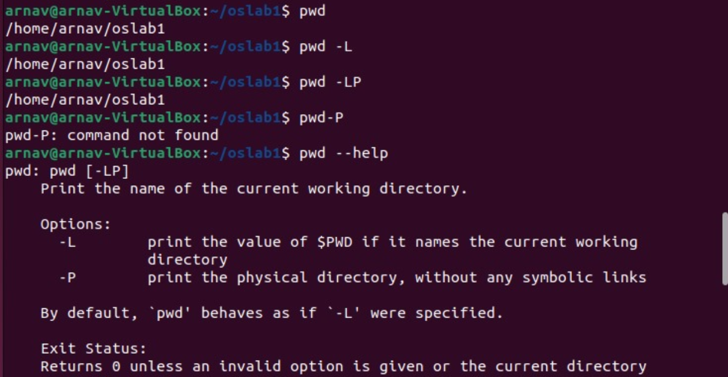

1. rm command –

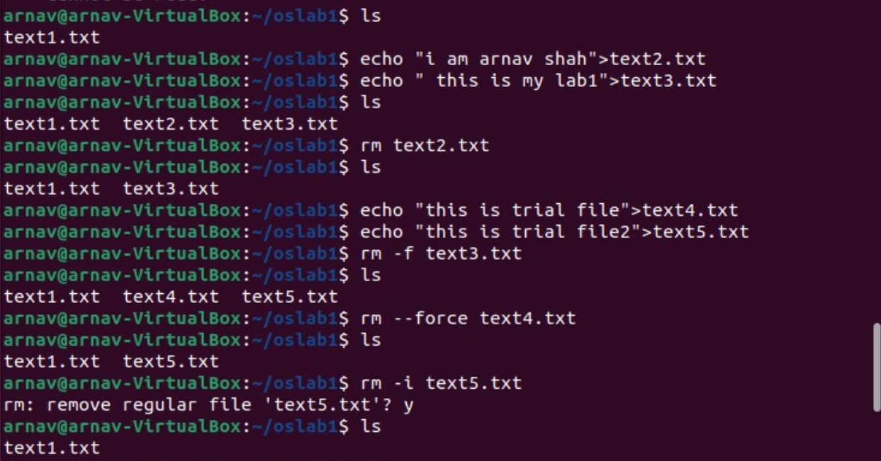

1. date command –

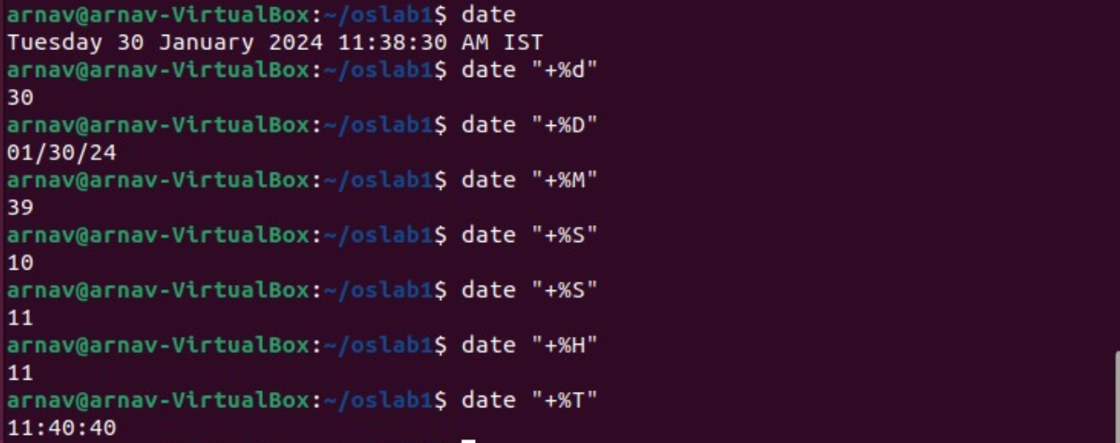

1. who command 

1. echo command –

