Experiment Number: 2

Problem Statement: **Execution of advance Linux commands**

Name: Pushkraj Shahane Roll No. : 22

Class: AI_C Batch: B2

1. Change your password to a password you would like to use for the remainder of the semester.

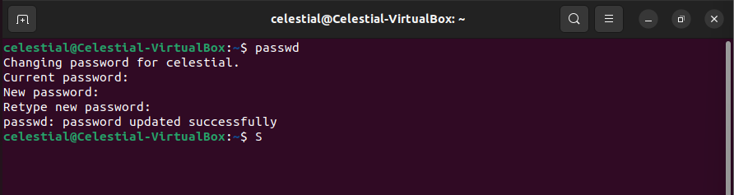

1. Display the system’s date.



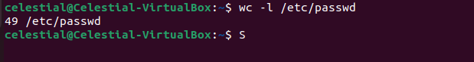

4. Find out who else is on the system.



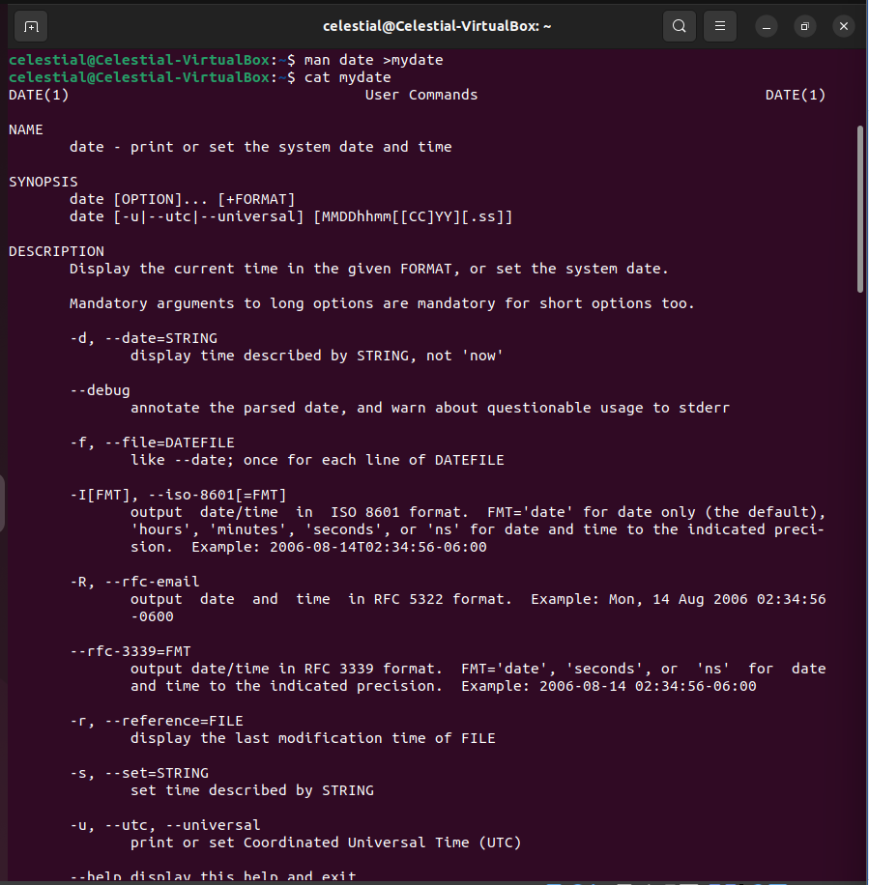

6. Create a subdirectory called mydir.

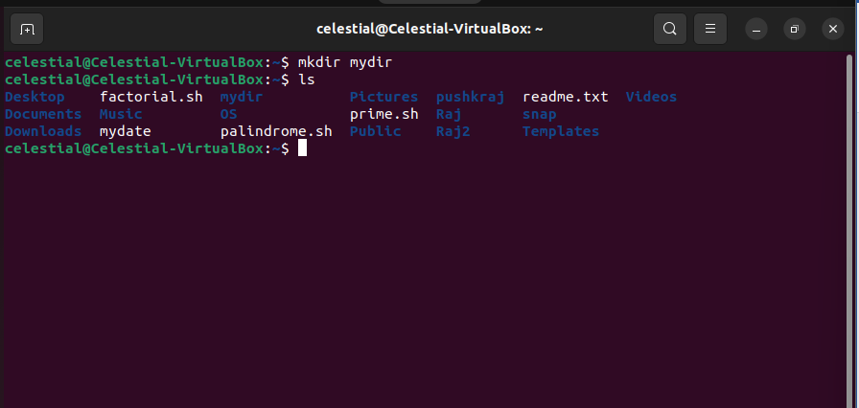

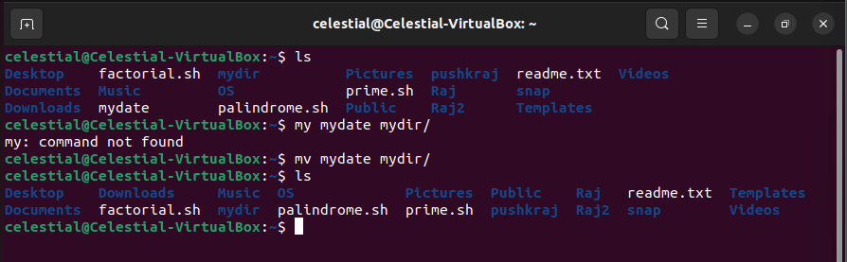

8. Go to the subdirectory mydir and copy the file mydate to a new file called ourdate

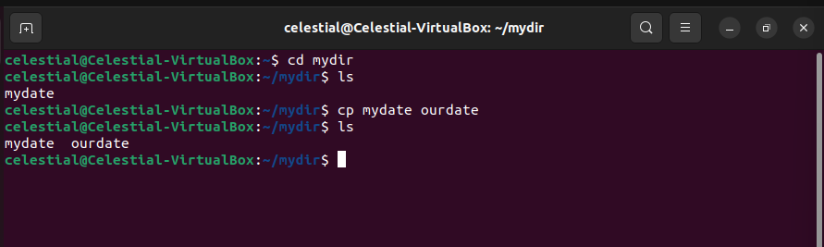

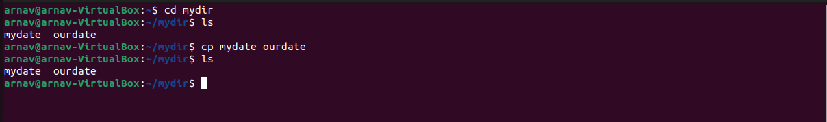

10. Do a long listing on the file ourdate and note the permissions.

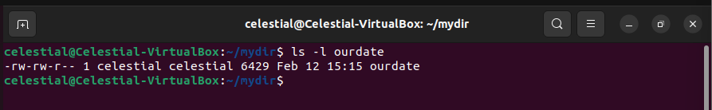

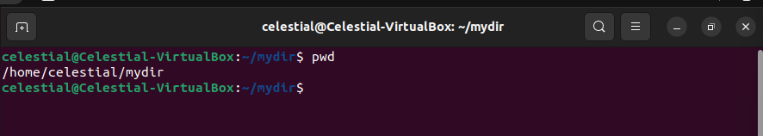

12. Move the files in the directory mydir back to the HOME directory.

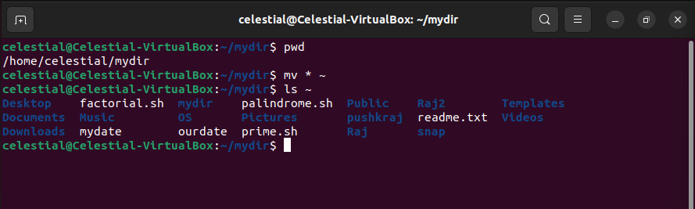

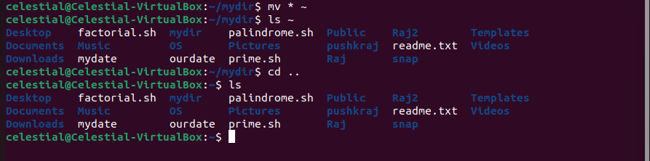

14. Display the first 5 lines of mydate.

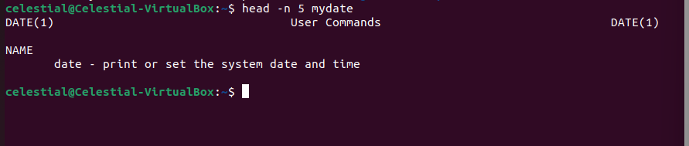

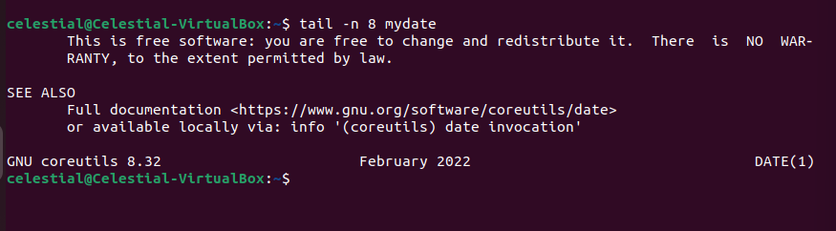

16. Remove the directory mydir.

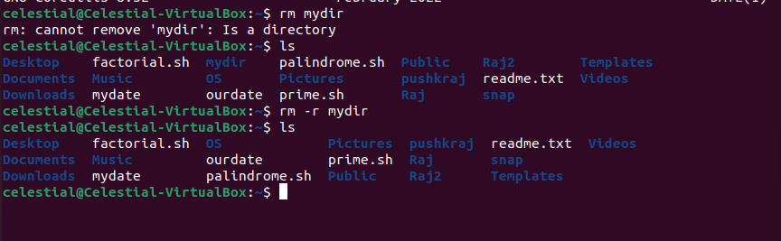

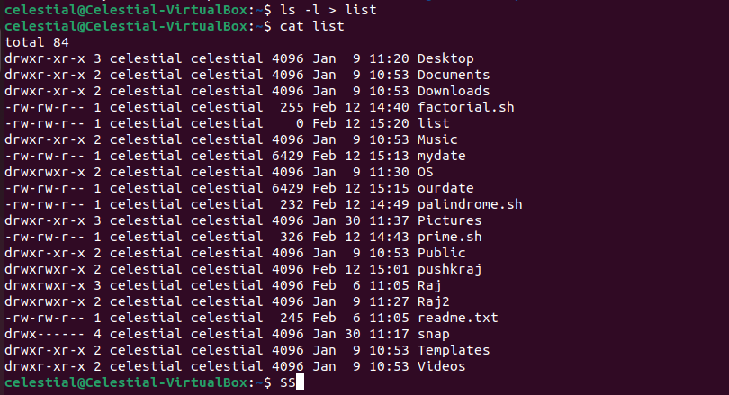

18. Select any 5 capitals of states in India and enter them in a file named capitals1. Choose 5 more capitals and enter them in a file named capitals2. Choose 5 more capitals and enter

them in a file named capitals3. Concatenate all 3 files and redirect the output to a file named capitals.

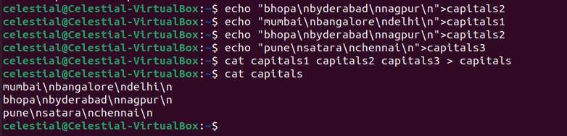

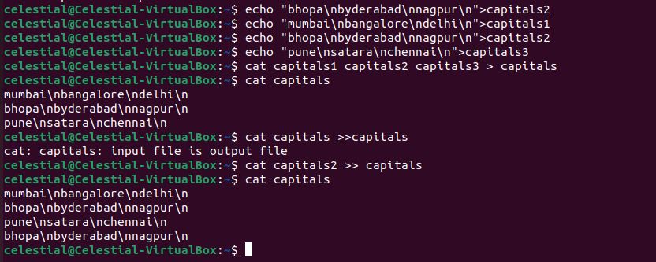

20. Redirect the file capitals as an input to the command “wc –l”.



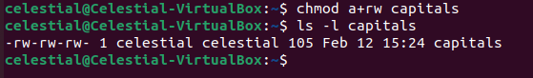

1. Give read permissions only to the owner of the file capitals. Open the file, make some changes and try to save it. What happens ?

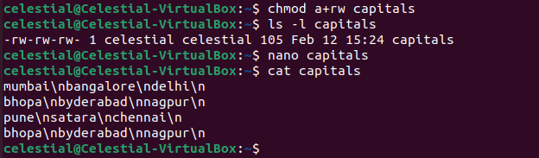

1. Create an alias to concatenate the 3 files capitals1, capitals2, capitals3 and redirect the output to a file named capitals. Activate the alias and make it run.

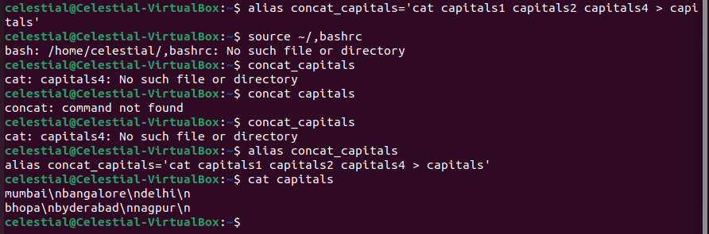

1. What are the environment variables PATH, HOME and TERM set to on your terminal ?

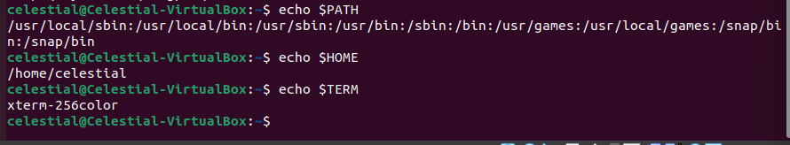

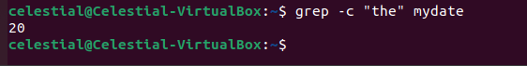

26. Find out the line numbers on which the string “date” exists in mydate.

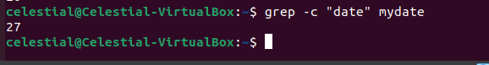

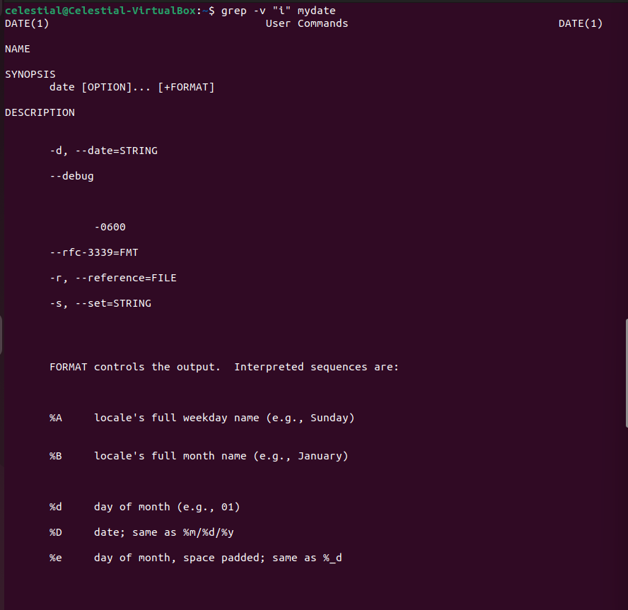

1. Create the file monotonic as follows:

^a?b?b?c? x?y?z$

Run the egrep command for monotonic against /usr/dict/words and search for all 4 letter words.

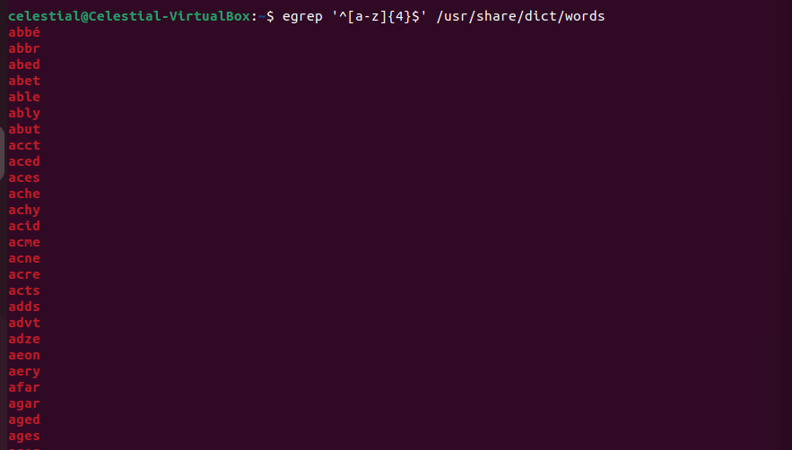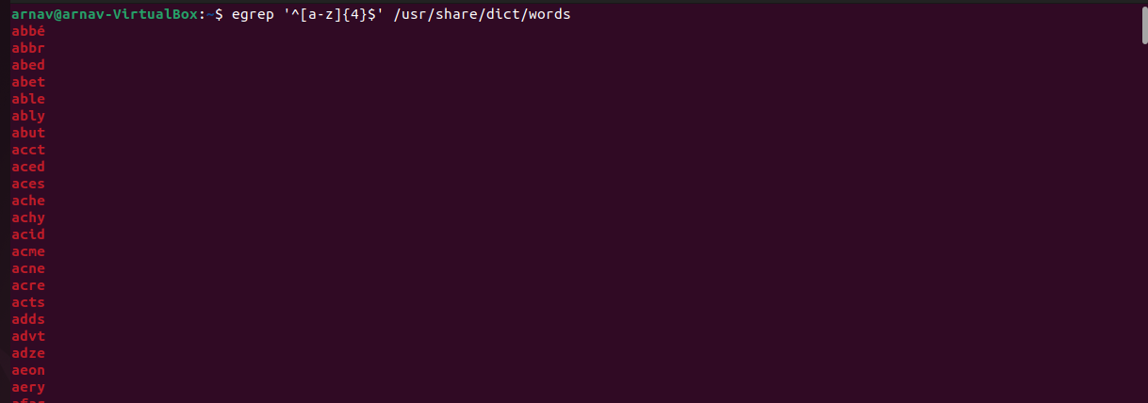

1. List 5 states in north east India in a file mystates. List their corresponding capitals in a file mycapitals. Use the paste command to join the 2 files.

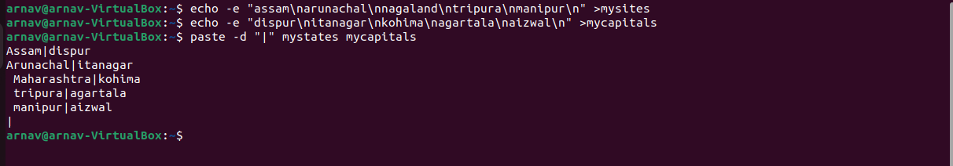

1. Use the cut command to print the 1st and 3rd columns of the /etc/passwd file for all students in this class.

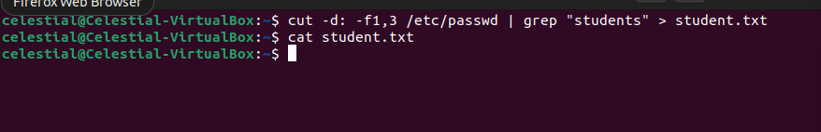

1. Count the number of people logged in and also trap the users in a file using the tee Command.

