***Operating Systems***

***Assignment 3***

Name:Aaryan Mattoo

Roll no.: 1

PRN no:12110004

Div:AI-A

Batch- 1

**Problem Statement: *Shell Programming***

1. **Write a shell program to print given number in reverse order**

**Code:**

echo enter n

read n

num=0

while [ $n -gt 0 ]

do

num=$(expr $num \* 10)

k=$(expr $n % 10)

num=$(expr $num + $k)

n=$(expr $n / 10)

done

echo number is $num

**Output:**

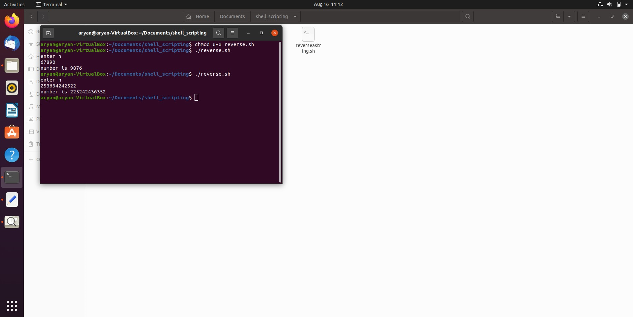

1. **Write a shell program to perform arithmetic operations using case**

**Code:**

echo " Enter the 1st number"

read n1

echo " Enter the 2nd number"

read n2

echo "Menu: 1:Add 2:Sub 3:Mul 4:Div 5:Mod"

echo "Enter the choice"

read ch

case $ch in

1) echo "Addition is: $((n1+n2))";;

2) echo "Subtraction is: $((n1-n2))";;

3) echo "Multiplication is: $((n1\*n2))";;

4) echo "Division is: $((n1\/n2))";;

5) echo "Modulas is: $((n1\%n2))";;

*) echo "Enter valid choice";;

Esac

**Output:**

1. **Write a shell script to check file type and permissions of a given input by user**

**Code:**

echo -n "Enter file name : "

read file

[ -w $file ] && W="Write = yes" || W="Write = No"

[ -x $file ] && X="Execute = yes" || X="Execute = No"

[ -r $file ] && R="Read = yes" || R="Read = No"

echo "$file permissions"

echo "$W"

echo "$R"

echo "$X"

**Output:**

1. **Write a shell script to Find factorial of a given number using function**

**Code:**

factorial()

{

product=$1

if((product <= 2)); then

echo $product

else

f=$((product -1))

f=$(factorial $f)

f=$((f*product))

echo $f

fi

}

echo "Enter the number:"

read num

if((num == 0)); then

echo 1

else

factorial $num

fi

**Output:**

1. **Write a shell script to reverse a string**

**Code:**

read -p "Enter a string: " str

length=${#str}

i=$((length-1))

while [ $i -ge 0 ]

do

revstr=$revstr${str:$i:1}

i=$((i-1))

done

echo "Reverse of $str is $revstr"

**Output:**

1. **White a shell script to print fibonacci series**

**Code:**

function print_fibonacci() {

num=$1

a=0

b=1

echo "The Fibonacci sequence for $num terms is: "

for (( i=0; i<num; i++ ))

do

echo -n "$a "

fn=$((a + b))

a=$b

b=$fn

done

}

# Main script

read -p "Enter the total number of Fibonacci terms: " total_terms

print_fibonacci $total_terms

**Output:**

