Experiment Number: 3

Problem Statement: **Execution Shell Programming**

Name: Arnav Shah Roll No. : 21

Class : AI_C Batch : B2

1. **Write a shell script to Find factorial of a given number using function**

Factorial.sh

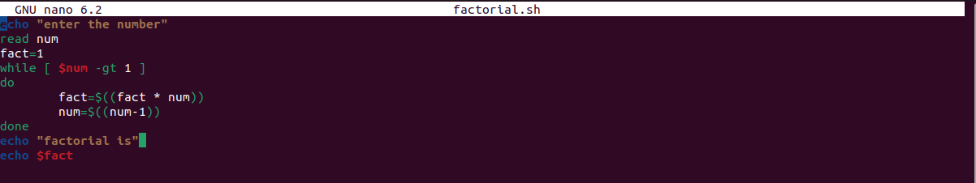

**Output:-**

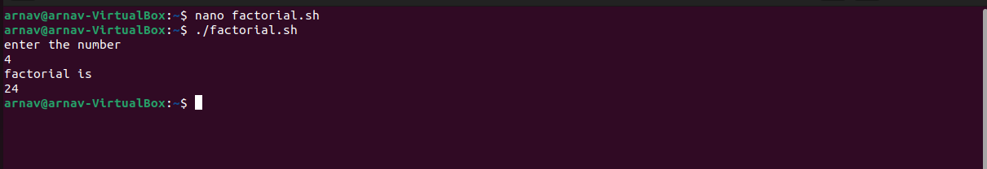

1. **Write a shell script to find prime no.**

Prime.sh

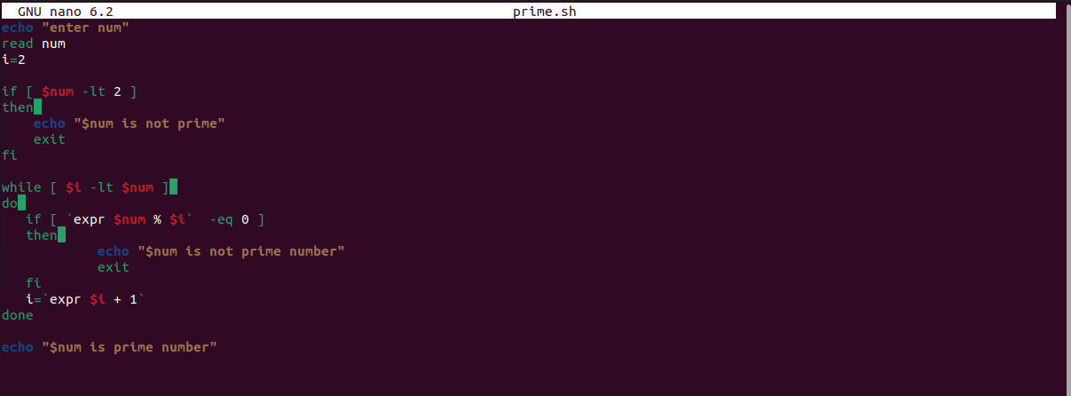

**Output :-**

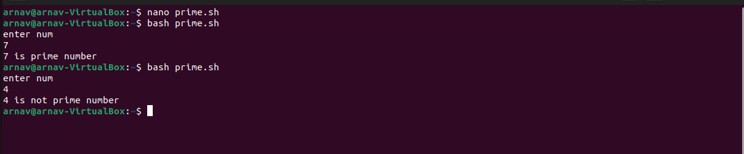

1. **Write a shell script to find palindrome**

Palindrome.sh :-

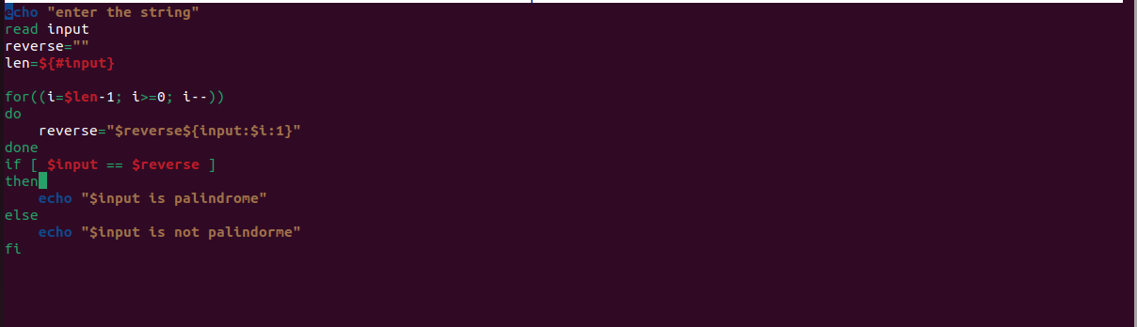

**Output:-**

