**PROJECT REPORT**

## On

**E-VILLAGE**

**A Project Submitted in partial fulfillment of their requirements for the award of the Diploma**

**INFORMATION TECHNOLOGY**

***Under the Guidance of***

***Mr. Akhilesh Kumar***

***MECATREDZ TECHNOLOGY PVT LTD LUCKNOW (UP)***

**Submitted To : Submitted By:**

**Mr .Viplav Shrivastav Deepti Maurya**

**Mr.Vishwa Deepak Bharti**



**GOVERNMENT GIRLS POLYTECHNIC AYODHYA**

**Session 2021-2022**

##### 

##### DECLARATION

This is to certify that the project report entitled “**E-Village**” is done by me is an authentic work carried out for the partial fulfillment of the requirements for the award of the **Diploma** in **“Information Technology”** under the guidance of Er. Akhilesh Kumar The matter embodied in this project work has not been submitted earlier for award of any degree or B.Tech to the best of my knowledge and belief.

**Deepti Maurya**

##### ACKNOWLEDGEMENT

I would like to express my deep and sincere gratitude to **Mecatredz Technology** (P) Ltd. Lucknow, who gave me his full support and encouraged me to work in an innovative and challenging project for Educational field. His wide knowledge and logical thinking gave me right direction all the time.

I am deeply grateful my project coordinator for his/her help and support provided at every step of the project.

Last but not the least, I thank to all employees of **Mecatredz Technology (P) Ltd. Lucknow** for their support and co-operation.

**Deepti Maurya**



Mecatredz Technology

(AN ISO 9001 : 2015 CERTIFIED COMPANY)

MT/VT/22/…..……....

**COMPLETION CERTIFICATE**

This is to certify that Mr/ Miss. **Deepti Maurya** of **Diploma(IT)** from **GGPAyodhya**

was working on the project entitled “**E-village**” in **Mecatredz Technology Pvt. Ltd**.

He/She was engaged .

He/She has done an excellent job during his/her engagement with the Software Development & Testing Division of the company. He/She has completed his/her project during the training tenure. His/her performance has been good and satisfactory.

I would like to take this opportunity to express my appreciation to Mr./Miss **Deepti Maurya**

For his/her work and wish him/her all the very best for his/her future endeavours.

**Regards,**

**HR-Manager**

**Mecatredz Technology Pvt. Ltd. Lucknow**

|  |  |  |
| --- | --- | --- |
| **Index** | | |
| **1.** | **Declaration** |  |
| **2.** | **Acknowledgement** |  |
| **3.** | **Certificate** |  |
| **4.** | **Introduction** |  |
| **5.** | **Overview of Organization** |  |
| **6.** | **Objectives** |  |
| **7.** | **Existing System Description** |  |
| **8.** | **Proposed System** |  |
| **9.** | **Tools Used** |  |
| **10.** | **System** |  |
| **11.** | **Analysis** |  |
| **12.** | **Objective** |  |
| **13.** | **SDLC Phases**   * 1. **Feasibility Study**   2. **Report Approval**   3. **System Analysis**   4. **System Design**   5. **Coding**   6. **Testing**   7. **Implementation**   8. **Maintenance** |  |
| **14.** | **Process Description** |  |
| **15.** | **Project Model Used** |  |
| **16.** | **ER-Diagram** |  |
| **17.** | **Data Flow Diagram** |  |
| **18.** | **Software Requirement** |  |
| **19.** | **Specification……….**   * 1. **Hardware Requirement**   2. **Software Requirement**   3. **Support Maintenance** |  |
| **20.** | **System Design……………** |  |
| **21.** |  | |
| **22.** | **Low Level Design**  **22.1 Description of Classes and Methods** |  |

|  |  |  |
| --- | --- | --- |
| **23.** | **Data Modeling** |  |
| **24.** | **List of Tables** |  |
| **25.** | **Structure of Tables** |  |
| **26.** | **Testing** |  |
| **27.** | **Input-Output** |  |
| **28.** | **Forms………**   * 1. **Modularization Details**   2. **User Screenshots**   3. **Admin Screenshots** |  |
| **29.** | **Future Scope………….** |  |
| **30.** | **Conclusion……………..** |  |

**INTRODUCTION**

E-village portal helps that one can take any information about that particular village for which project is concerned. E-village portal can store all the information dynamically about that village like

population of that village, voter list, APL list, BPL list, Antyodaya list, primary school, primary health

center etc. One can contact directly to the Pradhan, Village development officer (VDO), Lekhpal, Aanganwari, Asha bahu, ANM, Prerak, Panchayat mitra etc through the list having the name and contact number of the

above persons in the portal.

##### Overview of Organization

Mecatredz Technology Pvt Ltd is a software consulting firm provides a full-range of software solution, web design and development services for start-up to well-established companies.

Technologies are transcending boundaries and their volatility is putting stringent demands on the time and mind-space of techno-professionals. At SPG, we update ourselves with technologies even before they become norms and master them long before they become redundant. That's why we are on the roster of clients from across the continents. Come to think of it, we have engineered ourselves to be at the very forefront in Web based technology. Our core competencies span a spectrum of web-intensive services that range from website designing to robust backend management.

##### OBJECTIVES

We had meetings with the concern persons like pradhaan, employees and officers of the tehsil and block level like SDM, VDO, Lekhpal, ABSA etc. We also had a CHAUPAL with the villagers for knowing their problems and requirements. The objective of this E-village project is to fulfill the various requirements so that one can share all the information about a village.

* + 1. . To provide the information about geographical & transportable reach to that village.
    2. Enabling knowledge sharing at lower economies.

3) List of APL and BPL card beneficiaries.

4) To provide information about the promotion of girl education like KANYA VIDYA DHAN YOJNA

5)Easy for patients to use and customize.

6)To provide information about the NGOs working on that village.

**PROBLEM DEFINITION**

In this section we shall discuss the limitation and drawback of the existing system that forced us to take up this project. Really that work was very typical to manage the daily errors free records and adding or removing any node from server. This problem produces a need to change the existing system. Some of these shortcomings are being discussed below: -

* + Low Functionality

With the existing system, the biggest problem was the low functionality. The problem faced hampered the work. For small task like adding any new node to server or deleting a node or keeping daily record we have to appoint minimum two or three employee.

* + Erroneous Input and Output

In the existing system, humans performed all the tasks. As in the human tendency, error is also a possibility. Therefore, the inputs entered by the person who is working in the

Company, in the registers may not be absolutely foolproof and may be erroneous. As a result of wrong input, the output reports etc.will also be wrong which would in turn affect the performance.

* + Portability Problem

System that existed previously was manual. As a result, the system was less portable. One has to carry the loads of many registers to take the data from one place to another. A big problem was that the system was less flexible and if we wanted to calculate yearly or monthly maintenance report or efficiency report, then it was a big headache.

* + Security-

Security concerns were also one of the motives of the Company for the need of software. In the registers, the data is not secure as anybody can tamper with the data written in the registers. While in this software, just a password makes it absolutely secure from the reach of unauthorized persons.

* + Data Redundancy

In the case of manual system, the registers are maintained in which, a lot of data is written.

* + Processing Speed

In manual system maintaining a register and performing the necessary calculation has proved to be a troublesome job, which takes a lot of time and may affect the performance of the Company. But with this software we can have all the tasks performed in a fraction of second by a single click thus making the troublesome job much easier.

* + Manual Errors

When a number of tough tasks are prepared by the humans like preparation of reports, performing long calculation then some human error are obvious due to a number of factors like mental strain, tiredness etc. But as we all know that computer never get tired irrespective of the amount of work it has to do. So this software can nullify the probability of manual error that improve the performance.

* + Complexity in Work

In manual system whenever a record is to be updated or to be deleted a lot of cutting and overwriting needs to be done on the registers that are concerned that are deleted or updated record, which makes the work very complex.

##### SYSTEM ANALYSIS

**OBJECTIVE:**

After gathering requirements we have decided the following aims and objectives of Canteen Automation System :

1. To provide online booking from any corner of local area of campus.
2. To provide best services of food material ,the student who want to enjoy with his friends on getting good marks in exams or birthday etc .
3. We also provides the offer like as other other Restaurant .then admin notify to the registered students .

4).To maintains a user records.

Phases:

System Development Life Cycle(SDLC) mainly consists of the following7 phases which can be detailed:-

Preliminary Investigation: -

This is the first phase of the system development life cycle. In this phase we tend to find out the needs of the client ―what exactly does the client want? Before the development of any system the important point is to know the needs, objectives and scope of the system .

Feasibility Study: -

Feasibility study is these conducted step of the system development life cycle. Things are always easy at the beginning in any software process. In fact nothing is infeasible with unlimited time and resources. But it is not the fact. So, practically we have to do in limited resources in a restricted time margin. So for the system to be feasible, following points we have to consider.

The feasibility study is conducted to check whether the candidate system is feasible. The system which is selected to be the best against the criteria is thereafter designed and developed. The feasibility study takes in to consideration, the risks involved in the project development beforehand. Therefore in this phase we have to do feasibility study which is the test of the website according to its workability, impact on the organization, ability to meet user need and effective use of resources. We do the feasibility study for website to analyze the risks, costs and benefits relating to economics, technology and user organization. There are several types of feasibility depending on the aspect they cover. Import of these includes:

* Technical Feasibility:

This is an important outcome of preliminary investigation .It comprise of following questions:-

* + Can the work of project be done with the current equipment ,existing software and available man power resource?
  + If Technology is required what are the possibilities that it can be developed?
* Economic Feasibility:

It deals with question related to the economy .It comprise of the following questions:-

* + Are there sufficient benefits in creating the system to make the cost acceptable?
  + Are the costs of not creating the system so great that the project must be undertaken?

# legal Feasibility:

It deals with the question related to the legal issues. It comprise of the following questions:-

* + Contract Signing
  + Software License agreement
  + Issues related to cyber laws.
  + Legal issues relating to the man power contract.
* **Operational Feasibility**:

The operational feasibility consists of the following activity:-

* + Will the system be useful if it is developed &implemented?
  + Will the reb resistance from employee?
* Social &Behavioral Feasibility:

It deals with the various issues related to the human behavior like:-

* + Whether the user be able to adapt a new change or not?
  + Whether the ambiance we are providing suits the user or not?

Request Approval:-

Request approval is the third phase of system development lifecycle. Request approval is the phase in which all the requirements which would be provide in the system are stated. The request approval is a sort of agreement between the client and the company which is building his software. Both the parties should be mutually agreed on the stated requirements.

System Analysis:-

System analysis is the phase following the phase of the quest approval. In this phase wet end to analyze the overall system which we have to build. System analysis is the crucial part in SDLC.

System Design:-

System design means the designing of the system. The System can be done in either of the following two ways:-

* Logical System Design
* Physical System Design

Coding:-

Coding is the phase in which a developer codes using any programming languages. Coding constitutes only20 %of the whole project and which is easier to write. The coding work is also done in the teams; development of the system is usually done under the modular programming style, which can be either top-down approachor bottom-up approach.

Testing:-

Testing is the phase in which the system that has been developed is tested. Testing comprises of the 60%ofthe overall development of the system. Testing of the system is important because testing aims to uncover the different errors in the system. There are various different testing techniques that can be used for the testing of the system.

Implementation:-

Implementation process involved the installation of software on user’s side. Implementation process actually depends on type of a system &various. Opting for suitable conversion approach is a step implementation. The conversion processes are as follows:-

* + Parallel Conversion
  + Direct Conversion Approach
  + Pilot Conversion Approach
  + Phase In Conversion Approach

**Maintenance**: -

Merelydevel oping the system is not important but also maintenance is important. The company that has built the system provides for some time free of cost maintenance to the client and after that period it is usually a paid service.

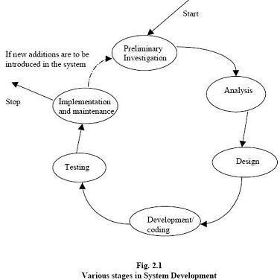

15

**Process Description**

Gantt charts mainly used to allocate resources to activities. The resources allocated to activities include staff, hardware, and software. Gantt charts (named after its developer Henry Gantt) are useful for resource planning. A Gantt chart is special type of bar chart where each bar represents an activity. The bars are drawn along a timeline. The length of each bar is proportional to the duration of the time planned for the corresponding activity.

Gantt chart is a project scheduling technique. Progress can be represented easily in a Gantt chart, by coloring each milestone when completed. The project will start in the month of January and end after 4 months at the beginning of April.

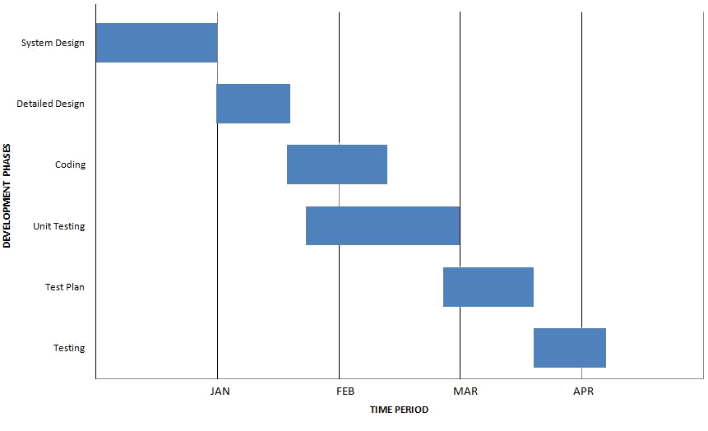

**PROJECT MODEL USED**

##### Iterative Enhancement Model

➢

This model has the same phases as the waterfall model, but with fewer restrictions.

Generally the phases occur in the same order as in the waterfall model, but they may be conducted in several cycles.

➢

Useable product is released at the end of the each cycle, with each release providing

additional functionality. Customers and developers specify as many requirements as possible and prepare a SRS document. Developers and customers then prioritize these requirements. Developers implement the specified requirements in one or more cycles of design, implementation and test based on the defined priorities.

The procedure itself consists of the initialization step, the iteration step, and the Project Control List. The initialization step creates a base version of the system. The goal for this initial implementation is to create a product to which the user can react. It should offer a sampling of the key aspects of the problem and provide a solution that is simple enough to understand and implement easily. To guide the iteration process, a project control list is created that contains a record of all tasks that need to be performed. It includes such items as new features to be implemented and areas of redesign of the existing solution. The control list is constantly being revised as a result of the analysis phase.

The iteration involves the redesign and implementation of iteration is to be simple, straightforward, and modular, supporting redesign at that stage or as a task added to the project control list. The level of design detail is not dictated by the iterative approach. In a light-weight iterative project the code may represent the major source of [documentation](http://en.wikipedia.org/wiki/Software_documentation) of the system; however, in a critical iterative project a formal [Software Design Document](http://en.wikipedia.org/wiki/Software_Design_Document) may be used. The analysis of an iteration is based upon user feedback, and the program analysis facilities available. It involves analysis of the structure, modularity, [usability,](http://en.wikipedia.org/wiki/Usability) reliability, efficiency, & achievement of goals. The project control list is modified in light of the analysis results.

PHASES:

Incremental development slices the system functionality into increments (portions). In each increment, a slice of functionality is delivered through cross-discipline work, from the requirements to the deployment. The unified process groups increments/iterations into phases: inception, elaboration, construction, and transition.

* Inception identifies project scope, requirements (functional and non-functional) and risks at a high level but in enough detail that work can be estimated.
* Elaboration delivers a working architecture that mitigates the top risks and fulfills the non- functional requirements.
* Construction incrementally fills-in the architecture with production-ready code produced from analysis, design, implementation, and testing of the functional requirements.
* Transition delivers the system into the production operating environment.

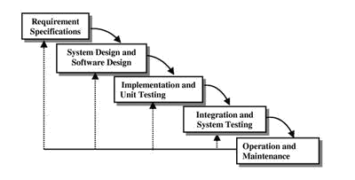

**ER-Diagram**

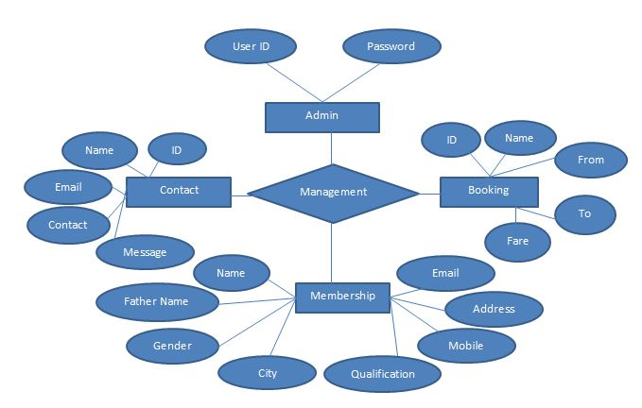

**Introduction:-**

[In software engineering, an entity](http://en.wikipedia.org/wiki/Software_engineering)-relationship model(ERM) is an abstract and conceptual representation [of data.](http://en.wikipedia.org/wiki/Data) Entity-relationship modeling is [a database modeling method,](http://en.wikipedia.org/wiki/Database_model) used to produce a type of [conceptual schema or](http://en.wikipedia.org/wiki/Conceptual_schema) [semantic data model of a](http://en.wikipedia.org/wiki/Conceptual_schema) system, often a [relational](http://en.wikipedia.org/wiki/Relational_database) [database, and](http://en.wikipedia.org/wiki/Relational_database) its requirements [in a top-down](http://en.wikipedia.org/wiki/Top-down) fashion. Diagrams created by this process are called entity-relationship diagrams, ER diagrams, or ERDs. ER Diagrams depicts relationship between data objects. The attribute of each data objects noted in the entity-relationship diagram can be described using a data object description. Entity relationship diagram is very basic, conceptual model of data and it is fundamental to the physical database design. This analysis is then used to organize data as relations, normalizing relations, and obtaining a Relational database.

The entity-relationship model for data uses three features to describe data. These are:

1. Entities which specify distinct real-world items in an application.
2. Relationship, which connect entities and represent meaningful dependencies between them.
3. Attributes which specify properties of entities & relationships.

##### Introduction:-

**Data Flow Diagram**

DFD is an acronym for the word Data Flow Diagram. DFD is pictorial representation of the system. DFD is a graphical representation of the ―flow of data through the information system. DFD are also used forth visualization of data processing (structured design). ADFD provides no information about the timings of the process, or about whether process will operate in parallel or sequence. DFD is an important technique for modeling a system’s high-level detail by showing how input data is transformed too input results through as sequence of functional transformations. DFD reveal relationships among between the various components in a program or system. of DFD lies in the fact that using few symbols we are able to express program design in an easier manner . ADFD can be used to represent the following:-

* External Entity sending and receiving data.
* Process that change the data.
* Flow of data within the system.
* Data Storage locations.

Uses of DFD:-

The main uses of data flow diagrams are as follows:-

DFD is a method of choice for representation of showing of information through a system because of the following reasons:-

* + - DFDs are easier to understand by technical and non-technical audiences.
    - DFDs can provide a high level system overview, complete with boundaries and connections to other system.
    - DFDs can provided tailed representation of system components.

##### 0 Level DFD:-

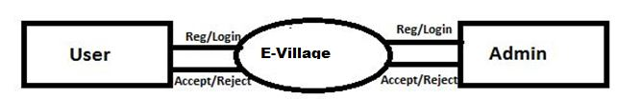

**1 Level DFD:-**

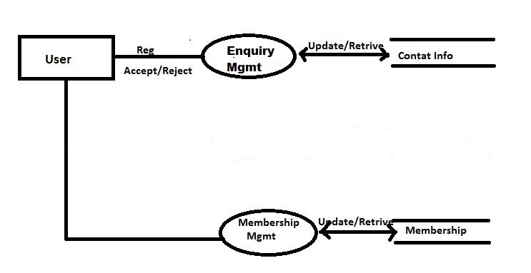

**2.Lavel DFD:-**

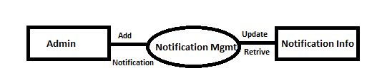

**SOFTWAREREQUIREMENT SPECIFICATION**

A requirements specification for a software system is a complete description of the behavior of a system to be developed and it includes a set of use cases that describe all the interactions the users will have with the software. In addition to use cases, the SRS also contains non-functional requirements.

Non-functional requirements are requirements which impose constraints on the design or implementation (such as performance engineering requirements, quality standards, or design constraints).Requirements are a sub-field of software engineering that deals with the elicitation, analysis, specification, and validation of requirements for software.

The software requirement specification document enlists all necessary requirements for project development. To derive the requirements we need to have clear and thorough understanding of the products to be developed. This is prepared after detailed communications with project team and the customer.

##### Hardware Requirements

###### For Client Side –

* Internet explorer 8, Chrome or any supported browser
* Pentium 4
* 256 MB RAM
* 1 GB HDD

###### For Server Side –

* Xeon based or higher end Server
* 4 GB RAM
* 200 GB disk space

##### Software Requirements

* Client on Internet: Web Browser, Operating System (any).
* Client on Intranet: Client Software, Web Browser, Operating System (any).
* Web Server: IIS 7 or higher, Operating System (windows server).
* Application framework: Microsoft .NET Framework 4.0.
* Data Base Server: MS SQL SERVER 2008 R2, Operating System (windows Server).
* Development End: Visual Studio 2012 (ASP.NET, HTML, JavaScript), MS SQL SERVER 2008, OS (Windows Server), Web Server (IIS 6 or higher).
* Management studio 2012

##### SUPPORTANDMAINTENANCE

One year free support for rectifying system bugs including front end and beck end will be provided. During warranty period Software Engineers will be responsible for removing bugs and improving it. After one year support can be extended @ 20% of the total product deployment cost

##### SYSTEM DESIGN APPROACH

###### Top – Down designing:

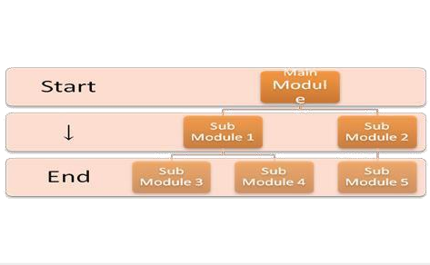The top - down designing approach started with major components of the system. It is a stepwise refinement which starts from an abstract design, in each steps the design is refined two or more concrete levels until we reach a level where no – more refinement is possible or not needed.

###### Bottom – Up designing:

In bottom – up designing the most basic and primitive components are designed first, and we proceed to higher level components. We work with layers of abstractions and abstraction are implemented until the stage is reached where the operations supported by the layer is complete.

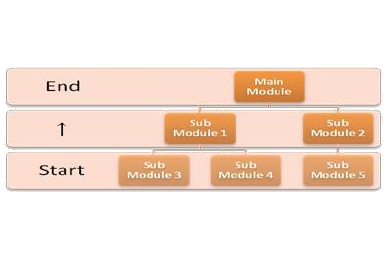

##### Approach we are following:

In this project we are following **Mixed Approach** i.e. A combination of top – down and bottom

– up. We are developing some of the components using top – down designing approach (e.g. the WebPages) and the some components in bottom – up designing approach (e.g. the middle tier classes).

##### DATA MODELING

**LIST OF TABLES:**

1. **Tbl_Registration**
2. **Tbl_Enquiry**

**3.Tbl_Notification4.Tbl_Login**

**1.Tbl_Registration:-**

|  |  |  |
| --- | --- | --- |
| Field Name | Data Type | Status |
| FirstName | Varchar(100) | Not null |
| LastName | Varchar(7) | Not null |
| Gender | Varchar(100) | Not null(Primary key) |
| DOB | Varchar(20) | Not null |
| Address | Varchar(Max) | Not null |
| Contact | Varchar(Max) | Not null |
| Email Id | Varchar(20) | Not null |
| Password | Varchar(30) | Not null |
| Profile | Varchar(70) | Not null |
| Reg Date | dateTime | Null |

**2.Tbl_Enquiry**

|  |  |  |
| --- | --- | --- |
| Field Name | Data Type | Status |
| Id | Int | Not null (primary key) |
| Name | varchar(50) | Not null |
| Mobile | Varchar(30) | Not null |
| EmailId | Varchar(90) | Not null |
| Massage | Varchar(100) | Not null |
| Enq_Date | Datetime | Null |

**3.Tbl_Notification**

|  |  |  |
| --- | --- | --- |
| Field Name | Data Type | Status |
| ID | Int | Not null(primary key) |
| Addnotification | Varchar(100) | Not null |
| Notidate | Datetime | Null |

**4.Tbl_Login**

|  |  |  |
| --- | --- | --- |
| Field Name | Data Type | Status |
| ID | Int | Not null(primary key) |
| EmailId | Varchar(100) | Not null |
| Password | Varchar(60) | Not null |

**Low Level Design**

**Description:** Low Level Design creation is one of the most important activities in the development of any software product. The low level design document gives the design of the actual software application. Low level design document is based on High Level Design document . It defines internal logic of every sub module. A good low level design document will make the application very easy to develop by the developer. An effective design document results in very low efforts in developing a Software product.

Each project's low level design document should provide a *complete and detailed* specification of the design for the software that will be developed in the project,

including the classes, member and non-member functions, and associations between classes that

are involved.

The low level design document should contain a listing of the declarations of all the classes, non-member-functions, and class member functions that will be defined during the subsequent implementation stage, along with the associations between those classes and any other details of those classes (such as member variables) that are firmly determined by the low level design stage. The low level design document should also describe the classes, function signatures, associations, and any other appropriate details, which will be involved in testing and evaluating the project according to the *evaluation plan* defined in the project's requirements document.

##### TESTING

Testing is the integral part of any System Development Life Cycle insufficient and interested application tends to crash and result in loss of economic and manpower investment besides user’s dissatisfaction and downfall of reputation.

“Software Testing can be looked upon as one among much process, an organization performs, and that provides the last opportunity to correct any flaws in the developed system. Software Testing includes selecting test data that have more probability of giving errors.” The first step in System testing is to develop the plan that all aspect of system .Complements, Correctness, Reliability and Maintainability.

Software is to be tested for the best quality assurance, an assurance that system meets the specification and requirement for its intended use and performance.

System Testing is the most useful practical process of executing the program with the implicit intention of finding errors that makes the program fail.

##### Types of Testing

Black Box (Functional) Testing:

Testing against specification of system or component. Study it by examining its inputs and related outputs. Key is to devise inputs that have a higher likelihood of causing outputs that reveal the presence of defects. Use experience and knowledge of domain to identify such test cases. Failing this a systematic approach may be necessary. Equivalence partitioning is where the input to a program falls into a number of classes, e.g. positive numbers vs. negative numbers. Programs normally behave the same way for each member of a class. Partitions exist for both input and output. Partitions may be discrete or overlap. Invalid data (i.e. outside the normal partitions) is one or more partitions that should be tested.

Internal System design is not considered in this type of testing. Tests are based on requirements and functionality.

This type of test case design method focuses on the functional requirements of the software, ignoring the control structure of the program. Black box testing attempts to find errors in the following categories:

➢

Incorrect or missing functions.

* + Interface errors.
  + Errors in data structures or external database access.
  + Performance errors.
  + Initialization and termination errors.

##### White Box (Structural) Testing

Testing based on knowledge of structure of component (e.g. by looking at source code). Advantage is that structure of code can be used to find out how many test case need to be performed. Knowledge of the algorithm (examination of the code) can be used to identify the equivalence partitions. Path testing is where the tester aims to exercise every independent execution path through the component. All conditional statements tested for both true and false cases. If a unit has n control statements, there will be up to 2n possible paths through it. This demonstrates that it is much easier to test small program units than large ones. Flow graphs are a pictorial representation of the paths of control through a program (ignoring assignments, procedure calls and I/O statements). Use flow graph to design test cases that execute each path. Static tools may be used to make this easier in programs that have a complex branching structure. Tools support. Dynamic program analysers instrument a program with additional code. Typically this will count how many times each statement is executed. At end print out report showing which statements have and have not been executed. Problems with flow graph derived testing:

#### 

Data complexity could not take into account.

* We cannot test all paths in combination.

#### 

In really only possible at unit and module testing stages because beyond that complexity is too high.

This testing is based on knowledge of the internal logic of an application’s code. Also known as a Glass Box Testing .Internal software and code working should be known for this type of testing. Tests are based on coverage of code statements, branches, paths, conditions.

Unit Testing:

Unit testing concentrates on each unit of the software as implemented in the code. This is done to check syntax and logical errors in programs. At this stage, the test focuses on each module individually, assuring that it functions properly as a unit. In our case, we used extensive white- box testing at the unit testing stage.

A developer and his team typically do the unit testing do the unit testing is done in parallel with coding; it includes testing each function and procedure.

Incremental Integration Testing:

Bottom up approach for testing i.e. continuous testing of an application as new functionality is added; Application functionality and modules should be independent enough to test separately done by programmers or by testers.

Integration Testing:

Testing of integration modules to verify combined functionality after integration .Modules are typically code modules, individual applications, client and server and distributed systems.

Functional Testing:

This type of testing ignores the internal parts and focus on the output is as per requirement or not .Black box type testing geared to functionality requirements of an application.

System Testing:

Entire system is tested as per the requirements. Black box type test that is based on overall requirement specifications covers all combined parts of a system.

End-to-End Testing:

Similar to system testing ,involves testing of a complete application environment in a situation that mimics real-world use, such as interacting with a database ,using network communications, or interacting with hardware, applications, or system if appropriate.

Regression Testing:

Testing the application as a whole for the modification in any module or functionality .Difficult to cover all the system in regression testing so typically automation tools are used for these testing types.

Acceptance Testing:

Normally this type of testing is done to verify if system meets the customer specified requirements. User or customers do this testing to determine whether to accept application.

Performance Testing:

Term often used interchangeably with “stress” and “load” testing, To check whether system meets performance requirements, Used different performance and load tools to do this.

Alpha Testing:

In house virtual user environment can be created for this type of testing. Testing is done at the end of development .Still minor design changes may be made as a result of such testing.

Beta Testing:

Testing typically done by end-users or others. This is final testing before releasing application for commercial purpose.

**Description Of DB Manager :**

DBManager.cs:

using System;

using System.Collections.Generic;

using System.Linq;

using System.Web;

using System.Data;

using System.Data.SqlClient;

using System.IO;

namespace Evillage.Models

{

public class DatabaseManager

{

SqlConnection con = new SqlConnection(@"Data Source=DESKTOP-129QF40\SQLEXPRESS;Initial Catalog=student_tbl;Integrated Security=True");

public bool InsertUpdateAndDelete(string command)

{

SqlCommand cmd = new SqlCommand(command,con);

if (ConnectionState.Closed == con.State)

{

con.Open();

}

int n=cmd.ExecuteNonQuery();

if(n>0)

return true;

else

return false;

}

public DataTable GetAllRecord(string command)

{

SqlDataAdapter sa = new SqlDataAdapter(command,con);

DataTable dt = new DataTable();

sa.Fill(dt);

return dt;

}

}

}

CaptchaGenerator .cs:

using System;

using System.Collections.Generic;

using System.Linq;

using System.Web;

namespace Evillage.Models

{

public class CaptchaGenerator

{

public string captcha()

{

char ch1, ch2, ch3, ch4, ch5;

string cph;

Random rm = new Random();

ch1 = (char)(rm.Next(65, 90));

ch2=(char)(rm.Next(48,55));

ch3=(char)(rm.Next(97,122));

ch4=(char)(rm.Next(65,90));

ch5=(char)(rm.Next(50,55));

cph=(ch1+""+ ch2+""+ ch3+""+ ch4 +""+ ch4+""+ ch5).ToString();

return cph;

}

}

##### }

##### Encryption.cs:

using System;

using System.Collections.Generic;

using System.Linq;

using System.Web;

using System.Text;

namespace Evillage.Models

{

public class EncryptionManager

{

public string Encrrypt(string encrpt)

{

byte[] b;

string enc;

b = ASCIIEncoding.ASCII.GetBytes(encrpt);

enc = Convert.ToBase64String(b);

return enc;

}

//code for decrypt data

public string Decrypt(string decrpt)

{

byte[] b;

string dec;

b = Convert.FromBase64String(decrpt);

dec = ASCIIEncoding.ASCII.GetString(b);

return dec;

}

}

}

**User Screenshots:**

**HomePage**

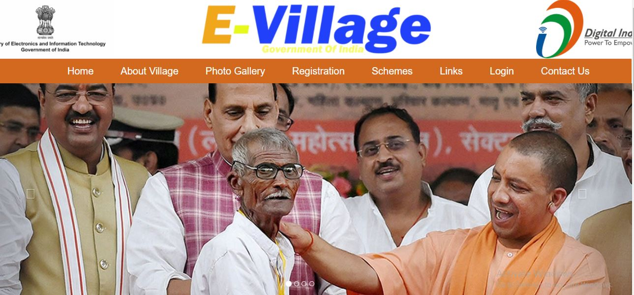

**AboutUs**

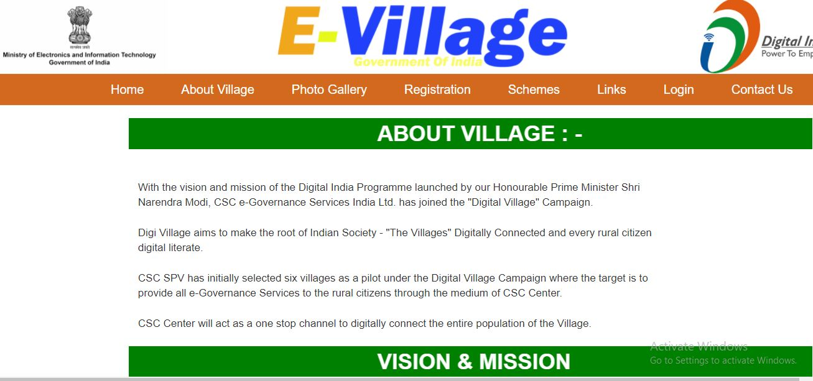

**Registration:**

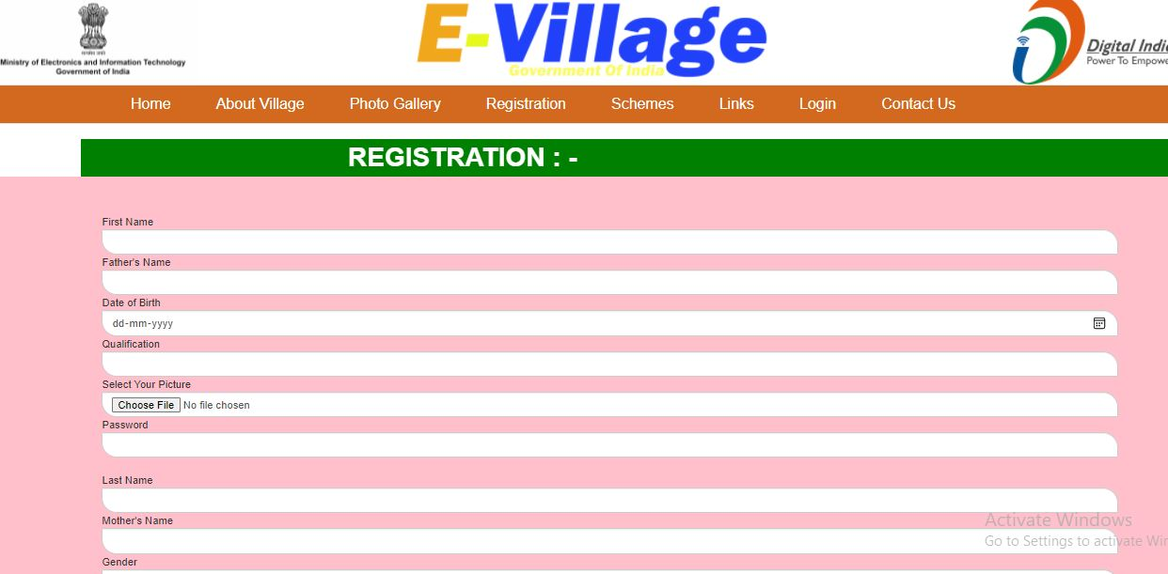

**Scehme**

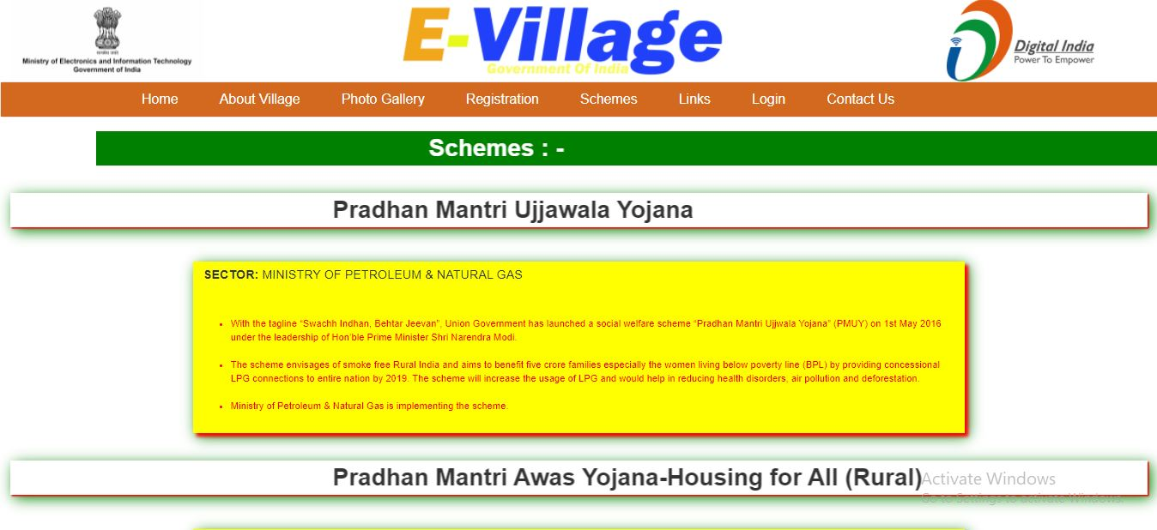

**Admin Login**

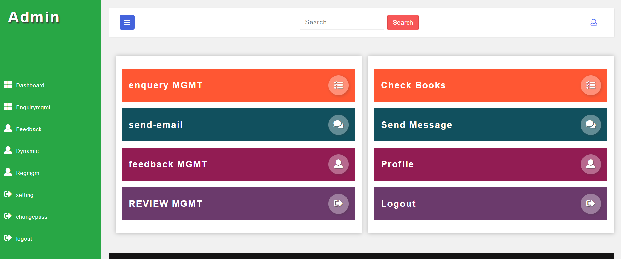

**Admin Login:**

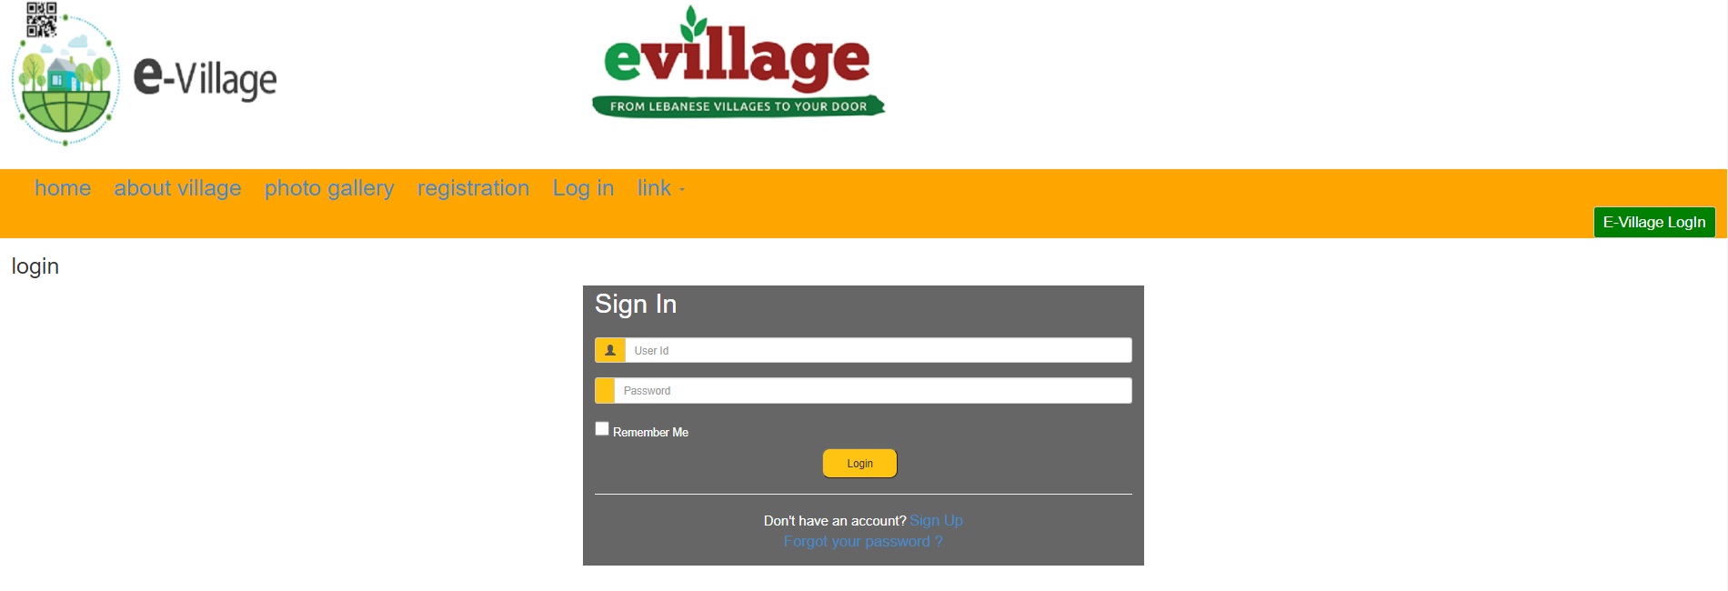

**IndexCs:**

<html>

<head>

<link href="~/content/link/css/bootstrap.min.css" rel="stylesheet"/>

<link rel="stylesheet" href="https://cdnjs.cloudflare.com/ajax/libs/font-awesome/4.7.0/css/font-awesome.min.css">

<link href="~/content/link/css/hover-min.css" rel="stylesheet"/>

<script src="~/content/link/js/jquery.js"></script>

<script src="~/content/link/js/bootstrap.min.js"></script>

<style>

a {

font-size: 20px;

margin-left: 25px;

}

</style>

</head>

<body>

<div class="container-fluid">

<div class="row" style="min-height:120px;background:white">

<div class="col-sm-4">

<img src="~/content/images/ministry1.png" height="120px;"/>

</div>

<div class="col-sm-4">

<img src="~/content/images/evillage2.png" height="120px;"/>

</div>

<div class="col-sm-4">

<img src="~/content/images/digital2.png" height="120px;" style="margin-left:240px;"/>

</div>

</div>

<div class="row">

<nav class="navbar navbar-default">

<div class="container-fluid" style="background:chocolate;min-height:10px;">

<div class="navbar-header">

<button type="button" class="navbar-toggle" data-toggle="collapse" data-target="#menu1">

<span class="icon-bar"></span>

<span class="icon-bar"></span>

<span class="icon-bar"></span>

</button>

</div>

<div class="collapse navbar-collapse" id="menu1">

<ul class="nav navbar-nav" style="margin-left:130px;">

<li><a href="../Home/Index"style="color:white;">Home</a></li>

<li><a href="../Home/aboutvillage"style="color:white;">About Village</a></li>

<li><a href="../Home/photogallery"style="color:white;">Photo Gallery</a></li>

<li><a href="../Home/registration"style="color:white;">Registration</a></li>

<li><a href="../Home/schemes"style="color:white;">Schemes</a></li>

<li><a href="../Home/links"style="color:white;">Links</a></li>

<li><a href="../Home/login"style="color:white;">Login</a></li>

<li><a href="../Home/contactus"style="color:white;">Contact Us</a></li>

</ul>

</div>

</div>

</nav>

</div>

<div class="row" style="margin-top:-21px;">

<div id="carousel-example-generic" class="carousel slide" data-ride="carousel">

<ol class="carousel-indicators">

<li data-target="#carousel-example-generic" data-slide-to="0" class="active"></li>

<li data-target="#carousel-example-generic" data-slide-to="1"></li>

<li data-target="#carousel-example-generic" data-slide-to="2"></li>

<li data-target="#carousel-example-generic" data-slide-to="3"></li>

</ol>

<div class="carousel-inner" role="listbox">

<div class="item active">

<img src="~/content/images/slider1.jpg" style="min-height:400px;width:1522px;">

<div class="carousel-caption">

</div>

</div>

<div class="item">

<img src="~/content/images/slider2.jpg" style="min-height:400px;width:1522px;">

<div class="carousel-caption">

</div>

</div>

<div class="item">

<img src="~/content/images/slider3.jpg" style="min-height:400px;width:1522px;"/>

<div class="carousel-caption">

</div>

</div>

<div class="item">

<img src="~/content/images/slider4.png" style="min-height:480px;width:1522px;"/>

<div class="carousel-caption">

</div>

</div>

</div>

<!-- Controls -->

<a class="left carousel-control" href="#carousel-example-generic" role="button" data-slide="prev">

<span class="glyphicon glyphicon-chevron-left" aria-hidden="true"></span>

<span class="sr-only">Previous</span>

</a>

<a class="right carousel-control" href="#carousel-example-generic" role="button" data-slide="next">

<span class="glyphicon glyphicon-chevron-right" aria-hidden="true"></span>

<span class="sr-only">Next</span>

</a>

</div>

</div>

<div class="row">

<div class="col-sm-1" style="background:white; min-height:600px;"></div>

<div class="col-sm-6" style="background:white; min-height:600px;font-size:18px;text-decoration:wavy;"><br><br>

<p>ASAA E-Village India Mobile Application is a technological initiative by the A S AGRI AND AQUA LLP(ASAA Group of Companies) that bridges the digital gap between the Urban and Rural India, created with vision as directed under the Government of India’s flagship National e-Governance Plan, to boost digital connectivity throughout the length and breadth of the country.</p>

<p>India is a vastly diverse country, encompassing a multitude of cultures, languages, and peoples spread across multiple states, districts, talukas, and villages. However, most of us are completely unaware about much of the information of our country, especially the villages.</p>

<p>Through our flagship ASAA E-Village App, we aim to enhance Human, Digital, and Physical network throughout the country’s various villages with each other and with Urban areas, providing efficient access to information, communication, products, services, and many other facilities. The app will be run by A S Advance E-Village India LLP’s Entrepreneurs and IT professionals and will be operational in all states, districts, talukas, and villages of India, providing a comprehensive connectivity and information network across the country.</p>

<p>The company will also provide job opportunities and employment to locals by appointing & training one representative in every 10 villages and special co-operative officers in each taluka and district, who will be responsible for information updates, guidance, marketing, research, and grievance resolution in their designated areas.</p>

</div>

<div class="col-sm-4" style="background:white; min-height:600px;">

<img src="~/content/images/thumbnail.jpg" class="img img-thumbnail img img-responsive hvr-pop" style="min-height:600px;"/>

</div>

<div class="col-sm-1" style="background:white; min-height:600px;"></div>

</div>

<div class="row" style="min-height:120px;background:#FFF8DC;text-align:center;font-size:70px;">OUR VISION</div>

<div class="row">

<div class="col-md-1" style="min-height:120px;background:#FFF8DC;"></div>

<div class="col-md-10" style="min-height:120px;background:#FFF8DC;text-align:center;font-size:20px;">To create a digital hub for India’s villages that will provide details for all the states, districts, talukas, and villages in the country, and serve as center for information, communication, and many more services – facilitating efforts to modernize neglected villages, improve tourism, and lend support to local businesses.</div>

<div class="col-md-1" style="min-height:120px;background:#FFF8DC;"></div>

</div>

<div class="row">

<div class="col-sm-1" style="min-height:500px;background:black;"></div>

<div class="col-sm-3 footer-widget" style="min-height:500px;background:black;">

<div class="about-widget">

<h6 class="fw-title" style="font-size:25px;text-align:center;color:orange;"><b>ABOUT US</b></h6><br><br>

<p style="font-size:15px;color:white;">Serving in the field of Technical Education from last 28 years Jawahar Lal Nehru Polytechnic, Mahmudabad was opened and established on 28th Oct. Vide G.O.2573/18G.H. 147 (H) B.E.D./75at 28th Aug. </p>

<div class="social pt-1"><br><br>

<a href=""><i class="fa fa-twitter-square" style="color:white;"></i></a>

<a href=""><i class="fa fa-facebook-square" style="color:white;"></i></a>

<a href=""><i class="fa fa-google-plus-square" style="color:white;"></i></a>

<a href=""><i class="fa fa-linkedin-square" style="color:white;"></i></a>

<a href=""><i class="fa fa-rss-square" style="color:white;"></i></a>

</div>

</div>

</div>

<div class="col-sm-2" style="min-height:500px;background:black;">

<div class="fw-title" style="font-size:25px;text-align:center;color:orange;"><b>USEFUL LINK</b></div><br><br>

<div class="dobule-link">

<ul>

<li class="active"><a href="../Home/Index" style="color:white;">Home</a></li>

<li><a href="../Home/aboutvillage" style="color:white;">About Village</a></li>

<li><a href="../Home/photogallery" style="color:white;">Photo Gallery</a></li>

<li><a href="../Home/registration" style="color:white;">Registration</a></li>

<li><a href="../Home/schemes" style="color:white;">Schemes</a></li>

<li><a href="../Home/links" style="color:white;">Links</a></li>

<li><a href="../Home/login" style="color:white;">Login</a></li>

<li><a href="../Home/contactus" style="color:white;">Contact Us</a></li>

</ul>

</div>

</div>

<div class="col-sm-2 footer-widget" style="min-height:500px;background:black;">

<h6 class="fw-title" style="font-size:25px;margin-left:70px;color:orange;"><b>CONTACT</b></h6><br><br>

<ul class="contact">

<li><p style="color:white;"><i class="fa fa-map-marker" style="color:white;"></i>E-Village Government of India</li>

<li><p style="color:white;"><i class="fa fa-phone" style="color:white;"></i >+91 7905798764</p></li>

<li><p style="color:white;"><i class="fa fa-envelope" style="color:white;"></i>siddiquiasad.a@gmail.com</p></li>

<!--<li><p><i class="fa fa-clock-o"></i> Monday - Friday, 08:00AM - 06:00 PM</p></li>-->

</ul>

</div>

<div class="col-sm-4 footer-widget" style="min-height:500px;background:black;">

<h6 class="fw-title" style="font-size:25px;margin-left:80px;margin-left:150px;color:orange;"><b>LOCATE US</b></h6>

<iframe class="img img-thumbnail img img-responsive hvr-pop" style="min-height:400px" src="https://www.google.com/maps/embed?pb=!1m18!1m12!1m3!1d3554.2547557490298!2d78.30685611500027!3d27.022114783080593!2m3!1f0!2f0!3f0!3m2!1i1024!2i768!4f13.1!3m3!1m2!1s0x39743fdfa6eca649%3A0x45e38620ed18bb8f!2sE%20Village%20India!5e0!3m2!1sen!2sin!4v1632575833685!5m2!1sen!2sin" width="450" height="400" style="box-shadow:2px 2px 2px white,2 px 2px; black;" allowfullscreen="" loading="lazy"></iframe>

</div>

</div>

<div class="row" style="min-height:15px;background:#FFF8DC;"></div>

<div class="row">

<div class="col-sm-12" style="min-height:50px;background:#FFF8DC;color:black;text-align:center;font-size:18px;">2021 © Copyright 2021, All rights reserved by Government of India- Designed and Developed by Asad Nawab</div>

</div>

</div>

</body>

</html>

**About.cs:**

@{

ViewBag.Title = "aboutvillage";

Layout = "~/Views/Shared/General.cshtml";

}

<div class="container-fluid">

<div class="row">

<div class="col-sm-2"></div>

<div class="col-sm-10" style="background:green;min-height:50px;font-size:35px;color:white;"><marquee direction="right" behavior="alternate"><b>ABOUT VILLAGE : - </b></marquee></div><br><br>

</div>

<div class="row" style="min-height:50px;background:white;"></div>

<div class="row">

<div class="col-sm-2"></div>

<div class="col-sm-8" style="font-size:17px;">

With the vision and mission of the Digital India Programme launched by our Honourable Prime Minister Shri Narendra Modi, CSC e-Governance Services India Ltd. has joined the "Digital Village" Campaign.<br><br>

Digi Village aims to make the root of Indian Society - "The Villages" Digitally Connected and every rural citizen digital literate.<br><br>

CSC SPV has initially selected six villages as a pilot under the Digital Village Campaign where the target is to provide all e-Governance Services to the rural citizens through the medium of CSC Center.<br><br>

CSC Center will act as a one stop channel to digitally connect the entire population of the Village.<br><br>

</div>

<div class="col-sm-2"></div>

</div>

<div class="row">

<div class="col-sm-2"></div>

<div class="col-sm-10" style="background:green;min-height:50px;font-size:35px;color:white;"><marquee direction="right" behavior="alternate"><b>VISION & MISSION</b></marquee></div><br><br>

</div>

<div class="row">

<div class="col-sm-2"></div>

<div class="col-sm-8" style="font-size:17px;margin-top:50px;">Creating a One Stop Service Solution for the village area citizens, providing them with qualityservices like telemedicine, Financial Services, Internet Connectivity and other G2C/B2C services which are easily accessibleat an affordable price round the year.</div>

<div class="col-sm-2"></div>

</div>

<div class="row" style="min-height:50px;background:white;"></div>

</div>

**Registration.cs:**

@{

ViewBag.Title = "registration";

Layout = "~/Views/Shared/General.cshtml";

}

<div class="row">

<div class="col-sm-1"></div>

<div class="col-sm-11" style="background:green;min-height:50px;font-size:35px;color:white;"><marquee direction="right" behavior="alternate"><b>REGISTRATION : - </b></marquee></div>

</div>

<form action="../Home/registration" method="post" enctype="multipart/form-data">

<div class="container-fluid">

<div class="row" style="min-height:50px;background:pink"></div>

<div class="row" style="min-height:500px;background:pink">

<div class="col-sm-1"></div>

<div class="col-sm-10">

First Name<input type="text" name="fname" class="form-control" style="border-radius:0px 20px 0px 20px;"/>

Father's Name<input type="text" name="fathername" class="form-control" style="border-radius:0px 20px 0px 20px;"/>

Date of Birth<input type="date" name="dob" class="form-control" style="border-radius:0px 20px 0px 20px;"/>

Qualification<input type="text" name="qualification" class="form-control" style="border-radius:0px 20px 0px 20px;"/>

Select Your Picture<input type="file" name="profile" class="form-control" style="border-radius:0px 20px 0px 20px;"/>

Password<input type="password" name="password" class="form-control" style="border-radius:0px 20px 0px 20px;"/><br>

Last Name<input type="text" name="lname" class="form-control" style="border-radius:0px 20px 0px 20px;"/>

Mother's Name<input type="text" name="mothername"class="form-control" style="border-radius:0px 20px 0px 20px;"/>

Gender<input type="text" name="gender"class="form-control" style="border-radius:0px 20px 0px 20px;"/>

Address<input type="text" name="address" class="form-control" style="border-radius:0px 20px 0px 20px;"/>

Email Id<input type="email" name="email" class="form-control" style="border-radius:0px 20px 0px 20px;"/>

Confirm Password<input type="password" class="form-control" style="border-radius:0px 20px 0px 20px;"/><br>

<button class="btn btn-danger form-control" style="border-radius:0px 20px 0px 20px;">Cancel</button>

<button class="btn btn-success form-control" type="submit" style="border-radius:0px 20px 0px 20px;">Submit</button><br>

</div>

<div class="col-sm-1"></div>

</div>

</div>

</form>

**Admin Index:**

@{

Layout = null;

}

<!DOCTYPE html>

<html lang="en">

<head>

<title>Admin Panel</title>

<link rel="stylesheet" href="https://cdnjs.cloudflare.com/ajax/libs/font-awesome/4.7.0/css/font-awesome.min.css">

<!-- Bootstrap Css -->

<link href="~/content/link/css/bootstrap.css" rel="stylesheet" type="text/css" media="all" />

<!-- Bootstrap Css -->

<!-- Common Css -->

<link href="~/content/link/css/style.css" rel="stylesheet" type="text/css" media="all" />

<!--// Common Css -->

<!-- Nav Css -->

<link rel="stylesheet" href="~/content/link/css/style4.css">

<!--// Nav Css -->

<!-- Fontawesome Css -->

<link href="css/fontawesome-all.css" rel="stylesheet">

<!--// Fontawesome Css -->

</head>

<body>

<div class="wrapper">

<!-- Sidebar Holder -->

<nav id="sidebar">

<div class="sidebar-header">

<h1>

<a href="/Admin/Index">Admin</a>

</h1>

<span>M</span>

</div>

<div class="profile-bg"></div>

<ul class="list-unstyled components">

<li class="active">

<a href="/Admin/Dashboard">

<i class="fas fa-th-large"></i> Dashboard

</a>

</li>

<li>

<a href="/Admin/EnquiryManagement">

<i class="fas fa-sign-out-alt"></i> EnquiryManagement

</a>

</li>

<li>

<a href="/Admin/FeedbackManagement">

<i class="fas fa-comments"></i> Feedback Management

</a>

</li>

<li>

<a href="/Admin/DynamicUpdation">

<i class="fas fa-user"></i>Dynamic Updation

</a>

</li>

<li>

<a href="/Admin/RegistrationManagement">

<i class="fas fa-user"></i>Registration Management

</a>

</li>

<li>

<a href="/Admin/Logout">

<i class="fas fa-sign-out-alt"></i> Logout

</a>

</li>

</ul>

</nav>

<!-- Page Content Holder -->

<div id="content">

<!-- top-bar -->

<nav class="navbar navbar-default mb-xl-5 mb-4">

<div class="container-fluid">

<div class="navbar-header">

<button type="button" id="sidebarCollapse" class="btn btn-info navbar-btn">

<i class="fas fa-bars"></i>

</button>

</div>

<!-- Search-from -->

<form action="#" method="post" class="form-inline mx-auto search-form">

<input class="form-control mr-sm-2" type="search" placeholder="Search" aria-label="Search" required="">

<button class="btn btn-style my-2 my-sm-0" type="submit">Search</button>

</form>

<!--// Search-from -->

<ul class="top-icons-agileits-w3layouts float-right">

<li class="nav-item dropdown">

<a class="nav-link dropdown-toggle" href="#" id="navbarDropdown2" role="button" data-toggle="dropdown" aria-haspopup="true" aria-expanded="false">

<i class="far fa-user"></i>

</a>

<div class="dropdown-menu drop-3">

<div class="profile d-flex mr-o">

<div class="profile-l align-self-center">

<img src="~/Content/images/asadnawab.jpg" class="img-fluid mb-3" alt="Responsive image">

</div>

<div class="profile-r align-self-center">

<h3 class="sub-title-w3-agileits">Asad Nawab</h3>

<a href="mailto:info@example.com">siddiquiasad.a@gmail.com</a>

</div>

</div>

<a href="../Admin/ChangePassword" class="dropdown-item mt-3">

<h4>

<i class="far fa-thumbs-up mr-3"></i>Change Password</h4>

</a>

<div class="dropdown-divider"></div>

<a class="dropdown-item" href="../Admin/Logout">Logout</a>

</div>

</li>

</ul>

</div>

</nav>

<!--// top-bar -->

<div class="container-fluid">

<div class="row">

<div class="outer-w3-agile col-xl ml-xl-3 mt-xl-0 mt-3">

<div class="stat-grid p-3 d-flex align-items-center justify-content-between " style="background-color: #FF5733;">

<div class="s-l">

<h5>Dashboard</h5>

</div>

<div class="s-r">

<h6>

<i class="fas fa-tasks"></i>

</h6>

</div>

</div>

<div class="stat-grid p-3 mt-3 d-flex align-items-center justify-content-between" style="background-color: #11505e;">

<div class="s-l">

<h5>Send Message</h5>

</div>

<div class="s-r">

<h6>

<i class="fas fa-comments"></i>

</h6>

</div>

</div>

<div class="stat-grid p-3 mt-3 d-flex align-items-center justify-content-between " style="background-color: #921c53;">

<div class="s-l">

<h5>Feedback</h5>

</div>

<div class="s-r">

<h6>

<i class="fas fa-edit"></i>

</h6>

</div>

</div>

<div class="stat-grid p-3 mt-3 d-flex align-items-center justify-content-between" style="background-color: #6B3A6C;">

<div class="s-l">

<a href="/Admin/Logout"><h5>Logout</h5></a>

</div>

<div class="s-r">

<h6>

<i class="fas fa-sign-out-alt"></i>

</h6>

</div>

</div>

</div>

<div class="outer-w3-agile col-xl ml-xl-3 mt-xl-0 mt-3">

<div class="stat-grid p-3 d-flex align-items-center justify-content-between " style="background-color: #FF5733;">

<div class="s-l">

<h5>Check Books</h5>

</div>

<div class="s-r">

<h6>340

<i class="fas fa-tasks"></i>

</h6>

</div>

</div>

<div class="stat-grid p-3 mt-3 d-flex align-items-center justify-content-between" style="background-color: #11505e;">

<div class="s-l">

<h5>Send Message</h5>

</div>

<div class="s-r">

<h6>250

<i class="fas fa-comments"></i>

</h6>

</div>

</div>

<div class="stat-grid p-3 mt-3 d-flex align-items-center justify-content-between " style="background-color: #921c53;">

<div class="s-l">

<h5>Profile</h5>

</div>

<div class="s-r">

<h6>232

<i class="fas fa-user"></i>

</h6>

</div>

</div>

<div class="stat-grid p-3 mt-3 d-flex align-items-center justify-content-between" style="background-color: #6B3A6C;">

<div class="s-l">

<h5>Logout</h5>

</div>

<div class="s-r">

<h6>190

<i class="fas fa-sign-out-alt"></i>

</h6>

</div>

</div>

</div>

<!-- Pie-chart -->

</div>

</div>

<!-- Copyright -->

<div class="copyright-w3layouts py-xl-3 py-2 mt-xl-5 mt-4 text-center">

<p>© 2021 Library Adda24 . All Rights Reserved | Design by

<a href="#"> Asad Nawab</a>

</p>

</div>

<!--// Copyright -->

</div>

</div>

<!-- Required common Js -->

<script src='~/content/link/js/jquery-2.2.3.min.js'></script>

<!-- //Required common Js -->

<!-- Sidebar-nav Js -->

<script>

$(document).ready(function () {

$('#sidebarCollapse').on('click', function () {

$('#sidebar').toggleClass('active');

});

});

</script>

<!-- Js for bootstrap working-->

<script src="~/content/link/js/bootstrap.min.js"></script>

<!-- //Js for bootstrap working -->

</body>

</html>

**FUTURE SCOPE**

*Following modification or upgrades can be done in system.*

1. Our Future scope and plannings as well as NGOs working for that village in various areas like education, health, women empowerment etc. The current system in use is a paper-based system.

2.Any villager can get information about his KHASRA number and all other status through the E- village portal.

**CONCLUSION:**

E-village is a great initiative by the govt. under e-governance project. This portal will help the people/villagers to have information or current status of the village because admin will have dynamic updation responsibilities so that one can know the current & real situation of the village like population of village, about voter list, about natural disaster if any on the village and more…

References:

**[1] ASP.NET MVC and Web Development Overview,**

**http://msdn.microsoft.com/en-us/library/4w3ex9c2.aspx**

**[2] Microsoft Visual Studio Overview,**

**http://en.wikipedia.org/wiki/Microsoft_Visual_Studio#Visual_Studio_2012**

**[3] Microsoft SQL Server 2008,**

**http://en.wikipedia.org/wiki/Microsoft_SQL_Server**

**[4] 3-Tier System Architecture,**

**http://en.wikipedia.org/wiki/Multitier_architecture**

**[5] Introduction to ADO.NET,**

**http://en.wikipedia.org/wiki/ADO.NET**

**[6] Load Testing using Apache JMeter Testing**

**Tool, http://jakarta.apache.org/jmeter/**

**[7] Introduction to .NET Architecture,**

**http://www.devtopics.com/what-is-net/**

**[8] Common Language Infrastructure Definition,**

**http://en.wikipedia.org/wiki/Common_Language_Infrastructure**

**[9] AJAX – Bridging the Thin-Client Performance Gap,**

**http://www.ironspeed.com/articles/ajax-bridging%20the%20thinclient**