PROJECT REPORT

On


Unlocking Retail Success: Forecasting Walmart's Sales
COURSE: FORECASTING MODELS (SM855)

Submitted to

Dr. Savita Bhat

Submitted by

R Lakshmi
Abhilash Bharadwaj
Gaikwad Rahul Ganesh
Mukilan Murugan
Ganesh I Shetagar
Anvitha U Shetty

NATIONAL INSTITUTE OF TECHNOLOGY KARNATAKA, SURATHKAL
MANGALORE - 575025, KARNATAKA, INDIA
ABSTRACT
With the ever-increasing use of technology in the 21st century, there has never been a greater need for data. Retail giants such as Walmart view this data as their most important asset, as it allows them to predict future sales and customer behaviour, generate profit, and remain competitive in the marketplace. Walmart, one of the largest American multinational retail corporations, operates in more than 27 countries and has almost 11,000 locations, employing over 2,2 million associates. Walmart, which prides itself on offering “everyday low prices” and a wide variety of products, generates almost $500 billion in annual turnover. As a result, it becomes essential for Walmart to employ cutting-edge techniques to forecast sales and generate profit. Walmart sells a wide variety of goods and services, including groceries, home furnishings, electronics, apparel, and more, all of which generate a large amount of consumer data. Walmart uses this data to predict customer buying habits, plan future sales, and develop cutting-edge in-store technology. In the fiercely competitive global market, it is paramount for Walmart to embrace modern technological approaches to not only survive but also to create unique products and services that set it apart from its rivals.
The main goal of the study is to predict Walmart’s sales based on historic data and look at how weather, unemployment, and fuel prices affect the weekly sales of particular stores in the study. In addition, the study looks at whether sales increase during holidays such as Christmas and Thanksgiving as compared to other days of the week. This data can help retailers create promotional offers to increase sales and revenue.
Walmart makes a lot of markdown sales year-round, especially after the major US holidays. Therefore, it’s important for the company to understand how these promotions impact weekly sales in order to effectively allocate resources. Understanding customer behaviour and buying habits is equally important for Walmart to build customer loyalty, increase demand and ultimately improve profitability. The results of this study will allow the company to adjust to seasonal market dynamics and allocate resources based on regional demand and profit. In addition, the use of big data will allow the organization to effectively analyse historical data, gain valuable insights, identify under performing locations, forecast and increase future sales and profit, and serve as a guide to evaluate the organization’s strategic direction.
The analysis for this study has been done using Python with the help of a publicly available dataset on Kaggle.

1.1 INTRODUCTION
Sales forecasting is one of the most important aspects of retail. Walmart is one of the biggest and most influential retail companies in the world, and it relies heavily on sales forecasting to maintain its competitive edge.

1.1.1 The Significance of Sales Forecasting in Retail
Sales forecasting refers to the process of anticipating future sales on the basis of historical information, current market trends, and other factors. It is at the core of strategic planning in the retail industry. Companies like Walmart rely on sales forecasting to ensure that they can adjust resources, inventory and pricing strategies to meet expected customer demand.
Effective sales forecasting is essential for several reasons:
- Inventory Management: Accurate forecasts allow retailers to manage inventory levels, reducing surplus inventory while making sure products are always available to meet customer needs. This not only improves operational efficiency, but also reduces carrying costs.
- Supply Chain Optimization: Sales forecasts are the backbone of the supply chain, enabling retailers like Walmart to manage procurement, manufacturing, shipping, and distribution effectively.
- Pricing Strategies: Sales forecasts play a big role in pricing decisions. Retailers use sales forecasts to create dynamic pricing plans, increase sales and offer discounts, and increase revenue.
- Resource Allocation: From workforce planning to marketing budgeting, sales forecasts optimize resource allocation, reduce waste, and increase profitability.
- Competitive Advantage: In a market where every penny counts, good sales forecasting gives retailers a competitive edge by allowing them to react quickly to changes in the market.

1.1.2 Introduction to Walmart
Walmart was founded in 1962 by Sam Walton in Rogers, Arkansas. With over 50 years of experience in the retail industry, Walmart is synonymous with success and innovation. According to the latest data available, Walmart operates thousands of stores around the world, serving millions of people every day. Walmart’s success is largely due to its customer-centric approach. The company’s core values, such as “Save Money, Live Better,” demonstrate its commitment to providing quality products at affordable prices. The company’s presence is not limited to the United States. Walmart operates under various banners around the world, such as Asda in the UK, Seiyu (Japan), and Flipkart (India). This global presence makes Walmart one of the few retailers that can successfully execute sales forecasting strategies in different markets with different consumer preferences and different economic conditions.

1.2 OBJECTIVES
To perform data cleaning, followed by an exploratory data analysis (EDA) of the dataset to understand the impact of time-based and space-based factors on sales.
To predict weekly sales using historical data with machine learning and arrive at the best forecasting model.

1.3 DATASET
The dataset for this study has been taken from Kaggle. The dataset includes historical weekly sales data of 32 months for 45 Walmart stores across various regions in the country, as well as department-wide data for these stores. Another important factor to consider in this study is whether the weekly store sales increase due to changes in the weather, fuel prices, holiday sales, markdowns, the unemployment rate, and changes in consumer price indexes (CPIs). The dataset provides all the information needed to analyze the impact of these factors on sales performance.

1.3 DATA CLEANING
Data cleaning involved the removal of missing values (NaN) and incorrect values (0 or negative sales) as needed. Significant gaps in the feature dataset were found in the markdown columns. These columns contained information about different promotional events happening at different Walmart locations. The high frequency of missing data in the markdown column can be explained by the seasonal nature of the promotional pricing that stores use during the holiday season, especially from November to January.

1.4 EXPLORATORY DATA ANALYSIS
It is important to have a good understanding of the data set that we are using in this analysis to determine the models that would provide the most accurate predictions. Sometimes there are patterns or trends within the data that are not easily visible, so we need to conduct a thorough exploratory data analysis in order to understand the structure of the data set and to draw conclusions or conclusions about the correctness of our analysis.
Packages like matplotlib and sea-born have been used in this study to create visualizations that provide information about weekly sales by store and department, weekly sales on holidays versus on normal days, weekly sales based on region, store type and store size, average sales per year, change in sales as a result of factors like CPI, fuel price, temperature, and unemployment, etc in the form of heatmaps, histograms, scatterplots, etc.
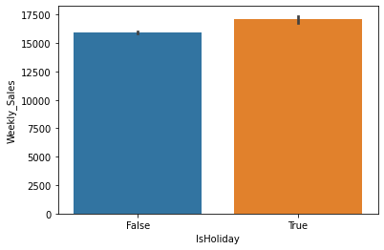
Fig.1: Weekly sales on normal days versus on holidays
Fig. 1 clearly illustrates that weekly sales experience an increase during holidays when compared to regular days.
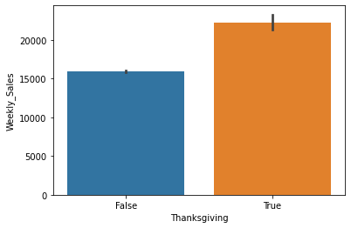
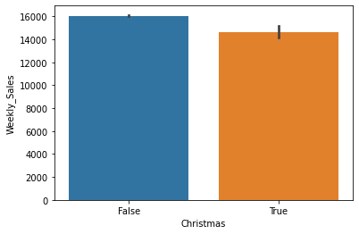

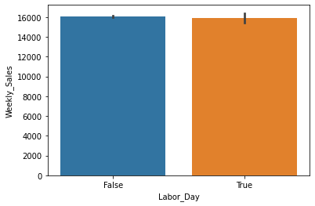
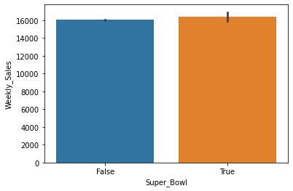

Fig. 2: Impact of special holidays (Christmas, Thanksgiving, Super Bowl, Labour Day) on Weekly sales
Fig.2 shows that Labour Day and Super Bowl holidays do not have any impact on weekly sales. There is positive effect on weekly sales during Thanksgiving and there’s Black Friday sales too at that time. People might generally prefer to buy Christmas gifts 1-2 weeks before Christmas, so it does not show a positive change in weekly sales during actual Christmas.

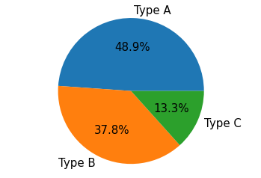
Fig.3: Store types
Fig.3 shows that 48.9% (nearly half) of the stores are of Type A, 37.8% are of Type B and 13.3% are of Type C.

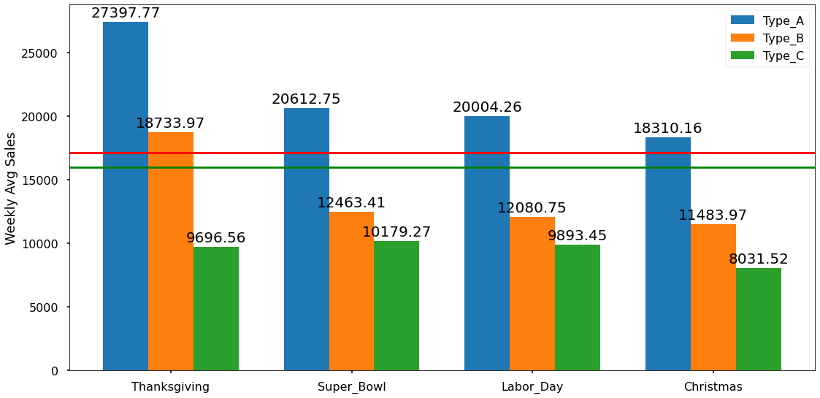

Fig.4: Weekly Avg. sales at each type of store during special holidays

Fig.4 shows that the highest average sales occur during the week of Thanksgiving among all the holiday periods. Additionally, Type A stores consistently demonstrate the highest sales figures across all holidays.

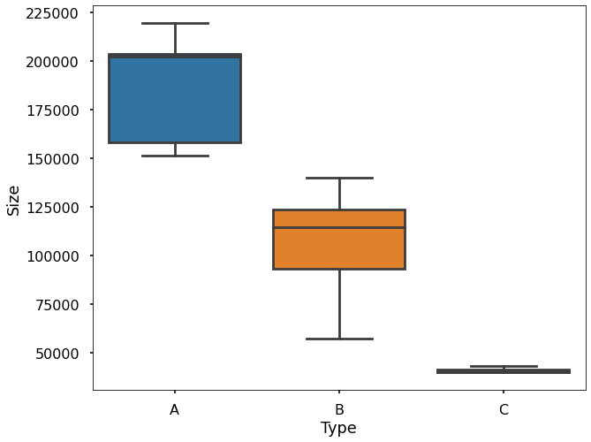

Fig.5: Box-plot showing Size-Type relation of stores

Fig.5 shows that the store sizes align with sales as anticipated, with larger stores generating higher sales. The graph indicates that Walmart categorizes stores based on their sizes, with Type A starting after the smallest size value, followed by Type B beginning after the smallest size value of Type A, and then Type C starting after the smallest size value of Type B.

DEPARTMENT-WISE SALES

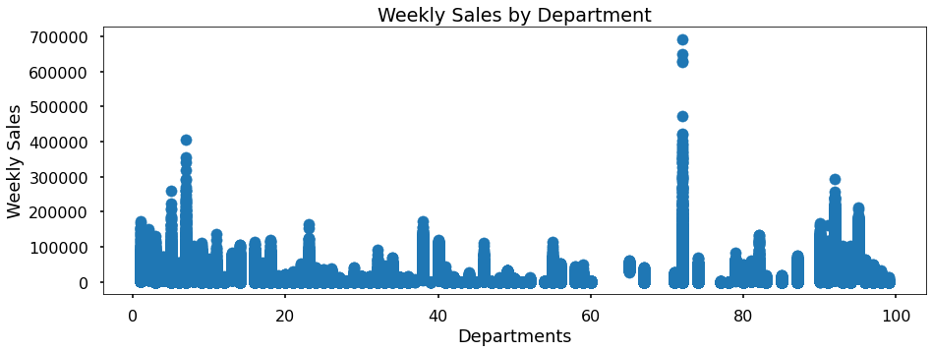

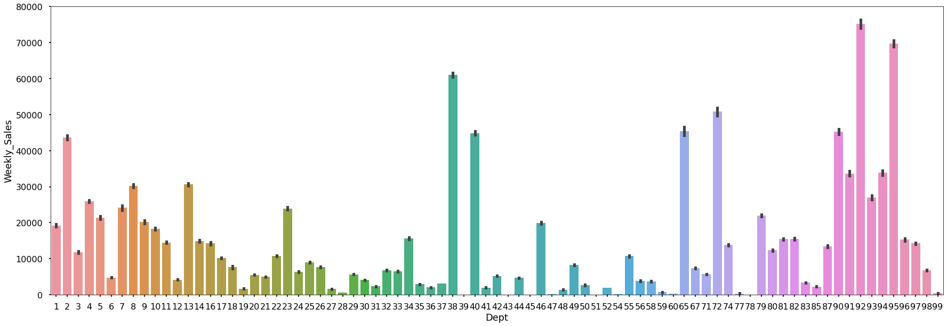
Fig.6: Scatterplot and barplot showing weekly sales and average weekly sales of departments

In Fig.6, the scatterplot suggests that there is one department, presumably department 72, with higher sales values within the 60-80 range. However, when we calculate the averages, it becomes evident from the barplot that department 92 has a higher mean sales value. It appears that department 72 might be a seasonal department, exhibiting higher sales in certain seasons, but when considering overall averages, department 92 surpasses it.

STORE-WISE SALES

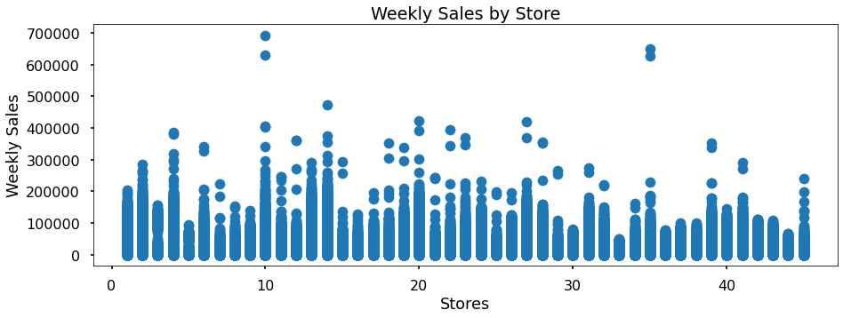

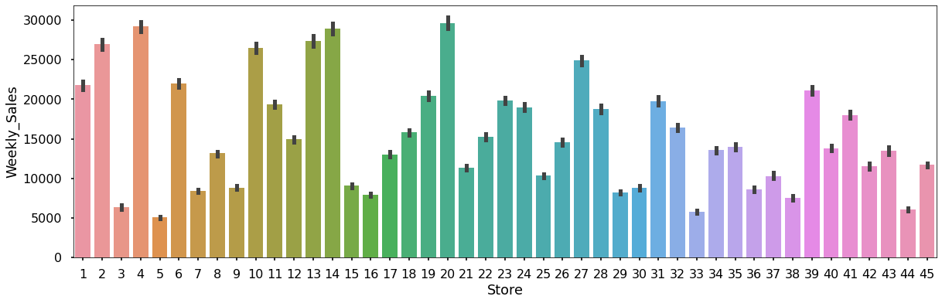
Fig.7: Scatterplot and barplot showing weekly sales and average weekly sales of stores

Fig.7 shows that similar patterns emerge in the case of stores. While the scatterplot indicates that specific stores exhibit higher sales, the barplot shows that on average, store 20 stands out as the top performer, with stores 4 and 14 following closely behind.

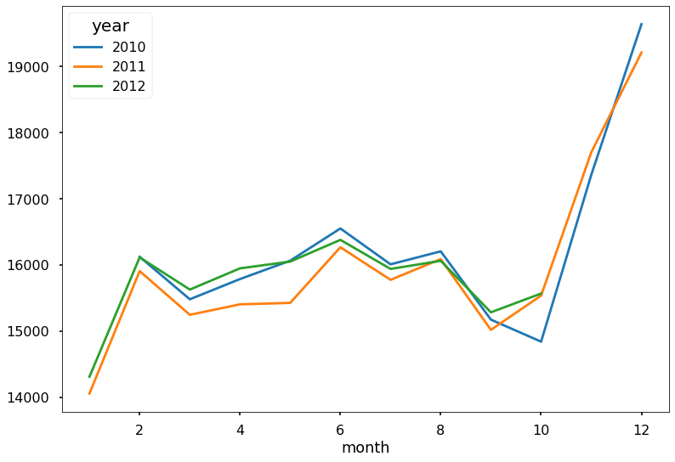
Fig.8: Monthly sales for 2010, 2011 & 2012
Fig.8 clearly indicates that, in general, sales for the year 2011 are lower than those in 2010. When we consider the average sales, 2010 emerges as the year with higher values. However, it's important to note that 2012 lacks data for November and December, which are known to have higher sales. Despite this gap in information, the mean sales for 2012 are closely aligned with those of 2010. It's highly likely that 2012 would claim the top position if we were to obtain and include the sales results for those missing months.

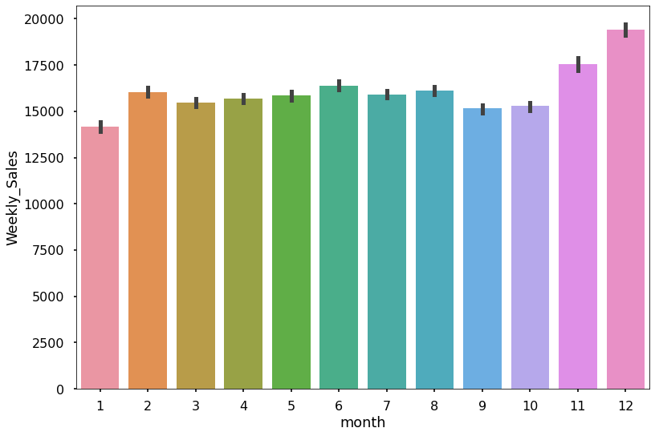
Fig.9: Average sales over the months
From Fig.9, it becomes evident that the highest sales occur in December and November, aligning with expectations. Thanksgiving holiday shows the highest peak values, but when we calculate the averages, December clearly stands out as the month with the best sales performance.

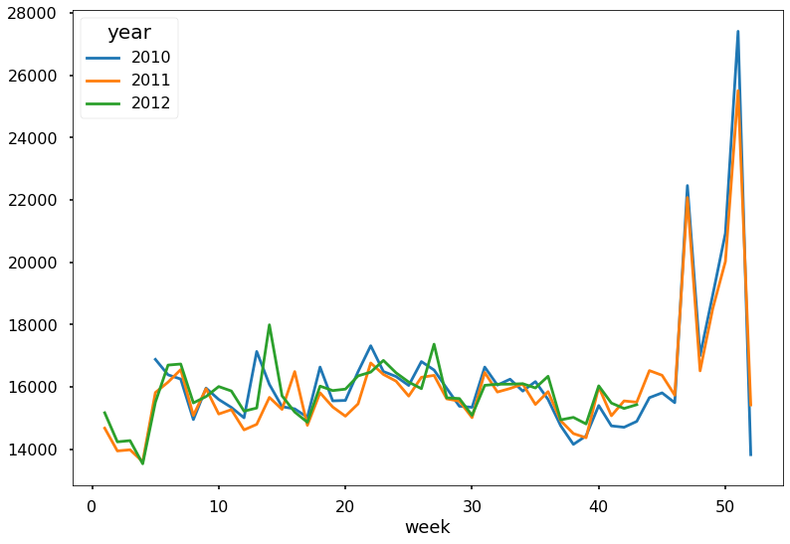
Fig.10: Weekly sales for 2010, 2011 & 2012

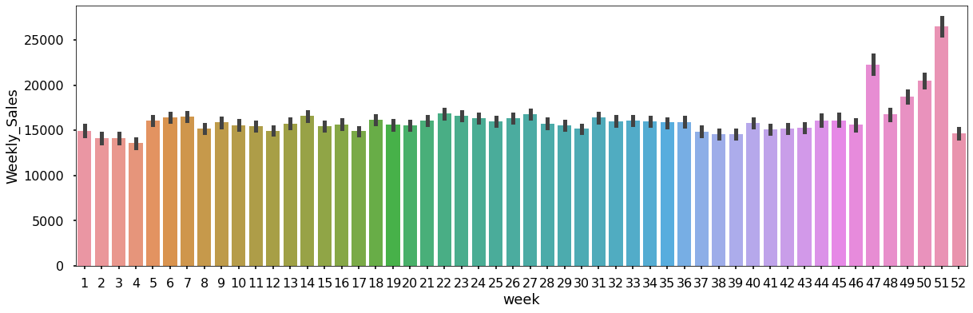
Fig.11: Average sales over the weeks
Fig.10 & 11 clearly illustrate that the 51st and 47th weeks exhibit notably higher averages, primarily due to the impact of Christmas, Thanksgiving, and Black Friday.

IMPACT OF REGIONAL FUEL PRICE, CONSUMER PRICE INDEX, UNEMPLOYMENT RATE & TEMPERATURE ON SALES

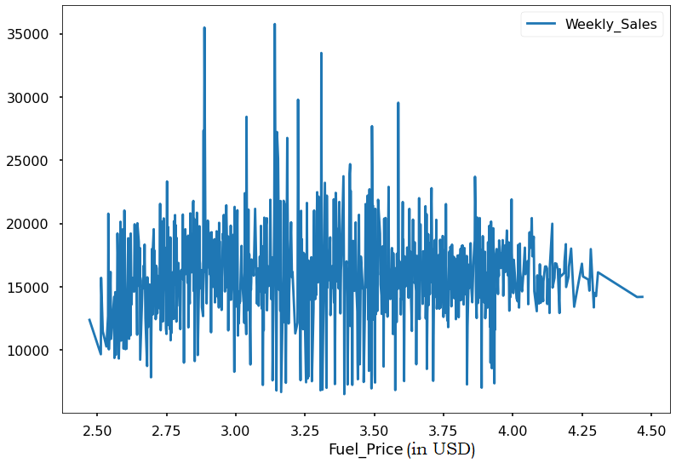
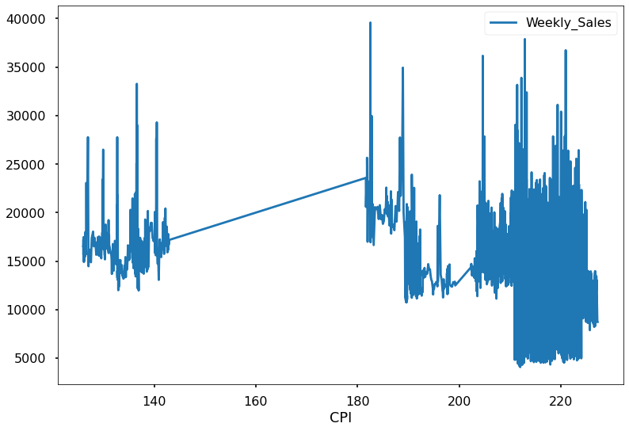

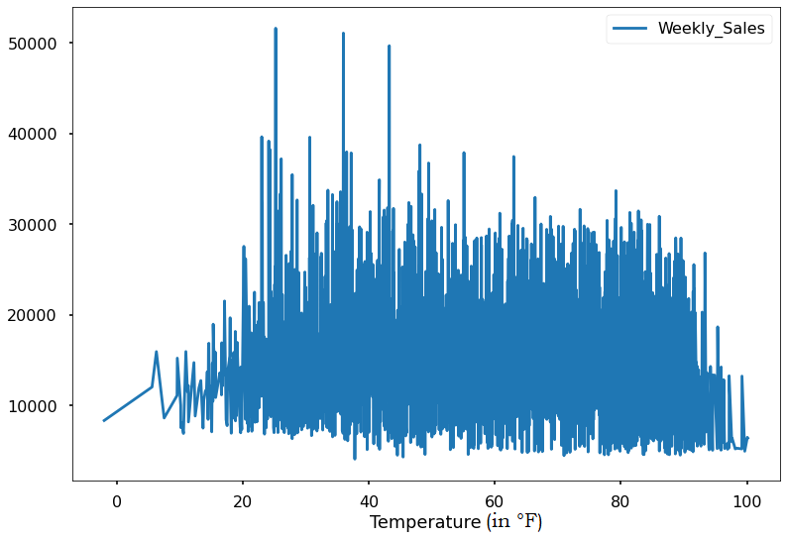
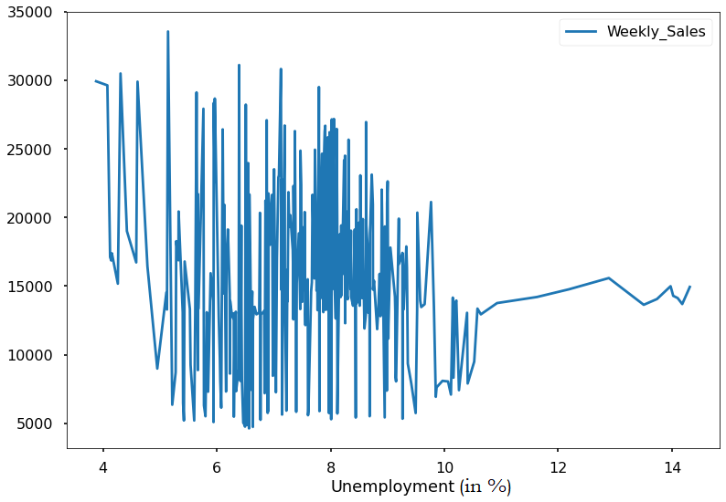

Fig.12: Graphs showing impact of space-based factors on weekly sales

From Fig.12, it's apparent that there are no significant patterns when comparing CPI, temperature, unemployment rate, and fuel prices with weekly sales. Furthermore, it's worth noting that there is an absence of data within the CPI range of 140 to 180.

Observing the interaction between features

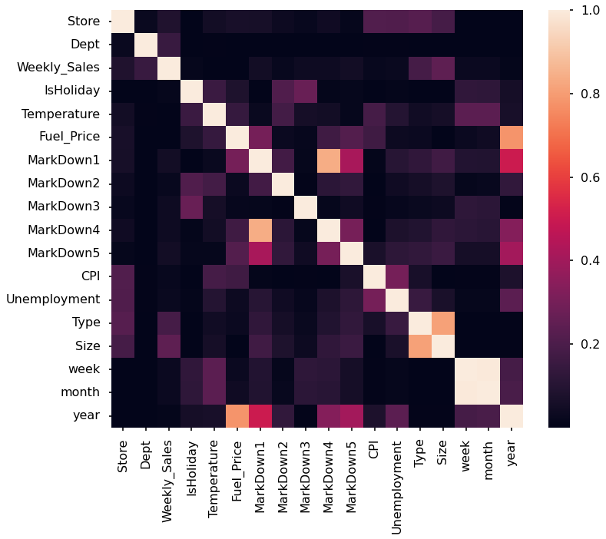

Fig.13: Heatmap showing the correlation between feature

Temperature, unemployment, and CPI show no substantial impact on weekly sales; therefore, we can exclude them from the analysis. Additionally, a high correlation is observed between Markdown 4 and 5 with Markdown 1. Consequently, we will also remove Markdown 4 and 5 to prevent potential issues related to multicollinearity. We will proceed with the analysis without these variables.

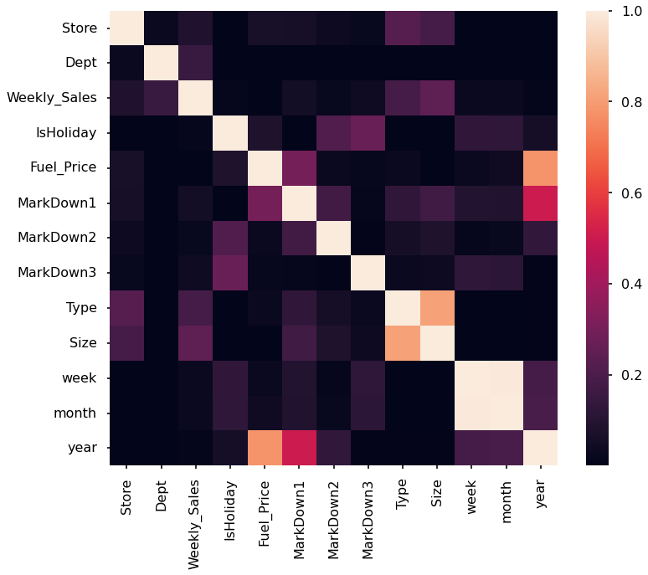

Fig.14: Updated heatmap after dropping insignificant features

Fig.14 shows that there is a strong correlation between the size and type of stores and their impact on weekly sales. Additionally, the specific department and store variables are also closely linked to sales.

1.5 OVERALL INFERENCE FROM EXPLORATORY DATA ANALYSIS

- In the dataset, there are 45 different stores and 81 unique departments. It's worth noting that not all departments are present in every store. While department 72 stands out with higher weekly sales values, department 92 emerges as the leader in terms of the average. This suggests that some departments experience seasonal spikes in sales, particularly during events like Thanksgiving. This seasonal trend is consistent, as the top 5 sales values in the data all belong to department 72 during Thanksgiving.

- Concerning stores, although stores 10 and 35 occasionally achieve higher weekly sales, on average, stores 20 and 4 consistently secure the top two positions. This indicates that certain areas experience higher seasonal sales.

- Stores are categorized into three types - A, B, and C - based on their sizes. Approximately half of the stores fall under the category of "A," which represents larger stores. The type of store has a notable influence on their sales.

- As expected, holiday periods exhibit higher average sales compared to regular dates. Christmas, considered the year-end holiday, sees significant shopping activity. However, the 51st week appears to be the prime time for shopping. Analysing the total holiday sales, Thanksgiving emerges as the leader, a distinction designated by Walmart.

- In terms of the years, 2010 outperforms 2011 and 2012. Yet, it's important to note that sales data for November and December in 2012 is missing. Even without these peak months, 2012's performance is not significantly behind that of 2010. Therefore, once the sales data for the last two months is included, 2012 could potentially claim the top position.

- The data clearly shows that the 51st and 47th weeks have the highest values, followed closely by weeks 50 to 48. Interestingly, the fifth-highest sales value occurs in the 22nd week of the year, signifying that Christmas, Thanksgiving, and Black Friday are the most critical weeks for sales. The fifth most significant period falls in the 22nd week, which happens to be at the end of May when schools are typically on vacation. This suggests that people are likely preparing for holiday celebrations during this time.

- Sales in January are notably lower than other months, likely due to the high sales in November and December. After two months of heavy spending, people tend to opt for more cost-efficient shopping in January.

- CPI, temperature, unemployment rate, and fuel prices do not exhibit any significant patterns in relation to weekly sales.

1.6 Future work
- To compare different machine learning models, such as linear regression, random forest, and neural networks, for sales forecasting and evaluate their performance using metrics such as mean absolute error, root mean squared error, and R-squared.
- To explore the effects of different features, such as store type, store size, department, holiday, and markdown, on sales forecasting and identify the most influential factors using feature importance or feature selection methods.
- To incorporate external data sources, such as social media sentiment, customer reviews, or competitor prices, to enhance the sales forecasting accuracy and capture the customer behavior and market dynamics more comprehensively.

