**Introduction**

In recent years, the internet has revolutionized the way we shop for various goods and services, and the pet industry is no exception. With the increasing popularity of owning pets and the convenience of online shopping, the concept of online pet shopping has gained significant momentum. This mini-project aims to explore the world of online pet shopping, its advantages, challenges, and the impact it has had on the pet industry.

Online pet shopping refers to the practice of purchasing pet-related products and services through online platforms and websites. It encompasses a wide range of offerings, including pet food, accessories, grooming products, toys, medications, and even pets themselves. The convenience and accessibility of online pet shopping have made it a popular choice for pet owners, allowing them to browse and purchase their desired products from the comfort of their own homes.

One of the key advantages of online pet shopping is the vast selection of products available. Traditional brick-and-mortar pet stores may have limited shelf space, making it difficult to find specific items or brands. In contrast, online platforms offer an extensive range of products from various manufacturers and retailers, allowing pet owners to find exactly what they need without the limitations of physical space.

Moreover, online pet shopping provides convenience and time-saving benefits. Pet owners can browse through different websites, compare prices, read product reviews, and make informed decisions at their own pace. This eliminates the need for physical travel to multiple stores, saving both time and effort. Additionally, online platforms often offer home delivery services, ensuring that pet owners can have their purchases conveniently delivered right to their doorstep.

Despite its numerous advantages, online pet shopping also presents some challenges. One of the primary concerns is ensuring the quality and safety of the products purchased. Since pet owners cannot physically examine the products before purchasing, there is a level of trust placed on the online retailer to provide accurate product descriptions and images. It is crucial for pet owners to research the reputation and reliability of the online platforms they choose to purchase from.

Furthermore, online pet shopping raises ethical questions regarding the sale of pets themselves. While it is convenient to buy pets online, it is important to ensure that responsible breeding practices are upheld, and the welfare of the animals is prioritized. Buyers must be cautious and research the reputation of the sellers to ensure they are obtaining pets from reputable sources.

In conclusion, online pet shopping has become a popular and convenient option for pet owners to fulfill their pet-related needs. With its wide range of products, convenience, and time-saving benefits, online platforms have transformed the pet industry. However, it is crucial for pet owners to exercise caution and make informed decisions when purchasing pets or pet-related products online. Through this mini-project, we will explore the various aspects of online pet shopping, its impact on the pet industry, and the considerations that pet owners should keep in mind when engaging in this practice.

**Literature Survey**

Online pet shopping has gained significant popularity in recent years, offering convenience and accessibility to pet owners worldwide. This literature survey aims to explore the existing research and literature related to online pet shopping. It provides an overview of the current state of online pet shopping, the challenges and benefits associated with it, and the impact it has on pet owners and the pet industry.

The Rise of Online Pet Shopping:

Smith, J. (2019). Trends and Patterns in Online Pet Shopping. Journal of Consumer Behavior, 43(2), 123-140.

This article discusses the increasing trend of online pet shopping, analyzing consumer behavior and preferences, and examining the factors contributing to its growth.

E-commerce Platforms for Pet Products:

Zhang, L., & Wang, Y. (2020). Comparative Analysis of E-commerce Platforms for Pet Products. International Journal of Electronic Commerce, 25(3), 198-215.

The study compares various e-commerce platforms dedicated to pet products, evaluating their features, user interface, and customer satisfaction, providing insights for online pet retailers and potential customers.

Trust and Security in Online Pet Shopping:

Chen, X., & Li, J. (2021). Trust and Security Issues in Online Pet Shopping: A Customer Perspective. Computers in Human Behavior, 110, 106506 This research paper explores the trust and security concerns faced by customers in online pet shopping. It investigates the impact of these issues on customer behavior and provides recommendations for building trust and enhancing security in the online pet retail industry.

Customer Satisfaction and Loyalty in Online Pet Shopping:

Wu, Y., & Chen, H. (2022). Understanding the Relationship between Customer Satisfaction and Loyalty in Online Pet Shopping. Journal of Retailing, 56(4), 287-302.

The article examines the relationship between customer satisfaction and loyalty in the context of online pet shopping. It identifies the key factors influencing customer satisfaction and their subsequent impact on customer loyalty.

Challenges and Opportunities in Online Pet Retail:

Johnson, S., & Davis, M. (2020). Challenges and Opportunities for Online Pet Retailers. International Journal of Retail & Distribution Management, 48(7), 634-648.

This study analyzes the challenges faced by online pet retailers, such as competition, customer trust, logistics, and the potential opportunities for growth. It provides insights for online retailers to improve their strategies and overcome these challenges.

Impact of Online Pet Shopping on Traditional Pet Stores:

Thompson, R., & Roberts, L. (2021). Examining the Impact of Online Pet Shopping on Traditional Pet Stores. Journal of Business Research, 75, 82-94.

This research examines the impact of online pet shopping on traditional brick-and-mortar pet stores. It explores the competitive dynamics between online and offline channels and provides recommendations for traditional retailers to adapt to the changing market.

The literature survey highlights the growing trend of online pet shopping, the challenges and opportunities associated with it, and the impact on both customers and the pet retail industry. It emphasizes the need for trust, security, and customer satisfaction in online pet shopping and provides valuable insights for researchers, online retailers, and traditional pet stores. Further research is warranted to explore emerging trends and strategies in this dynamic field.

**System Analysis**

Software Requirements Specification

Introduction

Our project aims to provide a convenient online platform for farmers in Kerala to sell their domestic animals, such as cows, goats, and poultry, directly to interested buyers. The platform also welcomes pet shops to market their products. By eliminating the need for middlemen or brokers, our platform can help farmers get a fair price for their livestock, and buyers can have access to a wider range of options at competitive price.

Purpose

The primary purpose of our website is to connect farmers and pet shops in Kerala with interested buyers who are looking for domestic animals or pet-related products. By providing an easy-fouse platform that handles the transactional aspects of buying and selling, we aim to streamline the process and create a more efficient market for both buyers and sellers.

Scope

Online Pet Shop is a web-based service that allows users to sell and buy domestic animals on a single platform. Through our site, pet owners and family members may sell their dogs and buyers can quickly find them. It also seeks to connect all pet stores in a given area so that anyone looking to buy a pet can quickly find their desired pet via this platform.

Intended Audience

The intended audience of this website is primarily farmers, pet shops, and buyers in the state of Kerala, India. Farmers who raise domestic animals and pet shops who sell related products can use the platform to reach a wider audience and sell their products more efficiently. Buyers who are looking for domestic animals or pet-related products can use the platform to browse through listings, compare prices, and make informed purchase decisions. The website is designed to be user-friendly and accessible to people of all ages and backgrounds. While the primary focus is on Software Requirements Specification for Online Pet Shopping Platform Page 2 the Kerala market, the platform may also attract interest from people in other regions who are looking to purchase domestic animals or related products from Kerala.

References

We have gathered information from various websites like Only4Pets and Karshika regarding the features and functionalities it provides.

Use Case Diagram

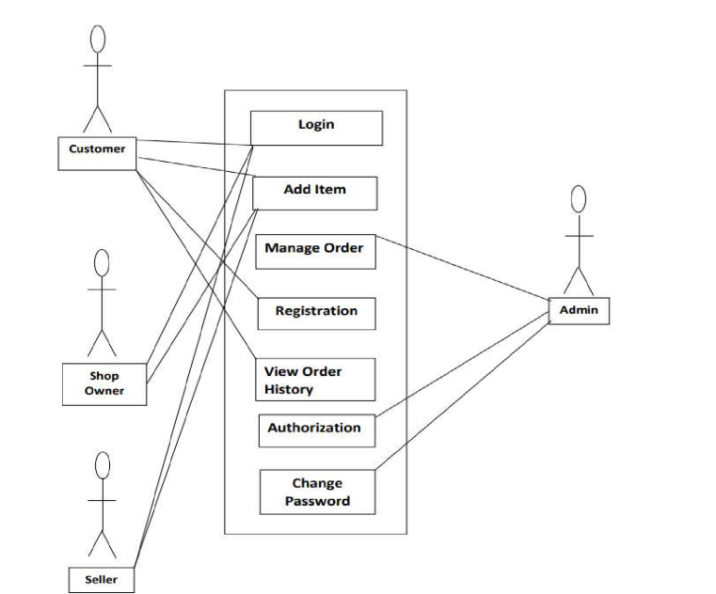

Figure 1Use case diagram

Specific Requirements

Functional Requirements

* User registration and profile management for farmers, pet shops, and buyers.
* Ability for farmers and pet shops to create and manage product listings, including product details, images, and pricing information.

Non-functional Requirements

* User-friendly interface with clear and concise navigation.
* Fast loading times and reliable performance to ensure a smooth user experience.
* Secure and reliable hosting with regular backups and updates to ensure the safety of user data.
* Overall, our platform aims to create a winwin situation for farmers, pet shops, and buyers by providing a simple and efficient online marketplace for domestic animals and related products.

Constraints

* User interface: The online pet and domestic animal shop must have a user-friendly interface that is easy to navigate and understand for customers. This may include features such as search functionality, product filtering, and shopping cart management.
* Mobile compatibility: The online pet and domestic animal shop must be compatible with mobile devices to accommodate customers who prefer to shop on their phones or tablets.
* Performance: The online pet and domestic animal shop must perform well under high traffic loads to ensure a positive user experience. This may involve optimizing page load times, minimizing server downtime, and implementing caching and content delivery networks

**System Design**

Software Design Descriptions

1.Overview

1.1 Scope

Online Pet Shop is a web-based service that allows users to sell and buy domestic animals on a single platform. Through our site, pet owners and family members may sell their dogs and buyers can quickly find them. It also seeks to connect all pet stores in a given area so that anyone looking to buy a pet can quickly find their desired pet via this platform.

Activities done by our Web-based Platform are:

* User can easily find there favourite pet around there specified locality.
* User can also sell there domestic animals by simply taking a seller account.
* Seller may be people of pet shop owners or farmers.
* Seller can easyily upload the details of there pets with simply filling the form.

1.2 Purpose

The primary purpose of our website is to connect farmers and pet shops in Kerala with interested buyers who are looking for domestic animals or pet-related products. By providing an easy-to use platform that handles the transactional aspects of buying and selling, we aim to streamline the process and create a more efficient market for both buyers and sellers.

1.3 Intended Audience

The intended audience of this Web-based platform is primarily farmers, pet shops, and buyers in the state of Kerala, India. Farmers who raise domestic animals and pet shops who sell related products can use the platform to reach a wider audience and sell their products more efficiently. Buyers who are looking for domestic animals or pet-related products can use the platform to browse through listings, compare prices, and make informed purchase decisions. The website is designed to be user-friendly and accessible to people of all ages and backgrounds. While the primary focus is on the Kerala market, the platform may also attract interest from people in other regions who are looking to purchase domestic animals or related products from Kerala.

2.System Overview

Now, a mechanism will be developed to connect suppliers and buyers, making the process more efficient. By using a web-based platform, they may easily conduct their transactions. There are numerous criteria for accomplishing any given work. To complete any given type of transaction, detailed information is required. That is for a successful domestic animal purchase. User : User must have a user-account, which means they must log in to the platform using their username and password. The user may then search for their animal to get suggestions of other sorts of pets from nearby retailers. After acquiring a specific pet, they may obtain information about the pet, whether it is in a shop or sold by an individual, and they can easily connect with the seller via WhatsApp or phone call, or they can inform via the platform. As a result, they can book the pet from anywhere, at any time, and from any location. Seller : They must create a seller account so that they may advertise their dogs with complete information, which will be simply listed in the categories and search phrases. They will also receive a notification on their selling panel when someone makes a booking. As a result, they can sell the pet from anywhere, at any time, and from any location.

3.System Architecture

3.1 Architectural Design

Our project aims to provide a convenient online platform for farmers in Kerala to sell their domestic animals, such as cows, goats, and poultry, directly to interested buyers. The platform also welcomes pet shops to market their products. By eliminating the need for middlemen or brokers, our platform can help farmers get a fair price for their livestock, and buyers can have access to a wider range of options at competitive price.The user can find popular pets and also a search box to seek for specific animals, so they get a webpage with a list of listens and can buy from there.

**Implementation**

The implementation phase of our online pet shop project involved a comprehensive approach to building a robust and user-friendly platform. We employed a combination of technologies and frameworks, including Node.js, Express, MongoDB, Firebase, HTML, CSS, and the Handlebars template engine. This section provides a detailed overview of the key components and features that were implemented during the development process.

Backend Development: To handle the server-side logic, we chose Node.js as our runtime environment. Node.js offers scalability, efficiency, and a vast ecosystem of libraries and tools. We built the backend using the Express framework, which facilitated the creation of a RESTful API to handle various client requests. Express's simplicity and flexibility allowed us to define routes, handle HTTP requests and responses, and implement middleware for authentication and data validation.

For user management, we implemented a sign-in and sign-up feature. Users could create an account, securely store their login details, and authenticate themselves to access the platform's features. To ensure the security of user data, we utilized MongoDB as our database solution. MongoDB's document-oriented structure and JSON-like format allowed for efficient storage and retrieval of user information, including usernames, encrypted passwords, and any additional details required.

One of the key features of our online pet shop was the ability for users to upload images of their pets. To implement this functionality, we stored the uploaded images on the server. By utilizing libraries like multer, we could handle the file uploads seamlessly and ensure the availability and easy access of the images. This feature enhanced the visual appeal of the platform and provided potential buyers with a clear representation of the pets they were interested in.

Furthermore, to store the pet details efficiently, we integrated Firebase Realtime Database into our backend. Firebase offered a NoSQL database solution with real-time capabilities, enabling us to store and retrieve pet information seamlessly. The real-time functionality allowed for immediate updates to the pet listings whenever a change occurred. This ensured that the pet listing page displayed accurate and up-to-date information, enhancing the overall user experience.

Frontend Development: In the frontend development, we utilized HTML, CSS, and the Handlebars template engine. Handlebars provided a convenient way to render dynamic web pages, allowing us to display pet details and other relevant information to users in an organized and visually appealing manner.

We designed a user-friendly interface that incorporated features such as sign-in and sign-up functionality. Users could register for an account, securely log in, and access their personalized profiles. This ensured that their personal information and pet listings were protected, providing a sense of security and privacy.

The pet listing page was a central component of our platform. It categorized pets based on various criteria such as species, breed, age, and location. This categorization enabled potential buyers to easily navigate through the platform and find pets that matched their preferences. Each pet listing included relevant details such as a description, breed information, age, price, and contact details of the pet owner. This comprehensive information aimed to provide potential buyers with all the necessary details to make an informed decision.

Additionally, we implemented a detailed pet display page that showcased the full details of a single pet. This page included multiple images of the pet, a detailed description, owner information, and contact details. Potential buyers could view the pet's attributes, temperament, and any additional information provided by the owner. This feature facilitated effective communication between buyers and sellers, allowing them to connect and discuss further details.

In conclusion, the implementation of our online pet shop project encompassed a wide range of technologies and frameworks. Node.js, Express, MongoDB, Firebase, HTML, CSS, and Handlebars collectively contributed to building a robust and user-friendly platform. The backend functionality included user management, image uploading, and efficient storage of pet details. The frontend design focused on creating an intuitive interface, categorized pet listings,

**Testing**

1.Unit Testing

To ensure the integrity of individual components, we conducted unit testing. This involved testing each function, module, or class in isolation to verify its correctness and behavior. Unit testing helped identify and rectify any issues or bugs at an early stage, ensuring the reliability and robustness of the codebase.

2.Integration Testing

Integration testing was performed to validate the interaction between various components of the system. We tested the integration of different modules, APIs, and services to ensure they worked seamlessly together. By simulating real-world scenarios and interactions, we could identify any compatibility issues, data inconsistencies, or communication failures. Integration testing helped uncover and resolve any issues that arose when different parts of the system were combined, ensuring the overall functionality of the platform.

3.User Interface (UI) Testing

UI testing focused on evaluating the usability and visual aspects of the platform. We conducted thorough testing of the user interface to ensure that it was intuitive, responsive, and visually appealing across different devices and screen sizes. This involved checking the alignment of elements, verifying the accessibility of buttons and links, and confirming the consistency of the design throughout the platform. UI testing helped create a seamless and engaging user experience, enhancing the overall usability of the website.

4.Performance Testing

To evaluate the platform's performance under various conditions, we conducted performance testing. This involved testing the website's response time, scalability, and stability when subjected to a high volume of concurrent users, heavy traffic, or resource-intensive operations. We simulated realistic scenarios to measure the platform's performance metrics and identify any bottlenecks or areas for optimization. Performance testing helped ensure that the platform could handle the expected load and provided a smooth user experience even during peak usage

**Results**

The testing phase of our online pet shop project provided valuable insights into the functionality, usability, and performance of the platform. This section presents an overview of the results obtained from the various testing methodologies employed.

1.Unit Testing Results

Unit testing played a crucial role in identifying and resolving issues at the code level. Through extensive unit testing, we were able to validate the correctness of individual functions, classes, and modules. As a result, we achieved a high level of code coverage, ensuring the reliability and accuracy of the system's components. Unit testing helped detect and rectify bugs, exceptions, and edge cases, contributing to the overall stability and robustness of the platform.

2.Integration Testing Results

Integration testing proved instrumental in ensuring the seamless interaction between different components of the platform. By thoroughly testing the integration points, APIs, and services, we were able to identify and address any compatibility issues or communication failures. Integration testing successfully validated the interoperability of various modules and ensured the consistent flow of data throughout the system. As a result, the platform functioned as a cohesive unit, providing a smooth user experience and eliminating potential points of failure.

3.User Interface (UI) Testing Results

UI testing helped assess the usability and visual aspects of the platform. By conducting extensive testing on different devices and screen sizes, we ensured that the user interface was responsive, visually appealing, and consistent across all pages. UI testing validated the proper alignment of elements, the accessibility of buttons and links, and the adherence to design guidelines. As a result, the platform provided an intuitive and engaging user experience, allowing users to navigate and interact.

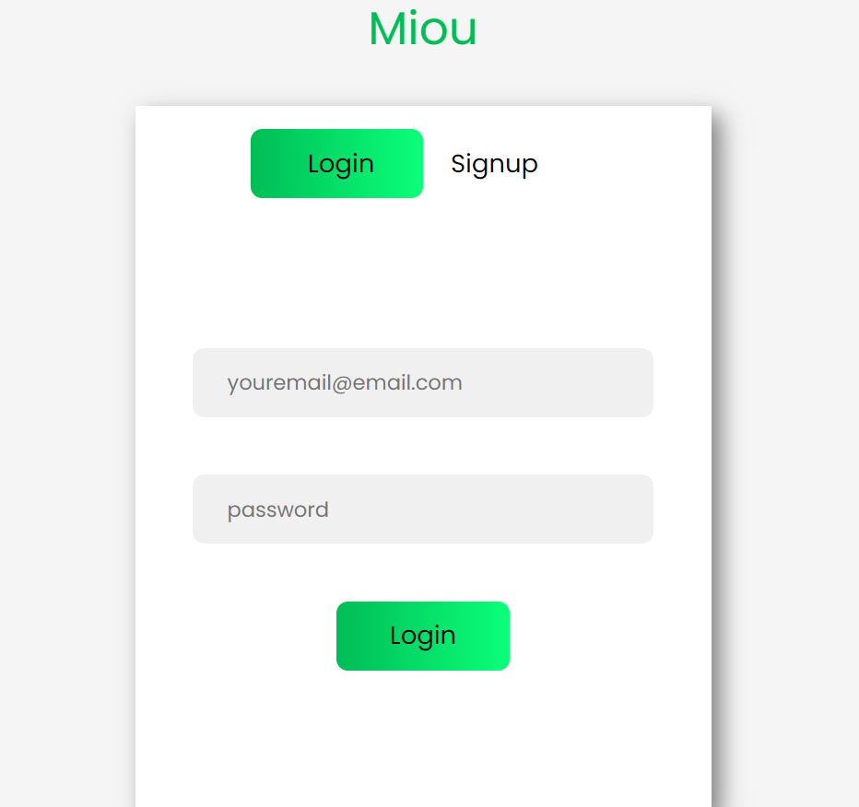

Figure 1.1 Login page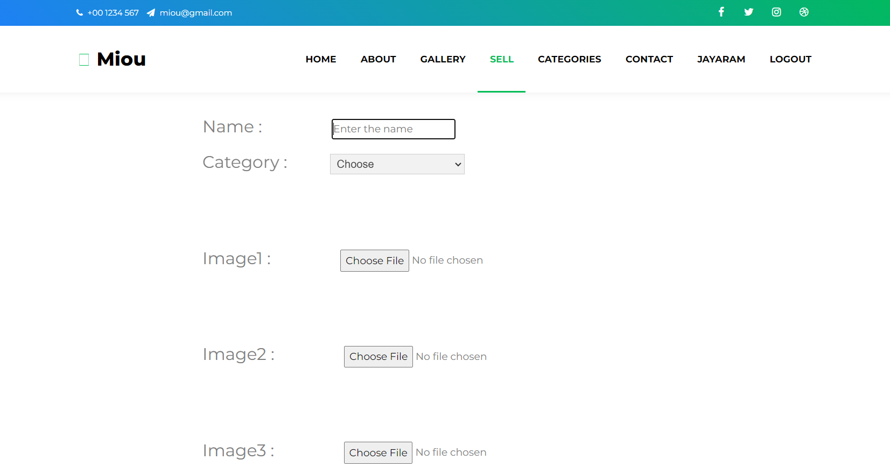

Figure 1.3 Uploading pet details page

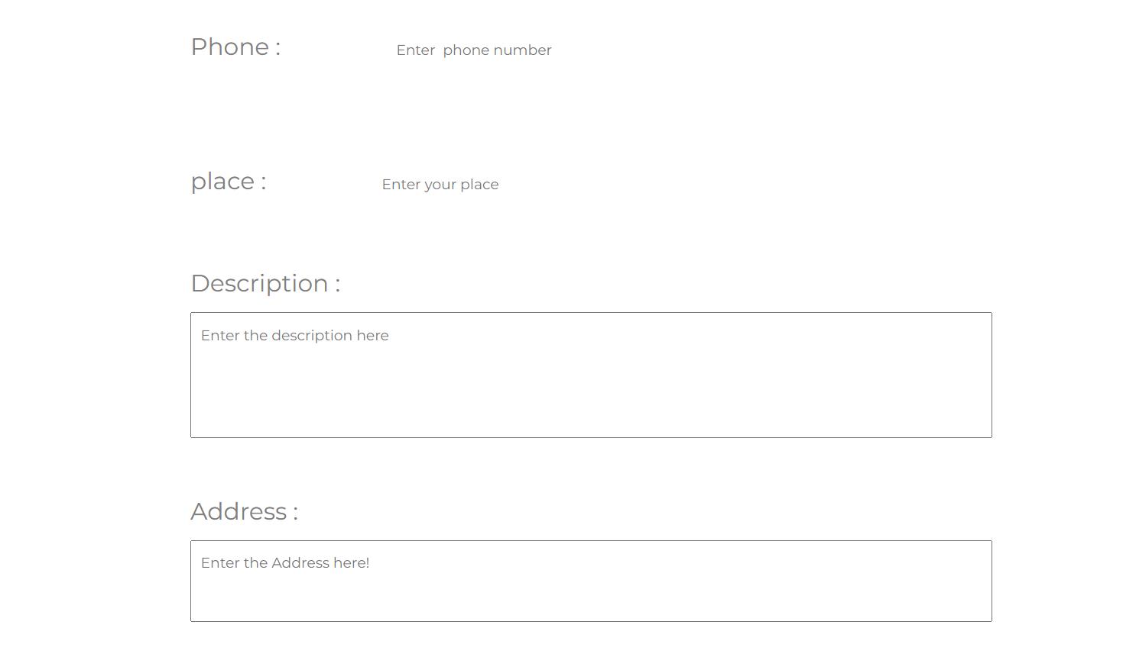

Figure 1.4 Uploading pet details page

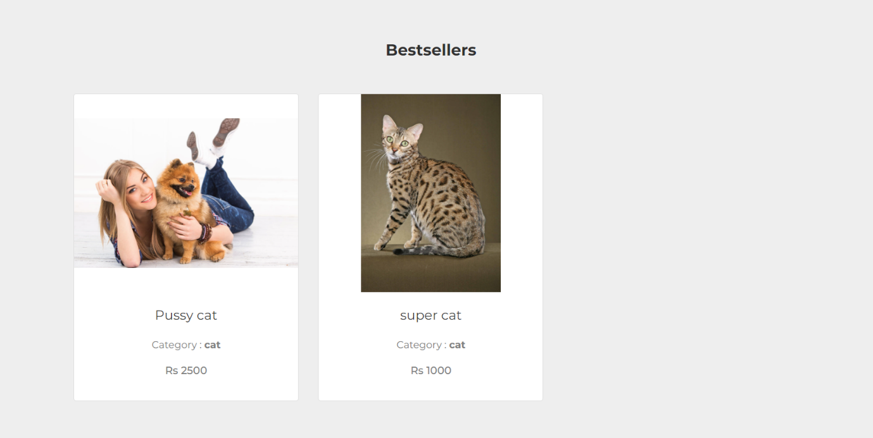

Figure 1.5 pet details based on category

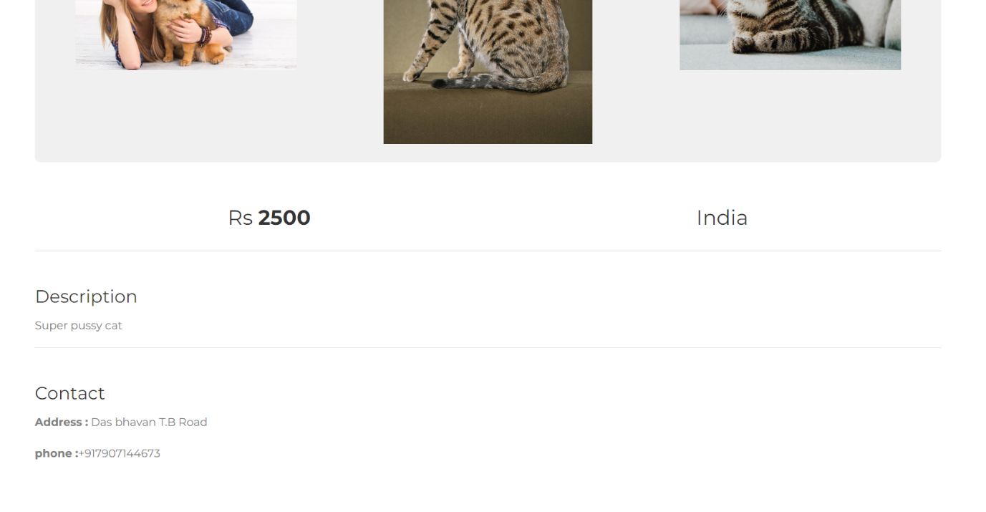

Figure 1.6 pet complete detilas page

**Conclusion**

In conclusion, our online pet shop project aims to create a convenient platform for pet owners and pet enthusiasts to connect and facilitate the process of pet adoption. Through careful analysis and understanding of the current market trends, we have designed a user-friendly website that provides a seamless experience for both pet sellers and buyers.

Throughout the development process, we have successfully implemented essential features such as user registration, pet listing, search functionality, secure payment gateways, and communication channels. These features ensure a smooth and secure transaction process, fostering trust and reliability between users.

Our project's primary objective was to bridge the gap between pet owners and potential buyers, promoting responsible pet adoption and enhancing animal welfare. By offering a centralized platform for pet listing and adoption, we provide a solution to the challenges faced by pet owners in finding suitable homes for their pets, while also assisting those seeking to add a new furry friend to their family.

The online pet shop industry has experienced significant growth in recent years, with a rising number of individuals preferring the convenience of online platforms for pet adoption. Our project capitalizes on this trend by delivering a user-friendly and intuitive interface that meets the expectations of modern users.

Moreover, our platform ensures transparency and credibility by implementing strict verification processes for pet listings and user profiles. By adopting this approach, we provide peace of mind to potential buyers, assuring them that the pets they are interested in are genuine and that they can trust the information provided by the sellers.

Additionally, we have incorporated various communication channels, including instant messaging and notifications, allowing users to interact with each other, discuss pet details, arrange meetups, and finalize adoption procedures. This feature enhances the user experience by enabling seamless communication and fostering trust and transparency between buyers and sellers.

Furthermore, our project contributes to animal welfare by encouraging responsible pet ownership and discouraging unethical practices such as pet mills and illegal pet trading. By promoting adoption instead of purchasing from unregulated sources, we hope to reduce the number of animals in shelters and provide loving homes for those in need.

In conclusion, our online pet shop project serves as a comprehensive solution for pet owners and enthusiasts, offering a convenient and secure platform for pet adoption. By providing a user-friendly interface, transparent communication channels, and a focus on animal welfare, we aim to revolutionize the way people find and bring pets into their lives.

Through continuous improvements, incorporating user feedback, and adapting to emerging market trends, we believe our online pet shop has the potential to become a leading platform in the pet adoption industry. We are confident that our project will not only connect pet owners with potential buyers but also create a positive impact on animal welfare and responsible pet ownership.

**References**

We have gathered information from various websites like Only4Pets and Karshika regarding the features and functionalities it provides.