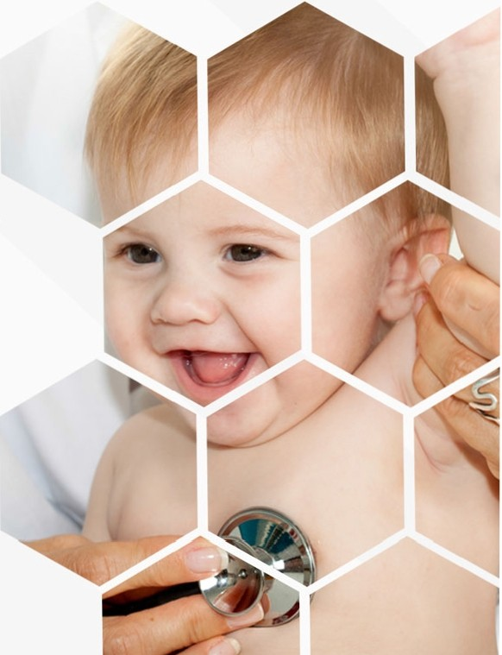

Child Specialist and Neonatology

Dr AnuKarthika.S.M

*I am pacifier of the preemi, bundler of the baby, healer of the helpless*