MATLAB code for ODE solution plots

f = @(t,x) [ -30\*x(1) + (100+5000\*(x(1)^2))/(1+x(1)^2+(x(2)^2));-x(2) + (1+100\*(x(1)^2))/(1+(x(1)^2))];

[t,xa] = ode45(f,[0 30],[1 10]);

figure(1)

plot(t,xa(:,1),'g')

title('a(t)')

xlabel('t'), ylabel('a')

figure(2)

plot(t,xa(:,2))

title('r(t)')

xlabel('t'), ylabel('r')





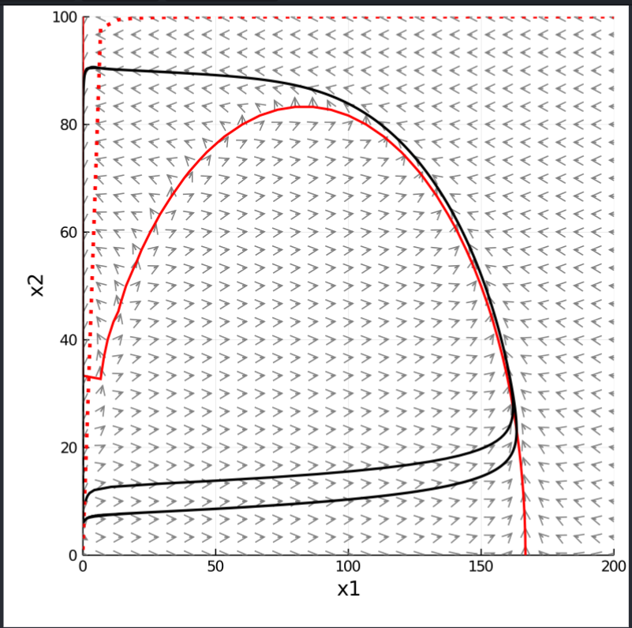2b …plot for n=1

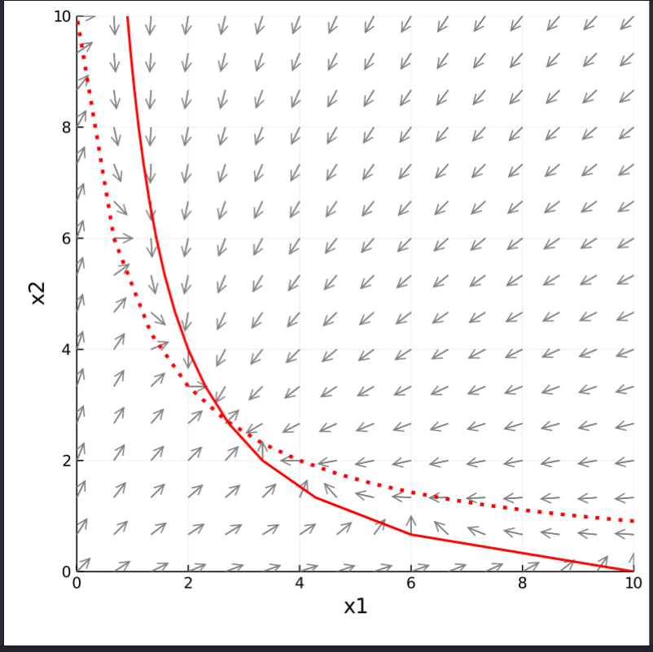

3b…plot for n=1

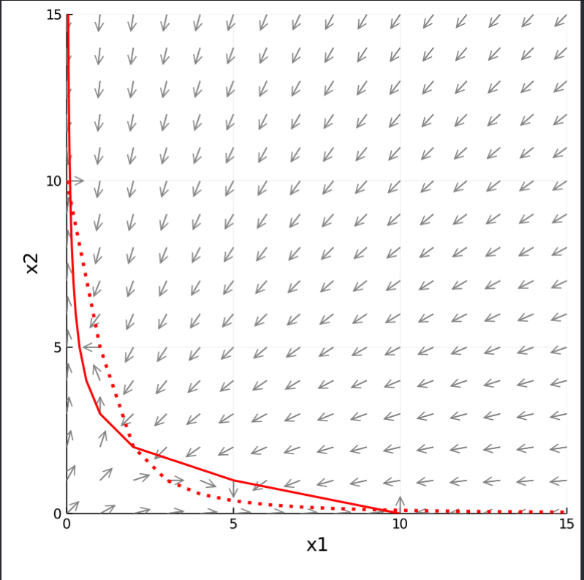

3 b … Plot for n=2

Matlab Code for Eigen values

syms u v n a e A

n=1 ;

a=10;

u=10;

A = [-1 -n\*a\*(u^(n-1))\*((1+u)^-2); -n\*a\*(u^(n-1))\*((1+u)^-2) -1]

e= eig(A);

display(e);