LOW LEVEL DESIGN

EShoppingZone – E-Commerce Shopping Cart System

Technology Stack | ASP.NET Core 8.0 | C# 12 | MSSQL
Architecture | 3-Tier Layered (Controller → Service → Repository)
ORM | Entity Framework Core 8.0
Authentication | JWT Bearer (HMAC-SHA256)
Testing | NUnit + Moq + EF InMemory

1. System Overview
The EShoppingZone system is a RESTful e-commerce backend API designed to support online product browsing, shopping cart management, and order processing.
The system supports two main user roles:
Customer
- Browse products
- Add items to cart
- Checkout and place orders
- View previous orders
- Manage wallet balance
Admin
- Manage product catalog
- View and manage orders

The backend is built using ASP.NET Core 8.0, uses Entity Framework Core as ORM, and stores data in Microsoft SQL Server. All protected endpoints are secured using JWT authentication.

Key Features
• User registration and login using JWT.
• Product catalog browsing and searching.
• Shopping cart management.
• Order placement and order history.
• Wallet payments and cash-on-delivery.
• Product management.
• Centralized exception handling middleware.
• Swagger API documentation.

2. Solution Diagram
The following diagram illustrates the high-level architecture of the EShoppingZone system.
The client interacts with the backend system through REST APIs exposed via Swagger UI.
Requests are received by the Controller layer, which forwards them to the Service layer for business logic processing.
The Service layer communicates with the Repository layer, which performs database operations using Entity Framework Core.
The data is stored in a Microsoft SQL Server database.

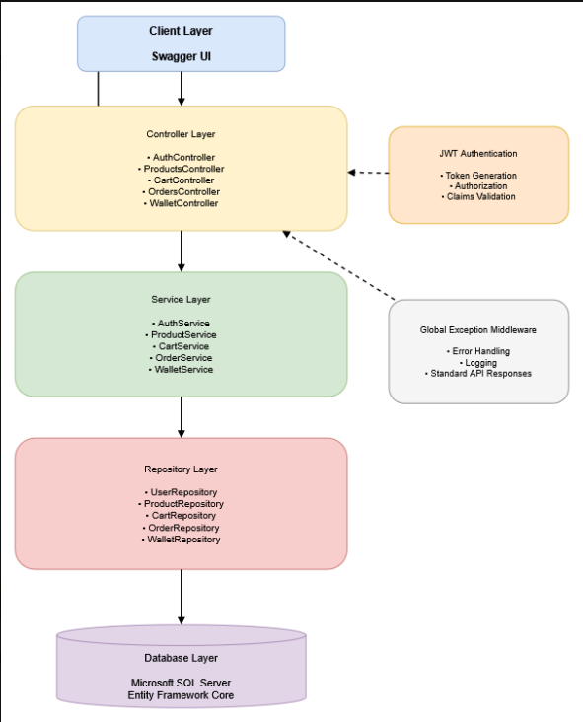

3. Technology Stack

Component | Technology | Version
Backend Framework | ASP.NET Core | 8.0
Language | C# | 12
ORM | Entity Framework Core | 8.0
Database | Microsoft SQL Server | 2019 / 2022
Authentication | JWT Bearer | HMAC-SHA256
API Documentation | Swagger | Swashbuckle
Unit Testing | NUnit + Moq | Latest
In-Memory Testing | EF Core InMemory | 8.0
Logging | Microsoft.Extensions.Logging | Built-in

The system uses a 3-tier layered architecture:
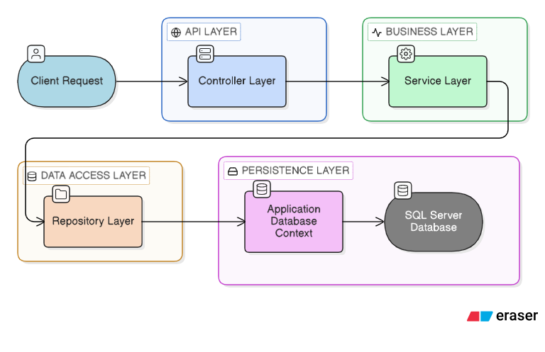
Controllers → Services → Repositories → Database
Design patterns used:
- Repository Pattern
- Dependency Injection
- DTO Pattern
- Middleware Pipeline

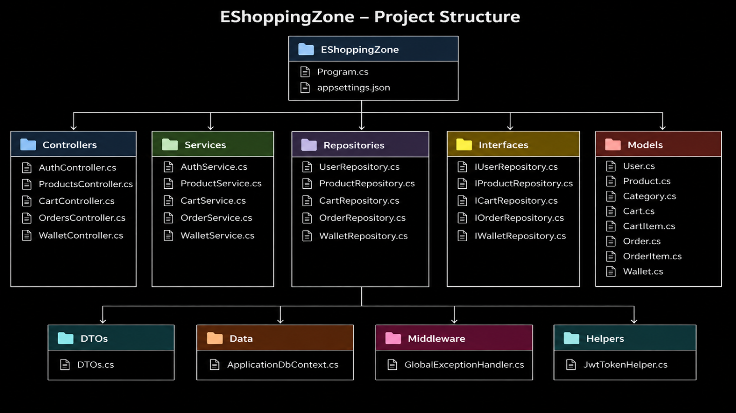
4. Project Structure

Folder | Description
Controllers/ | API endpoints
Services/ | Business logic
Interfaces/ | IService and IRepository interfaces
Repositories/ | EF Core database operations
Models/ | Domain entities
DTOs/ | Request and response objects
Data/ | ApplicationDbContext
Middleware/ | GlobalExceptionHandler
Helpers/ | JWT token helper
Program.cs | Application startup
appsettings.json | Configuration

5. Use Case Diagram

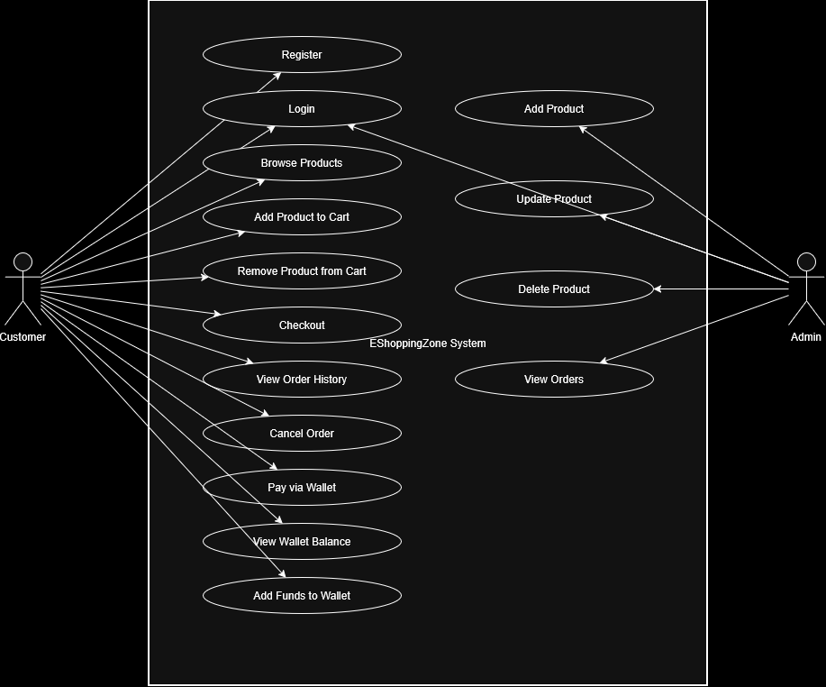

Actors:
Customer
Admin

Customer Use Cases
• Register
• Login
• Browse Products
• Add Product to Cart
• Remove Product from Cart
• Checkout
• View Order History
• Pay via Wallet

Admin Use Cases
• Login
• Add Product
• Update Product
• Delete Product
• View Orders

6. Database Design
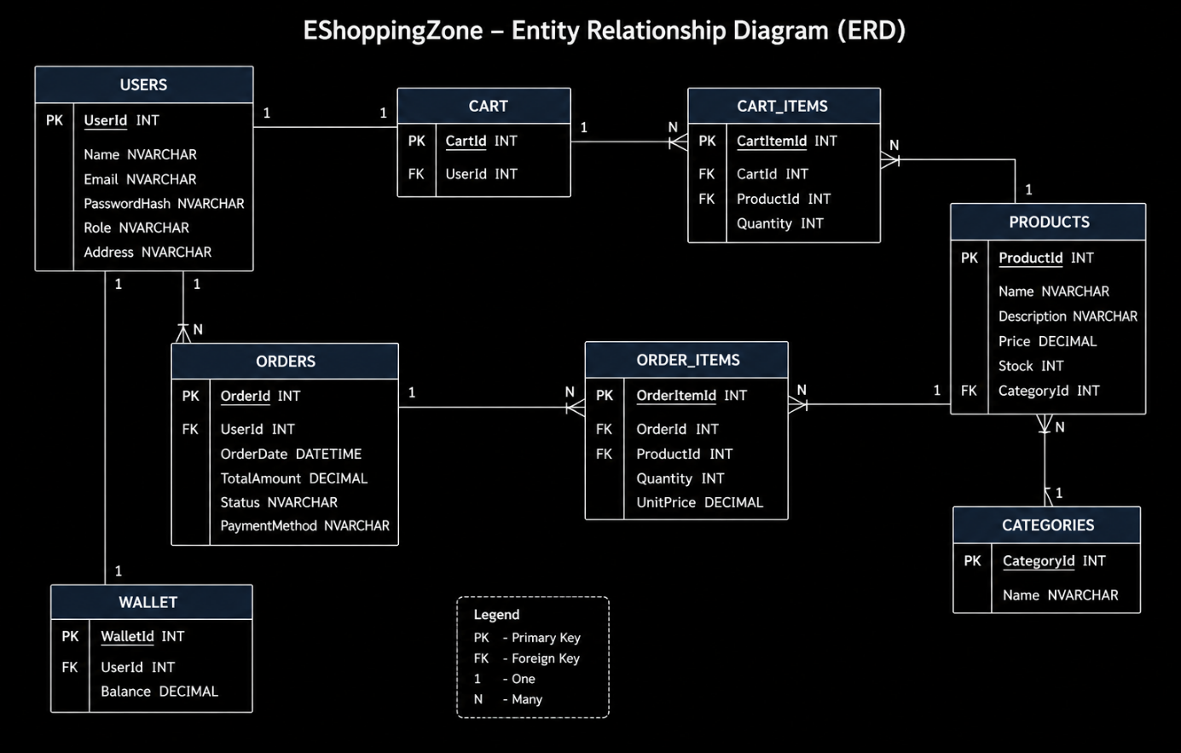
Tables used in the system:

USERS
Column | Type | Description
UserId | INT PK | Primary key
Name | NVARCHAR(100) | Full name
Email | NVARCHAR(150) | Login email
PasswordHash | NVARCHAR(256) | Encrypted password
Role | NVARCHAR(20) | Admin / Customer
Address | NVARCHAR(200) | Delivery address

PRODUCTS
Column | Type
ProductId | INT PK
Name | NVARCHAR(150)
Description | NVARCHAR(500)
Price | DECIMAL
Stock | INT
CategoryId | INT FK

CATEGORIES
Column | Type
CategoryId | INT PK
Name | NVARCHAR(100)

CART
Column | Type
CartId | INT PK
UserId | INT FK

CART_ITEMS
Column | Type
CartItemId | INT PK
CartId | INT FK
ProductId | INT FK
Quantity | INT

ORDERS
Column | Type
OrderId | INT PK
UserId | INT FK
OrderDate | DATETIME
TotalAmount | DECIMAL
Status | NVARCHAR(30)
PaymentMethod | NVARCHAR(20)

ORDER_ITEMS
Column | Type
OrderItemId | INT PK
OrderId | INT FK
ProductId | INT FK
Quantity | INT
UnitPrice | DECIMAL

WALLET
Column | Type
WalletId | INT PK
UserId | INT FK
Balance | DECIMAL

7. Domain Models
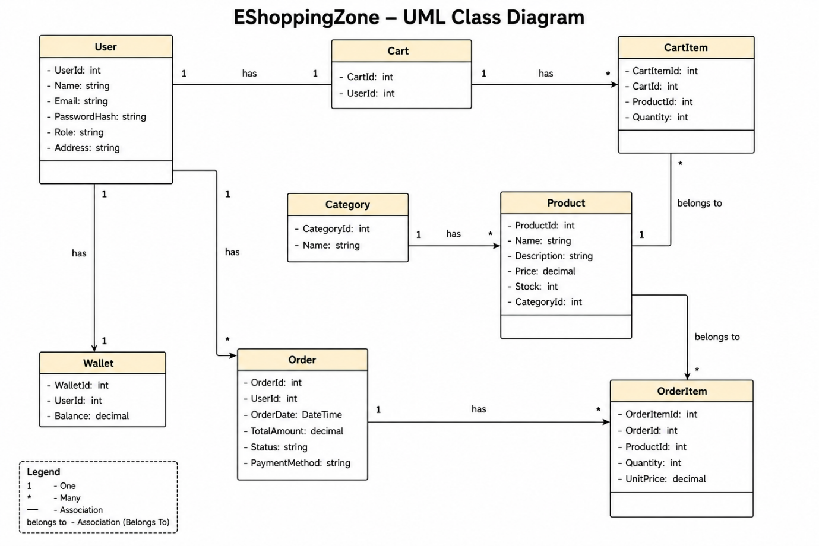

User
Represents system users.
Properties:
UserId
Name
Email
PasswordHash
Role
Address

Product
Represents a product in the store.
ProductId
Name
Description
Price
Stock
CategoryId

Category
Represents product category.
CategoryId
Name

Cart
Represents a shopping cart.
CartId
UserId

CartItem
Represents product inside cart.
CartItemId
CartId
ProductId

Order
Represents a placed order.
OrderId
UserId
OrderDate
TotalAmount
Status
PaymentMethod

OrderItem
Represents items in an order.
OrderItemId
OrderId
ProductId
Quantity
UnitPrice

Wallet
Represents user wallet.
WalletId
UserId
Balance

8. Repository Layer
Repositories handle database operations.

IUserRepository
FindByEmail()
GetById()
Add()

IProductRepository
GetAll()
GetById()
Add()
Update()
Delete()

ICartRepository
GetCartByUser()
AddItem()
RemoveItem()

IOrderRepository
GetOrdersByUser()
GetOrderById()
CreateOrder()
UpdateStatus()

IWalletRepository
GetWallet()
AddBalance()
UpdateBalance()

9. Service Layer
Services contain business logic.
Asynchronous programming is used throughout the Service and Repository layers using the async and await keywords.
All database operations are executed using Entity Framework Core asynchronous methods such as ToListAsync(), FirstOrDefaultAsync(), and SaveChangesAsync().
This ensures that the application performs non-blocking I/O operations, improves scalability, and enhances overall API performance.

AuthService
RegisterUser()
LoginUser()

ProductService
GetProducts()
GetProductById()
AddProduct()
UpdateProduct()
DeleteProduct()

CartService
AddToCart()
RemoveFromCart()
GetCartItems()

OrderService
CreateOrder()
GetUserOrders()
CancelOrder()

WalletService
GetBalance()
AddFunds()

10. Controller Endpoints

AuthController
POST /api/auth/register
POST /api/auth/login

ProductController
GET /api/products
GET /api/products/{id}
POST /api/products
PUT /api/products/{id}
DELETE /api/products/{id}

CartController
POST /api/cart/add
DELETE /api/cart/remove
GET /api/cart

OrderController
POST /api/orders
GET /api/orders/my
POST /api/orders/{id}/cancel

WalletController
GET /api/wallet/balance
POST /api/wallet/add

11. Middleware

Global Exception Handler
Handles all exceptions across the application.

Exception Mapping
Exception | HTTP Status
ArgumentException | 400 Bad Request
KeyNotFoundException | 404 Not Found
UnauthorizedAccessException | 401 Unauthorized
Exception | 500 Internal Server Error

12. Security

JWT Authentication
Token contains:
UserId
Email
Role

Expiration:
Customer → 24 hours
Admin → 24 hours
Protected Endpoints require:
Authorization: Bearer <JWT>

Security Recommendations
• Use BCrypt password hashing
• Enforce HTTPS
• Implement refresh tokens
• Store JWT secrets securely

13. Testing
Testing framework used in the system:
- NUnit
- Moq (for mocking dependencies)
- Entity Framework Core InMemory Database (for isolated testing)
The following components are tested using unit tests:
- AuthServiceTests – Tests user registration, login, and JWT token generation.
- ProductServiceTests – Tests product retrieval and product management operations.
- CartServiceTests – Tests adding and removing products from the shopping cart.
- OrderServiceTests – Tests order creation and order history functionality.
Unit tests ensure that the business logic in the service layer works correctly and independently of the database.

14. Summary
The EShoppingZone LLD defines a modular and maintainable architecture built on ASP.NET Core best practices.

Key design decisions:
Concern | Decision
Architecture | Controller → Service → Repository
Framework | ASP.NET Core 8.0
Database | MSSQL with EF Core
Authentication | JWT
Dependency Injection | ASP.NET Core built-in DI
Error Handling | Global Exception Middleware
Testing | NUnit + Moq

