
DEPARTMENT OF CSE
PROJECT ABSTRACT SUBMISSION
COURSE: SOA PROGRAMMING AND MICROSERVICES– (24SDCS03) A.Y. 2026 - 2027
TITLE OF THE PROJECT | AgriIQ: AI-Driven Crop Recommendation & Agricultural Advisory System
S. No. | University ID | Name
1 | 2420030263 | KONGARI ABHINAV
2 | 2420030617 | SONTIREDDY SRINIKA
3 | 2420030742 | ISRAJIWADI SRIVALLI
4
Name of the Guide

Abstract:
Agriculture remains the backbone of livelihood for millions of farmers, yet crop selection is still largely guided by tradition and guesswork rather than the actual soil and climatic conditions of the land. Choosing a crop that is poorly suited to the prevailing soil nutrient levels (Nitrogen, Phosphorus, and Potassium), pH, temperature, humidity, and rainfall often results in reduced yield, wasted resources, and financial loss for the farmer. Farmers also frequently lack timely access to reliable advisory information on fertilizer usage, pest management, and crop care once a crop has been chosen. This gap between available agronomic data and practical, farmer-friendly decision support highlights the need for an accessible, automated system that can recommend suitable crops and provide the corresponding agricultural guidance in one place.

To address this need, this project proposes AgriIQ, an AI-driven crop recommendation and agricultural advisory system built using a Service-Oriented Architecture (SOA) and Spring Boot microservices. The system is designed around three independently deployable microservices, each with its own dedicated database, communicating through a centralized API Gateway and secured using JSON Web Token (JWT) based authentication. This architecture ensures that the system is modular, scalable, and maintainable, while still delivering a simple and practical experience for the end user.
The first component is the Auth Service, which manages farmer and admin registration, login, and role-based access control.
Every request in the system passes through the Spring Cloud Gateway, which routes traffic to the appropriate microservice and enforces JWT validation on every protected endpoint, preventing unauthorized access to farmer data or recommendations. Passwords are stored securely using encryption, and each user is assigned a role (Farmer or Admin) that determines the actions they are permitted to perform. This service maintains its own dedicated database, keeping user identity data fully isolated from the rest of the system.

The second component is the Crop Recommendation Service, the core intelligence of AgriIQ. A logged-in farmer submits soil and environmental parameters, namely Nitrogen, Phosphorus, Potassium, temperature, humidity, pH, and rainfall, through the frontend. This service evaluates the submitted values against defined agronomic ranges to identify the most suitable crop for the given conditions, and stores each request and its result in its own database so that farmers can review their recommendation history. This service represents the AI-driven decision-making layer of the system, forming the basis for the advisory guidance that follows.

The third component is the Advisory Service, which stores and serves crop-specific agricultural guidance, including fertilizer recommendations, irrigation schedules, and common pest and disease management tips. Once the Crop Recommendation Service identifies a suitable crop, the frontend queries this service to display practical care instructions alongside the recommendation, giving the farmer a complete, actionable result rather than a crop name alone. Like the other services, it maintains an independent database and is registered and discoverable through the system's service registry, in keeping with the database-per-service principle of the overall architecture.

Collectively, these three microservices work together behind a single Spring Cloud Gateway entry point to deliver a secure, modular, and easy-to-extend agricultural advisory platform. The system is built using Spring Boot, Spring Cloud Gateway, JWT and Spring Security, MySQL with a database-per-service design, Spring Data JPA, and Maven on the backend, with a React.js frontend, and is supported by Git/GitHub for version control, GitHub Actions for CI/CD automation, and Postman for API testing. By combining a practical crop recommendation engine with immediately usable agricultural advisory content, AgriIQ aims to give farmers a simple, reliable tool for making better-informed crop decisions, while demonstrating a complete, production-style microservices architecture.
Project Architecture/Project Overview:
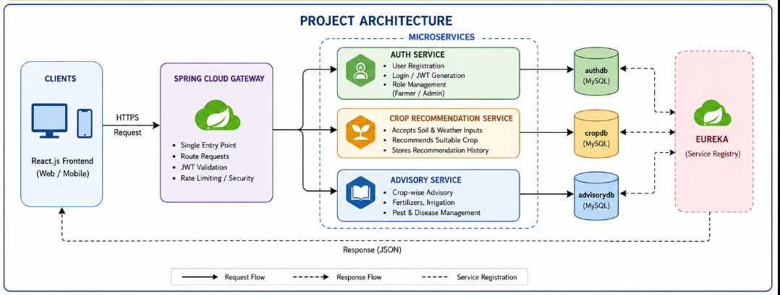

React.js Frontend → Spring Cloud Gateway (single entry point, JWT validation) → routed to one of three independent Spring Boot microservices, each with its own MySQL database:
• Auth Service (authdb) – registration, login, JWT issuance, role management
• Crop Recommendation Service (cropdb) – accepts soil/weather inputs, returns recommended crop, stores history
• Advisory Service (advisorydb) – serves fertilizer, irrigation, and pest-management guidance per crop
All three services register with the service registry for discovery and are deployed independently, each with its own database, in line with the database-per-service principle. GitHub Actions runs the CI/CD pipeline on every push, and the full API surface is validated through a Postman collection.

