**PROBLEM IDENTIFICATION**

Technological advancements in transportation, while reducing distances and improving connectivity, have led to an increase in road accidents and associated risks. This has resulted in a significant loss of life and serious injuries across India. The business problem is to analyse road safety and accident trends to understand the underlying factors contributing to these accidents. By leveraging data analytics, the goal is to identify patterns and risk factors, thereby informing strategies and policies to enhance road safety and mitigate the impact of accidents.

**BUSINESS REQUIREMENTS**

The business requirements are:

User Demographics Analysis: Provide insights into the demographics of road accident victims.

Accident Patterns Identification: Analyse patterns in road accidents across different regions and times.

Risk Factors Analysis: Identify and analyse factors contributing to road accidents, such as speeding and weather conditions.

Visualization: Create interactive and visually compelling dashboards to support strategic planning and operational improvements.

Decision Support: Generate insights to help policymakers and safety officials make informed decisions and implement better safety protocols.

Compliance and Reporting: Ensure compliance with regulations and facilitate reporting requirements through comprehensive data analysis.

**LITERATURE SURVEY**

Human Factors in Road Accidents:

Study: "Human Factors and Road Traffic Accidents" by Smith et al. (2018).

Findings: This study examined the impact of human behaviour on road traffic accidents, highlighting factors such as driver fatigue, distraction, and impaired driving. The research indicated that human error is a major contributor to road accidents and recommended strategies for improving driver awareness and training.

Vehicle Conditions and Road Safety

Study: "The Influence of Vehicle Maintenance on Road Safety" by Lee and Kim (2019).

Findings: The study explored how vehicle maintenance affects road safety, emphasising the role of regular inspections and repairs in preventing accidents. It found that poorly maintained vehicles are more likely to be involved in accidents due to mechanical failures.

**Impact of Road Infrastructure**

Study: "Road Infrastructure and Accident Rates: A Comparative Study" by Chen et al. (2020).

Findings: This research focused on the relationship between road infrastructure quality and accident rates. It concluded that poorly designed or maintained roads contribute significantly to accident rates and suggested improvements in road design and maintenance as effective measures for reducing accidents.

Environmental Conditions and Accident Patterns

Study: "Weather Conditions and Road Traffic Accidents" by Patel and Rao (2021).

Findings: The study analysed the impact of weather conditions, such as rain, fog, and snow, on road accidents. It highlighted that adverse weather conditions significantly increase the likelihood of accidents and recommended weather-related safety measures for drivers.

Advanced Data Analytics in Road Safety

Study: "Using Big Data for Road Safety Analysis: A Review" by Johnson and Wong (2022).

Findings: This review explored the use of big data and advanced analytics for road safety analysis. It discussed various analytical techniques, including data mining and predictive modelling, and highlighted the potential of data-driven approaches to identify accident patterns and risk factors.

Conclusion: The literature review reveals that human factors, vehicle conditions, road infrastructure, and environmental conditions all play crucial roles in road safety. While traditional studies have provided valuable insights, there is a gap in comprehensive research specifically focused on the Indian context. This project aims to address this gap by leveraging advanced data analytics and visualisation tools like Qlik Sense to analyse road safety and accident patterns in India.

**SOCIAL IMPACTS**

The social impact of analysing road safety and accident patterns in India through data analytics and visualisation can be significant:

1. Enhanced Road Safety: Improved understanding of accident patterns and risk factors can lead to better safety protocols and regulations, reducing the number of accidents and fatalities. This enhances public safety and quality of life.

2. Targeted Interventions: Identifying high-risk areas and causes allows for targeted interventions, such as improved road infrastructure, stricter enforcement of traffic laws, and enhanced driver education programs. This can lead to more effective prevention strategies.

3. Public Awareness: Insights from the analysis can be used to inform public awareness campaigns, educating drivers and pedestrians about safe practices and the risks associated with certain behaviours or conditions. Increased awareness can lead to safer road behaviour and reduced accident rates.

4. Policy Formulation: Data-driven evidence supports the development of more effective policies and strategies for road safety. This can lead to the implementation of evidence-based regulations and initiatives that address specific issues identified through the analysis.

5. Reduced Economic Burden: Fewer road accidents result in reduced medical costs, lower insurance premiums, and less economic disruption due to accidents. This can alleviate the financial burden on individuals, families, and the healthcare system.

6. Community Well-Being: Improved road safety contributes to overall community well-being by fostering a safer environment for all road users, including pedestrians, cyclists, and drivers. It enhances trust in public safety measures and promotes a sense of security within communities.

## Data Collection and Preparation

**Data Collection**

* **Gather comprehensive data on road accidents in India** from reliable sources like government reports, transportation department datasets, and research studies.
* Ensure the data includes accident types, locations, causes, and victim demographics.

**Connecting Data with Qlik Sense**

* **Import the collected dataset into Qlik Sense** for analysis.
* Use Qlik Sense's data loading capabilities to connect to various data sources.
* **Structure the data for analysis** using proper data modelling.
* **Clean and prepare the data** for visualisation by implementing necessary transformations.

**Benefits of Connecting with Qlik Sense**

* **Qlik Sense** offers powerful data visualisation and analytics capabilities.
* Connecting the data enables **real-time analysis and dynamic visualizations**.
* Qlik Sense's intuitive interface facilitates **data exploration and insight generation**.

**Data Integration Steps**

1. **Import the collected dataset** into Qlik Sense.
2. **Establish a connection** between the dataset and Qlik Sense.
3. **Structure the data model** within Qlik Sense to facilitate analysis.
4. **Clean and preprocess the data** to ensure accuracy and consistency.
5. **Create visualizations and dashboards** to present insights derived from the data.

**Data Preparation for Visualization**

* **Clean the data** to remove inconsistencies and errors.
* **Handle missing values and outliers** appropriately.
* **Transform the data** into a format suitable for visualization.
* **Perform necessary aggregations or calculations** to derive meaningful insights.
* **Ensure the data is structured and organized** for easy visualization.

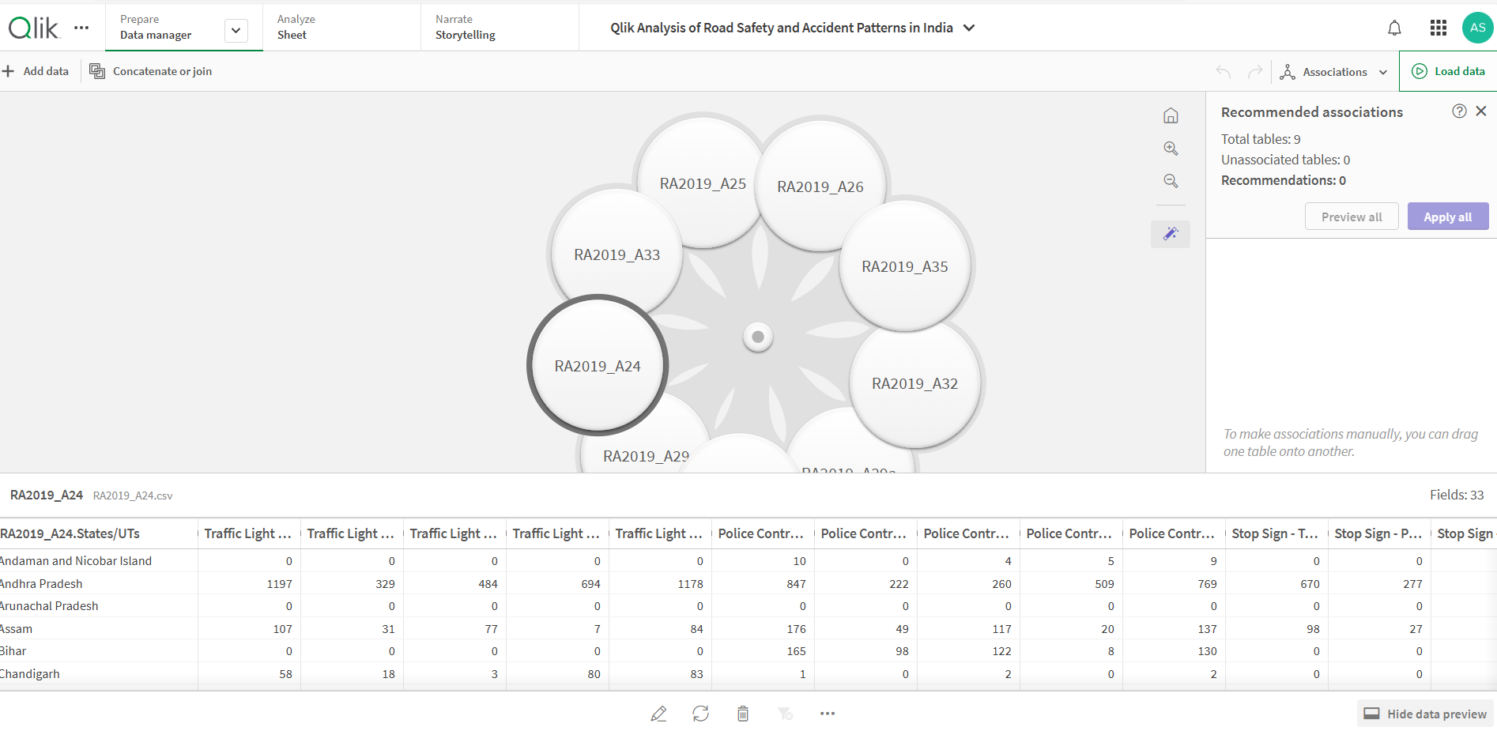

## Data Visualization

**Visualization Techniques**

* **Utilize various visualization types** like bar charts, line charts, scatter plots, and maps to represent different aspects of the data.
* **Choose visualization techniques that effectively communicate insights and trends** in the data.
* **Incorporate interactivity** to allow users to explore the data dynamically.

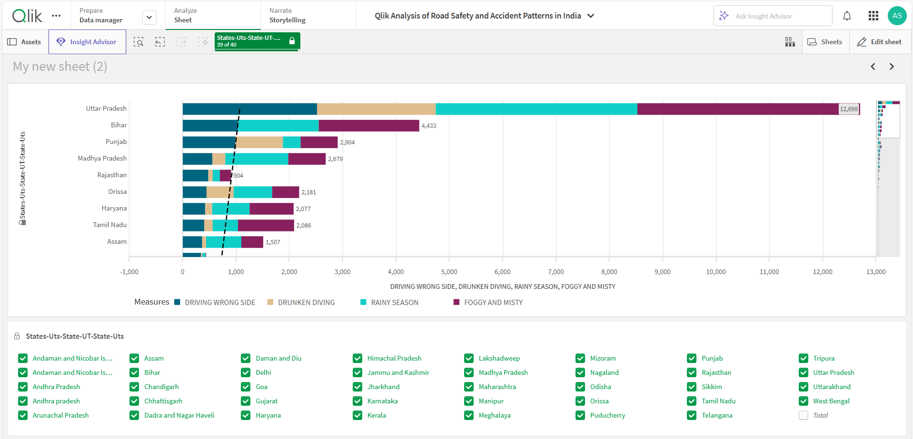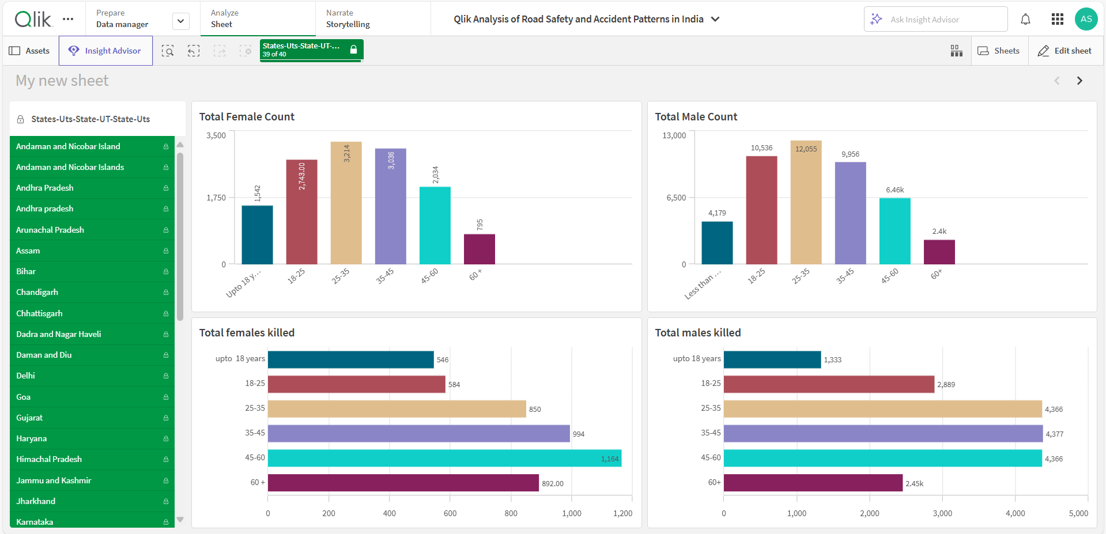

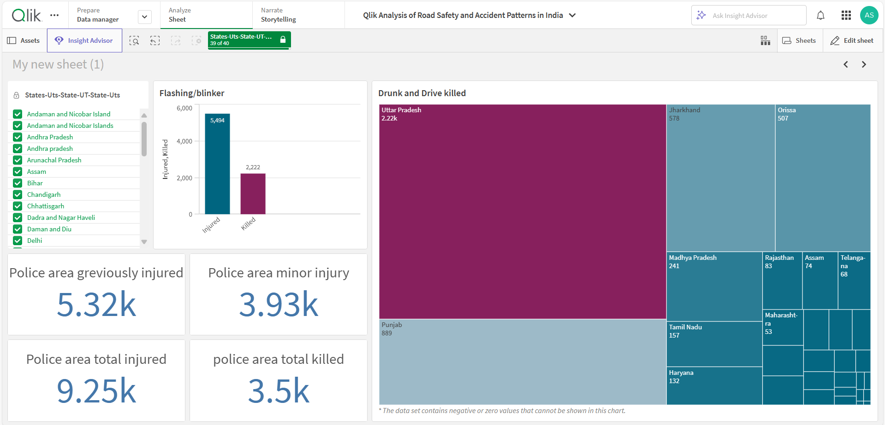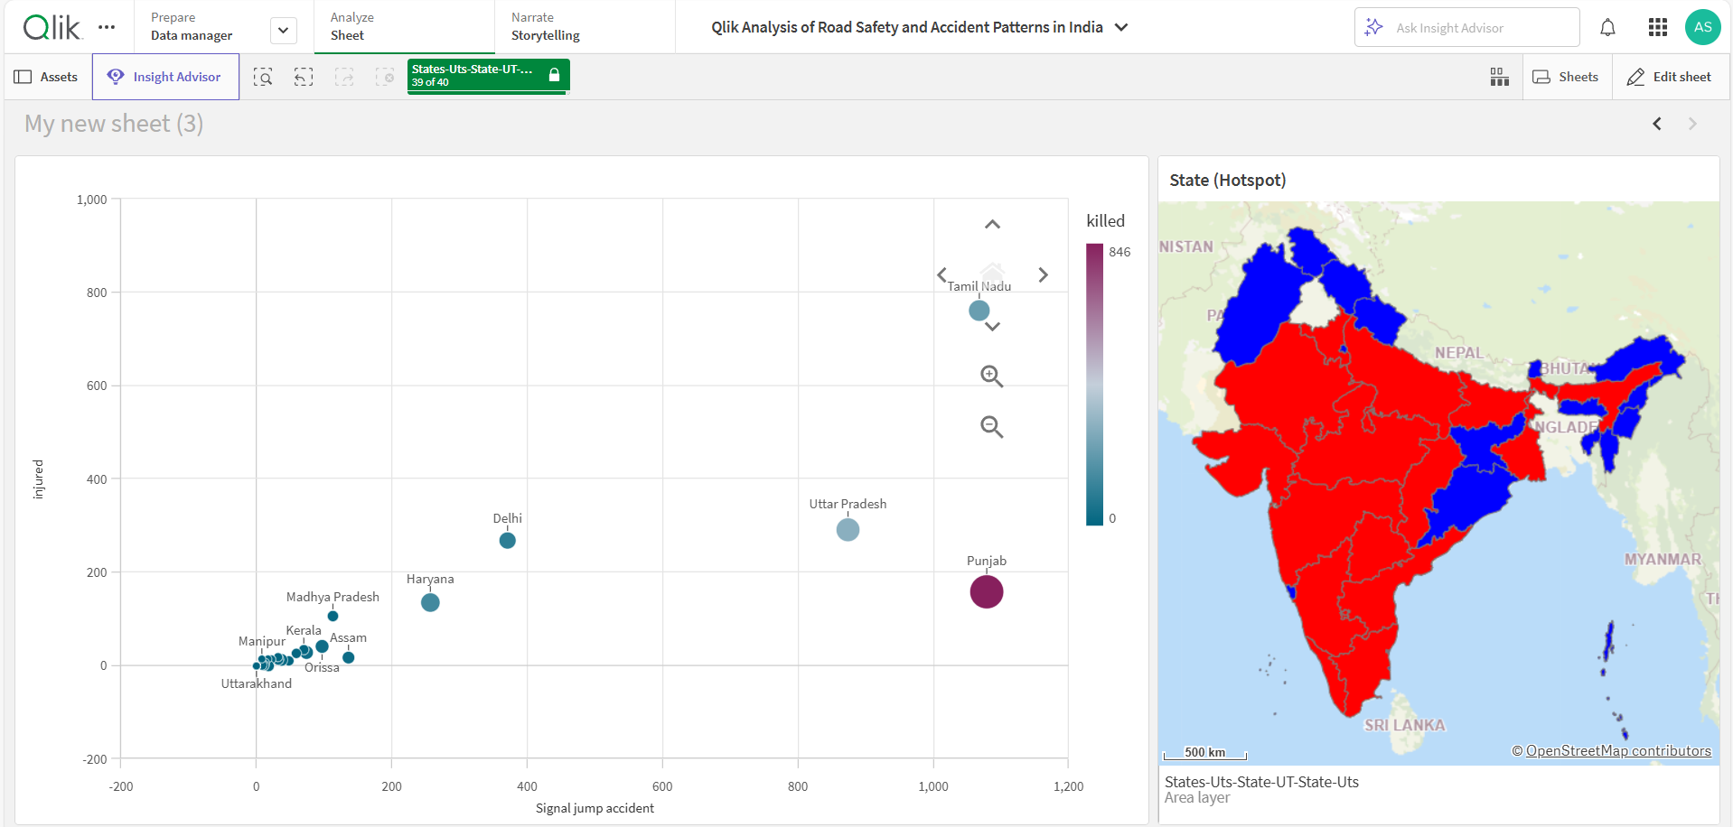

## Report Creation

**Report Components**

* **Summarize key findings and insights** derived from the data analysis.
* **Provide visual representations** of data trends and patterns.
* **Include explanations and interpretations** of the visualizations.
* **Offer recommendations** based on the analysis to improve road safety measures.

## Performance Testing

**Amount of Data Renders**

* **Measure the time taken to render different amounts of data** in the dashboard.
* **Assess the impact of data volume** on dashboard performance.
* **Optimize data rendering processes** to ensure smooth and efficient performance.

**Utilization of Data Filters**

* **Monitor the usage of data filters** by users to understand their impact on dashboard performance.
* **Evaluate the effectiveness of data filters** in facilitating data exploration and analysis.
* **Optimize data filter functionality** to enhance user experience and performance.

**Conclusion**

This research project effectively utilized data analytics and visualization tools, particularly Qlik Sense, to examine road safety and accident patterns in India. The insights gained from this study can significantly contribute to developing strategies and policies aimed at improving road safety measures and reducing accidents. By identifying high-risk areas, vulnerable groups, and contributing factors, targeted interventions and public awareness campaigns can be designed and implemented. Future research should focus on incorporating additional data sources, such as real-time traffic data and weather information, to further refine the analysis and provide more comprehensive insights. Additionally, exploring the application of advanced machine learning techniques for predictive modeling and risk assessment could potentially make valuable contributions to the field of road safety.