**QUES 1**

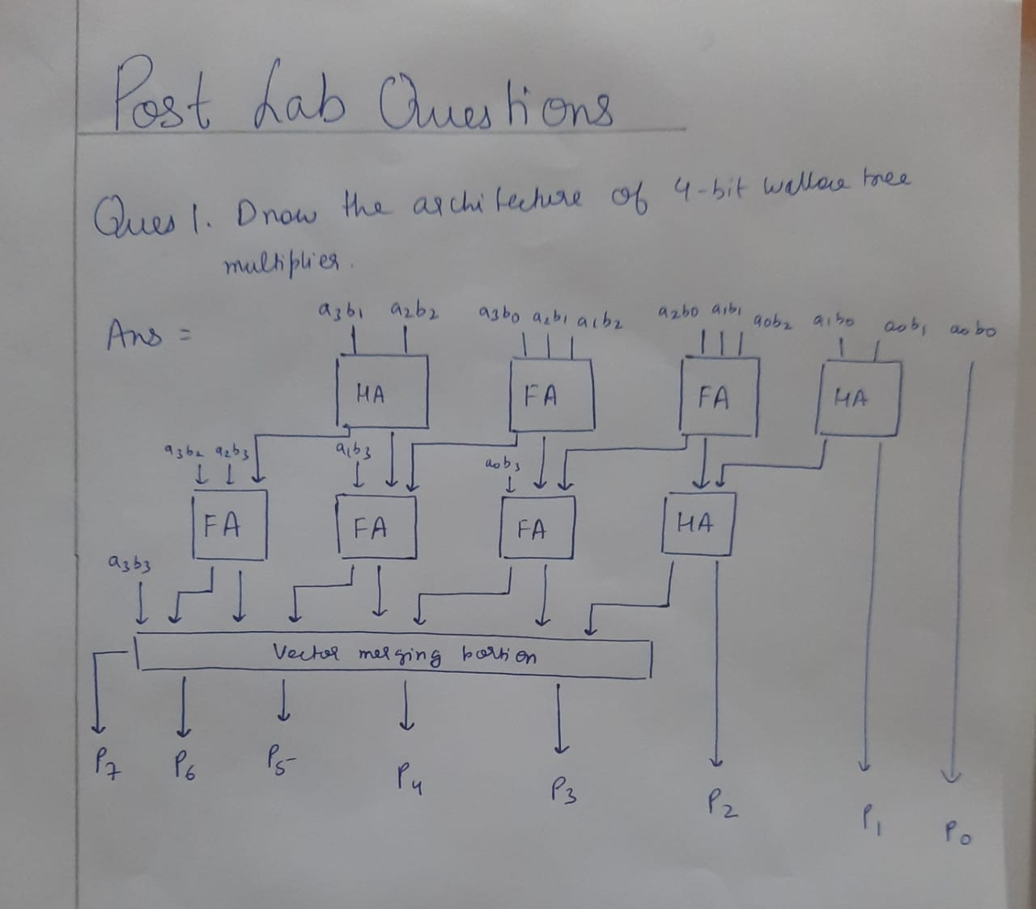

**QUES 2**

**4 bit Wallace tree multiplier**

module wallace(A,B,prod);

//inputs and outputs

input [3:0] A,B;

output [7:0] prod;

//internal variables.

wire s11,s12,s13,s14,s15,s22,s23,s24,s25,s26,s32,s33,s34,s35,s36,s37;

wire c11,c12,c13,c14,c15,c22,c23,c24,c25,c26,c32,c33,c34,c35,c36,c37;

wire [6:0] p0,p1,p2,p3;

//initialize the p's.

assign p0 = A & {4{B[0]}};

assign p1 = A & {4{B[1]}};

assign p2 = A & {4{B[2]}};

assign p3 = A & {4{B[3]}};

//final product assignments

assign prod[0] = p0[0];

assign prod[1] = s11;

assign prod[2] = s22;

assign prod[3] = s32;

assign prod[4] = s34;

assign prod[5] = s35;

assign prod[6] = s36;

assign prod[7] = s37;

//first stage

half_adder ha11 (p0[1],p1[0],s11,c11);

full_adder fa12(p0[2],p1[1],p2[0],s12,c12);

full_adder fa13(p0[3],p1[2],p2[1],s13,c13);

full_adder fa14(p1[3],p2[2],p3[1],s14,c14);

half_adder ha15(p2[3],p3[2],s15,c15);

//second stage

half_adder ha22 (c11,s12,s22,c22);

full_adder fa23 (p3[0],c12,s13,s23,c23);

full_adder fa24 (c13,c32,s14,s24,c24);

full_adder fa25 (c14,c24,s15,s25,c25);

full_adder fa26 (c15,c25,p3[3],s26,c26);

//third stage

half_adder ha32(c22,s23,s32,c32);

half_adder ha34(c23,s24,s34,c34);

half_adder ha35(c34,s25,s35,c35);

half_adder ha36(c35,s26,s36,c36);

half_adder ha37(c36,c26,s37,c37);

endmodule

**TESTBENCH**

module tb;

// Inputs

reg [3:0] A;

reg [3:0] B;

// Outputs

wire [7:0] prod;

integer i,j,error;

// Instantiate the Unit Under Test (UUT)

wallace uut (

.A(A),

.B(B),

.prod(prod)

);

initial begin

// Apply inputs for the whole range of A and B.

// 16*16 = 256 inputs.

error = 0;

for(i=0;i <=15;i = i+1)

for(j=0;j <=15;j = j+1)

begin

A <= i;

B <= j;

#1;

if(prod != A*B) //if the result isnt correct increment "error".

error = error + 1;

end

end

endmodule

**OUTPUT**

