EXP 8 POSTLAB

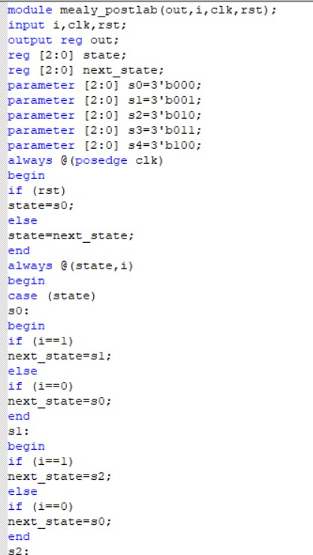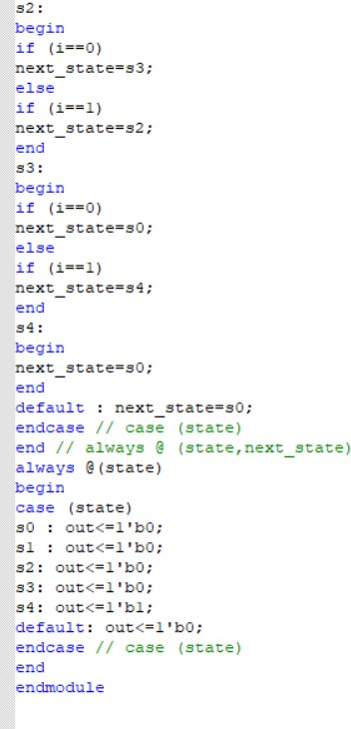

Fig 8.1 Verilog Code

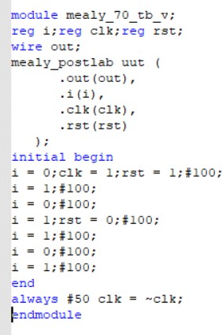

Fig 8.2 Testbench

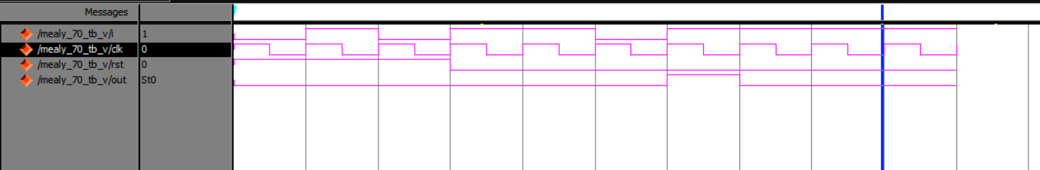

Fig 8.3 Output Waveform