Software Requirements Specification (SRS)

Secure Messaging Web Application using USID and End-to-End Encryption (Phase 1)

1. Introduction
1.1 Purpose
This document specifies the software requirements for the Secure Messaging Web Application developed as Phase 1. The document follows the ISO/IEC/IEEE 29148 standard.
1.2 Scope
The system is a web-based secure messaging application using USID as the primary identity. Messages are end-to-end encrypted and stored only on user devices. A Node.js server acts solely as a relay.
1.3 Product Perspective
The system follows a client-server architecture with web clients and a lightweight Node.js backend.

2. System Architecture
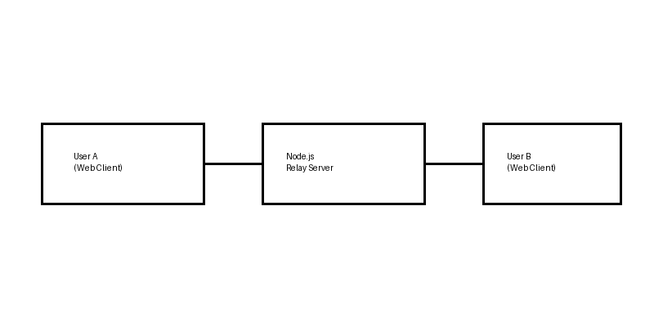

3. System Requirement

This section describes the minimum system requirements needed to run and test the Secure Messaging Web Application in Phase 1.

Hardware Requirements
- Processor: Intel Core i3 or equivalent (or higher)
- RAM: Minimum 4 GB
- Storage: At least 1 GB of free disk space
- Device Type: Desktop or Laptop computer

Software Requirements
- Operating System: Windows, Linux, or macOS
- Web Browser: Google Chrome, Mozilla Firefox, or Microsoft Edge
- Backend Runtime: Node.js (version 18 or higher)
- Code Editor (Optional): Visual Studio Code or any modern IDE

Network Requirements
- Stable internet connection
- Support for HTTPS communication
- WebSocket support for real-time message exchange

3. Data Flow Diagram (DFD)
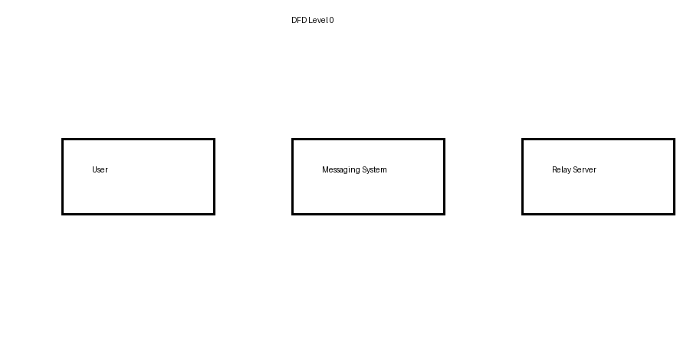

4. Sequence Diagram
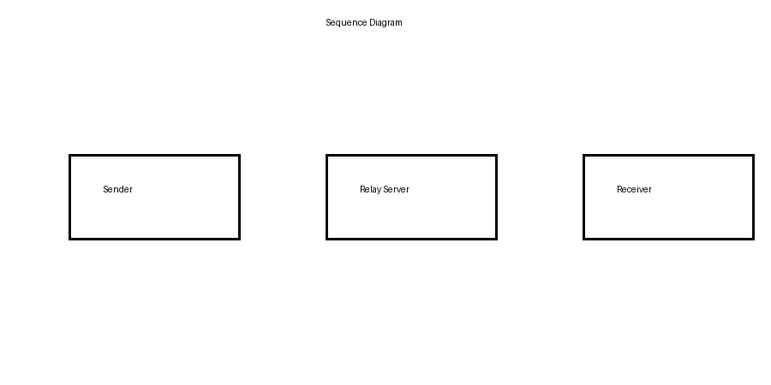

5. Use Case Diagram
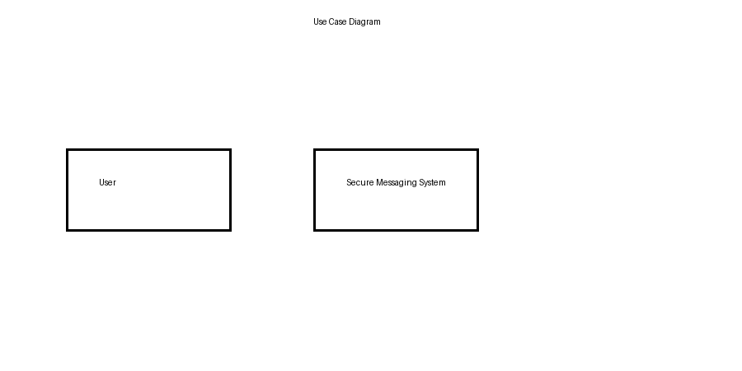

6. Functional Requirements
Req ID | Requirement | Description
FR-01 | USID Generation | Generate unique cryptographic USID
FR-02 | User Authentication | Authenticate users via public-key cryptography
FR-03 | Encrypted Messaging | Encrypt messages using Signal Protocol
FR-04 | Message Relay | Relay encrypted messages without storage
FR-05 | Local Storage | Store messages only on user devices

7. Non-Functional Requirements
Category | Requirement | Description
Security | E2EE | All messages encrypted end-to-end
Performance | Low Latency | Minimal message delay
Reliability | No Persistence | No server-side message storage
Usability | Simple UI | Easy to use interface

8. Requirement Traceability Matrix (RTM)
Requirement ID | Use Case | Design Component | Test Case
FR-01 | User Registration | USID Module | TC-01
FR-02 | Login | Auth Module | TC-02
FR-03 | Send Message | Signal Encryption | TC-03
FR-04 | Message Transfer | Node.js Relay | TC-04
FR-05 | View Message | Local Storage | TC-05

8. Future Enhancements
- Auto-delete and burn-after-read messages
- Metadata minimization
- Forensic-resistant data wiping

9. References
- K. Cohn-Gordon et al., “A Formal Security Analysis of the Signal Messaging Protocol,” IEEE EuroS&P, 2017.
- T. Perrin and M. Marlinspike, “The X3DH Key Agreement Protocol,” Signal Whitepaper, 2016.
- D. J. Bernstein, “Curve25519: New Diffie–Hellman Speed Records,” PKC, 2006.
- D. McGrew and J. Viega, “The Galois/Counter Mode of Operation (GCM),” NIST Workshop, 2004.
- M. Fischlin et al., “Backdoored Hash Functions: Immunizing HMAC and HKDF,” EUROCRYPT, 2014.
- B. Hale and N. Komlo, “On End-to-End Encryption,” IEEE S&P Workshops, 2019.
- E. Alshaer et al., “Secure Messaging for Military Applications,” Military Communications Conference, 2022.

