


SSAL is an Artifical Logic
PROJECT REPORT
submitted by
Abhijith N Raj
Abhiram S
TKM16CS001
TKM16CS003

to
APJ Abdul Kalam Technological University
in partial fulfillment of the requirements for the award of B.Tech Degree
in Computer Science Engineering.

Department of Computer Science Engineering
T.K.M. College of Engineering, Kollam
November 2018

DEPARTMENT OF COMPUTER SCIENCE ENGINEERING T.K.M COLLEGE OF ENGINEERING, KOLLAM

CERTIFICATE

Certified that this report entitled SSAL is the report of project presented by Abhijith N Raj and Abhiram S during year-2018 in partial fulfillment of the requirements for the award of the Degree of Bachelor of Technology in Computer Science Engineering of the APJ Abdul Kalam Kerala Technological University

Name:
Signature:
Designation: Project coordinator
Dept. of Computer Science Engineering
TKM College of Engineering, Kollam

(Name and Signature)
Head of the Department
Dept. of Computer Science
TKM College of Engg

DECLARATION

We, Abhijith N Raj and Abhiram S hereby declare that, this project report entitled SSAL is the bonafide work of us carried out under the supervision of Prof.Mohammed Siyad, senior advisor computer science of engineering TKM college of engineering kollam. We declare that, to the best of our knowledge, the work reported herein does not form part of any other project report or dissertation on the basis of which a degree or award was conferred on an earlier occasion to any other candidate. The content of this report is not being presented by any other student to this or any other University for the award of a degree.

Signature:
Name of the Student.:
Uni. Register No:............. of year .......…

Signature(s):
Name of Guide(s):

Countersigned with Name:
Head, Department of Computer Science
TKM College of Engineering, Kollam. Date:…../…../………

ACKNOWLEDGEMENTS

We take this opportunity to express my deep sense of gratitude and sincere thanks to all who helped me to complete the project successfully.
We are deeply indebted to our guide Prof. Mohammed Siyad , Prof. Rehanara Beegum, Prof. Nisa AK , Department of Computer Science Engineering for their excellent guidance, positive criticism and valuable comments. We am greatly thankful to Ansamma John Head of Computer Science Engineering Department for her support and cooperation.
Finally we thank my parents and friends near and dear ones who directly
and indirectly contributed to the successful completion of my project.
Abhijith N Raj
Abhiram S
Place:
Date :

ABSTRACT

We all are very busy leading our everyday life. We do not have time to think about little things like turning of the lights or fan. This is where home automation comes in. Although there exists technologies that provide these services they do not have pure AI IoT combination and lack privacy and security. We propose a new product namely SSAL – SSAL is a Sophisticated Artificial Logic to tackle these issues. SSAL contains all the conventional features of home automation systems such as facial recognition,voice recognition etc along with new IoT and AI features such as Dynamic Online Switching, Electronic Failure prediction etc. We made our projects open source in hopes of making an impact on the world in the coming years.

Table of Contents
Title Page No

Chapter 1: Selection of three products 0
1.1 Selecting the Home Automation Devices
1.1.1 Google Home 0
1.1.2 Amazon Echo 1
1.1.3 Apple Homepod 2
1.2 Our Product 3
1.2.1 SSAL 3
1.2.2 Specifications 3
1.3 Conclusion 6
Chapter 2: Design Tool 7
2.1 Design Tool Requirements 7
2.2 Chosen Design Tools 7
2.2.1 Arduino IDE 7
2.2.2 Jupyter 7
2.2.3 Pycharm 8
2.2.4 Eclipse 8
2.2.5 Blender 8
Chapter 3 : Feature Study And Comparison 9
3.1 Required Features of a Home Automation Device 9
3.2 Comparison of Features Of Chosen Products 9
3.2.1 Google Home 9
3.2.2 Amazon Echo 10
3.2.3 Apple Homepod 10
3.3 Privacy Concerns 10
3.4 SSAL 11
3.4.1 Functionalities 11
Chapter 4 : User Experiemce And Analysis 13
4.1 Methodology 13
4.2 Survey Results 13
4.2.1 Are You A Home Automation User 13
4.2.1.1 Results 13
4.2.1.2 Analysis 14
4.2.2 Which is your preffered home automation System 14
4.2.2.1 Results 14
4.2.2.2 Analysis 14
4.2.3 Are you satisfied with current solutions 15
4.2.3.1 Results 15
4.2.3.2 Analysis 15
4.2.4 Do you value privacy over experience? 15
4.2.4.1 Results 15
4.2.4.2 Analysis 16
4.2.5 Are you satisfied with Network security? 16
4.2.5.1 Results 16
4.2.5.2 Analysis 16
4.2.6 Would you prefer an open sourced project over a closed one? 16
4.2.6.1 Results 17
4.2.6.2 Analysis 17
4.3 Our Solution to Identified Issues 17
4.3.1 Would you like to try our product SSAL? 17
4.3.1.1 Results 17
4.3.1.2 Analysis 18
4.4 Conclusion 18
Chapter 5 : GUI Design 19
5.1 Design Choices 19
5.2 Study on Comparison Of Selected Products 19
5.2.1 Google Home 19
5.2.2 Amazon Echo 20
5.2.3 Apple Homepod 20
5.3 Modular Design 21
5.3.1 Design of SSAL AI 21
Chapter 6 : Scalability and Deployability Study 22
6.1 Terminology 22
6.1.1 Scalability 22
6.1.2 Deployability 22
6.2 Study of Scalability and Deployability of the selected products 22
6.2.1 Google Home 22
6.2.1.1 Scalability 22
6.2.1.2 Deployability 22
6.2.2 Amazon Echo 22
6.2.2.1 Scalability 22
6.2.2.2 Deployability 23
6.2.3 Apple Homepod 23
6.2.3.1 Scalability 23
6.2.3.2 Deployability 23
6.3 Scalability and Deployability of Our Product 23
6.3.1 Scalability 23
6.3.2 Deployability 23
Chapter 7 : Performance Analysis 24
7.1 Criterion for Performance Analysis 24
7.2 Performance Comparison 24
7.3 Performance of SSAL 24
Chapter 8 : Safety And Security 26
8.1 Introduction 26
8.2 Safety And Security Measures for SSAL 26
8.2.1 DarkNet 26
8.2.2 Telnet 26
8.2.3 Encryption Algorithm 26
8.2.4 LUKS(Linux Encrypted Key Setup) 27
8.2.5 DOS(Dynamic Online Switching) 27
8.2.6 Backup Power 27
Chapter 9 : Maintenance and Handling 28
9.1 Introduction 28
9.2 Methodology 28
9.2.1 OTA 28
9.2.2 Manual 28
9.2.2.1 Detials 28
Chapter 10 : Cost and Pricing 29
10.1 Comparison Study on Cost 29
10.2 Cost and Pricing of SSAL 29
Chapter 11 : Development of Design 30
11.1 Introduction to the Design Process 30
11.2 User Interface for SSAL 31
11.2.1 Telegram Chatbot 31
11.2.2 Desktop Command Line Application Interface 31
11.2.3 Minimalistic UI for Programmer Configuration 32
11.2.4 Telnet CLI ESP8266 32
11.2.5 Android Application 33
11.3 Advantages of Our Design 34
Chapter 12 : Conclusions and References 35
12.1 Summary of the Design Project 35
12.2 Conclusion 36
12.3 References 37

CHAPTER 1
PRODUCT SELECTION

1.1 Popular Home Automation Systems
1.1.1 Google Home

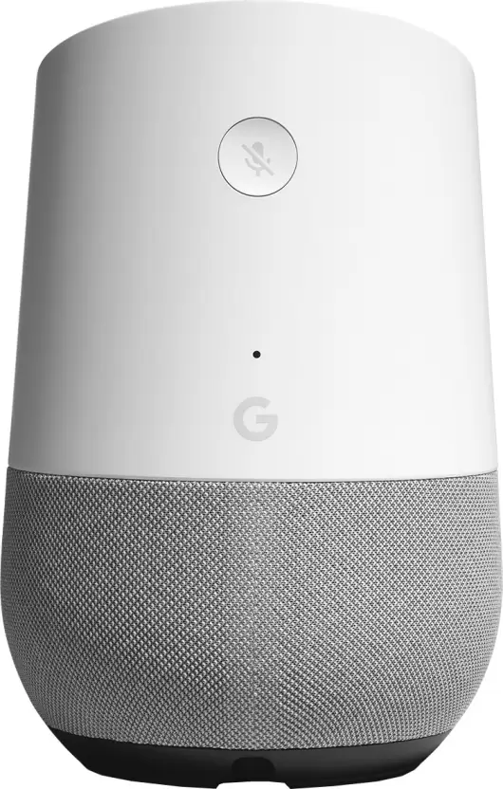

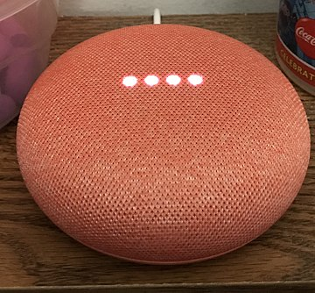

Google Home was first announced in May 2016 and subsequently released throughout the US in November 2016 and released globally by 2017. It featured a 1500 Mini Plus Dual 1500 Mini Plus dual-core ARM Cortex-A7 media processor. It allowed supports from in house and 3rd party apps. Also it allowed users to control smart home devices with their voice not limited to but including listening to music, watching videos and receiving news updates. It recognized different voices and responded differently. Later Google updated the functionalities including Bluetooth audio, reminders, calendars, alarms, schedules. Originally Google home supported only chrome cast.
The shape of Google home speaker was actually really attractive with a near cylindrical shape and status LED's on top. It offers different colors for base to allow it blend in to the environment.
Some of the services supported in Google home includes Netflix, YouTube, Spotify, Google photos, calendar etc, a list which keeps growing by day. It featured Google assistant an emotionally and real world intelligent AI. Google assistant also supports languages including but not limited to English, French and German which is expected to reach 30 by the end of 2018. It also allows users to make phone calls in their own mobile number and also it controls TV using chrome cast. Google Home had a mute button in the back to provide privacy in case.
Google Home was priced at Rs 8000. However Google further announced a more cheaper version called Google mini at a range Rs 3500. Also it released a more bigger version named Google home max at a price range of Rs 25-30k.
Google Mini needed a micro USB connection to draw energy. It is a more circular disk shaped device with status lights. It had a mute switch in contrast to a mute button in home. An important note is that after the release of mini its touch response on top of the speaker which allowed mini to respond to the queries subsequently asked rather than being called its name was disabled and removed subsequently due to privacy concerns after it malfunctioned and recorded without pressing.
Google Max is a much bigger version with bigger speakers. It uses machine learning techniques to change sound ambiance with respect to the environment.

1.1.2 Amazon Echo
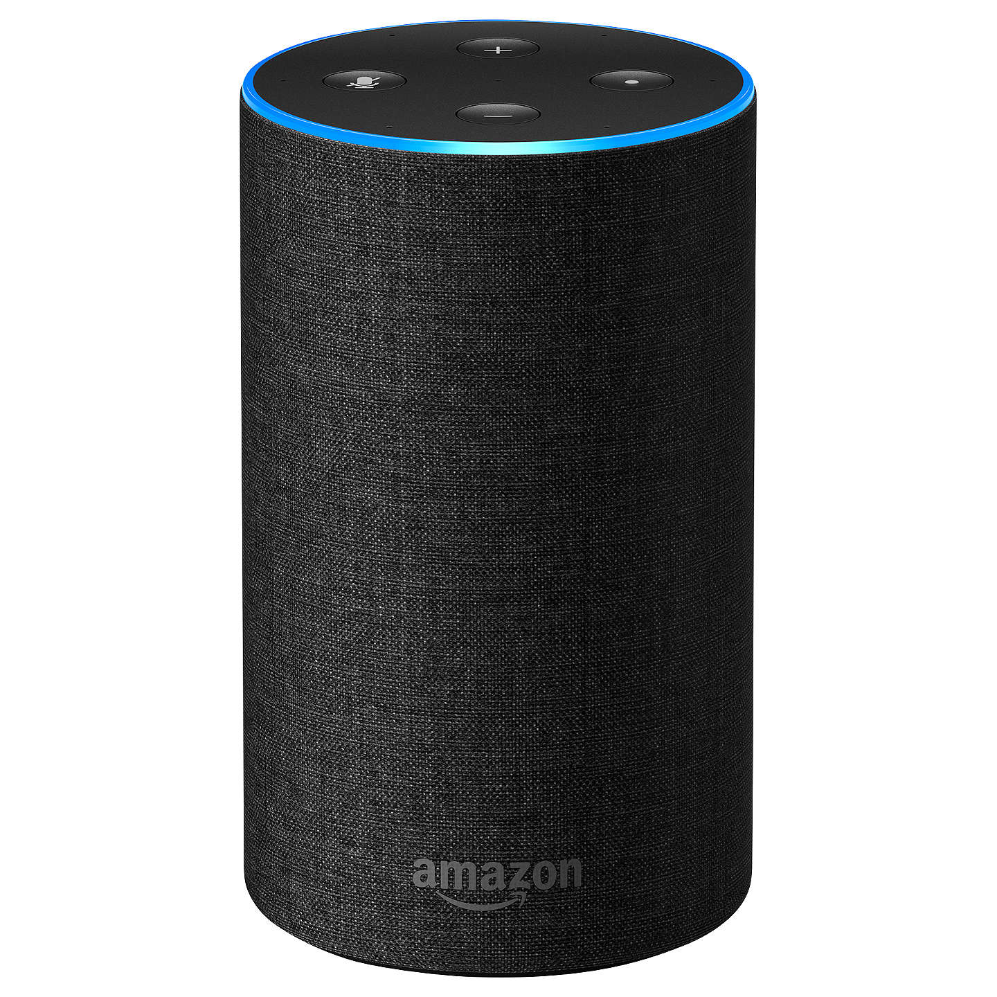
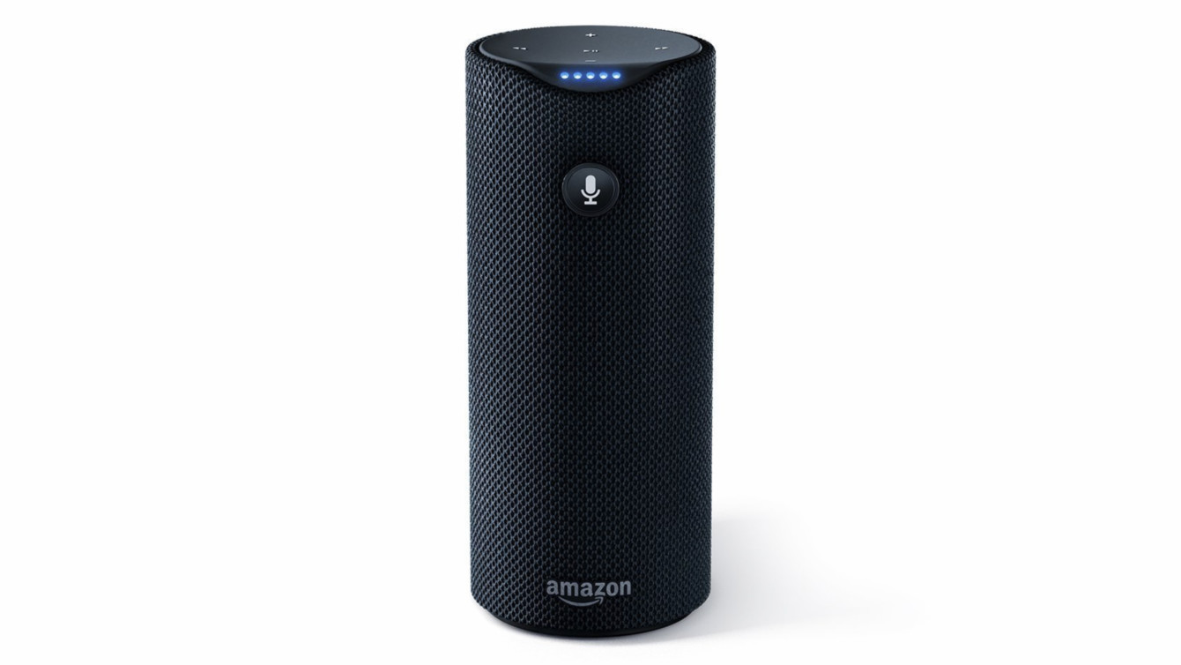

Amazon TAP

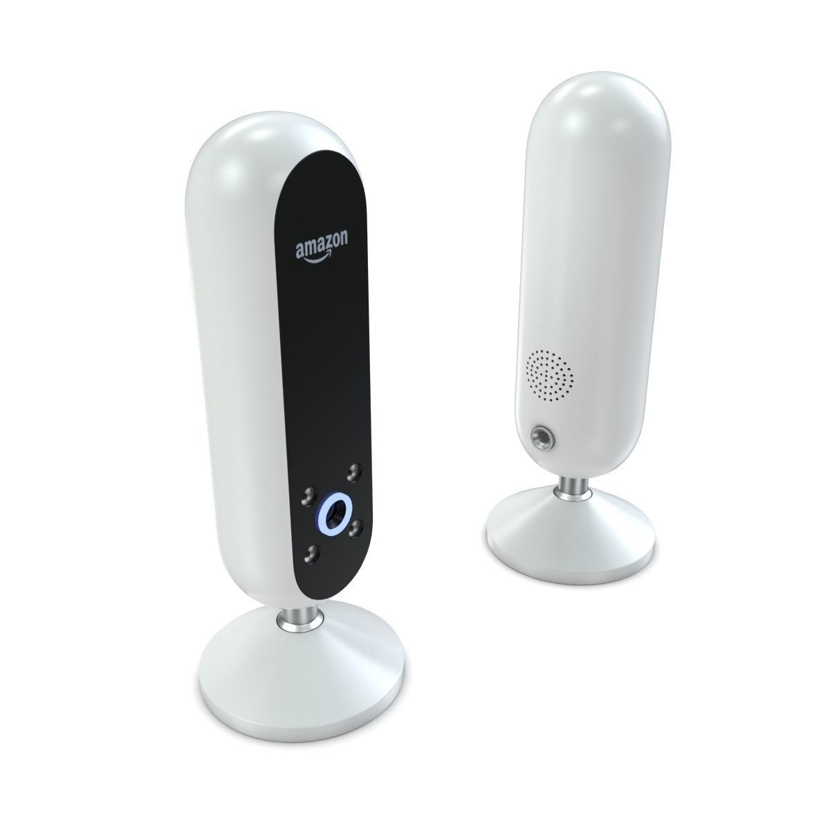
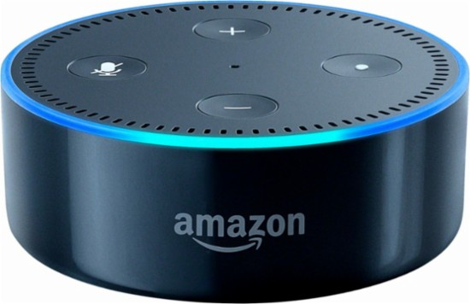

Amazon Look Echo Dot

Amazon echo was released by the company Amazon in 2015 order to increase its electronic presence beyond Kindle e-reader. Although Amazon had begun developing the device since at least 2010 the device was released only to Amazon prime users in the beginning by 23rd June 2015 and further exapanded to UK by 2016. It uses Fire OS as operating system.

The hardware of echo consisted of a microphone array(7 piece) with a DM3725 ARM Cortex-A8 processor,256MB of LPDDR1 RAM and 4GB of storage space. It rotates the top to change the volume. The device has no internal battery and has to be plugged in to work. The Amazon tap is a battery powered variant of echo but its cylindrical .It supports Bluetooth and WiFi for audio and video streaming as well as for accessing connected mobile devices.

Echo featured Alexa the smart AI. The functionalities included setting up alarms, listening to audio books, listening to podcast and music along with its primary use of controlling home automated devices. It also allowed users to shop for Amazon products online. However the installation required an Amazon account. It also needs a wireless internet connection to work. It integrates with fire-stick to watch television.

Echo can play music from our own account as well as Pandora and Spotify. It supports thermostats and quite a wide array of home automated devices including Yonom, Philips Hue, Belkin Wemo, SmartThings, Insteon, and Wink.
Alexa has a skill set which can be increased by developers using the Smart Home Skill API. Software versions are updated in a period of weeks so no sudden changes occur. Also most of alexa’s skill are cloud based which means its doesn't require software update to make new changes such as when it learned to supply users with live score.

Amazon Echo Look was another version of echo which included 360 degree camera allowing the users to record video and take photos on command and it also utilizes machine learning algorithm to provide fashion advice.

Privacy concerns linking echo had been raised as it listens always for the wake word. However, such concerns have been denied completely by Amazon authorities claiming that it begins streaming only after the wake word. Other malfunctions such as Alexa bursting into sudden laughter was actually only found and resolved later.

Much smaller versions of echo like echo dot was also introduced by Amazon.
1.1.3 Homepod

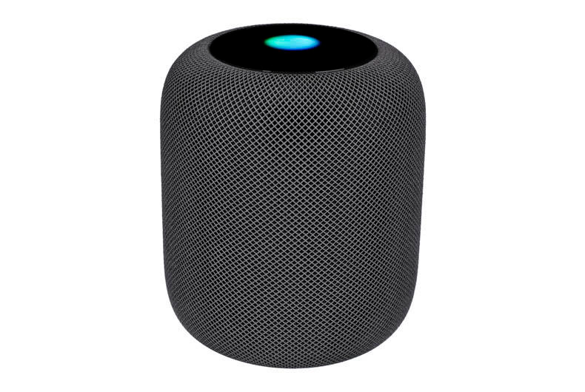

Homepod is developed and created by Apple Inc. It is classified clearly as a smart speaker and ranks 4th in terms of overall smart speaker scale. It was originally released in late 2018 available in two colors white and space gray. It uses an Apple A8 SOC(System On Chip) with 1 GB RAM and storage of 16GB and runs on an IOS called audio-OS. It has a cylindrical round shape with a touch screen on top as well as 6 microphones.
The functionalities include full control of the speaker and other home-kit devices and communication with the iPhone also includes integrating other Apple apps like Apple music, iTunes etc. Homepod doesn't support Bluetooth. It lacks multi-user support. It featured the voice assistant named Siri.
Although Homepod became very popular it was criticized largely for its high price tag and limited functionality of Siri compared to other voice assistants. Also it didn't support any third party apps contributing to its “intense inflexibility”. Also it caused a lot of inconvenience to the users who found a large silver stain after using the device for some time although Apple has reiterated that any silver device which vibrates would leave such a mark after long use. Apple in many ways allowed access only within its on ecosystem which made other platforms users virtually alienated from buying Homepods.

1.2 OUR PRODCUT
1.2.1 SSAL – SSAL is a Sophisticated Artificial Logic
We developed a new home automation system focusing on network security and privacy while combining the power of Artificial Intelligence and Internet of Things.
SSAL project contains DOS(Dynamic Online Switching) capable of intelligent switching between power grid and solar energy.
We developed a modular design for performing all the functionalitieis.
1.2.2 Specifications
Hardware is totally user configurable. Base specs include BCM2837B0 CPU which is an ARM Cortex V8 (Cortex A58). 64Bit SOC capable having wireless, and USB controller built in. Project Code Named SSAL is modular, modules includes
- Security Module (CAM)
- MIC (For hot word detection and voice recognition)
- Gas Sensor Module (For industry and kitchen use)
- Real Time current voltage(Power) Monitoring module.
- Automatic Switching Module.
- Earth Safety Module(Electric shock protection).
- Solar Power Balancing Module.
- Solar Panel Alignment Module.
- Real Time Display Module.Etc.
This is only few in a list of ever growing modules.This is totally user configurable, which means user can opt out as well as improve the functionalities.

COST (Comparison of Flag Ship model)
Feature | Google | Amazon | Apple | BrainNet’s SSAL
Variants | *Google Home  Google Home Mini  Google Home Max | *Amazon Echo  Amazon Echo Dot  Amazon Tap  etc.. | *Apple Homepod | *IoT Core B_V2.0_R15  *AI Core A_V1.1_R3  *Fail Safe Core S_V2.0
Price | 4000 to 25000 INR | 4000 to 8000 INR | 24200 INR in US | 1000 to 10000 INR
Aesthetics  Shape  Color | Cylindrical | Cylindrical | Cylindrical | Basically Cubical
Ergonomics
CPU | M-88DE3006  ARM Cortex V7 | Ti-DM3725  ARM Cortex V8 | Apple A8  APL1011 | BCM2837B0 or UC  1.4GHz  ARM Cortex V8 – A58
RAM | 512MB DDR3 | 256MB LPDDR1 | Expected 1GB | 1GB LPDDR2 or UC
FLASH | 256MB NAND | 4GB NAND | 16GB NAND | 4GB EMMC to UC
WiFi | 802.11 b/g/n/ac  Chipset- 88W8887 | 802.11 b/g/n/ac | 802.11 b/g/n/ac  Chipset-BCM4372 | 802.11 b/g/n/ac or UC
Bluetooth | V4.2  Chipset- 88W8887 | Unknown  Protocols -  A2DP, A2RCP | V5  Chipset-BCM4372 | V4.2 or UC
Power (Max) | UNKNOWN | 21W | S0 State – 2W  S3 State – 15W | 3W or UC
NFC | Yes  Chipset- 88W8887 | No | No | No or UC
LAN or Ethernet | No | No | No | Yes or UC
Dynamic Specs | No | No | No | Yes
Open Source | No | Partially | No | Yes except Encryption.
Additional Storage  (HDD, USB FLASH) | No | No | No | Yes
Additional Features | BT Speaker | BT Speaker | BT Speaker | DLNA Certified,  Security CAM DVR,  Media Server,  Solar Charge Controller,  Direct Control without server and port forwarding (Data Privacy).
UC – User Choice

1.3 CONCLUSION
After completing the market analysis from three different products some major conclusions can be drawn. Our analysis has shown a need in the market for new products that are more IoT driven and privacy oriented. Today’s home automation technologies are largely a black box with most of the processing done in the cloud which has the potential to violate the user’s privacy. Hence, we initiated the design of a more reliable product with open source hardware and software with maximum data encryption.

CHAPTER 2
DESIGN TOOL

2.1 DESIGN TOOL REQUIREMENTS
Our Product primarily had several components such as hardware and Software Design. The software design further needed to be divided into the hardcoded logic and Artificial Intelligence design. We chose to implement our hardware using the Arduino Platform and AI using Python. The remaining hardcoded logic was implemented using Python and Java.
This meant we had the following requirements:
- An IDE capable of integrating easily with the Arduino Platform
- IDEs capable of easy data handling, visualisation etc for AI.
- IDEs capable of designing 3D visual arrangement for our product.
- A Design tool capable of developing applications
- IDEs for Python and Java
2.2 CHOSEN DESIGN TOOLS
2.2.1 Arduino IDE
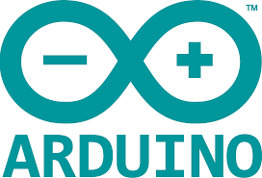

Arduino IDE is capable of easily uploading new libraries and programing with C++ based arduino programs for hardware interfacing. It is easy to use and is available on almost all platforms. It also provides support for multiple boards such as Arduino Nano , Uno etc. .
2.2.2 Jupyter Notebook


Jupyter Notebook is perhaps the most versatile IDE for python. It can be hosted on a web sever and can be acessed by anyone anywhere with the right credentials. It provides for a browser based interface. One can easily see the help and perform autocomplete using simple shorcuts. Visualisation is also very easy and it doesn’t need a secondary window to display information and displays everything in the browser itself. This meant that we can quite easily plot data, and can work from remote locations on our project. Thus this was the primary IDE that we chose for the entire software design phase for python for AI and hardcoded Logic.
2.2.3 Pycharm


Pycharm was more of a secondary choice. It provided the possibility of programming withing a sandbox. It automatically imported modules for the user who may not know the exact location of it. This was one of the more important use because during our entire design phase we had to use several libraries and Pycharm actually provided an easy integration for that. Also data representation,visualisation etc works almost as good as jupyter notebook. Another important aspect of Pycharm that attracted it for our project was that programs were easy to be debugged in Pycharm.
2.2.4 Eclipse


Eclipse was our one and only preference as an IDE for Java because it had everything our design requirement specified. Eclipse is the most reputable IDE among Java developers. It has many plugins that allow for easier GUI implementation both for Android as well as Desktop. Programing in Java meant platform independence and hence we wanted to create a material UI and Eclipse had all the necessary requirements for Swing and AWT preinstalled including Autocomplete, Error detection etc. Eclipse also had a debugger which helped faster prototyping.
2.2.5 Blender


Blender is an open source 3D design tool. It is a popular choice among developers trying to design a visual element or graphics. We chose blender because of its ability to create 3D models meant that we could create our product and test out its visual appeal in a virtual world.

CHAPTER 3
FEATURE STUDY AND COMPARISON
3.1 REQUIRED FEATURES OF A HOME AUTOMATION DEVICE
Although we studied several projects there is a need to mention certain common features that all home automation devices must have taking into account all factors.
- Privacy
- Network and Data Security
- Easier Integration
- Aesthetic and Ergonomic Design
- An efficient Interface
3.2 COMPARISON OF FEATURES OF CHOSEN PRODUCTS
3.2.1 Google Home

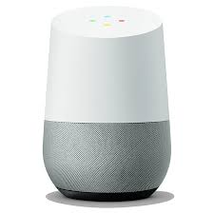

Google Home had several features such as
- A good AI namely, Google Assistant which was already pre installed in most Android Phones
- Visual Appeal and choices which came in the form of variants
- Supported large amount of devices
The variants of Google Home included Home, Mini and Max. The price ranged from Rs 4000 to Rs 25000. The design is mostly cylindrical in shape for Google Home and Max but with an oval shape at the top. For Google Home Mini, the design is mostly cylindrical but with less height. The processing power is low but there is decent amount of RAM. The connctivities available were WiFi and Bluetooth. The quality of the speaker was quite good as well. Google Home can control your devices, provide reminders etc.

3.2.2 Amazon Echo

Amazon Echo has its variants in the form of Tap,Dot and Look.
The main Features of Amazon Echo are :
- Wonderful design with bold color and animations
- An appealing Artificial Intelligence Amazon Alexa
- Several design choices as variants
The cost of Amazon Echo varied from Rs 4000 to Rs 8000. The design is cylindrical in shape. CPU has better Processing power than Google Home but Lower RAM. Dot also provides bluetooth and wifi connectivity. The design of Alexa is in such a way that developers can create skills for Alexa.
3.2.3 Apple Homepod

Apple Homepod is more of a glorified speaker than a Home Automation Device. The interface is very minimal. There is no Home Automation easily available. Although it houses a better Architecture than both Google Home and Amazon Alexa its full efficiency has not been put to use. The prices are off the charts at a total of Rs 24200. No variants of the device is available. Although what it lacks in the feature area it makes up for by being one of the best speakers in the market.
3.3 Privacy Concerns
The modern technology has made the world a global village. However, with rising technologies the main concern of most people is the Privacy. Unfortunately, they are right in being paranaoid. From the Cambridge Analytica Scandal to the creepy laughs of Alexa that wake you up in the middle our privacy is far from respected and even farther from protected. No system is completely safe. Security is nothing but an illusion and a skilled hacker can exploit even the tiniest bit of vulnerability in the network. The recent news of many national data gathering effects being hacked and the news of our power structures such as the Supreme Court websites being hacked shows that no one is safe from the invasion of their private space.
3.4 SSAL
Our motto while envisioning this project was to create a ”closed system with an open source”. Closed meaning the prying eyes don’t get a chance to hack into the device or third party doesnt have acess to the user’s information. An open source meant that the all the hardware and software design for this project is available for free and anyone and everyone can download and change the product to their wish for their use if they want to. This ensures the privacy of the user both from a security point of view and from the data point of view.
The main highlights of this project are:-
- An open source project.
- Combination of Artificial Intelligence and Internet of Things.
- Ensuring Data and System security for the users.
- Less cloud based and more client side services based on privacy policy chosen by user.
- Constant monitoring of the electronic system for identifying circuit failures.
- Intelligent switching between solar power and public power grid.
- All conventional features such as voice recognition,facial recognition,object detection etc
- Graceful execution even without internet connectivity.
3.4.1 Functionalities
The main feature of our SSAL system is that we protect the user’s privacy. Thus we made the code and hardware entirely open source and made all the chat functions and other AI functionalities local. This means that we provided a closed system with open source.
Further unlike Google, Amazon or Apple who converted their smart devices into promotional campaign for their other devices, we made sure that device be able to control not other devices but the electric circuit itself. That is, it will be compatible with existing set of devices as well whether smart or not. An efficient communication is established using WiFi with secure protocols for SSAL.
What Google and Amazon did was focusing on the assistant aspect of the system which helps them solve problems such as answering who the president of America is or what time the next cricket match is. But we took a different approach and focused more on the IoT aspect of the AI than other cognitive abilities.
We included more features such as home surveillance system capable of identifying intruders and also a visual recognition based lock systems. We created a further web UI for the AI to communicate with us which will help us be in contact with it even outside house.
We also depended heavily on machine learning to identify the user’s behavioral pattern like when a person leaves the room keeping the light on and is never going to return. In such a case the light can be turned off to save power. Similar is the case regarding the motors. It will automatically maintain the required level of water in the tank by implementing its own algorithms.
We also added mechanisms that will detect the failure in the electric circuits and also prepared a model capable of predicting when a device will fail so that the user can take preventive measures against it.
Adding visual surveillance also means that the user if he needs can activate the higher cognitive abilities of the AI helping it to analyze the sentiment of the user and setting mood according to it. SSAL anyway by implementing neural networks is capable of predicting the actions of the user and behave accordingly. For example, it can identify whether a person had had a tough day and play music according to it. It can also remind him to watch his favorite shows if any and automatically identify it and change the channel if necessary.
Modularity was the key in the development of the project. As such we support a plug and play system where every piece of software visual recognition, voice recognition etc are all modules which may or may not be used by the customer. Offering him this choice also creates a more customization version of Home Automation.
Several interfaces are provided for the user Web, app, voice etc. which can be used to communicate with the assistant. Synchronization of user data exists and is available on all the platforms, Even a telegram chat-bot is provided to the user as backup. We also made our network protocols highly encrypted using an elliptical curve encryption.

CHAPTER 4
USER EXPERIENCE AND ANALYSIS
4.1 Methodology
User experience analysis is one of the best methods of market surveys. This can be done in two ways direct survey and Indirect survey. We performed an indirect survey. We created a google Sheets with the following questions and passed it around amoing varying and diverse users.
We tried asking the following basic questions:
- Are you a home automation user?
- Which is your preferred home automation System?
(a) Amazon Echo (b) Google Home (c) Apple Homepod (d) Others
- Are you satisfied with current solutions?
- Do you value privacy over experience?
- Are you satisfied with Network security?
- Would you prefer an open sourced project over a closed one?
- Would you like to try our product SSAL?
The answers to all this questions were recorded and obtained as barcharts as shown below. To protect the privacy we will not include any of their names or individual responses.

4.2 Survey Results
The results will take the following format questions followed by their responses and finally an analysis on the said results.
4.2.1 Are You A Home Automation User?
We posed this question to find out about the user base and understand their experiences and how much we can actually trust their opinion.
4.2.1.1 Results

Most of the people were not home automation users. A significant amount had little to no experience regarding any home automation techniques.
4.2.1.2 Analysis
The main reason why most people are not home automation users could be any of the following:
- High cost of device
- Lack of supporting devices
- Cost Benefit Ratio is poor
- Lack of privacy and security
4.2.2 Which is your preferred home automation System?
We posed this question to find out relevant information regarding the major player in the market. The objective was to identify the device which everyone preferred and understand what makes it better.
4.2.2.1 Results

Most of the people preferred Google Home while lesser supprted Amazon Echo or others
4.2.2.2 Analysis
Google Home has a better AI and brand recognition. Hence people with little idea about to buy a new home automation device is more likely to buy a Google Home than any other. The heavy price of Homepod could also be a contributing factor.

4.2.3 Are you satisfied with current solutions?
This question reflected the relevance of our solution.
4.2.3.1 Results

Most users were not satisfied with the existing solutions.
4.2.3.2 Analysis
There is a need for a new and better product in the market. This could also be the reason that most people are not home automation users. The reasons for this could be the AI not performing up to the expectations or the lack of perfect hardware integration.
4.2.4 Do you value privacy over experience?
This question allowed us to identify whether our moto of a closed system with an open source will be welcome or not.
4.2.4.1 Results

Only a few percentage of the people survived were indecisive. The rest had strong opinion on whether they will value privacy over experience. Almost all of the people surveyed preferred to have their privacy protected rather than have a good experience.
4.2.4.2 Analysis
As stated earlier the truth is most people are rightfully paranoid about their privacy. Most of the companies exploit the users for their information. New such scandals are coming to light every day. Thus it is only normal to have received this response.
4.2.5 Are you satisfied with Network security?
The question was asked to identify the relevance of the techniques that we wanted to use in our product which were better than the other products.
4.2.5.1 Results

Most of the users are clearly not satisfied with the current state of network security.

4.2.5.2 Analysis
Any exploit is a total exploit. People are fed up of putting up with the giant MNCs who doesn’t value their privacy and add backdoor and what not into their systems. Current security is not always updated fast. Recent breaches in the servers of power structures have proved once and for all that security is merely an illusion and with time any system can be cracked,
4.2.6 Would you prefer an open sourced project over a closed one?
During the initial stages of open source development there was largely a mistrust on firmware like Linux kernels etc because of their untested nature. But that trend had been swayed in the past itself. We were just collecting proof to make completely sure that people trusted open source solutions again.

4.2.6.1 Results

4.2.6.2 Analysis
A large percentage were enlightened to have preferred open source over closed source solutions. This could be because of the past success of open source projects or because of the huge privacy it offers. It may also because of lack of vulnerability due to wide open source contributions or privacy and security concerns with the closed source systems.
4.3 OUR SOLUTION TO IDENTIFIED ISSUES
We created a relatively inexpensive product with a modular design so that all the non home automation users can easily buy it. We protected privacy and security by providing open source solution,encrypted data,client side services and a better privacy policy. Open sourced code also meant faster patches and less vulnerability.
4.3.1 Would you like to try our product SSAL?
We asked everyone after highlighting the details of our product whether they would be willing to actually try our product.
4.3.1.1 Results

Some people were indecisive but most people were ready to accept the idea of our product, We are sure that with right design choices we will be able to sway the opinion of the indecisive users as well.
4.3.1.2 Analysis
Our product aimed to tackle some major issues associated with other devices such as privacy,security,AI and IoT integration etc. Hence most people supported the idea of our project and many were followers of open source projects themselves must like the idea of having an open source home automation system to their liking.

4.4 CONCLUSION
There is a need existing in the market for our product. Privacy and security are major concerns and they form our greatest strength. Users are clearly not satisfied with the current solutions as is relevant from the fact that most people don’t use them either because of privacy issues or high cost of the devices etc. Since most people prefer open source solutions and we tackle some major issues people are more likely to use our product.

CHAPTER 5
GUI DESIGN
5.1 DESIGN CHOICES
While designing a good interface for our product we had to consider several things the most important being the provision for a hardware and software interface. Since our product needed to support developers and common users as well we needed multiple interfaces one minimalistic and another more configurable. We also needed to provide a visually appealing aesthetic and ergonomic design making it easy for the end users.
5.2 STUDY ON COMPARISON OF UI OF SELECTED PRODUCTS
5.2.1 Google Home
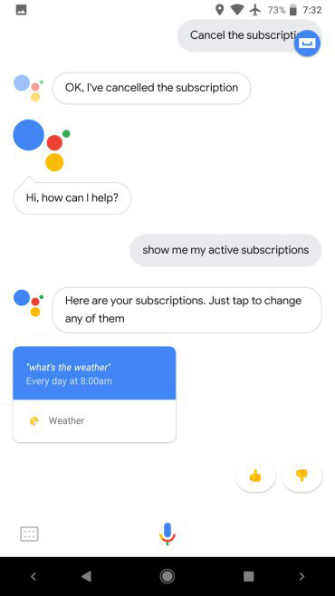
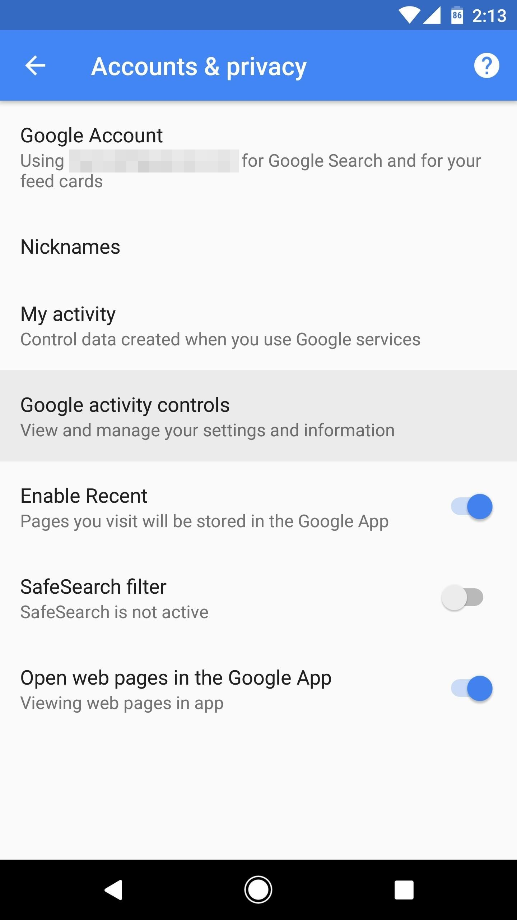
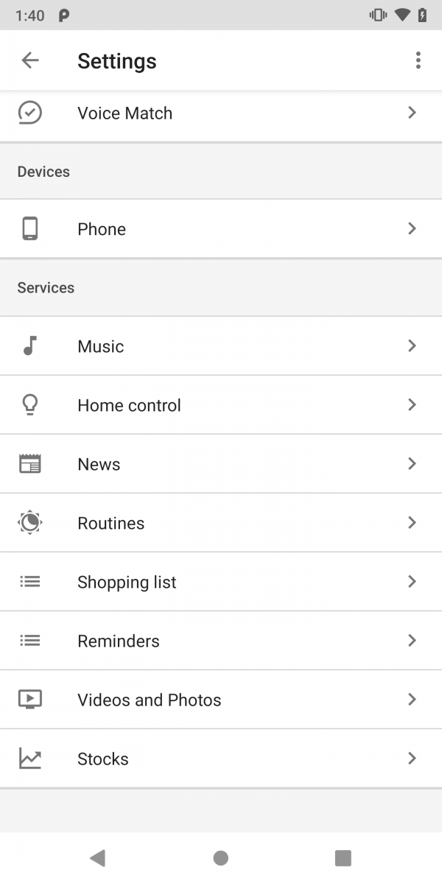

Google Assistant is the user interface for Google Home and it is visually appealing and aesthetically pleasing. We can easily have nice conversation with google assistant and it uses a flow pattern of layout meaning that each dialogue will follow a conversation based approach. There is also configurations and settings page which has all the configuration and complexities hidden well away from the user from the front page.

5.2.2 Amazon Echo
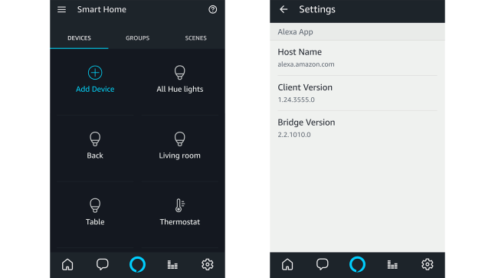

Amazon Alexa provides a grid layout for its devcies by default which is not quite good when it comes to a lot of devices also the UI is set as quite dark which may be unpleasant to some users although other themes may be available. The settings page is quite minimalistic which is good in terms of ergonomics but bad in terms of configurability for a power user. Unlike Google Assistant whose primary aim is as the name suggests to be an assistant. But for Alexa the primary aim is to provide assistance for the smart home and less to the artificial intelligence feature which is actually a pitfall for the AI part. Also it is less configurable and minimalistic.
5.2.3 Apple Homepod
Although Apple Homepod has no interface in itself we can compare Apple’s siri who is able to communicate with Homepod inorder to play music etc.
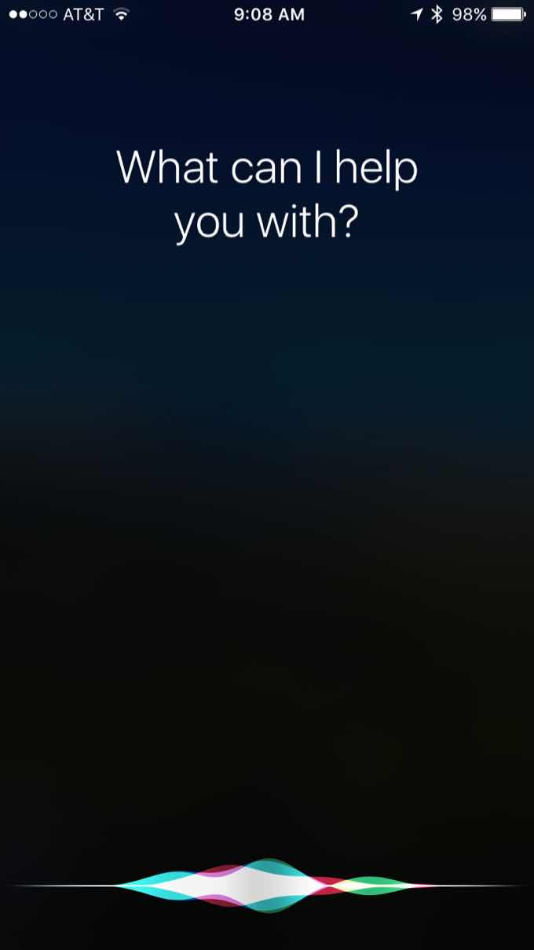

Siri’s interface is also minimalistic even more so than Google Assistant and Alexa combined. This is especially so because many of Apple’s designs are widely popular for being easy to use and handle. Still it leaves performances and specifications something to be desired and never attained. Siri is actually quite good at searching and finding answers but not as good as Google Assistant but definitely better than Alexa. Siri’s voice is actually quite pleasant.
5.3 MODULAR DESIGN
Modularity was one of the key features of SSAL. We designed it in such a way that there is a clear saparation between hardware and software. The hardware was controlled by SSAL Core. The AI then simply controls SSAL core by receiving input from the user. Thus any changes in hardware can be made to SSAL Core and any change to software can be made to SSAL AI.

5.3.1 DESIGN OF SSAL AI
SSAL AI was created using both heurisitic and machine learning models. We trained the AI using a sequence to sequence model with tensorflow and keras framerworks. After the design of the AI we made it as a seperate module so that its integration with other components will be easy

CHAPTER 6
SCALABILITY AND DEPLOYABILITY STUDY
6.1 TERMINOLOGY
6.1.1 Scalability
Scalability is a characteristic of a system, model or function that describes its capability to cope and perform well under an increased or expanding workload or scope.A system that scales well will be able to maintain or even increase its level of performance or efficiency even as it is tested by larger and larger operational demand.
6.1.2 Deployability
Deployability is a non-functional requirement that addresses how reliably and easily software can be deployed from development into the production environment. For desktop (client-side) software, deployability addresses the installation and update mechanisms that may be built into the software itself. For server-side software, deployability is addressed through the system architecture and the deploy process.
6.2 STUDY OF SCALABILITY AND DEPLOYABILITY OF THE SELECTED PRODUCTS
6.2.1 Google Home
6.2.1.1 Scalability
Google Home can support upto 6 accounts at a time. The mighty Google’s servers can handle any no of requests at a time from the users as they use distrubuted computing to achieve effieciency. App interface for each user is personalized by Google Assistant.
6.2.1.2 Deployability
Google Assistant app needed to be configired to identify the devices in the network. Google Home automatically recieves data when connected to google account and know all your details. Google Assistant is preinstalled in almost all Android devices. If not one can download it for Android from playstore if the device supports it.
6.2.2 Amazon Echo
6.2.2.1 Scalability
It can also handle multiple users at a time. But there exists no restriction on the no of accounts that can be handled. Amazon echo can easily handle multiple users because of its good microphone which can hear you from a long distance and hence can recognise you from anywhere in the house.

6.2.2.2 Deployability
Amazon Alexa app is needed to configure Echo which can be downloaded directly from playstore or app store. To connect to devices within the WiFi a user must open the settings and go to device settings and change the WiFi network. For a first time configuration Echo will turn blue and then red meaning installation was complete and good. Now simply connect the echo devie to a speaker via bluetooth or cable
6.2.3 Apple Homepod
6.2.3.1 Scalability
Since it is primarily a speaker it is not capable of tending to the needs of multiple users at a time. Hence it fails when it comes to scalability.
6.2.3.2 Deployability
Apple Homepod automatically identifies the accoustics of the room and adjusts to it. A setup automatically appears in the IOS devices when you place it close to Homepod. Enable Homepod to uese icloud data, Apple Music data etc. Wait from Homepod to finish setup and Siri will greet you. It is controlled via the Home App.
6.3 SCALABILITY AND DEPLOYABILITY OF OUR PRODUCT – SSAL
6.3.1 Scalability
SSAL has the ability to recognise multiple users from each other. Since the server can be made local no request overhead may occur. All devices and rooms can be connected with a simple plugboard installation. All the new devices are easily identified by communicating with the SSAL core.
6.3.2 Deployability
Automatic identification of devices as soon as WiFi connection is established. Configuration is done via talking to SSAL or via App, We provide with constant updates which is a rolling version. The source can also be downloaded from github directly which all means easy installation and faster deployment. We provide an option of using a client side or a cloud based server whichever the user can chose to deploy.

CHAPTER 7
PERFORMANCE ANALYSIS
7.1 CRITERION FOR PERFORMANCE ANALYSIS
Performance of home automation devices can be acessed on two fronts Hardware integration and AI integration. Degree of combination of AI and IoT. The performance can also be measured on the basis of privacy and secuirity considerations. Faster connectivity and the no of devices supported by the automation system.
7.2 PERFORMANCE COMPARISON
Every product is good spec wise. In specs, apple home pod stands forward with exceptional specs (with a huge price tag). Performance of all devices is good. Apple, Google, Amazon does their computing all in cloud while SSAL can do that in cloud as well as locally. As SSAL is fully open with root access to user, user can install may more plugins and also customize os to their taste. That means, features that are not officially supported can be added by the user.

AI used by google is exceptional but Alexa is also good in terms of AI performance. Apple's striped down version of Siri lack so much functionality that we cannot even call it a digital assistant or an AI. Google used the slowest CPU and made good results.. So overall Google is the winner in performance aspect.
7.3 PERFORMANCE OF SSAL
SSAL deploys Jarvis as the main AI. Due to bottleneck of Tor, multiple jumps and strong encryption, there is a clear lag which may or may not be annoying. SSAL has the best features of all as it is upgradable module wise. Hence Upgrade cost is low.

Name | CPU | MEMORY | Supported Services | NETWORK | AI
AMAZON ECHO Plus Gen 1 | Unknown | Unknown | Amazon Music, Pandora, SiriusXM internet radio, Spotify, TuneIn, iHeartRadio | Zigbee, Bluetooth, WiFi a/b/g/n/ac | Alexa
Apple Home POD | STM32L051C8T7  APL1011 (A8) | 1GB | Apple Music, iTunes, iCloud, Beats, Apple Podcast, AirPlay | WiFi-802.11 a/b/g/n/ac, BT 5.0 | Siri
Google Home | Marvell 88DE3006 | 512MB | NetFlix, Youtube, Google Play Music, Spotify, Pandora, iHeartRadio, Youtube Music etc... | WiFi-802.11 a/b/g/n/ac, BT4.1. | Assitant
SSAL | BCM2837B0 | 1GB | Spotify, Youtube Music, Youtube, DLNA, DirectPlay, Prime Music etc.. | WiFi-802.11 b/g/n/ac, BT4.2, 1GBPS Ethernet. | Jarvis
CHAPTER 8
SAFETY AND SECURITY
8.1 INTRODUCTION
Safety and Security is the number one most import aspect in a product. Data breaches are common now a days. So to prevent data breaches, we should be prepared. Google uses SSL (Secure Socket Later ) to encrypt traffic from and to device. Apple uses a proprietary encryption protocol which no one knows about. Amazon uses SSL like Google does.
Because of these we have deployed military grade encryption. For this we use RSA(length 4096). We have chip level encryption of ext4 partition with LUKS encryption scheme. Website is protected with OpenSSL and we have DarkNet access, through which telnet is provided. DarkNet ensures encryption and also gives rolling ip(IP changes periodically). This means one has to predict key (at a particular moment) and current IP. Which is practically impossible (both at once).
Human safety is the number one priority in case of safety. For this we have DOS (Dynamic Online Switching). Dynamic online ensures that a human is not connected as load. It also has REMS (Real-time Earth-Leakage Monitoring System) which monitors earth Leakage (threshold adjustable) below 10mA(RCCB is 20mA or above normally).
8.2 SAFETY AND SECURITY MEASURES FOR SSAL
8.2.1 DarkNet
DarkNet(TOR) created by US military for anonymizing internet traffic. It does not require a public IP. Then also it gives a public DarkNet IP via Online Routing technology. Normally rolling IP changes ever 1 hr. In our version of Tor, we have escalated that to 10min. External access with encryption is only guaranteed via Tor and normally setup in such a way that it never connects to internet unless there is a working Tor connection.
8.2.2 Telnet
Normal access to the client is plain text. If an authentication token is provided, a Encryption handshake occurs. After this handshake, via Diffie Hellman key exchange, RSA keys are transferred and connection is fully encypted using any one of good encryption schemes wrapped by RSA (Like PGP, roundCrypt).
8.2.3 Encryption Algorithms
We support all algorithms supported by SSH 2.0. Algorithms like (curve25519-sha256,curve25519-sha256@libssh.org,ecdh-sha2-nistp256,ecdh-sha2-nistp384,ecdh-sha2-nistp521,diffie-hellman-group-exchange-sha256,diffie-hellman-group16-sha512,diffie-hellman-group18-sha512,diffie-hellman-group14-sha256,diffie-hellman-group14-sha1Arsa-sha2-512,rsa-sha2-256,ssh-rsa,ecdsa-sha2-nistp256,ssh-ed25519lchacha20-poly1305@openssh.com,aes128-ctr,aes192-ctr,aes256-ctr,aes128-gcm@openssh.com,aes256-gcm@openssh.comlchacha20-poly1305@openssh.com,aes128-ctr,aes192-ctr,aes256-ctr,aes128-gcm@openssh.com,aes256-gcm@openssh.com, umac-64-etm@openssh.com,umac-128-etm@openssh.com,hmac-sha2-256-etm@openssh.com,hmac-sha2-512-etm@openssh.com,hmac-sha1-etm@openssh.com,umac-64@openssh.com,umac-128@openssh.com,hmac-sha2-256,hmac-sha2-512,hmac-sha1-umac-64-etm@openssh.com,umac-128-etm@openssh.com,hmac-sha2-256-etm@openssh.com,hmac-sha2-512-etm@openssh.com,hmac-sha1-etm@openssh.com,umac-64@openssh.com,umac-128@openssh.com,hmac-sha2-256,hmac-sha2-512,hmac-sha1none,zlib@openssh.comnone,zlib@openssh.com) with some algorithms we personally wrote like roundCrypt, wordTypoCrypt. Any one of these algorithm is chosen in random and is used as inner encryption which expires every 30 min.
8.2.4 LUKS(Linux Encypted Key Setup)
Similar to DM-Verity in android. It is normally used to encrypt a partiton table like GPT.
8.2.5 DOS(Dynamic Online Switching)
This is mainly used for solar panel switching. Which works by switching devices from grid to secondary gid which is powered by an Invertor which is powered by solar panels. SSAL takes care of power factor and power division. DOS system also don't provide power unless DOS system detects a valid load in Input. It also measures current differential and earth current there by detecting unknown Leakage (which may be a human). SSAL core overrides and disables DOS output immediately in this case (SSAL core is a micro-controller hence response is immediate).
8.2.6 Backup Power
Each device has a direct connection to alternate grid or 12v power. This is the UPS for SSAL system. Hence this system is fail free.

CHAPTER 9
MAINTENANCE AND HANDLING

9.1 INTRODUCTION
Every smart device should have some sort of update mechanism. It should update frequently to fix security flaws and also to stay ahead in the curve. Updates can be delivered via OTA or Manual.

9.2 METHODOLOGY
9.2.1 OTA
On The Air updates are quite common, it is there with android, ios, now even windows. OTA means updates are automatically downloaded and installed.
9.2.2 Manual
This can be partial OTA or completely manual. Completely manual means, user is supposed to buy the hardware or software then install or replace it.
UPDATE
OTA
Manual

9.2.2.1 Details
Google, Amazon, Apple all uses OTA to upgrade. SSAL uses Manual method. It is because, if some kind of malfunction is caused by the update, it will require manual downgrade. SSAL is like a home operating system. So malfunction of SSAL can indirectly mean a malfunction of home itself.

To upgrade system, user has to run a command
sudo pacman -Syu
To upgrade Core and other modules (update is very less frequent for modules)
In the SSAL System Commandline, type in
reboot –maintenance
fwlock –disable
rwmode –enable ( answer yes to prompt )
run update –critical

Some of the modules are never meant to be upgraded, hence may need to be send back to upgrade. One of that is security module inside core which maintains chip level encryption.

CHAPTER 10
COST AND PRICING

10.1 COMPARISON STUDY ON COST
Amazon's and google's products cost same. Google's top of the line product's price is same as that of Apple's homepod. Spec wise most bang for buck is Amazon echo dot. If you take AI into consideration amazon's AI is not that good as google's but, apple's AI is just a joke. Apple HomePod is just a glorified speaker.

Apple is the costliest of all. Google has cheap as well as costly counterparts. So google's and amazon's products are more affordable. Speaking of affordability, amazon's top of the line product is way cheaper than all of other's top of the line product.

10.2 COST AND PRICING of SSAL

SSAL comes in modular format. Any one can build or replace these modules by themselves, increasing flexibility. If user don't want a feature or has an alternative, they can opt out of buying that module.

Base unit with a Raspberry PI as server ( which can be replaced by existing server (PC) ) costs around 5000. This with custom PC as server can drop to around 500rs. So SSAL can range from 7000INR for full version to 500 for bare minimum version.
CHAPTER 11
DEVELOPMENT OF DESIGN

11.1 INTRODUCTION TO THE DESIGN PROCESS
One framing of the engineering design process delineates the following stages: research, conceptualization, feasibility assessment, establishing design requirements, preliminary design, detailed design, production planning and tool design, and production.[2] Others, noting that "different authors (in both research literature and in textbooks) define different phases of the design process with varying activities occurring within them," have suggested more simplified/generalized models - such as problem definition, conceptual design, preliminary design, detailed design, and design communication.[3] A standard summary of the process in European engineering design literature is that of clarification of the task, conceptual design, embodiment design, detail design.[4] In these examples, other key aspects - such as concept evaluation and prototyping - are subsets and/or extensions of one or more of the listed steps. It's also important to understand that in these as well as other articulations of the process, different terminology employed may have varying degrees of overlap, which affects what steps get stated explicitly or deemed "high level" versus subordinate in any given model.
The Design Process is an approach for breaking down a large project into manageable chunks. Architects, engineers, scientists, and other thinkers use the design process to solve a variety of problems. Use this process to define the steps needed to tackle each project, and remember to hold to all of your ideas and sketches throughout the process.
The design process consists of 6 steps:
1. Define the Problem
You can’t find a solution until you have a clear idea of what the problem is.
2. Collect Information
Collect sketches, take photographs and gather data to start giving you inspiration.
3. Brainstorm and Analyze Ideas
Begin to sketch, make, and study so you can start to understand how all the data and information you’ve collected may impact your design.
4. Develop Solutions
Take your preliminary ideas and form multiple small-scale design solutions.
5. Gather Feedback
Present your ideas to as many people as possible: friends, teachers, professionals, and any others you trust to give insightful comments.

6. Improve
Reflect on all of your feedback and decide if or to what extent it should be incorporated. It is often helpful to take solutions back through the Design Process to refine and clarify them.
11.2 USER INTERFACE FOR SSAL
11.2.1 Telegram Chatbot
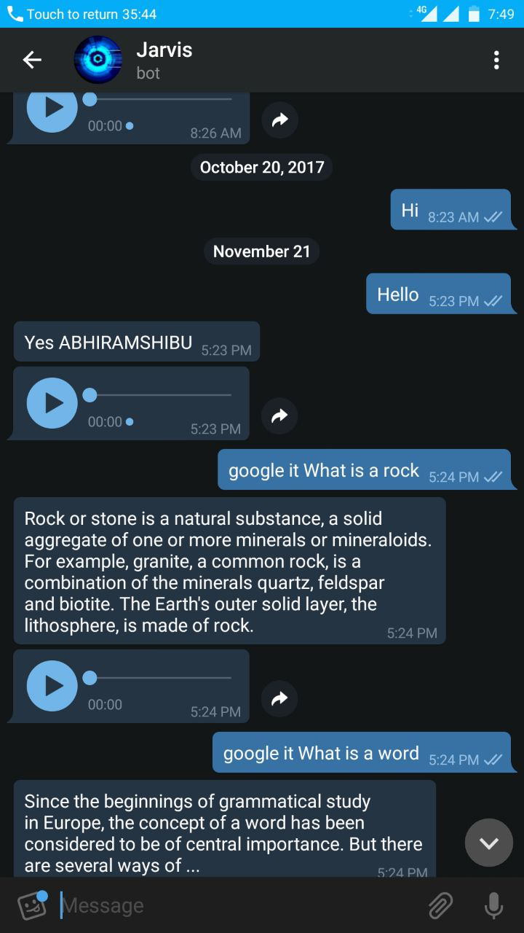
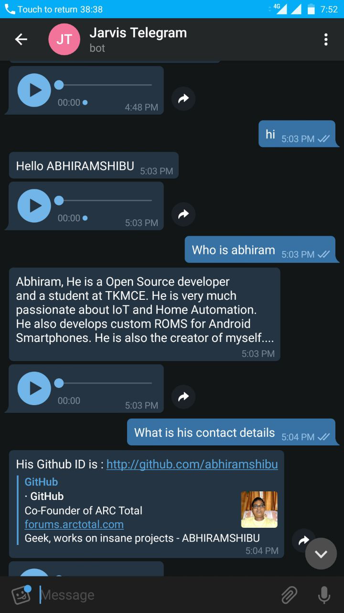
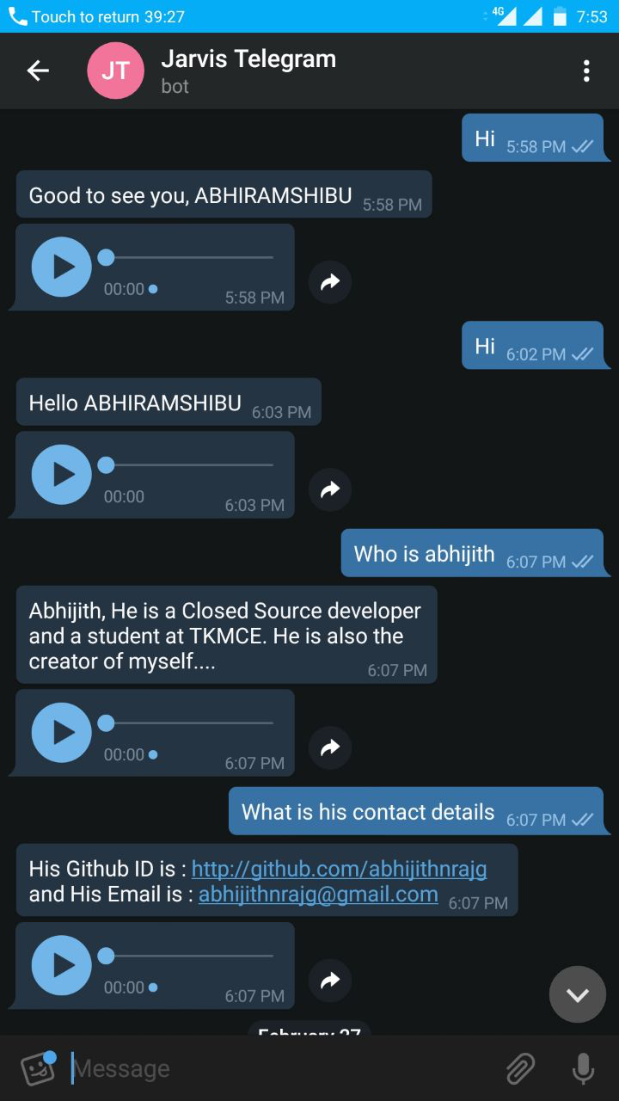

Our primary interface is a telegram chatbot. You can use the chatbot to communicate with SSAL when you are inside or outside the house. The communication is quite easy as it is simple dialogue or conversation based model. The artificial intelligence is quite superior in the sense that we focused more on the AI IoT integration. The AI is also capable of answering simple queries such as who designed you our what his name is etc. The advantage of using telegram chatbot was that it was a familiar interface for almost everyone and it supported our idea of SSAL being a ’friend at home’. Telegram also has end to end encryption providing for complete security over all conversations which is a bad news for all evesdroppers.
11.2.2 Desktop Command Line Application Interface
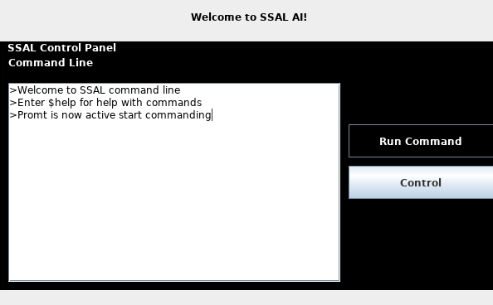

Our project is meant for both developers and end users and as such needed to provide an interface for both of them. Here shown in Figure is the interface for SSAL command line UI which will allow the programmers to configure, test, debug and run commands to IoT core and make development far easier.
11.2.3 Minimalistic UI for Programmer Configuration
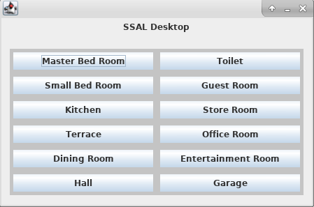

Given above is a simple UI meant only for debugging purposes after the configuration has been added and hence visual appeal has not been made a major concern as it is not a necessary specification here.
11.2.4 Telnet CLI for ESP8266
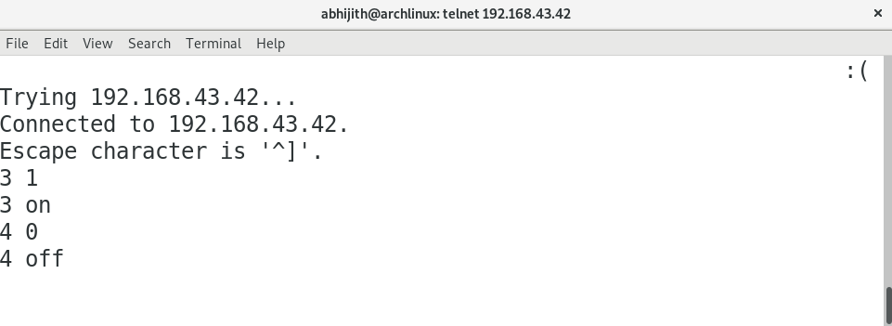

Since the communication protocols are established in wifi via telnet one can easily test the telnet connectivity by test commands after turning off the encryption on both sides.

11.2.5 Android Application
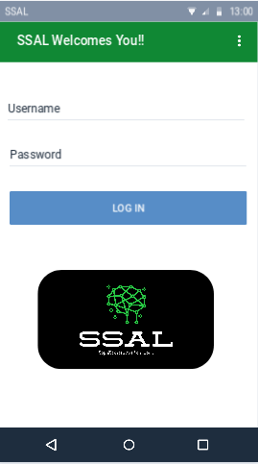
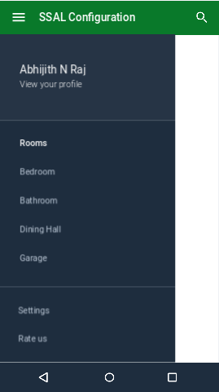

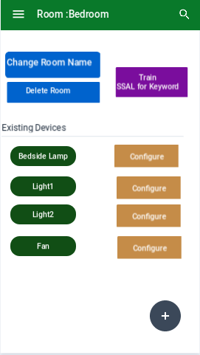
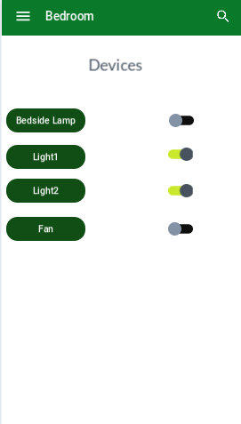

An android application can certainly help the end user in simply configuring the devices connected to the network. The Interface is pretty self explanatory because we went for an ergonomic design. Users can add new rooms and devices and train the AI for keyword identification from one page. All the complexity of the configuration are hidden behind the settings pannel which can be easily acessed from the top left corner of the screen.
PS: Not much effort has been made to explain the user interface. A common quote among designers goes along the lines of ”A user interface is like a joke. If you have to explain it, it’s not that good”.

11.3 Advantages of Our Design
Our design has the following advantages
- Modular design allowing easier debugging and integration with new devices
- Easy to use interface with visual appeal and ergonomics
- Seperate interfaces for development and end user applications
CHAPTER 12
CONCLUSIONS AND REFERENCES

12.1 SUMMARY OF THE DESIGN PROJECT
12.1.1 Product Selection
We began our design by identifying three important home automation devices available in the market- Google Home, Amazon Alexa and Apple Homepod.These were our main competition. Google Home had better AI in terms of search etc. Amazon Echo Dot had the best visual appeal. Apple Homepod had an ergonomic design but it lacked performance and was nothing more than a glorified speaker.
12.1.2 Design Tools
We chose the following design tools -
- Jupyter Notebook – Python IDE for data science, visualisation with a browser based user interface which can be run on a server
- Eclipse – Java IDE for developing the graphical user interface by using frameworks such as Swing, AWT etc
- Blender - A 3D design tool for graphical rendering
- Pycharm – Python IDE for machine learning,library support etc
- Arduino IDE – IDE for firmware design for Arduino
12.1.3 Feature Study And Comparison
After reviewing the selected products we identified several conventional features such as voice recognition, facial recognition, Artificial Intelligence etc. However we found out that there was no real integration with AI and IoT and the systems lacked security and privacy. So we created a new design - ’A closed system with an open source’ namely SSAL – SSAL is a Sophisticated Artificial Logic. SSAL had several features such as DOS(Dynamic online Switching), integration between AI and IoT devices, Electronic Failure Prediction. It also included conventional features as well.
12.1.4 User Experience And Analysis
Many of the users that we surveyed were not home automation users themselves owing to the high price of the products. Most of them were unsatisfied with the current solutions which lacked network security and privacy and supported open source solutions over closed sourced ones.Thus we identified the need existing in the market for our product which they confirmed when they said they were open to trying our product.
12.1.5 GUI Design
We compared the user interfaces for the chosen products and came to the conclusion that we needed to develeoped a modular design seperating AI and IoT part. We also needed to provide seperate interfaces for the end users and for the developers who are going to work on it.
12.1.6 Scalability And Deployability Study
The comparison on scalability and deployability on other products we identified that the methods used by these products were not really easy or user friendly. We decided to provide easy to install plug and play system with processing having multiple options via cloud or by a local server.
12.1.7 Performance Analysis
The analysis of performance on the selected products for comparison yielded the result that although most of the products had the processing power to do much more they act simply as an interface for the cloud based services which peeks into the privacy of the user. We decided to provide a faster, efficient method via the choice of cloud v/s local processing as our code was open sourced.
12.1.8 Safety And Security
We used heavy encryption to prevent network breaches and implemented our own communication protocols to provide security for the system. We made our code open sourced so that the vulnerabilities if any exists will be found and patched.
12.1.9 Maintenance and Handling
We provide rolling updates which the user can chose when to perform and since all our design is modular new devices can be easily integrated unlike the other products.
12.1.10 Cost And Pricing
The cost of the other products are heavy. Since we provided a modular approach our base cost is very less to get a system up and running.
12.1.11 Development of The Design
We created a minimalistic UI with all the complexities hidden. We also provided multiple user interfaces for different purposes like one for developers and another one for end users.

12.2 CONCLUSIONS
The main conclusion that can be drawn from the different phases of our design is that the existing products in the markets doesn’t have enough security and privacy and lacks integration with the IoT.
We created a product capable of solving this pitfalls. We also developed interfaces which were minimalistic. Multiple interfaces were designed for multiple purposes. The modular approach of the design allowed for a plug and play approach. Overall our system works much better in cost,performance,scalability and deployability of the other products.
12.2.1 Future of the Product
The future of the product include the following projects-
- Developer APIs making it easier for programming
- More faster and efficient machine learning models

12.3 REFERENCES
- https://www.apple.com/homepod/
- https://www.amazon.com/all-new-amazon-echo-speaker-with-wifi-alexa-dark-charcoal/dp/B06XCM9LJ4
- https://store.google.com/product/google_home
- https://en.wikipedia.org/wiki/HomePod
- https://en.wikipedia.org/wiki/Google_Home
- https://en.wikipedia.org/wiki/Amazon_Echo
- https://www.ifixit.com/Teardown/Amazon+Echo+Teardown/33953
- https://www.ifixit.com/Teardown/Google+Home+Teardown/72684
- https://www.ifixit.com/Teardown/HomePod+Teardown/103133

