***1.Open the OPENLANE Software***

cd Desktop/work/tools/openlane_working_dir/openlane

Desktop/work/tools/openlane_working_dir/openlane$ docker

./flow.tcl -interactive

% package require openlane 0.9

% prep –design picorv32a

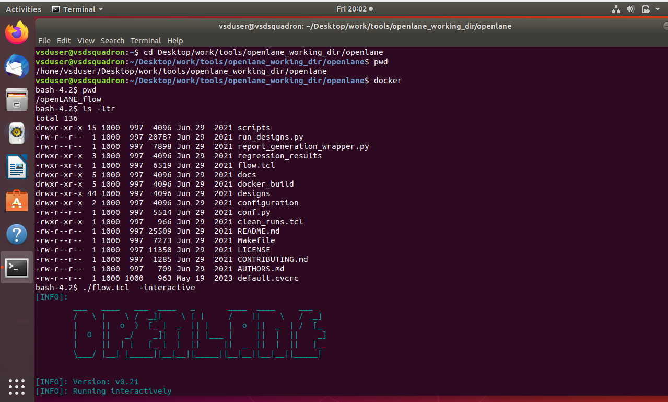

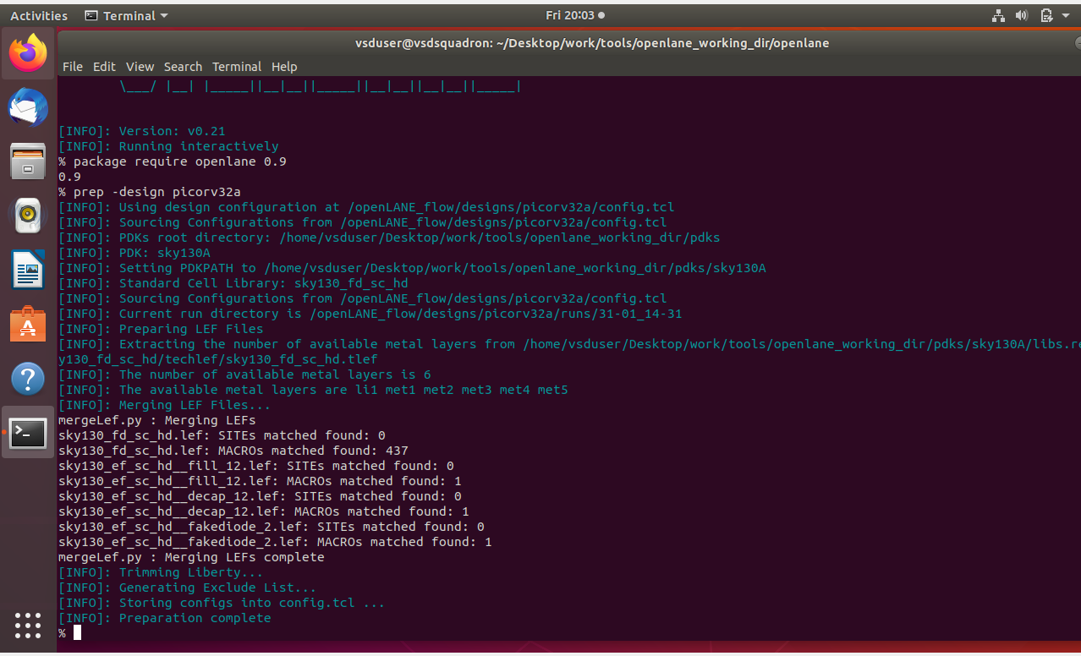

2.% run_synthesis (Command for Synthesis)

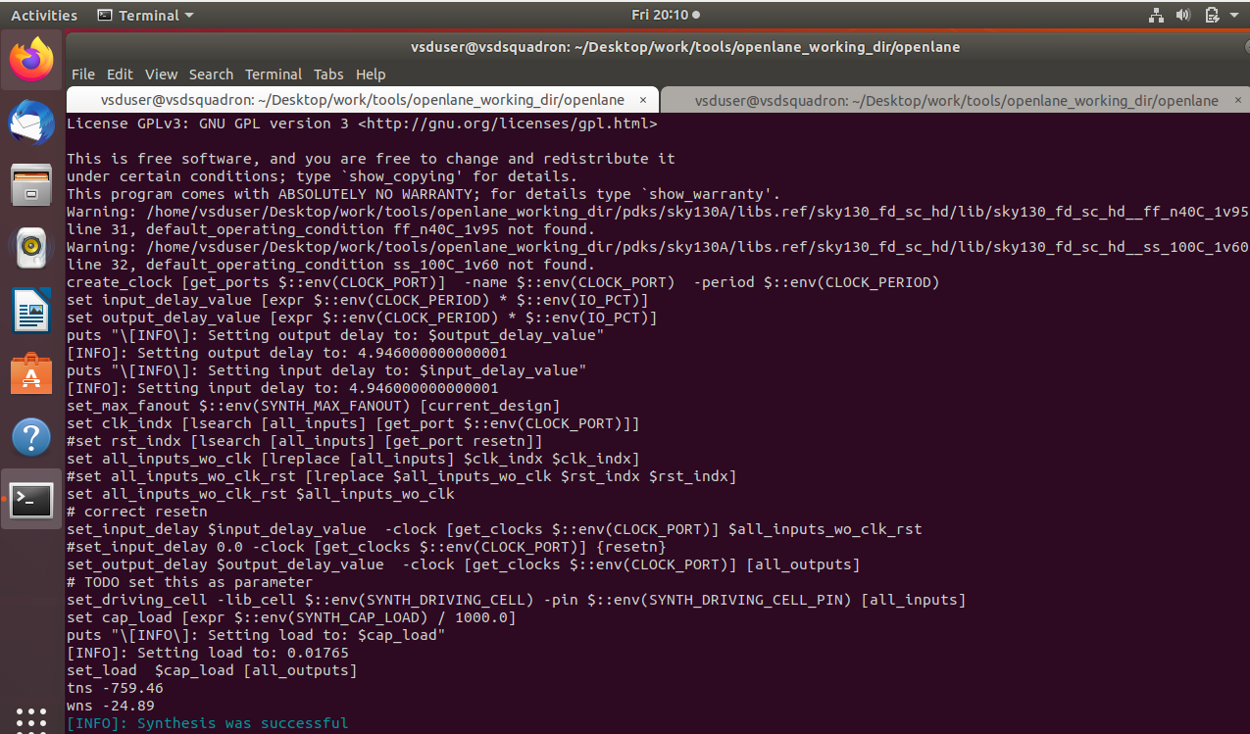

3.Reviewing synthesis results

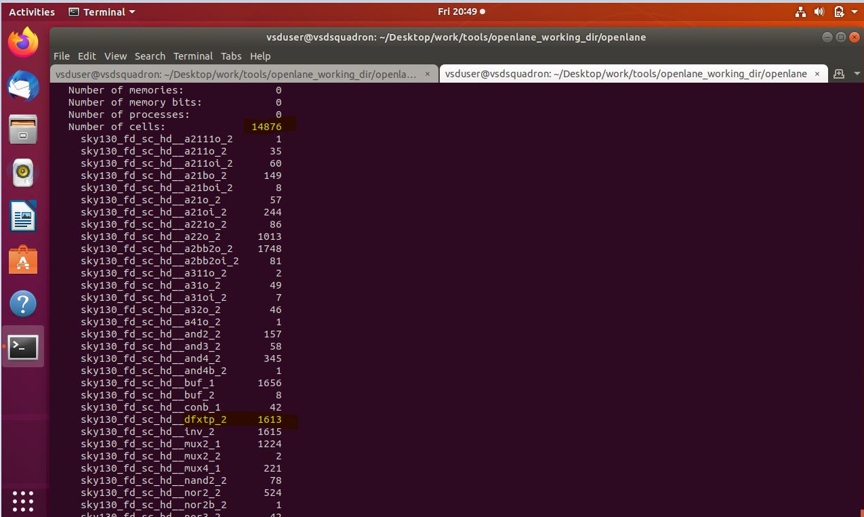

Flop ratio=Flipflop cell/Total number of cells

=1613/14876

* cd Desktop/work/tools/openlane_working_dir/openlane/designs/picorv32a/runs
* Desktop/work/tools/openlane_working_dir/openlane/designs/picorv32a/runs$ ls -ltr
* Desktop/work/tools/openlane_working_dir/openlane/designs/picorv32a/runs$ cd date_time
* Desktop/work/tools/openlane_working_dir/openlane/designs/picorv32a/runs/ date_time$ cd results
* Desktop/work/tools/openlane_working_dir/openlane/designs/picorv32a/runs/ date_time/results$

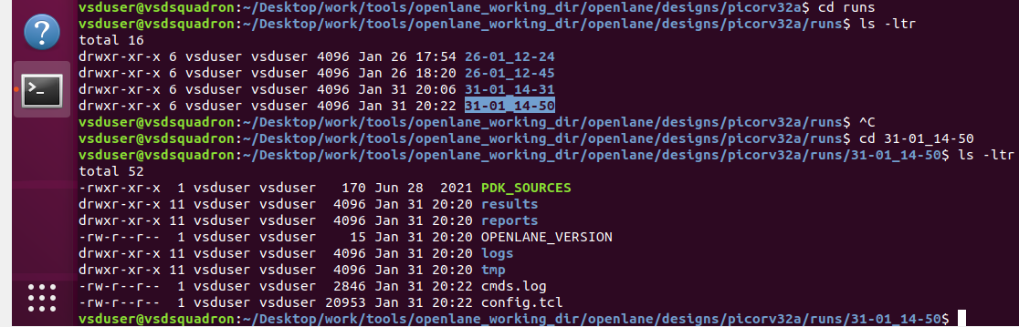

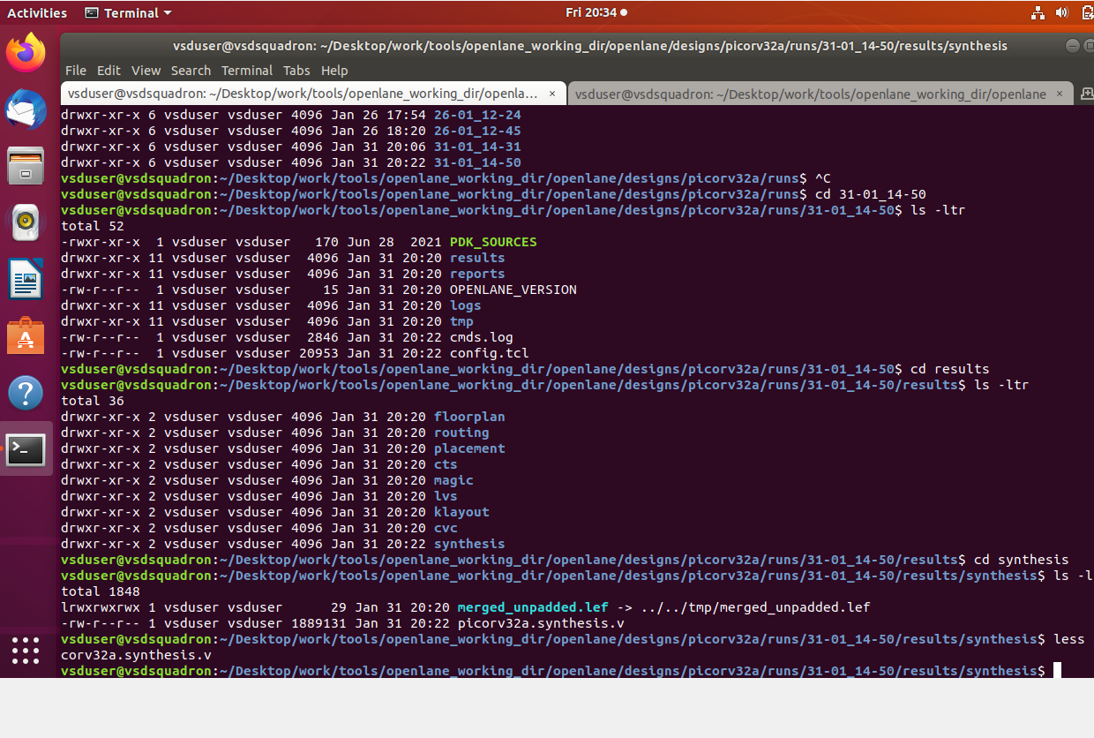

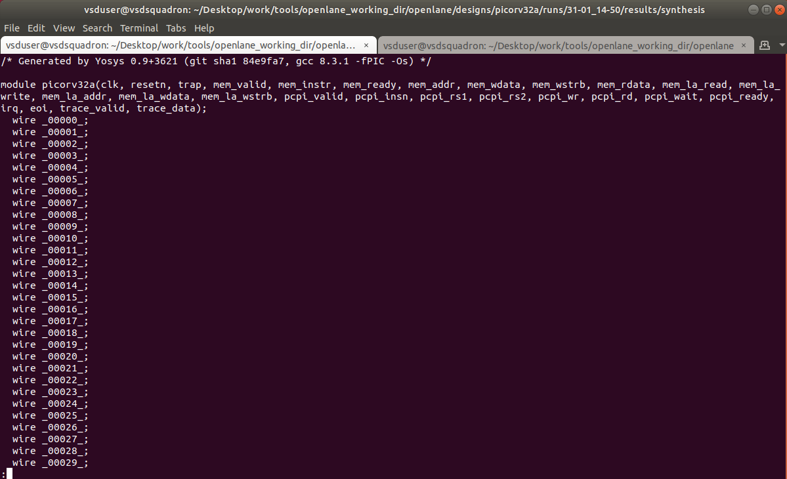

*4. FloorPlanning*

% run_floorplan

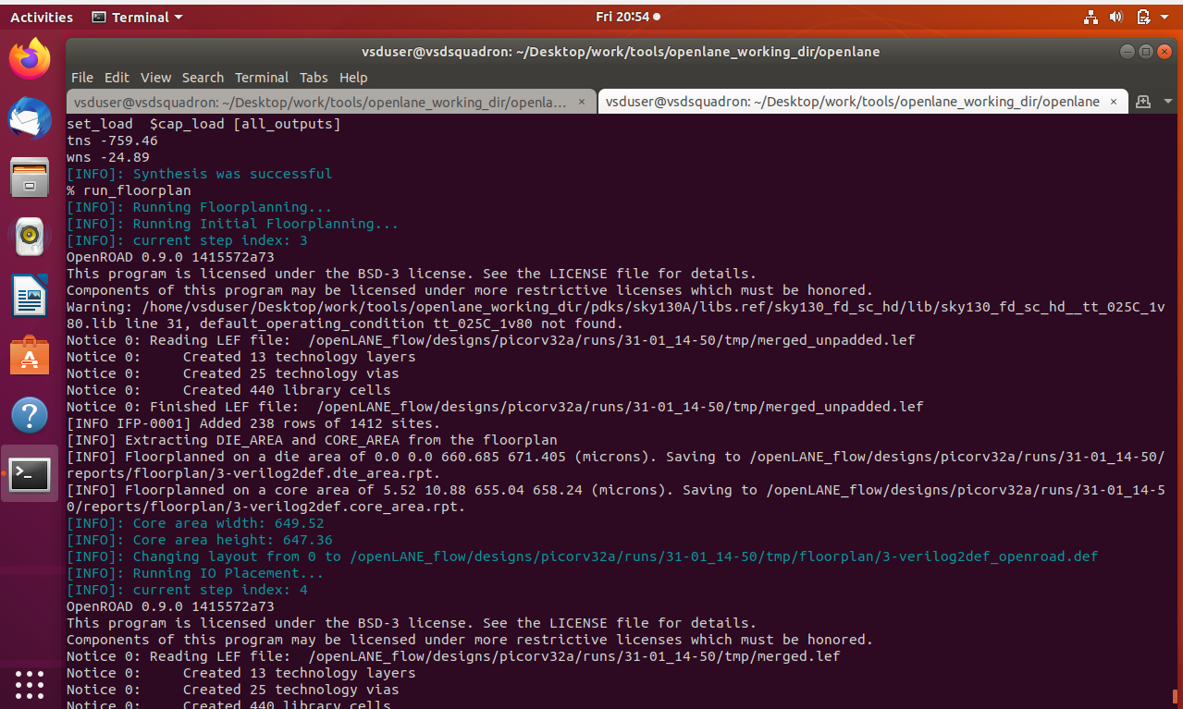

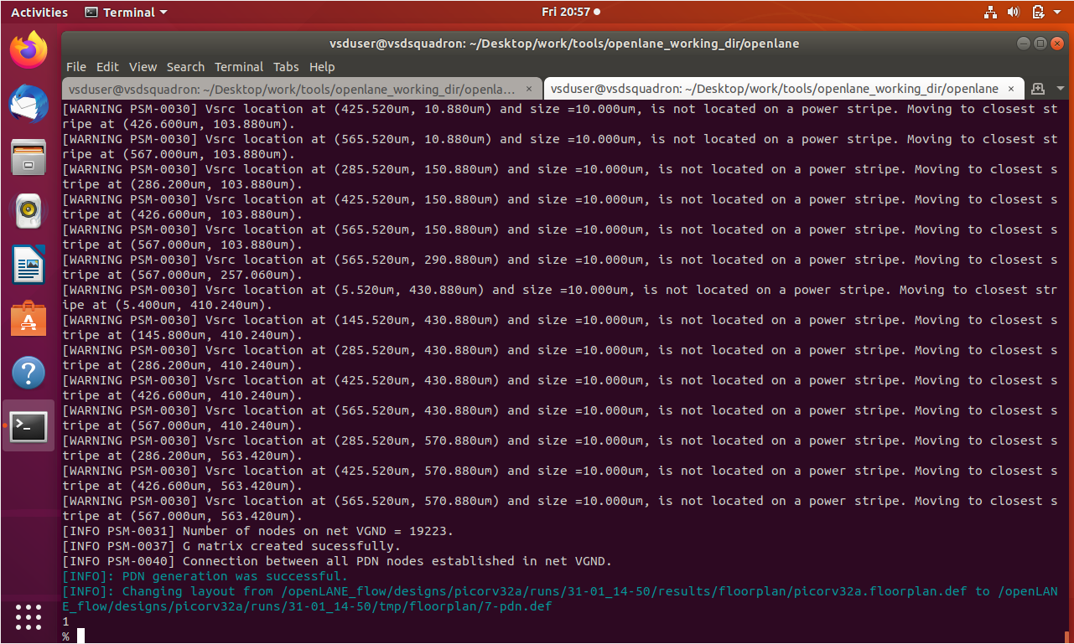

Finding Die Area in Micron

* Desktop/work/tools/openlane_working_dir/openlane/designs/picorv32a/runs/ date_time/ results/floorplan$ less picorv32a.floorplan.def

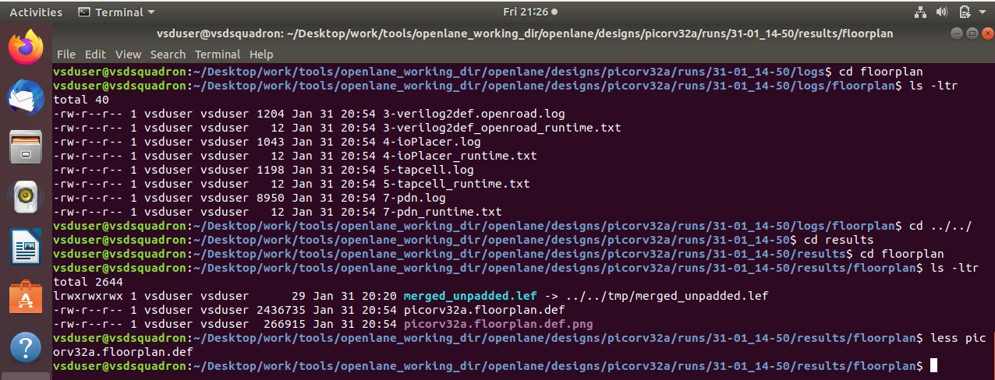

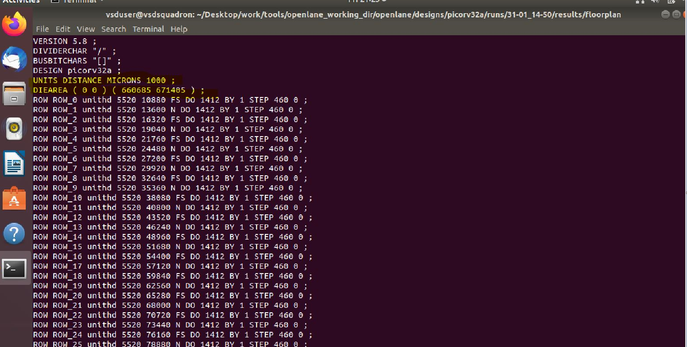

Open floorplan in Magic

* Desktop/work/tools/openlane_working_dir/openlane/designs/picorv32a/runs/ date_time/ results/floorplan$ magic –T /home/vsduser/Desktop/work/tools/openlane_working_dir/pdks/sky130A/libs.tech/ magic/ sky130A.tech.lef read ../../tmp/merged.lef def read picorv32a.floorplan.def &

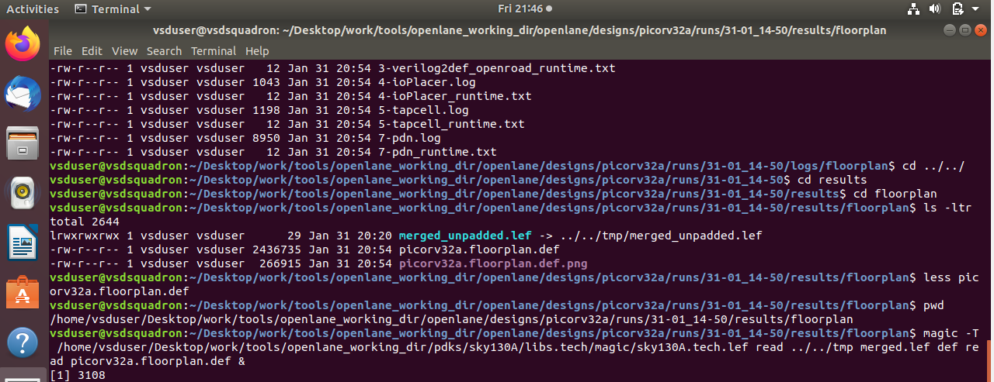

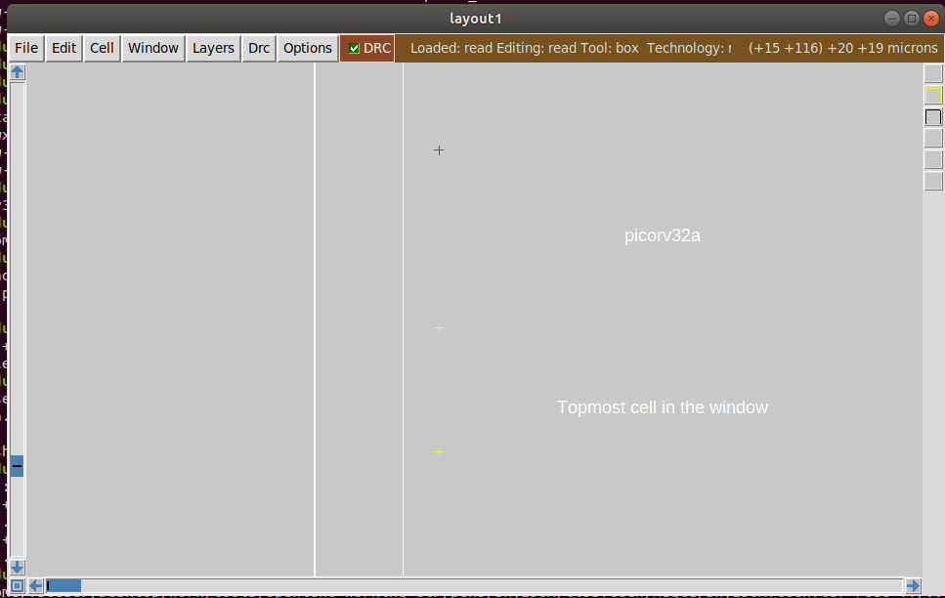

Placement

* Desktop/work/tools/openlane_working_dir/openlane/designs/picorv32a/runs/ date_time/ results/floorplan$ cd ../placement/
* Desktop/work/tools/openlane_working_dir/openlane/designs/picorv32a/runs/ date_time/ results/ placement$ magic –T /home/vsduser/Desktop/work/tools/openlane_working_dir/pdks/sky130A/libs.tech/ magic/ sky130A.tech.lef read ../../tmp/merged.lef def read picorv32a.placement.def &