**PROJECT DESCRIPTION**

The project involves deploying IoT sensors to measure noise pollution in public areas and providing real-time noise level data accessible to the public through a platform or mobile app. The primary objective is to raise awareness about noise pollution and enable informed decision-making. This project includes defining objectives, designing the IoT sensor system, developing the noise pollution information platform, and integrating them using IoT technology and Python.

**ABSTRACT OF IDEA**

* The rapid urbanization and population growth in cities have led to an increase in noise pollution, posing significant challenges to public health and urban planning.
* This project proposes the development of an IoT-based noise monitoring system designed to provide real-time noise level data in public areas.
* The system leverages a network of calibrated microphones strategically deployed across urban environments, interfaced with microcontrollers and cloud-based platforms.
* This data is then accessible to the public through a user-friendly web application and mobile interface.

**IOT SENSOR DESIGN**

* It should be designed in place determined remote locations it should be freely operate in its range and it should be sensible to all the possible interventions so it shall can be efficiently determine the noise pollution
* The data should be easy to accommodate and should be able to transmit data with minimum delay and losses possible
* we could use NodeMCU ESP8266-12E board with its characteristics to perform various operations at minimum loss,
* the basic circuit we would be using be:

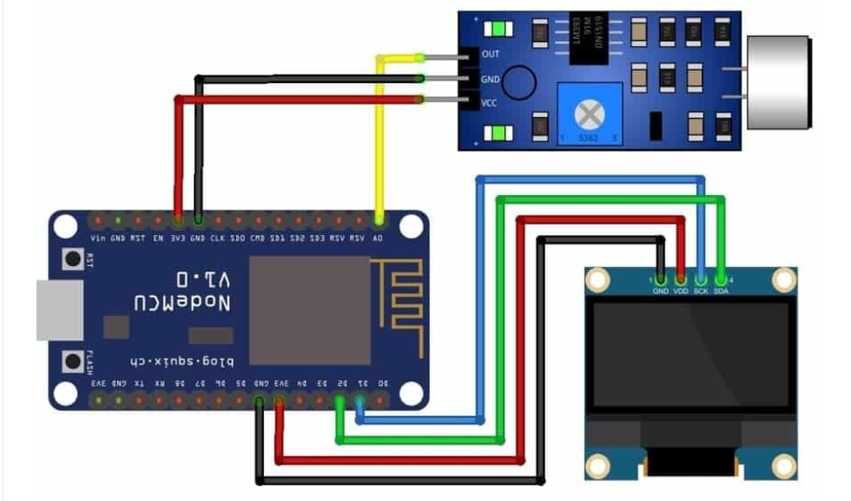

**NOISE POLLUTION INFORMATION PLATFORM**

* + To transmit information from the board to the mobile device or platform we are utilizing to deliver the noise characteristics, we could utilize an IOT-based internet router and a module.
  + We will also distinguish between the sound signals (weak depending on the type of effect it is making).
  + When the noise patterns are noticeable on a broad scale, governmental power may be able to take the appropriate measures.
  + The information platform would increase public knowledge of the negative impacts of noise pollution, such as stress-related illnesses, high blood pressure, speech impediment, hearing loss, disrupted sleep, and decreased productivity.

**INTEGRATION APPROACH**

* An ADC to transform analog audio signals into digital data signals for analysis and interpretation using the decibel system.
* To ensure security and data interoperability, the data should be communicated to the nearby device using functional protocols like wi-fi and Bluetooth.
* Thus, the information would be shown on a viable platform or on an LCD screen.
* It could be classified as low, medium, or high depending on the intensity of the various noise signals are.