**Introduction and Problem Statement**

As cities continue to grow and become more densely populated, noise pollution has become a growing concern. High noise levels can lead to stress, sleep disturbances, and various health problems. Additionally, urban planners need accurate data to make informed decisions regarding noise control and city development. This project aims to provide a solution for these issues.This issue involves:

* **System Architecture:**

The IoT-based noise monitoring system comprises several key components:

* **Calibrated Microphones:** A network of calibrated microphones is deployed throughout the urban environment. These microphones are strategically located in areas of interest, such as busy streets, parks, residential neighborhoods, and industrial zones. They are specifically designed to capture a wide range of frequencies and accurately measure noise levels.
* **Cloud-Based Platforms:** The processed noise data is stored, managed, and made accessible through cloud-based platforms. Cloud infrastructure ensures scalability, data redundancy, and accessibility from anywhere with an internet connection.
* . **User Interface:** The noise level data is made available to the public through a user-friendly web application and a mobile interface. Users can access real-time noise level information in various parts of the city, view historical data, and receive notifications or alerts when noise levels exceed certain thresholds.
* **Benefits:**
* **Public Awareness:** Citizens can be more aware of noise pollution in their areas and take measures to reduce their exposure.
* **Urban Planning:** City planners can make informed decisions about noise control, zoning regulations, and infrastructure development.
* **Health and Well-being:** Public health officials can use this data to study the effects of noise pollution and implement policies to improve public health.
* **Components and Hardware:**
* **NodeMCU ESP8266-12E:** This is a popular development board for IoT projects, equipped with a Wi-Fi module. It's cost-effective, compact, and compatible with the Arduino IDE, making it a suitable choice for your project.
* **Microphone Sensor**: To capture noise levels, you'll need a microphone sensor. Electret condenser microphones are commonly used in IoT noise monitoring systems. These sensors convert sound waves into electrical signals, which can be measured by the NodeMCU.

* **Power Supply**: Power the NodeMCU via its micro USB port, LiPo battery, or an external 3.3V power source, depending on your deployment scenario and power requirements.
* **Voltage Divider (if required):** The NodeMCU operates at 3.3V, while the microphone sensor may require a different voltage level. A voltage divider can help match the voltage levels.
* **Pull-up/Pull-down Resistors:** To ensure stable signal readings and avoid floating inputs, use pull-up or pull-down resistors where necessary.

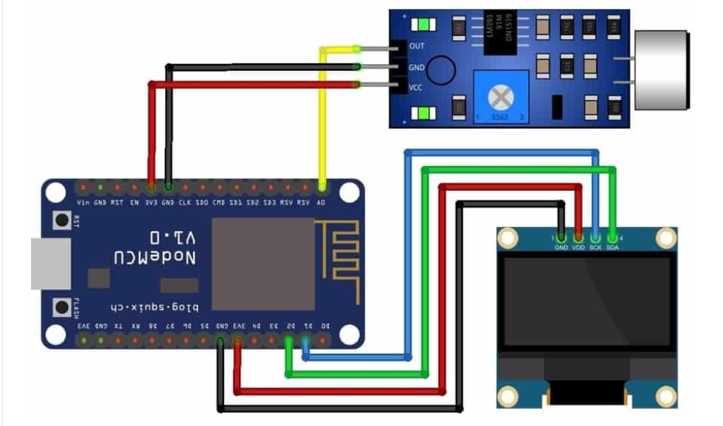

**Noise pollution information platform.**

* The Noise Pollution Information Platform is a system designed to transmit noise data from IoT-based sensors to mobile devices and online platforms. It aims to raise public awareness of the detrimental effects of noise pollution while enabling authorities to take necessary actions when significant noise patterns emerge.IoT-based sensors, such as the NodeMCU ESP8266-12E, collect noise data and transmit it to the platform through an internet router and module. This allows for real-time monitoring and data transmission to mobile devices and online platforms.The system can distinguish between various types of noise signals, categorizing them based on their intensity and impact. For instance, it can recognize weak signals associated with background noise versus loud or disruptive sounds.When noise patterns reach noticeable levels on a broad scale, the system can trigger alerts to relevant governmental authorities. These alerts can prompt actions such as noise regulation enforcement, zoning changes, or infrastructure adjustments to mitigate noise pollution in affected areas.

**Data Integration**

* The system includes an Analog-to-Digital Converter (ADC) to transform analog audio signals from the microphone sensor into digital data. This digitization process is essential for subsequent analysis and interpretation. The system measures noise levels in decibels (dB), providing a standardized and quantifiable measure of sound intensity.
* Data Communication Protocols: To ensure data security and interoperability, the system uses functional communication protocols such as Wi-Fi and Bluetooth. Wi-Fi can facilitate long-range communication with remote servers and cloud platforms, while Bluetooth enables local and short-range connectivity with nearby devices.
* Data Presentation: The processed noise data is presented on a user-friendly platform or displayed on an LCD screen. This can be a mobile app or a web interface for remote access, or an LCD screen for real-time on-site monitoring. The data visualization can include real-time noise levels, historical trends, and noise intensity classification.
* Noise Intensity Classification: The system classifies noise levels into different categories, such as low, medium, or high, based on the intensity of the noise signals. This classification helps users quickly assess the current noise situation and make informed decisions or take appropriate actions.
* Alerts and Notifications: To enhance user experience and situational awareness, the system can send alerts and notifications when noise levels reach certain thresholds or change significantly. This feature ensures that users are promptly informed of noise disturbances.
* **Challenges:**
* There are several challenges to address, including the calibration and maintenance of the microphones, data security and privacy, ensuring network connectivity in remote areas, and integrating the system with existing urban infrastructure.
* In conclusion, the proposed IoT-based noise monitoring system is a valuable tool for addressing the growing issue of noise pollution in rapidly urbanizing cities. It offers real-time data to the public and stakeholders, ultimately contributing to more informed decision-making, improved public health, and enhanced urban planning.