**Noise Level Monitoring System - Abstract Documentation**

**Overview**

A sophisticated web-based program designed to retrieve and display real-time noise level data from external noise detectors is called the Noise Level Monitoring System. It maintains a detailed record of noise data and provides users with an easy-to-use interface for monitoring and analyzing the noise levels coming from these external devices. This specialized system was developed to address the unique requirements of users who depend on data from external noise detectors for their monitoring needs by offering precise and actual data.

**Key Features**

**Real-time Noise Level Display**

* The system features a prominent display of the current noise level in decibels (dB).
* The value is updated at regular intervals to provide accurate and up-to-date information
* Users can initiate or halt the noise level monitoring process with the "Start Monitoring" button.
* The button toggles between "Start Monitoring" and "Stop Monitoring" depending on the current monitoring status
* The system maintains a table of historical noise level data.
* Each entry includes the timestamp and corresponding noise level recorded
* High noise levels are visually flagged with an alert, helping users quickly identify problematic periods.

**Design.**

* The user interface is designed to be clean, user-friendly, and aesthetically pleasing.
* It features a responsive layout for optimal viewing on various devices.
* The color scheme is chosen to provide a pleasant visual experience while ensuring readability.
* The system provides feedback to users through text updates and button labels to indicate the current status of the monitoring process.

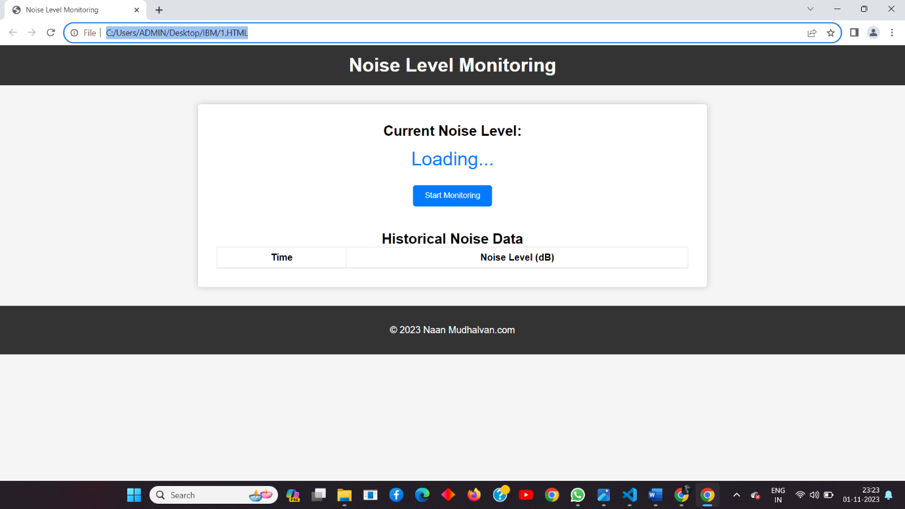

**Website Design**

**Components and Hardware:**

* **NodeMCU ESP8266-12E:** This is a popular development board for IoT projects, equipped with a Wi-Fi module. It's cost-effective, compact, and compatible with the Arduino IDE, making it a suitable choice for your project.
* **Microphone Sensor**: To capture noise levels, you'll need a microphone sensor. Electret condenser microphones are commonly used in IoT noise monitoring systems. These sensors convert sound waves into electrical signals, which can be measured by the NodeMCU.

* **Power Supply**: Power the NodeMCU via its micro USB port, LiPo battery, or an external 3.3V power source, depending on your deployment scenario and power requirements.
* **Voltage Divider (if required):** The NodeMCU operates at 3.3V, while the microphone sensor may require a different voltage level. A voltage divider can help match the voltage levels.
* **Pull-up/Pull-down Resistors:** To ensure stable signal readings and avoid floating inputs, use pull-up or pull-down resistors where necessary.

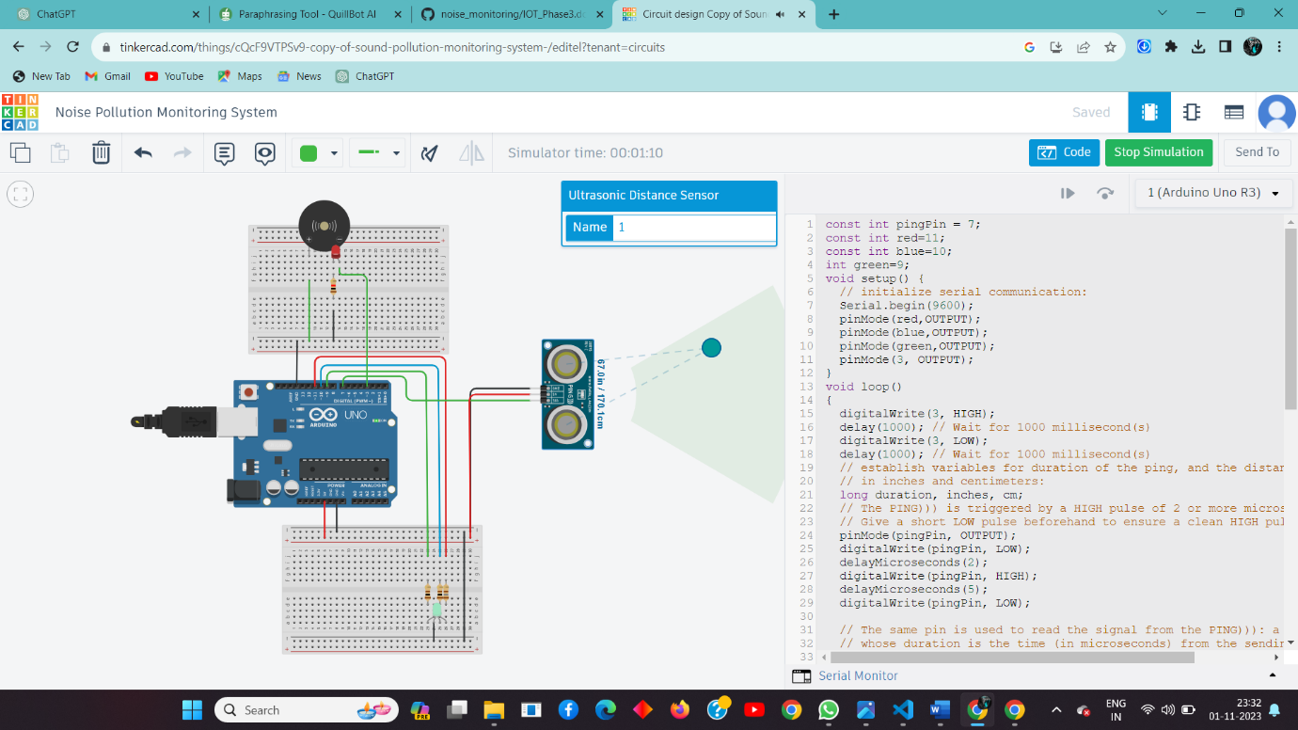

**Tinkercad software Simulation**

**Technical Implementation**

* HTML, CSS, and JavaScript are used to create the user interface and handle dynamic updates.
* Noise levels are generated randomly within a specified range to simulate real-time data.
* Historical data is stored in an array, limiting the number of entries to maintain a manageable record.
* User interactions, such as starting or stopping monitoring, are managed through event listeners in JavaScript.
* The system updates the noise level and historical data at regular intervals for real-time monitoring.

**Future Enhancements**

* Implementing a backend server to store and retrieve historical data for long-term tracking
* Adding user accounts and authentication for personalized monitoring and data management
* Allowing users to set custom thresholds for noise levels that trigger alert
* Incorporating geolocation features to track noise levels in specific areas or environments.

**Implementation:**

Thus,the Noise Level Monitoring System provides a reliable real-time noise level monitoring solution with an intuitive user interface, aesthetically pleasing design, and strong scalability to accommodate growing demand. The system is well-suited to deal with noise pollution and involve the community in noise reduction initiatives thanks to its modular architecture and consideration for future improvements.

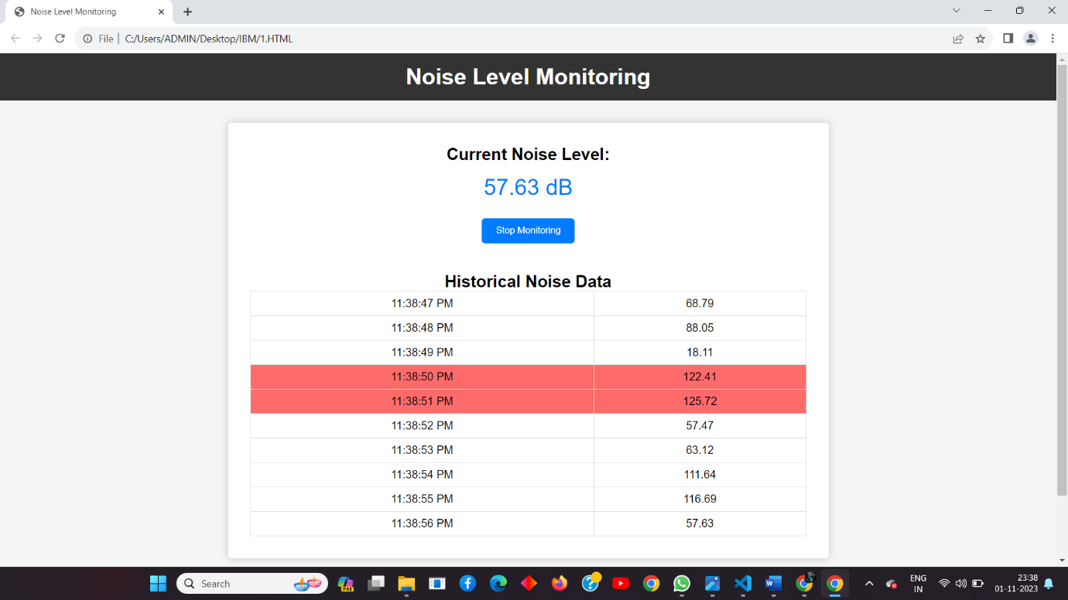

**Conclusion**

The Noise Level Monitoring System provides an effective solution for real-time noise level monitoring with user-friendly features and a visually appealing interface. Its modular design allows for easy integration of additional functionalities in the future.

**Team Members:**

|  |  |  |  |  |
| --- | --- | --- | --- | --- |
| **S.no** | **Name** | **Department** | **Register No** | **Email** |
| 1 | Abhishek Kumar M | ECE | 721221106001 | 21eca01@karpagamtech.ac.in |
| 2 | Dharun Kumar N | ECE | 721221106019 | 21eca19@karpagamtech.ac.in |
| 3 | Harishwar A | ECE | 721221106033 | 21eca33@karpagamtech.ac.in |