# Curriculum Vitae

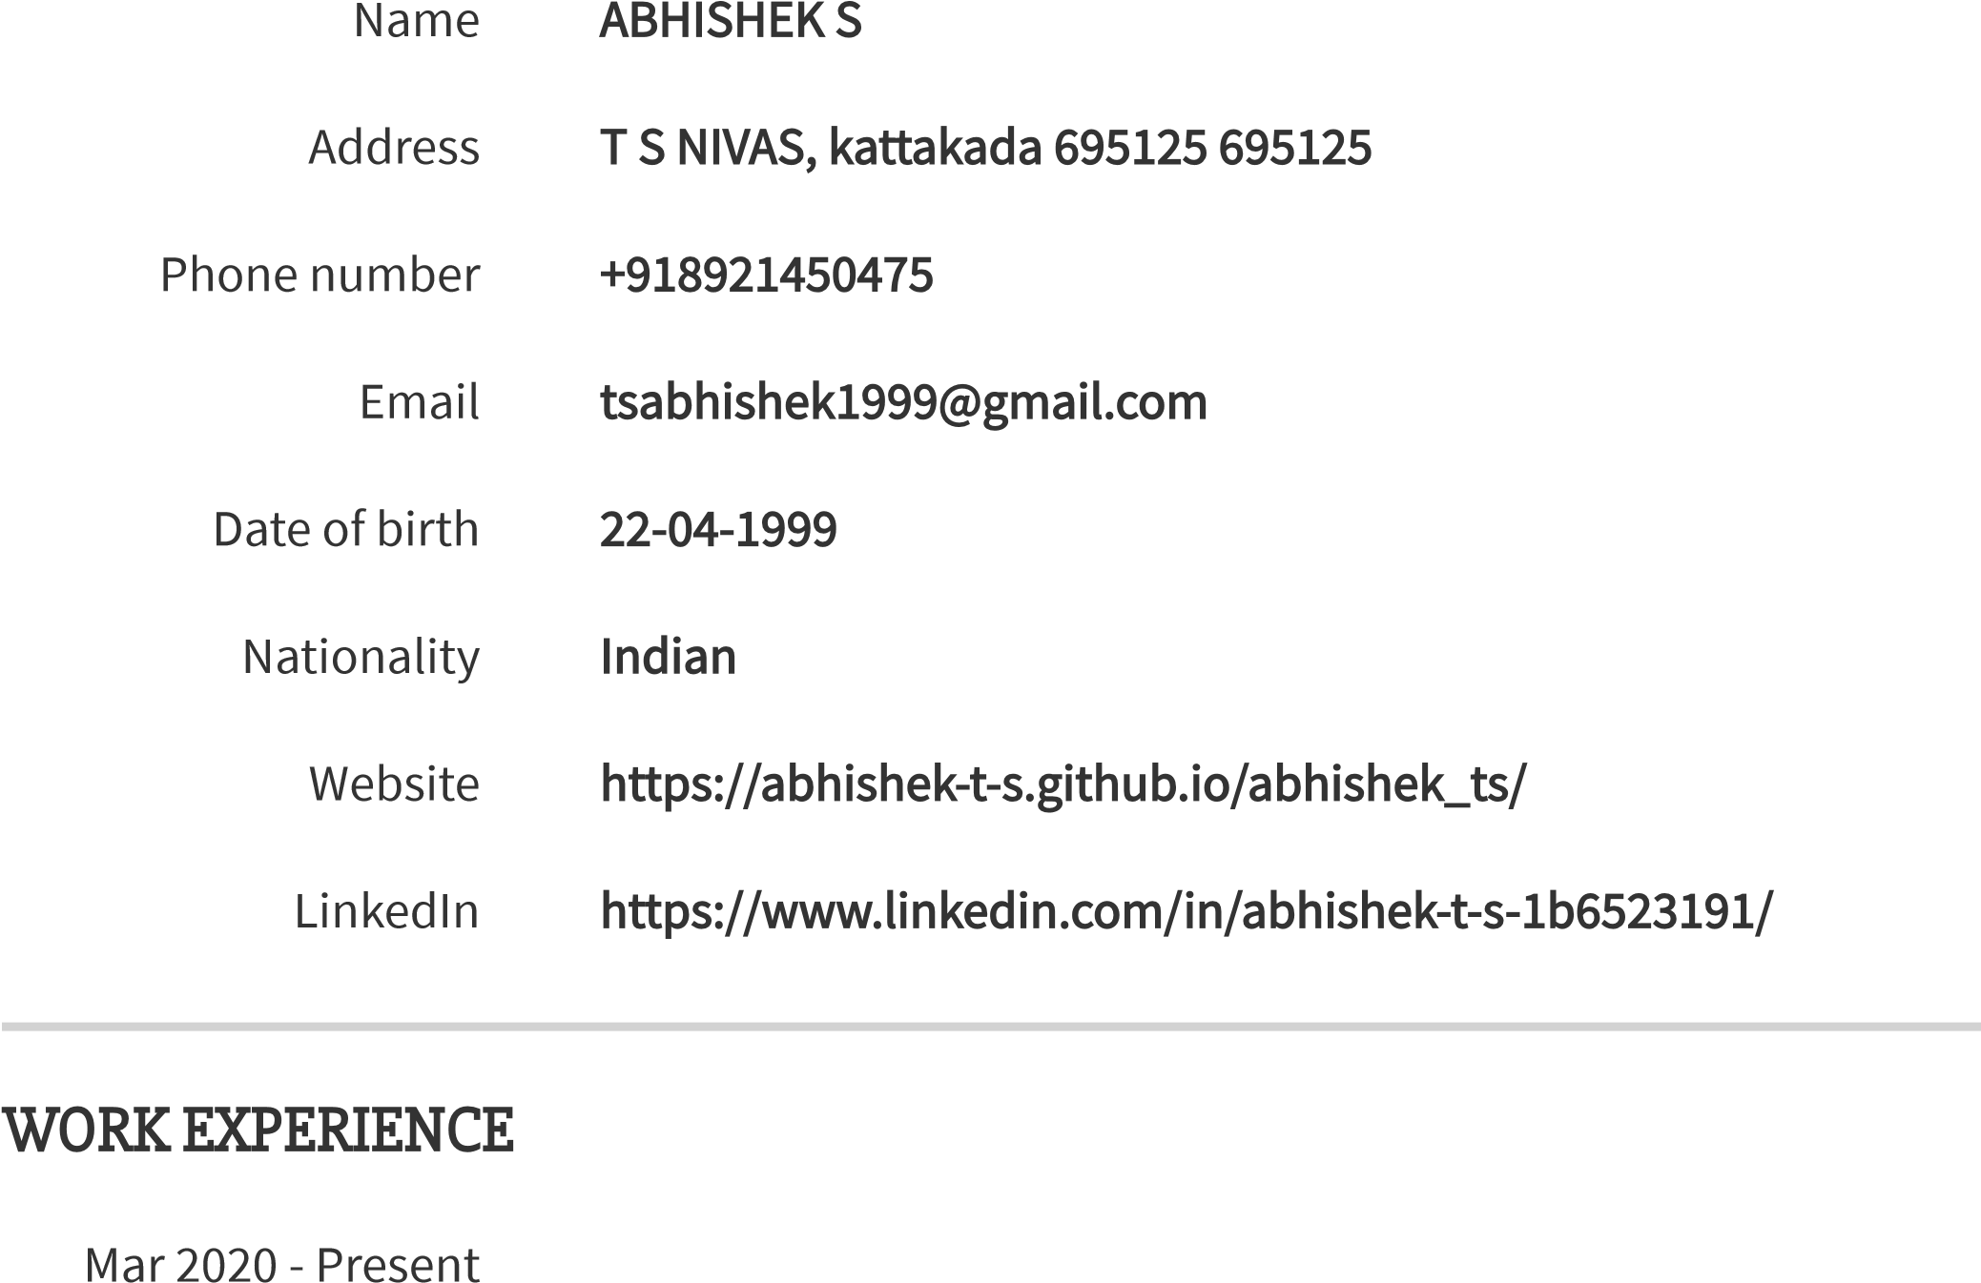

Freelancer , Thiruvananthapuram

Jul 2017 - Jul 2021

A P J Abdul Kalam Technological University

Jun 2015 - Jun 2017

LMS Higher Secondary School , Chemboor, kattakada

Traveling , Keep updated with new Technologies

SKILLS

HTML

CSS

JavaScript

React JS

Node JS

Mango DB

https://api.cvmaker.nl/resumes/5050b1279c2f32d0388eb892252a7592f1c9bbaa/preview/5/333333/sDV3LnAHaa8sTCg 2/2