**Architecture Design:**

**FIFA-19**

**Data Analysis**



**Last Date** **of Revision:28/12/2022**

**Submitted By: Abhishek Sachan**

**Content:**

1. **Introduction**
   1. **What is an Architecture Design Document?**
   2. **Scope**
2. **Architecture**
   1. **Tableau Architecture**
   2. **Component of Tableau Architecture**
3. **Deployment**
   1. **Tableau Deployment**
   2. **Publish datasets and report from Tableau**

**1. Introduction:**

**1.1 What is an Architecture Design Document?**

**Any software needs** **architectural design to** **represent the design of software. IEEE defines architectural design as “the process of defining a collection of hardware and software components and their interfaces to establish the framework for the development of a computer system.” The software that is built for computer-based systems can exhibit one of these many architectures.**

**Each style will describe a system category that consists of:**

**• A set of components (****e.g.: a database, computational modules) that will perform a function**

**required by the system.**

**• The set of connectors will help in coordination, communication, and cooperation between**

**the components.**

**• Conditions that how components can be integrated to form the system.**

**• Semantic models that help the designer to understand the overall properties of the**

**System.**

**1.2 What is Scope?**

**Architecture Design Document (ADD) is an architecture design process that follows a step-by-step refinement process. The process can be used for designing data structures, required software architecture, source code and ultimately, performance algorithms. Overall, the design principles may be defined during requirement analysis and then refined during architectural design work.**

**2 Architecture:**

**2.1 Tableau Public Architecture**

**Tableau Server is designed to connect many data tiers. It can connect clients from Mobile, Web, and Desktop. Tableau Desktop is a powerful data visualization tool. It is very secure and highly available.**

**It can run on both physical machines and virtual machines. It is a multi-process, multi-user, and multi-threaded system.**

**Providing such powerful features requires unique architecture.**

**The different layers used in Tableau server are given in the following architecture** **diagram: -**

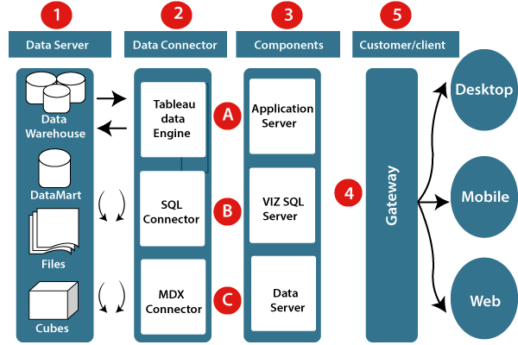

**2.2 Component of Tableau Architecture:**

**1. Data server:- The primary component of Tableau Architecture is the Data sources which can connect to it.**

**Tableau can connect with multiple data sources. It can blend the data from various data sources. It can connect to an excel file, database, and a web application at the same time. It can also make the relationship between different types of data sources.**

**2. Data connector:- The Data Connectors provide an interface to connect external data sources with the Tableau Data Server.**

**Tableau has in-built SQL/ODBC connector. This ODBC Connector can be connected with any databases without using their native connector. Tableau desktop has an option to select both extract and live data. On the uses basis, one can be easily switched between live and extracted data.**

* **Real-time data or live connection: Tableau can be connected with real data by linking to the external database directly. It uses the infrastructure existing database by sending dynamic multidimensional expressions (MDX) and SQL statements.**
* **Extracted or in-memory data: Tableau is an option to extract the data from external data sources. We make a local copy in the form of Tableau extract file. It can remove millions of records in the Tableau data engine with a single click. Tableau's data engine uses storage such as ROM, RAM, and cache memory to process and store data.e.**

**3. Components of Tableau server: Different types of component of the Tableau server are:**

* + **Application server**
  + **VizQL server**
  + **Data server**

**A. Application server: The application server is used to provide the authorizations and authentications. It handles the permission and administration for mobile and web interfaces.**

**B. VizQL server: VizQL server is used to convert the queries from the data source into visualizations. Once the client request is forwarded to the VizQL process, it sends the query directly to the data source retrieves information in the form of images. This visualization or image is presented for the users. Tableau server creates a cache of visualization to reduce the load time. The cache can be shared between many users who have permission to view the visualization.**

**C. Data server: Data server is used to store and manage the data from external data sources. It is a central data management system. It provides data security, metadata management, data connection, driver requirements, and data storage. It stores the related details of data set like calculated fields, metadata, groups, sets, and parameters.**

**4. Gateway: The gateway directed the requests from users to Tableau components. When the client sends a request, it is forwarded to the external load balancer for processing. The gateway works as a distributor of processes to different components.**

**5. Clients:** The visualizations and dashboards in Tableau server can be edited and viewed using different clients. Clients are **a web browser, mobile applications**, and **Tableau Desktop**.

* + **Web Browser:** Web browsers like **Google Chrome, Safari**, and **Firefox** support the Tableau server. The visualization and contents in the dashboard can be edited by using these web browser.
  + **Mobile Application:** The dashboard from the server can be interactively visualized using mobile application and browser. It is used to edit and view the contents in the workbook.
  + **Tableau Desktop:** Tableau desktop is a business analytics tool. It is used to **view, create**, and **publish** the dashboard in Tableau server. Users can access the various data source and build visualization in Tableau desktop

**3. Deployment:**

**3.1 Tableau Deployment:**

**Tableau prioritizes choice in flexibility to fit, rather than dictate, your enterprise architecture. Tableau Server and Tableau Cloud leverage your existing technology investments and integrate into your IT infrastructure to provide a self-service, modern analytics platform for your users. With on-premises, cloud, and hosted options, there is a version of Tableau to match your requirements.**

|  |  |  |
| --- | --- | --- |
| TYPE | PROS | CONS |
| Tableau Server - On Premises | Full control of hardware and software  Infrastructure and data remain behind your firewall | Need dedicated administrators to manage hardware and software  Additional infrastructure needed to access off-network (mobile, external) |
| Tableau Server - Public Cloud (IaaS) | Full control of software on managed hardware  Puts infrastructure in same place as data (for migration to cloud)  Flexibility to spin up/down hardware as needed | Need dedicated administrators to manage software  Additional infrastructure needed to access off-network (mobile, external) |
| Tableau Cloud (SaaS) | Fully hosted solution (hardware, software upgrades)  Fast to deploy  Easy for external audience to access | Single site in multi-tenant environment  Cubes are not supported  No guest account access |

**3.2 Publish Datasets** **and Reports from Tableau Public:**

**Tableau public is the free edition by Tableau. This tool has several limitations ranging from;**

* **Fewer data connections.**
* **Not being able to save workbooks locally or packaging workbooks.**
* **Not being able to export workbooks in other formats like images and PDFs.**
* **The fact that – this tool can only save work in the Tableau public server only.**

**To share your craft when working with Tableau public – you MUST publish your work in the Tableau public server. If you do not have a Tableau public account – head over the link below and get one.**

**To publish your dashboard with Tableau public – head over to the File menu and select Save to Tableau Public As…**

