**High Level** **Design(HLD)**

**FIFA 19 DATA ANALYTICS**



**Submitted By: Abhishek Sachan**

**Last Date of Revision:28/12/2022**

**Content**

**Abstract**

1. **Introduction** 
   1. **Why this** **High-Level Design Document** **4**
   2. **Scope. 4**
2. **General Description**
   1. **Product** **Perspective & Problem Statement 5**
   2. **Tools Used 5**
3. **Design Details**
   1. **Function** **Architecture 6**
   2. **Optimization 7**
4. **KPI**
   1. **Key P****erformance Indicator 9**
5. **Deployment 12**

**Abstract:**

[**FIFA**](https://en.wikipedia.org/wiki/FIFA_(video_game_series)) **is one of the most popular football simulation video games of all times. I am sure that not only me but most of the people (I guess the majority would be males) probably played this game once in their life. Especially if you are a football fan, then you played this game not only once. I, as a football fan, have played FIFA’s series for a long period of time, especially during my school years, and never got bored. :)**

**football fans also play football video games** **in order to maintain and live its excitement over and over again.** [**EA’s FIFA**](https://www.ea.com/games/fifa)**Football simulation video games have a very long history in** **the game industry and their FIFA series have been** **played** **by many users. Recently, while I was doing my research about finding a good dataset, I found** [**FIFA 19**](https://www.ea.com/games/fifa/fifa-19) **players dataset on Ineuron site and got very excited about it. Because I love football and my job in data space, I wanted to do my own analysis in this dataset.**

**1.Introduction**

**1.1 Why this High-Level Design Document?**

**The purpose of this High-Level Design (HLD) Document is to add the necessary detail to the current project description to represent a suitable model for coding. This document is also help detect contradictions before coding and can be used as a reference manual for how the modules Interact at high level.**

**The HLD will:**

* **Present** **all the design aspects and define them in detail**
* **Describe the user interface being implemented**
* **Describe the hardware and software interfaces**
* **Describe the performance requirements**
* **Include design features and the architecture of the project**
* **List and describe the non-functional attributes like:**

**Security**

**o Reliability**

**o Maintainability**

**o Portability**

**o Reusability**

**o Application compatibility**

**o Resource utilization**

**o Serviceability**

**1.2 Scope:**

**The HLD documentation presents the structure of the system, such as the database**

**architecture, application architecture (layers), application flow (Navigation), and technology**

**architecture. The HLD uses non-technical to** **mildly technical terms which should be**

**understandable to the administrators of the system.**

**2. General Description:**

**2.1 Product Perspective & Problem Statement**

**The goal of this project to** **analyzed to top 10 strikers, top 10** **goalkeeper and top 10 Mid Filder and their wages and their overall rating.**

**How wages of player will affect due to its weight and** **penalties and** **aggression.Sum** **of Wages of player will also** **depend on nationality and different club level** **leagues which player participates.**

**In jupyter notebook I** **analyzed how player age and** **height, and** **weight affect their overall rating and how many** **players are high paying and their positions can also affect their features like vision,accerlation,sprint,vision and long passes etc.**

**In** **SQL** **predict best playing squad of** **30 players in which 3** **goalkeeper,7 defender,10 mid fielder and 10** **striker. Based on their various skilled** **factors like Penalites,LongShots,Finishing,Dribling,Ball Control,Long Passing,Short Passing etc.**

**2.2 Tools Used:**

**Business i****ntelligence tools like Tableau Public and libraries works such** **as** **NumPy** **,****Pandas****,** **Matplotlib,** **Seaborn,** **requests, OS, Jupyter-Notebook,** **MS Excel, MySQL and Python are used to build the whole framework.**

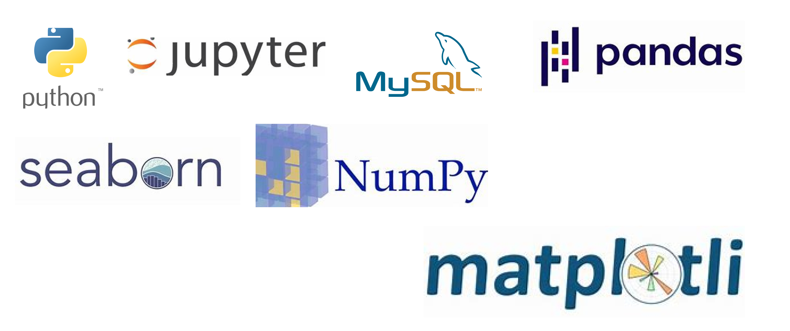

**3. Design Details:**

**3.1 Functional** **Architecture:**

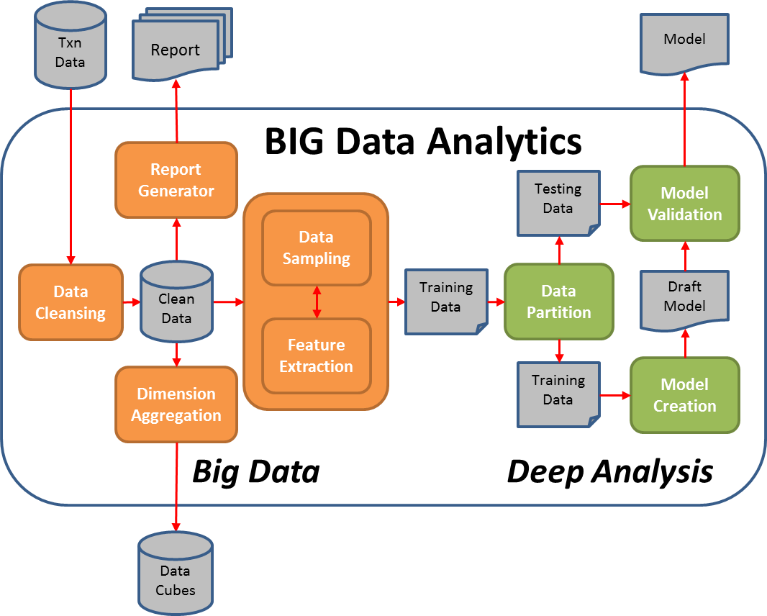

**3.2 How BI Tool Worked:**

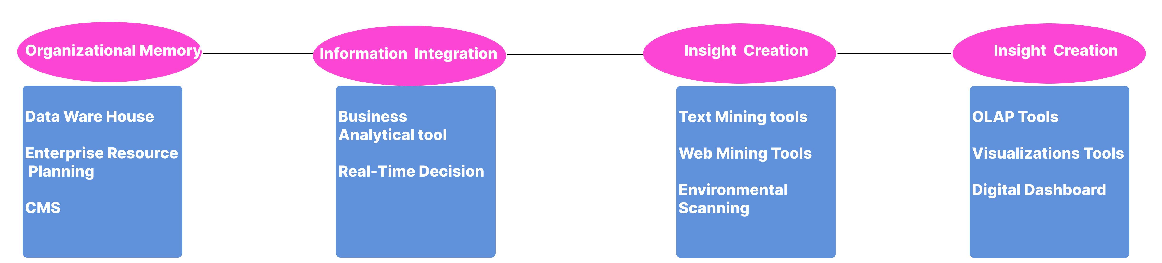

**3.2 Optimization:**

**Your data strategy drives performance**

**• Minimize the number of fields**

**• Minimize the number of records**

**• Optimize extracts to speed up future queries by materializing calculations, removing columns and the use of accelerated views**

**Reduce the marks (data points) in your view**

**• Practice guided analytics. There’s no need to fit everything you plan to show in a single**

**view. Compile related views and connect them with action filters to travel from overview**

**to highly-granular views at the speed of thought.**

**• Remove unneeded dimensions from the detail shelf.**

**• Explore. Try displaying your data in different types of views.**

**Limit your filters by number and type**

**• Reduce the number of filters in use. Excessive filters on a view will create a more**

**complex query, which takes longer to return results. Double-check your filters and**

**remove any that aren’t necessary.**

**• Use an include filter. Exclude filters load the entire domain of a dimension, while**

**include filters do not. An include filter runs much faster than an exclude filter, especially**

**for dimensions with many members.**

**Optimize and materialize your calculations**

**• Perform calculations in the database**

**• Reduce the number of nested calculations.**

**• Reduce the granularity of LOD or table calculations in the view. The more granular**

**the calculation, the longer it takes**

**• Where possible, use MIN or MAX instead of AVG. AVG requires more processing**

**than MIN or MAX. Often rows will be duplicated and display the same result with**

**MIN, MAX, or AVG.**

**4 KPI:**

**Dashboards will be implemented to display and indicate certain KPIs and relevant indicators**

**for the** **disease. As and when, the system starts to capture the historical/periodic data for a user, the**

**dashboards will be included to display charts over time with progress on various indicators or**

**Factors.**

**4.1 Key Performance Indicator:**

* **Wages**
* **Ages**
* **Weights**
* **Nationality**
* **Acceleration**
* **Strength**
* **Vision**
* **Sprint Speed**
* **Long shorts**
* **Finishing**
* **Overall Rating of Player**
* **Position Of Player**
* **Short Power**
* **Sliding Tackel**
* **Header Accuracy**

**5 Deployment:**

