Objective:

Develop machine learning models to classify emotions in text samples.

Dataset:

<https://drive.google.com/file/d/1HWczIICsMpaL8EJyu48ZvRFcXx3_pcnb/view?usp=drive_link>

Key components to be fulfilled :

1. Loading and Preprocessing (3 marks)

* Load the dataset and perform necessary preprocessing steps. This should include text cleaning, tokenization, and removal of stopwords. Explain the preprocessing techniques used and their impact on model performance.

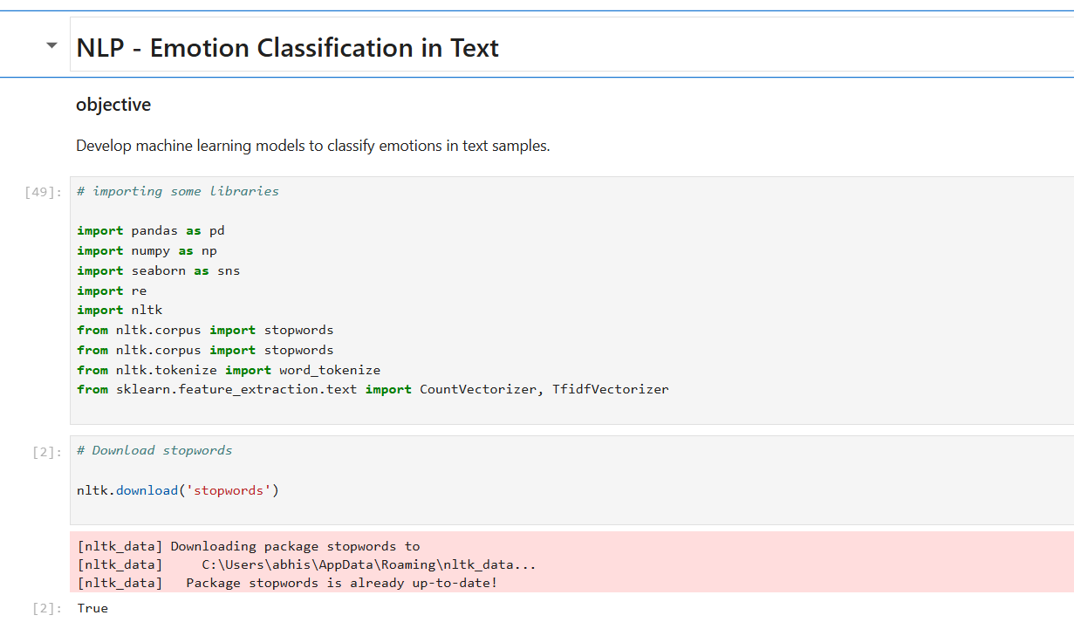

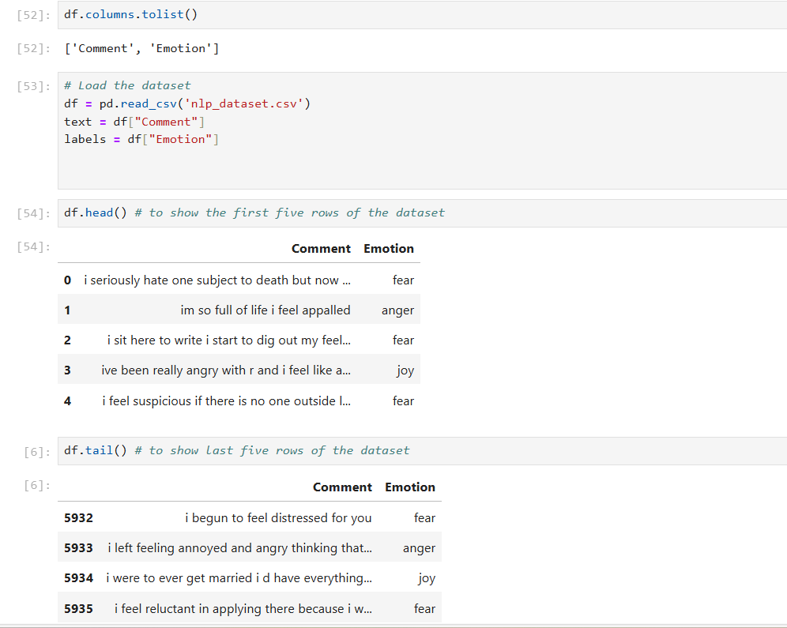

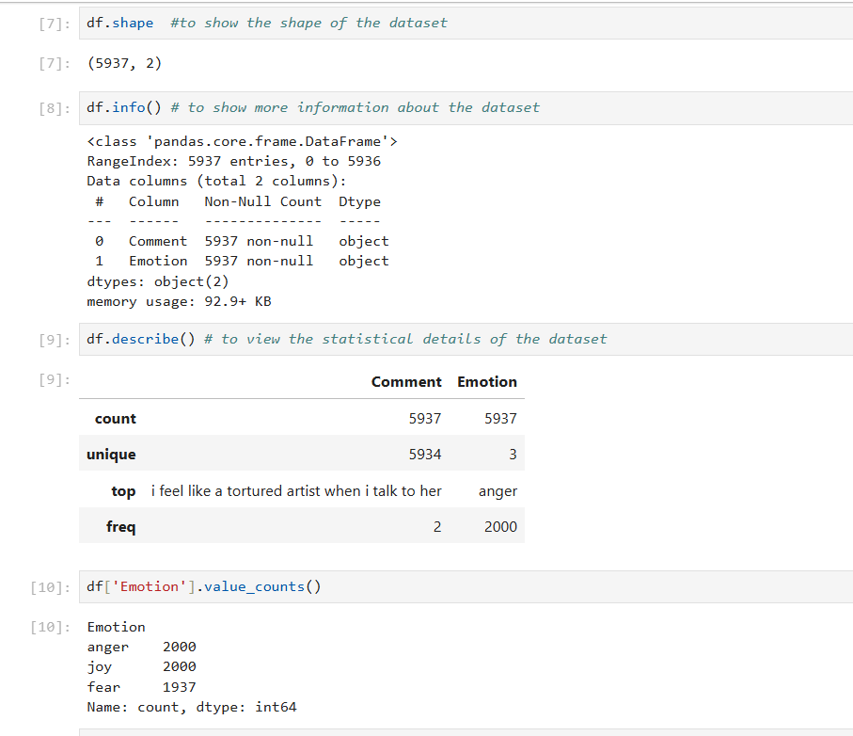

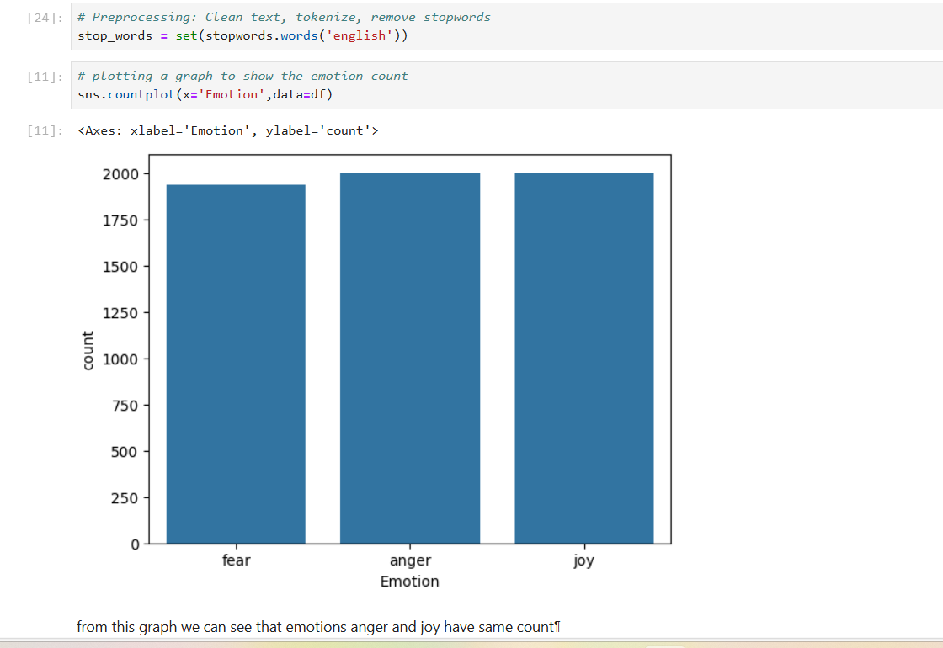

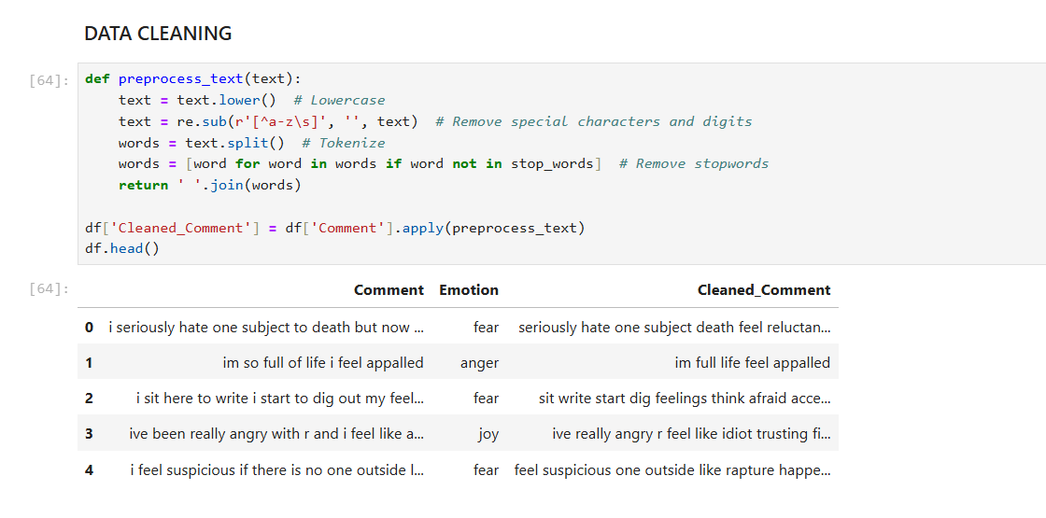

2. Feature Extraction (2 marks):

* Implement feature extraction using CountVectorizer or TfidfVectorizer. Describe how the chosen method transforms the text data into numerical features.

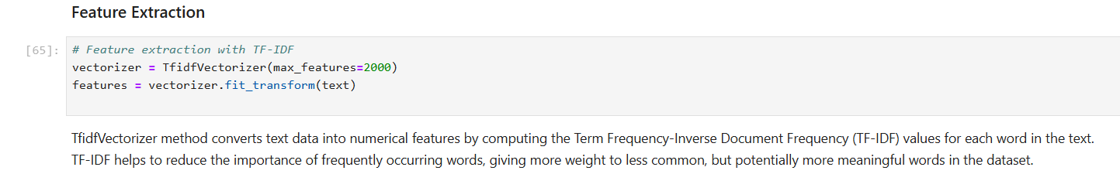

3. Model Development (2 marks):

* Train the following machine learning models

**a)Naive Bayes b)Support Vector Machine**

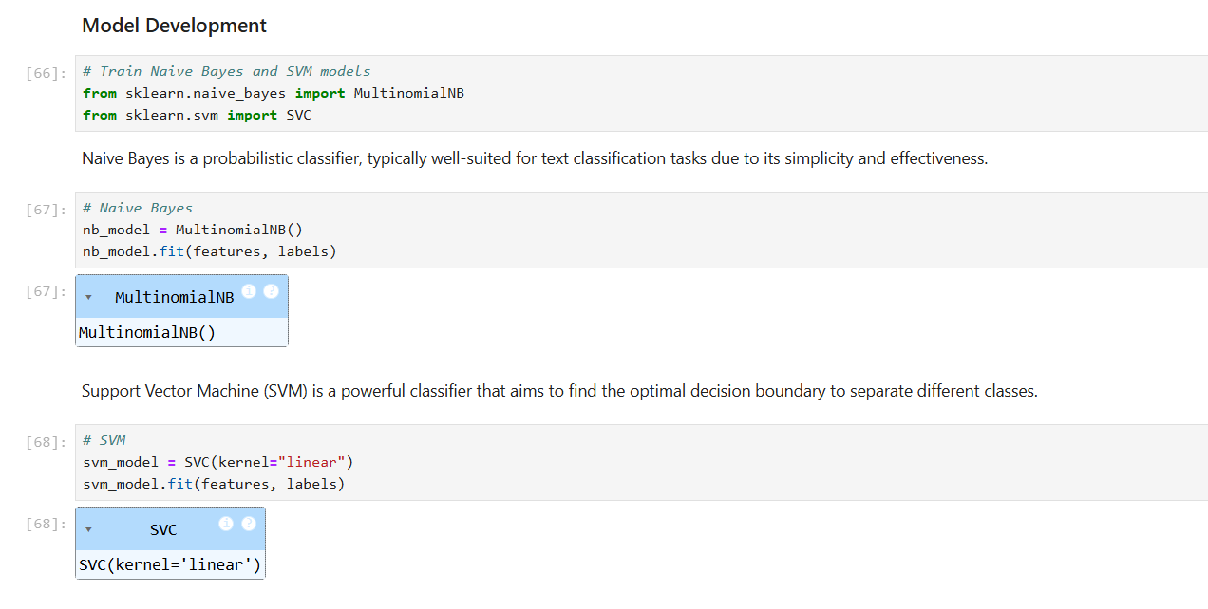

4. Model Comparison (2 marks)

* Evaluate the model using appropriate metrics (e.g., accuracy, F1-score). Provide a brief explanation of the chosen model and its suitability for emotion classification.

