**Answers (Sessional-1)**

**Q1.BioDATA**

**<!DOCTYPE html>**

**<html lang="en">**

**<head>**

**<meta charset="UTF-8">**

**<meta name="viewport" content="width=device-width, initial-scale=1.0">**

**<title>Biodata</title>**

**<style>**

**body {**

**font-family: Arial, sans-serif;**

**max-width: 800px;**

**margin: 0 auto;**

**padding: 20px;**

**border: 1px solid #e72222;**

**border-radius: 10px;**

**}**

**h1,**

**h2,**

**h3 {**

**color: #333;**

**}**

**h1 {**

**font-size: 24px;**

**margin-bottom: 10px;**

**}**

**h2 {**

**font-size: 20px;**

**margin-bottom: 10px;**

**}**

**h3 {**

**font-size: 16px;**

**margin-bottom: 10px;**

**}**

**p {**

**margin-bottom: 10px;**

**}**

**table {**

**width: 100%;**

**border-collapse: collapse;**

**margin-bottom: 20px;**

**}**

**th,**

**td {**

**border: 1px solid #ccc;**

**padding: 8px;**

**}**

**th {**

**background-color: #f2f2f2;**

**}**

**.header {**

**text-align: center;**

**}**

**.about-me,**

**.education,**

**.experience,**

**.skills,**

**.certifications {**

**margin-bottom: 20px;**

**}**

**</style>**

**</head>**

**<body>**

**<!-- Ques:1- Create and Style a Biodata**

**Task:**

**Create a resume using HTML and CSS that includes the following**

**sections:**

**Header:**

**Name**

**Job Title**

**Number**

**Email**

**About Me Section:**

**A brief paragraph about the individual's professional background and**

**skills.**

**Education Section:**

**A table with columns for Degree, Institution, and Year of Graduation.**

**Experience Section:**

**A list of job experiences with each job title, company name, and job**

**description in separate paragraphs.**

**Skills Section:**

**A list of skills, with each skill presented in a paragraph.**

**Certifications Section:**

**A table listing certifications with columns for certification name and**

**year.**

**Requirements:**

**HTML:**

**Structure the resume using appropriate HTML elements, including**

**headings, paragraphs, lists, and tables.**

**Use <table> elements for organizing education and certification details.**

**CSS:**

**Style the resume to make it professional and easy to read.**

**Include styling for the header, section titles, tables, and paragraphs.**

**Ensure that the resume is centered on the page with a maximum width**

**of 800px.**

**Add padding and borders where necessary for clarity and aesthetics.**

**Your Task:**

**Write the HTML and CSS code to create and style this resume. -->**

**<div class="resume">**

**<div class="header">**

**<h1>Biodata</h1>**

**<h1>Abhishek Kumar</h1>**

**<h2> Data Analyst</h2>**

**<p>Number:4547984654</p>**

**<p>Email:**

**<a href="mailto:0221csds002@niet.co.in">**

**0221csds002@niet.co.in**

**</a>**

**</p>**

**</div>**

**<div class="about-me">**

**<h3>About Me</h3>**

**<p>I am an analyst with a solid foundation in statistical analysis, data mining, and predictive modeling.**

**Skilled in leveraging tools like SQL, Python, and Excel to interpret and visualize complex datasets,**

**enabling data-driven decision-making</p>**

**</div>**

**<hr>**

**<div class="education">**

**<h3>Education</h3>**

**<table>**

**<tr>**

**<th>Degree</th>**

**<th>Institution</th>**

**<th>Year of Graduation</th>**

**</tr>**

**<tr>**

**<td>B.tech in Computer Science (Data Science)</td>**

**<td>NIET GR Noida</td>**

**<td>2026</td>**

**</tr>**

**</table>**

**</div>**

**<hr>**

**<div class="experience">**

**<h3>Experience</h3>**

**<p>Job Title: Data Analyst</p>**

**<p>Company Name: Google</p>**

**<p>Job Description:As a </p>**

**</div>**

**<hr>**

**<div class="skills">**

**<h3>Skills</h3>**

**<p>Machine Learning</p>**

**<p>Power BI</p>**

**<p>SQL</p>**

**<p>MongoDB</p>**

**<p>Hadoop</p>**

**</div>**

**<hr>**

**<div class="certifications">**

**<h3>Certifications</h3>**

**<table>**

**<tr>**

**<th>Coursera</th>**

**<th>2023</th>**

**</tr>**

**<tr>**

**<td>Python For Data Science</td>**

**<td>2023</td>**

**</tr>**

**<tr>**

**<td>Big Data Analysis</td>**

**<td>2024</td>**

**</tr>**

**</table>**

**</div>**

**</div>**

**</body>**

**</html>**

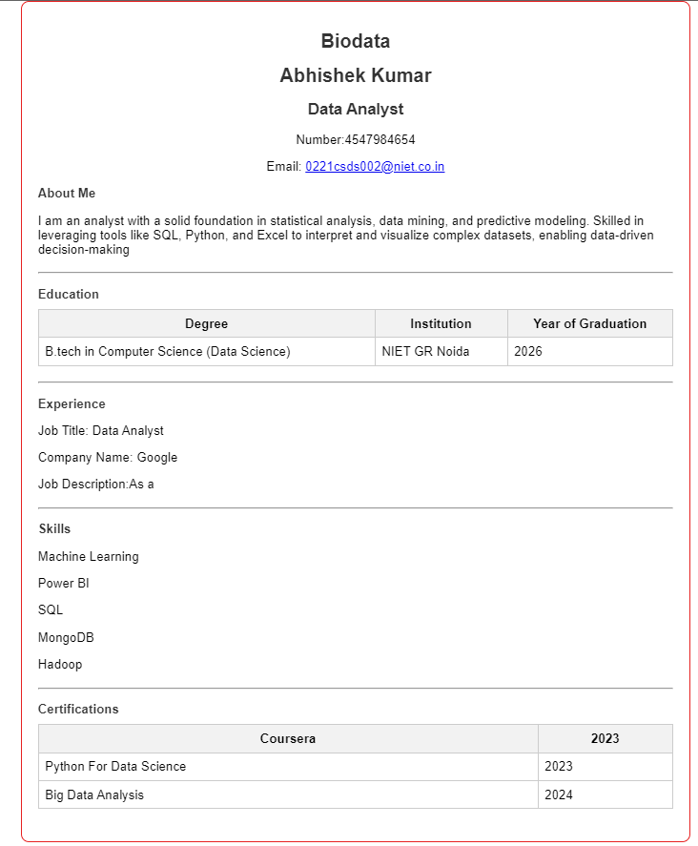

**<!DOCTYPE html>**

**<html lang="en">**

**<head>**

**<meta charset="UTF-8">**

**<meta name="viewport" content="width=device-width, initial-scale=1.0">**

**<title>Registration Form</title>**

**<style>**

**body {**

**font-family: Arial, sans-serif;**

**background-color: #f4f4f4;**

**display: flex;**

**justify-content: center;**

**align-items: center;**

**min-height: 100vh;**

**margin: 0;**

**}**

**.form-container {**

**background-color: #ffffff;**

**border-radius: 8px;**

**box-shadow: 0 0 10px rgba(0, 0, 0, 0.1);**

**padding: 40px;**

**max-width: 500px;**

**width: 100%;**

**}**

**form {**

**display: flex;**

**flex-direction: column;**

**}**

**h2 {**

**text-align: center;**

**margin-bottom: 20px;**

**}**

**label {**

**margin-bottom: 8px;**

**font-weight: bold;**

**}**

**input[type="text"],**

**input[type="email"],**

**input[type="number"],**

**input[type="password"],**

**select {**

**width: 100%;**

**padding: 10px;**

**margin-bottom: 15px;**

**border: 1px solid #ddd;**

**border-radius: 4px;**

**}**

**input[type="checkbox"] {**

**margin-right: 10px;**

**}**

**button {**

**padding: 10px;**

**border: none;**

**border-radius: 4px;**

**background-color: #007bff;**

**color: white;**

**font-size: 16px;**

**cursor: pointer;**

**}**

**button:hover {**

**background-color: #0056b3;**

**}**

**</style>**

**</head>**

**<body>**

**<div class="form-container">**

**<form action="#" method="post">**

**<h2>Registration Form</h2>**

**<label for="fullname">Full Name:</label>**

**<input type="text" id="fullname" name="fullname" required>**

**<label for="email">Email Address:</label>**

**<input type="email" id="email" name="email" required>**

**<label for="phone">Phone Number:</label>**

**<input type="number" id="phone" name="phone" required>**

**<label for="password">Password:</label>**

**<input type="password" id="password" name="password" required>**

**<label>Gender:</label>**

**<label for="male">**

**<input type="radio" id="male" name="gender" value="male"> Male**

**</label>**

**<label for="female">**

**<input type="radio" id="female" name="gender" value="female"> Female**

**</label>**

**<label for="other">**

**<input type="radio" id="other" name="gender" value="other"> Other**

**</label>**

**<label for="country">Country:</label>**

**<select id="country" name="country" required>**

**<option value="IND">India</option>**

**<option value="USA">USA</option>**

**<option value="UK">United Kingdom</option>**

**<option value="AUS">Australia</option>**

**<!-- Add more countries as needed -->**

**</select>**

**<label>**

**<input type="checkbox" id="terms" name="terms" required>**

**I agree to the terms and conditions**

**</label>**

**<button type="submit">Register</button>**

**</form>**

**</div>**

**</body>**

**</html>**

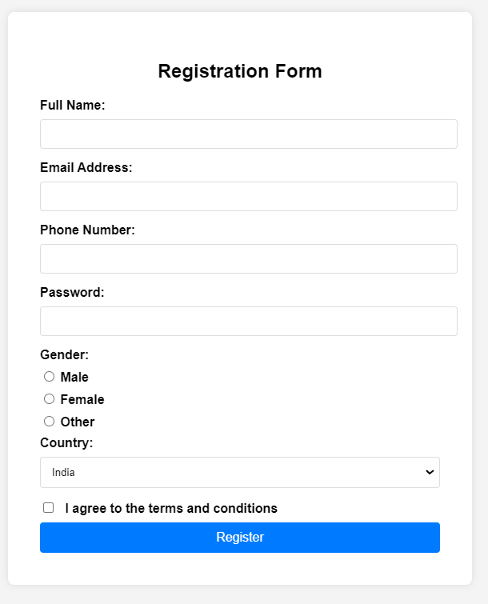

**Q3.StudentTable**

**<!DOCTYPE html>**

**<html lang="en">**

**<head>**

**<meta charset="UTF-8">**

**<meta name="viewport" content="width=device-width, initial-scale=1.0">**

**<title>Student Table</title>**

**<style>**

**/* CSS styling for the container */**

**.container {**

**width: 70%;**

**margin: 0 auto;**

**padding: 20px;**

**box-shadow: 0 0 10px rgba(0, 0, 0, 0.1);**

**border-radius: 8px;**

**}**

**/* CSS styling for the table */**

**table {**

**width: 100%;**

**border-collapse: collapse;**

**}**

**th, td {**

**border: 1px solid #dddddd;**

**text-align: left;**

**padding: 8px;**

**}**

**th {**

**background-color: #f2f2f2;**

**}**

**caption {**

**font-size: 1.5em;**

**margin: 10px 0;**

**}**

**.total-row {**

**font-weight: bold;**

**text-align: center;**

**background-color: #f2f2f2;**

**}**

**</style>**

**</head>**

**<body>**

**<div class="container">**

**<table>**

**<caption>STUDENT TABLE</caption>**

**<thead>**

**<tr>**

**<th>ID</th>**

**<th>Name</th>**

**<th>Department</th>**

**<th>Address</th>**

**</tr>**

**</thead>**

**<tbody>**

**<tr>**

**<td>101</td>**

**<td>xyz</td>**

**<td>AIML</td>**

**<td>DELHI</td>**

**</tr>**

**<tr>**

**<td>102</td>**

**<td>abc</td>**

**<td>IoT</td>**

**<td>Greater Noida</td>**

**</tr>**

**<tr>**

**<td>103</td>**

**<td>def</td>**

**<td>CSE</td>**

**<td>Bihar</td>**

**</tr>**

**<tr>**

**<td>104</td>**

**<td>ghi</td>**

**<td>MCA</td>**

**<td>Gaya</td>**

**</tr>**

**<tr>**

**<td>105</td>**

**<td>hij</td>**

**<td>EEE</td>**

**<td>Kochi</td>**

**</tr>**

**<tr class="total-row">**

**<td colspan="4">Total student count: 5</td>**

**</tr>**

**</tbody>**

**</table>**

**</div>**

**</body>**

**</html>**

**Output:**

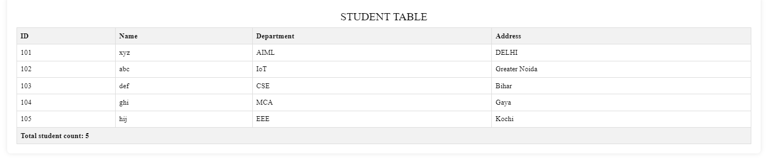

**<!DOCTYPE html>**

**<html lang="en">**

**<head>**

**<meta charset="UTF-8">**

**<meta name="viewport" content="width=device-width, initial-scale=1.0">**

**<title>Web Tech Workshop Registration</title>**

**<style>**

**body {**

**font-family: Arial, sans-serif;**

**background-color: #080808;**

**margin: 0;**

**padding: 0;**

**display: flex;**

**justify-content: center;**

**align-items: center;**

**height: 100vh;**

**}**

**.container {**

**background-color: #3ba9c7;**

**padding: 20px;**

**border-radius: 8px;**

**box-shadow: 0 4px 8px rgba(0, 0, 0, 0.2);**

**width: 100%;**

**max-width: 600px;**

**}**

**h1 {**

**text-align: center;**

**color: #333;**

**margin-bottom: 20px;**

**}**

**table {**

**width: 100%;**

**border-collapse: collapse;**

**margin-top: 20px;**

**}**

**table th {**

**background-color: #007bff;**

**color: #ffffff;**

**padding: 10px;**

**text-align: left;**

**}**

**table td {**

**padding: 20px;**

**background-color: #f9f9f9;**

**}**

**form {**

**display: flex;**

**flex-direction: column;**

**}**

**.form-group {**

**margin-bottom: 15px;**

**}**

**label {**

**display: block;**

**font-weight: bold;**

**margin-bottom: 8px;**

**color: #555;**

**}**

**input[type="text"],**

**input[type="date"],**

**input[type="tel"],**

**input[type="email"],**

**input[type="password"],**

**select {**

**width: 100%;**

**padding: 10px;**

**border: 1px solid #ccc;**

**border-radius: 4px;**

**box-sizing: border-box;**

**font-size: 16px;**

**}**

**input[type="text"]:focus,**

**input[type="date"]:focus,**

**input[type="tel"]:focus,**

**input[type="email"]:focus,**

**input[type="password"]:focus,**

**select:focus {**

**border-color: #007bff;**

**outline: none;**

**}**

**input[type="checkbox"] {**

**margin-right: 5px;**

**}**

**button {**

**background-color: #007bff;**

**color: #ffffff;**

**border: none;**

**padding: 10px;**

**border-radius: 4px;**

**font-size: 16px;**

**cursor: pointer;**

**transition: background-color 0.3s ease;**

**}**

**button:hover {**

**background-color: #0056b3;**

**}**

**</style>**

**</head>**

**<body>**

**<div class="container">**

**<h1>Welcome to Web Tech Workshop</h1>**

**<table>**

**<tr>**

**<th>Registration Form</th>**

**</tr>**

**<tr>**

**<td>**

**<form action="#" method="post">**

**<div class="form-group">**

**<label for="fullname">Full Name:</label>**

**<input type="text" id="fullname" name="fullname" placeholder="Enter your full name" required>**

**</div>**

**<div class="form-group">**

**<label for="date">Date of Joining:</label>**

**<input type="date" id="date" name="date" required>**

**</div>**

**<div class="form-group">**

**<label>Shift:</label>**

**<input type="checkbox" id="morning" name="shift" value="morning">**

**<label for="morning">Morning</label>**

**<input type="checkbox" id="evening" name="shift" value="evening">**

**<label for="evening">Evening</label>**

**</div>**

**<div class="form-group">**

**<label for="phone">Phone Number:</label>**

**<input type="tel" id="phone" name="phone" placeholder="Enter your phone number" required>**

**</div>**

**<div class="form-group">**

**<label for="email">Email ID:</label>**

**<input type="email" id="email" name="email" placeholder="Enter your email ID" required>**

**</div>**

**<div class="form-group">**

**<label for="password">Password:</label>**

**<input type="password" id="password" name="password" placeholder="Enter your password" required>**

**</div>**

**<!DOCTYPE html>**

**<html lang="en">**

**<head>**

**<meta charset="UTF-8">**

**<meta name="viewport" content="width=device-width, initial-scale=1.0">**

**<title>Student Table</title>**

**<style>**

**/* CSS styling for the container */**

**.container {**

**width: 70%;**

**margin: 0 auto;**

**padding: 20px;**

**box-shadow: 0 0 10px rgba(0, 0, 0, 0.1);**

**border-radius: 8px;**

**}**

**/* CSS styling for the table */**

**table {**

**width: 100%;**

**border-collapse: collapse;**

**}**

**th, td {**

**border: 1px solid #dddddd;**

**text-align: left;**

**padding: 8px;**

**}**

**th {**

**background-color: #f2f2f2;**

**}**

**caption {**

**font-size: 1.5em;**

**margin: 10px 0;**

**}**

**.total-row {**

**font-weight: bold;**

**text-align: center;**

**background-color: #f2f2f2;**

**}**

**</style>**

**</head>**

**<body>**

**<div class="container">**

**<table>**

**<caption>STUDENT TABLE</caption>**

**<thead>**

**<tr>**

**<th>ID</th>**

**<th>Name</th>**

**<th>Department</th>**

**<th>Address</th>**

**</tr>**

**</thead>**

**<tbody>**

**<tr>**

**<td>101</td>**

**<td>xyz</td>**

**<td>AIML</td>**

**<td>DELHI</td>**

**</tr>**

**<tr>**

**<td>102</td>**

**<td>abc</td>**

**<td>IoT</td>**

**<td>Greater Noida</td>**

**</tr>**

**<tr>**

**<td>103</td>**

**<td>def</td>**

**<td>CSE</td>**

**<td>Bihar</td>**

**</tr>**

**<tr>**

**<td>104</td>**

**<td>ghi</td>**

**<td>MCA</td>**

**<td>Gaya</td>**

**</tr>**

**<tr>**

**<td>105</td>**

**<td>hij</td>**

**<td>EEE</td>**

**<td>Kochi</td>**

**</tr>**

**<tr class="total-row">**

**<td colspan="4">Total student count: 5</td>**

**</tr>**

**</tbody>**

**</table>**

**</div>**

**</body>**

**</html>                      <div class="form-group">**

**<label for="fee-status">Fee Status:</label>**

**<select id="fee-status" name="fee-status" required>**

**<option value="" disabled selected>Select your fee status</option>**

**<option value="paid">Paid</option>**

**<option value="unpaid">Unpaid</option>**

**</select>**

**</div>**

**<div class="form-group">**

**<button type="submit">Submit</button>**

**</div>**

**</form>**

**</td>**

**</tr>**

**</table>**

**</div>**

**</body>**

**</html>**

**OUTPUT:**

