Shop Sales Details 2025 - Complete Project Report
Dashboard, Slicers, Charts & Raw Data Analysis

1. Main Dashboard Overview
This screenshot shows the master view of your Shop Sales Details 2025 Excel Dashboard. It visualizes sales, orders, gender distribution, order status, top cities, channels, and slicers all in one place through interactive charts.
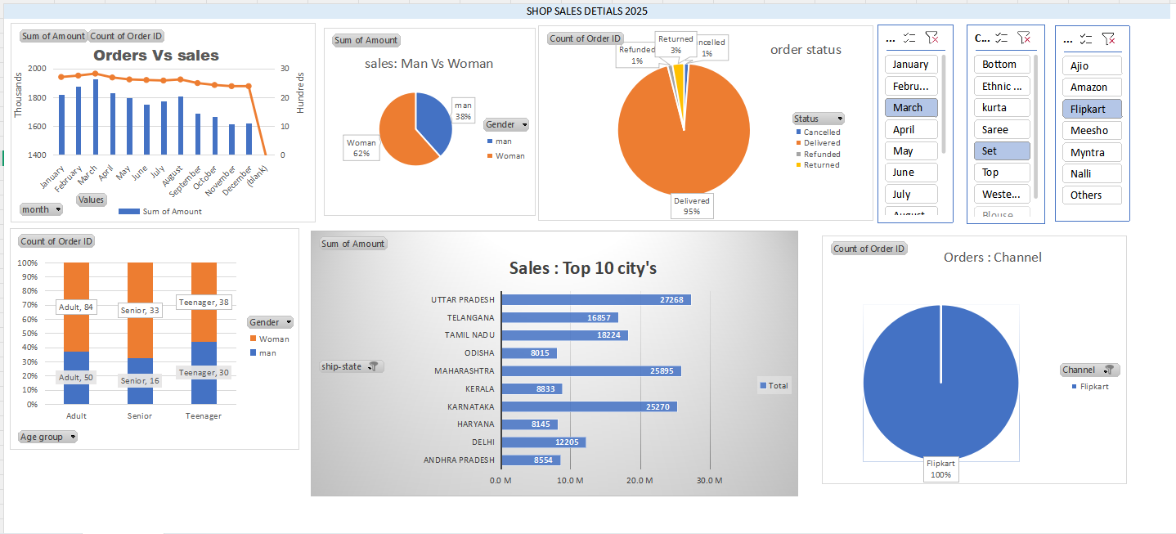

2. Slicers (Month, Category & Sales Channel Filters)
This screenshot displays a close-up view of the dashboard slicers. It includes three main slicers: (1) Month Slicer (showing months like January, February, March selected), (2) Category Slicer (showing product categories like Bottom, Ethnic, Kurta, Saree, Set selected), and (3) Sales Channel Slicer (showing e-commerce channels like Ajio, Amazon, Flipkart, Meesho, Myntra, etc., with Flipkart selected). These slicers allow users to dynamically filter and analyze the entire dashboard data based on any specific month, product category, or sales channel.
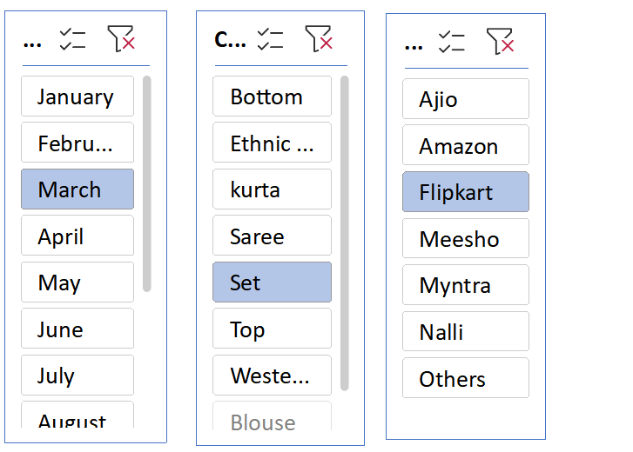

3. Orders vs Sales (Monthly Trend)
This section illustrates the monthly trend (from January to December) comparing total Sum of Amount (Sales) and Count of Order ID (Order Volume). The blue bars represent monthly sales revenue, while the orange line indicates the order count trend over time.
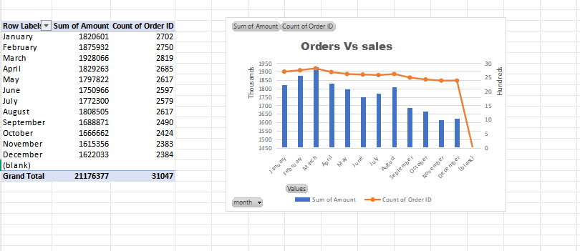

4. Sales: Man vs Woman (Gender Distribution)
This chart gives a breakdown of sales based on gender. It highlights that the Woman category contributes 62% to total sales, whereas the Man category contributes 38%.
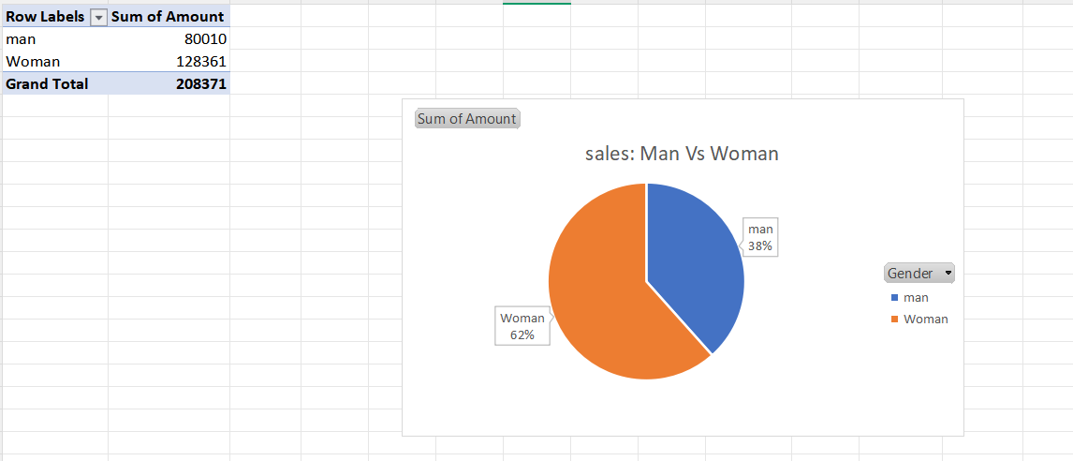

5. Order Status Analysis
This screenshot displays the current status of orders (such as Delivered, Cancelled, Refunded, and Returned). According to this chart, approximately 95% of orders were successfully Delivered, while Returned accounts for 3%, Refunded for 1%, and Cancelled for 1%.
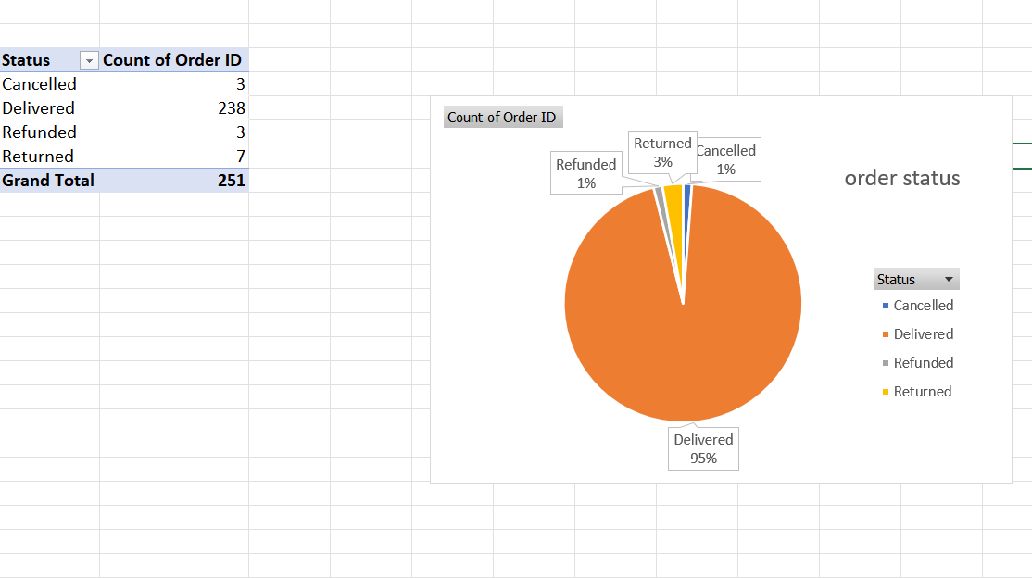

6. Sales: Top 10 Cities / States
This section presents top sales performance by shipping states (ship-state) in a horizontal bar chart. Top-performing regions with the highest sales amounts include Uttar Pradesh, Maharashtra, and Karnataka.
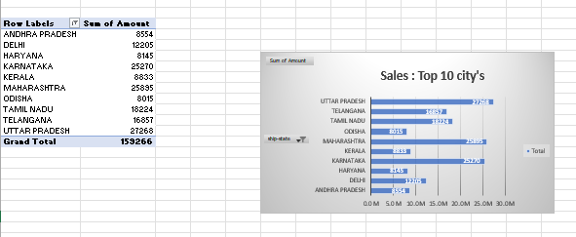

7. Sales According to Age and Gender
This chart analyzes order distribution across different age groups (Adult, Senior, Teenager) combined with gender (Man, Woman), helping identify which demographic segments generate the highest order volume.
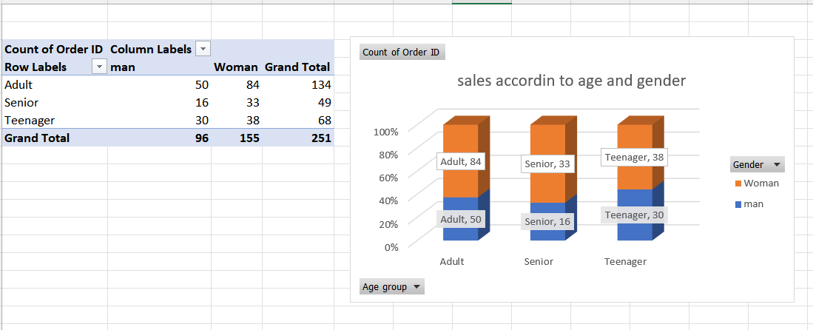

8. Orders: Sales Channel Distribution
This chart shows order distribution across various e-commerce sales channels. Based on the current filter and view, it displays 100% of orders routed through Flipkart.
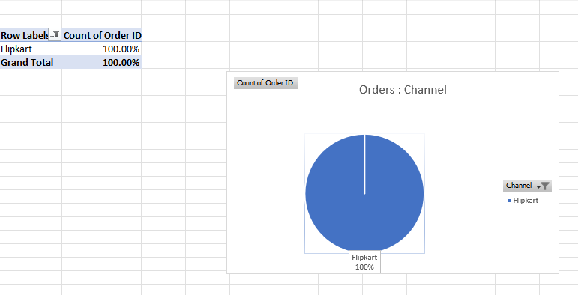

9. Raw Data Sheet 1 (Details Table)
This screenshot provides a view of the raw dataset containing detailed transaction records for each order, including Order ID, Cust ID, Gender, Age, Date, Month, Status, Channel, SKU, Category, Size, Qty, Currency, Amount, ship-city, and ship-state.
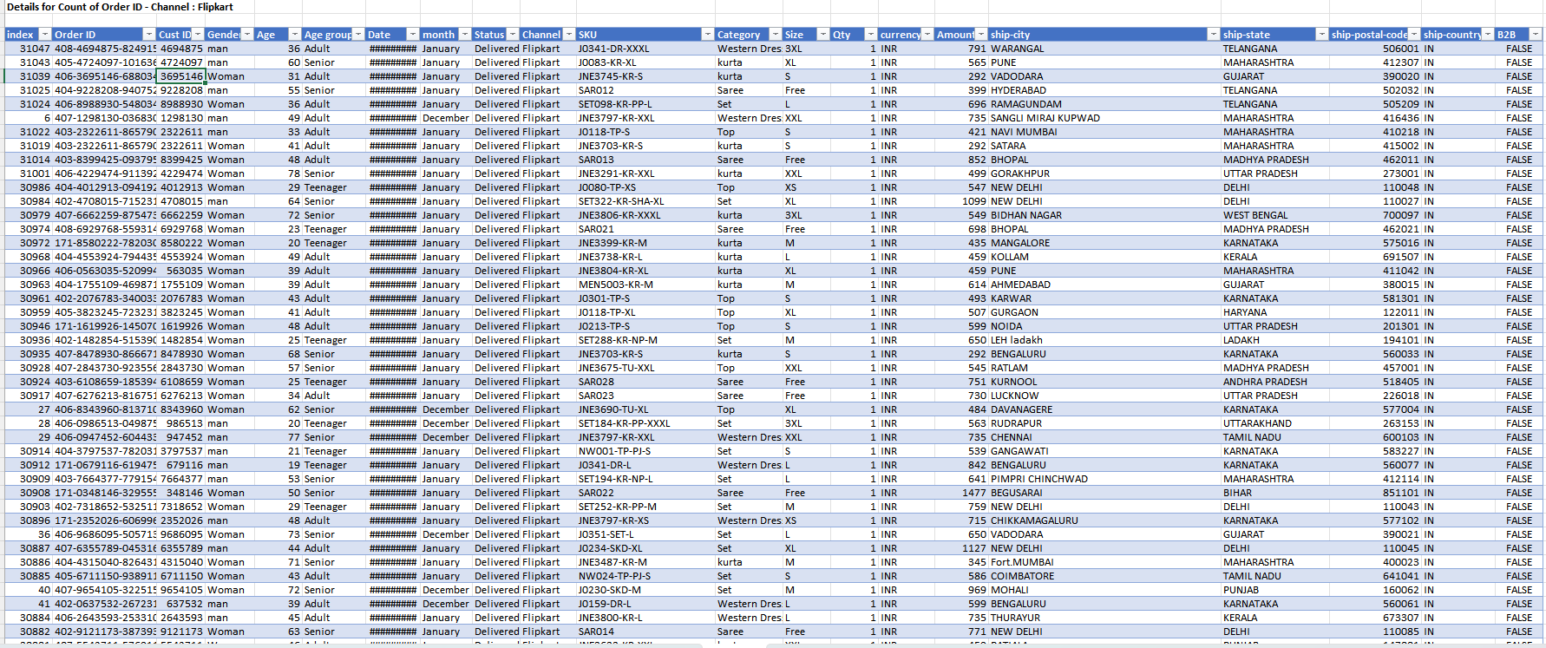

10. Raw Data Sheet 2 (Extended Dataset View)
This is another view of the dataset capturing transactions and shipping details across multiple e-commerce platforms (such as Myntra, Ajio, Amazon, Flipkart, etc.), which serves as the foundational data source for pivot tables and charts.
