Name :- Yogesh Rajendra Deolalkar

PRN :- 1930331245059

Subject :- **Building IOT with Arduino**

**Building IOT with Arduino**

**!**

**Arduino Board:**

* An Arduino is actually a microcontroller based kit.
* It is basically used in communications and in controlling or operating many devices.
* Arduino UNO board is the most popular board in the Arduino board family.
* In addition, it is the best board to get started with electronics and coding.
* Some boards look a bit different from the one given below, but most Arduino’s have majority of these components in common.
* It consists of two memories- Program memory and the data memory.
* The code is stored in the flash program memory, whereas the data is stored in the data memory.
* Arduino Uno consists of 14 digital input/output pins (of which 6 can be used as PWM outputs), 6 analog inputs, a 16 MHz crystal oscillator, a USB connection, a power jack, an ICSP header, and a reset button

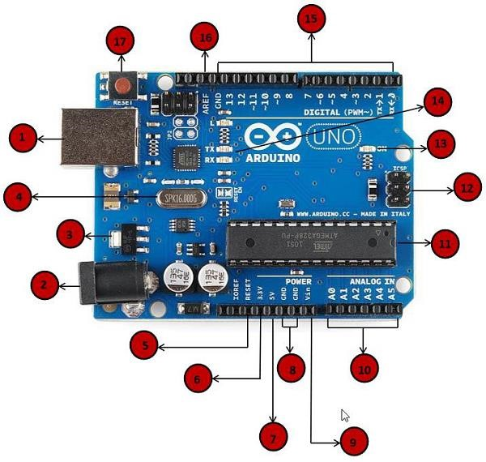

**1**

**.Power**

**USB**

**.Power**

**2**

**)**

**Barrel Jack**

**(**

**3**

**.Voltage**

**Regulator**

**.Crystal Oscillator**

**4**

**17**

**.Arduino Reset**

**5**

**.Arduino Reset**

**6**

**,7,8,9.Pins (3.3,**

**5**

**, GND, Vin**

**)**

**10**

**.Analog pins**

**11**

**.Main**

**microcontroller**

**.ICSP pin**

**12**

**LED**

**indicator**

**14**

**.TX and RX**

**LEDs**

**15**

**.Digital I/O**

**16**

**.AREF**

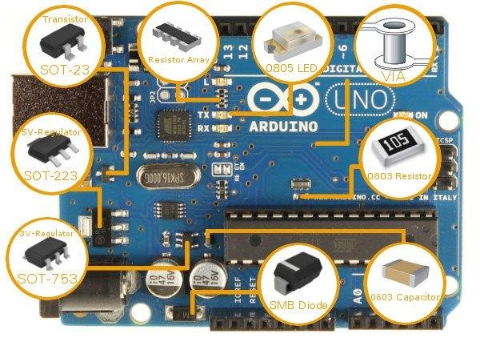

## 1.Power USB

Arduino board can be powered by using the USB cable from your computer. All you need to do is connect the USB cable to the USB connection (1).

## 2.Power (Barrel Jack)

Arduino boards can be powered directly from the AC mains power supply by connecting it to the Barrel Jack (2).

## 3.Voltage Regulator

The function of the voltage regulator is to control the voltage given to the Arduino board and stabilize the DC voltages used by the processor and other elements.

## 4.Crystal Oscillator

The crystal oscillator helps Arduino in dealing with time issues. How does Arduino calculate time? The answer is, by using the crystal oscillator. The number printed on top of the Arduino crystal is 16.000H9H. It tells us that the frequency is 16,000,000 Hertz or 16 MHz.

## 5,17.Arduino Reset

You can reset your Arduino board, i.e., start your program from the beginning. You can reset the UNO board in two ways. First, by using the reset button (17) on the board. Second, you can connect an external reset button to the Arduino pin labelled RESET (5). **6,7,8,9.Pins (3.3, 5, GND, Vin)**

* 3.3V (6) − Supply 3.3 output volt
* 5V (7) − Supply 5 output volt
* Most of the components used with Arduino board works fine with 3.3 volt and 5 volt.
* GND (8)(Ground) − There are several GND pins on the Arduino, any of which can be used to ground your circuit.
* Vin (9) − This pin also can be used to power the Arduino board from an external power source, like AC mains power supply.

## 10.Analog pins

The Arduino UNO board has six analog input pins A0 through A5. These pins can read the signal from an analog sensor like the humidity sensor or temperature sensor and convert it into a digital value that can be read by the microprocessor.

## 11.Main microcontroller

Each Arduino board has its own microcontroller (11). You can assume it as the brain of your board. The main IC (integrated circuit) on the Arduino is slightly different from board to board. The microcontrollers are usually of the ATMEL Company. You must know what IC your board has before loading up a new program from the Arduino IDE. This information is available on the top of the IC. For more details about the IC construction and functions, you can refer to the data sheet.

## 12.ICSP pin

Mostly, ICSP (12) is an AVR, a tiny programming header for the Arduino consisting of MOSI, MISO, SCK, RESET, VCC, and GND. It is often referred to as an SPI (Serial Peripheral Interface), which could be considered as an "expansion" of the output. Actually, you are slaving the output device to the master of the SPI bus.

## 13.Power LED indicator

This LED should light up when you plug your Arduino into a power source to indicate that your board is powered up correctly. If this light does not turn on, then there is something wrong with the connection.

## 14.TX and RX LEDs

On your board, you will find two labels: TX (transmit) and RX (receive). They appear in two places on the Arduino UNO board. First, at the digital pins 0 and 1, to indicate the pins responsible for serial communication. Second, the TX and RX led (13). The TX led flashes with different speed while sending the serial data. The speed of flashing depends on the baud rate used by the board. RX flashes during the receiving process.

## 15.Digital I/O

• The Arduino UNO board has 14 digital I/O pins (15) (of which 6 provide PWM (Pulse Width Modulation) output. These pins can be configured to work as input digital pins to read logic values (0 or 1) or as digital output pins to drive different modules like LEDs, relays, etc. The pins labeled “~” can be used to generate PWM.

## 16.AREF

• AREF stands for Analog Reference. It is sometimes, used to set an external reference voltage (between 0 and 5 Volts) as the upper limit for the analog input pins.

**Program an Arduino**

* The most important advantage with Arduino is the programs can be directly loaded to the device without requiring any hardware programmer to burn the program.
* This is done because of the presence of the 0.5KB of Bootloader which allows the program to be burned into the circuit.
* All we have to do is to download the Arduino software and writing the code.
* The Arduino tool window consists of the toolbar with the buttons like verify, upload, new, open, save, serial monitor.
* It also consists of a text editor to write the code, a message area which displays the feedback like showing the errors, the text console which displays the output and a series of menus like the File, Edit, Tools menu.

# Steps to program an Arduino

* Programs written in Arduino are known as sketches. A basic sketch consists of 3 parts
  1. Declaration of Variables
  2. Initialization: It is written in the setup () function.
  3. Control code: It is written in the loop () function.
* The sketch is saved with .ino extension. Any operations like verifying, opening a sketch, saving a sketch can be done using the buttons on the toolbar or using the tool menu.
* The sketch should be stored in the sketchbook directory.
* Chose the proper board from the tools menu and the serial port numbers.
* Click on the upload button or chose upload from the tools menu. Thus the code is uploaded by the bootloader onto the microcontroller.

**Basic Adruino functions are:**

* **digitalRead**(pin): Reads the digital value at the given pin.
* **digitalWrite**(pin, value): Writes the digital value to the given pin.
* **pinMode**(pin, mode): Sets the pin to input or output mode.
* **analogRead**(pin): Reads and returns the value.
* **analogWrite**(pin, value): Writes the value to that pin.
* **serial.begin**(baud rate): Sets the beginning of serial communication by setting the bit rate.

# Design your own Arduino

➢ The following components are needed to design Arduino Board- A breadboard, a led, a power jack, a IC socket, a microcontroller, few resistors, 2 regulators, 2 capacitors.

* The IC socket and the power jack are mounted on the board.
* Add the 5v and 3.3v regulator circuits using the combinations of regulators and capacitors.
* Add proper power connections to the microcontroller pins.
* Connect the reset pin of the IC socket to a 10K resistor.
* Connect the crystal oscillators to pins 9 and 10
* Connect the led to the appropriate pin.
* Mount the female headers onto the board and connect them to the respective pins on the chip.
* Mount the row of 6 male headers, which can be used as an alternative to upload programs.
* Upload the program on the Microcontroller of the readymade Adruino and then pry it off and place back on the user kit.

# Advantages of Arduino Board

1. It is inexpensive
2. It comes with an open source hardware feature which enables users to develop their own kit using already available one as a reference source.
3. The Arduino software is compatible with all types of operating systems like Windows, Linux, and Macintosh etc.
4. It also comes with open source software feature which enables experienced software developers to use the Arduino code to merge with the existing programming language libraries and can be extended and modified.
5. It is easy to use for beginners.
6. We can develop an Arduino based project which can be completely stand alone or projects which involve direct communication with the software loaded in the computer.
7. It comes with an easy provision of connecting with the CPU of the computer using serial communication over USB as it contains built in power and reset circuitry. **Interfaces**

**UART Peripheral:**

|  |
| --- |
| * A UART (Universal Asynchronous Receiver/Transmitter) is a serial interface. * It has only one UART module. |
| ➢ The pins (RX, TX) of the UART are connected to a USB-to-UART converter circuit and also connected to pin0 and pin1 in the digital header. |
|  | | |
| **SPI Peripheral:** | | |

➢ The SPI (Serial Peripheral Interface) is another serial interface. It has only one SPI module.

**TWI:**

|  |
| --- |
| ➢ The I2C or Two Wire Interface is an interface consisting of only two wires, serial data, |
| and a serial clock: SDA, SCL. |
| ➢ You can reach these pins from the last two pins in the digital header or pin4 and pin5 in |
| the analog header. |