**Assignment – 1**

Name: Yogesh Rajendra Deolalkar

Subject: Software Engineering

Branch: Computer Engineering

Class: 4th Year

PRN: 1930331245059

**Task 1:**

Code for HashSet in Python:

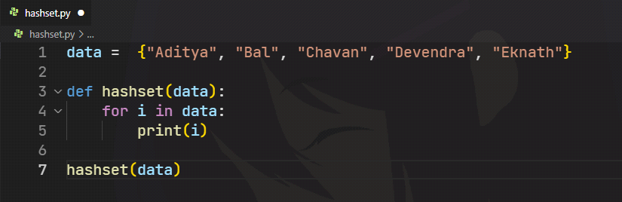

Execution on various compilers:

* **Programiz:**

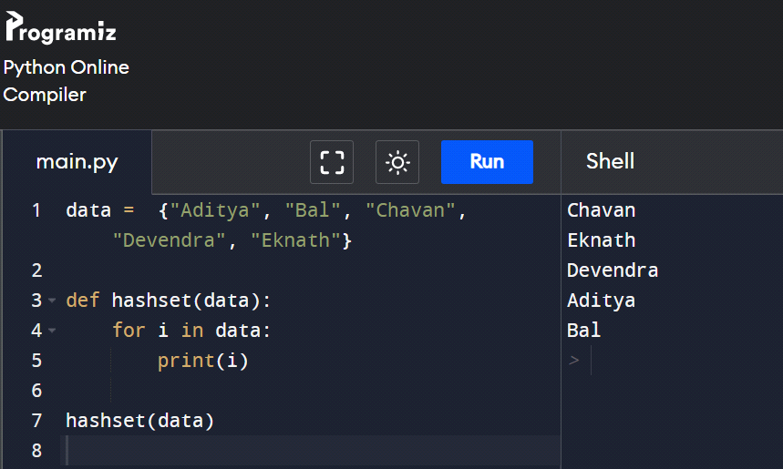

* **Online-GDB:**

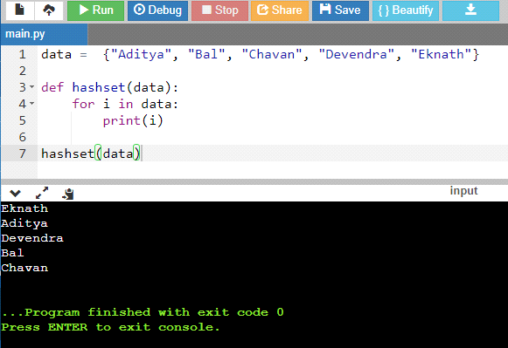

* **W3Schools:**

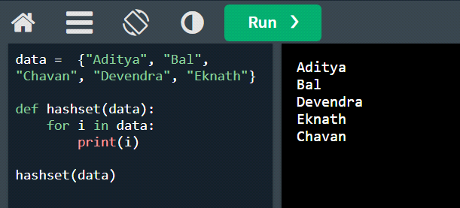

**Conclusion:** The order was random every time.

**Task 2:**

|  |  |  |
| --- | --- | --- |
| **Version No. Released** | **Date and Month**  **of Release** | **Feature Released** |
|  | **Linux Kernel** |  |
| 5.19 | 2022-07-31 | * Initial support for LoongArch * Support for Big TCP * More secure encrypted virtualization with AMD SEV-SNP and Intel TDX * Armv9 Scalable Matrix Extension support * Introduce Intel In-Field Scan driver to run targeted low level diagnostics outside of the CPU's architectural error detection capabilities * a.out support removed |
| 5.15 | 2021-10-31 | * New NTFS file system implementation * ksmbd, a in-kernel SMB 3 server * Migrate memory pages to persistent memory in lieu of discard * DAMON, a data access monitor * Introduce process_mrelease system call |
| 5.10 | 2020-12-13 | * Long Term Support * Ext4 fast commit support, for faster metadata performance * Support io_uring restrictions to facilitate secure sharing of rings * Memory hints for other processes |
| 5.4 | 2019-11-24 | * Kernel lockdown mode * virtio-fs, a bridge to share file systems with virtualized guests * fs-verity, for detecting file modifications * Kernel symbol namespacing |
| 4.19 | 2018-10-22 | * Better networking experience with the CAKE queue management algorithm * Block I/O latency controller * Preliminary Wi-Fi 6 (802.11ax) support * New asynchronous I/O polling interface * Intel Cache Pseudo-locking |
| 4.14 | 2017-11-12 | * Bigger memory limits * Better kernel traces with the ORC unwinder * zstd compression in Btrfs and Squashfs * Heterogeneous Memory Management for future GPUs * Asynchronous buffered I/O support |
| 4.9 | 2016-12-11 | * Shared data extents + copy-on-write support on XFS * Virtually mapped stacks for more secure and reliable stack handling * Efficient BPF-based profiler * BBR TCP congestion control algorithm * Protection keys syscall support * Greybus support * Hardware latency tracer |
|  | **Apache Web Server** |  |
| 2.4 | 2022-06-08 | * Run-Time Loadable MPMs * Event MPM * Asynchronous support * Per-module and pre-de |
| 2.2 | 2017-07-11 | * Authn/Authz * Caching * Configuration * Graceful Stop * Proxying * Regular Expression Library Updated * Smart Filtering |
| 2.0 | 2013-07-10 | * Unix Threading * New Build System * Multiprotocol Support * Better support for non-Unix Platforms * IPv6 Support |
|  | **MySQL DB** |  |
| 8.0 | 2018-04-19 | Data dictionary, Atomic data definition statements (Atomic DDL), Upgrade procedure, Session Reuse, Security and account management, Resource management, Character set support, Table encryption management, Window functions, Common table expressions, Connection management, Plugins, Dump file output synchronization. |
| 5.7 | 2015-10-21 | Security improvements, SQL mode changes, Online ALTER TABLE, System and status variables, sys schema, Condition handling, Optimizer, Triggers, Logging, Generated Columns. |
| 5.6 | 2013-02-05 | Security improvements, MySQL Enterprise, Changes to server defaults, Optimizer enhancements, InnoDB enhancements, Partitioning, Performance Schema, Replication and logging, Condition handling, Data types. |

**Task 3:**

**Conclusion:** It took approximately about 15 to 30 minutes to setup the LAMP stack on Ubuntu.