C# Exception Handling

* Exception Handling in C# is a process to handle runtime errors. We perform exception handling so that normal flow of the application can be maintained even after runtime errors.
* In C#, exception is an event or object which is thrown at runtime. All exceptions the derived from System.Exception class. It is a runtime error which can be handled. If we don't handle the exception, it prints exception message and terminates the program.

### Advantage

* It maintains the normal flow of the application. In such case, rest of the code is executed event after exception.

## C# Exception Classes

* All the exception classes in C# are derived from **System.Exception** class. Let's see the list of C# common exception classes.

|  |  |
| --- | --- |
| **Exception** | **Description** |
| System.DivideByZeroException | handles the error generated by dividing a number with zero. |
| System.NullReferenceException | handles the error generated by referencing the null object. |
| System.InvalidCastException | handles the error generated by invalid typecasting. |
| System.IO.IOException | handles the Input Output errors. |
| System.FieldAccessException | handles the error generated by invalid private or protected field access. |

## C# Exception Handling Keywords

* In C#, we use 4 keywords to perform exception handling :-
* try
* catch
* finally, and
* throw

Moreover, we can create user-defined exception which we will learn in next chapters.

# try/catch

* In C# programming, exception handling is performed by try/catch statement. The **try block** in C# is used to place the code that may throw exception. The **catch block** is used to handled the exception. The catch block must be preceded by try block.

### C# example without try/catch

**using** System;

**public** **class** tryCatchExample

{

**public** **static** **void** Main(**string**[] args)

    {

**int** a = 10;

**int** b = 0;

**int** x = a/b;

        Console.WriteLine("Rest of the code");

    }

}

**OUTPUT :-**

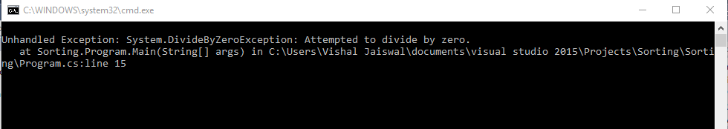

### C# try/catch example

**using** System;

**public** **class** tryCatchExample

{

**public** **static** **void** Main(**string**[] args)

    {

**int** a = 10;

**int** b = 0;

**int** x = a/b;

        Console.WriteLine("Rest of the code");

    }

}

**OUTPUT :-**

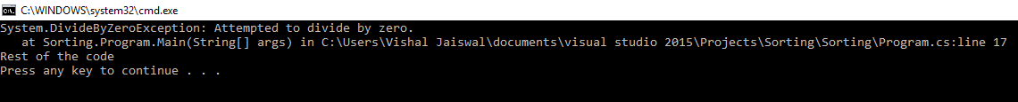

# C# finally

* C# finally block is used to execute important code which is to be executed whether exception is handled or not. It must be preceded by catch or try block.

### C# finally example if exception is handle

**using** System;

**public** **class** finallyExample

{

**public** **static** **void** Main(**string**[] args)

    {

**try**

        {

**int** a = 10;

**int** b = 0;

**int** x = a / b;

        }

**catch** (Exception e) { Console.WriteLine(e); }

**finally** { Console.WriteLine("Finally block is executed"); }

        Console.WriteLine("Rest of the code");

    }

}

**OUTPUT :-**

### 

### **C# finally example if exception is not handled**

**using** System;

**public** **class** ExExample

{

**public** **static** **void** Main(**string**[] args)

    {

**try**

        {

**int** a = 10;

**int** b = 0;

**int** x = a / b;

        }

**catch** (NullReferenceException e) { Console.WriteLine(e); }

**finally** { Console.WriteLine("Finally block is executed"); }

        Console.WriteLine("Rest of the code");

    }

}

**OUTPUT :-**

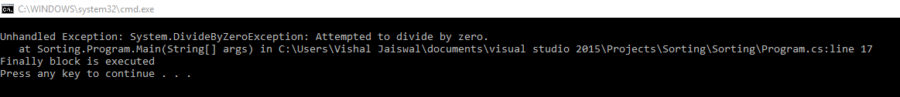

# C# User-Defined Exceptions

* C# allows us to create user-defined or custom exception. It is used to make the meaningful exception. To do this, we need to inherit Exception class.

**using** System;

**public** **class** InvalidAgeException : Exception

{

**public** InvalidAgeException(String message)

        : **base**(message)

    {

    }

}

**public** **class** TestUserDefinedException

{

**static** **void** validate(**int** age)

    {

**if** (age < 18)

        {

**throw** **new** InvalidAgeException("Sorry, Age must be greater than 18");

        }

    }

**public** **static** **void** Main(**string**[] args)

    {

**try**

        {

            validate(12);

        }

**catch** (InvalidAgeException e) { Console.WriteLine(e); }

        Console.WriteLine("Rest of the code");

    }

}

**OUTPUT :-**



# 

# C# Checked and Unchecked

* C# provides checked and unchecked keyword to handle integral type exceptions. Checked and unchecked keywords specify checked context and unchecked context respectively. In checked context, arithmetic overflow raises an exception whereas, in an unchecked context, arithmetic overflow is ignored and result is truncated.

## C# Checked :-

* The checked keyword is used to explicitly check overflow and conversion of integral type values at compile time.
* Let's first see an example that does not use checked keyword.

## C# Checked Example without using checked

**using** System;

**namespace** CSharpProgram

{

**class** Program

    {

**static** **void** Main(**string**[] args)

        {

**int** val = **int**.MaxValue;

                Console.WriteLine(val + 2);

        }

    }

}

**OUTPUT :-**

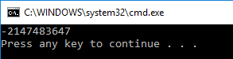

See, the above program produces the wrong result and does not throw any overflow exception.

### C# Checked Example using checked

This program throws an exception and stops program execution.

**using** System;

**namespace** CSharpProgram

{

**class** Program

    {

**static** **void** Main(**string**[] args)

        {

**checked**

            {

**int** val = **int**.MaxValue;

                Console.WriteLine(val + 2);

            }

        }

    }

}

**OUTPUT :-**

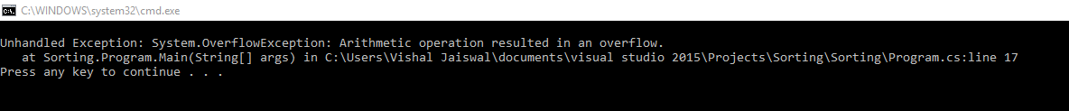

## C# Unchecked :-

The Unchecked keyword ignores the integral type arithmetic exceptions. It does not check explicitly and produce result that may be truncated or wrong.

**using** System;

**namespace** CSharpProgram

{

**class** Program

    {

**static** **void** Main(**string**[] args)

        {

**unchecked**

            {

**int** val = **int**.MaxValue;

                Console.WriteLine(val + 2);

            }

        }

    }

}

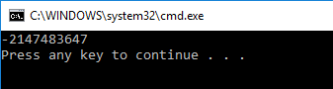

# C# SystemException class

* The SystemException is a predefined exception class in C#. It is used to handle system related exceptions. It works as base class for system exception namespace. It has various child classes like: ValidationException, ArgumentException, ArithmeticException, DataException, StackOverflowException etc.
* It consists of rich constructors, properties and methods that we have tabled below.

### C# SystemException Signature

### [SerializableAttribute]

[ComVisibleAttribute(**true**)]

**public** **class** SystemException : Exception

### C# SystemException Constructors **:-**

|  |  |
| --- | --- |
| **Constructors** | **Description** |
| SystemException() | It is used to initialize a new instance of the SystemException class. |
| SystemException(SerializationInfo,StreamingContext) | It is used to initialize a new instance of the SystemException class with serialized data. |
| SystemException(String) | It is used to initialize a new instance of the SystemException class with a specified error message. |
| SystemException(String,Exception) | It is used to initialize a new instance of the SystemException class with a specified error message and a reference to the inner exception that is the cause of this exception. |

### C# SystemException Properties **:-**

|  |  |
| --- | --- |
| **Property** | **Description** |
| Data | It is used to get a collection of key/value pairs that provide additional user-defined information about the exception. |
| HelpLink | It is used to get or set a link to the help file associated with this exception. |
| HResult | It is used to get or set HRESULT, a coded numerical value that is assigned to a specific exception. |
| InnerException | It is used to get the Exception instance that caused the current exception. |
| Message | It is used to get a message that describes the current exception. |
| Source | It is used to get or set the name of the application that causes the error. |
| StackTrace | It is used to get a string representation of the immediate frames on the call stack. |
| TargetSite | It is used to get the method that throws the current exception. |

### C# SystemException Methods :-

|  |  |
| --- | --- |
| **Method** | **Description** |
| Equals(Object) | It is used to check that the specified object is equal to the current object or not. |
| Finalize() | It is used to free resources and perform cleanup operations. |
| GetBaseException() | It is used to get root exception. |
| GetHashCode() | It is used to get hash code. |
| GetObjectData(SerializationInfo,StreamingContext) | It is used to get object data. |
| GetType() | It is used to get the runtime type of the current instance. |
| MemberwiseClone() | It is used to create a shallow copy of the current Object. |
| ToString() | It is used to create and return a string representation of the current exception. |

### C# SystemException Example

* This class can be used to handle exception of subclasses. Here, in the following program, program throws an IndexOutOfRangeException that is subclass of SystemException class.

**using** System;

**namespace** CSharpProgram

{

**class** Program

    {

**static** **void** Main(**string**[] args)

        {

**try**

            {

**int**[] arr = **new** **int**[5];

                arr[10] = 25;

            }

**catch** (SystemException e)

            {

                Console.WriteLine(e);

            }

        }

    }

}

**OUTPUT :-**



Reference :- https://javatpoint.com/c-sharp-exception-handling