A Project Report

On

ESTABLISHING ELECTRIC GRID IN TOWN USING BORUKA’S ALGORITHM

Submitted for the partial fulfilment of BTech Second year II semester

COMPUTER SCIENCE & ENGINEERING

By

V.ABHIRAM (2010030180)

K.SIDHARTH RAO (2010030443)

A .RAGHAVENDRA GOUD (2010030394)

R .VIVEK VARDHAN REDDY (2010030142)



DEPARTMENT OF COMPUTER SCIENCE & ENGINEERING

K L UNIVERSITY (Deemed to be)

HYDERABAD

K L UNIVERSITY (Deemed to be)

HYDERABAD

DEPARTMENT OF COMPUTER SCIENCE & ENGINEERING



**CERTIFICATE**

This is to certify that the project report titled “ESTABLISHING ELECTRIC GRID IN TOWN USING BORUKA’S ALGORITHM” is bonafide work of the following students of BTech second year II semester of K L UNIVERSITY (Deemed to be), Hyderabad.

V.Abhiram (2010030180)

K.Sidharth Rao (2010030443),

A .Raghavendra Goud (2010030394)

R .Vivek Vardhan Reddy (2010030142)

## Signature of the Supervisor

P. Sree Lakshmi

SIGNATURE OF INCHARGE SIGNATURE OF HOD

**ABSTRACT**

Optimization is important in an algorithm. It will show us the best path which has to be travelled to obtain the best and optimal solution, thereby saving the operational costs of an activity. In the Minimum Spanning Tree, the goal is to achieve how all vertices are connected with the smallest weights. There have been many algorithms which have been developed in obtaining the minimum path which has to be covered to complete a certain task. Such developed algorithms have many uses and one such use can be developing an electric grid in a town. We can choose the towns which are having the least distance among them, and thus, all those cities can be connected with each other, and further it will be connected to the electric grid. The purpose of this study is to find out the Primary electricity distribution network graph model and correct algorithm to determine the minimum spanning tree.

**DECLARATION**

We V.Abhiram (2010030180), K.Sidharth Rao (2010030443),

A .Raghavendra Goud (2010030394),R .Vivek Vardhan Reddy (2010030142) students of B.Tech – Semester – IV of K L University hereby declare that the project work presented in this report is our own work.

This work has not been previously submitted to any other University for any examinations.

**By**

V.Abhiram (2010030180)

K.Sidharth Rao (2010030443),

A .Raghavendra Goud (2010030394)

R .Vivek Vardhan Reddy (2010030142)

**ACKNOWLEDGEMENT**

The satisfaction that accompanies the successful completion of any task would be incomplete without mention of the people who made it possible and whose encouragement and guidance has been a source of inspiration throughout the course of the project.

We express our sincere gratitude to all our Professors of Computer Science & Engineering, K L University, Hyderabad, for their precious suggestions, motivation and cooperation for the successful completion of this project.

It is our privilege and pleasure to express our profound sense of gratitude and indebtedness to **Prof. Dr. Chiranjeevi Manike,** Head of Department of Computer Science & Engineering, K L University, Hyderabad, for her guidance, cogent discussion, constructive criticisms and encouragement throughout this dissertation work.

We express our sincere thanks **to Prof.Dr.L.Koteswar Rao**, Principal of K L University, Hyderabad, for his encouragement and constant help.

**INDEX**

Page No.

1. ABSTRACT
2. DECLARATION
3. ACKNOWLEDGEMENT
4. PROBLEM STATEMENT
5. ALGORITHM
6. FLOW CHART
7. NUMERICAL PROBLEM
8. CODE
9. RESULT
10. CONCLUSION

**PROBLEM STATEMENT**

Let’s take a situation where we have a city which has so many towns in it, and the distances between pairs of the town are known. The goal is to create a system of electric power lines that would minimize the total distance (and thus the construction cost), yet reach every town. In this scenario, it is not necessary to connect each town to the “source of electricity” directly – it is enough to connect it to another town that already got the power.

The problem which we chose comes under the domain of GREEDY METHOD. Greedy is an algorithmic paradigm that builds up a solution piece by piece, always choosing the next piece that offers the most obvious and immediate benefit. So, the problems where choosing locally optimal also leads to global solution are best fit for Greedy.

In this scenario, we have to find the MINIMUM COST SPANNING TREE. The cost of the spanning tree is the sum of the weights of all the edges in the tree. There can be many spanning trees. Minimum spanning tree is the spanning tree where the cost is minimum among all the spanning trees.

**Literature Survey**



**ALGORITHM**

**BORUVKA’S ALGORITHM**

Boruvka's algorithm is a greedy algorithm for finding a minimum spanning tree in a graph. The algorithm begins by finding the minimum-weight edge incident to each vertex of the graph, and adding all of those edges to the tree. Then, it repeats a similar process of finding the minimum-weight edge from each tree constructed so far to a different tree, and adding all of those edges to the forest. Each repetition of this process reduces the number of trees, within each connected component of the graph, to at most half of this former value, so after logarithmically many repetitions the process finishes.

This algorithm can be applied in our problem in the following way. For each town, connect it with its nearest neighboring town. Now, for each of the resulting groups of towns, connect them to their nearest neighbor... Proceed until there is just one group left.

algorithm Borůvka is

input: A weighted undirected graph G = (V, E).

output: F, a minimum spanning forest of G.

Initialize a forest F to (V, E') where E' = {}.

completed := false

while not completed do

Find the connected components of F and assign to each vertex its component

Initialize the cheapest edge for each component to "None"

for each edge uv in E, where u and v are in different components of F:

let wx be the cheapest edge for the component of u

if is-preferred-over(uv, wx) then

Set uv as the cheapest edge for the component of u

let yz be the cheapest edge for the component of v

if is-preferred-over(uv, yz) then

Set uv as the cheapest edge for the component of v

if all components have cheapest edge set to "None" then

// no more trees can be merged -- we are finished

completed := true

else

completed := false

for each component whose cheapest edge is not "None" do

Add its cheapest edge to E'

function is-preferred-over(edge1, edge2) is

return (edge2 is "None") or

(weight(edge1) < weight(edge2)) or

(weight(edge1) = weight(edge2) and tie-breaking-rule(edge1, edge2))

function tie-breaking-rule(edge1, edge2) is

The tie-breaking rule; returns true if and only if edge1

is preferred over edge2 in the case of a tie.

**FLOWCHART**

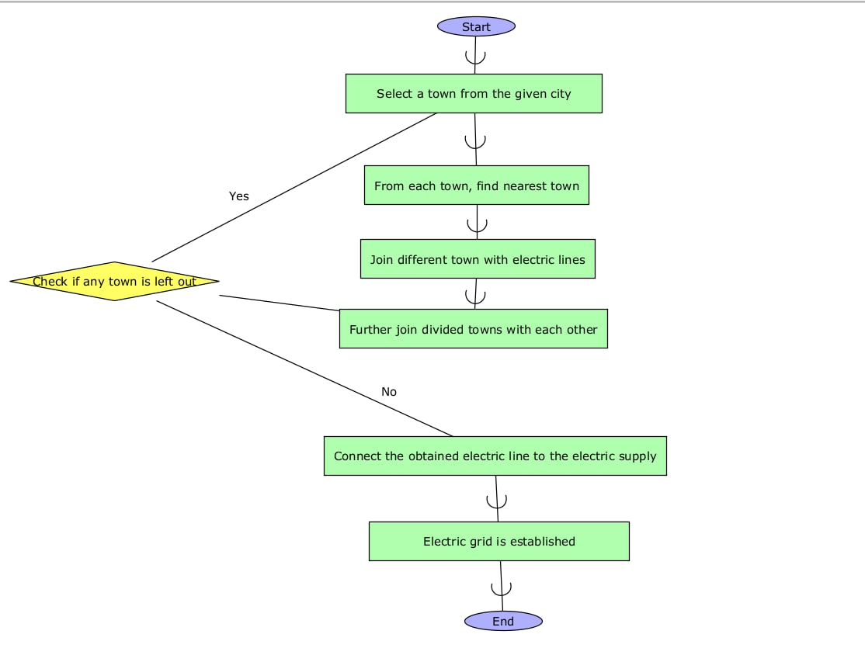

**NUMERICAL PROBLEM**

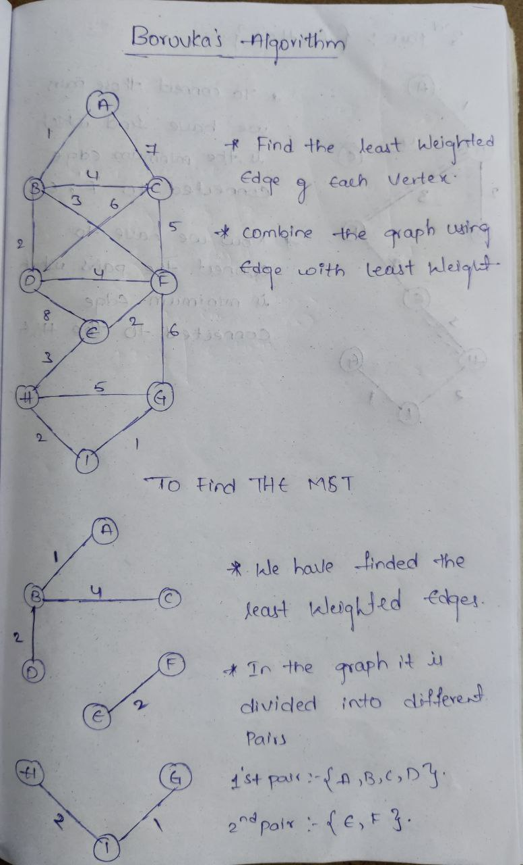

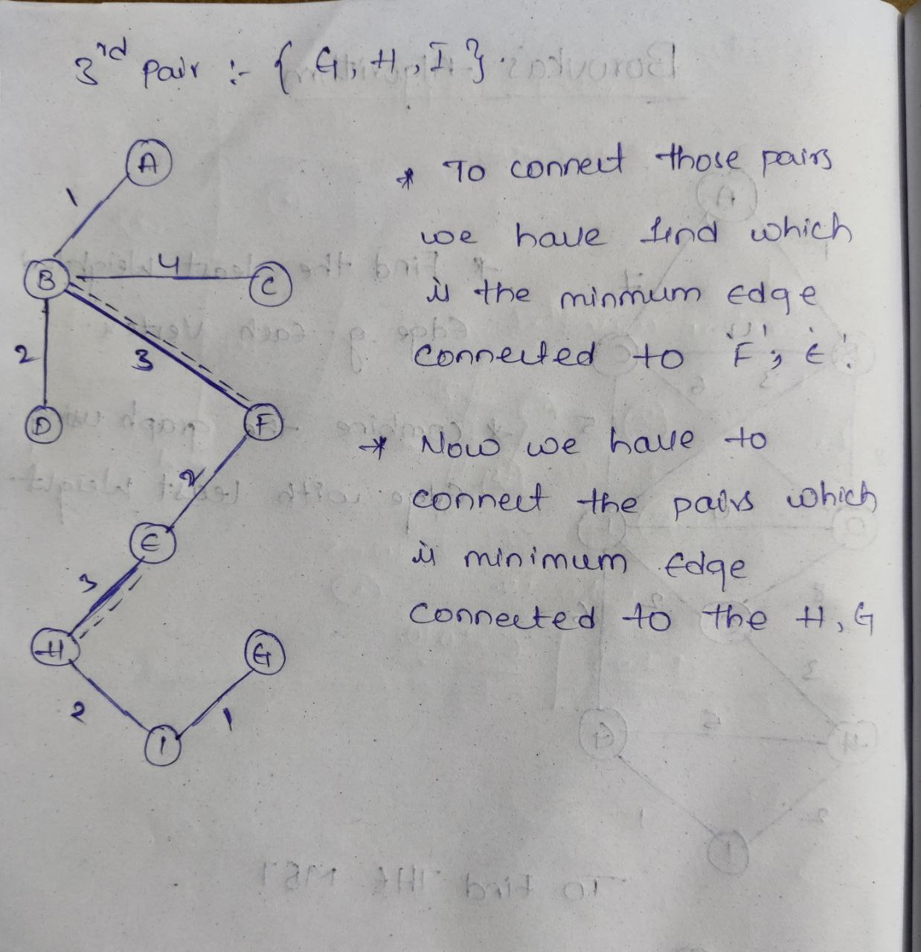

**CODE**

Boruvkas.py

class BoruvkasAlgorithm:

def __init__(self, graph):

self.graph = graph

self.graph_edges = graph.edges_with_weight

self.V = len(self.graph.nodes)

self.cheapest = [-1] * self.V

self.cheapest_nodes,self.parents, self.rank = [], [], []

self.MST_weight = 0

def find_cheapest(self):

for i in range(len(self.graph.edges_with_weight)):

u,v, w = self.graph.edges_with_weight[i]

set1, set2 = u, v

if set1 != set2:

if self.cheapest[set1] == -1 or self.cheapest[set1][2] > w:

self.cheapest[set1] = [u, v, w]

if self.cheapest[set2] == -1 or self.cheapest[set2][2] > w:

self.cheapest[set2] = [u, v, w]

def union(self,x, y):

xroot = self.find(self.parents, x)

yroot = self.find(self.parents, y)

if self.rank[xroot] < self.rank[yroot]:

self.parents[xroot] = yroot

elif self.rank[xroot] > self.rank[yroot]:

self.parents[yroot] = xroot

else:

self.parents[yroot] = xroot

self.rank[xroot] += 1

def find_MST(self):

numTrees = self.V

MSTweight = 0

for n in range(self.V):

self.parents.append(n)

self.rank.append(0)

while numTrees > 1:

self.find_cheapest()

for node in range(self.V):

if self.cheapest[node] != 1:

u, v, w = self.cheapest[node]

set1 = self.find(self.parents, u)

set2 = self.find(self.parents, v)

if set1 != set2:

MSTweight += w

self.union(set1, set2)

print("Towns %d-%d with distance %d are included in establishing electric grid " % (u, v, w))

numTrees = numTrees - 1

self.cheapest_nodes = self.cheapest

self.cheapest = [-1] * self.V

self.MST_weight = MSTweight

return MSTweight

def find(self, parent, i):

if parent[i] == i:

return i

return self.find(parent, parent[i])

test.py

import boruvkas

import networkx as nx

import random

import graph

def MST_problem(n):

weightsvector = random.sample(range(1,100), 25)

weightindex = 0

G = nx.Graph()

G.edges_with_weight = []

for i in range(n):

for j in range(i+1, n):

weight = weightsvector[weightindex]

G.add_edge(i, j, weight=weight)

G.edges_with_weight.append((i,j,weight))

weightindex += 1

A = boruvkas.BoruvkasAlgorithm(G)

graph.display(G)

A.find_MST()

graph.display(G, path=A.cheapest_nodes)

if __name__ == "__main__":

MST_problem(4)

Graph.py

import networkx as nx

import matplotlib.pyplot as plt

def display(G, path=None):

pos = nx.spring_layout(G)

nx.draw(G, pos, node_color='k')

nx.draw_networkx_labels(G, pos, font_size=20)

if path is not None:

nx.draw_networkx_edges(G, pos, edgelist=path, width=6, edge_color='r')

else:

nx.draw_networkx_edges(G, pos, width=1)

nx.draw_networkx_edge_labels(G, pos, font_size=10)

plt.axis('off')

plt.plot(weight=True)

plt.show()

main.py

# This is a sample Python script.

# Press Shift+F10 to execute it or replace it with your code.

# Press Double Shift to search everywhere for classes, files, tool windows, actions, and settings.

def print_hi(name):

# Use a breakpoint in the code line below to debug your script.

print(f'Hi, {name}') # Press Ctrl+F8 to toggle the breakpoint.

# Press the green button in the gutter to run the script.

if __name__ == '__main__':

print_hi('PyCharm')

# See PyCharm help at https://www.jetbrains.com/help/pycharm/

**RESULTS**

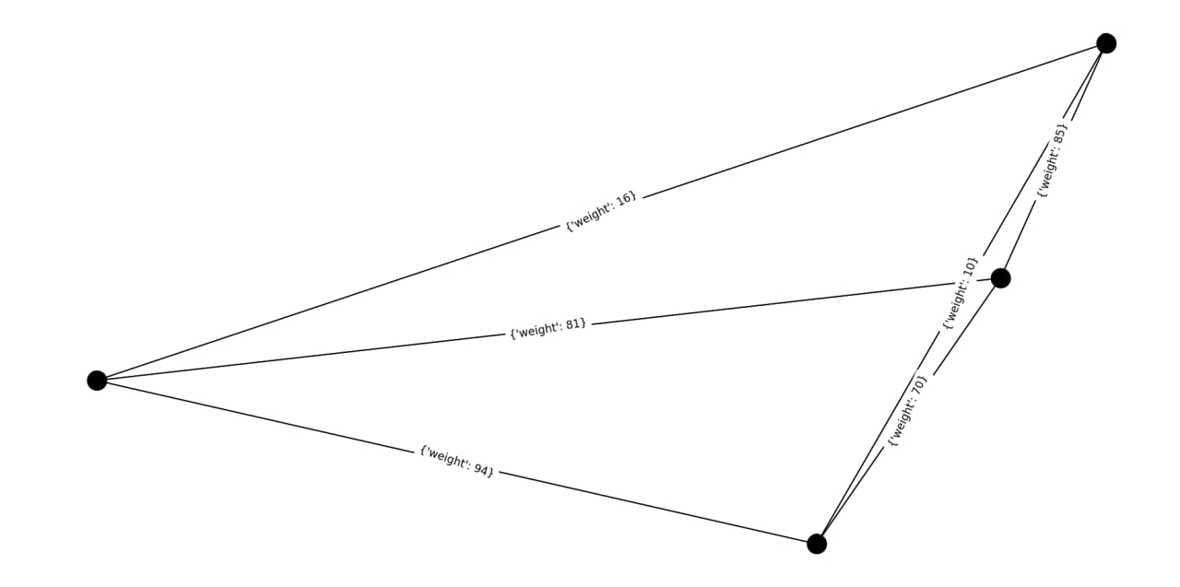

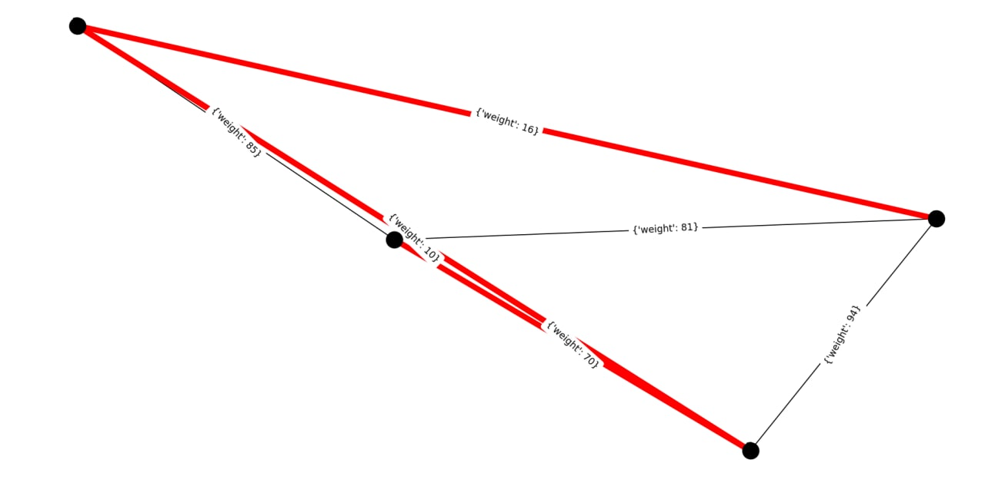

**CONCLUSION**

In the future, we will explore and test our developed algorithm “BORUVKA’S” in various domains. It is an important combinatorial optimization problem which is improved in recent times. The availability of reliable software, extremely fast and inexpensive hardware and high –level languages that make the modeling of complex problems faster have led to much greater demand for optimization tools. Keeping the above points of view our future work will more emphasize much larger problems on personal computers, much of the necessary data is routinely collected and tools exist to speed up both the modeling and the post optimality analysis.The front end can be also added to this.