A Project Report

on

**RENT & GO**

**ENTERPRICE PROGRAMMING**

A project report submitted in partial fulfillment of the requirements for the degree of Bachelor of Technology in Computer Science and Engineering

By

**ROKKAM VIVEVEK VARDHAN REDDY (2010030142)**

**VIDIYALA ABHIRAM (2010030180)**

**TAHSHEEN BEGUM (2010030168)**

**ALWALA RAGHAVENDRA GOUD (2010030394)**

Under the guidance of

**Dr K . Srinivas**

Professor



**K L University Hyderabad**

**DEPARTMENT OF COMPUTER SCIENCE AND ENGINEERING**

K L University Hyderabad,

Aziz Nagar, Moinabad Road, Hyderabad – 500 075, Telangana, India.

November 2022

**K L University Hyderabad**

Aziz Nagar, Moinabad Road, Hyderabad – 500 075, Telangana, India.

November 2022

**DEPARTMENT OF COMPUTER SCIENCE AND ENGINEERING**

**CERTIFICATE**

This is to certify that the Project work entitled “**RENT & GO**” is carried out by  **VIDIYALA ABHIRAM (2010030180) TAHSHEEN BEGUM (2010030168) ALWALA RAGHAVENDRA GOUD (2010030394) ROKKAM VIVEVEK VARDHAN REDDY (2010030142)** in partial fulfillment for the award of degree of **Bachelor of Technology** in **Computer Science and Engineering**, Name of the University, Full address of the University during the academic year 2022-2023.

**Dr K . Srinivas**

Professor

(Internal Guide)

Signature of the HOD External Examiner

**DECLARATION**

I hereby declare that the project titled “RENT & GO” submitted to COMPUTER SCIENCE AND ENGINEERING, KL UNIVERSITY, HYDERABAD for the award of the degree of Bachelor of Technology in Computer Science and Engineering is a result of original work carried-out in this project report. I understand that my report may be made electronically available to the public. It is further declared that the project report or any part thereof has not been previously submitted to any University or Institute for the award of degree or diploma.

Name of Student(s) : ROKKAM VIVEVEK VARDHAN REDDY ,VIDIYALA ABHIRAM ,TAHSHEEN BEGUM , ALWALA RAGHAVENDRA GOUD

Hall Ticket Number(s): (2010030142), (2010030180), (2010030168), (2010030394)

Degree : Bachelor of Technology

Department : **Computer Science and Engineering**

Title of the project: RENT & GO

_________________________________

ROKKAM VIVEVEK VARDHAN REDDY

VIDIYALA ABHIRAM

TAHSHEEN BEGUM

ALWALA RAGHAVENDRA GOUD

Date: 28-11-2022

## ACKNOWLEDGEMENT

First and foremost, we thank the lord almighty for all his grace & mercy showered upon us, for completing this project successfully.

We take grateful opportunity to thank our beloved Founder and Chairman who has given constant encouragement during our course and motivated us to do this project. We are grateful to our Principal **Dr. L. Koteswara Rao** who has been constantly bearing the torch for all the curricular activities undertaken by us.

We pay our grateful acknowledgement & sincere thanks to our Head of the Department **Dr. Chiranjeevi Manike** for his exemplary guidance, monitoring and constant encouragement throughout the course of the project.

We thank **Dr K . Srinivas** of our department who has supported throughout this project holding a position of supervisor.

We whole heartedly thank all the teaching and non-teaching staff of our department without whom we won’t have made this project a reality. We would like to extend our sincere thanks especially to our parents, our family members and friends who have supported us to make this project a grand success.

_______________________

V.ABHIRAM (2010030180)

_______________________

TAHSHEEN BEGUM (2010030168)

_______________________

ALWALA RAGHAVENDRA GOUD (2010030394)

_______________________

ROKKAM VIVEK VARDHAN REDDY (2010030142)

**ABSTRACT**

This project is being considered in order to reduce and eliminate loss of customers to competitors, and save the company from folding up. The current system is manual and it is time consuming. It is also cost ineffective, and average return is low and diminishing. Currently, customers can call or walk-in in order to rent or reserve a vehicle. The staff of the company will check their file to see which vehicle is available for rental. The current system is error prone and customers are dissatisfied. The goal of this project is to automate vehicle rental and reservation so that customers do not need to walk-in or call in order to reserve a vehicle. They can go online and reserve any kind of vehicle they want from the inventory of available vehicles. Even when a customer chooses to walk-in, computers are available for him to go online and perform his reservation. When he choose to reserve by phone, any of the customer service representatives can help him reserve the vehicle speedily and issue him a reservation number. The project will maintain the database of all vehicles the company has. It will also keep track of all vehicle reservation and return. Reports will be generated bi-weekly. Reports for the Accounts Manager will detail the cost incurred to maintain each vehicle and revenue accrued on each vehicle.

**Keywords: Rent , vehicles.**

## TABLE OF CONTENTS

**Page**

**List of Figures 7**

|  |  |  |  |
| --- | --- | --- | --- |
|  | | |  |
| **CHAPTER 1: INTRODUCTION** | | | |  |
| 1.1 | Introduction | | 8 |
| 1.2  1.3 | Problem statement  Scope of Research | | 9  9 |
| **CHAPTER 2: LITERATURE REVIEW** | | | 10 |
|  | |
| 2.1 | Summary of literature review | | 10 |
| **CHAPTER 3: METHODOLOGY** | | | 12 |
| 3.1 | Materials | | 12 |
| 3.10 | Summary of methodology | | 12 |
| **CHAPTER 4: RESULTS** | | | 14 |
| 4.1 | results | | 14 |
| **CHAPTER 5: CONCLUSION** | | | 16 |
| 5.1 | Conclusion | | 16 |
| **REFERENCES** | | | 17 |

## LIST OF FIGURES

|  |  |  |
| --- | --- | --- |
|  |  | **Page** |
| Figure 4.1.1 | Home page | 14 |
| Figure 4.1.2 | Vehicles | 14 |
| Figure 4.1.3 | Admin controller | 15 |
| Figure 4.1.4 | payment | 15 |

**1. INTRODUCTION**

* 1. Introduction

This System is based on a concept to Rent vechiles and generate an rental invoice for the rental company (application) ]our target is to create the application more User friendly interface , Fast access to application , Less error , Search facility, Look and Feel Environment , Quick transaction using web appilications and servers , here we are trying to build this app with mysql , eclipse , spring boot and Jakarta Server Page(JSP)

we aim to improve the Rental vehicles business and we also consider to provide customers able to user easy way to make reservation .Example customer can use internet access to web-based system to, looking for vehicles detail or prices and so on .

-The system will save all customers details for feature references.

– Customers can save Time, save cost, get information on the web-based and can access in any time any where.

– Develop for Rental Vehicles business market in Langkawi Island.

-Easy administrator manages reservation data or processing data with customers.

-More suitable to customer with administrator to communication on internet.

1.2Problem Statement

Vehicle Rental Management System is software a web application , which is helpful for people, who wants to rent a vehicle for their needs and requirements. Vehicle Rental Management System is a windows application which focuses in the area of renting the vehicles such as cars, bikes , buses , trucks , auto , etc

In this application, a person can be register as a user and he can rent the vehicle he/she wants, the user needs to first login into the application using email id and password, if he is a new user for the application then he first need to register using email and create an account and set a password for it and need to fill in the details regarding the address and gender (some personal information) . then the user can choose the vehicle after logging in into the application, and go for the payment and billing option and the billing will be sent to mail.

1.3 Scope of Research

The scope of this project is create a user friendly web-based system for customers. The web-based system must be secured and easy to manage by administrator. The following feature to be focused on my web system. In booking list, this function enables customers to see booking date when customer booking . In registration account this function enables customers to create user details and information. In vehicles model list this function enables customers to view all types of vehicles . In payment list this function enables customers to view total of pay booking list. Last, in feedback-form enables customers to send admin suggestion.

**2. LITERATURE SURVEY**

2.1Summary of literature review

1, Author : Rahul Kulkarni , Chaitanya R , Pratibha , Pooja A Patil , Nikeeta Biradar.

Title: Online Car Rental System , Published on august 21 , the techniques used are The vehicle rental framework has a PHP outlook for the organization, an online entryway, and created utilizing PHP and MySQL individually. This entrance is a client well disposed of, practical, and lessens endeavors and time to look through a vehicle. Procs: The new data can be added or existing data can be edited or deleted too by administrators. Thus, there is no delay in the availability of any information, whether needed, can be captured very quickly and easily. Cons: the present structure and understanding the imperfections in it. The depicted system vanquishes all the imperfections of the present structure and brings a period of dynamic structure which is brisk, profitable and particularly adaptable.

2, Author : Amey Thakur

Title : Car Rental System, Published on July 21, the techniques used are Functional requirements are those that are used to demonstrate the system's internal functioning nature, as well as the system's description and explanation of each subsystem. It comprises the task that the system should accomplish, the processes involved, the data that the system should contain, and the user interfaces. With the dataset Data conversion is another expense connected with the implementation of this web application. The previously used

software database must be saved and backed up so that no time or money is wasted in the implementation of the new web-based application. Procs: In comparison to previous experiences, when every activity related to the vehicle rental business was restricted to a physical place alone, the car rental industry has emerged with new delicacies. Even if the physical location has not been completely eliminated, the internet's power has altered the nature of functions and how these tasks are accomplished.

Cons:

1)There is a problem operating XAMPP.

2) During the development process, to debug the mistake.

3) To depict a connection between two or more entities.

4) A database table has a minor mistake.

**3.METHODOLOGY**

3.1 Materials

**Software requirements:**

1. MYSQL
2. JAVA
3. JSP
4. SPRING BOOT
5. ECPLISE

**Hardware requirements:**

1. 1 GB Ram
2. 320 GB HDD
3. Intel 2.4 GHz Processor core2duo

3.2. Summary of methodology

A methodology is part of important technique used to manage and control research in project to achieve the specified objectives within a given time. In order to complete this research, there are five major phases involved.

Each phase involved in this project have significance in achieving the objectives of the project. This project begins with knowledge acquisition phase and finished with the documentation of result. As mentioned in the objective of this project, data matching technique is applied to provide vehicle rental service to the users.

The waterfall model is follows a linear and strict set of stages during its development process. The waterfall model can be process model follows a particular life cycle in order to ensure success in process of software development. Important is the waterfall model have high value in software development field and now a day still a lot of software develop company used to develop they are software productions.

The advantage of waterfall model is it allows for departmentalization and managerial control, after than a schedule can be set with an end time for each stage of development and a product can proceed through the development process like a shirt in a washing machine, and theoretically, can be finish on time. Development moves from concept, through design, implementation, testing, installation, troubleshooting, and end up at operation and maintenance. Each phase of development proceeds in strict order, without any overlapping or iterative steps.

The methodology used is the Waterfall process model because it is the most suitable method for this project. It has a linear framework and goes forward within a strict set of phases. This method has more advantages when compared with other methods. The system requirements which is the hardware and software requirements needed for the project were also discussed in this chapter. The next chapter covers the design and implementation part of this project

**4**.**RESULTS**

**4.1 Summary of results**

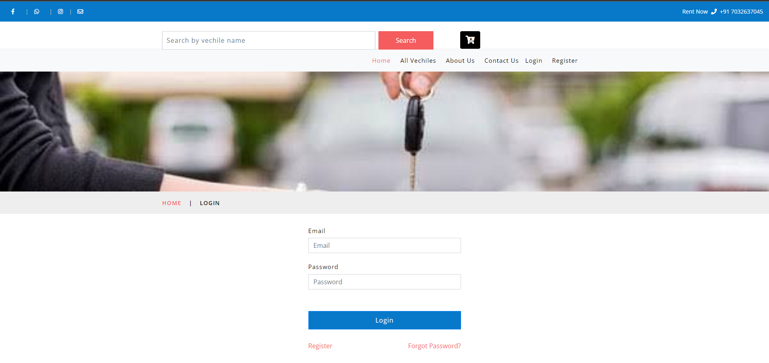

**Fig4.1.1 home page**

**Fig 4.1.2 vehicle’s provided for service**

**Fig4.1.3 admin accessing the request’s and responding to the request**

**Fig4.1.4 vehicle proceeding for the payment**

**5: CONCLUSION**

5.1 CONCLUSION

Summarizing the above presentation, for the concept of renting cars and generating rental invoice of a rental company ,we have done a front end with a good user Summarizing the above presentation, for the concept of renting cars and generating rental invoice of a rental company ,we have done a front end with a good user interface using tools like eclipse ide and java web api.

By using this application we can rent any vehicle for any kind of purpose. This is a common platform where we can rent to wheeler if we have only 1-2 people and rent a 4-wheeler if we are going out for a picnic with family or friends and we can also rent a 8 wheeler 12 - wheeler if we are shifting or moving to some place and we need to carry all the furniture and stuff.

REFERENCES

<https://www.altexsoft.com/blog/car-rental-reservation-system/>

<https://www.capterra.com/car-rental-software/>

<https://www.ukessays.com/essays/computer-science/case-study-of-a-vehicle-rental-system-computer-science-essay.php>

<https://ijirt.org/master/publishedpaper/IJIRT152529_PAPER.pdf>

<https://www.researchgate.net/publication/224352019_Car_rental_logistics_problem_A_review_of_literature>

<https://www.academia.edu/49897720/Car_Rental_System>

<https://www.researchgate.net/publication/323113580_Impact_of_the_online_car_rental_service_order_system_on_sales_turnover_with_financial_literacy_customer_as_intervening_variables>

<https://papers.ssrn.com/sol3/papers.cfm?abstract_id=3849830>