dhanush,  dsp,  State Cyber Crime Investigation Centre,  Cyber Crime Wing,  Tamil Nadu.  Ph:+91 1234567890 | 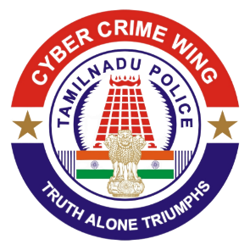 | Cyber Crime Wing,  PTC Complex,  Ashok Nagar, Chennai,  Tamil Nadu, India  Email: abishe@gmil.com  Dated: 29-07-2025
TAMIL NADU POLICE DEPARTMENT
(Notice U/s. 94 of Bharatiya Nagarik Suraksha Sanhita, 2023)

To
Grievance Officer / Legal Support Team
Google LLC
1600 Amphitheatre Parkway
Mountain View, California 94043
United States

Sir/Madam,
Sub: | Request for user account and IP log details for investigation by SCCIC, Tamil Nadu –Regarding.
Ref: | 1. SCCIC Crime No:12/8454.  2. NCRP acknowledgement no. 12564587451245.
*****
The State Cyber Crime Investigation Centre has registered and is conducting an investigation in relation to the above-referenced case. In furtherance of the investigation, you are hereby informed to produce the following documents, duly attested, before the undersigned at the address specified above, during working hours, within four (4) days from the receipt of this notice.

During investigation, it is identified that the below mentioned {{gmail_id}} accounts are involved in this fraudulent activity:

You are hereby directed to furnish the following information, duly attested, to the undersigned at the above-mentioned address during working hours within four (4) days of receiving this notice:

- User account details** (Name, Email, Phone number, linked devices)
- IP logs** (Login and access history from 2025-07-29 to 2025-07-29)
- Any other relevant information stored in connection with the suspect account(s)

