{{Officer_Name}},  {{Officer_Designation}},  State Cyber Crime Investigation Centre,  Cyber Crime Wing,  Tamil Nadu.  Ph:+91 {{Officer_Phone}} | 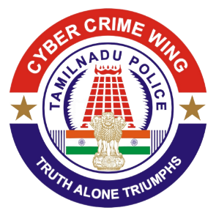 | Cyber Crime Wing,  PTC Complex,  Ashok Nagar, Chennai,  Tamil Nadu, India  Email: {{Officer_Email}}  Dated: {{Letter_Date}}
TAMIL NADU POLICE DEPARTMENT
(Notice U/s. 94 of Bharatiya Nagarik Suraksha Sanhita, 2023)

To
Grievance Officer / Legal Requests
X Corp. (formerly Twitter Inc.)
1355 Market Street, Suite 900
San Francisco, California 94103
United States
Sir/Madam,
Sub: | India - TN Police - Provide user account and IP log details for investigation – Regarding.
Ref: | 1. SCCIC Crime No:{{Crime_No_with_Section}}.  2. NCRP acknowledgement no. {{NCRP_ID}}.
*****
The State Cyber Crime Investigation Centre has registered a case and is conducting investigation in relation to the above-referenced case. During investigation, it is identified that the below mentioned {{Platform_Name}} account/s are involved in this fraudulent activity. In furtherance of the investigation, you are hereby informed to produce the following data related to the below mentioned account/s.

{{Platform_Account_Table}}

You are hereby directed to furnish the following information:

- User account details** (Name, Email, Phone number, linked devices)
- IP logs** (Login and access history from {{Date_From}} to {{Date_To}})
- Any other relevant information stored in connection with the suspect account(s)

{{Officer_Designation}}
Cyber Crime Wing
Chennai, Tamilnadu

