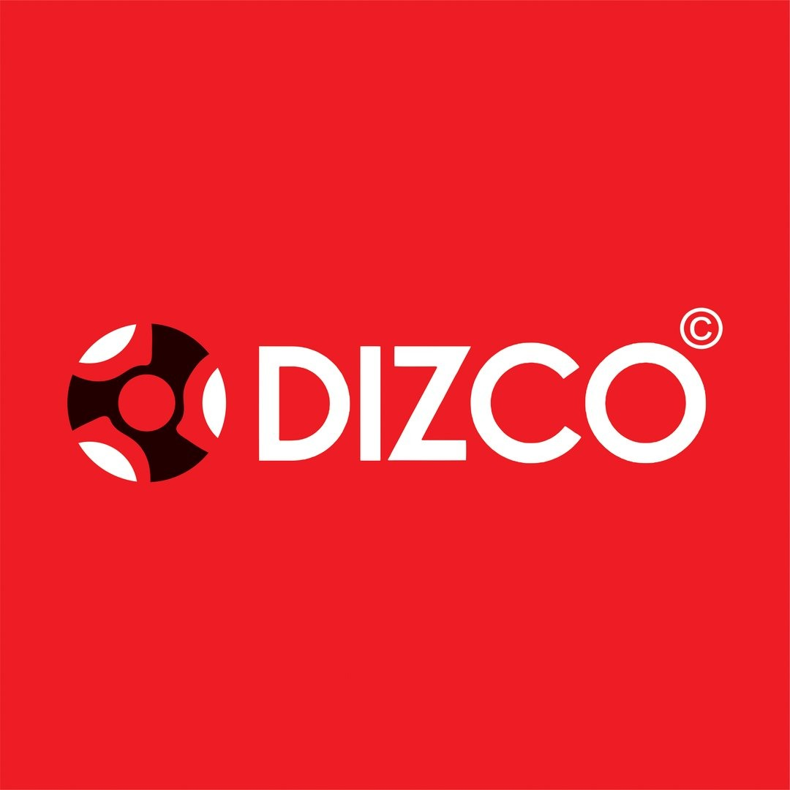
DIZCO — UI/UX & Design System
Design v1.0 • Reference-led • DIZCO brand freeze

1. Design Intent
Use the supplied DIZCO logo as the brand source of truth and the supplied fashion e-commerce visual as inspiration. Recreate the visual language, not a pixel-for-pixel copy: editorial imagery, compact utility/navigation bars, bold typography, black/white/neutral surfaces, product grids and high-impact campaign modules.

2. Design Principles
- Editorial first: fashion photography is the dominant visual element.
- Minimal chrome: controls stay compact and unobtrusive.
- Bold typography: large campaign headlines with clean commerce text.
- High contrast: DIZCO red is the primary brand accent; black/white/neutral form the base.
- Grid discipline: consistent product-card proportions and spacing.
- Fast purchase path: search → product → cart → checkout should be frictionless.
- Responsive by hierarchy: mobile preserves the content priority rather than simply shrinking desktop.

3. Visual Tokens
Token | Frozen Direction
Brand | DIZCO
Primary color | DIZCO red from supplied logo; exact production value to be sampled from source asset.
Base | Near-black and white.
Surface | Warm off-white/light neutral.
Typography | Modern grotesk/sans-serif; bold display + clean body weights.
Photography | Premium fashion/editorial imagery; consistent product crops.
Spacing | 8px rhythm: 8, 16, 24, 32, 48, 64, 96.
Product imagery | Prefer 4:5 or 3:4 apparel imagery.

4. Global Shell
- Top utility bar: promotion + app/help/order links + compact contact action.
- Primary header: DIZCO logo, New Arrivals, Men, Women, Collections, Essentials, Search, Account, Wishlist, Cart.
- Main content: full-width editorial modules within a controlled max-width.
- Footer: company info, quick links, contact, policies and social links.
- Mobile: logo + search/cart/menu controls; navigation becomes a drawer.

5. Home Page
Section | Design
Utility bar | Slim, high-contrast strip.
Navigation | Compact commerce header with DIZCO identity.
Hero | Large editorial collage/split image, oversized typography and primary CTA.
Category/brand strip | Compact navigation row.
Featured Products | 4-column desktop grid; 3 tablet; 2 mobile where usable.
Editorial Story | Image + copy block.
Seasonal Collection | Dark visual section with 3 strong panels.
New Arrivals | Product grid with badges, prices and quick action.
Footer | Information, support, policy and social links.

6. Product Listing
- Category title + short description.
- Compact filter/sort toolbar.
- Consistent product-card ratio.
- Card shows image, badge, product name, color indicators, current/old price and Add to Cart.
- Desktop may use hover secondary image/quick view; mobile cannot depend on hover.
- Default MVP pagination.

7. Product Details
- Large gallery left and product information right on desktop.
- Name, SKU, price/sale price, availability.
- Extensible size/color selector components.
- Quantity + Add to Cart + Buy Now.
- Description/specification accordions.
- Delivery/address check area.
- Related/recommended products.

8. Cart & Checkout
- Desktop: items + sticky order summary.
- Checkout sequence: Address → Review → Payment → Confirmation.
- Keep checkout visually calm; avoid unnecessary marketing.
- Show subtotal, shipping, discounts when introduced, final total and payment state.
- Payment failure must preserve the cart and provide retry.

9. Authentication
- Login landing presents two clear paths: User Login and Admin Login.
- User Login: email, password, remember me, forgot password, login and register.
- Admin Login: secure, visually distinct operational treatment; no public admin registration.
- Register is customer-only.

10. Admin UI
- Functional dashboard rather than editorial storefront.
- Left sidebar: Dashboard, Products, Categories, Orders, Customers, Inventory, Content, Settings.
- Top bar: page title, search/notifications, admin account and logout.
- Dashboard cards: products, orders, customers and stock alerts.
- Products table: image, SKU, price, stock, status and actions.
- Add/Edit Product: images, details, pricing, inventory and publish controls.
- Delete requires confirmation.
- Use DIZCO accents while keeping operational screens neutral and readable.

11. Component System
Component | States
Button | Primary, secondary, ghost, danger, loading, disabled
Product Card | Default, sale, new, trending, out-of-stock, compact
Input | Default, focus, error, disabled
Badge | New, Sale, Trending, Out of Stock
Modal | Delete confirmation, quick view, status confirmation
Toast | Success, error, warning, info
Header | Desktop, mobile
Grid | 4/3/2/1 responsive columns
Admin Table | Loading, empty, populated, pagination
Sidebar | Expanded desktop, mobile drawer

12. Responsive Rules
Viewport | Behavior
≥1280px | Full editorial layout, 4-column products, persistent admin sidebar.
1024–1279px | Reduced gutters, 3-column product grid.
768–1023px | Tablet navigation, 2–3 column grids.
<768px | Mobile header/drawer, stacked checkout, 2-column product grid where usable.
<480px | Compact typography/controls and single-column editorial blocks when needed.

13. UX States
- Loading: skeleton product cards/tables.
- Empty: helpful message + next action.
- Error: concise explanation + retry.
- Out of stock: explicit label and disabled purchase action.
- Success: toast and/or confirmation page.
- Destructive actions: confirmation dialog.

14. Accessibility & Performance
- Keyboard-accessible navigation, dialogs and forms.
- Visible focus states and semantic headings.
- Accessible labels for icon-only controls.
- Never rely on color alone for status.
- Lazy-load below-the-fold images.
- Use optimized WebP/AVIF where appropriate.
- Meaningful image alt text.

15. Design Freeze
- Frozen: DIZCO name/logo, editorial fashion direction, black/white/neutral base, DIZCO red accent, product-grid storefront, separate admin workspace.
- Flexible: campaign imagery, copy, exact icon library, minor spacing values and seasonal modules.
- Major navigation, purchase-flow or role-separation changes require product/design review.

16. Reference Note
The supplied Dribbble reference is used for inspiration around editorial composition, bold typography, image-led merchandising and premium fashion-commerce interactions. DIZCO branding remains the controlling identity.

