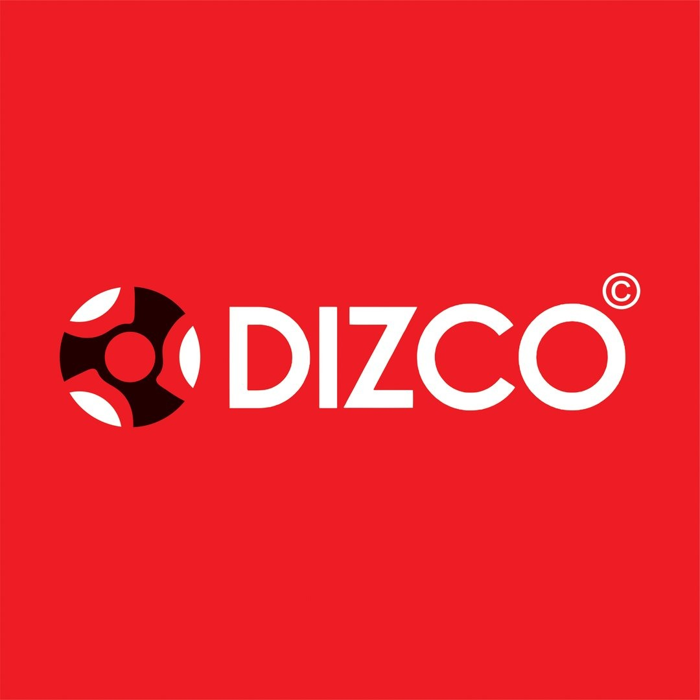
DIZCO — Product Requirements Document
PRD v1.0 • Fashion E-commerce • Scope + Technology Freeze

1. Product Vision
DIZCO is a premium fashion e-commerce platform with an editorial customer storefront and a secure operational admin panel. The experience follows the supplied visual reference: large fashion imagery, bold typography, generous whitespace, compact navigation, strong product grids and restrained high-contrast calls to action.

2. Goals
- Deliver a premium, responsive DIZCO shopping experience.
- Separate User Login and Admin Login.
- Let customers browse, search, cart, checkout, pay and view orders.
- Let admins create, edit, publish/unpublish and delete products, manage categories, inventory, orders and customers.
- Use INR and Razorpay for v1 payments.
- Keep the architecture ready for Tier-2 capabilities.

3. Roles
Role | Responsibilities | Access
Customer | Browse/search, product details, cart, checkout, payment, profile and order history. | Customer storefront
Admin | Products, categories, inventory, orders, customers, CMS and settings. | Admin panel

4. MVP Functional Requirements
Module | Requirements
Setup & Core | Domain, HTTPS/SSL, DNS/server setup, DIZCO branding, navigation, footer, contact/social links.
Products | Create/edit/delete, active/inactive, publish/unpublish, up to 5 images, description, SKU, price, quantity.
Categories | Create/view/edit/delete categories such as T-shirts, Pants and Trousers; frontend category display.
Search | Product-name search, category search and results page.
Customer Auth | Email/password signup, verification, activation, confirmation, login, remember me, forgot/reset password, session management.
Profile | View/edit profile, change password, order history, logout.
Cart | Add/view/update/remove, totals, persistent cart, empty cart and item-count badge.
Address | Single delivery address: name, address, city, ZIP, phone.
Checkout | Review items, select address, order summary and final total.
Payment | Razorpay, secure processing, payment status, confirmation and failure handling.
Orders | Create order, confirmation email, order reference and basic invoice.
Inventory | Stock tracking, reduction on order, out-of-stock display/notification, low/out-of-stock admin alerts.
CMS | About, Contact, Privacy Policy, Terms & Conditions and editable footer/company/social content.
Admin | Dashboard counts, product management, order management, customer management and INR/store settings.
Deployment | Code deployment, server/database setup, migrations, live URL, email, SSL and domain linking.

5. Tier-2 Backlog
- Size/color product variants and variant inventory/images.
- Wishlist, reviews and ratings with admin moderation.
- Multiple customer addresses and support tickets.
- Coupons, discounts and price history.
- Advanced order tracking, shipment, returns and refunds.
- Multiple payment gateways with Stripe as alternative.
- Sales/product/customer analytics and CSV/Excel exports.
- Automated transactional emails and newsletters.
- Advanced admin dashboard and inventory history.
- Image optimization, caching, performance optimization and SEO.

6. Acceptance Criteria
- Customer sessions cannot access admin routes.
- Admin sessions cannot access customer-only routes.
- Product CRUD persists in PostgreSQL and is reflected on the storefront.
- Only active/published products are customer-visible.
- Checkout totals and stock are validated server-side.
- Paid status is set only after verified Razorpay payment/webhook processing.
- Customers can only view their own profile/orders.
- Production uses HTTPS.

7. Frozen Technology Stack
Layer | Frozen Technology | Rule
Frontend | React.js + Vite | No framework migration during MVP.
Routing | React Router | Role-based route separation.
Styling | Standard CSS / CSS Modules | Custom DIZCO design system.
HTTP | Axios | Single frontend API client.
State | React Context + local state | Server data comes from API.
Backend | FastAPI (Python) | REST API.
ORM | SQLAlchemy | Database models/access.
Database | PostgreSQL | Primary production database.
Auth | JWT + role-based authorization | User/Admin roles.
Password | Argon2id or bcrypt | Never store plaintext passwords.
Payments | Razorpay | Only v1 gateway.
Images | Cloudinary | Product image storage/optimization.
Email | SMTP provider | Verification/reset/order emails.
Deployment | Vercel/Netlify + Render/Railway + managed PostgreSQL | Production baseline.
API | REST + OpenAPI | Frontend/backend contract.
Source control | Git + GitHub | Version control.

8. Scope Freeze
- The above technology stack is frozen for MVP.
- Do not replace PostgreSQL with MongoDB, FastAPI with another backend framework, or React/Vite with another frontend framework without explicit approval.
- Do not add a second payment gateway in v1.
- Tier-2 features are backlog items and do not block MVP.
- Design can evolve within the frozen DIZCO visual language.

9. Source Scope Mapping
The supplied Complete Modules List is the functional baseline. Modules 1–8 form the core MVP foundation; Modules 9–19 are treated as Tier-2/expansion scope.

