What is c++
C++ is regarded as a middle-level language, as it comprises a combination of both
high-level and low-level language features.

C++ is an object-oriented programming language and include
classes,inheritance,polymorphism,data abstaraction and encapsulation.

C++ allows exception handling, and function overloading which are not possible in C

Constructor
A constructor is a special type of member function that is called automatically when
an object is created.

In C++, a constructor has the same name as that of the class and it does not have a
return type.

-Default Constructor:

A constructor with no parameters is known as a default constructor.
Sum()

In the example, Wall() is a default constructor.

-Parameterized Constructor:

In C++, a constructor with parameters is known as a parameterized constructor.
Sum(inta,intb)
-Copy Constructor:

The copy constructor in C++ is used to copy data of one object to another.
Sum(sum sum &obj)
Constructor:
#include<iostream>
using namespace std;
class A
{
public:
int id;
A()
{
cout<<"default constructor"<<endl;
id=-1;
}
A(int x)
{
cout<<"parameterized constructor"<<endl;
id=x;
}
};
int main()
{

A obj1;
cout<<"id is:"<<obj1.id<<endl;
A obj2(23);
cout<<" id is :"<<obj2.id<<endl;
return 0;
}
Output:
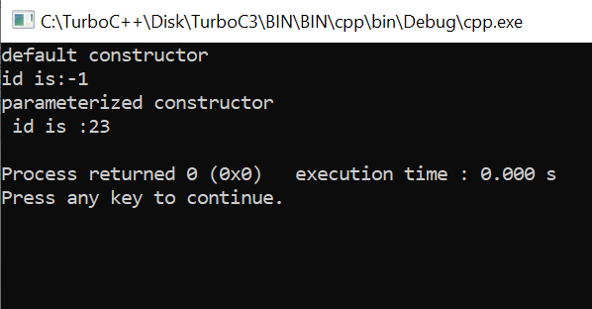
Destructor:
#include <iostream>
using namespace std;

class box {
public:
int length, width;

box(int x, int y) { // parameterized constructor
length = x;
width = y;
}

void print() {
cout << "length: " << length << endl;
cout << "width: " << width << endl;
}

~box() {
cout << "object deleted";
}
};

int main() {
if (1) {
box box1(10, 20);
cout << "box1 details" << endl;
box1.print();

}
cout << "object deleted";

return 0; // Added return statement to the main function
}
Output:

Object-oriented programming has several advantages:

OOP is faster and easier to execute.

OOP provides a clear structure for the programs.

OOP makes it possible to create full reusable applications with less code and shorter
development time.
Classes and Objects

Data Abstraction

Encapsulation

Inheritance

Polymorphism

Class:
A class in C++ is the building block that leads to Object-Oriented programming.

It is a user-defined data type, which holds its own data members and member
functions, which can be accessed and used by creating an instance of that class.

A C++ class is like a blueprint for an object.

Object:

An Object is an instance of a Class.

When a class is defined, only the specification for the object is defined; no memory or
storage is allocated. To use the data and access functions defined in the class, you
need to create objects.

Class and object:
#include<iostream>
using namespace std;
class calculator
{
public:
int a,b;
int addition()
{
return a+b;
}
};

int main()
{

calculator calc1;
calc1.a=10;
calc1.b=20;
cout<<calc1.addition()<<endl;
return 0;
}

Output:

Abstraction:
Data abstraction refers to providing only essential information to the

outside world and hiding their background details, i.e., to represent the

needed information in program without presenting the details.

#include <iostream>
using namespace std;

class implementAbstraction {
private:
int a, b;

public:
// method to set values of
// private members
void set(int x, int y)
{
a = x;
b = y;
}

void display()
{
cout << "a = " << a << endl;
cout << "b = " << b << endl;
}
};

int main()
{
implementAbstraction obj;
obj.set(10, 20);
obj.display();
return 0;
}

Output:


Encapsulation:

Encapsulation is defined as wrapping up of data and information under a single unit. In
Object Oriented Programming, Encapsulation is defined as binding together the data
and the functions that manipulates them.
#include<iostream.h>

#include<conio.h>

class Rectangle

{

public:

int length;

int breadth;

Rectangle(int len,int brth):length(len),breadth(brth)

{

}

int getArea()

{
return length*breadth;

}

};

int main()

{

clrscr();

Rectangle rect(8,6);

cout<<"Area="<<rect.getArea();

getch();

return 0;

}
Output:


Inheritance:

The capability of a class to derive properties and characteristics fromanother class is
called Inheritance.

Types of Inheritance in C++

Single Inheritance.

Multiple Inheritance.

Multilevel Iheritance.

Hierarchical Iheritance.

Hybrid Inheritance.

Single Inheritance.

