**Name : Abisha V**

**WEEK – 7**

**1)** 9. ReactJS-HOL

**ListofPlayers.js**

import React from 'react'; const ListofPlayers = () => { const players = [

{ name: 'Rohit', score: 80 },

{ name: 'Virat', score: 65 },

{ name: 'Gill', score: 50 },

{ name: 'Rahul', score: 90 },

{ name: 'Jadeja', score: 70 },

{ name: 'Hardik', score: 40 },

{ name: 'Shami', score: 85 },

{ name: 'Bumrah', score: 60 },

{ name: 'Pant', score: 95 },

{ name: 'Ashwin', score: 55 },

{ name: 'Surya', score: 72 },

];

const filteredPlayers = players.filter(player => player.score < 70); return (

<div>

<h2>All Players</h2>

<ul>

{players.map((p, index) => (

<li key={index}>{p.name} - {p.score}</li>

))}

</ul>

<h3>Players with score below 70</h3>

<ul>

{filteredPlayers.map((p, index) => (

<li key={index}>{p.name} - {p.score}</li>

))}

</ul>

</div>

);

};

export default ListofPlayers;

**IndianPlayers.js** import React from 'react'; const IndianPlayers = () => {

const oddPlayers = ['Rohit', 'Gill', 'Jadeja', 'Shami', 'Pant']; const evenPlayers = ['Virat', 'Rahul', 'Hardik', 'Bumrah', 'Ashwin', 'Surya']; const [p1, p2, p3, ...restOdd] = oddPlayers; const [e1, e2, e3, ...restEven] = evenPlayers; const T20players = ['Rohit', 'Virat', 'Hardik']; const RanjiTrophyPlayers = ['Jaiswal', 'Sarfaraz', 'Iyer'];

const allPlayers = [...T20players, ...RanjiTrophyPlayers]; // ES6 Merge feature return (

<div>

<h2>Odd Team Players (Destructured)</h2>

<ul>

<li>{p1}</li>

<li>{p2}</li>

<li>{p3}</li>

</ul>

<h2>Even Team Players (Destructured)</h2>

<ul>

<li>{e1}</li>

<li>{e2}</li>

<li>{e3}</li>

</ul>

<h2>Merged List (T20 + Ranji Players)</h2>

<ul>

{allPlayers.map((p, i) => <li key={i}>{p}</li>)}

</ul>

</div>

);

}; export default IndianPlayers; **App.js**

import React from 'react'; import ListofPlayers from './ListofPlayers'; import IndianPlayers from './IndianPlayers'; function App() {

const flag = true; // Toggle this to false to see the other component return (

<div className="App">

<h1> Cricket App</h1>

{flag ? <ListofPlayers /> : <IndianPlayers />}

</div>

);

}

export default App;

**OUTPUT :**

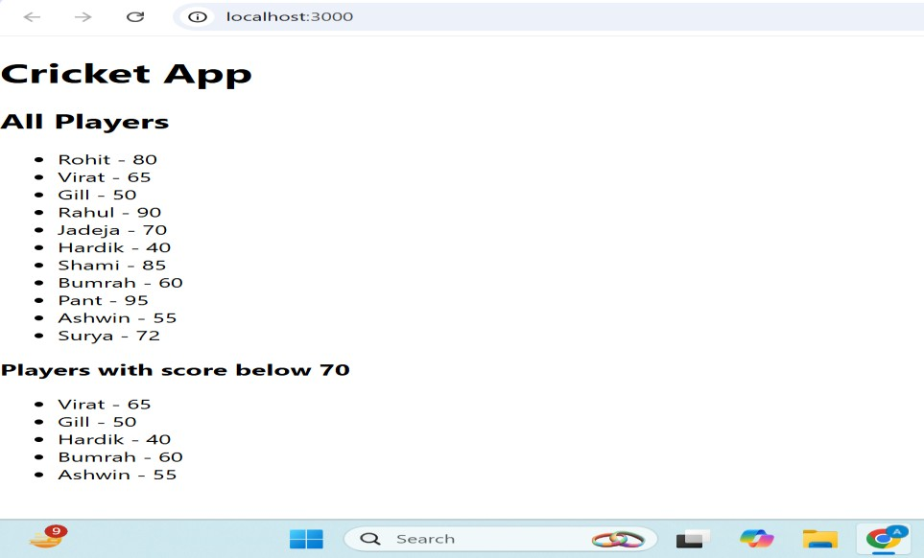

**2) 10. ReactJS-HOL**

# App. js

import React from 'react';

function App() {

const heading = <h1 style={{ textAlign: 'center' }}>Office Space Rental App</h1>;

const imageURL = "https://synergyestates.in/wp-content/uploads/2025/03/office-space- fore-rent.jpg"; const office = { name: "CyberTech Park", rent: 55000,

address: "Sector 21, Bengaluru"

};

const offices = [

{ name: "InnovateHub", rent: 45000, address: "Indiranagar" }, { name: "TechSpace", rent: 65000, address: "Koramangala" },

{ name: "WorkNest", rent: 55000, address: "HSR Layout" },

{ name: "StartX", rent: 75000, address: "MG Road" },

];

return (

<div style={{ fontFamily: 'Arial', padding: '20px' }}>

{heading}

<img src={imageURL} alt="Office Space" style={{ display: 'block', margin: '20px auto', borderRadius: '10px' }} /> <h2>Featured Office</h2>

<p><strong>Name:</strong> {office.name}</p>

<p><strong>Rent:</strong> ₹{office.rent}</p>

<p><strong>Address:</strong> {office.address}</p>

<hr />

<h2>Other Office Listings</h2>

<ul>

{offices.map((item, index) => {

const rentColor = item.rent < 60000 ? 'red' : 'green'; // 👉 7. Conditional inline CSS return (

<li key={index} style={{ marginBottom: '15px' }}>

<p><strong>Name:</strong> {item.name}</p>

<p><strong>Rent:</strong> <span style={{ color: rentColor }}>₹{item.rent}</span></p>

<p><strong>Address:</strong> {item.address}</p>

</li>

);

})}

</ul>

</div>

);

}

export default App;

**OUTPUT :**

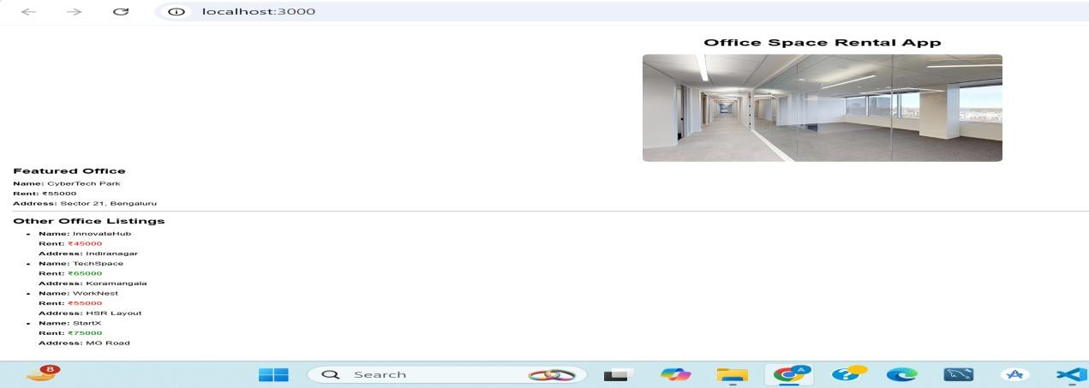

3) 11. ReactJS-HOL

# Counter.js

import React, { Component } from 'react';

class Counter extends Component { constructor() { super(); this.state = {

count: 0

};

this.increment = this.increment.bind(this); this.sayHello = this.sayHello.bind(this); this.handleIncrement = this.handleIncrement.bind(this); this.decrement = this.decrement.bind(this); this.sayWelcome = this.sayWelcome.bind(this);

this.handleSyntheticClick = this.handleSyntheticClick.bind(this);

}

increment() {

this.setState({ count: this.state.count + 1 });

}

decrement() {

this.setState({ count: this.state.count - 1 });

}

sayHello() {

console.log('Hello! This is a static message.');

}

handleIncrement() { this.increment();

this.sayHello(); // Multiple methods

}

sayWelcome(message) {

alert(message);

}

handleSyntheticClick(event) { alert("I was clicked");

console.log(event); // Synthetic Event

}

render() { return (

<div style={{ padding: '20px', borderBottom: '2px solid #ccc' }}>

<h2>Counter: {this.state.count}</h2>

<button onClick={this.handleIncrement}>Increment</button>&nbsp;

<button onClick={this.decrement}>Decrement</button>

<hr />

<button onClick={() => this.sayWelcome("Welcome!")}>Say Welcome</button>

<hr />

<button onClick={this.handleSyntheticClick}>Synthetic Event Button</button>

</div>

);

}

}

export default Counter;

# CurrencyConverter.js

import React, { useState } from 'react'; const CurrencyConverter = () => { const [inr, setInr] = useState(''); const [euro, setEuro] = useState(''); const handleSubmit = (e) => { e.preventDefault();

const euroValue = (parseFloat(inr) / 90).toFixed(2); setEuro(euroValue);

};

return (

<div style={{ padding: '20px' }}>

<h2>Currency Converter (INR to Euro)</h2>

<form onSubmit={handleSubmit}>

<label>INR Amount:</label><br />

<input type="number"

value={inr}

onChange={(e) => setInr(e.target.value)}

/><br /><br />

<button type="submit">Convert</button>

</form>

{euro && <p><strong>Converted Euro:</strong> €{euro}</p>}

</div>

);

};

export default CurrencyConverter;

# App.js

import React from 'react'; import Counter from './Counter'; import CurrencyConverter from './CurrencyConverter'; function App() { return (

<div style={{ textAlign: 'center', fontFamily: 'Arial' }}>

<h1>React Event Handling Examples</h1>

<Counter />

<CurrencyConverter />

</div>

);

}

export default App;

**OUTPUT :**

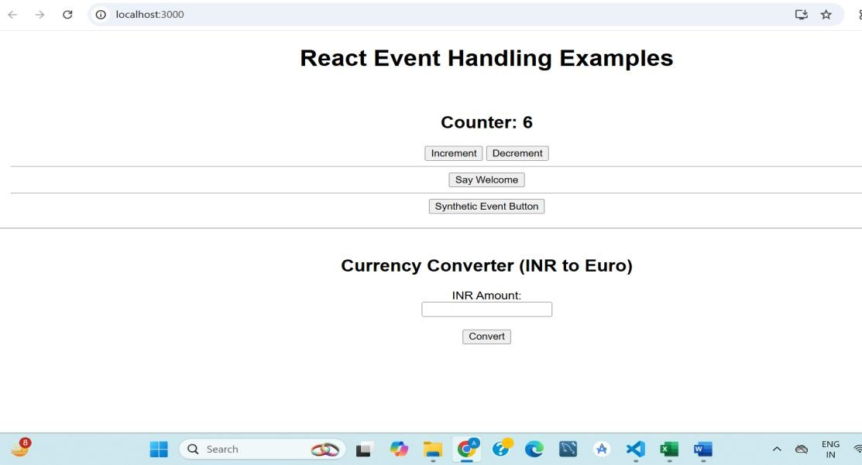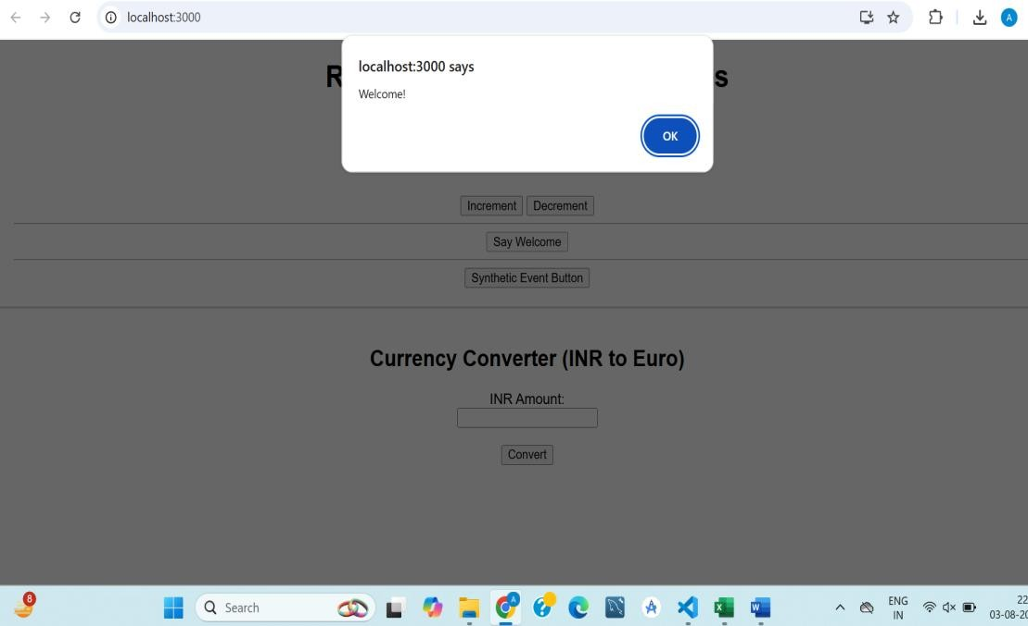

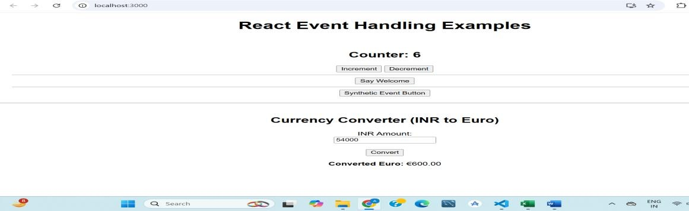

4) 12. ReactJS-HOL

## GuestPage.js

import React from 'react';

function GuestPage() { return (

<div>

<h2>Welcome Guest!</h2>

<p>You can view flight details but cannot book tickets.</p>

<ul>

<li>Flight: AI 202 | From: Delhi → Mumbai | Time: 10:00 AM</li>

<li>Flight: Indigo 501 | From: Chennai → Bangalore | Time: 1:00 PM</li>

</ul>

</div>

);

}

export default GuestPage;

## UserPage.js

import React from 'react';

function UserPage() { return (

<div>

<h2>Welcome Back, User!</h2>

<p>You can book tickets below:</p>

<button>Book AI 202</button>&nbsp;

<button>Book Indigo 501</button>

</div>

);

}

export default UserPage;

## App.js

import React, { useState } from 'react'; import GuestPage from './GuestPage'; import UserPage from './UserPage'; function App() {

const [isLoggedIn, setIsLoggedIn] = useState(false); let content; if (isLoggedIn) { content = <UserPage />;

} else {

content = <GuestPage />;

}

return (

<div style={{ textAlign: 'center', fontFamily: 'Arial', padding: '20px' }}>

<h1>✈️ Ticket Booking App</h1>

{content}

<br /><br />

{/* Toggle login/logout button */}

{isLoggedIn ? (

<button onClick={() => setIsLoggedIn(false)}>Logout</button>

) : (

<button onClick={() => setIsLoggedIn(true)}>Login</button>

)}

</div>

);

}

export default App;

**OUTPUT :**

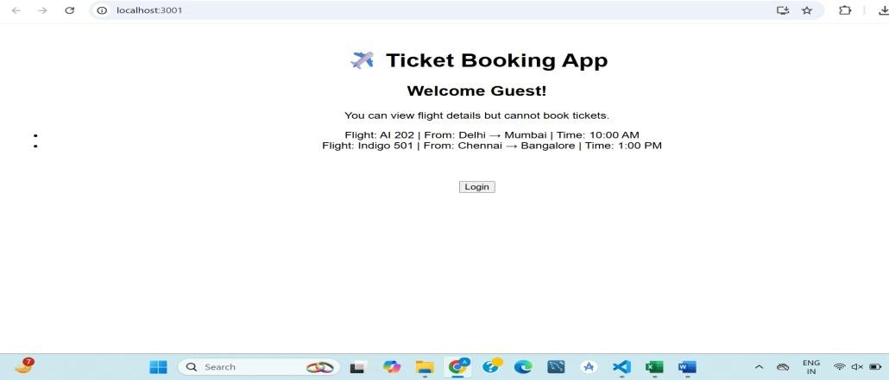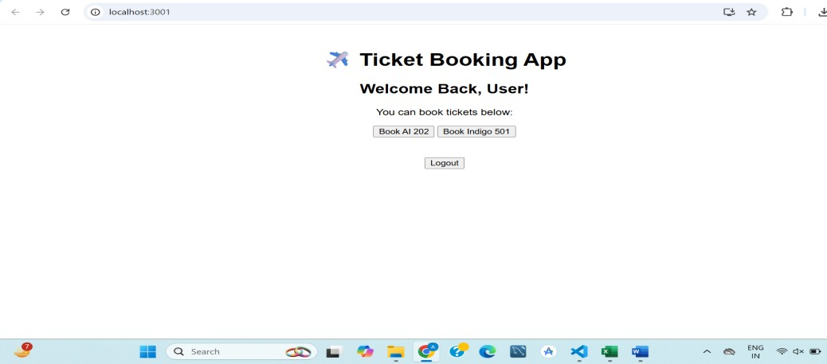

5) 13. ReactJS-HOL

## BlogDetails.js

import React from 'react';

function BlogDetails() {

return (

<div>

<h2>📝 Blog Highlights</h2>

<p>1. How to Learn React</p>

<p>2. State vs Props Explained</p>

</div>

);

}

export default BlogDetails;

## CourseDetails.js

import React from 'react';

function CourseDetails() { return (

<div>

<h2>🎓 Available Courses</h2>

<ul>

<li>React Fundamentals</li>

<li>Advanced JavaScript</li>

<li>Web Accessibility</li>

</ul>

</div>

);

}

export default CourseDetails;

## BookDetails.js

import React from 'react'; function BookDetails({ books }) {

return (

<div>

<h2>📚 Book List</h2>

<ul>

{books.map((book, index) => (

<li key={book.id}>

<strong>{book.title}</strong> by {book.author}

</li>

))}

</ul>

</div>

);

}

export default BookDetails;

## App.js

import React, { useState } from 'react'; import BookDetails from './BookDetails'; import BlogDetails from './BlogDetails'; import CourseDetails from './CourseDetails'; function App() {

const [view, setView] = useState('books'); // default view const books = [

{ id: 1, title: "React Made Easy", author: "Dan Abramov" },

{ id: 2, title: "JS Deep Dive", author: "Kyle Simpson" },

{ id: 3, title: "Learning Hooks", author: "Sarah Drasner" },

];

let content; if (view === 'books') {

content = <BookDetails books={books} />;

} else if (view === 'blogs') {

content = <BlogDetails />;

} else {

content = <CourseDetails />;

}

return (

<div style={{ textAlign: 'center', fontFamily: 'sans-serif' }}>

<h1>🧑‍💻 Blogger App</h1>

<div style={{ marginBottom: '20px' }}>

<button onClick={() => setView('books')}>Books</button>

<button onClick={() => setView('blogs')}>Blogs</button>

<button onClick={() => setView('courses')}>Courses</button>

</div>

{content}

<div style={{ marginTop: '40px' }}>

<h3>🔍 Bonus Info:</h3>

{books.length > 0 && <p>We have {books.length} books in our library.</p>}

</div>

</div>

);

}

export default App;

**OUTPUT :**

