Argos_document

Cancer epidemiology

# **Incidence Rate**

### Age Adjusted Incidence Rate according to Diagnosis Year

1. colon cancer 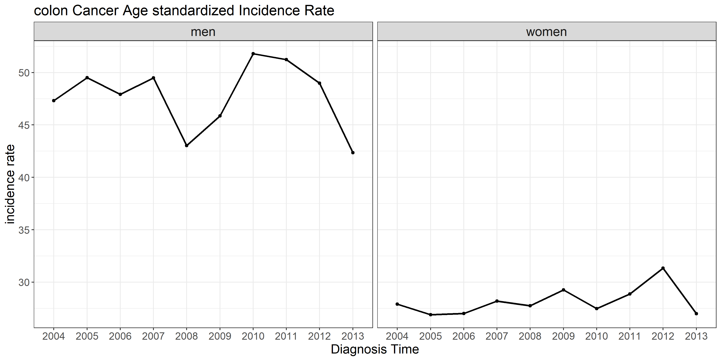

|  |  |  |  |  |  |  |  |  |  |  |
| --- | --- | --- | --- | --- | --- | --- | --- | --- | --- | --- |
| gender | 2004 | 2005 | 2006 | 2007 | 2008 | 2009 | 2010 | 2011 | 2012 | 2013 |
| men | 198 | 225 | 226 | 254 | 227 | 246 | 289 | 300 | 316 | 289 |
| women | 140 | 157 | 156 | 154 | 175 | 188 | 191 | 215 | 234 | 193 |

1. stomach cancer 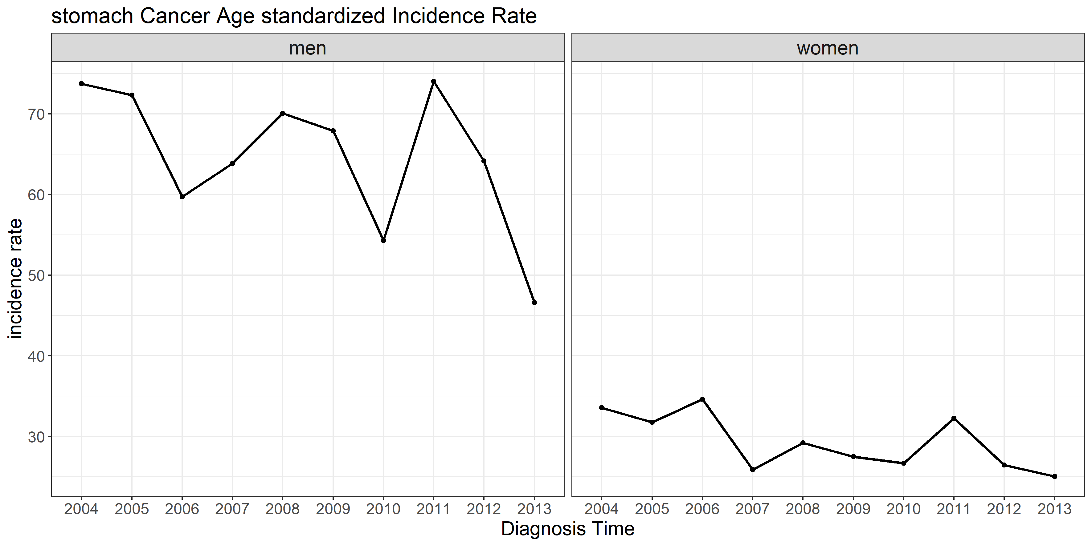

|  |  |  |  |  |  |  |  |  |  |  |
| --- | --- | --- | --- | --- | --- | --- | --- | --- | --- | --- |
| gender | 2004 | 2005 | 2006 | 2007 | 2008 | 2009 | 2010 | 2011 | 2012 | 2013 |
| men | 344 | 346 | 297 | 336 | 381 | 395 | 330 | 447 | 416 | 325 |
| women | 173 | 170 | 188 | 151 | 184 | 162 | 180 | 221 | 192 | 173 |

1. lung cancer 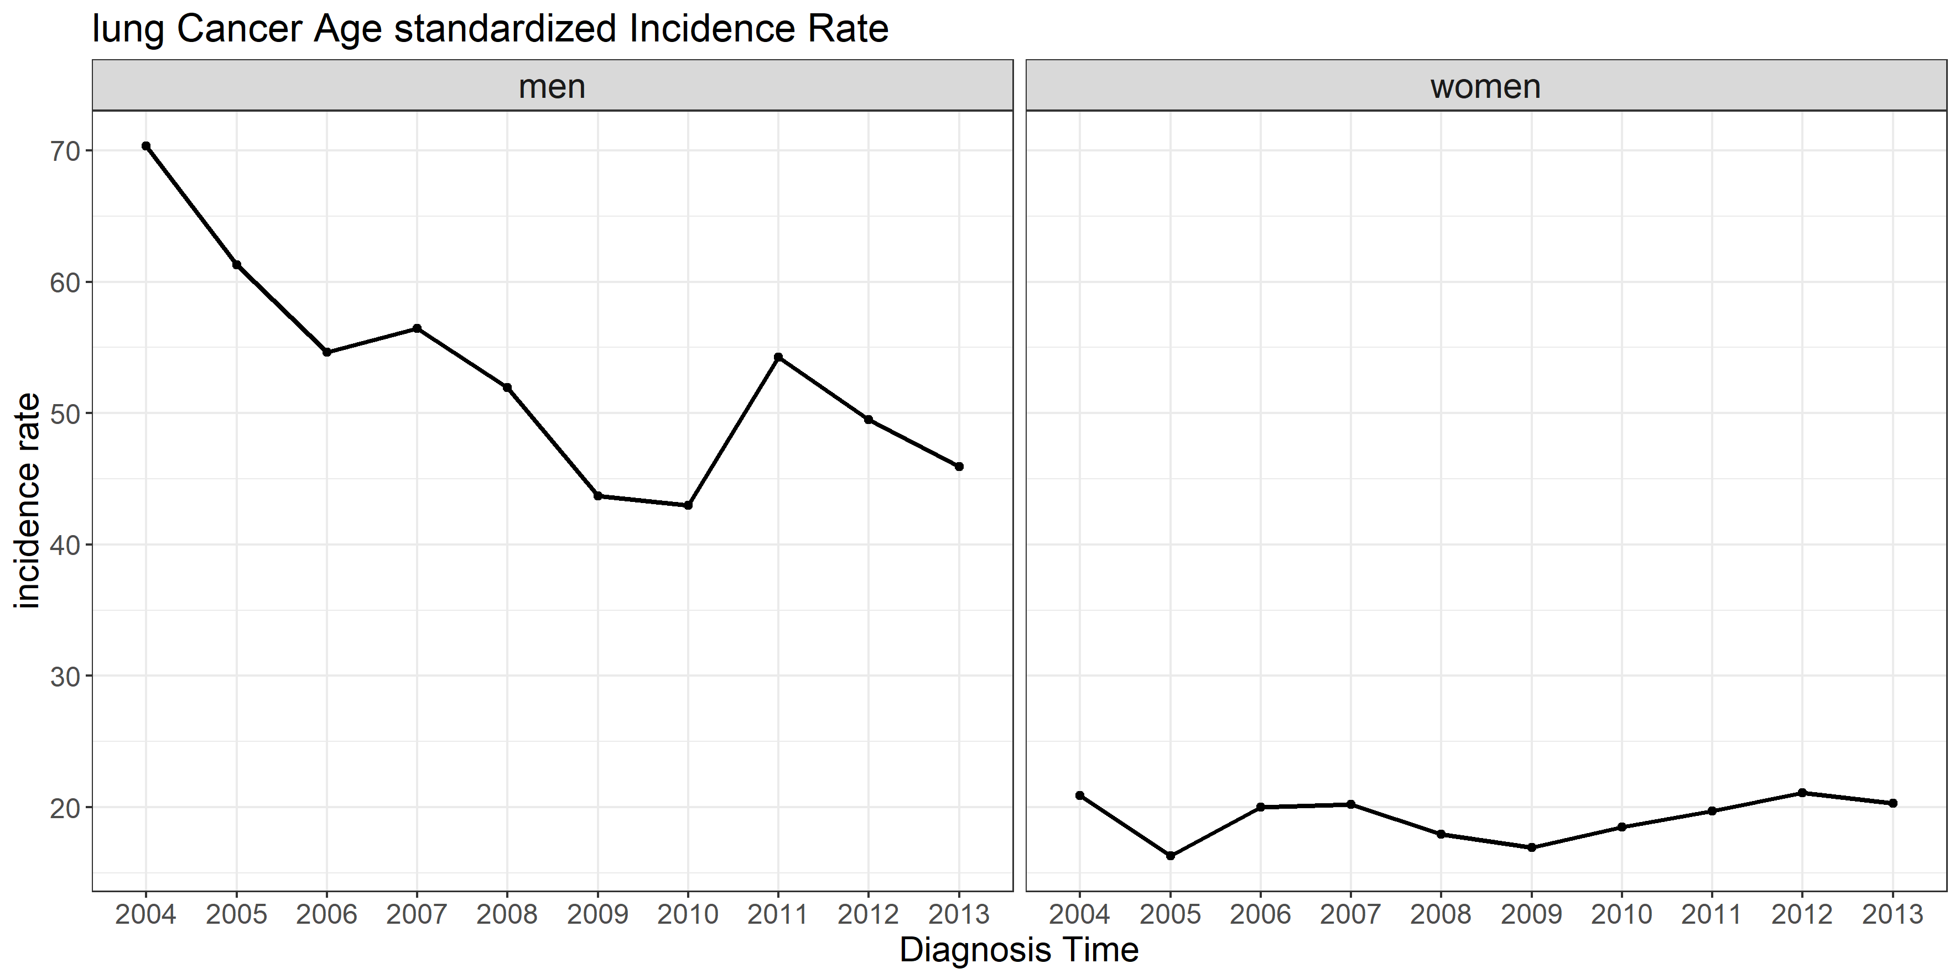

|  |  |  |  |  |  |  |  |  |  |  |
| --- | --- | --- | --- | --- | --- | --- | --- | --- | --- | --- |
| gender | 2004 | 2005 | 2006 | 2007 | 2008 | 2009 | 2010 | 2011 | 2012 | 2013 |
| men | 288 | 252 | 258 | 267 | 264 | 240 | 247 | 340 | 314 | 286 |
| women | 86 | 84 | 100 | 104 | 99 | 99 | 108 | 146 | 152 | 128 |

### Age Specified Incidence Rate according to Diagnosis Year

### Age Specified Incidence Rate according to Birth Cohort

## character(0)

# **Survival Rate**

### 1,3,5 year Survival Rate (Relative)

You can also embed plots, for example:



Note that the echo = FALSE parameter was added to the code chunk to prevent printing of the R code that generated the plot.