Study of Denosumab vs. Zoledronic Acid to Treat Bone Metastases in Men With Hormone-refractory Prostate Cancer

**Version:** 0.1

**Authors:**

Martijn Schuemie, PhD, Janssen Research and Development

Erica Voss, MPH, Janssen Research and Development

**Date:** 26 January 2018

**Acknowledgment:** The analysis is based in part on work from the Observational Health Sciences and Informatics collaborative. OHDSI (<http://ohdsi.org>) is a multi-stakeholder, interdisciplinary collaborative to create open-source solutions that bring out the value of observational health data through large-scale analytics.

The authors declare the following disclosures: Dr. Schuemie and Ms. Voss are employees of Janssen Research & Development.

1. **Table of contents**

2 List of abbreviations 4

3 Abstract 4

4 Amendments and Updates 4

Milestones 4

5 Rationale and Background 4

5.1 Research Questions 5

5.2 Objectives 5

6 Research methods 5

6.1 Study Design 5

6.1.1 Overview 5

6.1.2 Output and Evaluation 7

6.1.3 Study population 8

6.2 Variables 8

6.2.1 Exposures 8

6.2.2 Outcomes 9

6.2.3 Negative controls 9

6.3 Data Sources 10

6.3.1 Pooling effect estimate across databases 10

6.4 Quality control 10

6.5 Power 10

6.6 Strengths and Limitations of the Research Methods 11

7 Protection of Human Subjects 11

8 Plans for Disseminating and Communicating Study Results 11

9 Appendix 1 12

9.1 Outcomes to exclude 12

9.2 Negative controls 12

10 Appendix 2 Study diagnostic materials 12

10.1 Attrition Diagram 12

10.2 Attrition Diagram Strata 12

10.3 Covariate Balance Top 12

10.4 Covariate Balance Scatter 12

10.5 Propensity Score Plot 12

10.6 Propensity Score Plot Strata 12

11 References 12

# List of abbreviations

ATC Anatomic Therapeutic Chemical

CYCLOPS Cyclic coordinate descent for logistic, Poisson and survival analysis

SNOMED Systematized Nomenclature of Medicine

OHDSI Observational Health Data Sciences and Informatics

OMOP Observational Medical Outcomes Partnership

T Target cohort

C Comparator cohort

O Outcome cohort

PS Propensity Scores

RANKL receptor activator of nuclear factor kappa-Β ligand

LASSO Least absolute shrinkage and selection operator

MDRR Maximum detectable relative risk

CI Confidence Interval

DOD Date of Death

# Abstract

This study aims to compare denosumab with zoledronic acid for prevention of skeletal-related events in men with bone metastases from castration-resistant prostate cancer. In this study, we will analyze data from one observational claims database using the OHDSI CohortMethod package framework to perform this comparative study.

# Amendments and Updates

|  |  |  |  |
| --- | --- | --- | --- |
|  |  |  |  |
|  |  |  |  |

# Milestones

|  |  |
| --- | --- |
| Milestone | Planned / Estimated Date |
| Start of analysis | 26 Jan 2018 |
| End of analysis | 26 Jan 2018 |
| Posting of results | 26 Jan 2018 |
| Submission of manuscript | 31 Jan 2018 |

# Rationale and Background

In western countries, prostate cancer is the most common non-dermatological malignant disease in men [1, 2]. Bone metastases often develop in patients with advanced prostate cancer; the associated complications present a substantial disease and economic burden [3]. Since the late 1990s, the assessment of bone-targeted agents for treatment of bone metastases has been based on the endpoint of skeletal-related events, a composite of local skeletal complications consisting of pathological fracture, spinal cord compression, and radiotherapy or surgery to bone. This composite endpoint was the primary endpoint in a phase 3 study in which intravenous zoledronic acid was better than placebo for prevention of skeletal-related events in patients with bone metastases from castration-resistant prostate cancer [4, 5]. A subsequent phase 3 study (ClinicalTrials.gov Identifier: NCT00321620) compared denosumab, a human monoclonal antibody against the receptor activator of nuclear factor kappa-Β ligand (RANKL), showing denosumab was better than zoledronic acid for prevention of skeletal-related events [6].

Here we aim to replicate the trial comparing denosumab to zoledronic acid using observational data. Although there have been two observational studies comparing denosumab to zoledronic acid for the indication of osteoporosis [7, 8], there have been no observational studies focused on comparing these drugs for the prevention of skeletal-related events in patients with bone metastases from castration-resistant prostate cancer. An observational study will allow us to evaluate whether the findings from the clinical trial translate to real world settings. Our primary analysis will aim to replicate the trial as faithfully as possible, restricting to the subset of men meeting all criteria in the trial. Subsequent analysis will relax the inclusion criteria to the total set of men with the indication for which the drug was approved based on the trial.

# Study Objectives

## Primary Hypothesis

* This study’s primary hypothesis is that there is no difference in incidence rate of skeletal-related events between subjects taking denosumab and zoledronic acid for the treatment of bone metastasis from castration-resistant prostate cancer.

## Secondary Hypothesis

* Our secondary hypothesis is that any effect observed in the subgroup of men meeting all criteria in the clinical trial is also observed in the total set of men having the indication for which the drug was approved based on the trial.

## Primary Objective

* To compare the risk of **O: skeletal-related events** between **T: new users of denosumab in patients with bone metastasis from castration-resistant prostate cancer** and **C: new users of zoledronic acid in patients with bone metastasis from castration-resistant prostate cancer**, we will estimate the population-level effect of exposure on the hazards of the outcome during the period from cohort start date to 40.5 months from cohort end date.

## Secondary Objective

* Compare the risk mentioned in the primary objective in the subgroup of men meeting all criteria in the clinical trial to the risk in the total set of men having the indication for which the drug was approved based on the trial.

# Research methods

## Study Design

In this study, we compare the risk of **O: skeletal-related events** between **T: new users of denosumab in patients with bone metastases from castration-resistant prostate cancer** and **C: new users of zoledronic acid in patients with bone metastases from castration-resistant prostate cancer**, we will estimate the population-level effect of exposure on the hazards of the outcome during the period from cohort start date to 40.5 months from cohort end date.

For T and C cohorts, we impose a requirement that patients must have at least 365 days of continuous observation prior to cohort entry and 0 days post cohort entry and that they be aged 18 or older at index. We additionally impose that patients must be male, have: at least 1 condition occurrence of prostate cancer all days prior to 0 days before the index, at least 1 condition occurrence of bone metastasis all days prior to 0 days before the index.

Note that neither T nor C explicitly requires the prostate cancer to be castration-resistant. This is because this requirement is hard to encode in observational data. Instead, we rely on the fact that the prostate cancer is metastatic, and that hormonal therapy has been attempted, to give a high probability that it is in fact also castration resistant.

For the primary analysis, in line with the clinical trial, we further restrict the T and C cohorts to those having:

1. At least 1 drug exposure to hormonal therapy for prostate cancer all days prior to 0 days before the index.
2. Exactly 0 drug exposures to bisphosphonates all days prior to 1 days before the index.
3. Exactly 0 condition occurrences of osteonecrosis or osteomyelitis of the jaw all days prior to 0 days before the index.
4. Exactly 0 condition occurrences of other malignant diseases 3 years prior to 0 days before the index.

The overall study population could be considered to be patients who enter either the target cohort or comparator cohort. Patients who qualify for both the target cohort and comparator cohort are only considered for whichever cohort occurs first.

The time-to-event of outcome among patients in the target and comparator cohorts is determined by calculating the number of days from the start of the time-at-risk window, 0 days from cohort start date until the earliest event among 1) the first occurrence of the outcome, **O: new skeletal-related events**, 2) the end of the time-at-risk window, 40.5 months from cohort start date, and 3) the end of the observation period that spans the time-at-risk start.

### Overview

This study will follow a retrospective, observational, comparative cohort design. We define ‘retrospective’ to mean the study will be conducted using data already collected prior to the start of the study. We define ‘observational’ to mean there is no intervention or treatment assignment imposed by the study. We define 'cohort' to mean a set of patients satisfying a one or more inclusion criteria for a duration of time. We define ‘comparative cohort design’ to mean the formal comparison between two cohorts, a target cohort and comparator cohort, for the risk of an outcome during a defined time period after cohort entry. The design will be conducted in one administrative claims databases in the US, as described in section 8.2. The specific exposure cohorts are described in section 8.3. The time-at-risk definitions are described in section 10.1. The statistical analysis plan for population-level effect estimation is described in section 10.3.

## Data Source(s)

The analyses will be performed across one observational databases. This database has been transformed into the OMOP Common Data Model, version 5.1. The complete specification for OMOP Common Data Model, version 5.3 is available at: <https://github.com/OHDSI/CommonDataModel>.

Data sources expected to participate to include:

* Optum Extended DOD (US claims)

This database is described below:

* Optum’s Clinformatics® Extended Data Mart – Date of Death (DOD)

Optum Clinformatics® Extended DataMart is an adjudicated US administrative health claims database for members of private health insurance, who are fully insured in commercial plans or in administrative services only (ASOs), Legacy Medicare Choice Lives (prior to January 2006), and Medicare Advantage (Medicare Advantage Prescription Drug coverage starting January 2006). The population is primarily representative of commercial claims patients (0-65 years old) with some Medicare (65+ years old) however ages are capped at 90 years. It includes data captured from administrative claims processed from inpatient and outpatient medical services and prescriptions as dispensed, as well as results for outpatient lab tests processed by large national lab vendors who participate in data exchange with Optum. This dataset also provides date of death (month and year only) for members with both medical and pharmacy coverage from the Social Security Death Master File (however after 2011 reporting frequency changed due to changes in reporting requirements) and location information for patients is at the US state level. Family identifiers are provided and utilized to infer mother-child linkages.

The major data elements contained within this database are outpatient pharmacy dispensing claims (coded with National Drug Codes (NDC), inpatient and outpatient medical claims which provide procedure codes (coded in CPT-4, HCPCs, ICD-9-CM or ICD-10-PCS) and diagnosis codes (coded in ICD-9-CM or ICD-10-CM). The data also contain selected laboratory test results (those sent to a contracted thirds-party laboratory service provider) for a non-random sample of the population (coded with LOINC codes).

### Pooling effect estimates across databases

This study will not pool effect estimates across databases rather the results will be reported separately.

### Output and Evaluation

Covariate balance will be summarized in tabular form by showing the mean value for all baseline covariates in the target and comparator cohort, with the associated standardized mean difference computed for each covariate.

Once the propensity score model is fit, we will plot the propensity score distribution of the target and comparator cohorts to evaluate the comparability of the two cohorts. The plot will be scaled to the preference score, normalizing for any imbalance in cohort size. The covariates selected within the propensity score model, with associated coefficients will also be reported.

A plot showing the propensity score distributions for both cohorts after stratification will be provided, with each quantile cut point shown as a vertical line.

An attrition diagram will be provided to detail the loss of patients from the original target cohort, **T: new users of denosumab in patients with bone metastases from castration-resistant prostate cancer** and comparator cohort **C: new users of zoledronic acid in patients with bone metastases from castration-resistant prostate cancer** to the subpopulations that remain after all design considerations have been applied.

The final outcome model, a conditional Cox proportional hazards model, will be summarized by providing the hazards ratio and associated 95% confidence interval. The number of persons, amount of time-at-risk, and number of outcomes in each cohort will also be reported.

Negative control outcomes will be used to evaluate the potential impact of residual systematic error in the study design, and to facilitate empirical calibration of the p-value for the outcomes of interest. Negative control outcomes are concepts known not to be associated with either the target or comparator group, such that we can assume the true relative risk should equal 1. The negative control outcomes used in this study are labelled **negative controls for denosumab and zoledronic acid** as detailed in Appendix 1. For each negative control outcome, the study design described above will be implemented and the effect estimate will be recorded. The distribution of effect estimates across all negative control outcomes will be used to fit an empirical null distribution which models the observed residual systematic error. The empirical null distribution will then be applied to the target outcome of interest to calibrate the p-value. Empirical calibration serves as an important diagnostic tool to evaluate if the residual systematic error is sufficient to cast doubt on the accuracy of the unknown effect estimate. The calibration effect plot and calibration probability plots will be generated for review. We will report the traditional p-value and empirically calibrated p-value for each negative control, as well as the unknown outcomes of interest.

Section 9.2 contains study diagnostic materials.

### Study population

The study population is comprised of patients with bone metastases from castration-resistant prostate cancer in a target cohort T or comparator cohort C.

Comparator cohort T: new users of denosumab, is formally defined here:

<https://epi.jnj.com/atlas/#/cohortdefinition/5652>

Target cohort C: new users of zoledronic acid, is formally defined here:

<https://epi.jnj.com/atlas/#/cohortdefinition/5665>

All subjects in the database will be included who meet the following criteria: (note: the index date is the start of the first exposure to cabergoline or bromocriptine)

* Aged 18 or older.
* Exposure to denosumab or zoledronic acid.
* Male.
* At least 365 days of observation time prior to the index date.
* At least 0 days of observation time after the index date.
* at least 1 condition occurrence of prostate cancer all days prior to 0 days before the index, at least 1 condition occurrence of bone metastasis all days prior to 0 days before the index.
* At least 1 drug exposure to hormonal therapy for prostate cancer all days prior to 0 days before the index.
* Exactly 0 drug exposures to bisphosphonates all days prior to 1 days before the index.
* Exactly 0 condition occurrences of osteonecrosis or osteomyelitis of the jaw all days prior to 0 days before the index.
* Exactly 0 condition occurrences of other malignant diseases 3 years prior to 0 days before the index.

Both cohorts were further restricted to those subjects whose index date was in the time period when both T and C were observed. In this case, this mean that subjects in the comparator cohort (zoledronic acid) prior to December 2010 were removed.

## Variables

### Exposures

Target cohort T: new users of denosumab, is formally defined here:

<https://epi.jnj.com/atlas/#/cohortdefinition/5652>

Comparator cohort C: new users of zoledronic acid, is formally defined here:

<https://epi.jnj.com/atlas/#/cohortdefinition/5665>

### Outcomes

Skeletal-related events:

<https://epi.jnj.com/atlas/#/cohortdefinition/5729>

## Other Variables of Interest

Propensity scores (PS) will be used as an analytic strategy to reduce potential confounding due to imbalance between the target and comparator cohorts in baseline covariates. The propensity score is the probability of a patient being classified in the target cohort vs. the comparator cohort, given a set of observed covariates. In this study, the propensity score is estimated for each patient, using the predicted probability from a regularized logistic regression model, fit with a Laplace prior (LASSO) and the regularization hyperparameter selected by optimizing the likelihood in a 10-fold cross validation, using a starting variance of 0.01 and a tolerance of 2e-7.

The types of baseline covariates used to fit the propensity score model will be:

* Demographics
  + Gender
  + Age group (5-year bands)
  + Index year
  + Index month
* Conditions
  + In prior 30d
  + In prior 365d
* Condition aggregation
  + SNOMED
* Drugs
  + In prior 30d
  + In prior 365d
  + Overlapping index date
* Drug aggregation
  + Ingredient
  + ATC Class
* Risk scores
  + Charlson comorbidity index

Specific covariates to be excluded from the propensity score model are labelled **concepts to exclude** as detailed in Appendix 14.1.

All covariates that occur in fewer than 0.1% persons between the target and comparator cohorts combined will be excluded prior to model fitting.

The target cohort and comparator cohorts will be stratified into 5 quantiles of the propensity score distribution.

## Quality control

We will evaluate the PS by:

* Inspection of the fitted PS model for large coefficients (indicative of model-misspecification) and predictors that we cannot explain (post-hoc).
* Inspection of the PS distribution.
* Evaluation of covariate balance after matching using the standardized difference in means between treatment and comparator cohort before and after matching[9]. Standardized differences greater than 0.2 will be reported and investigated.

We will investigate the outcome model by

* Inspection of the fitted outcome model for large coefficients and predictors that we cannot explain (post-hoc). The error distribution estimated using the negative controls will be used to estimate residual bias after adjustments.

The CohortMethod package itself, as well as other OHDSI packages on which CohortMethod depends, use unit tests for validation.

# Sample Size, Study Power, and Diagnostics

## Sample Size and Study Power

The sample size of the target (denosumab) and comparator (zoledronic acid) cohorts as well as the maximum detectable relative risk (MDRR) is listed below. These patient counts represent the population.

|  |  |  |  |  |
| --- | --- | --- | --- | --- |
| Inclusion criteria | Subjects (Target) | Subjects (Comparator) | Outcomes (Both) | MDRR |
| All | 2,210 | 1,057 | 582 | 0.78 |
| * No other malignant diseases | 2,788 | 1,384 | 731 | 0.80 |
| * No osteonecrosis or osteomyelitis of the jaw | 2,791 | 1,386 | 731 | 0.80 |
| * No prior bisphosphonates | 3,022 | 1,443 | 778 | 0.81 |
| * Prior hormonal therapy | 3,502 | 1,764 | 913 | 0.82 |
|  |  |  |  |  |

For reference, the hazard ratio observed in the trial was 0.82 (95% CI 0.71–0.95).

## Diagnostics

## Cohort Comparability

Figures 1 show the preference score distribution for the two cohorts when applying all inclusion criteria, showing that the cohorts have substantial overlap based on their baseline covariates.

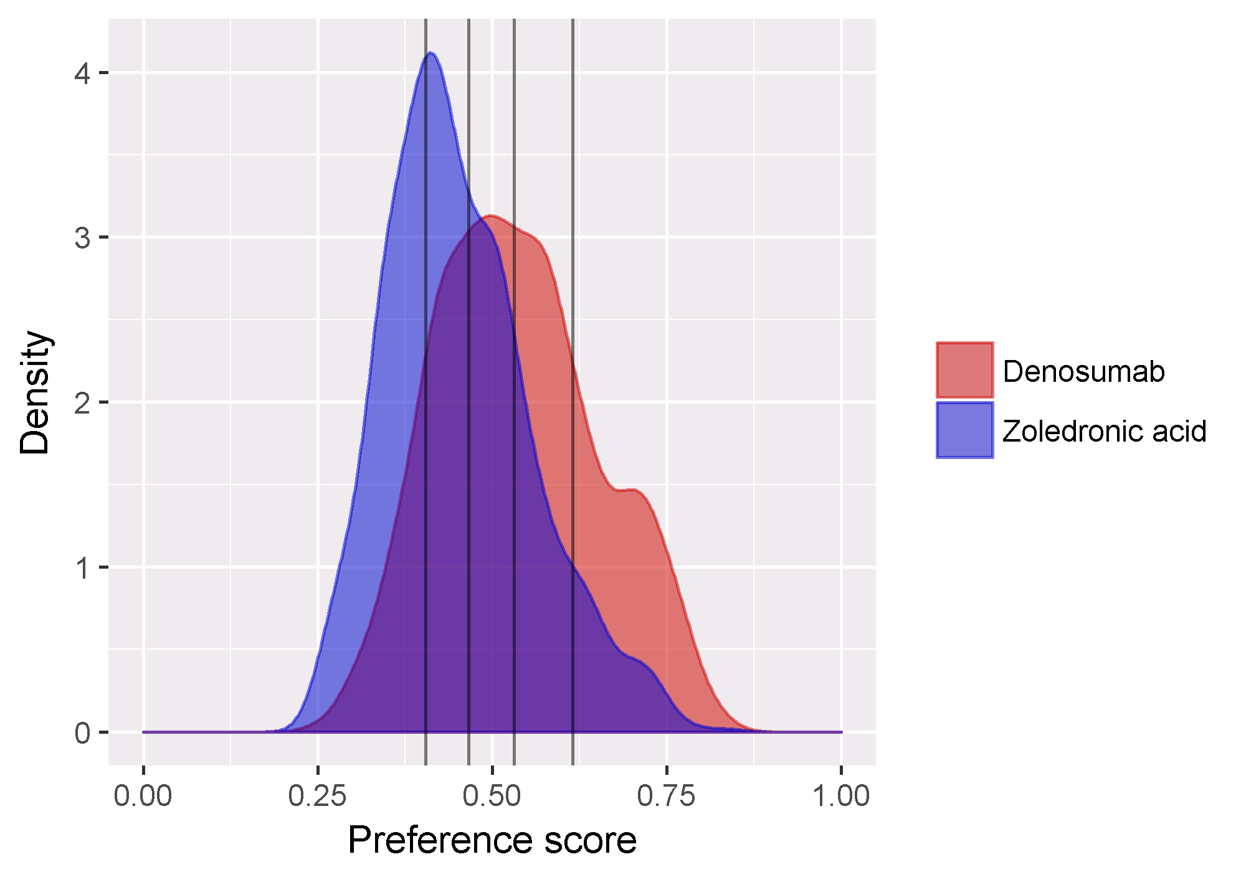

**Figure 1**. Preference score distribution

Figures 2-3 show the covariate balance on the propensity score, confirming that some covariates show imbalance before propensity score stratification. After matching, the balance is improved.

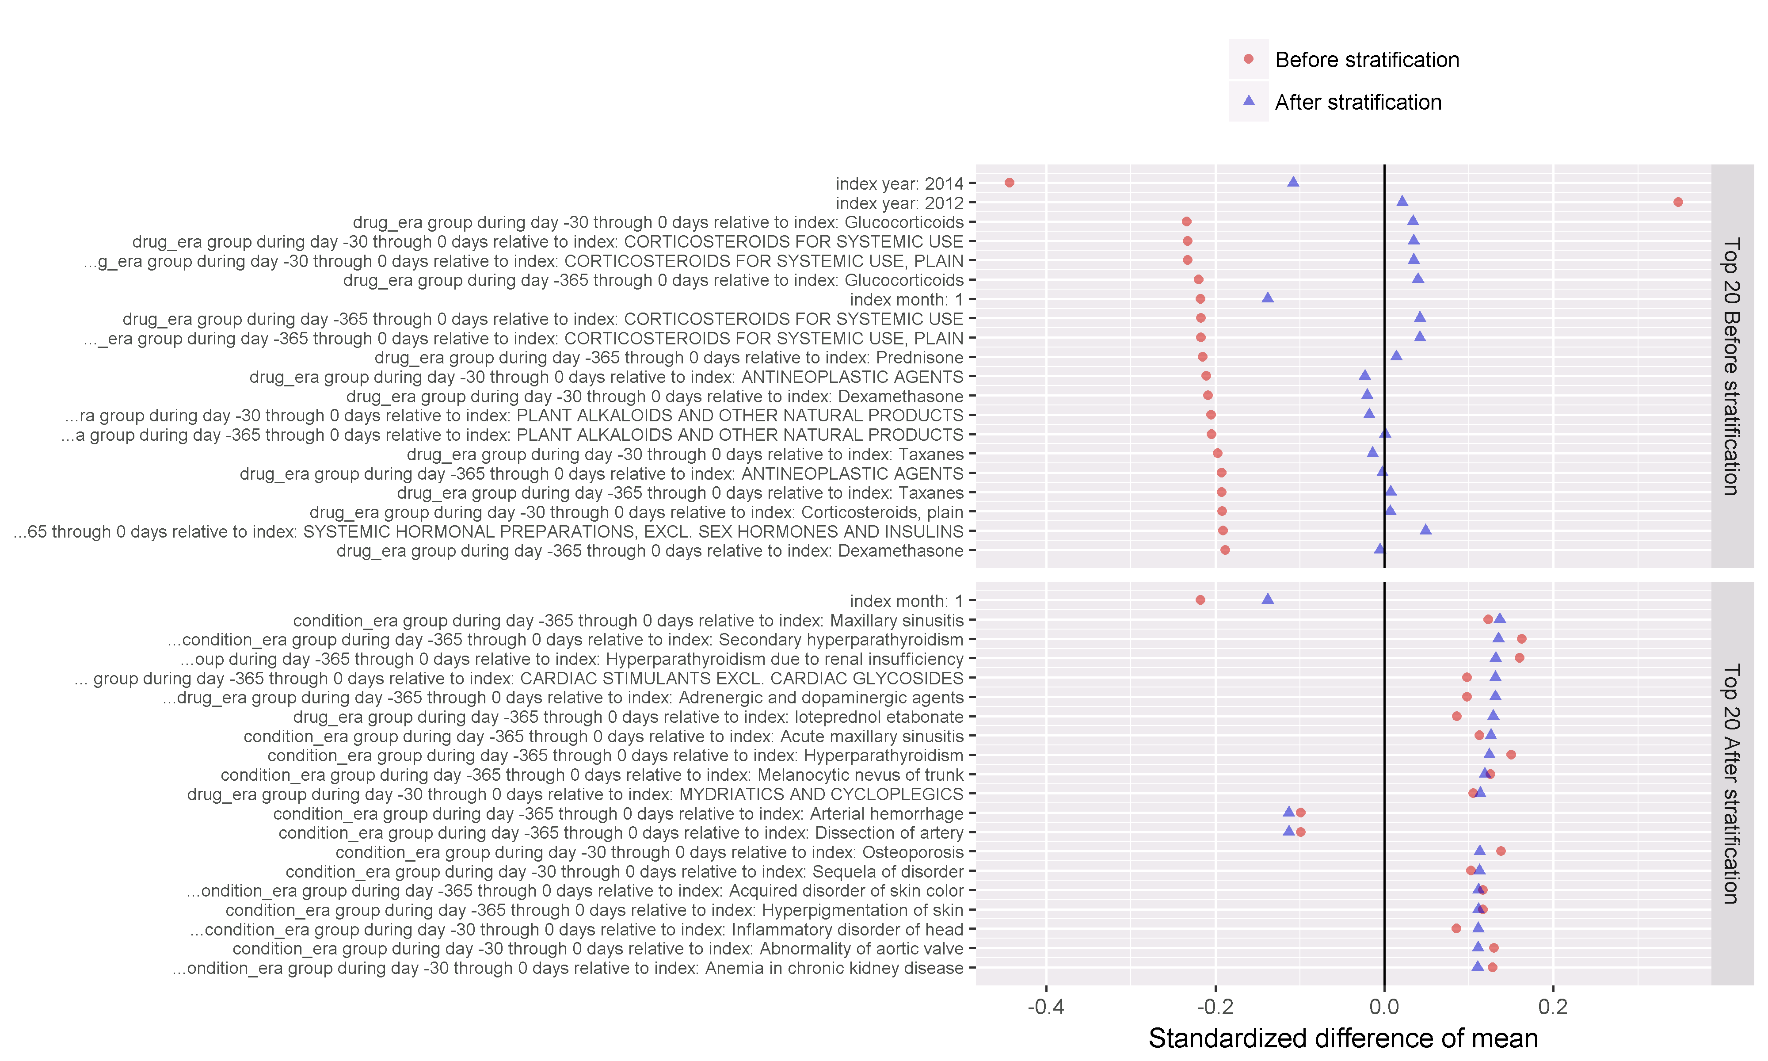**Figure 2**. Covariate balance, top covariates

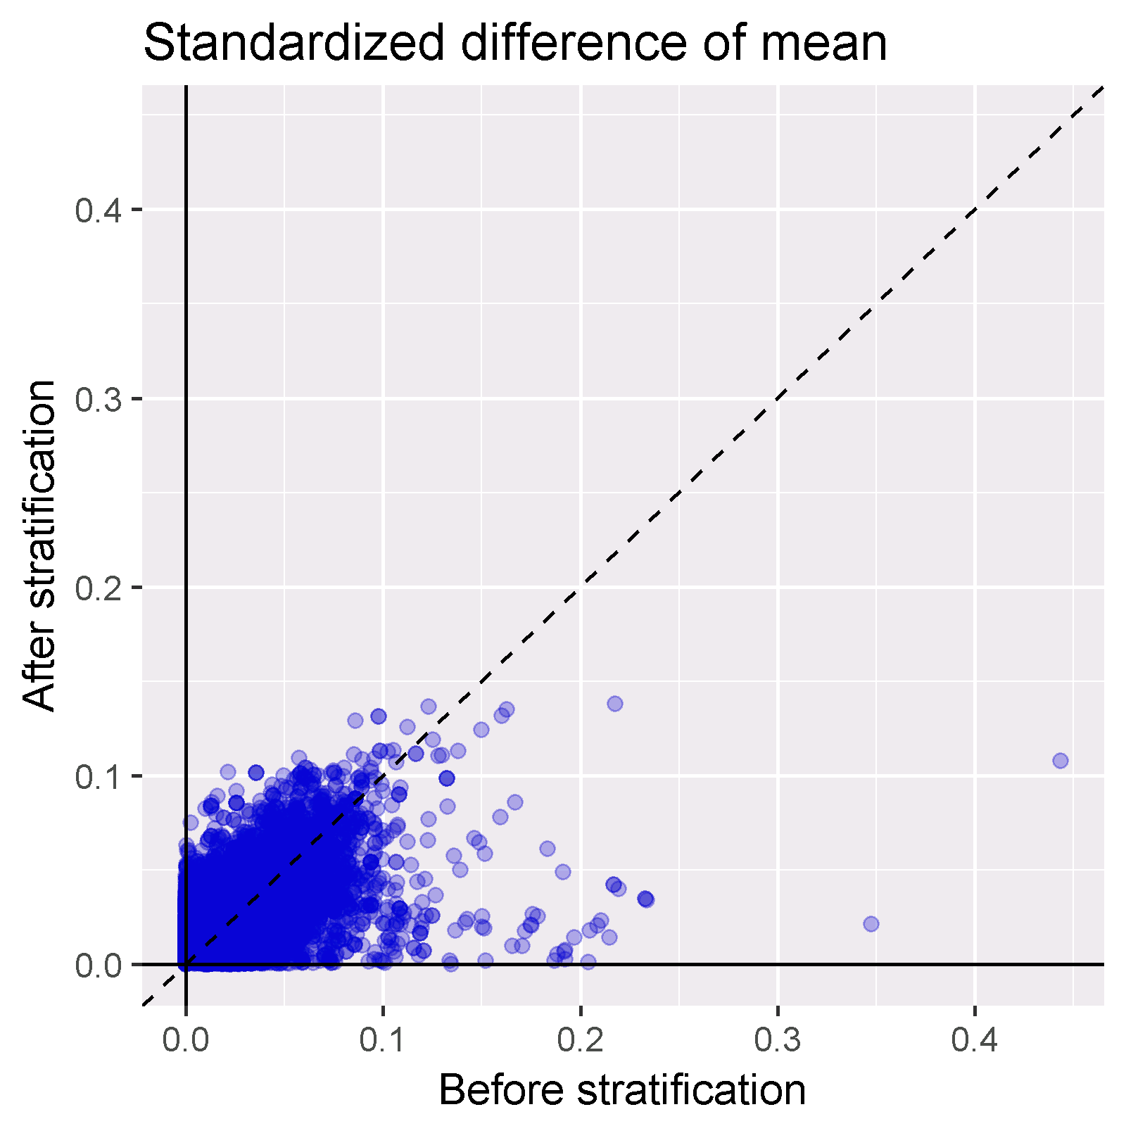

**Figure 3**. Covariate balance – scatter

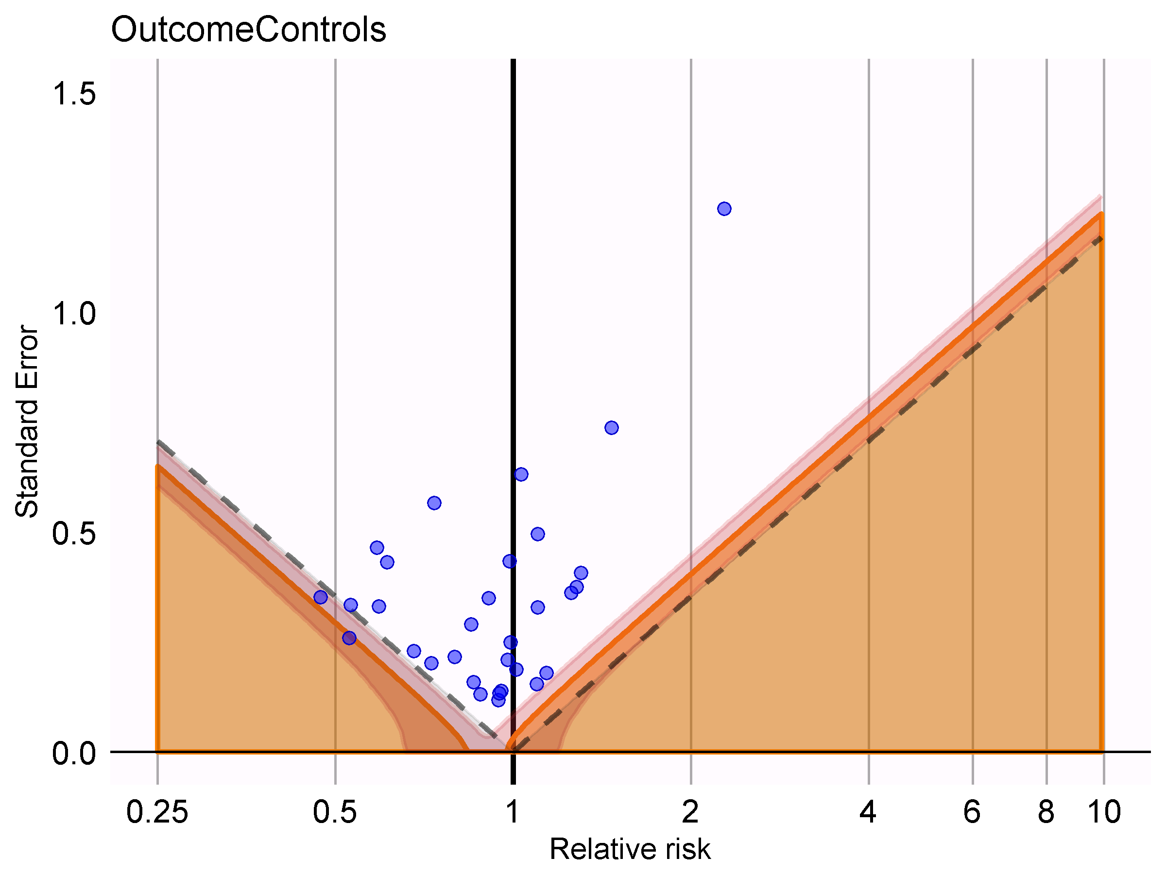

**Figure 4**. Calibrated Effect Estimate plots

# Data Analysis Plan

## Calculation of time-at risk

The time-at-risk will be defined as the ‘intent to treat’ period, defined as the time from the cohort start date to 40.5 months after cohort start date, because 40.5 months was the maximum time subjects could participate in the trial (time between enrollment start and primary analysis date).

## Model Specification

In this study, we compare the target cohort with the comparator cohort for the hazards of outcome during the time-at-risk by applying a Cox proportional hazards model.

The time-to-event of outcome among patients in the target and comparator cohorts is determined by calculating the number of days from the start of the time-at-risk window (the cohort start date), until the earliest event among 1) the first occurrence of the outcome, 2) the end of the time-at-risk window, 40.5 months after cohort end date, and 3) the end of the observation period that spans the time-at-risk start.

Patients with the outcome, observed prior to target or comparator cohort entry are not excluded from consideration.

Propensity scores will be used as an analytic strategy to reduce potential confounding due to imbalance between the target and comparator cohorts in baseline covariates. The propensity score is the probability of a patient being classified in the target cohort vs. the comparator cohort, given a set of observed covariates. In this study, the propensity score is estimated for each patient, using the predicted probability from a regularized logistic regression model, fit with a Laplace prior (LASSO) and the regularization hyperparameter selected by optimizing the likelihood in a 10-fold cross validation, using a starting variance of 0.01 and a tolerance of 2e-7. Covariates to be used in the propensity score model are listed in section 8.5.

All covariates that occur in fewer than 0.1% of the persons between the target and comparator cohorts combined will be excluded prior to model fitting for computational efficiency.

The target cohort and comparator cohorts will be stratified into five quantiles of the propensity score distribution. The final outcome model will apply a conditional Cox proportional hazard model, conditions on the propensity score strata.

## Output

Once the propensity score model is fit, we will plot the propensity score distribution of the target and comparator cohorts to evaluate the comparability of the two cohorts. The plot will be scaled to the preference score, normalizing for any imbalance in cohort size.

A plot showing the propensity score distributions for both cohorts after stratification will be provided, with each quantile cut point shown as a vertical line. Covariate balance will be evaluated by plotting the standardized mean difference of each covariate before propensity score stratification against the standardized mean difference for each covariate after propensity score stratification.

An attrition diagram will be provided to detail the loss of patients from the original target cohort and comparator cohort to the subpopulations that remain after all design considerations have been applied.

The final outcome model, a conditional Cox proportional hazards model, will be summarized by providing the hazards ratio and associated 95% confidence interval. The number of persons, amount of time-at-risk, and number of outcomes in each cohort will also be reported.

A Kaplan-Meier plot will be generated to characterize the contour of risk over time for the outcome of interest. Note, the Kaplan-Meier plot will be for the unadjusted cohorts, since adjusted analysis involves propensity score stratification.

## Evidence Evaluation

We will execute diagnostics to determine if the analysis can be appropriately conducted. The diagnostics will include:

* Propensity score distribution
* Covariate balance before and after propensity score matching
* Estimation for negative controls, to assess residual error
* Negative control outcomes will be used to evaluate the potential impact of residual systematic error in the study design, and to facilitate empirical calibration of the p-value and confidence interval for the exposures and outcome of interest.

Negative controls are listed in Appendix 14.2.

Negative controls are concepts known to not be associated with the target or comparator cohorts, such that we can assume the true relative risk between the two cohorts is 1. Negative controls are selected using a similar process to that outlined by Voss et al. [10]. Person counts of all potential drug-condition pairs are reviewed in observational data; this person count data helps determine which pairs are even probable for use in calibration. Given the list of potential drug-condition pairs, the concepts in the pairs must meet the following requirements to be considered as negative controls: (1) that there is Medline abstract where the MeSH terms suggest a negative association between the drug and the condition [11], (2) that there is no mention of the drug-condition pair on a US Product Label in the “Adverse Drug Reactions” or “Postmarketing” section [12], (3) there are no US spontaneous reports suggesting that the pair is in an adverse event relationship [13, 14], (4) that the OMOP Vocabulary does not suggest that the drug is indicated for the condition, (5) that the concepts are usable (i.e. not too broad, not suggestive of an adverse event relationship, not pregnancy related), and (6) the exact concept itself is utilized in patient level data (i.e. concepts that are not usually used within the data are usually indicative a broad concept that has a child that is more specific). The remaining concepts are “optimized”, meaning parent concepts remove children as defined by the OMOP Vocabulary (e.g. if both “Non-Hodgkin’s Lymphoma” and “B-Cell Lymphoma” we selected, child concept “B-Cell Lymphoma would be removed for its parent “Non-Hodgkin’s Lymphoma”). Once potential negative control candidates are selected, manual clinical review to exclude any pairs that may still be in a causal relationship or similar to the study outcome should be performed to select the top 50 concepts by patient exposure.

The candidate list was rank-ordered by prevalence and manually reviewed.

For each negative control outcome, a patient enters the negative control outcome cohort at the first occurrence of a diagnose code identified by the concepts listed above, or any one of its descendant codes.

Negative control outcomes in the context of this study are outcomes that are not believed to be caused by neither denosumab or zoledronic acid, and where therefore the true hazard ratio is equal to 1. We will execute the same analysis used for the primary hypothesis to produce hazard ratio estimates for the negative controls. The distribution of effect estimates across all negative controls will be used to fit an empirical null distribution which models the observed residual systematic error. The empirical null distribution will then be applied to the target exposures and outcome of interest to calibrate the p-value[15].

# Strengths and Limitations of the Research Methods

Strength

* Cohort studies allow direct estimation of incidence rates following exposure of interest, and the new-user design can capture early events following treatment exposures while avoiding confounding from previous treatment effects. New use allows for a clear exposure index date.
* PS matching and full outcome models allow balancing on a large number of baseline potential confounders.
* Use of negative control outcomes allow for evaluating the study design as a whole in terms of residual bias.

Limitations

* Even though many potential confounders will be included in this study, there may be residual bias due to unmeasured or misspecified confounders.

# Protection of Human Subjects

The study is using only de-identified data. Confidentiality of patient records will be maintained at all times. All study reports will contain aggregate data only and will not identify individual patients or physicians.

# Plans for Disseminating and Communicating Study Results

The study results will be posted on the OHDSI website after completion of the study. At least one paper describing the study and its results will be written and submitted for publication to a peer-reviewed scientific journal.

# Appendix 1

## Concepts excluded from covariates

These concepts and their descendants are excluded when creating covariates:

|  |  |  |
| --- | --- | --- |
| Concept ID | Concept Name |  |
| 21601136 | BLOOD SUBSTITUTES AND PERFUSION SOLUTIONS |  |
| 40222444 | denosumab |  |
| 21601195 | Electrolyte solutions |  |
| 21601194 | I.V. SOLUTION ADDITIVES |  |
| 21601153 | I.V. SOLUTIONS |  |
| 21600884 | OTHER MINERAL SUPPLEMENTS |  |
| 967823 | Sodium Chloride |  |
| 1524674 | zoledronic acid |  |

## Negative controls

|  |  |
| --- | --- |
| Concept ID | Concept name |
| 195562 | Hemorrhoids |
| 318736 | Migraine |
| 4090425 | Altered sensation of skin |
| 313459 | Sleep apnea |
| 136661 | Non-toxic nodular goiter |
| 197672 | Urinary incontinence |
| 4209423 | Nicotine dependence |
| 437390 | Hypoxemia |
| 380094 | Carpal tunnel syndrome |
| 377575 | Tinnitus |
| 253796 | Pneumothorax |
| 4214376 | Hyperglycemia |
| 318556 | Epistaxis |
| 434005 | Morbid obesity |
| 432730 | Difficulty speaking |
| 439147 | Amnesia |
| 253797 | Post-inflammatory pulmonary fibrosis |
| 441417 | Incoordination |
| 433454 | Adjustment disorder with mixed emotional features |
| 376065 | Neurologic disorder associated with type 2 diabetes mellitus |
| 4239682 | Chronic phototoxic dermatitis |
| 30133 | Acute laryngitis |
| 73090 | Contusion of foot |
| 137951 | Acquired keratoderma |
| 257683 | Posterior rhinorrhea |
| 137977 | Jaundice |
| 139850 | Acute frontal sinusitis |
| 376229 | Abnormal involuntary movement |
| 193020 | Incomplete emptying of bladder |
| 376382 | Tension-type headache |
| 137063 | Corns and callus |

# References

1. Ferlay, J., et al., *Cancer incidence and mortality patterns in Europe: estimates for 40 countries in 2012.* Eur J Cancer, 2013. **49**(6): p. 1374-403.

2. Jemal, A., et al., *Cancer statistics, 2010.* CA Cancer J Clin, 2010. **60**(5): p. 277-300.

3. Schulman, K.L. and J. Kohles, *Economic burden of metastatic bone disease in the U.S.* Cancer, 2007. **109**(11): p. 2334-42.

4. Saad, F., et al., *A randomized, placebo-controlled trial of zoledronic acid in patients with hormone-refractory metastatic prostate carcinoma.* J Natl Cancer Inst, 2002. **94**(19): p. 1458-68.

5. Saad, F., et al., *Long-term efficacy of zoledronic acid for the prevention of skeletal complications in patients with metastatic hormone-refractory prostate cancer.* J Natl Cancer Inst, 2004. **96**(11): p. 879-82.

6. Fizazi, K., et al., *Denosumab versus zoledronic acid for treatment of bone metastases in men with castration-resistant prostate cancer: a randomised, double-blind study.* Lancet, 2011. **377**(9768): p. 813-22.

7. Choi, N.K., et al., *Comparative Safety and Effectiveness of Denosumab Versus Zoledronic Acid in Patients With Osteoporosis: A Cohort Study.* J Bone Miner Res, 2017. **32**(3): p. 611-617.

8. Gagne, J.J., et al., *Prospective Benefit-Risk Monitoring of New Drugs for Rapid Assessment of Net Favorability in Electronic Health Care Data.* Value Health, 2015. **18**(8): p. 1063-9.

9. Austin, P.C., *Assessing balance in measured baseline covariates when using many-to-one matching on the propensity-score.* Pharmacoepidemiol Drug Saf, 2008. **17**(12): p. 1218-25.

10. Voss, E.A., et al., *Accuracy of an automated knowledge base for identifying drug adverse reactions.* J Biomed Inform, 2017. **66**: p. 72-81.

11. Winnenburg, R., et al., *Leveraging MEDLINE indexing for pharmacovigilance - Inherent limitations and mitigation strategies.* J Biomed Inform, 2015. **57**: p. 425-35.

12. Duke, J., J. Friedlin, and X. Li, *Consistency in the safety labeling of bioequivalent medications.* Pharmacoepidemiol Drug Saf, 2013. **22**(3): p. 294-301.

13. Evans, S.J., P.C. Waller, and S. Davis, *Use of proportional reporting ratios (PRRs) for signal generation from spontaneous adverse drug reaction reports.* Pharmacoepidemiol Drug Saf, 2001. **10**(6): p. 483-6.

14. Banda, J.M., et al., *A curated and standardized adverse drug event resource to accelerate drug safety research.* Sci Data, 2016. **3**: p. 160026.

15. Schuemie, M.J., et al., *Interpreting observational studies: why empirical calibration is needed to correct p-values.* Stat Med, 2014. **33**(2): p. 209-18.