Study of Denosumab vs. Zoledronic Acid to Treat Bone Metastases

**Version:** 0.3

**Authors:**

Martijn Schuemie, PhD, Janssen Research and Development

Erica Voss, MPH, Janssen Research and Development

**Date:** 3 March 2018

**Acknowledgment:** The analysis is based in part on work from the Observational Health Sciences and Informatics collaborative. OHDSI (<http://ohdsi.org>) is a multi-stakeholder, interdisciplinary collaborative to create open-source solutions that bring out the value of observational health data through large-scale analytics.

The authors declare the following disclosures: Dr. Schuemie and Ms. Voss are employees of Janssen Research & Development.

# Table of contents

1 Table of contents 2

2 List of abbreviations 3

3 Abstract 3

4 Amendments and Updates 3

5 Milestones 3

6 Rationale and Background 3

7 Study Objectives 4

7.1 Primary Hypothesis 4

7.2 Secondary Hypothesis 4

7.3 Primary Objective 4

7.4 Secondary Objective 4

8 Research methods 5

8.1 Study Design 5

8.2 Data Source(s) 5

8.3 Study population 6

8.3.1 Criteria common to both target and comparator cohorts 6

8.4 Exposures 7

8.4.1 Target: denosumab 7

8.4.2 Comparator: Zoledronic Acid 10

8.5 Outcomes 15

8.5.1 Skeletal-related events 15

8.5.2 Negative control outcomes 19

8.5.3 Positive control outcomes 19

8.6 Covariates 20

8.6.1 Propensity score covariates 20

9 Data Analysis Plan 20

9.1 Calculation of time-at risk 20

9.2 Model Specification 21

9.2.1 Pooling effect estimates across databases 21

9.3 Analyses to perform 21

9.4 Output 22

9.5 Evidence Evaluation 22

10 Study Diagnostics 23

10.1 Sample Size and Study Power 23

10.2 Cohort Comparability 23

10.3 Systematic Error Assessment 26

11 Strengths and Limitations of the Research Methods 27

12 Protection of Human Subjects 28

13 Management and Reporting of Adverse Events and Adverse Reactions 28

14 Plans for Disseminating and Communicating Study Results 28

15 Appendix 1 28

15.1 Concepts excluded from covariates 28

15.2 Negative controls 28

16 References 29

# List of abbreviations

ATC Anatomic Therapeutic Chemical

CYCLOPS Cyclic coordinate descent for logistic, Poisson and survival analysis

SNOMED Systematized Nomenclature of Medicine

OHDSI Observational Health Data Sciences and Informatics

OMOP Observational Medical Outcomes Partnership

T Target cohort

C Comparator cohort

O Outcome cohort

PS Propensity Scores

RANKL receptor activator of nuclear factor kappa-Β ligand

LASSO Least absolute shrinkage and selection operator

MDRR Maximum detectable relative risk

CI Confidence Interval

DOD Date of Death

ECOG Eastern Cooperative Oncology Group

PSA Prostate specific antigen

# Abstract

This study aims to compare denosumab with zoledronic acid for prevention of skeletal-related events in patients with bone metastases. We will replicate three phase III trials, each focusing on one class of cancer (prostate cancer, breast cancer, other cancers). In this study, we will analyze data from one observational claims database using the OHDSI CohortMethod package framework to perform this comparative study.

# Amendments and Updates

|  |  |  |  |
| --- | --- | --- | --- |
| 0.1 | 26 January 2018 | M.Schuemie, E.Voss | First draft |
| 0.2 | 29 January 2018 | M.Schuemie | Revision after PREP review:  Revised document structure. Added table comparing inclusion criteria of trial to this study. Added section 13. |
| 0.3 | 3 Match 2018 | M.Schuemie | Extended topic to include the two additional phase III trials (on breast cancer and other cancers). |

# Milestones

|  |  |
| --- | --- |
| Milestone | Planned / Estimated Date |
| Start of analysis | 10 March 2018 |
| End of analysis | 11 March 2018 |
| Submission of manuscript | 10 April 2018 |

# Rationale and Background

Every year, over 400,000 patients will be affected by skeletal metastases in the US [1]. Bone metastases are common in patients with advanced cancer, arising in 70–80% of patients with breast or prostate cancer and 30–40% of patients with lung cancer or other solid tumors [2], presenting a substantial disease and economic burden [3]. Indeed, long-term management of metastatic bone disease is increasingly relevant as new anticancer treatments extend the overall survival. Since the late 1990s, the assessment of bone-targeted agents for treatment of bone metastases has been based on the endpoint of skeletal-related events, a composite of local skeletal complications consisting of pathological fracture, spinal cord compression, and radiotherapy or surgery to bone. This composite endpoint was the primary endpoint in a phase 3 study in which intravenous zoledronic acid was better than placebo for prevention of skeletal-related events in patients with bone metastases from castration-resistant prostate cancer [4, 5]. Three subsequent phase III trials (ClinicalTrials.gov Identifiers: NCT00321620, NCT00321464, and NCT00330759) compared denosumab, a human monoclonal antibody against the receptor activator of nuclear factor kappa-Β ligand (RANKL), showing denosumab was superior to zoledronic acid for prevention of skeletal-related events in patients with prostate cancer [6] and breast cancer [7], and non-inferior in patients with other cancers [8].

Here we aim to replicate the trials comparing denosumab to zoledronic acid using observational data. Although there have been two observational studies comparing denosumab to zoledronic acid for the indication of osteoporosis [9, 10], there have been no observational studies focused on comparing these drugs for the prevention of skeletal-related events in patients with bone metastases. An observational study will allow us to evaluate whether the findings from the clinical trials translate to real world settings. Our primary analysis will aim to replicate the trials as faithfully as possible, restricting to the subset of subject meeting all criteria in the trial. Subsequent analysis will relax the inclusion criteria to the total set of subjects with the indication for which the drug was approved based on the trials.

# Study Objectives

## Primary Hypotheses

This study’s primary hypotheses are:

* There is no difference in the incidence of skeletal-related events between subjects taking denosumab and zoledronic acid for the treatment of bone metastasis in subjects with castration-resistant prostate cancer.
* There is no difference in the incidence of skeletal-related events between subjects taking denosumab and zoledronic acid for the treatment of bone metastasis in subjects with breast cancer.
* There is no difference in the incidence of skeletal-related events between subjects taking denosumab and zoledronic acid for the treatment of bone metastasis in subjects with advanced cancer (excluding breast and prostate cancer) or multiple myeloma.

## Secondary Hypotheses

* Any effects observed in the subgroups of subjects meeting all criteria in the clinical trial is also observed in the total set of subjects having the indication for which the drug was approved based on the trial.

## Primary Objectives

* To compare the risk of **O: skeletal-related events** between **T: new users of denosumab in patients with bone metastasis and castration-resistant prostate cancer** and **C: new users of zoledronic acid in patients with bone metastasis and castration-resistant prostate cancer**, we will estimate the population-level effect of exposure on the time to event during the period from cohort start date to 34 months from cohort end date.
* To compare the risk of **O: skeletal-related events** between **T: new users of denosumab in patients with bone metastasis and breast cancer** and **C: new users of zoledronic acid in patients with bone metastasis and breast cancer**, we will estimate the population-level effect of exposure on the time to event during the period from cohort start date to 34 months from cohort end date.
* To compare the risk of **O: skeletal-related events** between **T: new users of denosumab in patients with bone metastasis and advanced cancer (excluding breast and prostate cancer) or multiple myeloma** and **C: new users of zoledronic acid in patients with bone metastasis and advanced cancer (excluding breast and prostate cancer) or multiple myeloma**, we will estimate the population-level effect of exposure on the time to event during the period from cohort start date to 34 months from cohort end date.

## Secondary Objectives

* To compare the relative risks mentioned in the primary objectives in the subgroups of subjects meeting all criteria in the clinical trials to the risk in the total sets of subjects having the indication for which the drug was approved based on the trials.

# Research methods

## Study Design

This study will follow a retrospective, observational, comparative cohort design. We define ‘retrospective’ to mean the study will be conducted using data already collected prior to the start of the study. We define ‘observational’ to mean there is no intervention or treatment assignment imposed by the study. We define 'cohort' to mean a set of patients satisfying one or more inclusion criteria for a duration of time. We define ‘comparative cohort design’ to mean the formal comparison between two cohorts, a target cohort and comparator cohort, for the risk of an outcome during a defined time period after cohort entry [11]. The design will be conducted in one administrative claims database in the US, as described in section 8.2. The specific exposure cohorts are described in section 8.3 and 8.4. The time-at-risk definitions are described in section 9.1. The statistical analysis plan for population-level effect estimation is described in section 9.2.

## Data Source(s)

The analyses will be performed across one observational database. This database has been transformed into the OMOP Common Data Model, version 5.1. The complete specification for OMOP Common Data Model, version 5.1 is available at: <https://github.com/OHDSI/CommonDataModel>.

Data sources expected to participate to include:

* Optum Extended DOD (US claims)

This database is described below:

* Optum’s Clinformatics® Extended Data Mart – Date of Death (DOD)

Optum Clinformatics® Extended DataMart is an adjudicated US administrative health claims database for members of private health insurance, who are fully insured in commercial plans or in administrative services only (ASOs), Legacy Medicare Choice Lives (prior to January 2006), and Medicare Advantage (Medicare Advantage Prescription Drug coverage starting January 2006). The population is primarily representative of commercial claims patients (0-65 years old) with some Medicare (65+ years old) however ages are capped at 90 years. It includes data captured from administrative claims processed from inpatient and outpatient medical services and prescriptions as dispensed, as well as results for outpatient lab tests processed by large national lab vendors who participate in data exchange with Optum. This dataset also provides date of death (month and year only) for members with both medical and pharmacy coverage from the Social Security Death Master File (however after 2011 reporting frequency changed due to changes in reporting requirements) and location information for patients is at the US state level. Family identifiers are provided and utilized to infer mother-child linkages.

The major data elements contained within this database are outpatient pharmacy dispensing claims (coded with National Drug Codes (NDC), inpatient and outpatient medical claims which provide procedure codes (coded in CPT-4, HCPCs, ICD-9-CM or ICD-10-PCS) and diagnosis codes (coded in ICD-9-CM or ICD-10-CM). The data also contain selected laboratory test results (those sent to a contracted thirds-party laboratory service provider) for a non-random sample of the population (coded with LOINC codes).

## Study population

The overall study population consists of patients who enter either the target cohort or comparator cohort. Patients who qualify for both the target cohort and comparator cohort are only considered for whichever cohort occurs first. Both cohorts were further restricted to those subjects whose index date was in the period when both T and C were observed. In this case, this mean that subjects in the comparator cohort (zoledronic acid) prior to December 2010 were removed, since no subjects were observed in the target cohort (denosumab) prior to that date.

### Criteria common to both target and comparator cohorts for prostate cancer

For the T and C cohorts pertaining to prostate cancer, we impose the following requirements, compared to those in the clinical trial [6]:

|  |  |
| --- | --- |
| Trial | Observational study |
| Men >/= 18 years | Men >/= 18 years |
| Histologically confirmed prostate cancer | A prior diagnosis of malignant tumor of prostate |
| Radiographic evidence of at least one bone metastasis | A prior diagnosis of secondary malignant neoplasm of bone |
| Failure of at least one hormonal therapy as evidenced by a rising PSA | Prior exposure to hormonal therapy * |
| Serum testosterone level of <50 ng/dL |  |
| ECOG performance status 0, 1, or 2 |  |
| Adequate organ function |  |
| An albumin-adjusted serum calcium concentration of 2.0–2.9 mmol/L |  |
| No current or previous treatment with intravenous bisphosphonate or oral bisphosphonate for bone metastasis | No prior exposure to any bisphosphonates * |
| No planned radiation therapy or surgery to bone |  |
| No current or previous osteonecrosis or osteomyelitis of the jaw | No prior diagnose of osteomyelitis or aseptic necrosis of bone of jaw * |
| No malignant disease other than prostate cancer within the past 3 years | No other malignant diseases in the 3 years prior * |

For the secondary analyses, the criteria marked with a star (*) will be removed one at a time, starting with the last one, to explore the influence of these restrictions on the estimated effect.

Both cohorts were further restricted to those subjects whose index date was in the time period when both T and C were observed. In this case, this mean that subjects in the comparator cohort (zoledronic acid) prior to December 2010 were removed, since no subjects were observed in the target cohort (denosumab) prior to that date.

### Criteria common to both target and comparator cohorts for breast cancer

For the T and C cohorts pertaining to breast cancer, we impose the following requirements, compared to those in the clinical trial [7]:

|  |  |
| --- | --- |
| Trial | Observational study |
| Persons >/= 18 years | Persons >/= 18 years |
| histologically or cytologically confirmed breast adenocarcinoma | A prior diagnosis of primary malignant neoplasm of breast |
| Radiographic evidence of at least one bone metastasis | A prior diagnosis of secondary malignant neoplasm of bone |
| ECOG performance status 0, 1, or 2 |  |
| Adequate organ function |  |
| An albumin-adjusted serum calcium concentration of 2.0–2.9 mmol/L |  |
| No nonhealed dental/oral surgery | No recent dental surgery |
| No current or previous treatment with intravenous bisphosphonate or oral bisphosphonate for bone metastasis | No prior exposure to any bisphosphonates * |
| No planned radiation therapy or surgery to bone |  |
| No malignant disease other than breast cancer within the past 3 years | No other malignant diseases in the 3 years prior * |

For the secondary analyses, the criteria marked with a star (*) will be removed one at a time, starting with the last one, to explore the influence of these restrictions on the estimated effect.

### Criteria common to both target and comparator cohorts for other cancers

For the T and C cohorts pertaining to other cancers, we impose the following requirements, compared to those in the clinical trial [8]:

|  |  |
| --- | --- |
| Trial | Observational study |
| Persons >/= 18 years | Persons >/= 18 years |
| histologically or cytologically confirmed solid tumors (except breast and prostate) or myeloma | A prior diagnosis of solid tumors or multiple myeloma |
| No Diagnosis of breast or prostate cancer | No prior or current diagnosis of malignant tumor of breast or malignant tumor of prostate |
| Radiographic evidence of at least one bone metastasis | A prior diagnosis of secondary malignant neoplasm of bone |
| ECOG performance status 0, 1, or 2 |  |
| Adequate organ function |  |
| An albumin-adjusted serum calcium concentration of 2.0–2.9 mmol/L |  |
| No nonhealed dental/oral surgery | No recent dental surgery |
| No current or previous treatment with intravenous bisphosphonate or oral bisphosphonate for bone metastasis | No prior exposure to any bisphosphonates * |
| No planned radiation therapy or surgery to bone |  |

For the secondary analyses, the criteria marked with a star (*) will be removed one at a time, starting with the last one, to explore the influence of these restrictions on the estimated effect.

## Exposures

### Target: Denosumab new users with prostate cancer

URL: <https://epi.jnj.com/atlas/#/cohortdefinition/5652>

Denosumab new users with prostate cancer

Replication of this trial: https://clinicaltrials.gov/ct2/show/study/NCT00321620

Initial Event Cohort

People having any of the following:

* a drug exposure of Denosumab 3
  + for the first time in the person's history

with continuous observation of at least 365 days prior and 0 days after event index date, and limit initial events to: **earliest event per person.**

Inclusion Rules

Inclusion Criteria #1: Male

*Male*

Having all of the following criteria:

* with the following event criteria:
  + gender is any of: MALE

Inclusion Criteria #2: 18 years and older

*18 Years and older (Adult, Senior)*

Having all of the following criteria:

* with the following event criteria:
  + with age >= 18

Inclusion Criteria #3: Prostate cancer

*Histologically confirmed prostate cancer*

Having all of the following criteria:

* at least 1 occurrences of a condition occurrence of Prostate cancer8 starting between all days Before and 0 days After event index date

Inclusion Criteria #4: Bone metastasis

*Radiographic evidence of at least one bone metastasis*

Having all of the following criteria:

* at least 1 occurrences of a condition occurrence of Bone metastasis2 starting between all days Before and 0 days After event index date

Inclusion Criteria #5: At least one hormonal therapy

*Failure of at least one hormonal therapy as evidenced by a rising PSA*

Having all of the following criteria:

* at least 1 occurrences of a drug exposure of Hormonal therapy5 starting between all days Before and 0 days After event index date

Inclusion Criteria #6: No prior bisphosphonates

*No current or previous treatment with intravenous bisphosphonate or oral bisphosphonate for bone metastasis*

Having all of the following criteria:

* exactly 0 occurrences of a drug exposure of Bisphosphonates1 starting between all days Before and 0 days After event index date

Inclusion Criteria #7: No prior osteonecrosis or osteomyelitis of the jaw

*No current or previous osteonecrosis or osteomyelitis of the jaw*

Having all of the following criteria:

* exactly 0 occurrences of a condition occurrence of Osteonecrosis or osteomyelitis of the jaw7 starting between all days Before and 0 days After event index date

Inclusion Criteria #8: No other malignant disease in prior 3 years

*No malignant disease other than prostate cancer within the past 3 years*

Having all of the following criteria:

* exactly 0 occurrences of a condition occurrence of Malignant disease other than prostate cancer6 starting between 1095 days Before and 0 days After event index date

Limit qualifying cohort to: **earliest event per person.**

End Date Strategy

No end date strategy selected. By default, the cohort end date will be the end of the observation period that contains the index event.

Cohort Collapse Strategy:

Collapse cohort by era with a gap size of 0 days.

Appendix 1: Concept Set Definitions

1. Bisphosphonates

| **Concept Id** | **Concept Name** | **Domain** | **Vocabulary** | **Excluded** | **Descendants** | **Mapped** |
| --- | --- | --- | --- | --- | --- | --- |
| 21604148 | Bisphosphonates | Drug | ATC | NO | YES | NO |

2. Bone metastasis

| **Concept Id** | **Concept Name** | **Domain** | **Vocabulary** | **Excluded** | **Descendants** | **Mapped** |
| --- | --- | --- | --- | --- | --- | --- |
| 78097 | Secondary malignant neoplasm of bone | Condition | SNOMED | NO | YES | NO |

3. Denosumab

| **Concept Id** | **Concept Name** | **Domain** | **Vocabulary** | **Excluded** | **Descendants** | **Mapped** |
| --- | --- | --- | --- | --- | --- | --- |
| 40222444 | denosumab | Drug | RxNorm | NO | YES | NO |

4. Histology of prostate cancer

| **Concept Id** | **Concept Name** | **Domain** | **Vocabulary** | **Excluded** | **Descendants** | **Mapped** |
| --- | --- | --- | --- | --- | --- | --- |
| 4278515 | Biopsy of prostate | Procedure | SNOMED | NO | YES | NO |

5. Hormonal therapy

| **Concept Id** | **Concept Name** | **Domain** | **Vocabulary** | **Excluded** | **Descendants** | **Mapped** |
| --- | --- | --- | --- | --- | --- | --- |
| 21603812 | ENDOCRINE THERAPY | Drug | ATC | NO | YES | NO |

6. Malignant disease other than prostate cancer

| **Concept Id** | **Concept Name** | **Domain** | **Vocabulary** | **Excluded** | **Descendants** | **Mapped** |
| --- | --- | --- | --- | --- | --- | --- |
| 4163261 | Malignant tumor of prostate | Condition | SNOMED | YES | YES | NO |
| 439392 | Primary malignant neoplasm | Condition | SNOMED | NO | YES | NO |
| 444204 | Neoplasm of bone | Condition | SNOMED | YES | YES | NO |
| 436919 | Primary malignant neoplasm of unspecified site | Condition | SNOMED | YES | YES | NO |

7. Osteonecrosis or osteomyelitis of the jaw

| **Concept Id** | **Concept Name** | **Domain** | **Vocabulary** | **Excluded** | **Descendants** | **Mapped** |
| --- | --- | --- | --- | --- | --- | --- |
| 40480852 | Aseptic necrosis of bone of jaw | Condition | SNOMED | NO | YES | NO |
| 4314693 | Osteomyelitis of jaw | Condition | SNOMED | NO | YES | NO |
| 46270478 | Osteonecrosis of jaw caused by drug | Condition | SNOMED | NO | YES | NO |

8. Prostate cancer

| **Concept Id** | **Concept Name** | **Domain** | **Vocabulary** | **Excluded** | **Descendants** | **Mapped** |
| --- | --- | --- | --- | --- | --- | --- |
| 4163261 | Malignant tumor of prostate | Condition | SNOMED | NO | YES | NO |

### Comparator: Zoledronic Acid new users with prostate cancer

URL: <https://epi.jnj.com/atlas/#/cohortdefinition/5665>

Zoledronic acid new users with prostate cancer

Replication of this trial: https://clinicaltrials.gov/ct2/show/study/NCT00321620

Initial Event Cohort

People having any of the following:

* a drug exposure of Zoledronic acid 8
* a procedure of Any Procedure
  + Procedure Source Concept is Zoledronic acid source concept9

with continuous observation of at least 365 days prior and 0 days after event index date, and limit initial events to: **earliest event per person.**

For people matching the Primary Events, include:

Having all of the following criteria:

* exactly 0 occurrences of a drug exposure of Zoledronic acid 8 starting between all days Before and 1 days Before event index date
* and exactly 0 occurrences of a procedure of Any Procedure
  + Procedure Source Concept is Zoledronic acid source concept9

starting between all days Before and 1 days Before event index date

Limit cohort of initial events to: **earliest event per person.**

Inclusion Rules

Inclusion Criteria #1: Male

*Male*

Having all of the following criteria:

* with the following event criteria:
  + gender is any of: MALE

Inclusion Criteria #2: 18 years and older

*18 Years and older (Adult, Senior)*

Having all of the following criteria:

* with the following event criteria:
  + with age >= 18

Inclusion Criteria #3: Prostate cancer

*Histologically confirmed prostate cancer*

Having all of the following criteria:

* at least 1 occurrences of a condition occurrence of Prostate cancer7 starting between all days Before and 0 days After event index date

Inclusion Criteria #4: Bone metastasis

*Radiographic evidence of at least one bone metastasis*

Having all of the following criteria:

* at least 1 occurrences of a condition occurrence of Bone metastasis2 starting between all days Before and 0 days After event index date

Inclusion Criteria #5: At least one hormonal therapy

*Failure of at least one hormonal therapy as evidenced by a rising PSA*

Having all of the following criteria:

* at least 1 occurrences of a drug exposure of Hormonal therapy4 starting between all days Before and 0 days After event index date

Inclusion Criteria #6: No prior bisphosphonates

*No current or previous treatment with intravenous bisphosphonate or oral bisphosphonate for bone metastasis*

Having all of the following criteria:

* exactly 0 occurrences of a drug exposure of Bisphosphonates1 starting between all days Before and 1 days Before event index date

Inclusion Criteria #7: No prior osteonecrosis or osteomyelitis of the jaw

*No current or previous osteonecrosis or osteomyelitis of the jaw*

Having all of the following criteria:

* exactly 0 occurrences of a condition occurrence of Osteonecrosis or osteomyelitis of the jaw6 starting between all days Before and 0 days After event index date

Inclusion Criteria #8: No other malignant disease in prior 3 years

*No malignant disease other than prostate cancer within the past 3 years*

Having all of the following criteria:

* exactly 0 occurrences of a condition occurrence of Malignant disease other than prostate cancer5 starting between 1095 days Before and 0 days After event index date

Limit qualifying cohort to: **earliest event per person.**

End Date Strategy

No end date strategy selected. By default, the cohort end date will be the end of the observation period that contains the index event.

Cohort Collapse Strategy:

Collapse cohort by era with a gap size of 0 days.

Appendix 1: Concept Set Definitions

1. Bisphosphonates

| **Concept Id** | **Concept Name** | **Domain** | **Vocabulary** | **Excluded** | **Descendants** | **Mapped** |
| --- | --- | --- | --- | --- | --- | --- |
| 21604148 | Bisphosphonates | Drug | ATC | NO | YES | NO |

2. Bone metastasis

| **Concept Id** | **Concept Name** | **Domain** | **Vocabulary** | **Excluded** | **Descendants** | **Mapped** |
| --- | --- | --- | --- | --- | --- | --- |
| 78097 | Secondary malignant neoplasm of bone | Condition | SNOMED | NO | YES | NO |

3. Histology of prostate cancer

| **Concept Id** | **Concept Name** | **Domain** | **Vocabulary** | **Excluded** | **Descendants** | **Mapped** |
| --- | --- | --- | --- | --- | --- | --- |
| 4278515 | Biopsy of prostate | Procedure | SNOMED | NO | YES | NO |

4. Hormonal therapy

| **Concept Id** | **Concept Name** | **Domain** | **Vocabulary** | **Excluded** | **Descendants** | **Mapped** |
| --- | --- | --- | --- | --- | --- | --- |
| 21603812 | ENDOCRINE THERAPY | Drug | ATC | NO | YES | NO |

5. Malignant disease other than prostate cancer

| **Concept Id** | **Concept Name** | **Domain** | **Vocabulary** | **Excluded** | **Descendants** | **Mapped** |
| --- | --- | --- | --- | --- | --- | --- |
| 4163261 | Malignant tumor of prostate | Condition | SNOMED | YES | YES | NO |
| 439392 | Primary malignant neoplasm | Condition | SNOMED | NO | YES | NO |
| 444204 | Neoplasm of bone | Condition | SNOMED | YES | YES | NO |
| 436919 | Primary malignant neoplasm of unspecified site | Condition | SNOMED | YES | YES | NO |

6. Osteonecrosis or osteomyelitis of the jaw

| **Concept Id** | **Concept Name** | **Domain** | **Vocabulary** | **Excluded** | **Descendants** | **Mapped** |
| --- | --- | --- | --- | --- | --- | --- |
| 40480852 | Aseptic necrosis of bone of jaw | Condition | SNOMED | NO | YES | NO |
| 4314693 | Osteomyelitis of jaw | Condition | SNOMED | NO | YES | NO |
| 46270478 | Osteonecrosis of jaw caused by drug | Condition | SNOMED | NO | YES | NO |

7. Prostate cancer

| **Concept Id** | **Concept Name** | **Domain** | **Vocabulary** | **Excluded** | **Descendants** | **Mapped** |
| --- | --- | --- | --- | --- | --- | --- |
| 4163261 | Malignant tumor of prostate | Condition | SNOMED | NO | YES | NO |

8. Zoledronic acid

| **Concept Id** | **Concept Name** | **Domain** | **Vocabulary** | **Excluded** | **Descendants** | **Mapped** |
| --- | --- | --- | --- | --- | --- | --- |
| 1524674 | zoledronic acid | Drug | RxNorm | NO | YES | NO |

9. Zoledronic acid source concept

| **Concept Id** | **Concept Name** | **Domain** | **Vocabulary** | **Excluded** | **Descendants** | **Mapped** |
| --- | --- | --- | --- | --- | --- | --- |
| 2718650 | Injection, zoledronic acid (reclast), 1 mg | Drug | HCPCS | NO | NO | NO |
| 2720787 | Injection, zoledronic acid (reclast), 1 mg | Drug | HCPCS | NO | NO | NO |
| 2718649 | Injection, zoledronic acid (zometa), 1 mg | Drug | HCPCS | NO | NO | NO |
| 44786564 | Injection, zoledronic acid, 1 mg | Drug | HCPCS | NO | NO | NO |
| 44786608 | Injection, zoledronic acid, not otherwise specified, 1mg | Drug | HCPCS | NO | NO | NO |

### Target: Denosumab new users with breast cancer

URL: <https://epi.jnj.com/atlas/#/cohortdefinition/5847>

Denosumab new users with breast cancer

Replication of this trial: http://ascopubs.org/doi/pdf/10.1200/JCO.2010.29.7101

Initial Event Cohort

People having any of the following:

* a drug exposure of Denosumab 4
  + for the first time in the person's history

with continuous observation of at least 365 days prior and 0 days after event index date, and limit initial events to: **earliest event per person.**

Inclusion Rules

Inclusion Criteria #1: 18 years and older

*18 Years and older (Adult, Senior)*

Having all of the following criteria:

* with the following event criteria:
  + with age >= 18

Inclusion Criteria #2: Breast cancer

*Histologically confirmed prostate cancer*

Having all of the following criteria:

* at least 1 occurrences of a condition occurrence of Breast cancer3 starting between all days Before and 0 days After event index date

Inclusion Criteria #3: Bone metastasis

*Radiographic evidence of at least one bone metastasis*

Having all of the following criteria:

* at least 1 occurrences of a condition occurrence of Bone metastasis2 starting between all days Before and 0 days After event index date

Inclusion Criteria #4: Recent dental surgery

*No nonhealed dental/oral surgery*

Having all of the following criteria:

* exactly 0 occurrences of a procedure of Dental surgery5 starting between 14 days Before and 0 days After event index date

Inclusion Criteria #5: No prior bisphosphonates

*No current or previous treatment with intravenous bisphosphonate or oral bisphosphonate for bone metastasis*

Having all of the following criteria:

* exactly 0 occurrences of a drug exposure of Bisphosphonates1 starting between all days Before and 0 days After event index date

Inclusion Criteria #6: No other malignant disease in prior 3 years

*No malignant disease other than prostate cancer within the past 3 years*

Having all of the following criteria:

* exactly 0 occurrences of a condition occurrence of Malignant disease other than breast cancer6 starting between 1095 days Before and 0 days After event index date

Limit qualifying cohort to: **earliest event per person.**

End Date Strategy

No end date strategy selected. By default, the cohort end date will be the end of the observation period that contains the index event.

Cohort Collapse Strategy:

Collapse cohort by era with a gap size of 0 days.

Appendix 1: Concept Set Definitions

1. Bisphosphonates

| **Concept Id** | **Concept Name** | **Domain** | **Vocabulary** | **Excluded** | **Descendants** | **Mapped** |
| --- | --- | --- | --- | --- | --- | --- |
| 21604148 | Bisphosphonates | Drug | ATC | NO | YES | NO |

2. Bone metastasis

| **Concept Id** | **Concept Name** | **Domain** | **Vocabulary** | **Excluded** | **Descendants** | **Mapped** |
| --- | --- | --- | --- | --- | --- | --- |
| 78097 | Secondary malignant neoplasm of bone | Condition | SNOMED | NO | YES | NO |

3. Breast cancer

| **Concept Id** | **Concept Name** | **Domain** | **Vocabulary** | **Excluded** | **Descendants** | **Mapped** |
| --- | --- | --- | --- | --- | --- | --- |
| 4162253 | Primary malignant neoplasm of breast | Condition | SNOMED | NO | YES | NO |

4. Denosumab

| **Concept Id** | **Concept Name** | **Domain** | **Vocabulary** | **Excluded** | **Descendants** | **Mapped** |
| --- | --- | --- | --- | --- | --- | --- |
| 40222444 | denosumab | Drug | RxNorm | NO | YES | NO |

5. Dental surgery

| **Concept Id** | **Concept Name** | **Domain** | **Vocabulary** | **Excluded** | **Descendants** | **Mapped** |
| --- | --- | --- | --- | --- | --- | --- |
| 4305000 | Dental surgical procedure | Procedure | SNOMED | NO | YES | NO |

6. Malignant disease other than breast cancer

| **Concept Id** | **Concept Name** | **Domain** | **Vocabulary** | **Excluded** | **Descendants** | **Mapped** |
| --- | --- | --- | --- | --- | --- | --- |
| 439392 | Primary malignant neoplasm | Condition | SNOMED | NO | YES | NO |
| 444204 | Neoplasm of bone | Condition | SNOMED | YES | YES | NO |
| 436919 | Primary malignant neoplasm of unspecified site | Condition | SNOMED | YES | YES | NO |
| 4162253 | Primary malignant neoplasm of breast | Condition | SNOMED | YES | YES | NO |

### Comparator: Zoledronic Acid new users with breast cancer

URL: <https://epi.jnj.com/atlas/#/cohortdefinition/5848>

Zoledronic acid new users with breast cancer

Replication of this trial: http://ascopubs.org/doi/pdf/10.1200/JCO.2010.29.7101

Initial Event Cohort

People having any of the following:

* a drug exposure of Zoledronic acid 6
* a procedure of Any Procedure
  + Procedure Source Concept is Zoledronic acid source concept7

with continuous observation of at least 365 days prior and 0 days after event index date, and limit initial events to: **earliest event per person.**

For people matching the Primary Events, include:

Having all of the following criteria:

* exactly 0 occurrences of a drug exposure of Zoledronic acid 6 starting between all days Before and 1 days Before event index date
* and exactly 0 occurrences of a procedure of Any Procedure
  + Procedure Source Concept is Zoledronic acid source concept7

starting between all days Before and 1 days Before event index date

Limit cohort of initial events to: **earliest event per person.**

Inclusion Rules

Inclusion Criteria #1: 18 years and older

*18 Years and older (Adult, Senior)*

Having all of the following criteria:

* with the following event criteria:
  + with age >= 18

Inclusion Criteria #2: Breast cancer

*Histologically confirmed prostate cancer*

Having all of the following criteria:

* at least 1 occurrences of a condition occurrence of Breast cancer3 starting between all days Before and 0 days After event index date

Inclusion Criteria #3: Bone metastasis

*Radiographic evidence of at least one bone metastasis*

Having all of the following criteria:

* at least 1 occurrences of a condition occurrence of Bone metastasis2 starting between all days Before and 0 days After event index date

Inclusion Criteria #4: Recent dental surgery

*nonhealed dental/oral surgery*

Having all of the following criteria:

* exactly 0 occurrences of a procedure of Dental surgery4 starting between 14 days Before and 0 days After event index date

Inclusion Criteria #5: No prior bisphosphonates

*No current or previous treatment with intravenous bisphosphonate or oral bisphosphonate for bone metastasis*

Having all of the following criteria:

* exactly 0 occurrences of a drug exposure of Bisphosphonates1 starting between all days Before and 1 days Before event index date

Inclusion Criteria #6: No other malignant disease in prior 3 years

*No malignant disease other than prostate cancer within the past 3 years*

Having all of the following criteria:

* exactly 0 occurrences of a condition occurrence of Malignant disease other than breast cancer5 starting between 1095 days Before and 0 days After event index date

Limit qualifying cohort to: **earliest event per person.**

End Date Strategy

No end date strategy selected. By default, the cohort end date will be the end of the observation period that contains the index event.

Cohort Collapse Strategy:

Collapse cohort by era with a gap size of 0 days.

Appendix 1: Concept Set Definitions

1. Bisphosphonates

| **Concept Id** | **Concept Name** | **Domain** | **Vocabulary** | **Excluded** | **Descendants** | **Mapped** |
| --- | --- | --- | --- | --- | --- | --- |
| 21604148 | Bisphosphonates | Drug | ATC | NO | YES | NO |

2. Bone metastasis

| **Concept Id** | **Concept Name** | **Domain** | **Vocabulary** | **Excluded** | **Descendants** | **Mapped** |
| --- | --- | --- | --- | --- | --- | --- |
| 78097 | Secondary malignant neoplasm of bone | Condition | SNOMED | NO | YES | NO |

3. Breast cancer

| **Concept Id** | **Concept Name** | **Domain** | **Vocabulary** | **Excluded** | **Descendants** | **Mapped** |
| --- | --- | --- | --- | --- | --- | --- |
| 4162253 | Primary malignant neoplasm of breast | Condition | SNOMED | NO | YES | NO |

4. Dental surgery

| **Concept Id** | **Concept Name** | **Domain** | **Vocabulary** | **Excluded** | **Descendants** | **Mapped** |
| --- | --- | --- | --- | --- | --- | --- |
| 4305000 | Dental surgical procedure | Procedure | SNOMED | NO | YES | NO |

5. Malignant disease other than breast cancer

| **Concept Id** | **Concept Name** | **Domain** | **Vocabulary** | **Excluded** | **Descendants** | **Mapped** |
| --- | --- | --- | --- | --- | --- | --- |
| 439392 | Primary malignant neoplasm | Condition | SNOMED | NO | YES | NO |
| 444204 | Neoplasm of bone | Condition | SNOMED | YES | YES | NO |
| 436919 | Primary malignant neoplasm of unspecified site | Condition | SNOMED | YES | YES | NO |
| 4162253 | Primary malignant neoplasm of breast | Condition | SNOMED | YES | YES | NO |

6. Zoledronic acid

| **Concept Id** | **Concept Name** | **Domain** | **Vocabulary** | **Excluded** | **Descendants** | **Mapped** |
| --- | --- | --- | --- | --- | --- | --- |
| 1524674 | zoledronic acid | Drug | RxNorm | NO | YES | NO |

7. Zoledronic acid source concept

| **Concept Id** | **Concept Name** | **Domain** | **Vocabulary** | **Excluded** | **Descendants** | **Mapped** |
| --- | --- | --- | --- | --- | --- | --- |
| 2718650 | Injection, zoledronic acid (reclast), 1 mg | Drug | HCPCS | NO | NO | NO |
| 2720787 | Injection, zoledronic acid (reclast), 1 mg | Drug | HCPCS | NO | NO | NO |
| 2718649 | Injection, zoledronic acid (zometa), 1 mg | Drug | HCPCS | NO | NO | NO |
| 44786564 | Injection, zoledronic acid, 1 mg | Drug | HCPCS | NO | NO | NO |
| 44786608 | Injection, zoledronic acid, not otherwise specified, 1mg | Procedure | HCPCS | NO | NO | NO |

### Target: Denosumab new users with advanced cancer (excluding breast and prostate cancer) or multiple myeloma

URL: <https://epi.jnj.com/atlas/#/cohortdefinition/5866>

Denosumab new users with advanced cancer (excluding breast and prostate cancer) or multiple myeloma

Replication of this trial: https://clinicaltrials.gov/ct2/show/NCT00330759

Initial Event Cohort

People having any of the following:

* a drug exposure of Denosumab 4
  + for the first time in the person's history

with continuous observation of at least 365 days prior and 0 days after event index date, and limit initial events to: **earliest event per person.**

Inclusion Rules

Inclusion Criteria #1: 18 years and older

*18 Years and older (Adult, Senior)*

Having all of the following criteria:

* with the following event criteria:
  + with age >= 18

Inclusion Criteria #2: Solid tumors or multiple myeloma

*solid tumors or multiple myeloma*

Having all of the following criteria:

* at least 1 occurrences of a condition occurrence of Solid tumors or multiple myeloma8 starting between all days Before and 0 days After event index date

Inclusion Criteria #3: No prostate cancer or breast cancer

*No prostate cancer or breast cancer*

Having all of the following criteria:

* exactly 0 occurrences of a condition occurrence of Prostate cancer7 starting between all days Before and 0 days After event index date
* and exactly 0 occurrences of a condition occurrence of Breast cancer3 starting between all days Before and 0 days After event index date

Inclusion Criteria #4: Bone metastasis

*Radiographic evidence of at least one bone metastasis*

Having all of the following criteria:

* at least 1 occurrences of a condition occurrence of Bone metastasis2 starting between all days Before and 0 days After event index date

Inclusion Criteria #5: Recent dental surgery

*No nonhealed dental/oral surgery*

Having all of the following criteria:

* exactly 0 occurrences of a procedure of Dental surgery5 starting between 14 days Before and 0 days After event index date

Inclusion Criteria #6: No prior bisphosphonates

*No current or previous treatment with intravenous bisphosphonate or oral bisphosphonate for bone metastasis*

Having all of the following criteria:

* exactly 0 occurrences of a drug exposure of Bisphosphonates1 starting between all days Before and 0 days After event index date

Limit qualifying cohort to: **earliest event per person.**

End Date Strategy

No end date strategy selected. By default, the cohort end date will be the end of the observation period that contains the index event.

Cohort Collapse Strategy:

Collapse cohort by era with a gap size of 0 days.

Appendix 1: Concept Set Definitions

1. Bisphosphonates

| **Concept Id** | **Concept Name** | **Domain** | **Vocabulary** | **Excluded** | **Descendants** | **Mapped** |
| --- | --- | --- | --- | --- | --- | --- |
| 21604148 | Bisphosphonates | Drug | ATC | NO | YES | NO |

2. Bone metastasis

| **Concept Id** | **Concept Name** | **Domain** | **Vocabulary** | **Excluded** | **Descendants** | **Mapped** |
| --- | --- | --- | --- | --- | --- | --- |
| 78097 | Secondary malignant neoplasm of bone | Condition | SNOMED | NO | YES | NO |

3. Breast cancer

| **Concept Id** | **Concept Name** | **Domain** | **Vocabulary** | **Excluded** | **Descendants** | **Mapped** |
| --- | --- | --- | --- | --- | --- | --- |
| 4112853 | Malignant tumor of breast | Condition | SNOMED | NO | YES | NO |

4. Denosumab

| **Concept Id** | **Concept Name** | **Domain** | **Vocabulary** | **Excluded** | **Descendants** | **Mapped** |
| --- | --- | --- | --- | --- | --- | --- |
| 40222444 | denosumab | Drug | RxNorm | NO | YES | NO |

5. Dental surgery

| **Concept Id** | **Concept Name** | **Domain** | **Vocabulary** | **Excluded** | **Descendants** | **Mapped** |
| --- | --- | --- | --- | --- | --- | --- |
| 4305000 | Dental surgical procedure | Procedure | SNOMED | NO | YES | NO |

6. Malignant disease other than breast cancer

| **Concept Id** | **Concept Name** | **Domain** | **Vocabulary** | **Excluded** | **Descendants** | **Mapped** |
| --- | --- | --- | --- | --- | --- | --- |
| 439392 | Primary malignant neoplasm | Condition | SNOMED | NO | YES | NO |
| 444204 | Neoplasm of bone | Condition | SNOMED | YES | YES | NO |
| 436919 | Primary malignant neoplasm of unspecified site | Condition | SNOMED | YES | YES | NO |
| 4162253 | Primary malignant neoplasm of breast | Condition | SNOMED | YES | YES | NO |

7. Prostate cancer

| **Concept Id** | **Concept Name** | **Domain** | **Vocabulary** | **Excluded** | **Descendants** | **Mapped** |
| --- | --- | --- | --- | --- | --- | --- |
| 4163261 | Malignant tumor of prostate | Condition | SNOMED | NO | YES | NO |

8. Solid tumors or multiple myeloma

| **Concept Id** | **Concept Name** | **Domain** | **Vocabulary** | **Excluded** | **Descendants** | **Mapped** |
| --- | --- | --- | --- | --- | --- | --- |
| 4112752 | Basal cell carcinoma of skin | Condition | SNOMED | YES | YES | NO |
| 35102375 | Haematologic neoplasms NEC | Condition | MedDRA | YES | YES | NO |
| 4162276 | Malignant melanoma | Condition | SNOMED | YES | YES | NO |
| 443392 | Malignant neoplastic disease | Condition | SNOMED | NO | YES | NO |
| 4147164 | Malignant tumor of lymphoid hemopoietic and related tissue | Condition | SNOMED | YES | YES | NO |
| 4228286 | Precursor T-cell neoplasm | Condition | SNOMED | YES | YES | NO |
| 4111921 | Squamous cell carcinoma of skin | Condition | SNOMED | YES | YES | NO |

### Comparator: Zoledronic Acid new users with advanced cancer (excluding breast and prostate cancer) or multiple myeloma

URL: <https://epi.jnj.com/atlas/#/cohortdefinition/5867>

Zoledronic acid new users with advanced cancer (excluding breast and prostate cancer) or multiple myeloma

Replication of this trial: https://clinicaltrials.gov/ct2/show/NCT00330759

Initial Event Cohort

People having any of the following:

* a drug exposure of Zoledronic acid 8
* a procedure of Any Procedure
  + Procedure Source Concept is Zoledronic acid source concept9

with continuous observation of at least 365 days prior and 0 days after event index date, and limit initial events to: **earliest event per person.**

For people matching the Primary Events, include:

Having all of the following criteria:

* exactly 0 occurrences of a drug exposure of Zoledronic acid 8 starting between all days Before and 1 days Before event index date
* and exactly 0 occurrences of a procedure of Any Procedure
  + Procedure Source Concept is Zoledronic acid source concept9

starting between all days Before and 1 days Before event index date

Limit cohort of initial events to: **earliest event per person.**

Inclusion Rules

Inclusion Criteria #1: 18 years and older

*18 Years and older (Adult, Senior)*

Having all of the following criteria:

* with the following event criteria:
  + with age >= 18

Inclusion Criteria #2: Solid tumors or multiple myeloma

*Solid tumors or multiple myeloma*

Having all of the following criteria:

* at least 1 occurrences of a condition occurrence of Solid tumors or multiple myeloma7 starting between all days Before and 0 days After event index date

Inclusion Criteria #3: No prostate cancer or breast cancer

*No prostate cancer or breast cancer*

Having all of the following criteria:

* exactly 0 occurrences of a condition occurrence of Prostate cancer6 starting between all days Before and 0 days After event index date
* and exactly 0 occurrences of a condition occurrence of Breast cancer3 starting between all days Before and 0 days After event index date

Inclusion Criteria #4: Bone metastasis

*Radiographic evidence of at least one bone metastasis*

Having all of the following criteria:

* at least 1 occurrences of a condition occurrence of Bone metastasis2 starting between all days Before and 0 days After event index date

Inclusion Criteria #5: Recent dental surgery

*nonhealed dental/oral surgery*

Having all of the following criteria:

* exactly 0 occurrences of a procedure of Dental surgery4 starting between 14 days Before and 0 days After event index date

Inclusion Criteria #6: No prior bisphosphonates

*No current or previous treatment with intravenous bisphosphonate or oral bisphosphonate for bone metastasis*

Having all of the following criteria:

* exactly 0 occurrences of a drug exposure of Bisphosphonates1 starting between all days Before and 1 days Before event index date

Limit qualifying cohort to: **earliest event per person.**

End Date Strategy

No end date strategy selected. By default, the cohort end date will be the end of the observation period that contains the index event.

Cohort Collapse Strategy:

Collapse cohort by era with a gap size of 0 days.

Appendix 1: Concept Set Definitions

1. Bisphosphonates

| **Concept Id** | **Concept Name** | **Domain** | **Vocabulary** | **Excluded** | **Descendants** | **Mapped** |
| --- | --- | --- | --- | --- | --- | --- |
| 21604148 | Bisphosphonates | Drug | ATC | NO | YES | NO |

2. Bone metastasis

| **Concept Id** | **Concept Name** | **Domain** | **Vocabulary** | **Excluded** | **Descendants** | **Mapped** |
| --- | --- | --- | --- | --- | --- | --- |
| 78097 | Secondary malignant neoplasm of bone | Condition | SNOMED | NO | YES | NO |

3. Breast cancer

| **Concept Id** | **Concept Name** | **Domain** | **Vocabulary** | **Excluded** | **Descendants** | **Mapped** |
| --- | --- | --- | --- | --- | --- | --- |
| 4112853 | Malignant tumor of breast | Condition | SNOMED | NO | YES | NO |

4. Dental surgery

| **Concept Id** | **Concept Name** | **Domain** | **Vocabulary** | **Excluded** | **Descendants** | **Mapped** |
| --- | --- | --- | --- | --- | --- | --- |
| 4305000 | Dental surgical procedure | Procedure | SNOMED | NO | YES | NO |

5. Malignant disease other than breast cancer

| **Concept Id** | **Concept Name** | **Domain** | **Vocabulary** | **Excluded** | **Descendants** | **Mapped** |
| --- | --- | --- | --- | --- | --- | --- |
| 439392 | Primary malignant neoplasm | Condition | SNOMED | NO | YES | NO |
| 444204 | Neoplasm of bone | Condition | SNOMED | YES | YES | NO |
| 436919 | Primary malignant neoplasm of unspecified site | Condition | SNOMED | YES | YES | NO |
| 4162253 | Primary malignant neoplasm of breast | Condition | SNOMED | YES | YES | NO |

6. Prostate cancer

| **Concept Id** | **Concept Name** | **Domain** | **Vocabulary** | **Excluded** | **Descendants** | **Mapped** |
| --- | --- | --- | --- | --- | --- | --- |
| 4163261 | Malignant tumor of prostate | Condition | SNOMED | NO | YES | NO |

7. Solid tumors or multiple myeloma

| **Concept Id** | **Concept Name** | **Domain** | **Vocabulary** | **Excluded** | **Descendants** | **Mapped** |
| --- | --- | --- | --- | --- | --- | --- |
| 4112752 | Basal cell carcinoma of skin | Condition | SNOMED | YES | YES | NO |
| 35102375 | Haematologic neoplasms NEC | Condition | MedDRA | YES | YES | NO |
| 4162276 | Malignant melanoma | Condition | SNOMED | YES | YES | NO |
| 443392 | Malignant neoplastic disease | Condition | SNOMED | NO | YES | NO |
| 4147164 | Malignant tumor of lymphoid hemopoietic and related tissue | Condition | SNOMED | YES | YES | NO |
| 4228286 | Precursor T-cell neoplasm | Condition | SNOMED | YES | YES | NO |
| 4111921 | Squamous cell carcinoma of skin | Condition | SNOMED | YES | YES | NO |

8. Zoledronic acid

| **Concept Id** | **Concept Name** | **Domain** | **Vocabulary** | **Excluded** | **Descendants** | **Mapped** |
| --- | --- | --- | --- | --- | --- | --- |
| 1524674 | zoledronic acid | Drug | RxNorm | NO | YES | NO |

9. Zoledronic acid source concept

| **Concept Id** | **Concept Name** | **Domain** | **Vocabulary** | **Excluded** | **Descendants** | **Mapped** |
| --- | --- | --- | --- | --- | --- | --- |
| 2718650 | Injection, zoledronic acid (reclast), 1 mg | Drug | HCPCS | NO | NO | NO |
| 2720787 | Injection, zoledronic acid (reclast), 1 mg | Drug | HCPCS | NO | NO | NO |
| 2718649 | Injection, zoledronic acid (zometa), 1 mg | Drug | HCPCS | NO | NO | NO |
| 44786564 | Injection, zoledronic acid, 1 mg | Drug | HCPCS | NO | NO | NO |
| 44786608 | Injection, zoledronic acid, not otherwise specified, 1mg | Procedure | HCPCS | NO | NO | NO |

## Outcomes

### Skeletal-related events

URL: <https://epi.jnj.com/atlas/#/cohortdefinition/5729>

Skeletal-related events

Initial Event Cohort

People having any of the following:

* a condition occurrence of Pathological fracture 2
* a procedure of Radiation therapy3

Having all of the following criteria:

* + - at least 1 occurrences of a condition occurrence of Bone cancer1
      * condition type is any of: Outpatient header - 1st position, Outpatient header - 2nd position

starting between all days Before and all days After event index date   
**occurring within the same visit**

* a procedure of Surgery to bone5
* a condition occurrence of Spinal cord compression4

with continuous observation of at least 0 days prior and 0 days after event index date, and limit initial events to: **all events per person.**

Limit qualifying cohort to: **all events per person.**

End Date Strategy

No end date strategy selected. By default, the cohort end date will be the end of the observation period that contains the index event.

Cohort Collapse Strategy:

Collapse cohort by era with a gap size of 21 days.

Appendix 1: Concept Set Definitions

1. Bone cancer

| **Concept Id** | **Concept Name** | **Domain** | **Vocabulary** | **Excluded** | **Descendants** | **Mapped** |
| --- | --- | --- | --- | --- | --- | --- |
| 443564 | Malignant neoplasm of bone | Condition | SNOMED | NO | YES | NO |

2. Pathological fracture

| **Concept Id** | **Concept Name** | **Domain** | **Vocabulary** | **Excluded** | **Descendants** | **Mapped** |
| --- | --- | --- | --- | --- | --- | --- |
| 73571 | Pathological fracture | Condition | SNOMED | NO | YES | NO |

3. Radiation therapy

| **Concept Id** | **Concept Name** | **Domain** | **Vocabulary** | **Excluded** | **Descendants** | **Mapped** |
| --- | --- | --- | --- | --- | --- | --- |
| 2101788 | Anesthesia for non-invasive imaging or radiation therapy | Procedure | CPT4 | YES | NO | NO |
| 4081755 | Combined therapy follow-up | Procedure | SNOMED | YES | NO | NO |
| 4242118 | Compensating filter design and fabrication | Procedure | SNOMED | YES | NO | NO |
| 2108704 | Conformal radiation therapy not received (NMA-No Measure Associated) | Observation | CPT4 | YES | NO | NO |
| 4009266 | Disposal of radioactive source | Procedure | SNOMED | YES | NO | NO |
| 2108677 | Patient counseling at a minimum on all of the following treatment options for clinically localized prostate cancer: active surveillance, and interstitial prostate brachytherapy, and external beam radiotherapy, and radical prostatectomy, provided prior to | Observation | CPT4 | YES | NO | NO |
| 4175622 | Preparation of radioactive source | Procedure | SNOMED | YES | NO | NO |
| 4029715 | Radiation oncology AND/OR radiotherapy | Procedure | SNOMED | NO | YES | NO |
| 4076563 | Radiation therapy treatment planning, interpretation of special testing ordered by radiation therapist | Procedure | SNOMED | YES | NO | NO |

4. Spinal cord compression

| **Concept Id** | **Concept Name** | **Domain** | **Vocabulary** | **Excluded** | **Descendants** | **Mapped** |
| --- | --- | --- | --- | --- | --- | --- |
| 4322945 | Spinal cord compression | Condition | SNOMED | NO | YES | NO |

5. Surgery to bone

| **Concept Id** | **Concept Name** | **Domain** | **Vocabulary** | **Excluded** | **Descendants** | **Mapped** |
| --- | --- | --- | --- | --- | --- | --- |
| 4216057 | Curettage of bone | Procedure | SNOMED | NO | YES | NO |
| 4266202 | Amputation of limb | Procedure | SNOMED | NO | YES | NO |
| 4035025 | Disarticulation | Procedure | SNOMED | NO | YES | NO |
| 4263742 | Debridement of bone | Procedure | SNOMED | NO | YES | NO |
| 4198708 | Sequestrectomy | Procedure | SNOMED | NO | YES | NO |
| 45889422 | Vertebral corpectomy (vertebral body resection), partial or complete, anterior approach with decompression of spinal cord and/or nerve root(s) | Procedure | CPT4 | NO | YES | NO |
| 4209286 | Excision of bone from facial bones | Procedure | SNOMED | NO | YES | NO |

### Negative control outcomes

Negative controls are concepts known to not be associated with the target or comparator cohorts, such that we can assume the true relative risk between the two cohorts is 1. Negative controls are selected using a similar process to that outlined by Voss et al. [12]. Person counts of all potential drug-condition pairs are reviewed in observational data; this person count data helps determine which pairs are even probable for use in calibration. Given the list of potential drug-condition pairs, the concepts in the pairs must meet the following requirements to be considered as negative controls: (1) that there is no Medline abstract where the MeSH terms suggest an association between the drug and the condition [13], (2) that there is no mention of the drug-condition pair on a US Product Label in the “Adverse Drug Reactions” or “Postmarketing” section [14], (3) there are no US spontaneous reports suggesting that the pair is in an adverse event relationship [15, 16], (4) that the OMOP Vocabulary does not suggest that the drug is indicated for the condition, (5) that the concepts are usable (i.e. not too broad, not suggestive of an adverse event relationship, not pregnancy related), and (6) the exact concept itself is utilized in patient level data (i.e. concepts that are not usually used within the data are usually indicative a broad concept that has a child that is more specific). The remaining concepts are “optimized”, meaning parent concepts remove children as defined by the OMOP Vocabulary (e.g. if both “Non-Hodgkin’s Lymphoma” and “B-Cell Lymphoma” we selected, child concept “B-Cell Lymphoma would be removed for its parent “Non-Hodgkin’s Lymphoma”). Once potential negative control candidates were selected, manual clinical review to exclude any pairs that may still be in a causal relationship or similar to the study outcome was be performed to select the top concepts by patient exposure. The final list can be found in appendix 15.2.

For each negative control outcome, a patient enters the negative control outcome cohort at the occurrence of a diagnose code identified by the concepts listed above, or any one of its descendant codes.

### Positive control outcomes

In addition to negative control outcomes, we will also include synthetic positive control outcomes. These are outcomes based on the real negative controls, but where the true effect size is artificially increased to a desired effect size by injection of additional, simulated outcomes [17]. To preserve confounding, these additional outcomes are sampled from predicted probabilities generated using a fitted predictive model. For each negative control outcome, three positive control outcomes will be generated with true relative risk is 1.5, 2, and 4. Using both negative and positive controls, we will fit a systematic error model and perform confidence interval calibration [17].

## Covariates

### Propensity score covariates

Propensity scores (PS) will be used as an analytic strategy to reduce potential confounding due to imbalance between the target and comparator cohorts in baseline covariates. The propensity score is the probability of a patient being classified in the target cohort vs. the comparator cohort, given a set of observed covariates.

The types of baseline covariates used to fit the propensity score model will be:

* Demographics
  + Gender
  + Age group (5-year bands)
  + Index year
  + Index month
* Conditions
  + In prior 30d
  + In prior 365d
* Condition aggregation
  + SNOMED
* Drugs
  + In prior 30d
  + In prior 365d
  + Overlapping index date
* Drug aggregation
  + Ingredient
  + ATC Class
* Risk scores
  + Charlson comorbidity index

Specific covariates to be excluded from the propensity score model are labelled **concepts to exclude** as detailed in Appendix 15.1.

All covariates that occur in fewer than 0.1% of the persons between the target and comparator cohorts combined will be excluded prior to model fitting for computational efficiency.

# Data Analysis Plan

## Calculation of time-at risk

Similar to the trials, the time-at-risk will be defined as the ‘intent to treat’ period, defined as the time from the cohort start date to 34 months after cohort start date, because ‘The study duration from first patient enrollment to the primary analysis was approximately 34 months’ [7].

## Model Specification

In this study, we compare the target cohort with the comparator cohort for the hazards of outcome during the time-at-risk by applying a Cox proportional hazards model.

The time-to-event of outcome among patients in the target and comparator cohorts is determined by calculating the number of days from the start of the time-at-risk window (the cohort start date), until the earliest event among 1) the first occurrence of the outcome, 2) the end of the time-at-risk window, 34 months after cohort end date, and 3) the end of the observation period that spans the time-at-risk start.

Patients with the outcome, observed prior to target or comparator cohort entry are not excluded from consideration.

Propensity scores will be used as an analytic strategy to reduce potential confounding due to imbalance between the target and comparator cohorts in baseline covariates. The propensity score is the probability of a patient being classified in the target cohort vs. the comparator cohort, given a set of observed covariates. In this study, the propensity score is estimated for each patient, using the predicted probability from a regularized logistic regression model, fit with a Laplace prior (LASSO) and the regularization hyperparameter selected by optimizing the likelihood in a 10-fold cross validation using 10 replications per fold, a starting variance of 0.01 and a tolerance of 2e-7. Covariates to be used in the propensity score model are listed in section 8.5.

The target cohort and comparator cohorts will be stratified into five quantiles of the propensity score distribution. The final outcome model will apply a conditional Cox proportional hazard model, conditions on the propensity score strata.

### Pooling effect estimates across databases

This study will not pool effect estimates across databases rather the results will be reported separately.

## Analyses to perform

The following analyses will be performed:

* 10 comparisons: 3 main comparisons (in prostate cancer, breast cancer, and other cancers) using all inclusion criteria, and removing one criteria at a time in four, two, and one steps for each main comparison.
* 1 outcome: Skeletal-related events
* 1 time-at-risk definitions: intent-to-treat
* 1 model: Cox regression using propensity score stratification
* 1 databases: Optum

The total number of analyses is therefore 10 x 1 x 1 x 1 x 1 = 10 analyses.

## Output

Covariate balance will be summarized in tabular form by showing the mean value for all baseline covariates in the target and comparator cohort, with the associated standardized mean difference computed for each covariate.

Once the propensity score model is fit, we will plot the propensity score distribution of the target and comparator cohorts to evaluate the comparability of the two cohorts. The plot will be scaled to the preference score, normalizing for any imbalance in cohort size. The covariates selected within the propensity score model, with associated coefficients will also be reported.

A plot showing the propensity score distributions for both cohorts after stratification will be provided, with each quantile cut point shown as a vertical line. Covariate balance will be evaluated by plotting the standardized mean difference of each covariate before propensity score stratification against the standardized mean difference for each covariate after propensity score stratification.

An attrition diagram will be provided to detail the loss of patients from the original target cohort and comparator cohort to the subpopulations that remain after all design considerations have been applied.

The final outcome model, a conditional Cox proportional hazards model, will be summarized by providing the hazards ratio and associated 95% confidence interval. The number of persons, amount of time-at-risk, and number of outcomes in each cohort will also be reported.

## Evidence Evaluation

We have executed diagnostics to determine if the analysis can be appropriately conducted. The diagnostics include:

* Propensity score distribution
* Covariate balance before and after propensity score matching
* Estimation for negative and positive controls, to assess residual error
* Negative and positive control exposures and outcomes will be used to evaluate the potential impact of residual systematic error in the study design, and to facilitate empirical calibration of the p-value and confidence interval for the exposures and outcome of interest.

Negative control outcomes in the context of this study are outcomes that are not believed to be caused by neither denosumab nor zoledronic acid, and where therefore the true hazard ratio is equal to 1. We will execute the same analysis used for the primary hypothesis to produce hazard ratio estimates for the negative controls. The distribution of effect estimates across all negative controls will be used to fit an empirical null distribution which models the observed residual systematic error. The empirical null distribution will then be applied to the target exposures and outcome of interest to calibrate the p-value [18].

Positive control exposures and outcomes are pairs of exposures and outcomes where the hazard ratio is known to be of some magnitude greater than 1. We will synthesize positive controls by starting with the negative controls defined earlier, and adding additional, simulated outcomes during the time-at-risk until the desired true hazard ratio is achieved. The target hazard ratios are 1.5, 2 and 4. The negative and positive controls together will be used to estimate an empirical systematic error model, which will inform whether systematic error changes as a function of true effect size. The empirical systematic error model will then be applied to the target the target exposures and outcome of interest to calibrate the confidence interval [17].

Empirical calibration serves as an important diagnostic tool to evaluate if the residual systematic error is sufficient to cast doubt on the accuracy of the unknown effect estimate. The calibration effect plot and calibration probability plots will be generated for review. We will report the traditional and empirically calibrated p-value and confidence interval for each negative control, as well as the hypothesis of interest.

# Study Diagnostics

## Sample Size and Study Power

The sample size of the target (denosumab) and comparator (zoledronic acid) cohorts as well as the maximum detectable relative risk (MDRR) is listed below. These patient counts represent the population.

|  |  |  |  |  |
| --- | --- | --- | --- | --- |
| Inclusion criteria | Subjects | Subjects | Outcomes | MDRR |
| **(Target)** | **(Comparator)** | **(Both)** |
| All (prostate cancer) | 2,270 | 1,100 | 598 | 0.78 |
| - No other malignant diseases | 2,863 | 1,427 | 751 | 0.80 |
| - No osteonecrosis or osteomyelitis of the jaw | 2,865 | 1,429 | 752 | 0.81 |
| - No prior bisphosphonates | 3,117 | 1,504 | 806 | 0.81 |
| - Prior hormonal therapy | 3,610 | 1,843 | 943 | 0.82 |
| All (breast cancer) | 1,551 | 1,175 | 395 | 0.75 |
| - No other malignant diseases | 2,228 | 1,705 | 561 | 0.79 |
| - No prior bisphosphonates | 2,901 | 2,103 | 687 | 0.81 |
| All (other cancer) | 2,566 | 3,060 | 806 | 0.82 |
| - No prior bisphosphonates | 2,893 | 3,522 | 891 | 0.83 |

For reference, below are the number of subjects in the three trials, and the observed number of outcomes and hazard ratios.

|  |  |  |  |  |
| --- | --- | --- | --- | --- |
| Trial | Subjects (Target) | Subjects (Comparator) | Outcomes (Both) | HR (95% CI) |
| Prostate cancer | 950 | 951 | 727 | 0.82 (0.71-0.95) |
| Breast cancer | 1,026 | 1,020 | 687 | 0.82 (0.71-0.95) |
| Other cancers | 890 | 886 | 601 | 0.84 (0.71-0.98) |

The table below compares the event counts in the main analysis (using all inclusion criteria) by type, over all three cancer types. (The counts for the trials were reported in a paper combining data from the three trials [19]):

|  |  |  |
| --- | --- | --- |
|  | Observational study | Trial |
| Pathological fracture | 336 (18.7%) | 1,133 (44.2%) |
| Radiation to bone | 1,378 (76.6%) | 1,134 (44.2%) |
| Spinal cord compression | 53 (2.9%) | 162 (6.3%) |
| Surgery to bone | 32 (1.8%) | 135 (5.3%) |
| Total events | 1,799 (100.0%) | 2,564 (100.0%) |

## Cohort Comparability

Figure 1 show the preference score distributions for the two cohorts when applying all inclusion criteria, showing that the cohorts have substantial overlap based on their baseline covariates.

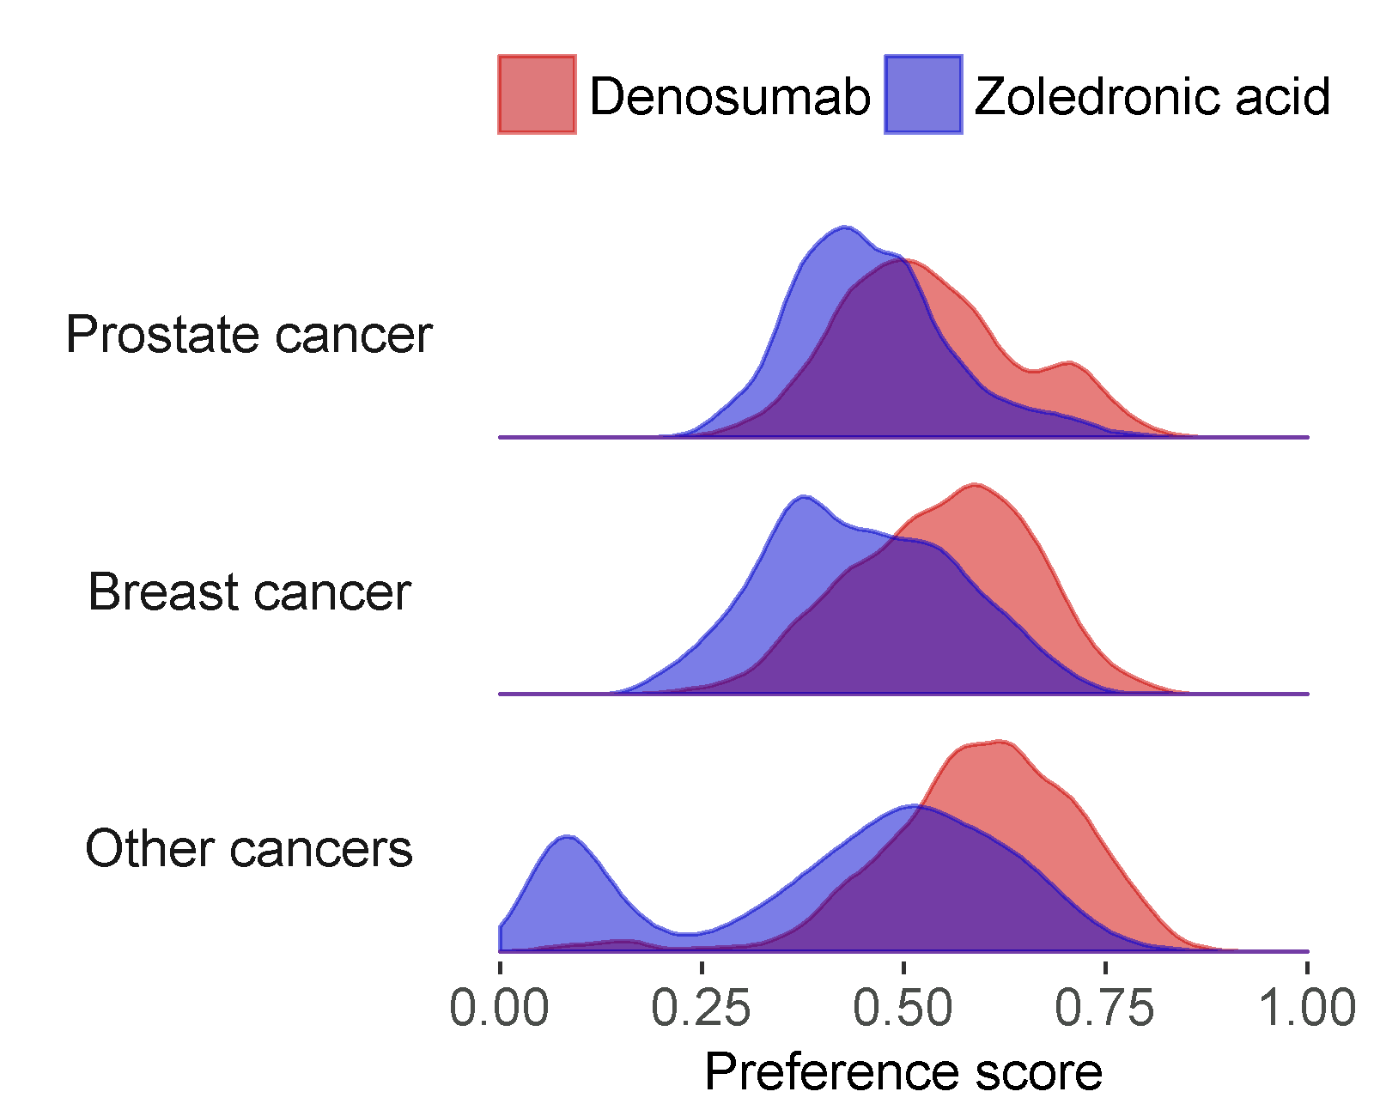

**Figure 1.** Preference score distribution for the two cohorts.

Figures 2 shows the covariate balance on the propensity score, confirming that some covariates show imbalance before propensity score stratification. After matching, the balance is improved.

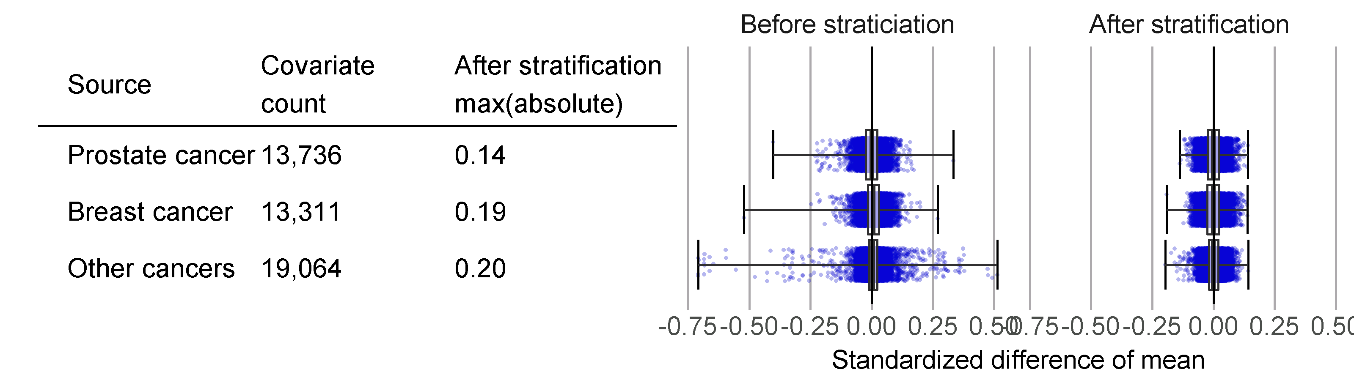

**Figure 2**. Covariate balance before and after stratification on the propensity score. Each blue dot represents a single covariate captured at baseline (treatment initiation). The left column shows the standardized difference in mean before PS stratification. The right column show the standardized difference in mean after PS stratification.

## Systematic Error Assessment

Using the estimates produced for the negative control outcomes we fitted null distributions. The parameters for the fitted distributions are shown in figure 3.

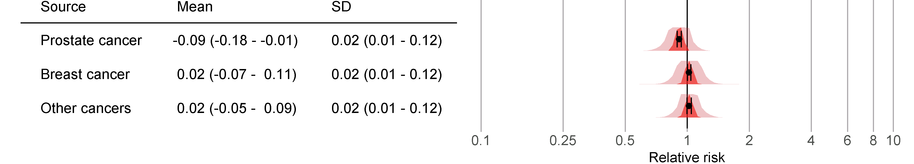**Figure 3**. Empirical null distributions based on the negative control outcomes. The distributions are expressed as the mean (95% confidence interval) and standard deviation (95% confidence interval).

Figures 4-6 shows the results of the analysis of systematic error using both negative and positive controls.

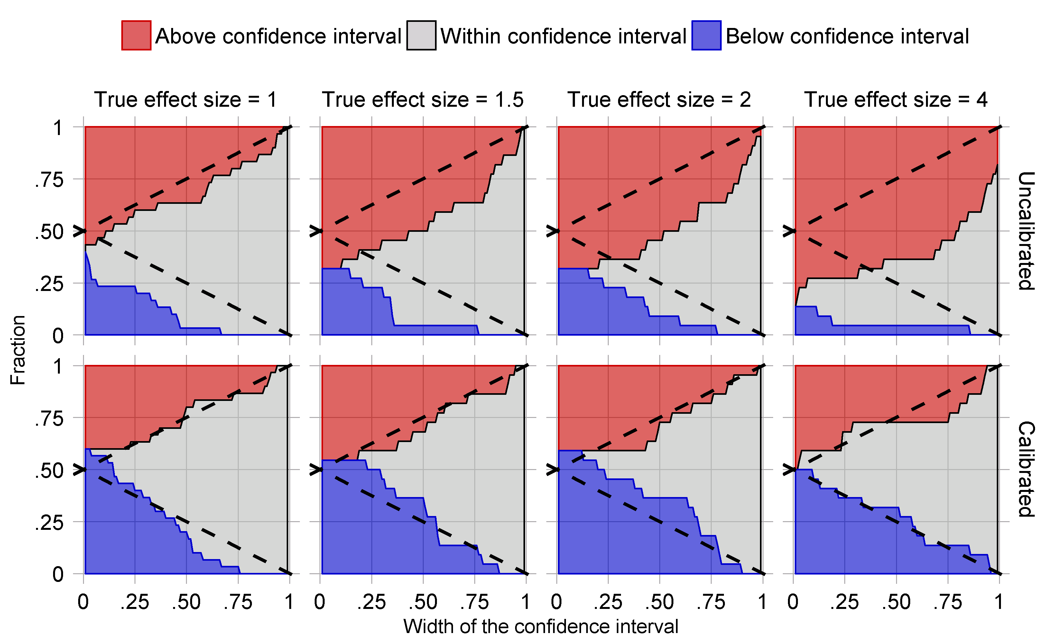

**Figure 4.** Prostate cancer: the fraction of controls where the true hazard ratio is above, within, or below the confidence interval, for various widths of the confidence interval and various true hazard ratios. The dashed lines indicate the boundaries of a perfectly calibrated and centered estimator. The top row shows fractions without confidence interval calibration. The bottom row shows fractions when using confidence interval calibration, and uses leave-one-out cross-validation.

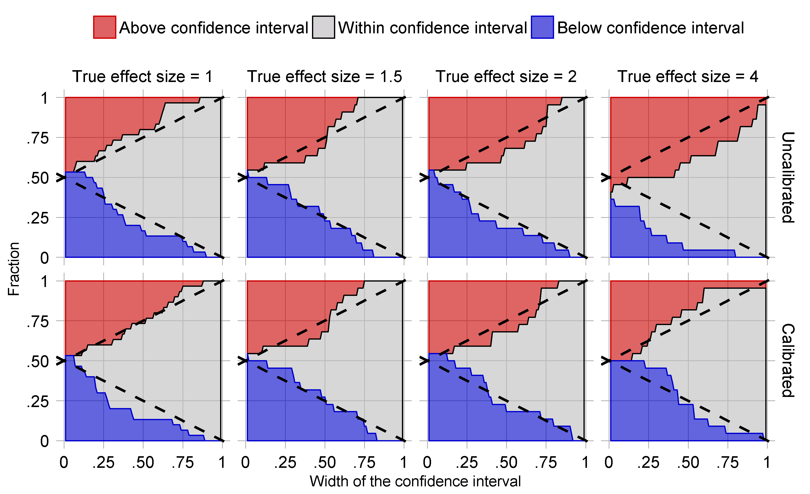

**Figure 5.** Breast cancer: the fraction of controls where the true hazard ratio is above, within, or below the confidence interval, for various widths of the confidence interval and various true hazard ratios. The dashed lines indicate the boundaries of a perfectly calibrated and centered estimator. The top row shows fractions without confidence interval calibration. The bottom row shows fractions when using confidence interval calibration, and uses leave-one-out cross-validation.

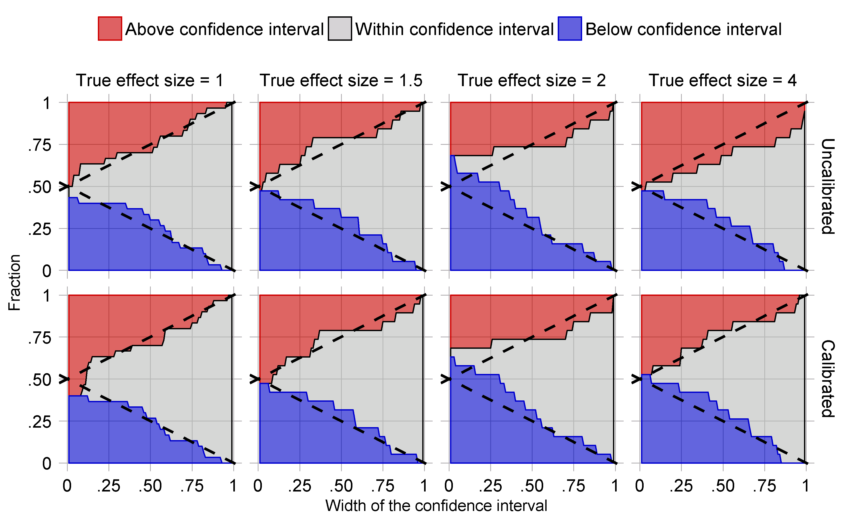

**Figure 6.** Other cancers: the fraction of controls where the true hazard ratio is above, within, or below the confidence interval, for various widths of the confidence interval and various true hazard ratios. The dashed lines indicate the boundaries of a perfectly calibrated and centered estimator. The top row shows fractions without confidence interval calibration. The bottom row shows fractions when using confidence interval calibration, and uses leave-one-out cross-validation.

# Strengths and Limitations of the Research Methods

Strength

* Cohort studies allow direct estimation of incidence rates following exposure of interest, and the new-user design can capture early events following treatment exposures while avoiding confounding from previous treatment effects. New use allows for a clear exposure index date.
* PS matching allow balancing on a large number of baseline potential confounders.
* Use of negative and positive control outcomes allow for evaluating the study design as a whole in terms of residual bias.

Limitations

* Even though many potential confounders will be included in this study, there may be residual bias due to unmeasured or misspecified confounders.

# Protection of Human Subjects

The use of the Optum Extended DoD database were reviewed by the New England Institutional Review Board (IRB) and was determined to be exempt from broad IRB approval, as this research project did not involve human subjects research.

# Management and Reporting of Adverse Events and Adverse Reactions

This study uses coded data that already exist in an electronic database. In this type of database, it is not possible to link (i.e., identify a potential causal association between) a particular product and medical event for any individual. Thus, the minimum criteria for reporting an adverse event (i.e., identifiable patient, identifiable reporter, a suspect product, and event) are not available and adverse events are not reportable as individual adverse events reports. The study results will be assessed for medically important results.

# Plans for Disseminating and Communicating Study Results

The study results will be posted on the OHDSI website after completion of the study. At least one paper describing the study and its results will be written and submitted for publication to a peer-reviewed scientific journal.

# Appendix 1

## Concepts excluded from covariates

These concepts and their descendants are excluded when creating covariates:

|  |  |  |
| --- | --- | --- |
| Concept ID | Concept Name |  |
| 21601136 | BLOOD SUBSTITUTES AND PERFUSION SOLUTIONS |  |
| 40222444 | denosumab |  |
| 21601195 | Electrolyte solutions |  |
| 21601194 | I.V. SOLUTION ADDITIVES |  |
| 21601153 | I.V. SOLUTIONS |  |
| 21600884 | OTHER MINERAL SUPPLEMENTS |  |
| 967823 | Sodium Chloride |  |
| 1524674 | zoledronic acid |  |

## Negative controls

|  |  |
| --- | --- |
| Concept ID | Concept name |
| 195562 | Hemorrhoids |
| 318736 | Migraine |
| 4090425 | Altered sensation of skin |
| 313459 | Sleep apnea |
| 136661 | Non-toxic nodular goiter |
| 197672 | Urinary incontinence |
| 4209423 | Nicotine dependence |
| 437390 | Hypoxemia |
| 380094 | Carpal tunnel syndrome |
| 377575 | Tinnitus |
| 253796 | Pneumothorax |
| 4214376 | Hyperglycemia |
| 318556 | Epistaxis |
| 434005 | Morbid obesity |
| 432730 | Difficulty speaking |
| 439147 | Amnesia |
| 253797 | Post-inflammatory pulmonary fibrosis |
| 441417 | Incoordination |
| 433454 | Adjustment disorder with mixed emotional features |
| 376065 | Neurologic disorder associated with type 2 diabetes mellitus |
| 4239682 | Chronic phototoxic dermatitis |
| 30133 | Acute laryngitis |
| 73090 | Contusion of foot |
| 137951 | Acquired keratoderma |
| 257683 | Posterior rhinorrhea |
| 137977 | Jaundice |
| 139850 | Acute frontal sinusitis |
| 376229 | Abnormal involuntary movement |
| 193020 | Incomplete emptying of bladder |
| 376382 | Tension-type headache |
| 137063 | Corns and callus |

# References

1. Coleman, R.E., et al., *Metastasis and bone loss: advancing treatment and prevention.* Cancer Treat Rev, 2010. **36**(8): p. 615-20.

2. Coleman, R.E., *Clinical features of metastatic bone disease and risk of skeletal morbidity.* Clin Cancer Res, 2006. **12**(20 Pt 2): p. 6243s-6249s.

3. Schulman, K.L. and J. Kohles, *Economic burden of metastatic bone disease in the U.S.* Cancer, 2007. **109**(11): p. 2334-42.

4. Saad, F., et al., *A randomized, placebo-controlled trial of zoledronic acid in patients with hormone-refractory metastatic prostate carcinoma.* J Natl Cancer Inst, 2002. **94**(19): p. 1458-68.

5. Saad, F., et al., *Long-term efficacy of zoledronic acid for the prevention of skeletal complications in patients with metastatic hormone-refractory prostate cancer.* J Natl Cancer Inst, 2004. **96**(11): p. 879-82.

6. Fizazi, K., et al., *Denosumab versus zoledronic acid for treatment of bone metastases in men with castration-resistant prostate cancer: a randomised, double-blind study.* Lancet, 2011. **377**(9768): p. 813-22.

7. Stopeck, A.T., et al., *Denosumab compared with zoledronic acid for the treatment of bone metastases in patients with advanced breast cancer: a randomized, double-blind study.* J Clin Oncol, 2010. **28**(35): p. 5132-9.

8. Henry, D.H., et al., *Randomized, double-blind study of denosumab versus zoledronic acid in the treatment of bone metastases in patients with advanced cancer (excluding breast and prostate cancer) or multiple myeloma.* J Clin Oncol, 2011. **29**(9): p. 1125-32.

9. Choi, N.K., et al., *Comparative Safety and Effectiveness of Denosumab Versus Zoledronic Acid in Patients With Osteoporosis: A Cohort Study.* J Bone Miner Res, 2017. **32**(3): p. 611-617.

10. Gagne, J.J., et al., *Prospective Benefit-Risk Monitoring of New Drugs for Rapid Assessment of Net Favorability in Electronic Health Care Data.* Value Health, 2015. **18**(8): p. 1063-9.

11. Ryan, P.B., et al., *Empirical performance of a new user cohort method: lessons for developing a risk identification and analysis system.* Drug Saf, 2013. **36 Suppl 1**: p. S59-72.

12. Voss, E.A., et al., *Accuracy of an automated knowledge base for identifying drug adverse reactions.* J Biomed Inform, 2017. **66**: p. 72-81.

13. Winnenburg, R., et al., *Leveraging MEDLINE indexing for pharmacovigilance - Inherent limitations and mitigation strategies.* J Biomed Inform, 2015. **57**: p. 425-35.

14. Duke, J., J. Friedlin, and X. Li, *Consistency in the safety labeling of bioequivalent medications.* Pharmacoepidemiol Drug Saf, 2013. **22**(3): p. 294-301.

15. Evans, S.J., P.C. Waller, and S. Davis, *Use of proportional reporting ratios (PRRs) for signal generation from spontaneous adverse drug reaction reports.* Pharmacoepidemiol Drug Saf, 2001. **10**(6): p. 483-6.

16. Banda, J.M., et al., *A curated and standardized adverse drug event resource to accelerate drug safety research.* Sci Data, 2016. **3**: p. 160026.

17. Schuemie, M.J., et al., *Empirical confidence interval calibration for population-level effect estimation studies in observational healthcare data.* Proceedings of the National Acadamy of Science, 2017. **Accepted for publication**.

18. Schuemie, M.J., et al., *Interpreting observational studies: why empirical calibration is needed to correct p-values.* Stat Med, 2014. **33**(2): p. 209-18.

19. Lipton, A., et al., *Superiority of denosumab to zoledronic acid for prevention of skeletal-related events: a combined analysis of 3 pivotal, randomised, phase 3 trials.* Eur J Cancer, 2012. **48**(16): p. 3082-92.