A Comparative Study of Bromocriptine and Cabergoline Use Among Hyperprolactinemia Subjects and Development of Cardiac Valve Disorder

**Version:** 0.1

**Authors:**

Jill Hardin PhD, Janssen Research and Development

Patrick B. Ryan, PhD, Janssen Research and Development

**Date:** 25 January 2018

**Acknowledgment:** The analysis is based in part on work from the Observational Health Sciences and Informatics collaborative. OHDSI (<http://ohdsi.org>) is a multi-stakeholder, interdisciplinary collaborative to create open-source solutions that bring out the value of observational health data through large-scale analytics.

The authors declare the following disclosures: Drs. Ryan and Hardin are employees of Janssen Research & Development.

1. **Table of contents**

2 List of abbreviations 4

3 Abstract 4

4 Amendments and Updates 4

Milestones 4

5 Rationale and Background 4

5.1 Research Questions 5

5.2 Objectives 5

6 Research methods 5

6.1 Study Design 5

6.1.1 Overview 5

6.1.2 Output and Evaluation 7

6.1.3 Study population 8

6.2 Variables 8

6.2.1 Exposures 8

6.2.2 Outcomes 9

6.2.3 Negative controls 9

6.3 Data Sources 10

6.3.1 Pooling effect estimate across databases 10

6.4 Quality control 10

6.5 Power 10

6.6 Strengths and Limitations of the Research Methods 11

7 Protection of Human Subjects 11

8 Plans for Disseminating and Communicating Study Results 11

9 Appendix 1 12

9.1 Outcomes to exclude 12

9.2 Negative controls 12

10 Appendix 2 Study diagnostic materials 12

10.1 Attrition Diagram 12

10.2 Attrition Diagram Strata 12

10.3 Covariate Balance Top 12

10.4 Covariate Balance Scatter 12

10.5 Propensity Score Plot 12

10.6 Propensity Score Plot Strata 12

11 References 12

# List of abbreviations

ATC Anatomic Therapeutic Chemical

CYCLOPS Cyclic coordinate descent for logistic, Poisson and survival analysis

MedDRA Medical Dictionary for Regulatory Activities

OHDSI Observational Health Data Sciences and Informatics

OMOP Observational Medical Outcomes Partnership

PRR Proportional Reporting Ratio

PS Propensity Scores

DA Dopamine Antagonist

CBG Cabergoline

BRC Bromocriptine

PD Parkinson’s Disease

CVR Cardiac valve regurgitation

FDA Food and Drug Administration

CRVD Clinically relevant valve disease

MDRR Minimum detectable relative risk

# Abstract

This study aims to compare the incidence of cardiac valve disorder in patients treated with cabergoline and bromocriptine. In this study, we will analyze data from two observational claims databases using the OHDSI CohortMethod package framework to perform this comparative study.

# Amendments and Updates

|  |  |  |  |
| --- | --- | --- | --- |
| 0.1 | 22 Jan 2018 | Jill Hardin | Initial draft |
| 0.2 |  |  |  |

# Milestones

|  |  |
| --- | --- |
| Milestone | Planned / Estimated Date |
| Start of analysis | 24 Jan 2018 |
| End of analysis | 25 Jan 2018 |
| Posting of results | 25 Jan 2018 |
| Submission of manuscript | 31 Jan 2018 |

# Rationale and Background

Dopamine agonists (DA) such as cabergoline (CBG) and bromocriptine (BRC) are the first line of therapy for prolactinomas[1]. The Endocrine Society Clinical Guideline recommends using cabergoline in preference to other DA because it has higher efficacy in normalizing prolactin levels [2]. Ergot-derived DAs used alone or in combination in treatment of Parkinson’s Disease (PD) include pergolide, cabergoline, bromocriptine, and lisuride. Cardiac valve regurgitation (CVR) has been reported in PD patients treated with CBG and pergolide. In 2007 the US Food and Drug Administration (FDA) withdrew pergolide from the US market due to risk of valvular heart disease [3]. While CBG is not approved for PD in the US it is approved for treatment of hyperprolactinemia and is used at 10 times lower dosages than used in PD.

A meta-analysis that includes articles through June 2012 and focuses on observational studies of CBG treated hyperprolactinemic patients, reports mild to moderate risk of tricuspid valve regurgitation and recommends periodic ultrasound evaluation of those patients receiving high doses (weekly dose of 2 mg) to detect new onset cardiac valve abnormalities [4]. A review focusing on the diagnosis and treatment of pituitary adenomas states that because the threshold dose of CBG causing valvular risk is unknown that echocardiograms should be obtained annually in the subset of patients exceeding a weekly dose of 2mg[5]. Retrospective and observational studies [6-21] have investigated CBG use on development of clinically relevant valve disease (CRVD) in hyperprolactinemia patients and report the prevalence of CVRD ranges from 0% [11, 17, 19, 20] to 54% [8], while some report no risk of CVRD[21]. Prospective clinical studies investigating the prevalence and severity of valve regurgitation in prolactinoma patients concluded CAB does not increase the risk of CVR [22, 23]. Sample sizes were very limited in the retrospective (ranging from 192 to 32 patients) and prospective (100 and 40 patients) studies. A multicountry nested case control study of risk of CVR with DA use in Parkinson’s and hyperprolactinemia patients pooled hyperprolactinemia populations and included 6740 patients with new exposure to DA and reported no association with CVR[24].

While many retrospective studies have been conducted they include small sample sizes and used a case control design, which hinder the ability to assess the risk of CVR among hyperprolactinemia subjects prescribed DAs. This study will use the OHDSI CohortMethod package to compare incident CVR among prolactinemic patients prescribed CBG against those prescribed BRC.

# Study Objectives

## Primary Hypothesis

* This study’s primary hypothesis is that there is no difference in incidence rate of cardiac valve disease between hyperprolactinemic subjects taking cabergoline and bromocriptine.

## Primary Objective

* To compare the risk of **O: new cases of cardiac valve disease** between **C: new users of cabergoline in patients with hyperprolactinemia** and **T: new users of bromocriptine in patients with hyperprolactinemia**, we will estimate the population-level effect of exposure on the hazards of the outcome during the period from 90 days from cohort start date to 9999 days from cohort end date.

# Research methods

## Study Design

In this study, we compare **C: new users of cabergoline in patients with hyperprolactinemia** with **T: new users of bromocriptine in patients with hyperprolactinemia for the hazards of O: new cases of cardiac valve disease** from 90 days from cohort start date to 9999 days from cohort end date.

For T/C/O cohorts, we impose a requirement that patients must have at least 365 days of continuous observation prior to cohort entry and 0 days post cohort entry and that they be aged 18 or older at index.

For T and C cohorts, we additionally impose that patients must have: at least 1 condition occurrence of hyperprolactinemia all days prior to 0 days before the index, exactly 0 condition occurrences of cardiac valve disorder all days prior to 0 days before the index, and exactly 0 condition occurrence of PD all days prior to 0 days before the index.

For the C cohort, we additionally impose that patients must have exactly 0 drug exposures to bromocriptine all days prior to and all days after index.

For the T cohort, we additionally impose that patients must have exactly 0 drug exposures to cabergoline all days prior to and all days after index.

The overall study population could be considered to be patients who entered either the target cohort or comparator cohort. Patients were excluded from consideration if they qualified for both the target cohort and comparator cohort at any time in their record.

The time-to-event of outcome among patients in the target and comparator cohorts is determined by calculating the number of days from the start of the time-at-risk window, 90 days from cohort start date until the earliest event among 1) the first occurrence of the outcome, **O: new cases of cardiac valve disorder** before 9999 days from cohort end date, 2) the end of the time-at-risk window, 9999 days from cohort end date, and 3) the end of the observation period that spans the time-at-risk start.

Patients with **O: new cases of cardiac valve disorder** prior to target or comparator cohort entry were excluded from consideration.

### Overview

This study will follow a retrospective, observational, comparative cohort design. We define ‘retrospective’ to mean the study will be conducted using data already collected prior to the start of the study. We define ‘observational’ to mean there is no intervention or treatment assignment imposed by the study. We define 'cohort' to mean a set of patients satisfying a one or more inclusion criteria for a duration of time. We define ‘comparative cohort design’ to mean the formal comparison between two cohorts, a target cohort and comparator cohort, for the risk of an outcome during a defined time period after cohort entry. The design will be conducted in two administrative claims databases in the US, as described in section 8.2. The specific exposure cohorts are described in section 8.3. The time-at-risk definitions are described in section 10.1. The statistical analysis plan for population-level effect estimation is described in section 10.3.

## Data Source(s)

The analyses will be performed across two observational databases. All databases have been transformed into the OMOP Common Data Model, version 5.3. The complete specification for OMOP Common Data Model, version 5.3 is available at: <https://github.com/OHDSI/CommonDataModel>.

Data sources expected to participate to include:

* Truven MarketScan Commercial Claims and Encounters (US claims)
* Optum Extended SES (US claims)

Although use of Truven Medicaid database was considered the final sample sizes were limited (T= 406; C= 425) and the covariate balance plot indicated many covariates after matching; therefore this analysis will not use the Medicaid database.

Each database is described below:

1. Truven Health MarketScanTM Commercial Claims and Encounters Database (CCAE)

CCAE is a medical and drug insurance claims database on over 120 million unique de-identified patients that include active employees, early retirees, COBRA continuers, and their dependents insured by employer-sponsored plans. The database contains inpatient admission records, outpatient services, prescription drugs, populations, eligibility status, and costs of services. The following limitations of Truven CCAE should be noted:

* The commercially insured patients represent a higher socioeconomic status than the overall US population.
* Data are based on financial claims filed for reimbursement; disease coding may reflect financial incentives for reimbursement rather than clinically and systematically verified definitions.
* Prescriptions are those filled at outpatient pharmacies, not those prescribed or administered within inpatient services. The extent to which prescribed records went unfulfilled is not known. It is also not known whether medications were actually taken as directed, although repeated dispensing of the same drug would suggest that this is the case.
* There is a data lag; Truven only sends records that are 100% paid, which can take about 6 months after year end.
* Prescriptions are those filled, not those prescribed. We do not know the universe of prescribed records that went unfulfilled.

1. OptumInsight’s de-identified ClinformaticsTM Datamart, Extended – SES (Optum)

Optum is an administrative health claims database for members who are fully insured in commercial plans or in administrative services only (ASOs) and commercial Medicare. For each group, only members with both medical and prescription drug coverage are included. Optum captures person-specific clinical utilization, expenditures, and enrollment across inpatient, outpatient, and prescription drug, and includes results for outpatient lab tests processed by large national lab vendors (about 30% of the population). The following limitations of Optum should be noted:

* Family enrollment, capitated plan information and exact birth date are not available
* All claims are limited to first 5 diagnostic codes.
* Data based on financial claims filed for reimbursement, disease coding may reflect financial incentives for reimbursement rather than clinically and systematically verified definitions.
* Prescriptions are those filled, not those prescribed. We do not know the universe of prescribed records that went unfulfilled.

### Pooling effect estimates across databases

This study will not pool effect estimates across databases rather the results will be reported separately.

### Output and Evaluation

Covariate balance will be summarized in tabular form by showing the mean value for all baseline covariates in the target and comparator cohort, with the associated standardized mean difference computed for each covariate.

Once the propensity score model is fit, we will plot the propensity score distribution of the target and comparator cohorts to evaluate the comparability of the two cohorts. The plot will be scaled to the preference score, normalizing for any imbalance in cohort size. The area under the Receiver Operating Characteric (ROC) curve (AUC) will be reported. The covariates selected within the propensity score model, with associated coefficients will also be reported.

A plot showing the propensity score distributions for both cohorts after stratification will be provided, with each quantile cutpoint shown as a vertical line.

An attrition diagram will be provided to detail the loss of patients from the original target cohort, **C: new users of cabergoline in patients with hyperprolactinemia**, and comparator cohort **T: new users of bromocriptine in patients with hyperprolactinemia** to the subpopulations that remain after all design considerations have been applied.

The final outcome model, a conditional Cox proportional hazards model, will be summarized by providing the hazards ratio and associated 95% confidence interval. The number of persons, amount of time-at-risk, and number of outcomes in each cohort will also be reported.

A Kaplan-Meier plot will be generated to characterize the contour of risk over time for the outcome of interest.

Negative control outcomes will be used to evaluate the potential impact of residual systematic error in the study design, and to facilitate empirical calibration of the p-value for the outcomes of interest. Negative control outcomes are concepts known not to be associated with either the target or comparator group, such that we can assume the true relative risk should equal 1. The negative control outcomes used in this study are labelled **negative controls for bromocriptine and cabergoline** as detailed in Appendix 1. For each negative control outcome, the study design described above will be implemented and the effect estimate will be recorded. The distribution of effect estimates across all negative control outcomes will be used to fit an empirical null distribution which models the observed residual systematic error. The empirical null distribution will then be applied to the target outcome of interest to calibrate the p-value. Empirical calibration serves as an important diagnostic tool to evaluate if the residual systematic error is sufficient to cast doubt on the accuracy of the unknown effect estimate. The calibration effect plot and calibration probability plots will be generated for review. We will report the traditional p-value and empirically calibrated p-value for each negative control, as well as the unknown outcomes of interest.

Section 9.2 contains study diagnostic materials.

### Study population

The study population is comprised of hyperprolactinemia patients in a target cohort T or comparator cohort C.

Comparator cohort C: new users of cabergoline, is formally defined here: [https://epi.jnj.com/atlas/#/cohortdefinition/4991](https://epi.jnj.com/atlas/%23/cohortdefinition/4991)

Target cohort T: new users of bromocriptine, is formally defined here: [https://epi.jnj.com/atlas/#/cohortdefinition/4992](https://epi.jnj.com/atlas/%23/cohortdefinition/4992)

All subjects in the database will be included who meet the following criteria: (note: the index date is the start of the first exposure to cabergoline or bromocriptine)

* Aged greater than 17 years
* Exposure to cabergoline or bromocriptine
* At least 365 days of observation time prior to the index date
* At least 0 days of observation time after the index date
* No prior cardiac valve disorders on or preceding the index date
* No PD on or preceding the index date
* No prior or post index drug exposure to cabergoline (C cohort) or bromocriptine (T cohort)
* Prior condition occurrence of hyperprolactinemia prior to the index

## Variables

### Exposures

C: new users of cabergoline in patients with hyperprolactinemia

<https://epi.jnj.com/atlas/#/cohortdefinition/4991>

T: new users of bromocriptine in patients with hyperprolactinemia

[https://epi.jnj.com/atlas/#/cohortdefinition/4992](https://epi.jnj.com/atlas/%23/cohortdefinition/4992)

### Outcomes

Cardiac valve disease:

<https://epi.jnj.com/atlas/#/cohortdefinition/4993>

Implementation of the outcome cohort is not based on a validated algorithm for cardiac valve disorder. The AHA/ACC guidelines [25] suggest use of an ECG and chest X-ray to assess patients with suspected cardiac valve disease. The features report for the O cohort (patients with cardiac valve disease) show in CCAE that only 43% of subjects had an echocardiogram and 0.6% of subjects had a chest x-ray; therefore if the O cohort were to include these procedures a number of patients would be excluded. There may be some patients in the O cohort that are not confirmed cardiac valve disease; this is a limitation of this study.

All concept set information is included here: 

For the full details see the OHDSI CohortMethod package (<https://github.com/OHDSI/CohortMethod>).

## Other Variables of Interest

Propensity scores will be used as an analytic strategy to reduce potential confounding due to imbalance between the target and comparator cohorts in baseline covariates. The propensity score is the probability of a patient being classified in the target cohort vs. the comparator cohort, given a set of observed covariates. In this study, the propensity score is estimated for each patient, using the predicted probability from a regularized logistic regression model, fit with a Laplace prior (LASSO) and the regularization hyperparameter selected by optimizing the likelihood in a 10-fold cross validation, using a starting variance of 0.01 and a tolerance of 2e-7.

The types of baseline covariates used to fit the propensity score model will be:

* Demographics
  + Gender
  + Age group (5-year bands)
  + Index year
  + Index month
  + Race
  + Ethnicity
* Conditions
  + In prior 30d
  + In prior 365d
  + In prior 180d within inpatient setting
  + All time prior
  + Overlapping index date
* Condition aggregation
  + SNOMED
* Drugs
  + All time prior
  + Overlapping index date
* Drug aggregation
  + Ingredient
  + ATC Class
* Measurement
  + Existence in prior 30d
  + Existence in prior 365d
* Risk scores
  + Charlson
  + DCSI
* Concept counts (count of distinct conditions/procedures/visits in history)

Specific covariates to be excluded from the propensity score model are labelled **outcomes to exclude** as detailed in Appendix 1.

All covariates that occur in fewer than 10 persons between the target and comparator cohorts combined will be excluded prior to model fitting.

The propensity score estimates are used to restrict the cohorts through patient trimming. Patients are excluded if their predicted probability is less than 10% or greater than 90% of the preference score.

The target cohort and comparator cohorts will be stratified into 5 quantiles of the propensity score distribution.

## Quality control

We will evaluate the PS by

* Inspection of the fitted PS model for large coefficients (indicative of model-misspecification) and predictors that we cannot explain (post-hoc).
* Inspection of the PS distribution.
* Evaluation of covariate balance after matching using the standardized difference in means between treatment and comparator cohort before and after matching[26]. Standardized differences greater than 0.2 will be reported and investigated.

We will investigate the outcome model by

* Inspection of the fitted outcome model for large coefficients and predictors that we cannot explain (post-hoc).

The error distribution estimated using the negative controls will be used to estimate residual bias after adjustments.

The CohortMethod package itself, as well as other OHDSI packages on which CohortMethod depends, use unit tests for validation.

# Sample Size, Study Power, and Diagnostics

## Sample Size and Study Power

The sample size of the target (bromocriptine) and comparator (cabergoline) cohorts as well as the minimum detectable relative risk (MDRR) is listed below. These patient counts represent the population.

|  |  |  |  |  |  |  |
| --- | --- | --- | --- | --- | --- | --- |
| Database | Subjects  (target) | Subjects  (comparator) | Days at risk  (target) | Days at risk  (comparator) | Outcomes (both) | MDRR |
| Optum | 2919 | 5906 | 428866 | 1007989 | 83 | 1.92 |
| CCAE | 4537 | 10128 | 687913 | 1779310 | 107 | 1.8 |

## Diagnostics

## Cohort Comparability

Figures 1-2 show the preference score distribution for the two cohorts in the two databases, showing that the cohorts are have some overlap based on their baseline covariates.

Figure 1 – CCAE – Preference score

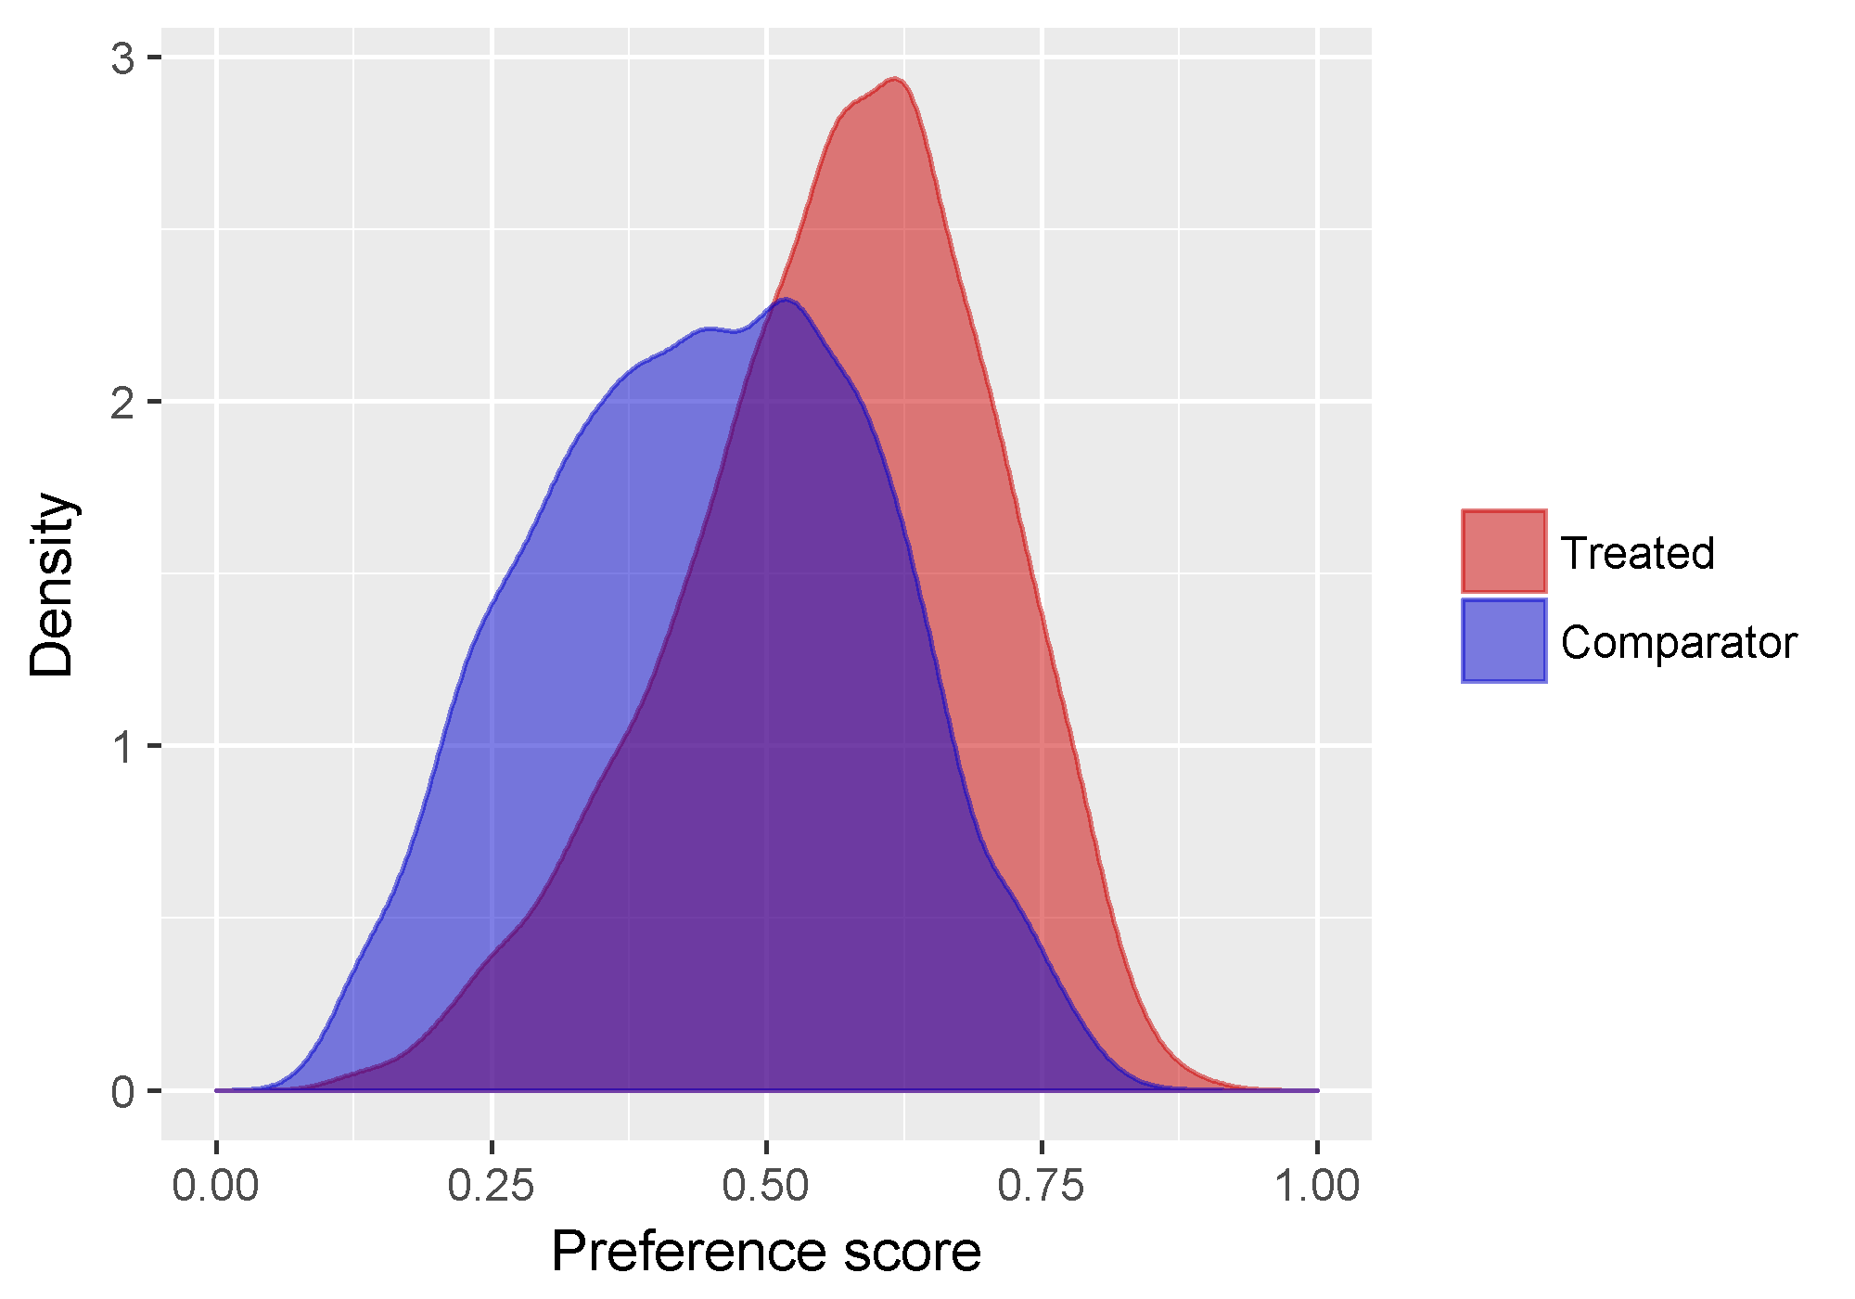

Figure 2 – OPTM SES– Preference score

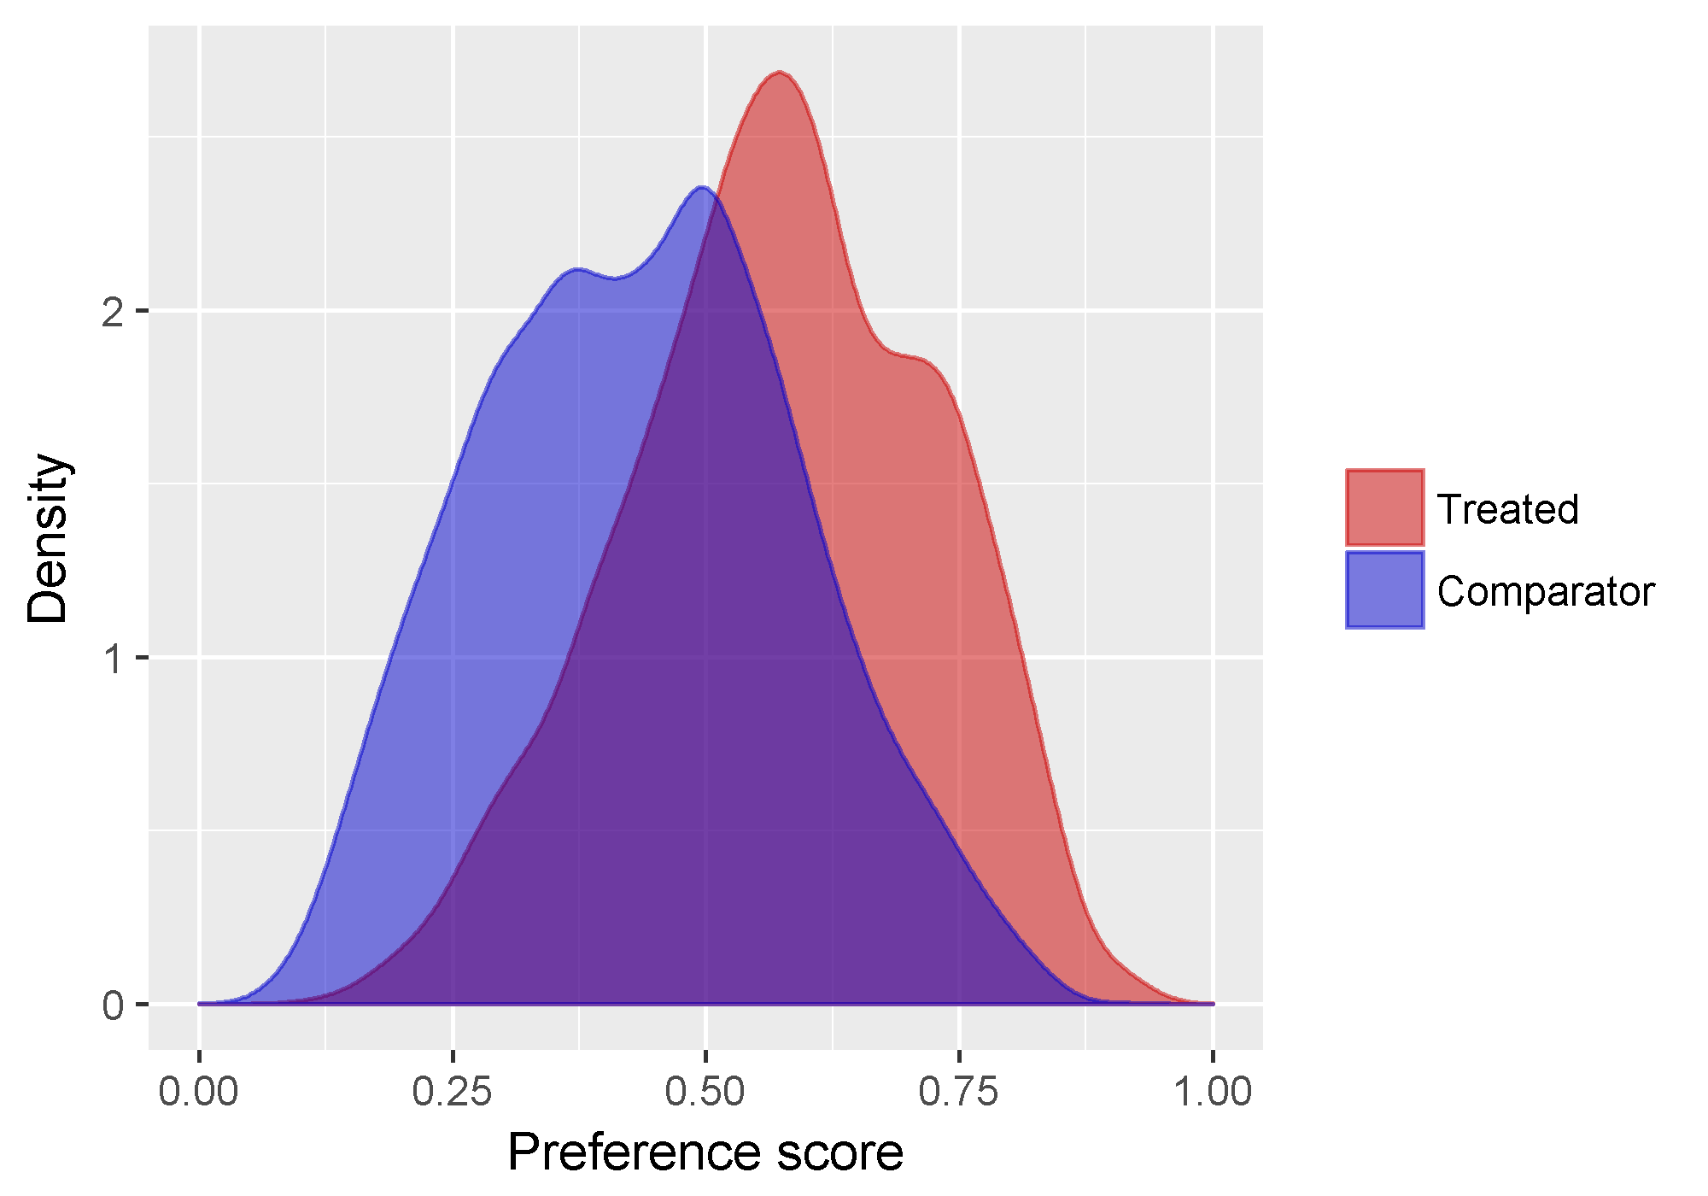

Figures 4-7 show the covariate balance on the propensity score, confirming that some covariates show imbalance before propensity score stratification. After matching, the balance is improved.

Figure 4 CCAE – Covariate balance-top

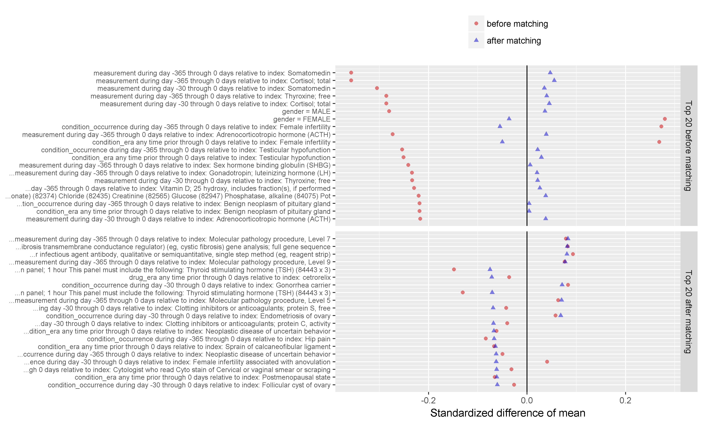

Figure 5 CCAE-Covariate balance – scatter

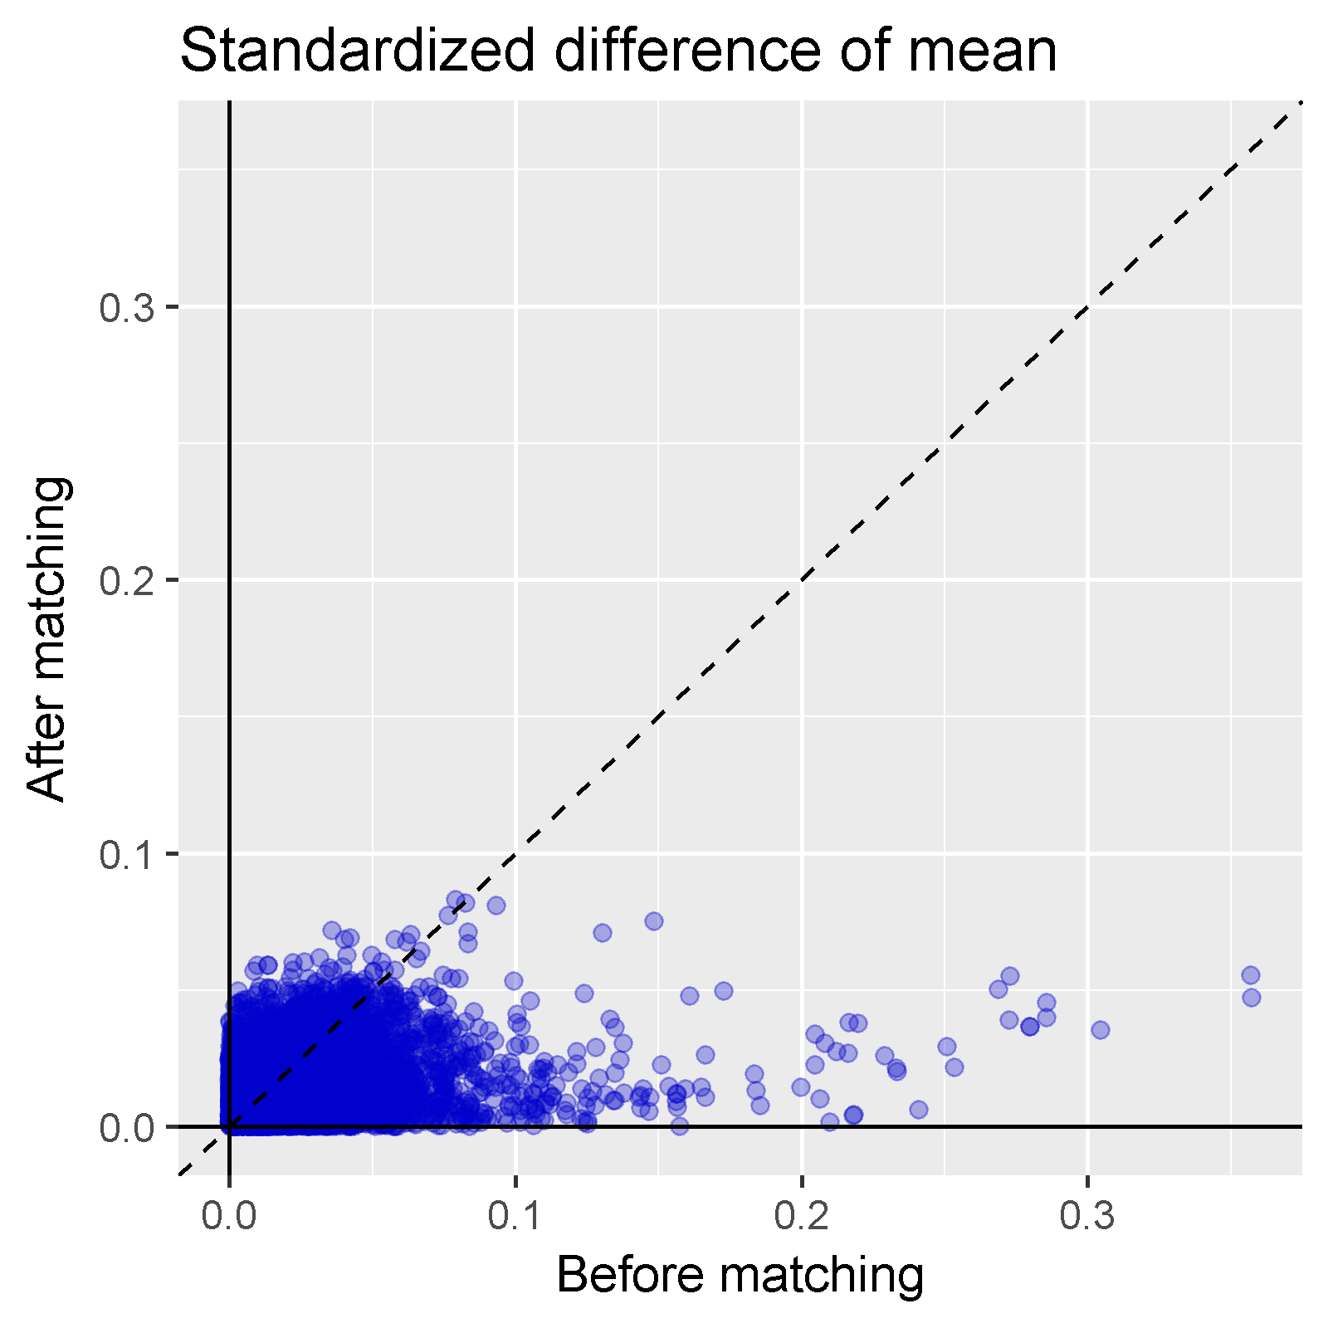

Figure 6 OPTM – Covariate balance-top

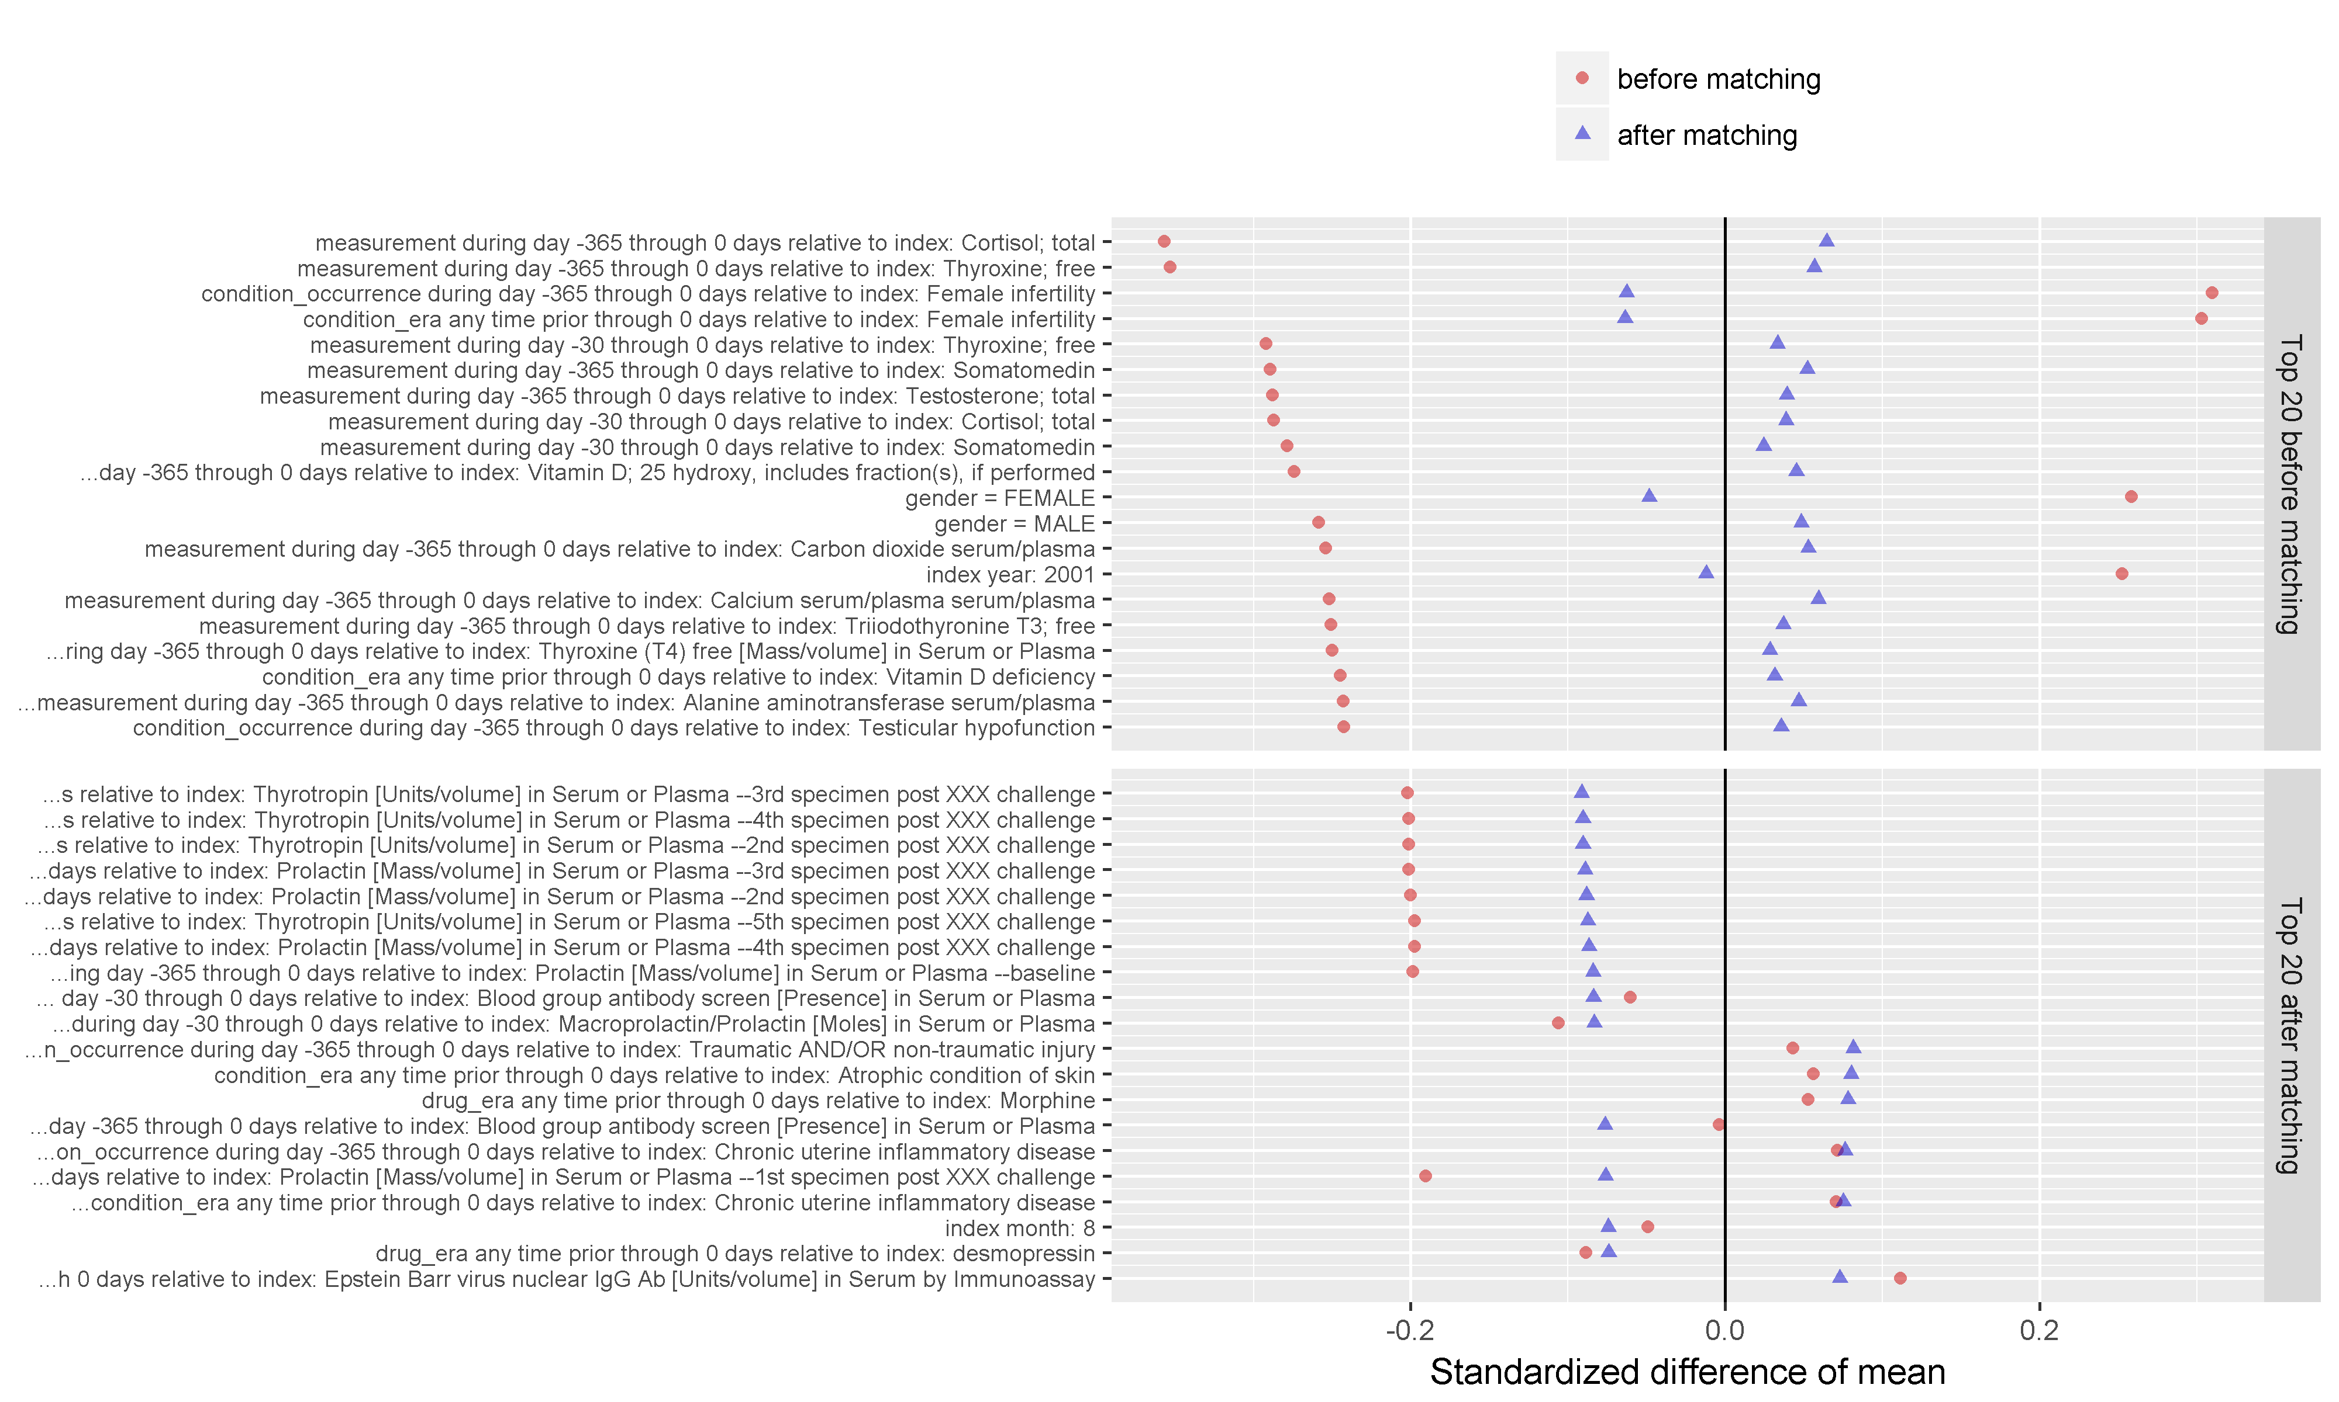

Figure 7 OPTM-Covariate balance – scatter

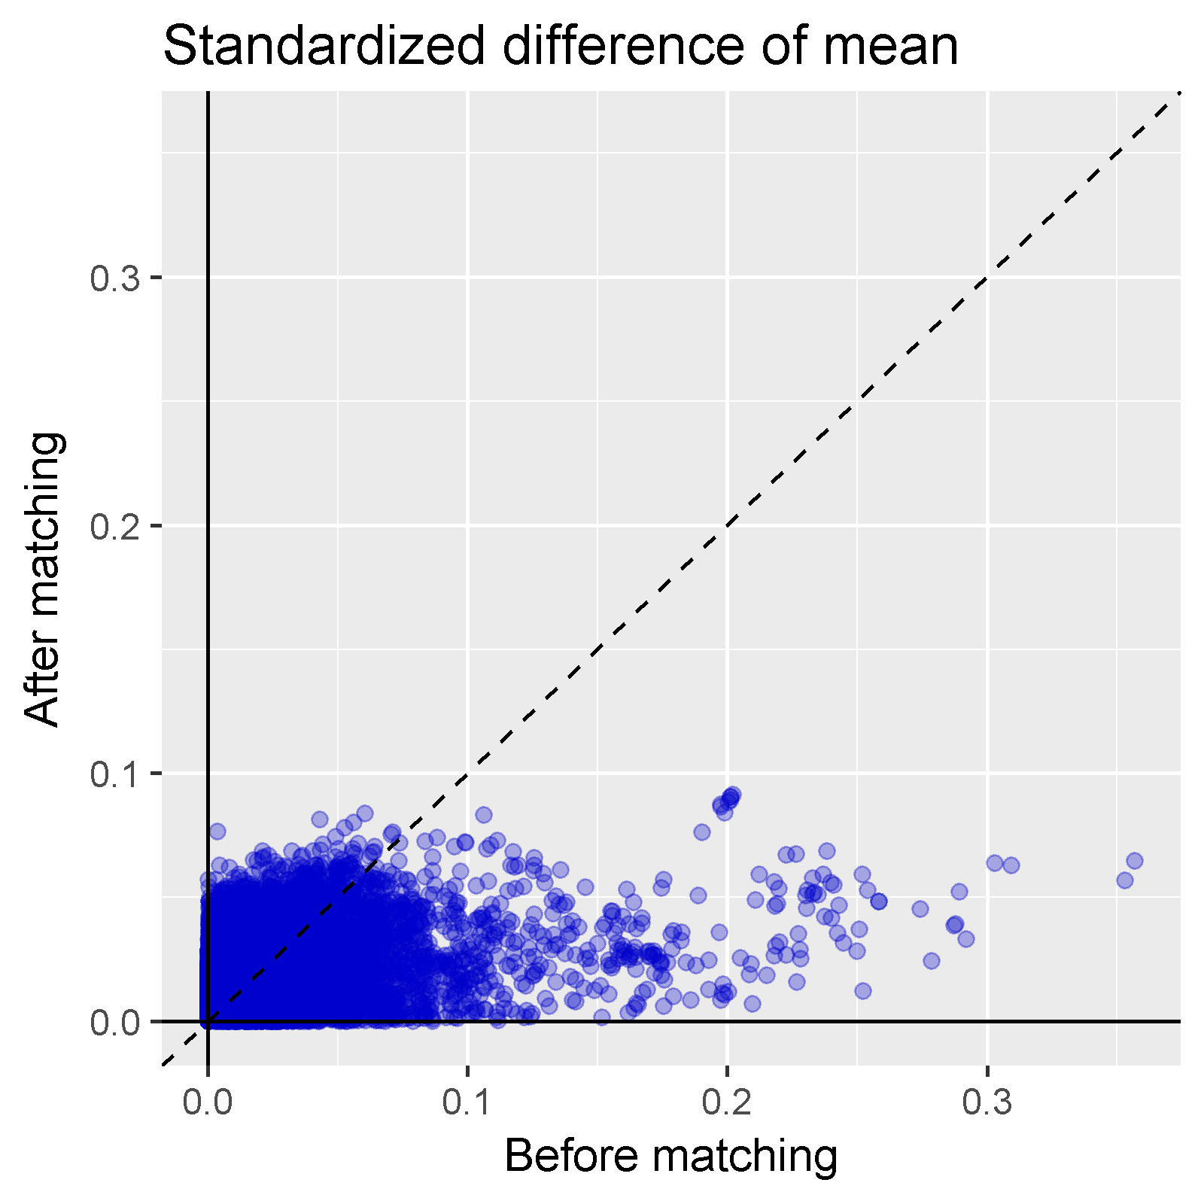

Figure 9-10 Calibrated Effect Estimate plots

Figure 9 – CCAE Calibrated Effect Estimate plot

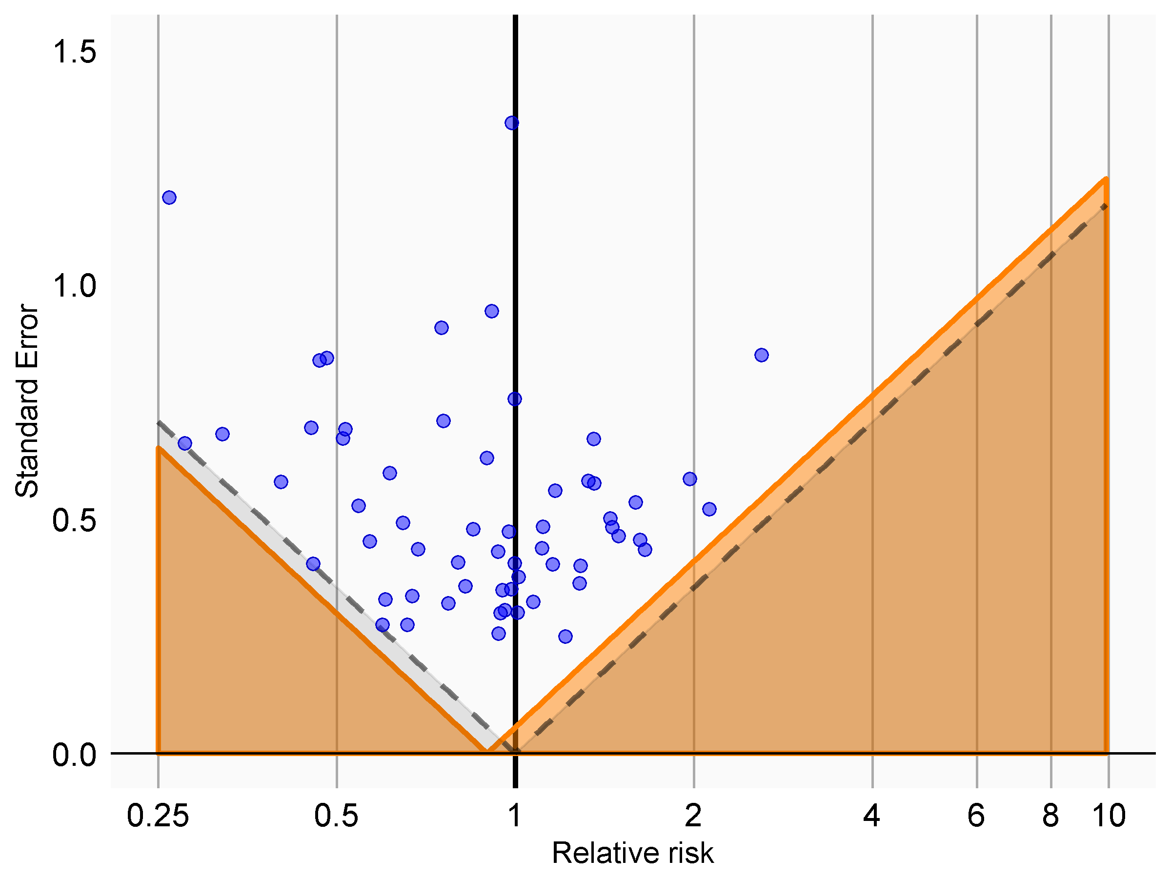

Figure 10 - OPTM Calibrated Effect Estimate plot

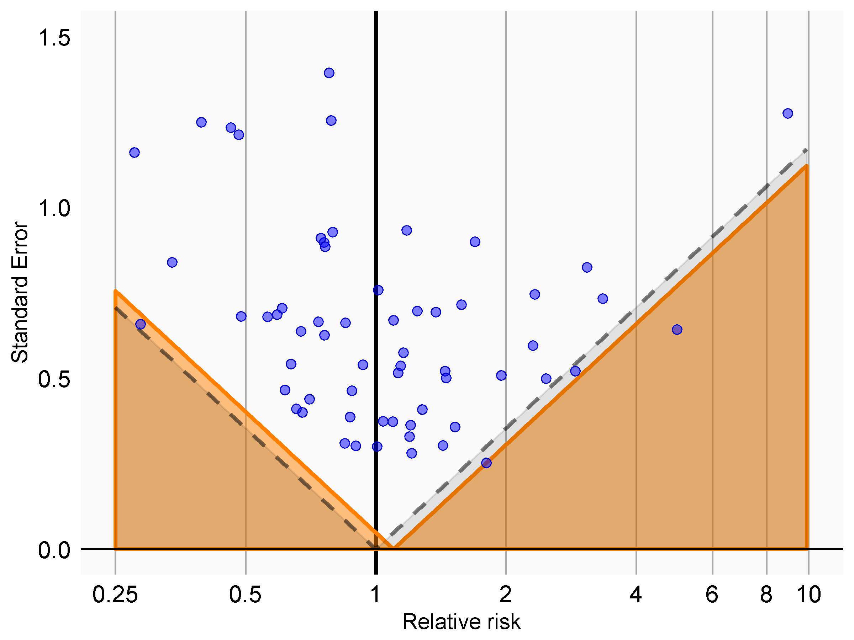

# Data Analysis Plan

## Calculation of time-at risk

The primary time-at-risk will be defined as the ‘on treatment’ period, defined as the time from 1 day after the cohort start date to 0 days from cohort end date, where cohort end date is defined as the persistent period of exposure, allowing for a 30-day gap between successive exposures. Cohort end date is defined exclusively by cessation of the index drug definition, and without respect to initiation of other treatments that may either reflect switching or augmentation.

## Model Specification

We will apply one time-at-risk definition:

1. Intent-to-treat, defined as the time from 1 day after the cohort start date to all days from cohort start date, which will be the end of the patient’s observation period for which the cohort start date occurred.

In this study, we compare the target cohort with the comparator cohort for the hazards of outcome during the time-at-risk by applying a Cox proportional hazards model.

The time-to-event of outcome among patients in the target and comparator cohorts is determined by calculating the number of days from the start of the time-at-risk window, 1 days from cohort start date, until the earliest event among 1) the first occurrence of the outcome, observed in inpatient setting before 0 days from cohort end date, 2) the end of the time-at-risk window, 0 days from cohort end date, and 3) the end of the observation period that spans the time-at-risk start.

Patients with the outcome, observed prior to target or comparator cohort entry are excluded from consideration.

Propensity scores will be used as an analytic strategy to reduce potential confounding due to imbalance between the target and comparator cohorts in baseline covariates. The propensity score is the probability of a patient being classified in the target cohort vs. the comparator cohort, given a set of observed covariates. In this study, the propensity score is estimated for each patient, using the predicted probability from a regularized logistic regression model, fit with a Laplace prior (LASSO) and the regularization hyperparameter selected by optimizing the likelihood in a 10-fold cross validation, using a starting variance of 0.01 and a tolerance of 2e-7. Covariates to be used in the propensity score model are listed in section 8.5.

All covariates that occur in fewer than 0.1% of the persons between the target and comparator cohorts combined will be excluded prior to model fitting for computational efficiency.

The target cohort and comparator cohorts will be stratified into five quantiles of the propensity score distribution. The final outcome model will apply a conditional Cox proportional hazard model, conditions on the propensity score strata.

## Output

Once the propensity score model is fit, we will plot the propensity score distribution of the target and comparator cohorts to evaluate the comparability of the two cohorts. The plot will be scaled to the preference score, normalizing for any imbalance in cohort size.

A plot showing the propensity score distributions for both cohorts after stratification will be provided, with each quantile cut point shown as a vertical line. Covariate balance will be evaluated by plotting the standardized mean difference of each covariate before propensity score stratification against the standardized mean difference for each covariate after propensity score stratification.

An attrition diagram will be provided to detail the loss of patients from the original target cohort and comparator cohort to the subpopulations that remain after all design considerations have been applied.

The final outcome model, a conditional Cox proportional hazards model, will be summarized by providing the hazards ratio and associated 95% confidence interval. The number of persons, amount of time-at-risk, and number of outcomes in each cohort will also be reported.

A Kaplan-Meier plot will be generated to characterize the contour of risk over time for the outcome of interest. Note, the Kaplan-Meier plot will be for the unadjusted cohorts, since adjusted analysis involves propensity score stratification.

## Evidence Evaluation

We will execute diagnostics to determine if the analysis can be appropriately conducted. The diagnostics will include:

* Propensity score distribution
* Covariate balance before and after propensity score matching
* Estimation for negative controls, to assess residual error
* Negative control outcomes will be used to evaluate the potential impact of residual systematic error in the study design, and to facilitate empirical calibration of the p-value and confidence interval for the exposures and outcome of interest.

Negative controls are listed in Appendix 14.2 and available as a conceptset here: <https://epi.jnj.com/atlas/#/conceptset/5435/details>

Negative controls are concepts known to not be associated with the target or comparator cohorts, such that we can assume the true relative risk between the two cohorts is 1. Negative controls are selected using a similar process to that outlined by Voss et al. [27]. Person counts of all potential drug-condition pairs are reviewed in observational data; this person count data helps determine which pairs are even probable for use in calibration. Given the list of potential drug-condition pairs, the concepts in the pairs must meet the following requirements to be considered as negative controls: (1) that there is Medline abstract where the MeSH terms suggest a negative association between the drug and the condition [28], (2) that there is no mention of the drug-condition pair on a US Product Label in the “Adverse Drug Reactions” or “Postmarketing” section [29], (3) there are no US spontaneous reports suggesting that the pair is in an adverse event relationship [30, 31], (4) that the OMOP Vocabulary does not suggest that the drug is indicated for the condition, (5) that the concepts are usable (i.e. not too broad, not suggestive of an adverse event relationship, not pregnancy related), and (6) the exact concept itself is utilized in patient level data (i.e. concepts that are not usually used within the data are usually indicative a broad concept that has a child that is more specific). The remaining concepts are “optimized”, meaning parent concepts remove children as defined by the OMOP Vocabulary (e.g. if both “Non-Hodgkin’s Lymphoma” and “B-Cell Lymphoma” we selected, child concept “B-Cell Lymphoma would be removed for its parent “Non-Hodgkin’s Lymphoma”). Once potential negative control candidates are selected, manual clinical review to exclude any pairs that may still be in a causal relationship or similar to the study outcome should be performed to select the top 50 concepts by patient exposure.

The candidate list was rank-ordered by prevalence and manually reviewed.

For each negative control outcome, a patient enters the negative control outcome cohort at the first occurrence of a diagnose code identified by the concepts listed above, or any one of its descendant codes.

Negative control exposures in the context of this study are pairs of exposures where neither exposure is believed to cause the outcome of heart valve disorder, and where therefore the true hazard ratio is equal to 1. Negative control outcomes in the context of this study are outcomes that are not believed to be caused by neither cabergoline or bromocriptine, and where therefore the true hazard ratio is equal to 1. We will execute the same analysis used for the primary hypothesis to produce hazard ratio estimates for the negative controls. The distribution of effect estimates across all negative controls will be used to fit an empirical null distribution which models the observed residual systematic error. The empirical null distribution will then be applied to the target exposures and outcome of interest to calibrate the p-value[32].

# Strengths and Limitations of the Research Methods

Strength

* Cohort studies allow direct estimation of incidence rates following exposure of interest, and the new-user design can capture early events following treatment exposures while avoiding confounding from previous treatment effects. New use allows for a clear exposure index date.
* PS matching and full outcome models allow balancing on a large number of baseline potential confounders.
* Use of negative control outcomes allow for evaluating the study design as a whole in terms of residual bias.

Limitations

* Even though many potential confounders will be included in this study, there may be residual bias due to unmeasured or misspecified confounders.

# Protection of Human Subjects

The study is using only de-identified data. Confidentiality of patient records will be maintained at all times. All study reports will contain aggregate data only and will not identify individual patients or physicians.

# Plans for Disseminating and Communicating Study Results

The study results will be posted on the OHDSI website after completion of the study. At least one paper describing the study and its results will be written and submitted for publication to a peer-reviewed scientific journal.

# Appendix 1

## Outcomes to exclude



## Negative controls



<https://epi.jnj.com/atlas/#/conceptset/5435/details>

# References

1. Casanueva, F.F., et al., *Guidelines of the Pituitary Society for the diagnosis and management of prolactinomas.* Clin Endocrinol (Oxf), 2006. **65**(2): p. 265-73.

2. Melmed, S., et al., *Diagnosis and treatment of hyperprolactinemia: an Endocrine Society clinical practice guideline.* J Clin Endocrinol Metab, 2011. **96**(2): p. 273-88.

3. Administration, F.a.D. *Withdrawal of Parkinson's treatment: pergolide*. 2007 1/10/2018]; Available from: https://[www.fda.gov/Drugs/DrugSafety/PostmarketDrugSafetyInformationforPatientsandProviders/ucm143341.htm](http://www.fda.gov/Drugs/DrugSafety/PostmarketDrugSafetyInformationforPatientsandProviders/ucm143341.htm).

4. De Vecchis, R., C. Esposito, and C. Ariano, *Cabergoline use and risk of fibrosis and insufficiency of cardiac valves. Meta-analysis of observational studies.* Herz, 2013. **38**(8): p. 868-80.

5. Molitch, M.E., *Diagnosis and Treatment of Pituitary Adenomas: A Review.* JAMA, 2017. **317**(5): p. 516-524.

6. Bogazzi, F., et al., *Treatment with low doses of cabergoline is not associated with increased prevalence of cardiac valve regurgitation in patients with hyperprolactinaemia.* Int J Clin Pract, 2008. **62**(12): p. 1864-9.

7. Boguszewski, C.L., et al., *A comparison of cabergoline and bromocriptine on the risk of valvular heart disease in patients with prolactinomas.* Pituitary, 2012. **15**(1): p. 44-9.

8. Colao, A., et al., *Increased prevalence of tricuspid regurgitation in patients with prolactinomas chronically treated with cabergoline.* J Clin Endocrinol Metab, 2008. **93**(10): p. 3777-84.

9. Cordoba-Soriano, J.G., et al., *Valvular heart disease in hyperprolactinemic patients treated with low doses of cabergoline.* Rev Esp Cardiol (Engl Ed), 2013. **66**(5): p. 410-2.

10. Delgado, V., et al., *Changes in heart valve structure and function in patients treated with dopamine agonists for prolactinomas, a 2-year follow-up study.* Clin Endocrinol (Oxf), 2012. **77**(1): p. 99-105.

11. Devin, J.K., et al., *Prevalence of valvular heart disease in a cohort of patients taking cabergoline for management of hyperprolactinemia.* Endocr Pract, 2008. **14**(6): p. 672-7.

12. Elenkova, A., et al., *Increased prevalence of subclinical cardiac valve fibrosis in patients with prolactinomas on long-term bromocriptine and cabergoline treatment.* Eur J Endocrinol, 2012. **167**(1): p. 17-25.

13. Halperin, I., et al., *No clinically significant valvular regurgitation in long-term cabergoline treatment for prolactinoma.* Clin Endocrinol (Oxf), 2012. **77**(2): p. 275-80.

14. Herring, N., et al., *Valvular heart disease and the use of cabergoline for the treatment of prolactinoma.* Clin Endocrinol (Oxf), 2009. **70**(1): p. 104-8.

15. Kars, M., et al., *Aortic valve calcification and mild tricuspid regurgitation but no clinical heart disease after 8 years of dopamine agonist therapy for prolactinoma.* J Clin Endocrinol Metab, 2008. **93**(9): p. 3348-56.

16. Lancellotti, P., et al., *Cabergoline and the risk of valvular lesions in endocrine disease.* Eur J Endocrinol, 2008. **159**(1): p. 1-5.

17. Nachtigall, L.B., et al., *Gender effects on cardiac valvular function in hyperprolactinaemic patients receiving cabergoline: a retrospective study.* Clin Endocrinol (Oxf), 2010. **72**(1): p. 53-8.

18. Tan, T., et al., *Assessment of cardiac valve dysfunction in patients receiving cabergoline treatment for hyperprolactinaemia.* Clin Endocrinol (Oxf), 2010. **73**(3): p. 369-74.

19. Vallette, S., et al., *Long-term cabergoline therapy is not associated with valvular heart disease in patients with prolactinomas.* Pituitary, 2009. **12**(3): p. 153-7.

20. Wakil, A., et al., *Low dose cabergoline for hyperprolactinaemia is not associated with clinically significant valvular heart disease.* Eur J Endocrinol, 2008. **159**(4): p. R11-4.

21. Drake, W.M., et al., *A Follow-Up Study of the Prevalence of Valvular Heart Abnormalities in Hyperprolactinemic Patients Treated With Cabergoline.* J Clin Endocrinol Metab, 2016. **101**(11): p. 4189-4194.

22. Auriemma, R.S., et al., *Safety of long-term treatment with cabergoline on cardiac valve disease in patients with prolactinomas.* Eur J Endocrinol, 2013. **169**(3): p. 359-66.

23. Vroonen, L., et al., *Prospective, long-term study of the effect of cabergoline on valvular status in patients with prolactinoma and idiopathic hyperprolactinemia.* Endocrine, 2017. **55**(1): p. 239-245.

24. Trifiro, G., et al., *Risk of cardiac valve regurgitation with dopamine agonist use in Parkinson's disease and hyperprolactinaemia: a multi-country, nested case-control study.* Drug Saf, 2012. **35**(2): p. 159-71.

25. Nishimura, R.A., et al., *2014 AHA/ACC guideline for the management of patients with valvular heart disease: a report of the American College of Cardiology/American Heart Association Task Force on Practice Guidelines.* J Thorac Cardiovasc Surg, 2014. **148**(1): p. e1-e132.

26. Austin, P.C., *Assessing balance in measured baseline covariates when using many-to-one matching on the propensity-score.* Pharmacoepidemiol Drug Saf, 2008. **17**(12): p. 1218-25.

27. Voss, E.A., et al., *Accuracy of an automated knowledge base for identifying drug adverse reactions.* J Biomed Inform, 2017. **66**: p. 72-81.

28. Winnenburg, R., et al., *Leveraging MEDLINE indexing for pharmacovigilance - Inherent limitations and mitigation strategies.* J Biomed Inform, 2015. **57**: p. 425-35.

29. Duke, J., J. Friedlin, and X. Li, *Consistency in the safety labeling of bioequivalent medications.* Pharmacoepidemiol Drug Saf, 2013. **22**(3): p. 294-301.

30. Evans, S.J., P.C. Waller, and S. Davis, *Use of proportional reporting ratios (PRRs) for signal generation from spontaneous adverse drug reaction reports.* Pharmacoepidemiol Drug Saf, 2001. **10**(6): p. 483-6.

31. Banda, J.M., et al., *A curated and standardized adverse drug event resource to accelerate drug safety research.* Sci Data, 2016. **3**: p. 160026.

32. Schuemie, M.J., et al., *Interpreting observational studies: why empirical calibration is needed to correct p-values.* Stat Med, 2014. **33**(2): p. 209-18.