Alendronate vs Raloxifen study

Table of Contents

# Introduction

This reports describes the results from a comparative effectiveness study comparing new users of alendronate to new users of raloxifen Propensity scores were generated using large scale regression, and stratification and trimming on propensity scores was performed. Effect sizes were estimated using a univariate Cox regression, conditioned on the matched sets. A set of negative control outcomes was included to estimate residual bias and calibrate p-values.

## Population characteristics

Key characteristics of the study population, stratified by treatment group.

|  |  |  |
| --- | --- | --- |
| Group | Number in treated (%) | Number in comparator (%) |
| Age group: 45-49 | 297 (6) | 27 (6.3) |
| Age group: 50-54 | 722 (14.5) | 65 (15.1) |
| Age group: 55-59 | 948 (19) | 79 (18.3) |
| Age group: 60-64 | 1,066 (21.4) | 80 (18.6) |
| Age group: 65-69 | 629 (12.6) | 44 (10.2) |
| Age group: 70-74 | 459 (9.2) | 53 (12.3) |
| Age group: 75-79 | 356 (7.2) | 25 (5.8) |
| Age group: 80-84 | 297 (6) | 31 (7.2) |
| Age group: 85-89 | 193 (3.9) | 25 (5.8) |
| FEMALE | NA (100) | NA (100) |
| 2007 | 1,044 (21) | 127 (29.5) |
| 2008 | 829 (16.7) | 98 (22.7) |
| 2009 | 1,141 (22.9) | 93 (21.6) |
| 2010 | 1,199 (24.1) | 75 (17.4) |
| 2011 | 707 (14.2) | 35 (8.1) |

## Analysis variations

In total, 1 analyses variation was executed:

1. Sisyphus challenge: Comparative effectiveness of alendronate vs. raloxifene in patients with osteoporosis for the risk of hip fracture

# Model diagnostics

## Propensity score distribution

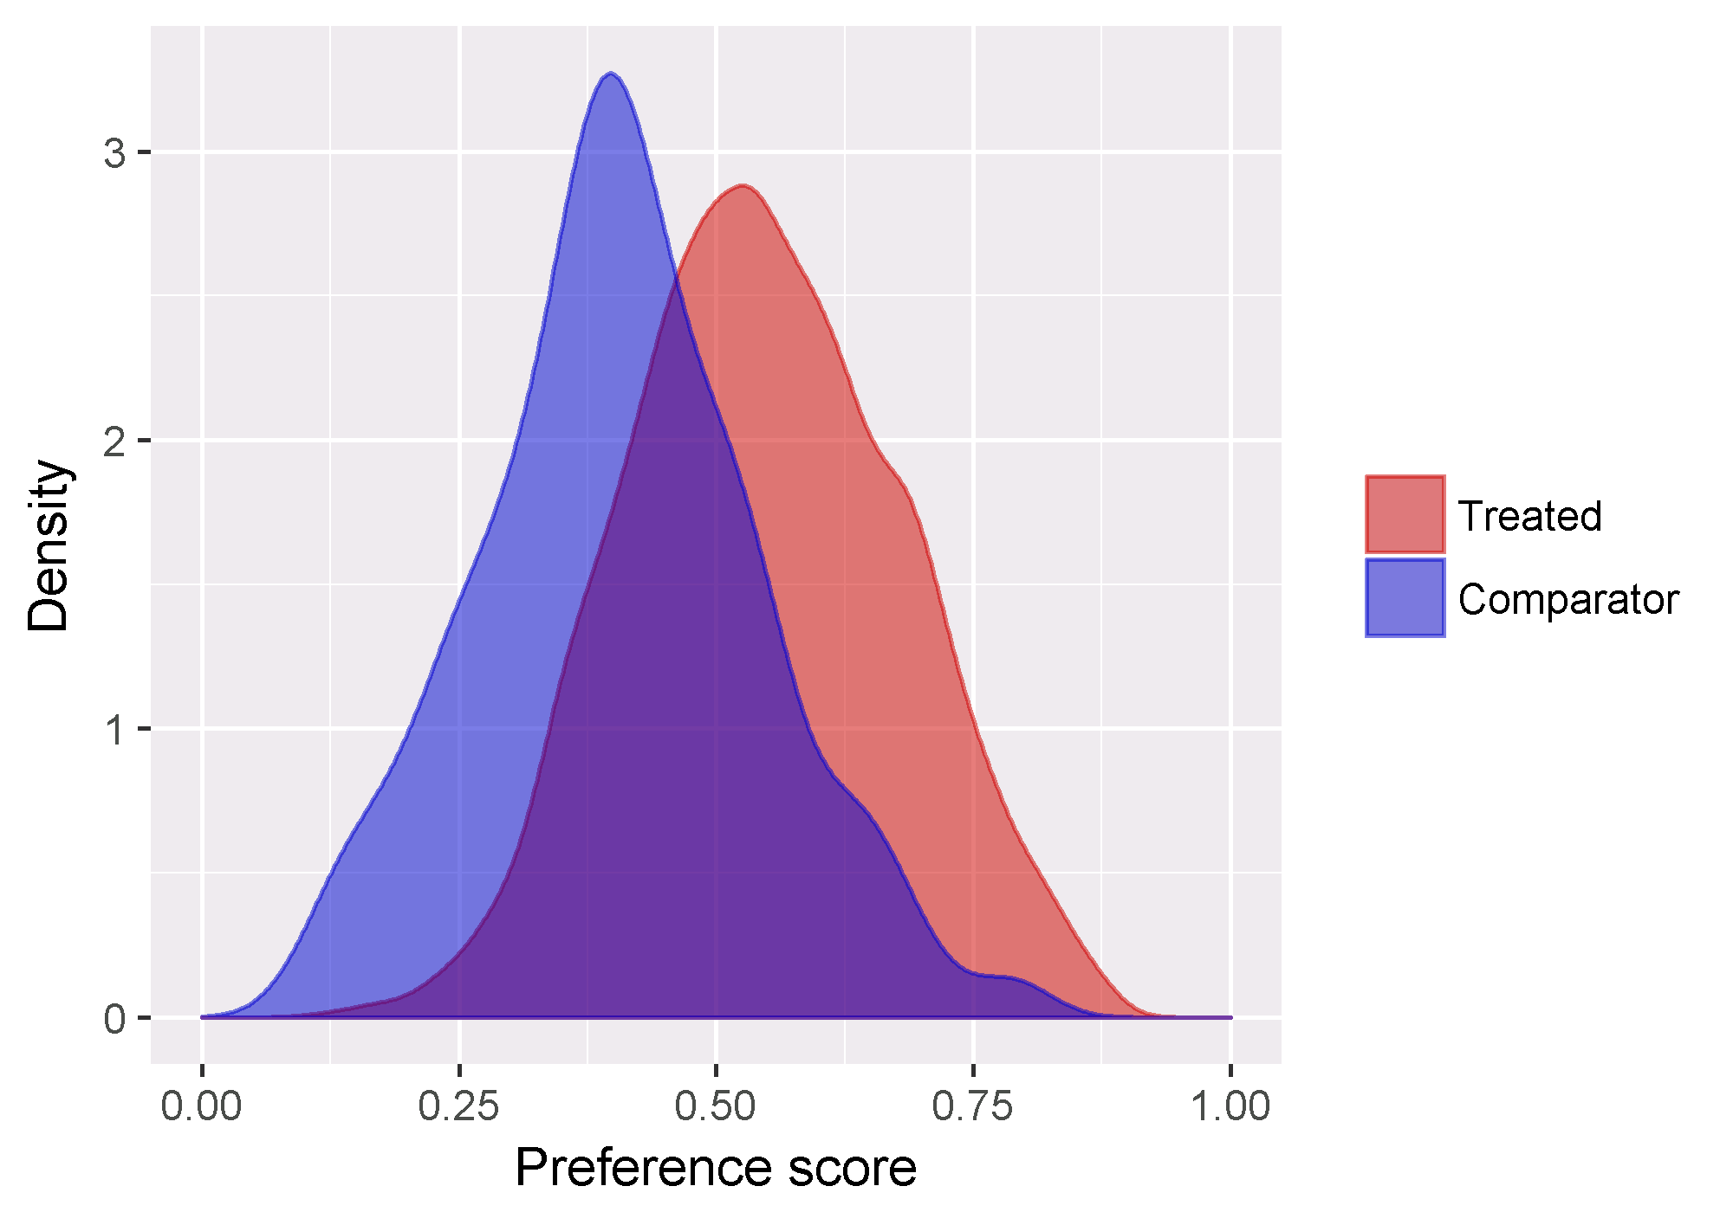

Propensity score distribution plot. This plot shows the propensity score distribution using the preference score scale.

## Covariate balance

### After stratification

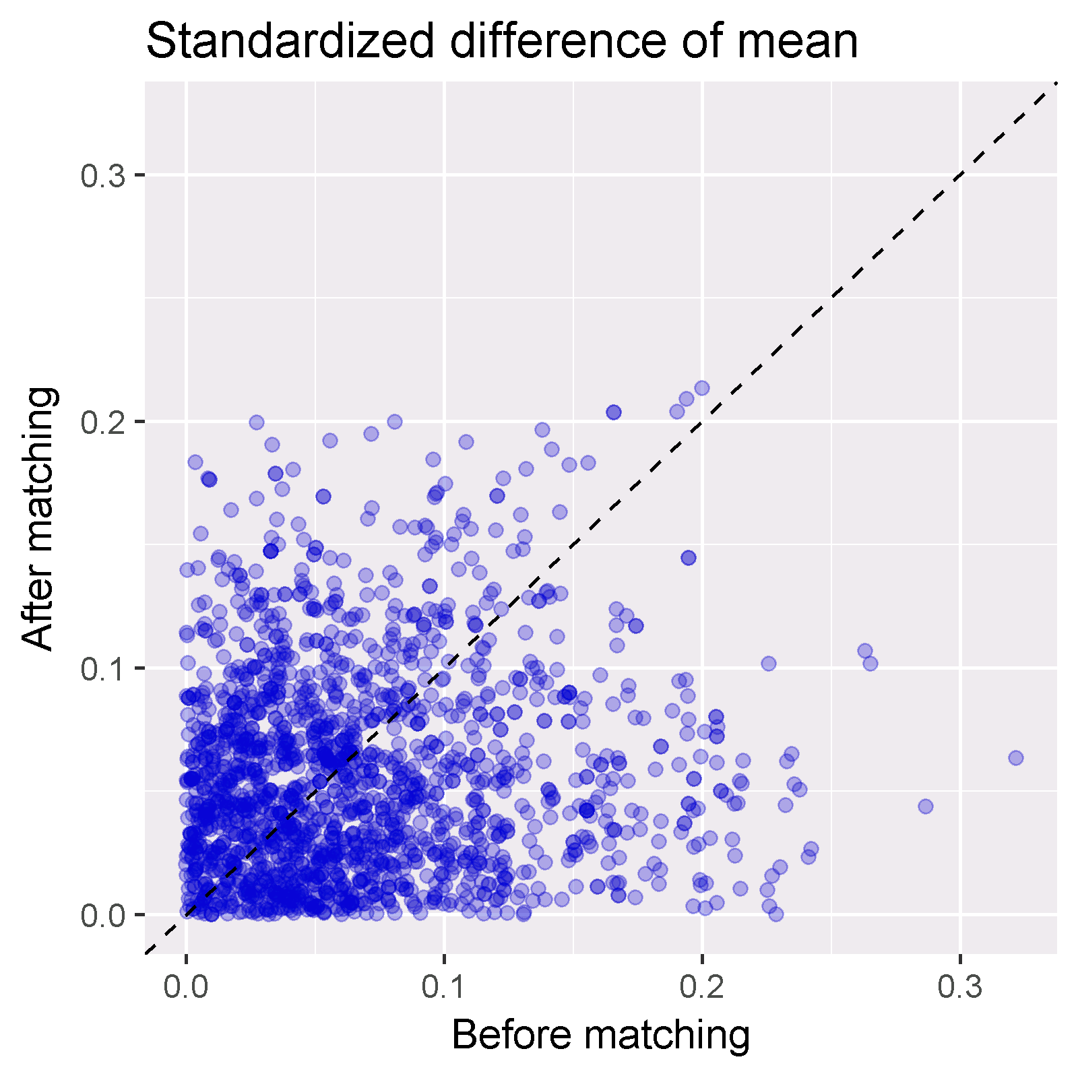

Balance scatter plot. This plot shows the standardized difference before and after matching for all covariates used in the propensity score model.

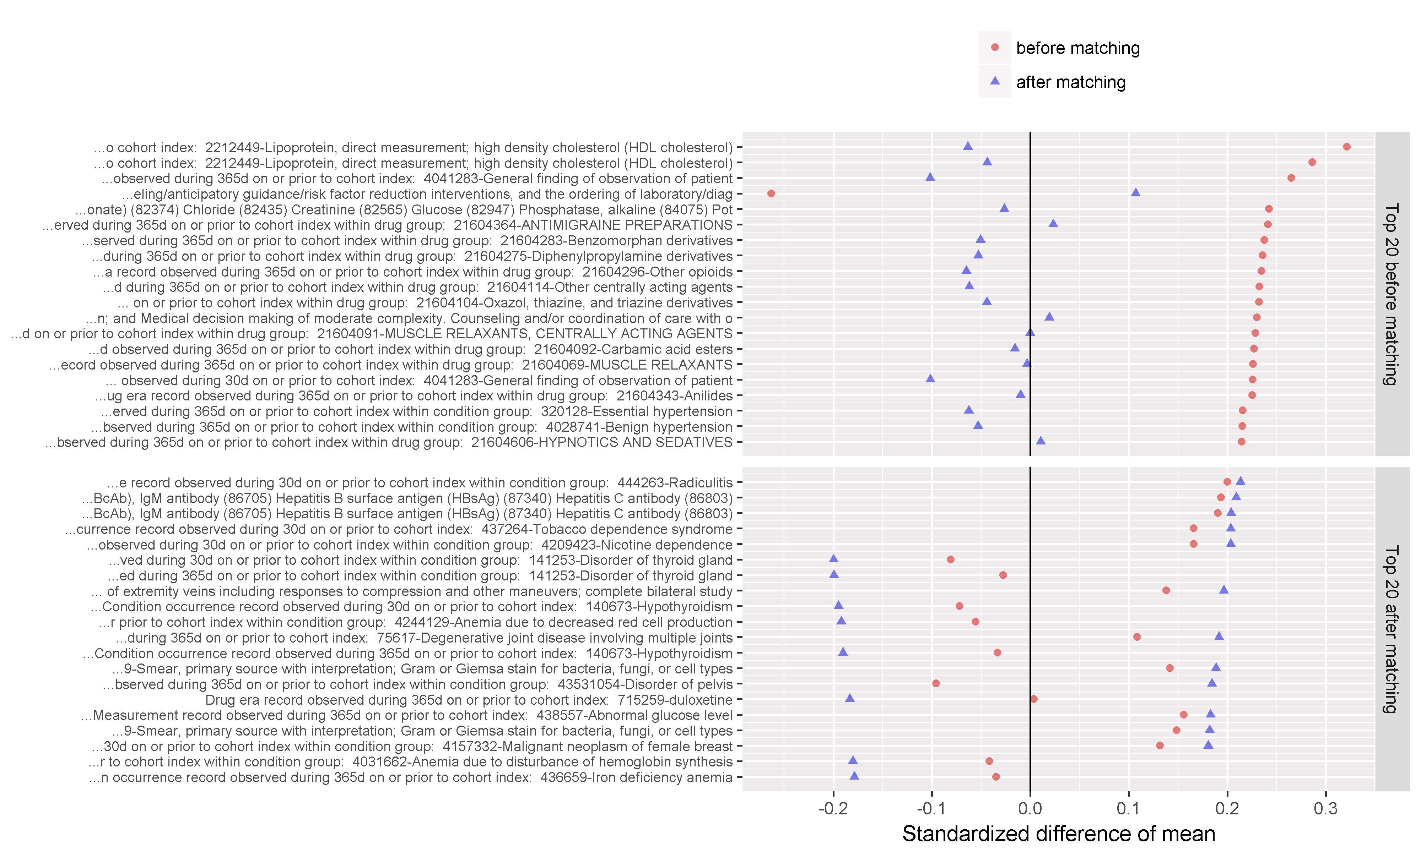

Balance plot for top covariates. This plot shows the standardized difference before and after stratification for those covariates with the largest difference before matching (top) and after matching (bottom). A negative difference means the value in the treated group was lower than in the comparator group.

## Empirical calibration

### Analysis 1: Sisyphus challenge: Comparative effectiveness of alendronate vs. raloxifene in patients with osteoporosis for the risk of hip fracture

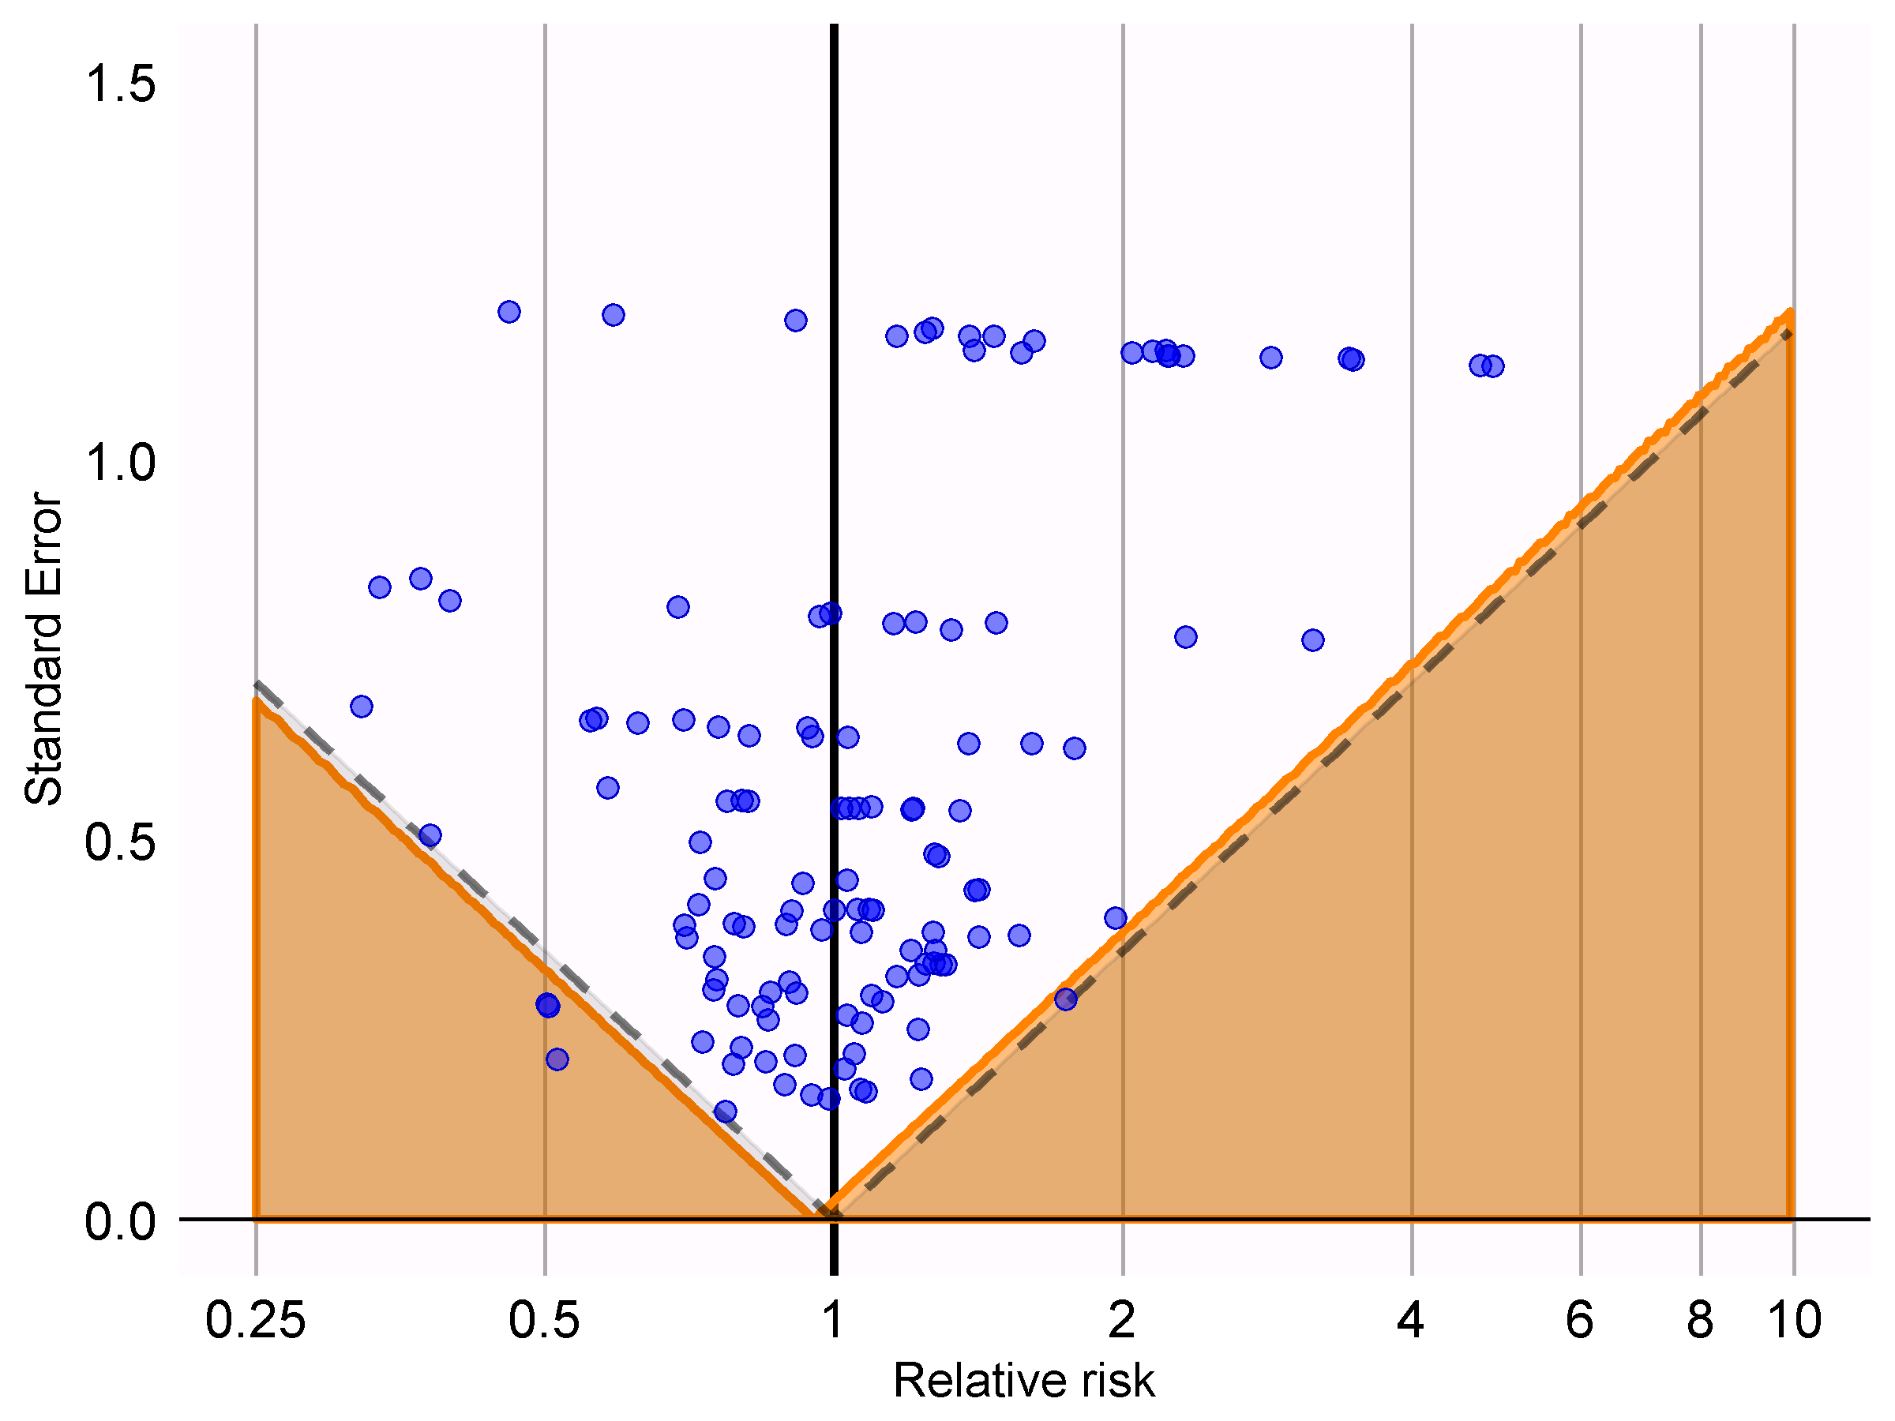

Calibration effect plot. Blue dots represent the negative controls used in this study. The dashed line indicates the boundary below which p < 0.05 using traditional p-value computation. The orange area indicated the area where p < 0.05 using calibrated p-value computation.

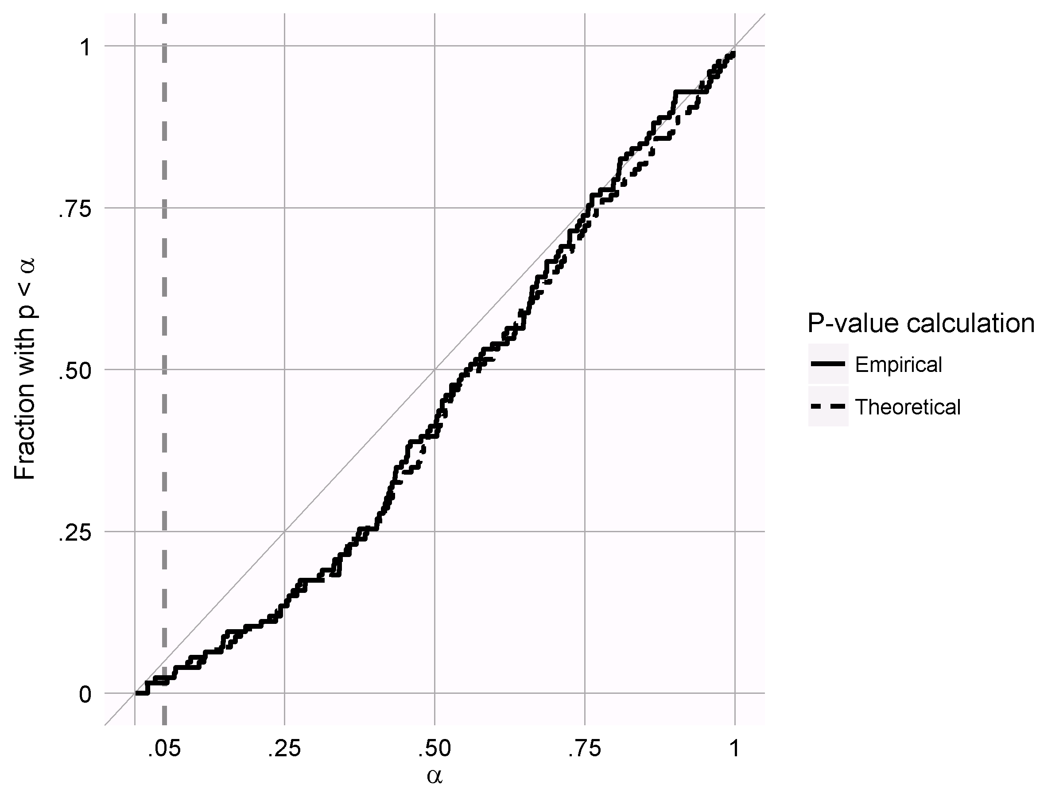 # Attrition

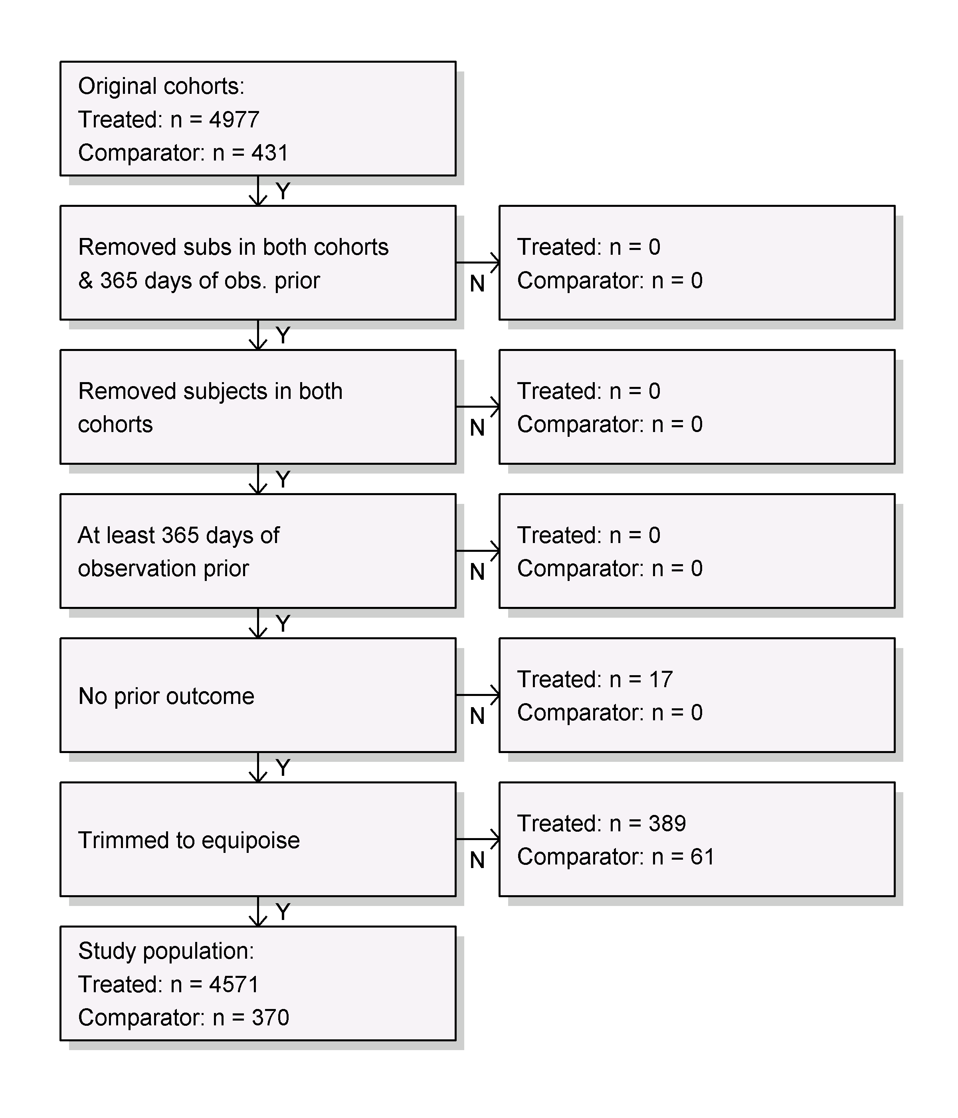

Attrition diagram when using 1-on-1 matching on propensity scores. Original cohorts are the treatment and comparator cohorts as defined in CIRCE.

# Main results

1. Sisyphus challenge: Comparative effectiveness of alendronate vs. raloxifene in patients with osteoporosis for the risk of hip fracture

Counts of subjects and events for the treated and comparator groups.

|  |  |  |  |  |
| --- | --- | --- | --- | --- |
| Analysis ID | # treated | # comparator | # treated with event | # comparator with event |
| 1 | 4,571 | 370 | 209 | 19 |

Harard ratios for angioedema in the levetiracetam group compared to the phenytoin group. Also included are traditional and calibrated p-values, as well as the 95% credible interval for the calibrated p-value.

|  |  |  |  |  |  |  |  |
| --- | --- | --- | --- | --- | --- | --- | --- |
| Analysis ID | Hazard Ratio | 95% CI LB | 95% CI UB | P | Calibrated P | Cal. P 95% CI LB | Cal. P 95% CI UB |
| 1 | 0.99 | 0.63 | 1.66 | 0.98 | 0.87 | 0.68 | 0.99 |

## Kaplan-Meier plots

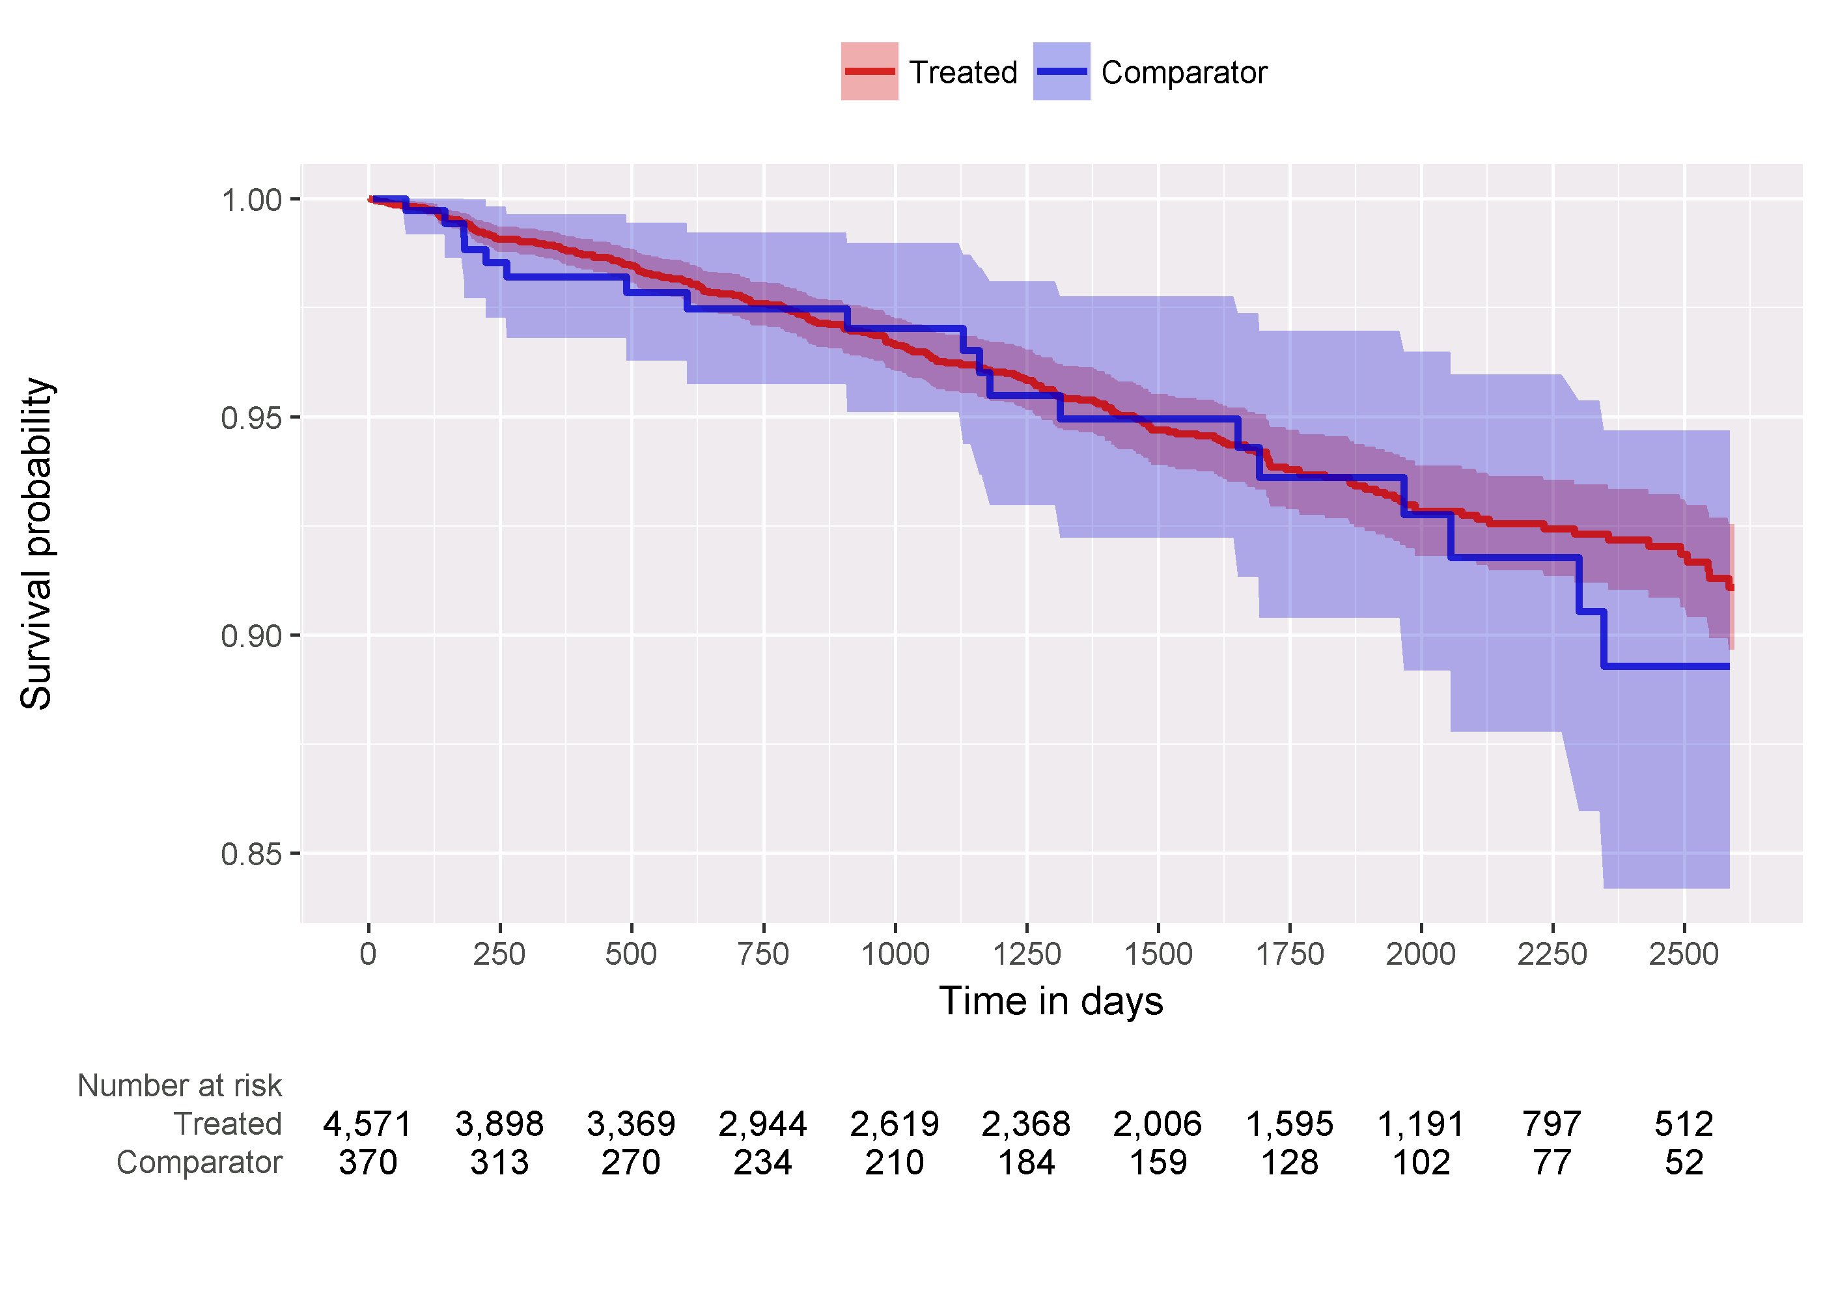

Kaplan-Meier plot. Shaded areas indicate the 95% confidence interval. Note that this plot does not take into account stratification, as done when fitting the Cox model.