REVISION HISTORY
REV | ECO
SW Programming Requirements (SPR)
CONTRACT NO. |  |  |  |  |  |  | Elbit Systems Ltd
ACTN |  | NAME |  | SIGNATURE | DATE | Advanced Technology Center
 |  |  |  |  |  | P.O.B. 539, Haifa 31053, Israel
PREP |  | Irit Pernat |  |  | 6/2015 | Title :
SEPG Manager |  | Sigalit Croitoru |  |  |  | SW Programming Requirements (PR)
SW Manager
SQA |  |  |  |  |  | SIZE |  | CAGE CODE |  | NO.
 |  |  |  |  |  | A |  | 2288A
 |  |  |  |  |  | SCALE NONE |  |  |  |  |  |  | SHEET 1 of 12

THIS DOCUMENT AND ITS CONTENT BELONGS TO ELBIT SYSTEMS LTD. AND CONTAINS ELBIT PROPRIETARY INFORMATION.
THIS DOCUMENT AND THE INFORMATION CONTAINED IN IT OR ANY PART THEREOF MAY NOT BE COPIED IN ANY WAY AND MAY NOT BE USED IN WHOLE OR PARTS THEREOF IN ANY WAY WITHOUT THE WRITTEN CONSENT OF ELBIT SYSTEMS LTD.
© 2015 by Elbit Systems Ltd.

SW Programming Requirements

FOR THE

[SRU Name] SRU

CDRL SEQUENCE NO. [CDRL number]

Prepared for:
[Contracting Agency Name, department code]

Prepared by:
[contractor name and address]

TABLE OF CONTENTS

1. Scope 4
2. Programming files Table 4
3. Programming Equipment and Set-Up 4
4. Programming Instruction 5
5. APPENDIX A - Programming with ICT or JTAG 6
6. APPENDIX B - Programming with Generic Loader 10
7. APPENDIX C - Programming with [Engineering Programming Tool] 12

Remove the first page of this document (the page with the template header and revision). This page will be added automatically by PLM

Scope
This SW PR describes the necessary files, means and procedures required to program the SRU with the SW files mentioned below.

Programming files Table

TABLE I.  LOADING SEQUENCE |  |  |  |  | TABLE II.  VDD REFERENCE
NOTE: The SEQ No. is the order of loading the programs!
SEQ | Programming Tool  [JTAG/ICT/ICE/G.L. /Data IO…] | FILE NAME | CHECKSUM  [from Generic Loader] |  | VDD Number
1
2
3
4
5
6

Programming Equipment and Set-Up

The programming equipment and set-up required to perform the programming process are described in the internal work procedures of the production team. See also relevant TPS and Test Procedure VDD.

Programming Instruction

The programming activities shall be performed according to the sequence in Table 1 above.
Specific instructions and parameters for each tool are given in the following appendices.
[If you have more relevant information, write it here]

APPENDIX A - Programming with ICT or JTAG
[If relevant fill this appendix, otherwise- write NA]

The Programming Instructions, when using the ICT / JTAG Device are part of the Production department internal work procedures:
# | Work Procedure Name | Work Procedure ID | Version / Date
 | Conversion of HEX Files to BIN Format- For ICT | 001751D-00 | Revision 01, June 07
 | Conversion of HEX Files to BIN Format- For JTAG | 001750D-00 | Revision 01, June 07

This appendix describes only the necessary parameters, in additions to tables I and II in this PR.

Parameters for ICT / JTAG:
[Fill the following parameters; you may need to get the information from the HW team. See explanation about these parameters in the following pages]

TABLE III. LOADING SEQUENCE for ICT and OFFSET PARAMETERS
Address (Hex file) Offset in FlashBig EndiansFLASH Array Data BusSeq
(Yes / No)
Width
File NameDES REF  (U1, U2,U4...) |  |  |  |  | Start |  | End
2
3
4
5

[Since the HEX file contains addresses for the data, a mapping between these addresses and the beginning of the physical flash is required. The Address range is the address in the HEX file, the Offset in Flash is where to put the data in that range in the flash (the first address in the flash is 0x0000)
See the example below for Flash Array Data Bus Width].

Example:

TABLE III. LOADING SEQUENCE for ICT and OFFSET PARAMETERS
Seq | DES REF  (U1, U2,U4...) | File Name | FLASH Array Data Bus  Width | Big Endians  (Yes / No) | Address (Hex file) |  | Offset in Flash
 |  |  |  |  | Start | End | Offset in Flash
1 | U4 |  | 8 | No | 0x12348010 | 0x1235000 | 0

Little-Endian
Assuming this is the HEX file:
:020000041234B4
:108010687400652068696768207365676D656E744C

The first byte in the flash will contain 0x68
The second byte in the flash will contain 0x74 and so on…

Big-Endian
Assuming this is the HEX file:
:020000041234B4
:108010687400652068696768207365676D656E744C

The first byte in the flash will contain 0x65
The second byte in the flash will contain 0x00
The 3rd: 0x74
The 4th: 0x68
The 5th: 0x67 and so on...

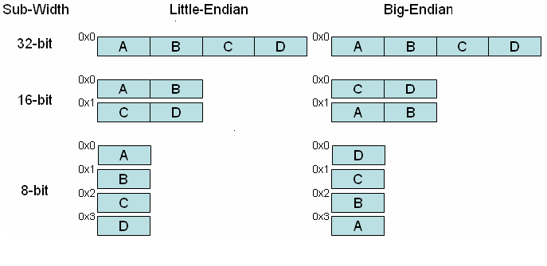
The picture above shows how data are ordered for a 32-bit register, in both little-endian and big-endian representation layout, for 32-bit, 16-bit and 8-bit sub-widths. Byte order within containers, and bit order within bytes is not significant.

FLASH Array Data Bus Width logics: For some systems, the CPU data bus is wider than the Flash it read from. In the example below, the CPU has 16bit data bus but each flash device has only 8bit data bus (the CPU and both flash devices share the same address bus. Since the ICT replaces the CPU, it has to know how to break the file into both flash devices. The bus width in the example below shall be 8 since it is bus width of each programmed device (the CPU bus width, 16 in the example bellow, is irrelevant).
D0
D0

CPU
D1
D1
D2
D2
D3
D3
D4
D4
D5
D5
D6
D6
D7
D7
Flash Low
D0
D8
D1
D9
D2
D10
D3
D11
D4
D12
D5
D13
D6
D14
D7
D15
Flash High

APPENDIX B - Programming with Generic Loader
[If relevant fill this appendix, otherwise- write NA]
- Install generic loader. See VDD 741bxx-xx for installation instructions. [xx-xx should be replaced by the relevant version]
- Replace the config.db in the installation directory (usually C:\Program Files\Generic Loader) with the one released with this PR.
- Setup the target system according to the following steps:
  - [Fill required setup such as muxbus cable connections, mode discretes setup, reset, powering up etc. At the end of the setup the target system shall be ready to interface the generic loader]
- Run the generic loader by clicking Start->Programs->Generic->Loader
- When prompted for password, click cancel
- Select the configuration for the first file in Table IV by clicking the left and right arrows buttons in the left pane of the generic loader screen
- Click ‘Get File’ and select the file to be programmed
- Verify that the checksum matches the one in Table I
- Click ‘Start’
- After programming is completed successfully: [write additional setups such as resetting the target before programming the next file]
- Repeat steps [complete steps number] for each file.

TABLE IV. Data for Generic Loader Files
Seq | Media [Muxbus/Ethernet/Serial] | File | Configuration
1 | [Serial] | [Defoe_appl_0107.hex] | [DEFOE]
2
3

[Remove the following image before release:]

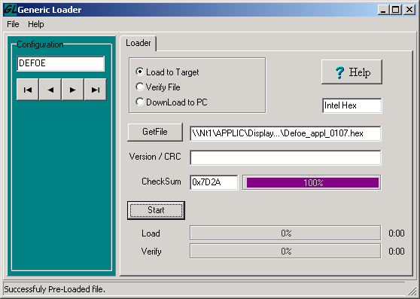

APPENDIX C - Programming with [Engineering Programming Tool]
[If the Programming is performed using another tool- describe here the Programming instructions and sequence, otherwise- write NA]

