

**Embedded Systems Project Documentation**

**Project Title**

**Anti-Theft Monitoring Device**

**Project Simulation**

[**https://wokwi.com/projects/351687292823274072**](https://wokwi.com/projects/351687292823274072)

**Team Members**

**Ahmed Kamal Aboelwafa Ahmed**

**Mohamed Hassan Mohamed Ali**

**Mohamed Abdul-Fattah Oraby**

**Abdul-Rahman Ahmed Fahmy**

**Aim Of Project**

The goal of the project is protection from thieves, where the device monitors the area surrounding the door and monitors it using the appropriate sensor for that. When it finds an object close to the door at a certain distance, it sounds an alarm accompanied by warning lights, indicating that there is a danger or a thief nearby, and the purpose of that is to provide protection and continuous monitoring For places and interests that require continuous monitoring throughout the day with the lack of people doing that task or to Decrease employment, as many of them will be dispensed with using this device.

**Used Components**

**1-Microcontroller:-Arduino-UNO**

A microcontroller is a small computer on a single integrated circuit containing a processor core, memory, and programmable input/output peripherals.

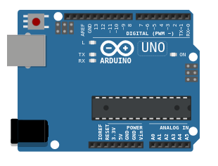The one we used is Arduino Uno.

Arduino is a single-board microcontroller designed to make the process of using electronics

in multidisciplinary projects more accessible.

The hardware consists of a simple open source

hardware board designed around an 8-bit Atmel AVR microcontroller. An Arduino board consists of an Atmel 8-bit AVR microcontroller with complementary components to facilitate programming and incorporation into other circuits. An important aspect of the Arduino is the standard way that connectors are exposed, allowing the CPU board to be connected to a variety of interchangeable add-on modules known as shields. The software consists of a standard programming language compiler and a boot loader that executes on the microcontroller.

**2-HC-SR04 Ultrasonic Distance Sensor**

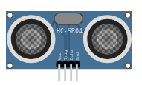An HC-SR04 ultrasonic distance sensor actually consists of two [ultrasonic transducers](https://en.wikipedia.org/wiki/Ultrasonic_transducer).

One acts as a transmitter that converts the electrical signal into 40 KHz ultrasonic sound pulses. The other acts as a receiver and listens for the transmitted pulses.

When the receiver receives these pulses, it produces an output pulse whose width is proportional to the distance of the object in front.

This sensor provides excellent non-contact range detection between 2 cm to 400 cm (~13 feet) with an accuracy of 3 mm. Since it operates on 5 volts, it can be connected directly to an Arduino or any other 5V logic microcontroller.

**3-lcd2004**

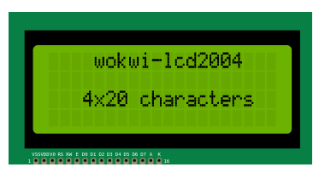An LCD with 2 lines, 16 characters per line.

The LCD1602 comes in 2 possible configurations: I2C configuration and standard configuration. The I2C configuration is usually simpler to use.

Controlling the backlight requires another I/O pin.

You can select the desired configuration by setting the pins attribute. Set it to "i2c" for the I2C configuration, or "full" for the standard configuration (the default).

The I2C configuration simulates a PCF8574T chip that controls the LCD module. Normally, you wouldn't have to worry about this as the LiquidCrystal_I2C library takes care of the communication with the chip.

**4-Piezoelectric Buzzer**

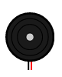A buzzer or beeper is an [audio](https://en.wikipedia.org/wiki/Sound) signaling device, which may be [mechanical](https://en.wikipedia.org/wiki/Machine), [electromechanical](https://en.wikipedia.org/wiki/Electromechanics), or [piezoelectric](https://en.wikipedia.org/wiki/Piezoelectricity) (piezo for short). Typical uses of buzzers and beepers include [alarm devices](https://en.wikipedia.org/wiki/Alarm_devices), [timers](https://en.wikipedia.org/wiki/Timer), [train](https://en.wikipedia.org/wiki/Train) and confirmation of user input such as a mouse click or keystroke.

The buzzer can operate in two modes: "smooth" (the default) and "accurate".

"smooth" sounds better and is suitable for simple, single-frequency tones. Use it when playing a melody or playing tones with Arduino's tone() function. Complex and polyphonic sounds may not play correctly (or not play at all) in "smooth mode"

Use the "accurate" mode when you need to play complex sounds. It will accurately play the sound you feed in. However, it'll add audible click noises to your sound. These noises are due to fluctuations in the simulation speed - it's not always able to provide the complete sound buffer in real time.

**5-Standard 5mm LED**

A Super Bright 5mm LED is exceptionally bright with a wide beam angle, so they’re suitable for use in your projects, illuminations, headlamps, spotlights, car lighting, and models. The 5mm LED can be used anywhere where you need low power, high-intensity reliable light, or indication. They go quickly into a breadboard and will add that extra zing to your project.

The 5mm T1 3/4 LED is the most common size of LED available.

**6-12mm Tactile Switch Button**

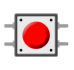

The push button has two set of pins (contacts), 1 and 2. When the push button is pressed, it connects these two contacts, thus closing an electrical circuit.

Each contact has a pin of the left side of the push button, and another pin on the right side of the push button. So pin 1.l is the left pin for first contact, and 1.r is the right pin for the first contact. Since both belong to the same contact, they are always connected, even when the button is not pressed.

When working with Arduino, you'd usually connect one contact (e.g. 1.r or 1.l) to a digital pin and configure that pin as INPUT_PULLUP, and the other contact (e.g. 2.r or 2.l) to the ground. The digital pin will read LOW when you press the button, and HIGH when the button is not pressed.

**Connections**

| **UltraSonic Sensor** | **Arduino UNO** |
| --- | --- |
| GND | GND2 |
| Echo Pin | Pin13 |
| Trig Pin | Pin 12 |
| Vcc | 5v Pin |
| **LEDS** | **Arduino UNO** |
| Led 1:A | Pin 2 |
| Led 1:C | GND |
| Led 2:A | Pin 2 |
| Led 2:C | GND |
| Led 3:A | Pin 8 |
| Led 3:C | GND |
| Led 4:A | Pin 8 |
| Led 4:C | GND |
| **Buzzers** | **Arduino UNO** |
| Bz 1:1 | GND |
| Bz 1:2 | ~10 |
| Bz 2:1 | GND |
| Bz 2:2 | ~9 |
| Bz 3:1 | GND |
| Bz 3:2 | ~9 |
| **LCD** | **Arduino UNO** |
| GND | GND |
| VCC | 5V |
| SDA | A4 |
| SCL | A5 |
| **Button** | **Arduino UNO** |
| 1:1.r | GND |
| 1:2.1 | Pin 7 |

**Use Case Scenario**

First, we connect an electric current source to the device, and then we turn on the Ultrasonic distance sensor which consists of two ultrasonic transducers.

One acts as a transmitter that converts the electrical signal into 40 KHz ultrasonic sound pulses. The other acts as a receiver and listens for the transmitted pulses.

When the receiver receives these pulses, it produces an output pulse whose width is proportional to the distance of the object in front.

From the previous procedures we can get the distance that the body is away from the door. If this distance is less than 200 cm, the sensor sends an alarm to the board, and then the board sounds the alarm and turns on warning lights

All this is done in a narrow range in the space surrounding the door, so I added other alarm devices at different distances from the door, as well as a button to control it.

If someone presses this button, the board triggers the remote alarms and does not turn off until the button is pressed again.

**Use Case Diagram**

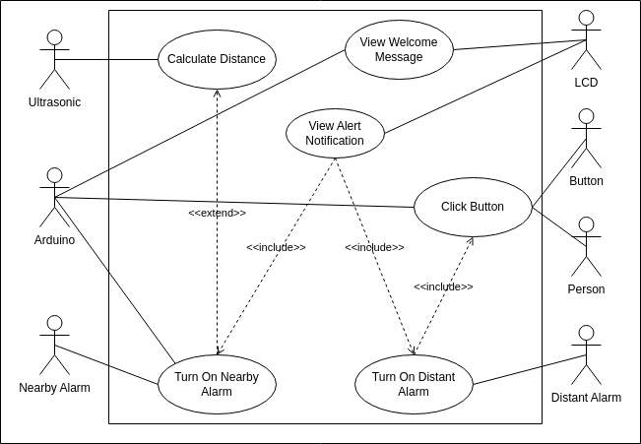

**Flowchart Diagram**

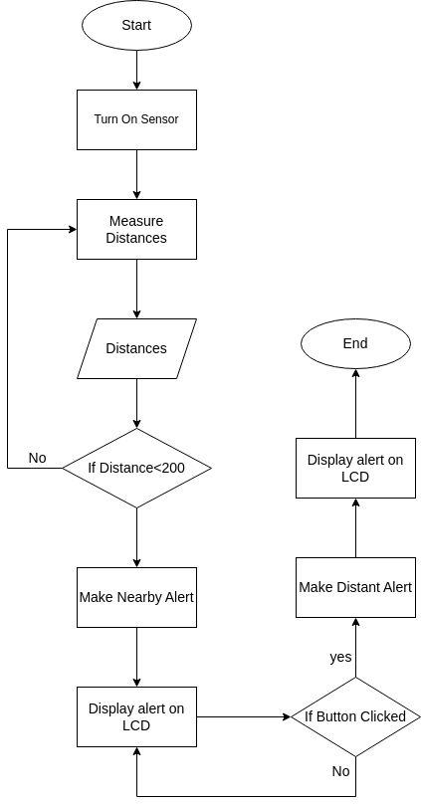

**Sequence Diagram**

