

**Project Documentation**

**Project**

**Handcraft Online Store**

**Website URL:**

**https://dev-fciproject.pantheonsite.io/**

**Team members**

**Ahmed Kamal AboElwafa Ahmed**

**Mohamed Hassan Mohamed Ali**

**Mohamed Abdul-Fattah Oraby**

**Abdul_Rahman Ahmed Fahmy**

**Abstract**

Handcraft online store is website that have all types of handmade clothes, accessoires, decorations and furnitures. This website present a service for people to browse the things they need and order it by one click. Then it is our round to provide their order by sending the order details to the vendor who is also have an account on the web site like the visitor, we send these details to the vendor’s mail; these mail contain the order details and the user comunicaton number and name. Then the vendor send the order to the delivery company, then the delivery company send the order to the buyer and receive the cash on deliver and send it to us.

**SWOT Analysis**

**1-Strengths**

**Accessibility**

Perhaps the biggest Strength of eCommerce businesses is their extensive accessibility. In the past, shopping meant physically traveling to a certain place, within certain times. With eCommerce, buyers can now browse, learn about, and purchase products from the comfort of their homes, at whatever time of the day (or night). Although teleshopping offers similar benefits, the advent of the internet has seen a huge number of consumers move away from TV, radio, and press towards computers.

**Lower Prices**

Another considerable Strength of online shopping is that products tend to have lower prices, when compared to traditional retail channels. One reason for this is that eCommerce typically involves sellers interacting directly with consumers, cutting out middlemen such as distributors. Another reason is that the eCommerce stores typically have significantly lower overheads than brick-and-mortar stores, which have to account for rent costs, employee salaries, and more.

**2-Weaknesses**

**Industry Specific**

Certain products lend themselves to eCommerce better than others. For example, books, electronics, and kitchen gadgets are all easy to sell through online stores, since consumers roughly know what to expect. However, some items are much less universal; the best example of this is clothing. It’s difficult for consumers to purchase the clothing they want online, since they don’t know whether it will fit, how it will feel, and how it will look. Unfortunately, it will be very difficult for eCommerce stores to expand into these industries.

**3-Opportunities**

**Growing Market**

One of the biggest opportunities for the online shopping industry is the growing market. While most consumers in developed countries already have electronic devices, there are plenty of consumers in developing countries who don’t — and, as a result, don’t buy goods online. As the prices of electronics continue to decline, it’s likely that we’ll see an increase in the number of potential internet shoppers. This will subsequently result in a greater volume of eCommerce sales.

**Influencers**

There are a number of internet users who use their large social followings to promote various goods and services. These people, known as influencers, present a powerful marketing opportunity for savvy eCommerce sellers. With social media becoming such a huge part of our everyday lives, influencers are set to play an increasingly important role in how products are marketed — and eCommerce stores are best positioned to take advantage of this.

**4-Threats**

**Competition**

Although the eCommerce industry’s low barrier to entry is, on the one hand, a Strength, it also poses a significant threat for existing sellers. This is because of how easy it is for just about anyone — anywhere — to launch a new eCommerce store and compete with other online shopping businesses. It’s important to know that this element of competition doesn’t affect the success of the eCommerce industry as a whole, but affects individual businesses.

**Fraud**

The world of eCommerce is fuelled by digital payments, whether that involves credit or debit cards, bank transfers, or even cryptocurrencies. This makes it a huge target for fraudsters, who now have an easy way to cash out on their illicit activities. Fraudsters can buy goods online using others’ payment details — while staying completely anonymous — and send those items to neighborhood doorsteps, where they’ll be swiped while the homeowner is out at work. Unfortunately, it’s incredibly difficult to combat internet fraud, which is why it’s such a big threat for the industry.

**Data Concerns**

Aside from blatant fraud, there’s a lot of potential for things to go wrong with online shopping — especially when it comes to users data. Shopping online requires you to hand over a lot of sensitive data, including your payment details, address, and other assorted information. If this information gets into the wrong hands, it can have devastating consequences. Also, since the introduction of new data-related regulations like the European Union’s GDPR, there are new complexities in the data aspects of running an online business.

**Monopolies**

Since eCommerce stores can cater to entire countries — or even the entire world — it leaves a lot of potential for monopolies to form. Perhaps the best example of this is if you review how Amazon has affected bookstores. In the past, a variety of local bookstores (including mom and pop stores, smaller chains, and larger chains) would have serviced a given area. With the advent of huge eCommerce alternatives like Amazon, these stores are dying off and Amazon is becoming the one-stop-shop for books. This trend may spread into other markets, and may at some point warrant government regulation.

**Use case Scenario**

**User:** first the user should register on the website using his email then browse the website according to the category of the products needed and click on the item wanted, the website will show the item details like its name, price and the name of the store after that click on the button of buying to send a request to the vendor on his

email.

**Vendor:** the vendor register on the website by creating a special account for him using his email, he displays his products on this account and he has the availability for adding or deleting products, he receives an email containing the user data like username, phone, and the quantity he wants.

**Delivey:** there is a delivery company that is resposibale for delivering the orders from the vendor to the customer (user), the delivery company receive an email from the vendor including the customer address, name and phone then take the order to target and receive the order total price.

**Admin:** the admin reviews the orders on the site and review the products of the vendor and has the power to accept or reject the products on the site in the event that this products compatible with the site policies or not and acts as an intermediary between the vendor and the delivery company, and monitors the activities of the

users and any transactions that occurs.

**Technical Support:** receives any technical problem that occured on the site and fixes it whether this problem occured with the customer, vendor or any user on site.

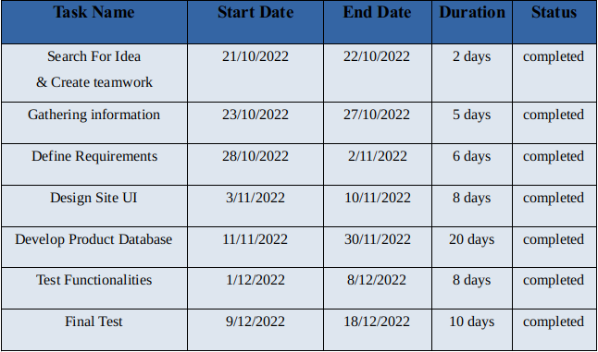**Time Line Plan For The Project**

**Flowchart Diagram**

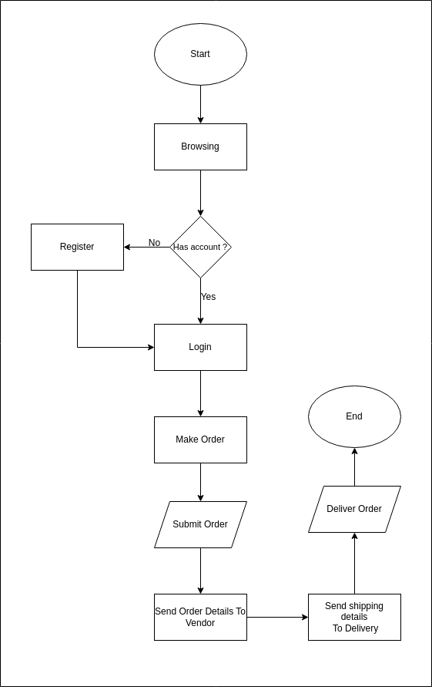

**Use case Diagram**

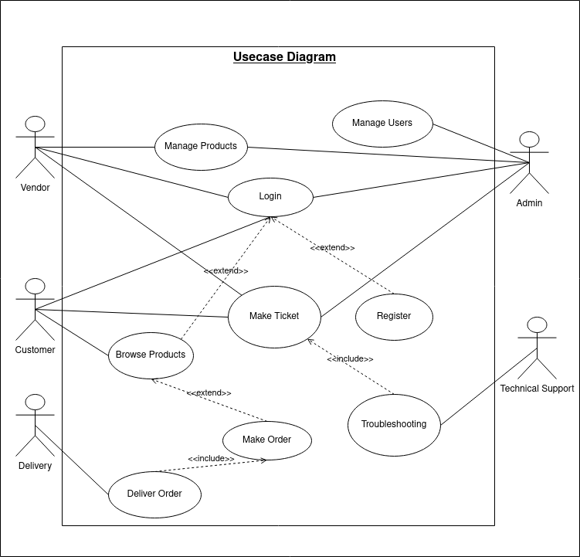

**Sequance Diagram**

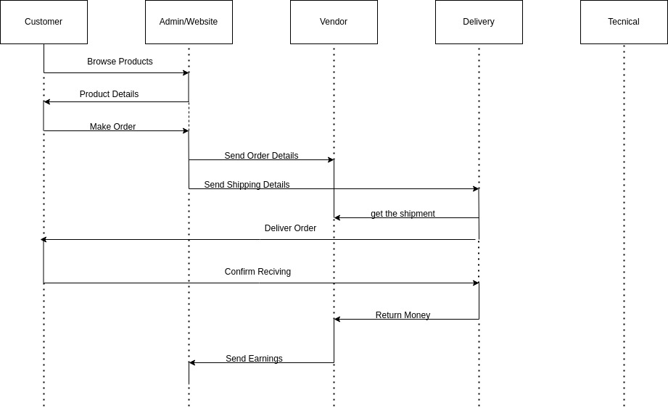

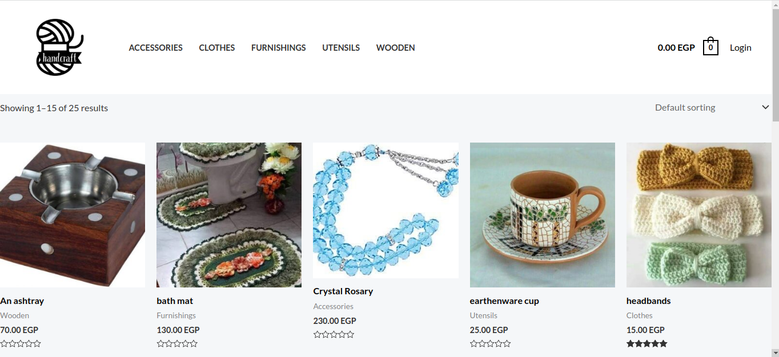**Website Forms**

**Homepage**



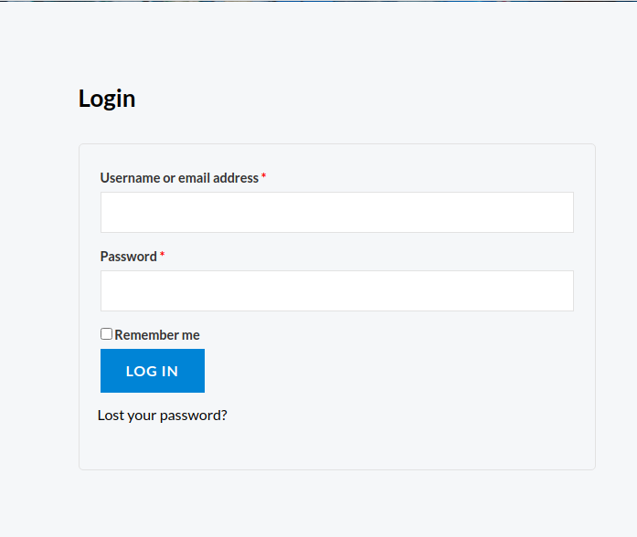**Website Forms**

**Register Page**

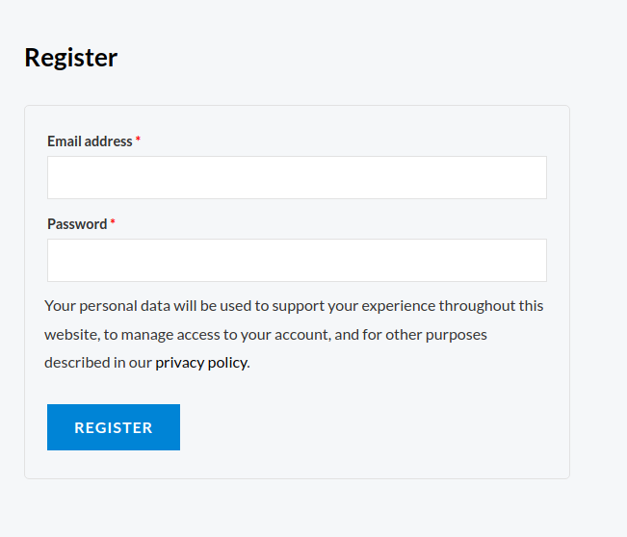

**Login Page**



**Website Forms**

**Vendor Dashboard**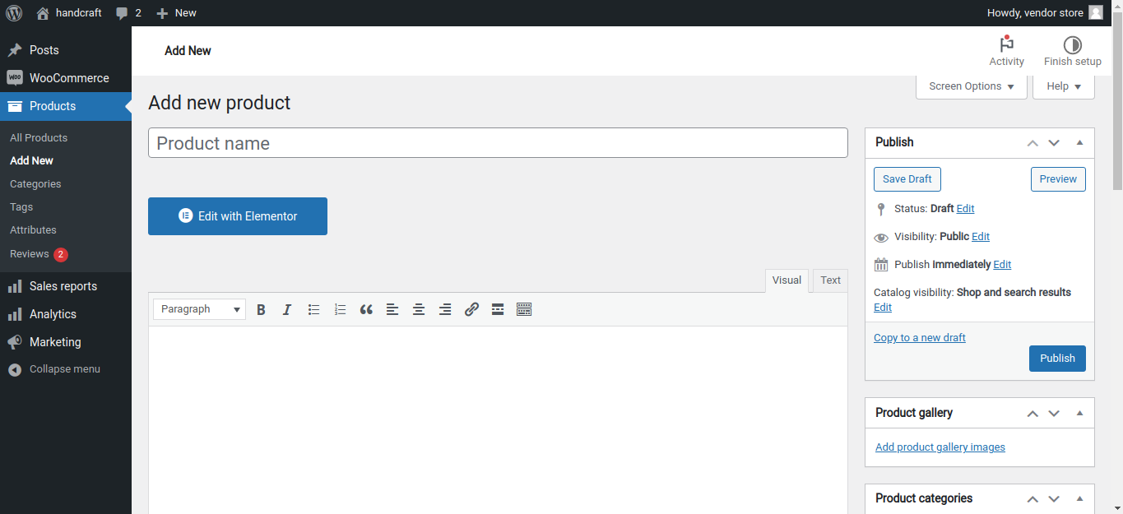

**Website Forms**

**Admin Dashboard**

