Weight training: SC_deep → LLBN
6th Feb 2015. Seb James
The problem: Find the correct weights for the superior colliculus deep retinotopic map to the LLBN neuron in the Oculomotor model.
A simplified version: Find some weights to enable a 1D saccade (rotation about the y axis, so that means side-to-side eye movements). Set weights along this line only. Find the functional form along this line to give accurate 5 - 15 degree saccades. Alex B already did this with an earlier version of the model, but unfortunately, his weights don't work with the newer version of the model which now matches the modlin model.
Alex's weights looked like this:
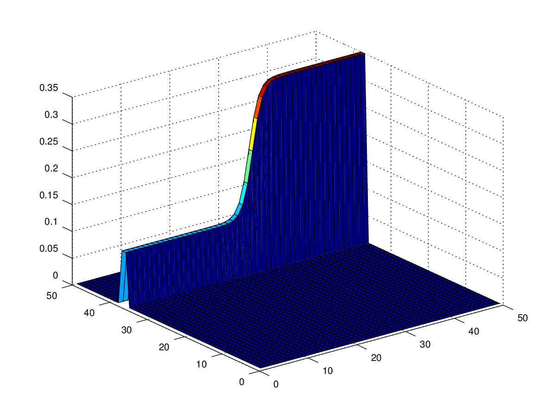
You can see that rows 37 and 38 are used, as these lie on the correct line for a pure left horizontal motion.
For the basic model I'm starting from/working with, see the branch Oculomotor_with_WDM_2_the_basic_model. The branch I'm working in now to train these weights is Oculomotor_with_WDM_2_Scdeep_to_LLBN_weight_finding. Catchy!
I've written an m script, batch_scripts/rotations_weight_finder.m, which takes a target rotation as an argument and has a hard-coded model location and starting weight, and this then finds the best const weight to set along the line to obtain the target. I found I just had to mask off the fovea in order to avoid a saccade with the initial phasic signal in SC_sup from the fixation luminance.
batch_scripts/rotations_weight_finder.m uses batch_scripts/write_onedim_binary.m to write out the explicitDataBinaryFile11.bin file which is the correct file for the SC_deep → LLBN_left weights.
I also connected up the tonic neurons back to the shunting input of SC_deep to make it impossible for any secondary saccades to occur after the first saccade.
Here's what a constant explicitDataBinaryFile11.bin looks like (use load_explicit_data.m from SpineCreator to load these, then reshape them to 50x50):
octave:48> weights = load_explicit_data ('../explicitDataBinaryFile11.bin');
octave:49> weights = reshape(weights, 50, 50, []);
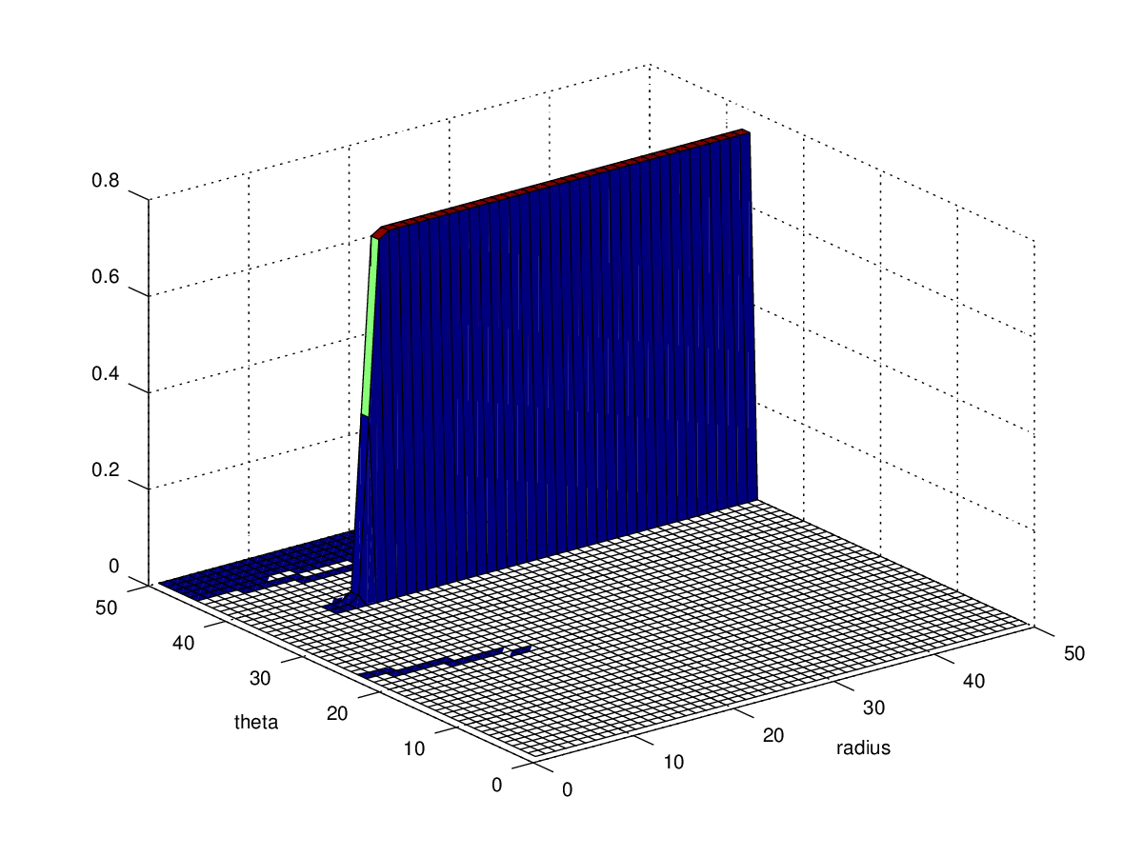
Note the sigmoid drop off starting at radius index 14. This modified what the weights need to be for smaller angle saccades.
Once I've got a reasonably close weight for a target angle, I can then run that weight ten times to see what the scatter is like. The script for doing this is batch_scripts/find_output_scatter.m.
Here are the results. See also one_d_weights.m.
Target RotY | Best weight from algorithm | 10 runs gives mean | 10 runs SD
5 | 0.30342 | 5.12 | 0.25
6 | 0.20002
7 | 0.19781
8 | 0.19578 | 8.04 | 0.12
9 | 0.1954 | 9.22 | 0.12
10 | 0.20097 | 9.83 | 0.1
11 | 0.25273 | 10.67 | 0.08
12 | 0.32019 | 11.83 | 0.23
13 | 0.36889
14 | 0.48451 | 14.04 | 0.15
15 | 0.754 | 15.1 | 0.4

I changed the threshold to try to get closer to the right value:
Target RotY | Best weight from algorithm | 10 runs gives mean | 10 runs SD
5 | 0.296682
6 | 0.208747
7 | 0.203354
8 | 0.193633
9 | 0.190071
10 | 0.203886
11 | 0.260928
12 | 0.322800
13 | 0.390243
14 | 0.489740
15 | 0.710785
20 | 8.825

These are available in weights.mat.

Next up, fit a curve; lets go for a polynomial fit, because these weights are not monotonically changing (we discussed the use of a dual exponential fit).

2015/02/09

Have modified the weight finding scripts to use the location of the SC deep hump to calculate the weights precisely where the hump occurs. This will calculate the weight required to get the target saccade as if there was no noise at all in the rest of the SC deep.

I want to see if the trend matches the “line weights” which I previously calculated. The new script is rotations_weight_finder_hump.m and this makes use of write_mapped_weights.m.

Target RotY | Best weight from algorithm | Centroid of hump | Time of hump peak | Points in mask
5 | 0.176263 | 20.242, 35.995 | 332 | 18
6 | 0.078302 | 20.034, 36.692 | 249 | 33
7 | 0.070911 | 20.426821,37.007192 | 225 | 39
8 | 0.071369 | 20.995542,36.973142 | 217 | 42
9 | 0.078371 | 21.663792,37.240760 | 212 | 44
10 | 0.095280 | 22.524379,37.166991 | 209 | 42
11 | 0.117941 | 23.806058,37.184657 | 212 | 39
12 | 0.158641 | 24.769762,37.029114 | 214 | 36
13 | 0.203979 | 25.616719,37.114060 | 218 | 32
14 | 0.26381 | 26.492797,37.120531 | 221 | 28
15 | 0.422993 | 27.524918,36.930518 | 227 | 28

Discounting the result for 5 degrees, gives a 5th order polynomial fit which is fairly close in the range 20 – 30. See disc_weight_data.mat and disc_weight_fit.mat

10th Feb: Spent more time on the disc scheme. Decided that removing the fixation luminance would make sense for the weight training. Experimented with the initial run to find the centroid and mask size with the SG weights set to 0 and realised this causes the SC deep hump to grow and grow, giving a larger mask that one would expect. Still working on this...

11th Feb: At higher angles there's more randomness in the final eye angle, and this messes up the gradient based search algorithm to find the correct weight. As a result, have been working on a version of rotations_weight_finder which does an average for each trial weight. See rotations_weight_finder_hump_average.m.

12th Feb
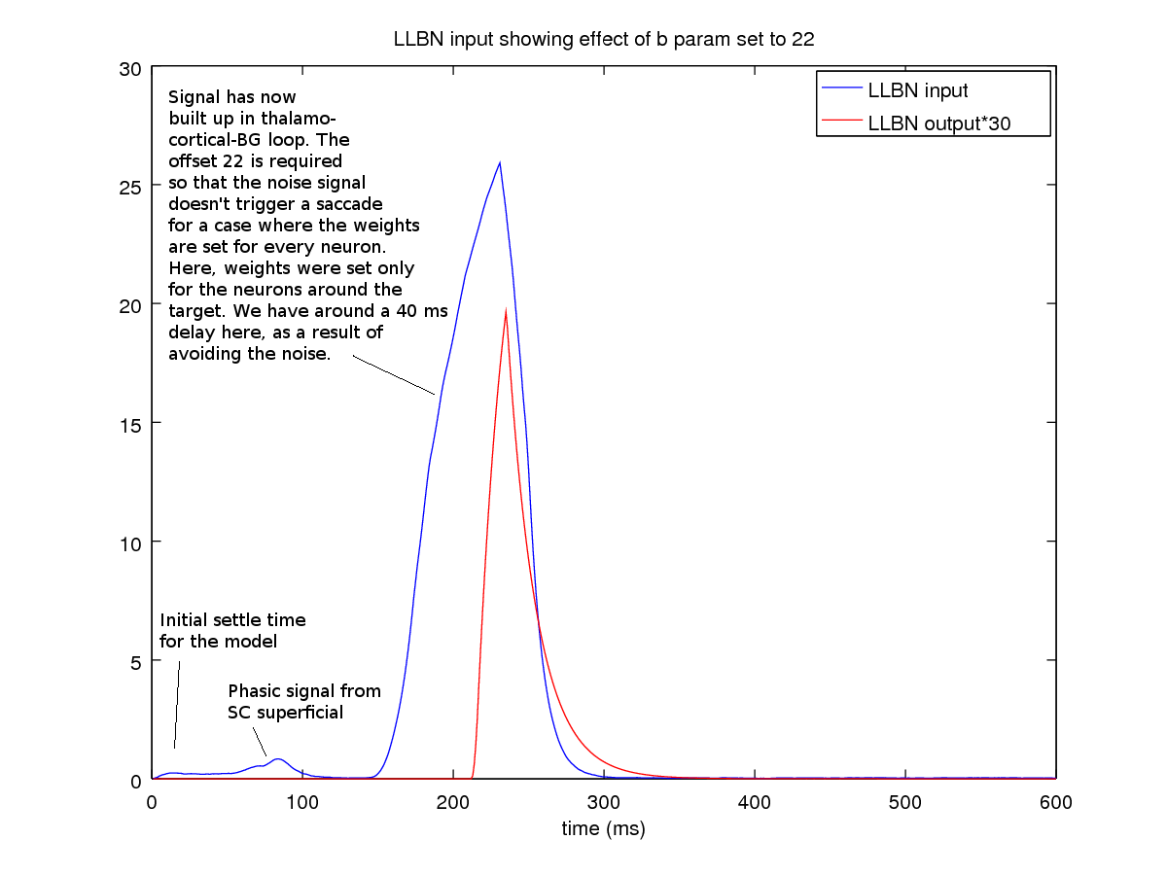
Have set the offset in the LLBN population to allow for noise propagating through from the SC deep population. Here's a graph of the inputs to LLBN, which show the effects of the initial settling of the model, then the effect of the SC superficial getting phasic input from retina2, both of which fail to extend beyond the LLBN threshold (the parameter in the LLBN's LIN component is 'b').

Next up: Lets find some weights for horizontal saccades all the way across the field of view.

This is nearly working now. I need to a) Find out why there's sometimes a lot of variance in the output angle:

lasterror = 0.85395
error = -11.121
errorplus = 4.8056
errorminus = -27.047
delta_weight = -0.040130
delta_error = -11.974
last weight: 3.400000 and weight: 3.359870 so delta_weight: -0.040130
error: -11.120527 and lasterror: 0.853950 so delta_error: -11.974477
dedw = 298.39
last_angle: 20.853950 cur_angle: 8.879473 last_error: 0.853950 cur_error: -11.120527 last_weight: 3.400000 cur_weight: 3.359870 next_weight: 3.385958 dedw: 298.391444

Also, figure out the right way to end the weight finding algorithm. Ending is straightforward – if the error is < the SD, then break.

Got these weights:

Target RotY | Best weight from algorithm
15 | 1.848672
20 | 2.90838

But no more. At 30 degrees I was back to seeing a saccade from the noise; the b value in the LIN component of the LLBN would need to be tuned again. I'm going to see about trying to blur out some of the noise from SC deep.

13th February

Have added SC_smoothing to do some time-based smoothing of the noise in the signal from SC deep. I've also run the model for 600 ms with no input and then saved all the state variables into the model, so there should be no turn-on transients at the start of a simulation and I should be able to turn the target luminance on very early and run for only 300 ms now – but I just tried running again and there's still a transient in the system, which seems to run for 100 ms or so. That's annoying.

16th February

I'm looking at the initial state problem. I am able to show that in the simple 6ch GPR model which I built in the summer (GPR_BG_seb) it's not possible to advance the model to 10ms, copy that model state back to be the “starting state” and then advance the model onwards – the results diverge from running the model straight through. See figure:

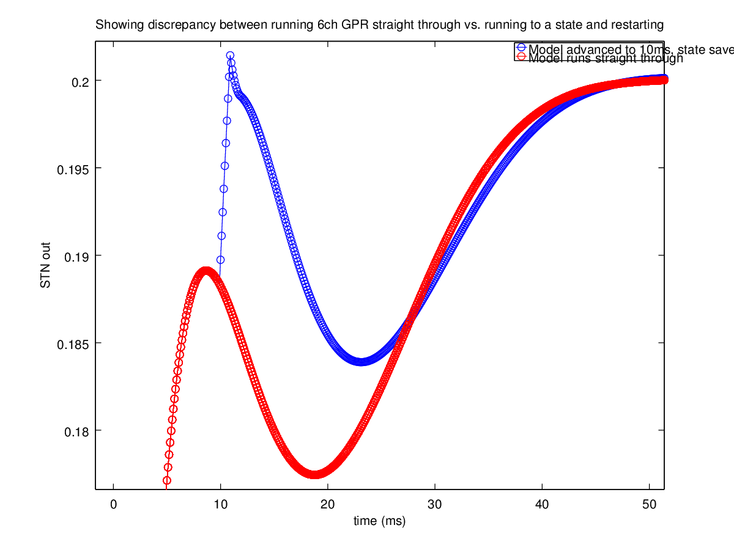
Reason: The delays cause this phenomenon – the values in the delay buffers in the simulation are not saved and returned to the model input. See github: https://github.com/SpineML/SpineML_2_BRAHMS/issues/20

I'll accept this for now, which just means giving the model about 150 ms of settling time before switching on the weight-training luminance.

I'm going to try to tune the 'b' parameters in the LLBN left population, then having set that, run through the algorithm to find the best weights over the widest possible range of target eccentricities.

To find b, I'll set the weights across approximately a quarter of the sheet to the value 2 [by calling write_line_weights ('/home/pc1ssj/abrg_local/Oculomotor/explicitDataBinaryFile51.bin', 2, [31:43])]. The sum of these weights across the whole surface should be somewhat equivalent to the weight surface we should see, up to some limit as it grows exponentially. I'll then set b to some value which avoids any LLBN activity for this weight map with just model noise. I'll compare llbn and llbn_in, as I did above in this document.

8 seems like a reasonable value for b. See quarter_sheet_weight_2_b_8.png. Will go ahead and train with b at that value.

(Having some trouble getting the model to train – the change of b means I have to get several features correct in rotations_weight_finder_hump_average.m).

Set b to 5.5 now.
10 degrees: weight
Overall best weight for targetThetaY=10: 0.44857 for which angle was: 10.075
Overall best weight for targetThetaY=11: 0.38541 for which angle was: 10.978
17th February.

I'm looking at what portion of the retinotopic maps I need to work with to set weights for one of the eye muscles. To do this, I've set a semicircle of luminances up to 25 degrees eccentricity and run this through my worldframe->eyeframe transform to obtain the retinotopic map.

Here are the results:

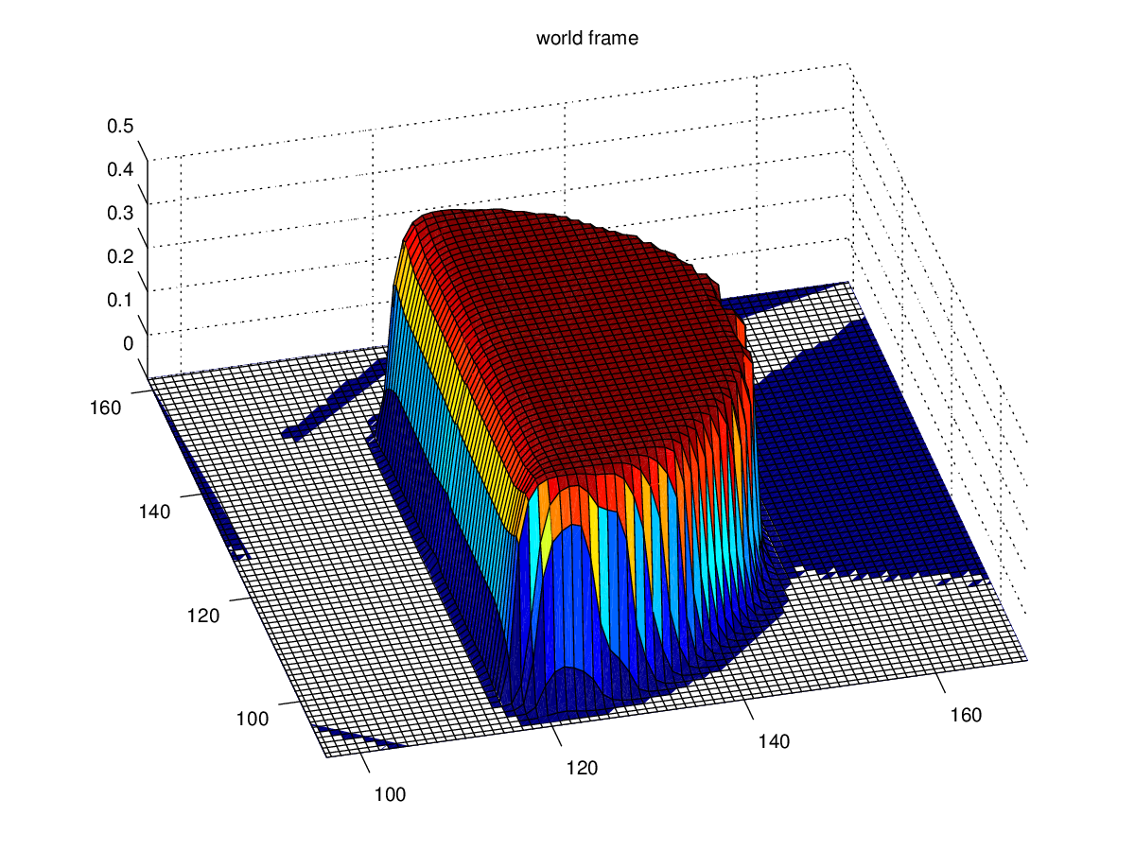
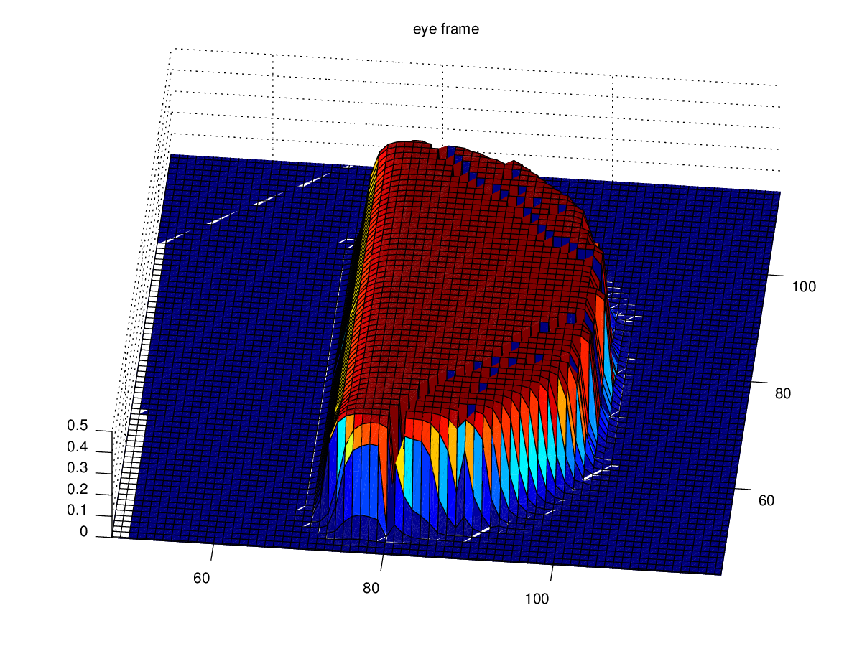
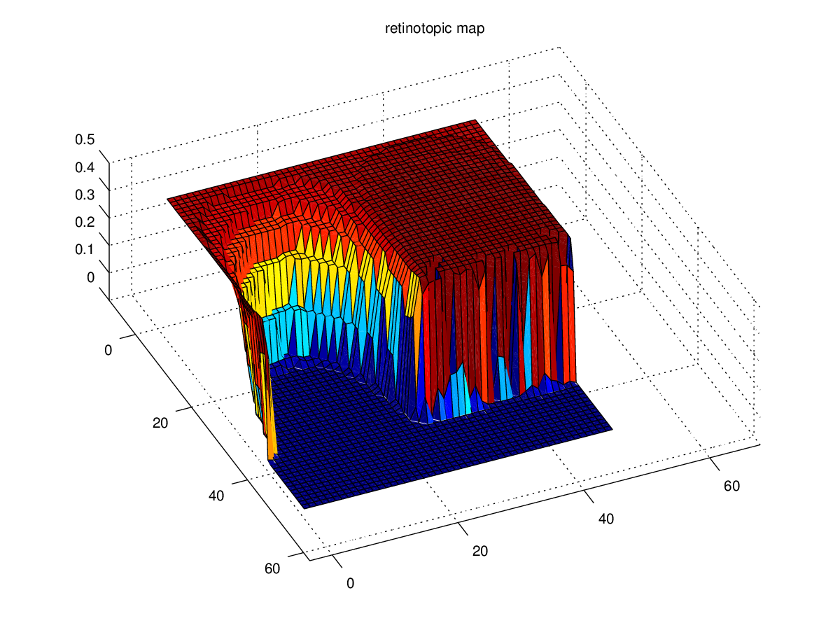
Note that there's some sort of rounding artefact in the eyeframe map which translates into the retinotopic map.

So, this defines the region over which I'll have a weight contribution for the positive thetaY muscle – and it should decay away from the purely horizontal line.

I added a foveal fall-off with

fov_dist_offset = 12;
x = 1:50;
weightline = 1 ;
sigmoid_narrowness = -4;
line = (1./(1 + exp(sigmoid_narrowness.*(x.-fov_dist_offset)))).*weightline;

And I filled in the most obvious of the tranform artefacts to produce the matlab data file cort_blur_fov_lim.mat which is the region of a retinotopic weights map, which covers positive horizontal movements of up to 25 degrees eccentricity. I'll use this to again evaluate how large b should be, prior to attempting to train the weights.

Here's the mask:

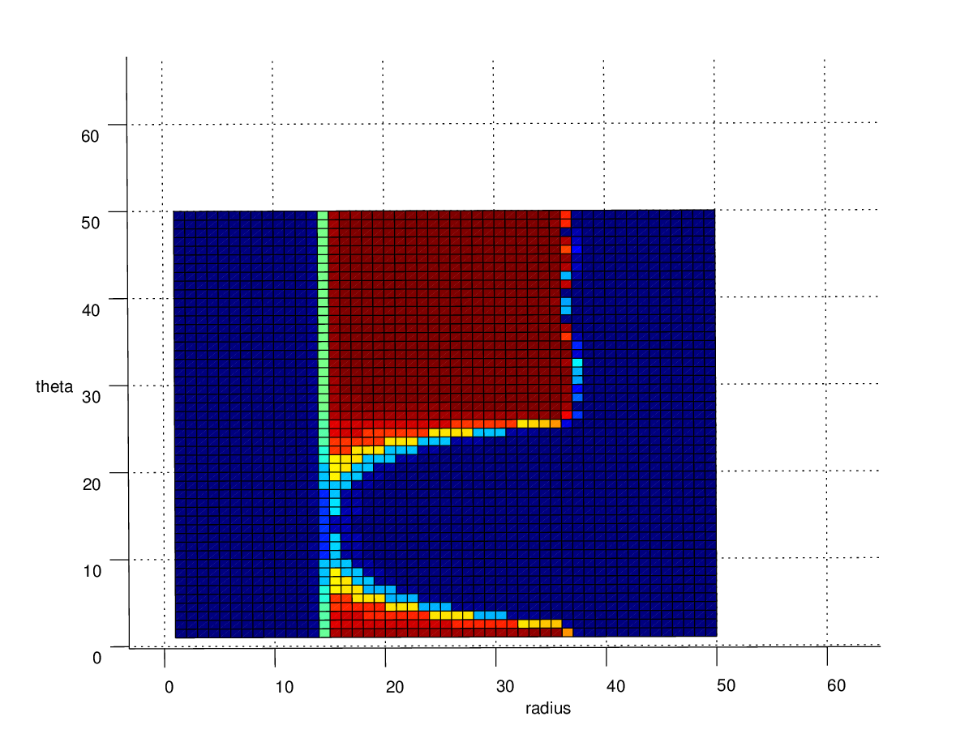
I've now multiplied this by a cosine(theta) curve and an exp (radius) curve to get:

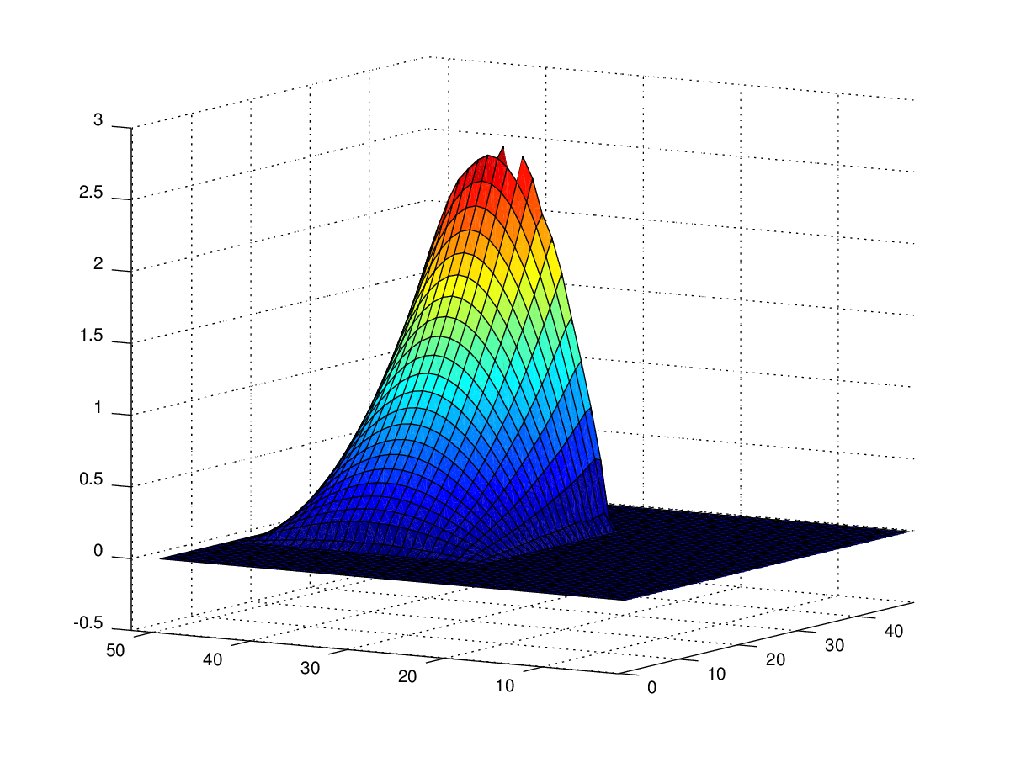

This sums to a total weight of 443. See cort_blur_fov_lim_cos_bump_exp_radius.mat for the numbers.

Using this map on the model, a b param of 2.5 seems ok; I also increased the SC_smoothing tau up to 10 ms from 5 ms to increase its smoothing. Am now trying to train weights. Have made a couple of improvements to the rotations_weight_finder_hump_average.m script and now it looks like the script is again converging stably.

Collecting weights now.

TargetThetaY | Best weight | For which angle | Centroid1 | Centroid2
6 | 0.55025 | 5.34 (SD was 0.95) | 20.427 | 37.38 +/- 0.59
7 | 0.30232 | 7.06 | 20.422
8 | 0.23400 | 7.88 | 20.97
9 | 0.21587 | 8.85 | 21.65
10 | 0.22275 | 10.08 | 22.56
11 | 0.23086 | 11.15 | 23.60
12 | 0.26141 | 12.15 | 24.57
13 | 0.29636 | 12.76 | 25.61
14 | 0.344952 | 14.08 | 26.51
15 | 0.38844 | 14.89 | 27.42
16 | 0.45306 | 15.99 | 28.30
17 | 0.5023 | 17.00 | 29.07
18 | 0.57582 | 18.00 | 29.78
19 | 0.67260 | 19.06 | 30.34
20 | 0.74034 | 20.07 | 31.01
21 | 0.84794 | 20.97 | 31.62
22 | 1.0021 | 21.90 | 32.14
23 | 1.16603 | 22.74 | 32.67
24 | 1.40995 | 24.01 | 33.09

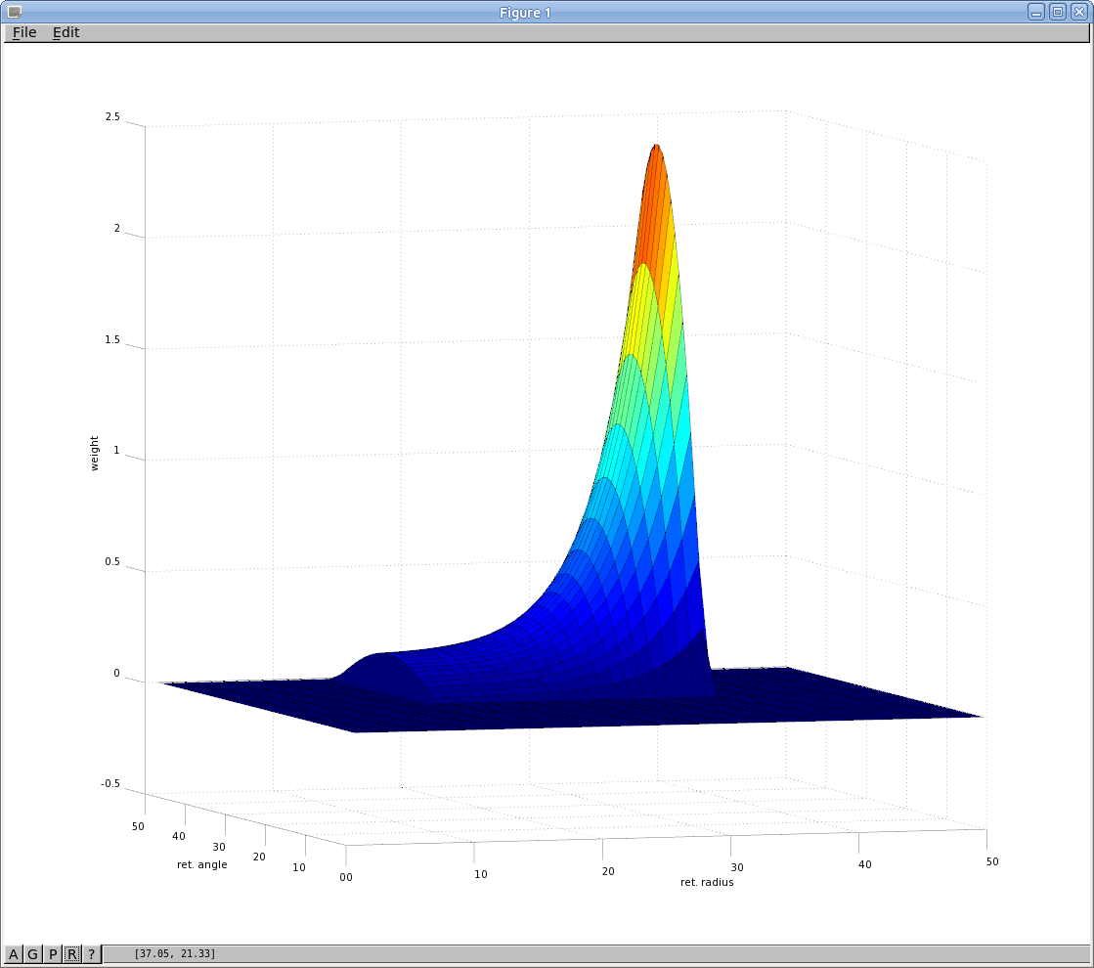
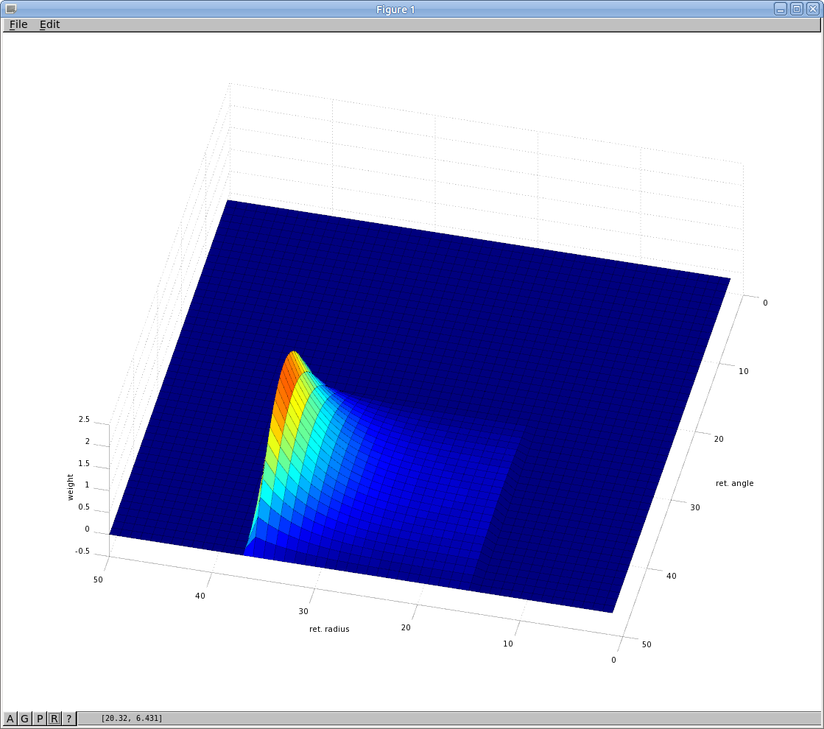
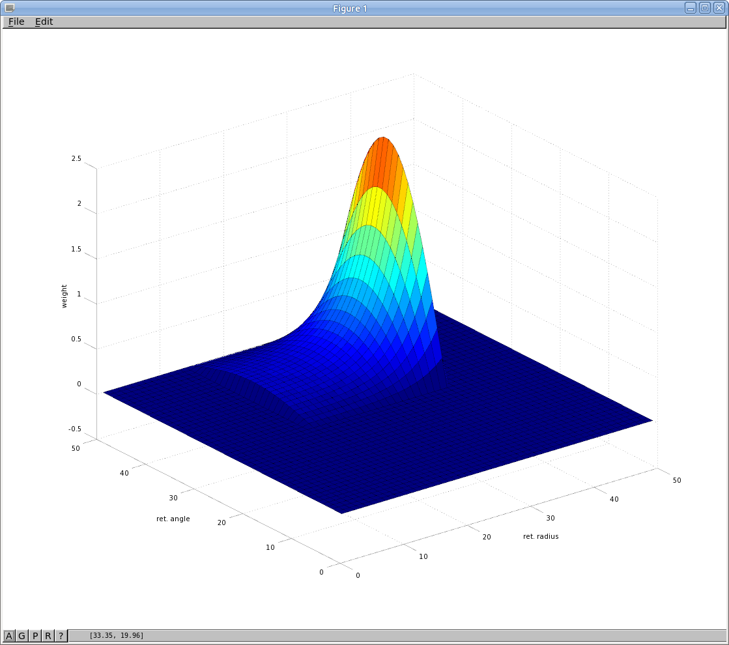
I've noticed that the starting weight is important – the 0.6 in: rotations_weight_finder_hump_average(target,0.6). If it's too low for the given target angle, then on the first run (not the zeroth one) when the mask is being calculated, there may be no saccade, and therefore no feedback from TN to attenuate the hump in SC deep and so the find_scd_mask.m code finds the max hump in SC deep at time 601 and the code errors out.

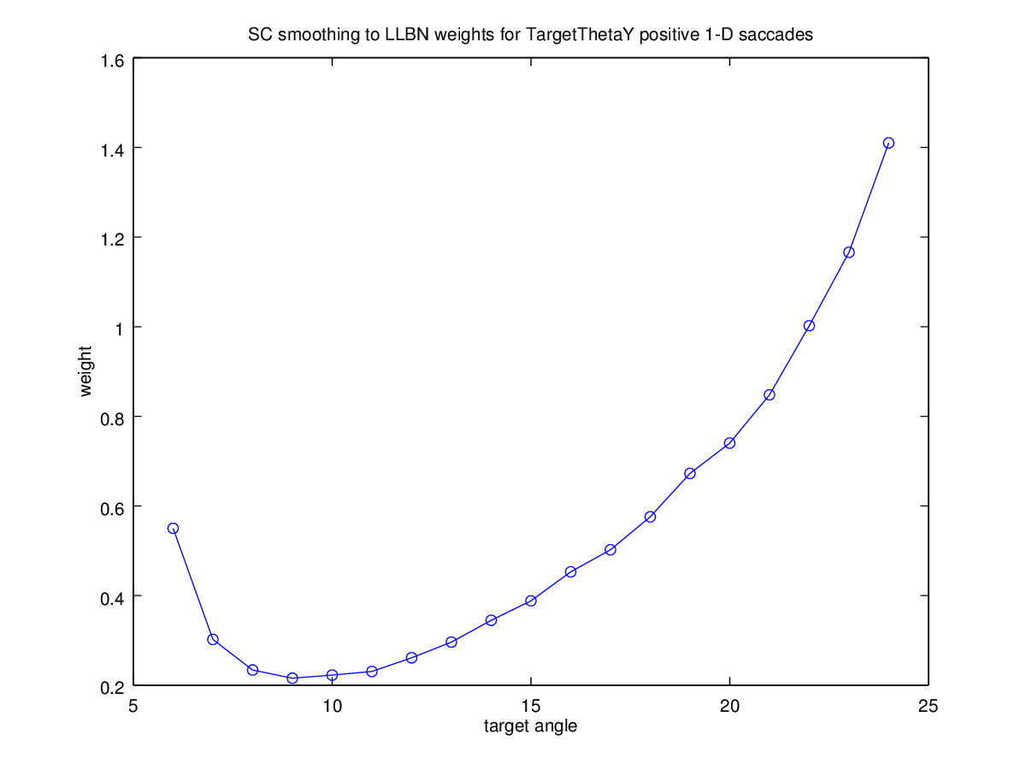
Here's the data above graphed:

Need to polyfit these data, and convert so that the curve fits the retinotopic map now. For this I need the centroid information, which is stored in the dbgTNN.log files in ~/fast/. I'll add those to the table above. Same data plotted vs. ret. Radius:
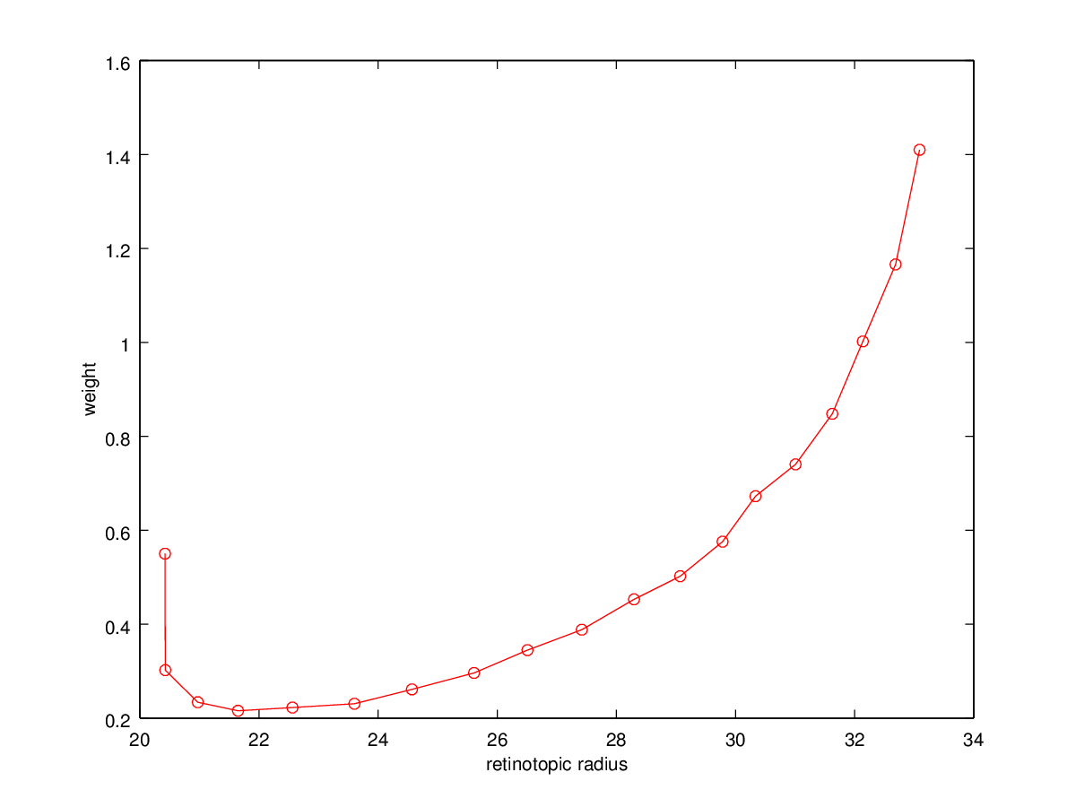
It goes odd towards the bottom end (6 degrees). The reason is that the rather wide luminance is occluded by the foveal mask in the model and so the centroid of the luminance stops moving towards the centre. This also explains why the weights start to shoot up. This graph shows that the range over which our model will work well is 9degrees to 24 degrees (or perhaps about 22 degrees to be safe, to ensure that our luminances full fully within the range over which the weights have been determined). Now polyfit, discarding the bottom three data points and also the top two. That graph looks good – monotonically increasing, could be exponential or quadratic. Try a polyfit first:
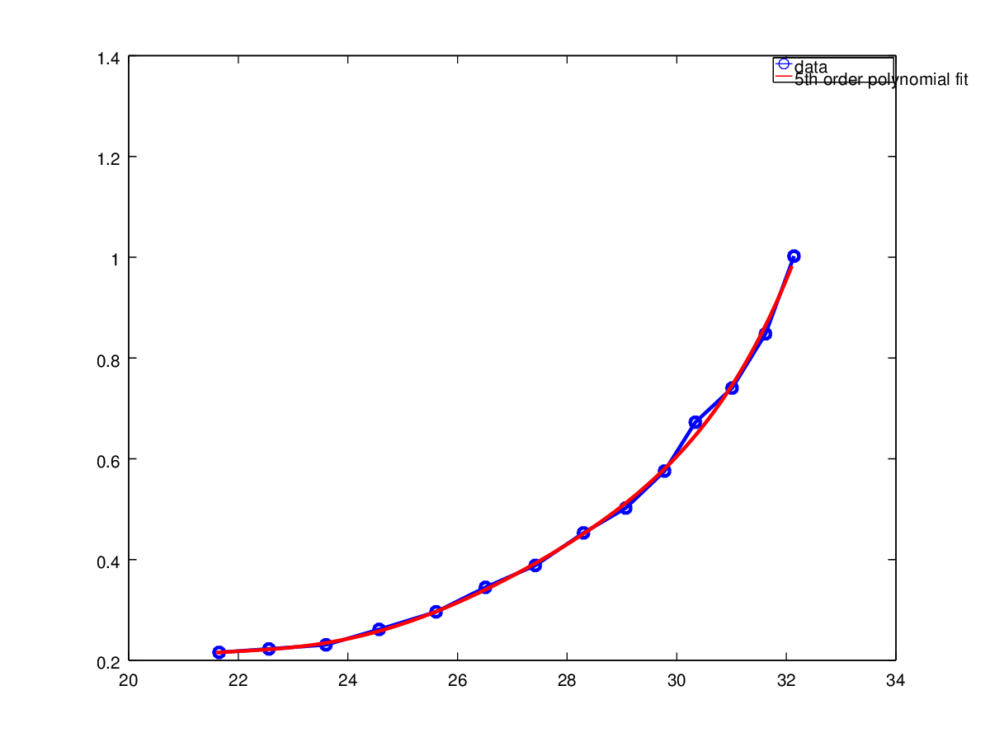
P = polyfit (centroid_points, weight_points, 5);
X = [21:32];
Y = polyval (P, X);
plot (X,Y,'ro-');

(A 5th order fit was good).

or an exp fit (matlab only):

>> F = fit (centroid_points, weight_points, 'exp1')

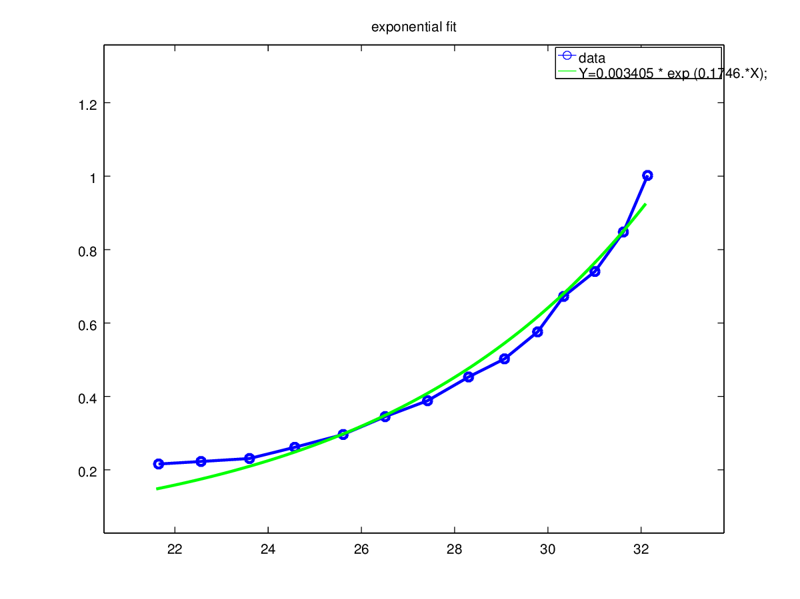
F =

General model Exp1:
F(x) = a*exp(b*x)
Coefficients (with 95% confidence bounds):
a = 0.003405 (0.001411, 0.0054)
b = 0.1746 (0.1552, 0.1939)
>>

Will choose the 5th order fit, so that gives:
X 21:33 gives weight values:

0.20846
0.21810
0.22604
0.24292
0.27259
0.31474
0.36755
0.43035
0.50623
0.60473
0.74443
0.95565
1.28307

octave:61> P5
P5 =

2.2041e-05 -2.8180e-03 1.4375e-01 -3.6518e+00 4.6160e+01 -2.3201e+02

Build this curve into a line covering the 1:50 range, then make it into a sheet by repmatting it. Now multiply by a sine curve:

octave:101> x=[1:50];
octave:102> sin_bump = -1.*sin(x*(pi/25));
octave:103> plot (x, sin_bump);

Remove the negative portion:

octave:111> sin_bump(1:24) = 0
octave:128> sin_bump_map = repmat (sin_bump, 50,1);
octave:128> sin_bump_map = sin_bump_map'; % Turns it round the right way

I put these two maps into the model and ran it quickly for several luminance inputs. The results weren't great:

Target theta Y | Exponential fit surface | 5th order fit surface | Double exp fit
8 |  |  | 3.74 (std=0.29)
9 |  |  | 7.3 (std=0.36)
10 | 4.8 | 1.63 | 9.91 (std=0.24)
15 | 14.75 | 7.5 | 14.33 (std=0.42)
20 | 19.2 | 17.5 | 20 (std=0.25)

What's odd is that the exponential fit does better, even though it looks worse in the 1-D plots, above. Perhaps I made a mistake applying the 5th order fit?
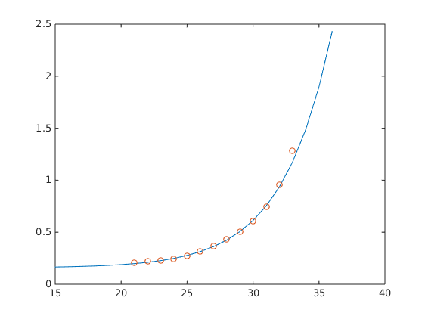
Found a double exponential fit algorithm which seems to work well. exp2fit.m – in my ownCloud. NB: matlab only and see below to find centroid_points.

s = exp2fit (centroid_points, weight_points, 2);
rad_for_fit = [15:36];
fun = @(s,t) s(1)+s(2)*exp(-t/s(3))+s(4)*exp(-t/s(5));
ff=fun(s,rad_for_fit);
plot (rad_for_fit, ff);
For this double exp fit, the parameters were:

s = 0.1578 0.0001 -3.7322 0.0000 -0.2495

where the function is:

fun = @(s,t) s(1)+s(2)*exp(-t/s(3))+s(4)*exp(-t/s(5));

From the table above (right hand col) we can see a good fit above 10 degrees, but a poor fit below, presumably because of the interaction between the luminance hump in SC deep and the foveal mask.

24th February

Have committed explicitDataBinaryFile51.bin as the SC deep → LLBN left weights. Looks like:

Now I'm going to translate that map into SC deep → LLBN right weights and try dopamine manipulation and try to implement an antisaccade scheme. Before those, I'll create a new branch or merge my work back into a shorter branch - perhaps Oculomotor_with_WDM_2.

NB: Just added SC_smoothing to LLBN right connection and now SC_smoothing to LLBN left is explicitDataBinaryFile50.bin whereas SC_smoothing to LLBN right is explicitDataBinaryFile51.bin.

25th February

Latencies. Running experiments in branch Oculomotor_with_WDM_2_201502_seb1. luminance.json file is generated by write_single_luminance.m:

fprintf (lum_file, ['{"luminances":[' ...
'{"shape":"cross","thetaX":0,' ...
'"thetaY":%d,"widthThetaX":6,"widthThetaY":2,' ...
'"luminance":0.8,"timeOn":0.1,"timeOff":0.6}]}'], ...
targetThetaY);

Am running parallel runs to find the latency, looking at the first moment at which the eye starts moving. For details, see run_sim_multi_for_latency.m and find_latency.m. Run it like this:

[avg, sd, finals, starts] = find_latency (14,10)

“starts” contains the starting times for the motion.

TargetThetaY (da=0.2) | Latency/SD (ms)
10 | 244/1.2
12 | 248/1.7
14 | 247/1.3
16 | 245/1
18 | 236.4/1.2
20 | 237/0.9

Now turn the dopamine knob for the 14 degree saccade:

Dopamine - da parameter | Start time (subtract 100 ms for latency). | SD
0.01 | 262 | 1.4
0.05 | 258.3 | 1.2
0.1 | 258 | 4.9
0.1 | 253.7 | 0.95
0.15 | 250 | 1.2
0.2 | 247 | 1.3
0.3 | 242.2 | 1.4
0.4 | 237.9 | 1.2
0.5 | 233.6 | 0.5
0.8 | 228.3 | 0.9

Oh, no! Have just noticed that the dopamine knob is changing the final angle quite substantially! e.g. 14.1 for da=0.15 and 19.0 for da=0.8. Presumably due to the size of the hump in SC deep.

8th March

To solve the above, we decided to implement a centroid finder, much like Alex Cope's implementation, but then we'd pass this centroid on to the saccade generator circuitry. I implemented this in Oculomotor/c++/centroid.cpp.

I improved the weight finding code (and modified it for the centroid scheme) so that I can pass the weight finding algorithm to iceberg for all weights and have these recomputed in parallel fairly quickly. Results to follow here.

9th March

Chris and Dimitris at Patras have modified their model so it can be compiled in “brahms only” mode, so that I don't have to mess around getting graphical dependencies figured out. I'll get that built and do another weight computing run.

I've created a new weight training expt with 0.45 s run time and reduced logging to be a good Iceberg citizen and hopefully increase the speed at which the models run.

Noticed that the system will not saccade more than about 24 degrees. This is due to the max of the squashing function in the LIN component of the LLBNs. Not going to change this now, though some tweaking should restore a wider range.

Am now training with the latest model from Patras.

While that goes ahead, I need the conversion from degrees to retinotopic radius. From data earlier in this document, I can plot a degrees vs retiontopic radius line and then best fit that line [with P=polyfit(deg,retrad,1)].

retrad = 15.0542 + 0.7908 * degrees
So to get the “centroid_points” as referenced above, you can do:

p=[0.7908,15.0542];
centroid_points = polyval(p, degrees);

So the full recipe (for leftward saccades), assuming you have your weight data in two arrays weight_points and degree_points is:

p=[0.7908,15.0542];
centroid_points = polyval(p, degree_points);
s = exp2fit (centroid_points, weight_points, 2);
rad_for_fit = [15:36];
fun = @(s,t) s(1)+s(2)*exp(-t/s(3))+s(4)*exp(-t/s(5));
ff=fun(s,rad_for_fit);
plot (rad_for_fit, ff, 'r-');
hold on;
plot (rad_for_fit, weight_points, 'bo');
% Now move on to the surface using the line as the maximum.
x=[1:50];
sin_bump = -1.*sin(x*(pi/25));
figure; plot (x, sin_bump);
% Remove the negative portion:
sin_bump(1:24) = 0
sin_bump_map = repmat (sin_bump, 50,1);
sin_bump_map = sin_bump_map'; % Turns it round the right way
% lastly, combine the two.
weightline = [zeros(1,14) ff zeros(1,14)]
weightmap = repmat (weightline, 50, 1);
final_weights = weightmap .* sin_bump_map;
% Save the weight map in SpineML-friendly format
write_mapped_weights ('explicitDataBinaryFileL.bin', 1, final_weights);
% Make the right hand weights
hump = final_weights(25;50,:);
restmap = zeros(24,50);
rightmap = [hump; restmap];
write_mapped_weights ('explicitDataBinaryFileR.bin', 1, rightmap);

Here is the weight training result using the “brahms” branch of the saccsim code base (that's Patras' latest model). It's only minimally different from the previous iteration in their model.
Target | Weight | Final angle
6 | 0.450240
7 | 0.478785
8 | 0.530447
9 | 0.579483
10 | 0.675425 | 10.36
11 | 0.699538
12 | 0.766815
13 | 0.826768
14 | 0.894620
15 | 0.979760
16 | 1.062603
17 | 1.293208
18 | 1.394471
19 | 1.836453
21 | 2.068908
22 | 3.996042

Now turn the dopamine knob AGAIN for a 14 degree saccade (8 runs per dopamine param):

Dopamine - da parameter | Start time (ms) (Subtract 100 for latency in this case) | Latency SD | Final angle/SD
0.01 | 223 | 0.8 | 16.6/0.33
0.05 | 221 | 1.2 | 16.95/0.15
0.1
0.15
0.2 | 215.1 | 0.6 | 16.95/0.33
0.3
0.4 | 210.1 | 1.5 | 17.07/0.33
0.5
0.8 | 203.4 | 1.6 | 17.19/0.25
1 | 201.4 | 1.4 | 17.29/0.11

10th March

We've made some fixes to the model. FEF to Thalamus weight was 0.3 and not 3 as it should have been. SNr to Thalamus Synapse 0 was -2.5 and not 2.5 as it should have been (it's a shunting input).

Alex is working on the cognitive control antisaccades. I'm looking again at latencies and dopamine. Here come some more numbers. Here, I'm doing a prosaccade protocol as per Chrystalina, with no gap, a fixation luminance initally then a switch to a target luminance at 10 degrees. Here, I've set luminances to 0.15 rather than something higher. The target luminance (and the fixation luminance) affect saccade latencies. The target comes on at 0.15 seconds.

Fixation 0.15 lum; 0 - 150 ms. Target 0.15 lum, 10 degrees, 150ms - 600 ms.
luminances.json:
{"luminances":[{"shape":"cross","thetaX":0,"thetaY":0,"widthThetaX":6,"widthThetaY":2,"luminance":0.15,"timeOn":0.0,"timeOff":0.15},{"shape":"cross","thetaX":0,"thetaY":10,"widthThetaX":6,"widthThetaY":2,"luminance":0.15,"timeOn":0.15,"timeOff":0.6}]}
Dopamine - da parameter | Latency (ms) | Latency SD | Final angle/SD
0.01 | 172 | 2.7255 | 10.909/0.27865
0.05 | 166.5 | 2.4495 | 10.988/0.070488
0.1 | 162.5 | 1.9272 | 10.927/0.2313
0.15 | 160.5 | 2.9277 | 10.885/0.34576
0.2 | 157.375 | 1.598 | 10.900/0.33548
0.3 | 151.75 | 1.165 | 11.012/0.30215
0.4 | 149.875 | 2.1002 | 10.928/0.39319
0.5 | 145.75 | 1.1650 | 10.86/0.4546
0.6 | 143.25 | 1.3887 | 10.965/0.41445
0.7 | 141.75 | 1.8323 | 11.018/0.36561
0.8 | 141.375 | 1.3025 | 10.874/0.53108
0.9 | 139.88 | 0.99103 | 10.928/0.49341

I've repeated the run above for 20 degrees too. See 20_degree_latencies.mat in the lab_book directory.

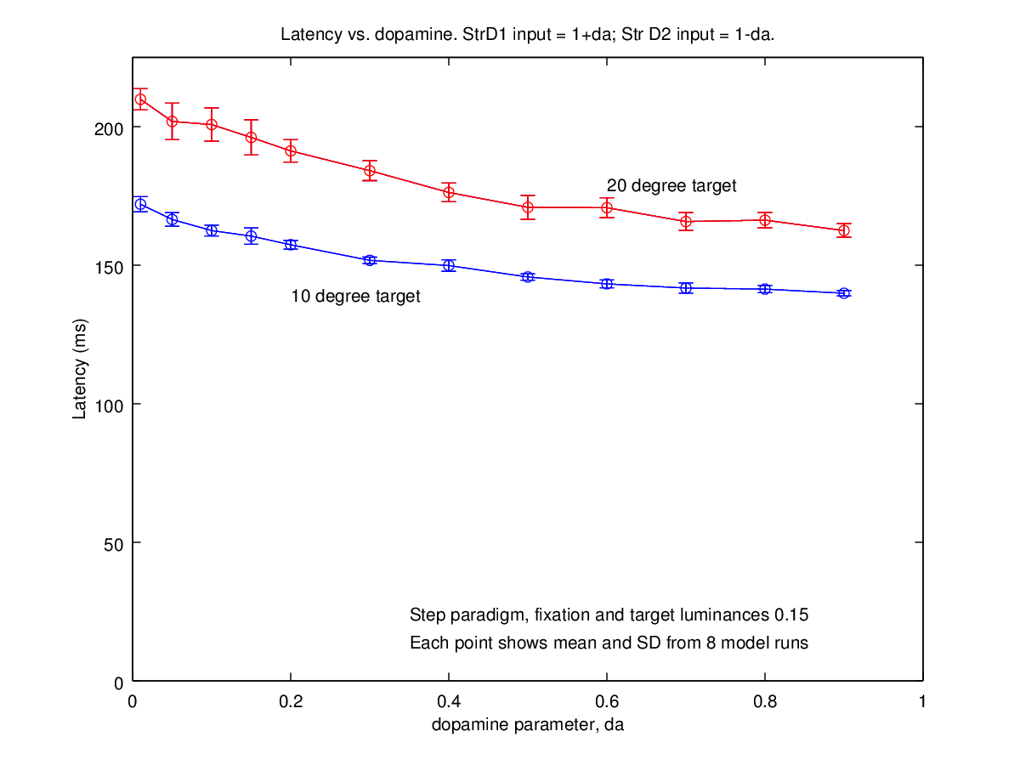

25th March

Back to this model. I've fixed some stuff in SpineCreator (See github issues 69, 70 and 71). I've merged the changes to the model into the Oculomotor branch.

The plan is now to try a “multiple stick” idea - passing 2 (or more?) normalised sticks from SC_deep through to the saccade generator. The idea here is to experiment with passing on selection from the BG/FEF/Thalamus/SC through to the brainstem, such that selection is not an “all in one place” activity, but rather a task contributed to by several brain regions.

I'd still also like to experiment with the “signal division idea” which Kevin suggested as a means to normalise the signal into the SG. I may take a little trial at that too in another branch (see Oculomotor_seb_weight_division).

30th March

I've copied the explicitDataBinaryFiles from Oculomotor_with_WDM_2_201502_seb1 into the lab_book directory as edbf_pre_centroid_left.bin and edbf_pre_centroid_right.bin. I want to reproduce the latency and final angle vs. dopamine data for the naïve connection scheme from SC_deep to LLBNs.

Multiple centroids. 13th April 2015.

Experiments show that the SC transmits in a way which vector averages activity in SC deep. See, for example, Lee, Rohrer and Sparks; “Population coding of sccadic eye movements by neurons in the superior colliculus”; Nature 332, 357 (1988). More recently, Goossens and van Opstal have investigated the behaviour of neurons within hills of activity in the SC (Optimal Control of Saccades by Spatial-Temporal Activity Patterns in the Monkey Superior Colliculus, PloS Comp Biol, 2012).

We don't want to get into building a detailed neural model of the SC in all its glory, but we need some way to make contact with the anti-saccade experiments and Parkinsons Disease. Because there are inter-laminar connections within SC (ref - some of the papers I have) which extend a finite distance out, we could use this to compute multiple centroids which would give us both the average saccading behaviour shown by the single centroid scheme, and also a possible route to selecting between similar, diametrically opposed luminances to left and right.

The problem is how to determine where to centroid out from. Activity at an SC deep neuron triggers centroiding? I guess so. What about if we have >threshold firing at two or more adjacent neurons? Perhaps once a centroid is in process, we “ban” other in-centroid neurons from triggering a new centroid?

Ok, so into the centroid_multi.cpp component (newly created, copied from centroid.cpp) I get the 2500 activations from SC_deep. I need to scan this and determine my “centroiding regions”. neuron activations above some threshold will set these centroiding regions. A sufficiently active neuron at position (i₁,j₁) will trigger a square region of side r centred on (i₁,j₁). A far-off active neuron at (i₂,j₂) will trigger a separate square region of side r centred on (i₂,j₂). A nearby active neuron, where (i₂,j₂) is within the square defined by i₁,j₁ and r will extend the first centroid, enlarging it. However, two centroid regions which may overlap at the edges should still generate separate centroid outputs - the idea here is that the centrally active neuron communicates its firing pattern out to the rest of the hill over a finite distance. If the hills are nearby, then we want the overall centroid containing both. If they're distant then we want separate centroids. The condition for them to “centroid together” is for the centre of one hill to be within another hill. How to code this in the program? Can I simply overlay the “centroiding regions”? Looking at the centroid algorithm, I think that'll work. I wondered if it would be easier to make the centroiding region a rectangle which encompassed both smaller squares, but I think that's unnecessary. It may even be easy enough to make the centroiding region for a single “active input” neuron a circular region.

Ok, I think I have a scheme. I iterate through the input neurons. Each time I find an input neuron which is larger than a threshold, then I run a recursive function to find its extent (above the general noise level) copying these parts of the hill of activity into a new sheet (called centroidRegions). As I go along, I have to somehow mark these as having been copied; perhaps by zeroing them in the inputSheet. This should be quite an efficient way of splitting up the inputSheet.

On the size of r

How big should r be? Quite big it seems. Looking at Lee, Rohrer and Sparks, 1988, a hill at 0º,5º extends ±20º in the medial-lateral directions and from 2º to 10º in the caudo-rostral direction. This is 4/24 squares or 1/6 of the total map.

28th April

I decided it would take too long to figure out the algorithm doing it in c++, so I dusted off the networkserver connector code to allow me to do this all in octave. I had a couple of days work getting the networkserver connector code fixed up (See git commits 95d3f8e up to 78c15ad in SpineCreator and 464d02b in abrg_local). Once this was working, it wasn't too hard to fix up the algorithm, which calculates the second derivative (wrt space) of the neural field and selects regions where the second derivative is below a threshold as the peaks of the field. This always generates one or more centroid peaks, but where the peaks are close to the background noise in the field, the magnitude of the centroid peaks is low and the SC_deep_output population, which is a “threshpass” component will ignore small centroid peaks (currently the min and max are set to 8 and 16 respectively; pure noise in the model generates centroid peaks of up to about 3 in magnitude).

For the multiple centroiding algorithm, see abrg_local/Oculomotor/matlab/multicentroid/

The actual algorithm is in multicentroid_compute.m.

I also experimented with a “power centroid”, as found in multicentroid_powercentroid.m - it turns out that this is the algorithm which Alex Cope used in the modlin oculomotor model.

The previous, single centroid weight training seems to hold quite well with the multiple centroid algorithm in place - final saccade sizes are relatively accurate (8º rather than 10º). However, it would be good to retrain the weights, and to be able to run the model on Iceberg again. It IS possible to run on Iceberg with the octave connector, but it's not straightforward to run models in parallel, and in any case, I'm seeing network based I/O errors running there, so I think it's best to view the networkserver scheme as being good for prototyping, but to make this a model which we can let others run, we don't want yet another complication (it's already tricky enough).

I will go ahead and recode the algorithm in c++ now, which will make it easier for Alex B to run the model and also for the greeks.

30th April

Now have multicentroid.cpp finished, which carries out an identical set of operations to multicentroid_compute.m. Ready to re-calculate weights for left and right motions, then investigate behaviour with multiple hills of activity.

1st May

Have run weight training runs (having connected the TN feedback again to prevent >1 saccade).

The leftwards rotations look sensible:

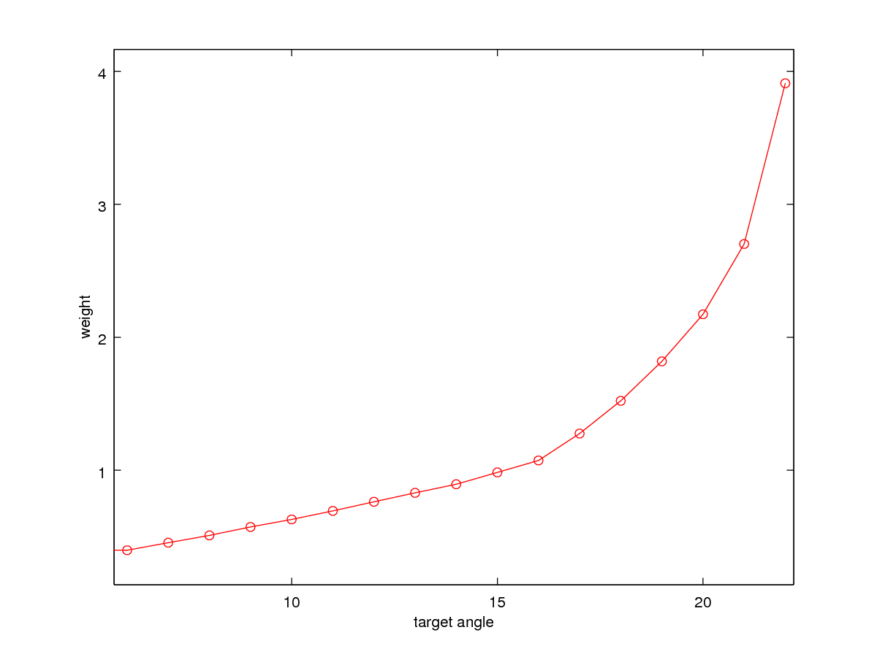
But the rightwards rotations differ somewhat in magnitude (as you head towards -22) and have a peculiar and unexpected kink:

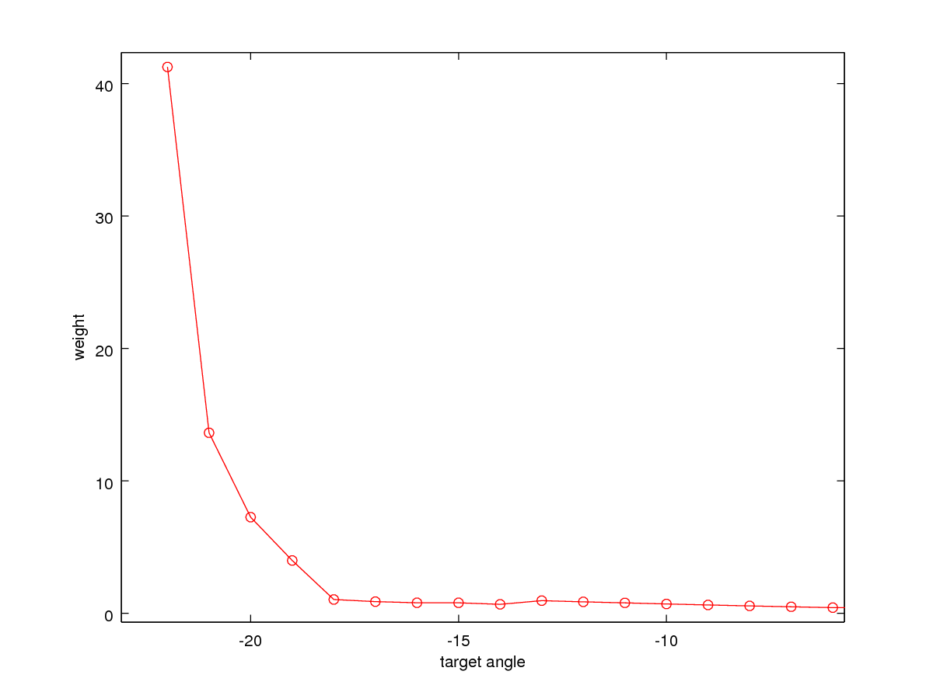
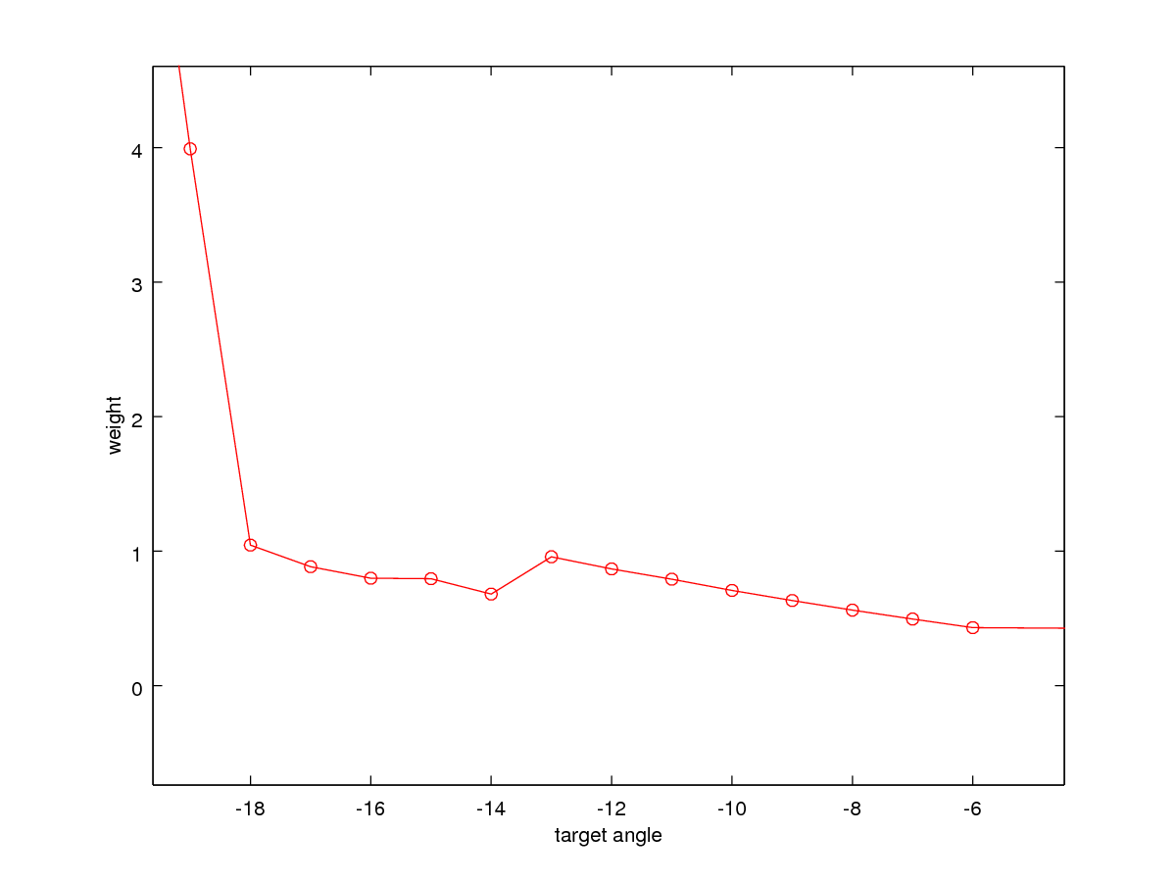
The kink occurs around the point where the “correct” weight is about the starting weight of 0.8 (specified in run_weight_finding_many.sh or similar). I'll try re-running the weight finding from a starting weight of 0.3 to see if the results differ. I do wonder if my weight finding algorithm is operating differently for -ve thetaY targets compared with +ve thetaY targets.

Here's additional data for the rightward (-ve target thetaY) saccades, using a starting weight of 0.3:

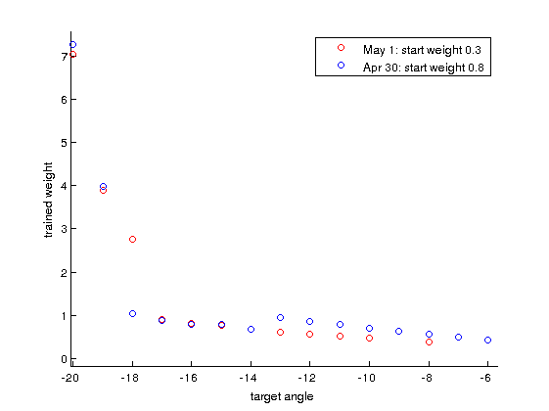
Oddly, the algorithm seems to be settling on two distinct curves. That suggests either an error in the weight finding algorithm or something strange about the model. To investigate, I'm looking at what happens if I run the model for -10 degrees with a weight either of 0.47 or 0.72. I'm just doing 4 runs of the model in parallel. See the script run_model_for_single_weight.m.

Target | Weight | Num par runs | Final angle/SD
-10 | 0.47 | 4 | -10.156/0.0094998
-10 | 0.72 | 4 | -10.201/0.053670
-10 | 0.47 | 8 | -10.127/0.051334

Graphing eyeRy for some of these runs, it becomes clear why there's the slight difference showing up for the different weights:

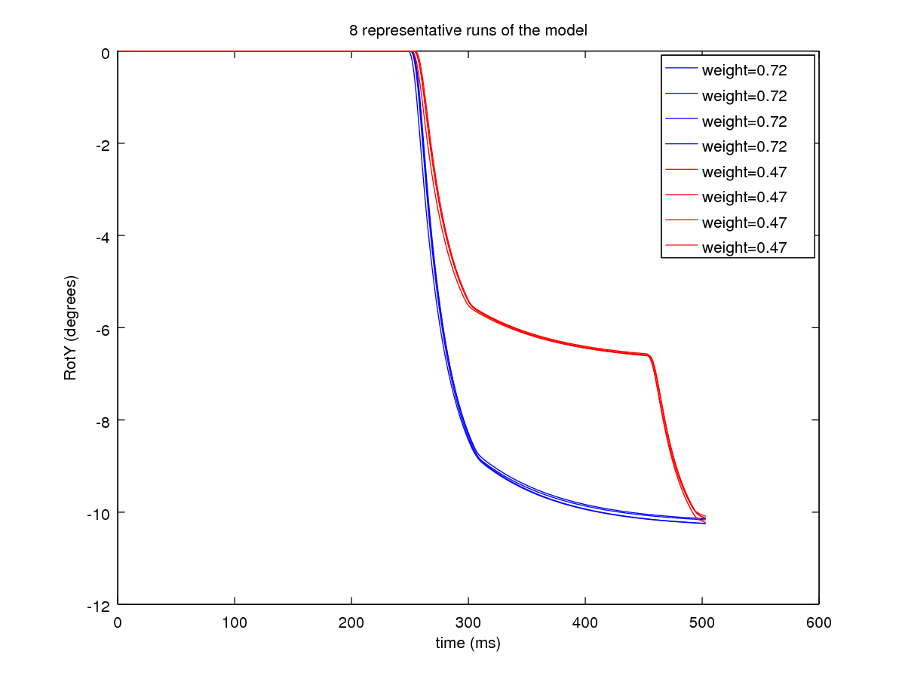
It seems that the TN feedback is NOT preventing a double saccade. Coincidently here, the weight of 0.47 causes the second movement to land the eye in almost the same position as the 0.72 weight!

So what's up with the model? Why the second saccade? Answer: The feedback of the right TN was coming into the “A” port of SC_deep and not the “S” port. So just a model bug. Bah.

I also had some trouble with Iceberg “losing jobs” - not all of my training runs were finishing. I'm not absolutely sure, but I think that it's probably Iceberg's flaky storage. Need to reproduce the error and then search through the stderr output from the jobs (wish I'd done that yesterday, I've lost them now and the last run worked perfectly!!)

I now have good results for leftwards and rightwards saccades to single targets. They're slightly asymmetric, but that's ok:

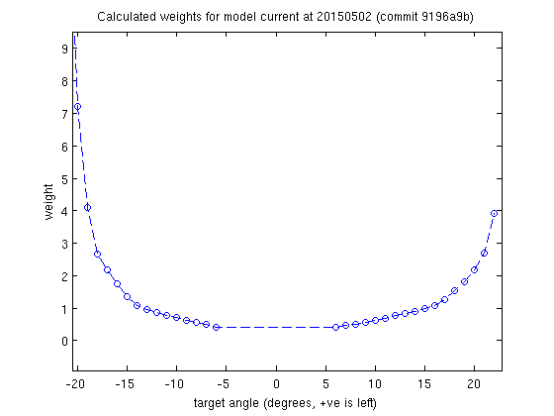

Degrees->Centroid Position

I'm going to revisit the degrees->centroid position conversion. Previously (2015/02/09) I did a calculation of the centroid location of the SC deep hump, but only for +ve RotY. Now I want -ve RotY.

With the current centroiding algorithm built in, I can just read the centroid location (for a single stimulus) out of the input to the SC_deep_output population. Having processed many runs for the weight training, I have all the data available, and it's easy to find:

First load some data:

A = load_ocm ('oculomotorT-10_7_9');

Find where in time the saccade is happening:

plot (A.mn_r) % or plot (A.mn) for a leftwards saccade

Now find the location of the peak in A.sco or A.sco_in:

[a,b] = find (A.sco_in(:,:,240))

This is the rounded location of the centroid though - I'd like to record the non-rounded values.

To do this, use centroid_linear.m to compute the centroid of SC deep:

[c_x, c_y, sigma_a] = centroid_linear (A.scd(:,:,240))

Choose a time shortly before the MN ramps up. You could compute an averate of c_x,c_y for different time steps as the hump builds, but I'll allow the curve fitting to do that for our final degrees->centroid_radius. Hmm - the centroid does evolve quite a bit as it builds. Look at the sco, and choose the time that the hump first appears as a spike in sco.

TargetThetaY | c_x | c_y | Onset time (ms)
-6 | 16.592 | 20.729 | 233
-7 | 16.654 | 21.444 | 226
-8 | 16.453 | 22.081 | 222
-9 | 16.154 | 23.136 | 223
-10 | 16.115 | 24.507 | 225
-11 | 16.169 | 24.872 | 228
-12 | 16.273 | 25.955 | 232
-13 | 16.682 | 26.356 | 236
-14 | 16.194 | 27.030 | 243
-15 | 16.164 | 28.250 | 239
-16 | 16.419 | 28.601 | 242
-17 | 16.416 | 29.172 | 239
-18 | 16.121 | 29.696 | 247
-19 | 16.512 | 30.360 | 253
-20 | 16.054 | 30.718 | 251
-21 | 16.063 | 30.977 | 253
-22 | 16.263 | 31.659 | 258

The mean/sd of c_x here is 16.312/0.210.

A linear polyfit of c_y gives:

octave:273> P = polyfit (thetaY, c_y_, 1)
P =

-0.69352 17.08741

for rightwards saccades.

Lets check the polyfit for the leftward saccades, collect data the same way as above:

TargetThetaY | c_x | c_y | Onset time (ms)
6 | 34.863 | 20.745 | 238
7 | 35.067 | 20.962 | 227
8 | 35.277 | 21.386 | 223
9 | 35.553 | 22.207 | 222
10 | 35.520 | 22.830 | 224
11 | 35.450 | 24.282 | 225
12 | 35.165 | 25.041 | 229
13 | 35.497 | 25.825 | 234
14 | 35.466 | 26.344 | 237
15 | 35.423 | 27.237 | 239
16 | 35.603 | 27.909 | 243
17 | 35.415 | 28.674 | 237
18 | 35.142 | 29.113 | 239
19 | 35.254 | 29.371 | 250
20 | 35.745 | 30.250 | 244
21 | 35.497 | 30.859 | 255
22 | 35.408 | 31.092 | 254

c_x mean/std for leftwards saccdes is 35.373/0.22

octave:88> P = polyfit (thetaYleft, c_y_l, 1)
P =

0.70224 16.29372

This is a little way off the previous numbers of [0.7908,15.0542], but not too far.

I'll run the weight-surface creation now, first for leftwards saccades, but using the new fit for degree_points vs centroid_points and the data in 20150502_1_multicentroid_weights/:

load left.mat
degree_points = L(:,3);
weight_points = L(:,2);
p=[0.70224,16.29372];
centroid_points = polyval(p, degree_points);
s = exp2fit (centroid_points, weight_points, 2);
rad_for_fit = [18:33];
fun = @(s,t) s(1)+s(2)*exp(-t/s(3))+s(4)*exp(-t/s(5));
ff=fun(s,rad_for_fit);
plot (rad_for_fit, ff, 'r-');
hold on;
plot (centroid_points, weight_points, 'bo');
% Now move on to the surface using the line as the maximum.
x=[1:50];
sin_bump = -1.*sin((x+2.5)*(pi/25)); % +2.5 for offset so max is at 35.
figure; plot (x, sin_bump);
% Remove the negative portion:
sin_bump(1:24) = 0;
sin_bump_map = repmat (sin_bump, 50,1);
% Remove any negative portions of the map:
sbm = (sin_bump_map>=0) .* sin_bump_map;
% Turn it round the right way:
sin_bump_map = sbm';
% lastly, combine the two.
weightline = [zeros(1,17) ff zeros(1,17)]
weightmap = repmat (weightline, 50, 1);
final_weights = weightmap .* sin_bump_map;
% Save the weight map in SpineML-friendly format
write_mapped_weights ('explicitDataBinaryFileL.bin', 1, final_weights);

Now carry out the same scheme for the rightward saccades:

load right.mat
degree_points = R(:,3);
weight_points = R(:,2);
p=[-0.69352, 17.08741];
centroid_points = polyval(p, degree_points);
centroid_points = centroid_points(2:end); % See *
weight_points = weight_points(2:end);
s = exp2fit (centroid_points, weight_points, 2);
rad_for_fit = [18:33];
fun = @(s,t) s(1)+s(2)*exp(-t/s(3))+s(4)*exp(-t/s(5));
ff=fun(s,rad_for_fit);
plot (rad_for_fit, ff, 'ro-');
hold on;
plot (centroid_points, weight_points, 'bo');
% Now move on to the surface using the line as the maximum.
x=[1:50];
sin_bump = sin((x-3)*(pi/25));
figure; plot (x, sin_bump);
% Remove the negative portion:
sin_bump(25:end) = 0;
sin_bump_map = repmat (sin_bump, 50,1);
% Remove any negative portions of the map:
sbm = (sin_bump_map>=0) .* sin_bump_map;
% Turn it round the right way:
sin_bump_map = sbm';
% lastly, combine the two.
weightline = [zeros(1,17) ff zeros(1,17)];
weightmap = repmat (weightline, 50, 1);
final_weights = weightmap .* sin_bump_map;
% Save the weight map in SpineML-friendly format
write_mapped_weights ('explicitDataBinaryFileR.bin', 1, final_weights);

[* Note: exp2fit didn't fit well for the data, so I removed the last data point with centroid_points = centroid_points(2:end) and weight_points = weight_points(2:end)].

See Oculomotor/lab_book/20150502_1_multicentroid_weights for the explicitDataBinaryFileL/R.bin. I'll commit these into the model and explicitDataBinaryFile52.bin and explicitDataBinaryFile53.bin (L:52;R:53).
A quick few runs of the model show reasonably accurate saccades, which are no more than about 1 degree out.

3rd July 2015
I'm back to ths model as it's time to write a methods paper. Prior to starting the paper, I need to extend this model to work in two dimensions, so that I can see what happens for arbitrary eye movements. I'm hoping that I'll be able to ignore the rotational component (the oblique muscles).

While I'm here, let's have a short section on...

How to run the model

This is a model of numerous parts and it's not easy to get it all together to work. Usually I run it on iceberg, as that's fastest.

Repositories

From github, you'll need ABRG-Models/abrg_local on the Oculomotor branch, ABRG-Models/saccsim on the brahms_for_iceberg branch and SpineML/SpineML_2_BRAHMS on the NoTremor_Incorp_Saccsim_Wdm_faster_sim branch along with SpineML/SpineML_PreFlight from the abrg_stable_201501 branch.

BRAHMS

The whole model is co-ordinated by BRAHMS. Each component of the model is a BRAHMS component. Within the brain model, each neural population is an instance of a BRAHMS component, automatically generated by SpineML_2_BRAHMS. However, in this model, there are some non-SpineML components as well as the regular SpineML components. These are:

- c++/worldDataMaker.cpp - builds a component which creates the world. This component reads a file called luminances.json and then projects the luminances specified there into the worldframe. It computes the locations of those luminances in the eye frame at every time step so that the retina and FEF populations in the brain receive the correct input whatever the current rotational state of the eye happens to be.
- c++/multicentroid.cpp - computes localised centroids of the activity in the deep layers of superior colliculus. We found this to be necessary to prevent a small hill in one location having the same effect on the LLBNs as a larger hill in a different location. Using the centroid approach, we activate only one (or a handful) of neural elements, passing these through to the LLBNs. It's multicentroid as it aims to average over the range over which there is coordinated activity seen in the SC, which allows there to be multiple hills in SC, with both contributing to eye movement.
- saccsim - This is the Patras biomechanical model. It builds in its own directory (that is, it's not to be found within the abrg_local/Oculomotor directory). Use a standard cmake process to build it. It has a few dependencies, documented within the Sheffield_Brahms_Mods_3 git branch (or in the README.md in the brahms branch). The most recent branches to use, at the time of writing are brahms or brahms_for_iceberg. These can be found on origin git@github.com:ABRG-Models/saccsim.git.

Once it's all built (and the components have been installed in your BRAHMS SystemML directory tree), you can run it.

SpineML_2_BRAHMS

SpineML_2_BRAHMS generates a sys.xml file describing the system to BRAHMS, which then runs it. Normally, that sys.xml incorporates only the SpineML-defined components. In order to include the three additional components described above, I have a modified version of SpineML_2_BRAHMS, which is specific to this model and which adds in the additional components after generating all the SpineML-defined components.

So, to run the Oculomotor model, you have to be on branch:

NoTremor_Incorp_Saccsim_Wdm_faster_sim

This stands for “NoTremor model incorporating the Saccsimm model and worldDataMaker”. The multicentroid component is also incorporated.

Other similar branches are NoTremor_Incorp_Saccsim_Wdm_faster_sim_nocentroid (similar but without the centroiding), NoTremor_Incorp_Saccsim_Wdm (old) and NoTremor_Incorp_Saccsim_2 (old).

SpineML_PreFlight

Use SpineML_PreFlight from branch abrg_stable_201501.

Running the model

With all the components in place, you can run the model something like this:

./convert_script_s2b -m ~/abrg_local/Oculomotor -e0 \
-o /fastdata/pc1ssj/oculomotor \
-p"Str_D1:da:0.5" \
-p"Str_D2:da:0.5" \
-p"Mirror to FEF Synapse 0 postsynapse:w:0" \
-p"FEF_add_noise to FEF Synapse 0 postsynapse:w:1"

Note that I'm using the parameter changing features in convert_script. The dopamine level is modified for Striatum and the part of the model which is intended to model anti-saccades is effectively disconnected.

17th July 2015

I've spent the last couple of weeks reading about superior colliculus.

I've identified the mechanism used by some groups to deal with the hump normalisation problem. See Tabareau et al (incl. Girard) to read about the “invariant integral property” which is based upon numerous observations that overall the neurons in a hump of activity will produce an invariant number of spikes when activated (Munoz et al 1996, Goosens and Van Opstal 2000, Goosens 2005, Soetedjo et al 2002, Anderson et al 1998). Number of spikes in a neuron seems to be invariant for a hump at a given centroid location (Goosens & van Opstal, 2012).

I've realised that in order to do justice to anti-saccades, we need a split model with separate hemifields. The SC is split into left and right hemifields, driven contra-laterally by left and right FEFs (etc?).

Striate cortex is also able to generate saccades; see lesion studies referred to in Sparks & Hartwich-Young, 1989.

I'd like to incorporate a neural multi-centroiding mechanism operating in sc-sup inspired by Volkoun et al 2014. This could go in without the split hemifield changes (which would be extensive). This may involve the addition of an intermediate layer in SC.

20th July 2015
van Opstal and Goosens are quite convincing on the requirement for vector addition in the SC motor output. I'd like to find a model which supports hill averaging in SCsup with motor output in the deepest layers and perhaps affererents to SCint and SCsup. I need to summarize the physiology data in the various papers I have to hand, so I'm making a spreadsheet in SC_physiology_comparison.ods.

22nd July 2015
Back to “why did I not just start figuring out the second lot of weights?”. One problem is that of “component stretching”. See Nichols and Sparks, J. Neurophysiology, 1996. For a horizontal saccade, the firing rate in horiz. EBNs is tightly related to peak velocity and the duration to the saccade duration. When stimulating in SC, the freq of stimulation influences sacc. peak vel. but not sacc. amplitude. Position in motor map influences sacc endpoint, level of activity influences vel (and hence duration). They propose that level of activity sets a gain for the EBNs.
The term cross coupling comes from ___. It's used in van Gisbergen et al. “Experimental test of two models...” Exp. Brain Res. 1985. That refers to some earlier papers describing the phenomenon.
23rd July 2015
So, cross coupling refers to the way that the firing rate in one direction of burst neurons (MLBNs) in PPRF affects the rate in the other “channel”. I found a mention of saccadic cross-coupling in a book chapter from 1982:
van Gisbergen, J. A. M., Ottes, F. P. & Eggermont, J. J. in Physiological and Pathological Aspects of Eye Movements (eds. Roucoux, A. & Crommelinck, M.) 34, 313–318 (Springer Netherlands, 1982).

which I've ordered from the library.
27th July 2015
Met with Kevin on Friday to discuss the SC model. We will need to deal with dual superior colliculi, but to avoid the need to re-design the entire model we'll encode the cross-inhibitory connectivity between the left and right colliculi as in-population connections, retaining our “all four directions in a single population” scheme.
To implement the cross-colliculus inhibition, I need to review the world and eye frame mapping. I'm going to write out a description of the mapping in the source code as readme.worldmapping.
28th July 2015
To change the field of view of the eye system in the model change EyeFrame::fieldOfView. In Alex Cope's version of the model, it is -75 to +75. We would prefer to concentrate on the region around +-30, so fieldOfView should be 61 (rather than 151 as previously).
Doing this, I've found a few bugs in EyeFrame/WorldFrame – mostly range error when writing into arrays - which I'm working through now.
29th July 2015
A note about reference frames. If you set up some luminances in the world frame that look like this:
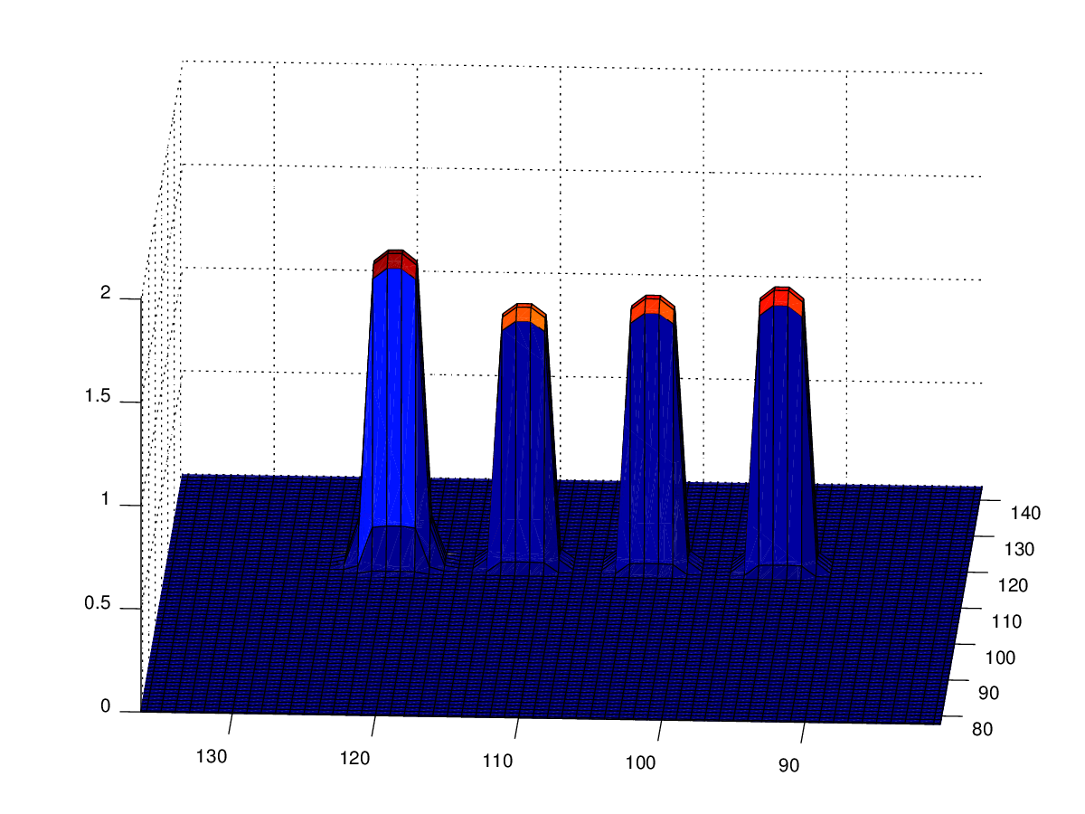
Then, if you rotate the eye by 15 degrees (Rotz) you may see this:
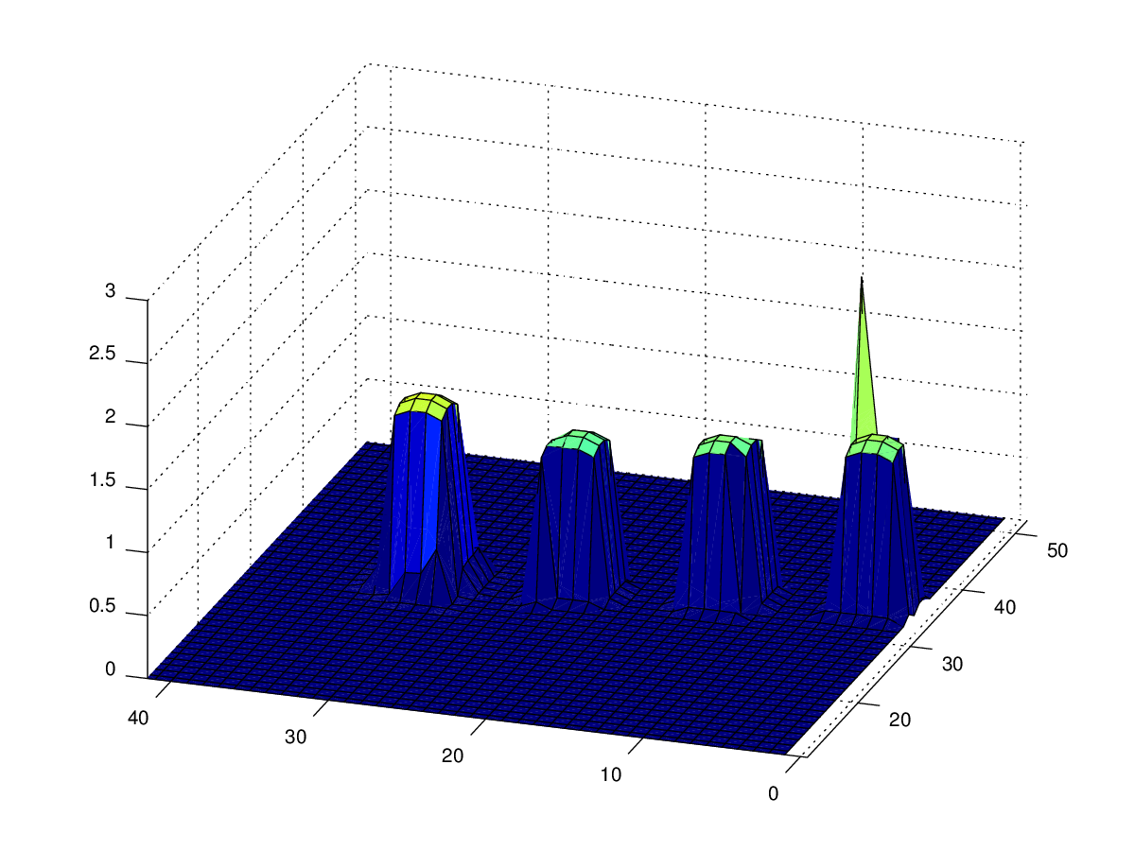
Note the spike. That occurs because after the rotation, the value from two of the pixels in the unrotated world frame are added to a single pixel in the rotated eye frame. It looks all wrong, but it does make sense. The integral of each frame of reference is identical.

12th August 2015
I have implemented cross-collicular inhibition and am now training weights for a two dimensional eye rotation - see rotations_weight_finder_centroid_2d.m. I believe I could also train RotZ weights for each RotX/RotY location to keep the eye “upright”. I need to re-calibrate the translation between units in collicular space and rotations of the eye frame because I re-scaled the size of the collicular maps by changing parameters in worldDataMaker.cpp - see EyeFrame::fieldOfView.
See the section “Degrees->Centroid Position” earlier in this document. That details a manual process for finding the relationship. It should be sufficient to do this just for two dimensions, but perhaps it would be better to automate it and have the position recorded for each weight found using rotations_weight_finder_centroid_2d.m.
Note: I'm currently on the following branches to run the model on Iceberg:
[pc1ssj@testnode03 fast]$ omm_gitver.sh
Oculomotor model git versions current at Wed Aug 12 12:17:53 BST 2015
abrg_local/Oculomotor
* 7882e18 - (HEAD, origin/Oculomotor, Oculomotor) (2 hours ago) Seb James
SpineML_2_BRAHMS
* cfefb08 - (HEAD, origin/NoTremor_Incorp_Saccsim_Wdm_newSC, NoTremor_Incorp_Saccsim_Wdm_newSC) (2 days ago) Seb James
SpineML_PreFlight
* 4cebb18 - (HEAD, origin/abrg_stable_201501, abrg_stable_201501) (5 months ago) Seb James
[pc1ssj@testnode03 fast]$

13th August
Started implementing a scheme to automatically obtain the coordinates (in collicular space) of the hump which causes the saccade in the training scheme. The position of the hump does vary somewhat. For example, for the 10,8 rotation I've been experimenting with, the mean centroid x/y position: 41.748/25.264 from 4 entries with sd 0.19125/0.085308 BUT the number found from the averaged layer (sca) is 47,26 !?
Something is up. Here are the mean values from computing the centroid from scd (allc_x,allc_y) along with the positions produced by the BRAHMS dev/NoTremor/multicentroid algorithm (alla,allb) from 4 runs of the simulation:
allc_x = 41.663 42.006 41.829 42.016
allc_y = 25.342 25.372 25.462 25.225
mean sca x/y position: 44.75/26from 4 entries with sd 2.63/0
alla = 42 47 47 43
allb = 26 26 26 26
Let's see if it's a bug in multicentroid, which is no longer necessary due to the implementation of the cross-commissural connections; I'll enable the centroid component for the centroiding function, as it's simpler.

18th August 2015
Over the weekend I got the weight training algorithms to run on Iceberg and on Monday it completed (circa 40 hours of wall clock time on Iceberg).
Today, I got the 3d version of the training algorithm to converge – the one with RotZ. I also identified a bug in the previous training algorithm. See various scripts with “3d” in their name, currently in the branch Oculomotor_201508_RotZ_training, but I'll merge this into the Oculomotor branch soon.
It would be nice to fit the correct surfaces to these data. That's my next task.

20th August 2015
Yesterday, I had RotZ training running on Iceberg. Today, I'm cleaning up the files (it takes that long!). I also just established that to have the centroids make sense out to the edges of the map, I need a power centroid (which is helpful) or (really) a “continuous centroid” like the one referred to in the Heinke paper. Work for tomorrow.

2nd Sept 2015
Back from a week's holiday + bank hols + EEG/LFP workshop. Prior to holiday, I realised that my RotZ training was leaving large amounts of data on /fastdata, which I then cleaned up with my cleanup.sh script - this took about 4 days!
I also did some work on the retinotopic mapping, finding a sign error in eyeframe.cpp (commit 24c83986). Run the binary worldtest_singlelum to generate the output then run worldtest_singlelum.m in octave to show results. This gives the definitive mapping - positive RotY corresponds to theta=12.5 in the retinotopic mapping. negative RotY to theta=37.5. Positive RotX corresponds to theta=50 and Negative RotX to theta=25. Let's have a table:
RotX/RotY | Direction | explicitData Binary File | Retinotopic Theta
+RotX | U | 53 | 50
-RotY | R | 52 | 37.5
-RotX | D | 54 | 25
+RotY | L | 50 | 12.5

See RetinotopicMapping.ipynb for the full story for mappings both ways, both in maths and in code.

9th Sept
Spent day developing the simulated annealing algorithm to fit a dual exponential curve to the trained weight data.

10th Sept
Notes on the failed runs from the 20150908 data:
48 instances failed with the error message:
error: out of memory or dimension too large for Octave's index type
331 total failed (see rwf3d_logs/missing.txt).
Have written findmissing.sh to find the missing runs and run_weight_finding_3d_list.sh to fill these in.

15th Sept
Now have most of the weights as generated by the weight training routines. I implemented load_interp.m to interpolate any missing values and I'm now working to place the weight maps back into the model. First impression is that it's not going to be very accurate in 2D...

17th Sept
Working out the retinotopic mapping. Again. Improvements/fixes to the RetinotopicMapping.ipynb notebook. Feel like I've nailed it down - both the mathematical mapping, the implementation in Python and the implementation in C++ within the model (in worldDataMaker.cpp).

21st Sept
At the end of the last working day, I got the model running with the new trained maps and verified that I get two dimensional movements for a simulus at an oblique location. The only example I ran was for ThetaX=+10º; ThetaY=+10º. The eye rotated about 7º and 8º, so not accurate, but in the right direction and with the correct order of magnitude. I'd like to know a) Why it's so inaccurate (one problem is that the centroided peak in SC_avg is not always in the same place for a given stimulus) and b) How much it varies from run to run. So, some data analysis now.

22nd Sept
I'm still not quite sure why the SCavg->LLBN maps which I trained from the 5th to the 15th of Sept (call them “201509_RotZ maps”) don't produce reasonably accurate saccades. I'm seeing 6-8 degrees instead of 10 degrees. However, answers to questions a) and b) from yesterday:
a) Don't know yet. The peak can easily move by 1 or even 2 pixels. With the 201509_RotZ maps, that equates to a change in the weight of about ±10%, which results in about ±10% difference in the output angle. However, this is not ±30%, which is the error I'm seeing when I try to run the model with the 201509_RotZ weight maps.
b) Not much - much less variability than the 2-3 degrees offset.
The main issue I found yesterday was that the amount of noise in the model seems to be large enough to trigger a saccade too early, so I have had to modify the min/max parameters in the threshold component called SC_avg, which takes the result from the centroid component and thresholds it to pass through to the LLBNs.
After this change, I did run the training algorithm again for 10º/10º then verify that placing the weight back into the model with write_plane_weight() would give the right result. It did. Here are the weights I got for 10/10/0:
# Run 1
# edbf_num,x/y/z rotn axis,x/y/z targets,phi,r,weight,phi_mean,r_mean
53,1,10/10/0,10,35,0.833146,9.573848,33.723748
50,2,10/10/0,10,35,0.638667,9.573848,33.723748
58,3,10/10/0,10,35,0.190078,9.573848,33.723748
# Run 2:
53,1,10/10/0,9,35,0.833150,9.569311,33.874390
50,2,10/10/0,9,35,0.638670,9.569311,33.874390
58,3,10/10/0,9,35,0.190080,9.569311,33.874390
To summarise, the best weights for a 10/10/0 rotation are (UP/LEFT/ROTZ): 0.833,0.639,0.190.
Now, if I load up the 201509_RotZ maps in octave with
e53 = load_neural_sheet ('~/abrg_local/Oculomotor/explicitDataBinaryFile53.bin');
e53 = reshape (e53, 50, 50, []);
Then the weights for the 10,35 and 9,35 positions aren't so far away from the trained weights above, but the rotation I see is about 15º/5º/0.05º (X/Y/Z).
Let's write_plane_weights() for both 0.833,0.639,0.190 and for the weights in the existing trained map for locations near phi=9,r=34. These are representative results for a single run with the following cmd line invocation:
./convert_script_s2b -e0 -m ~/abrg_local/Oculomotor -o /scratch/pc1ssj/oculomotor -p "Mirror to FEF Synapse 0 postsynapse:w:0" -p "FEF_add_noise to FEF Synapse 0 postsynapse:w:1"
Weights (53/up,50/left,58/oblq) | RotX | RotY | RotZ
most recent training:
0.833,0.639,0.190 | 10.28 | 10.39 | 0.34
201509_RotZ map values:
0.909789,0.350577,0.192250 (9,34) | 11.6547 | 6.21815 | 0.10
0.855267,0.460035,0.186010 (10,34) | 10.7307 | 7.66402 | 0.150841

I think this shows that the weights I determined from my weight training have been affected by the necessary change to max and min in the SC_avg population component and so I simply have to re-run the weight training.
I'll start by training two regions; ±8º to ±12º in RotY and ±8º to ±12º RotX, with RotZ trained to 0º as usual. I'll improve the process by starting from the 201509_RotZ weights - actually scratch that - it's too hard to convert from target thetaX/Y to model-centric retinotopic mapping within the SC deep. Edge effects cause the retinotopic map to be “contracted” from the edges within the SC deep. This effect is compounded by the centroiding algorithm and so it's exacerbated in SC avg. The maps which would be expected to extend to the edges of the square maps are contracted by about 4 or 5 pixels.
I've started a run which will span 8 to 12 degrees.

23rd Sept
Found one problem which was causing the result on my office PC to differ from the result from Iceberg - that saccsim was a different version. Having fixed this, the difference between Iceberg and my PC is smaller BUT it's still different. I have trained weights for TargetThetaX=-10; TargetThetaY=-8. On the Iceberg setup, I get -10 and -8 within the noise error. On the PC system, I get -10 and -10. Odd. The models should be the same; they're on the same branch. Sorted- I wrote my plane weights into explicitDataBinaryFile54 etc rather than explicitDataBinaryFile54.bin. So, now I can train on Iceberg and get sensible results on Iceberg or the PC. That's encouraging.

Sept 29th
Now I have usable weight maps which seem to work to first order. I've run a series of executions on Iceberg to find the error for a single saccade across the region of interest. I'm also now looking at how the model manages to perform multiple saccades.

October 2nd
Multiple saccades are off the menu. This is because the saccade burst generator doesn't have a means to reset the “tonic neurons”. We don't need to perform multiple saccades with the model, so I'm not going to try to have these neurons reset, as I don't really believe in the model of the SBG.
Yesterday I found a sign error in the rotational translation of the eye; this is now fixed.
I'm going to tidy up the various scripts, to bring them into one place, and I'm going to write a script to run some experiments on the model.

October 8th
Running expt_latency_vs_gap with da at 0.3. Also thinking about how to do the antisaccade investigation - initially this will be with fixation and then two luminances.
Results for latency vs. gap are in... but not very good. Looks like this:
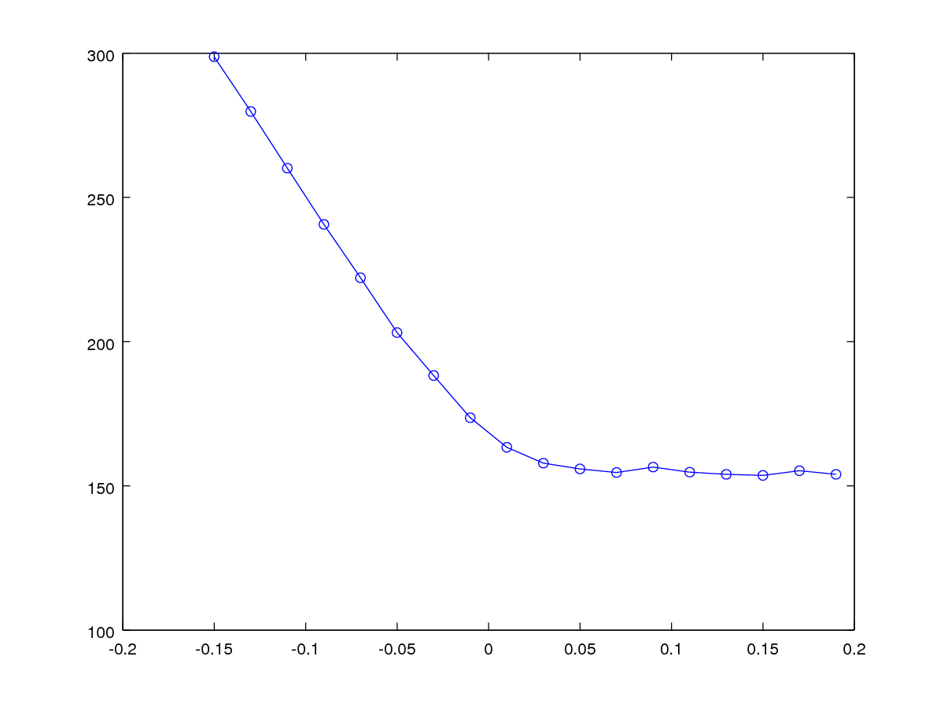
There's no backwards S. I think this is because the fixation is just too strong. The fixation always trumps the target. Is this due to my tecto-tectal inhibition? No, it's not that. Found that I have to make sure the target luminance is very large cf. the fixation luminance, otherwise the fixation continues to hold the system (via STN, which doesn't have the foveal mask).

December 9th
I'm trying to work out why the model is inaccurate when running, with significant undershoot in the final eye position. When training, the model is quite accurate. For example, taking data from the weight finding log file runwfRX-10RY10.out (that is 10º down, 10º left), I see that:
RR: last_angle: (-9.9262 9.8743 -0.17492) cur_angle: (-10.03 9.9943 -0.07724) (sd 0.081787 0.077975 0.0089133)
last_error: (0.073783 -0.12569 -0.17492) cur_error: (-0.03041 -0.00565 -0.07724) last_weight: (0.89711 0.67836 -0.21501)
cur_weight: (0.88837 0.67835 -0.20625) next_weight: (0.89015 0.67835 -0.2014) dedw: (11.918147 -29141.109 11.150634)
Finished with counter=13

Finishing because error is smaller than 1 SD.
Overall best weights for targetTheta=-10 10 0: 0.88837 0.67835 -0.20625 for which angles were: -10.03 9.9943 -0.07724
This shows us that during training, the SD in the end point of the saccade is much less than 1º.
A little further back in the same log file, I see that the pixel location in the retinotopic map space is (21,36):
mean sca x/y position: 21/36 from 8 entries with sd 0/0
I've just verified that the explicitDataBinaryFile maps for down (54) and left (52) contain the correct weights:
octave:89> e54(21,36)
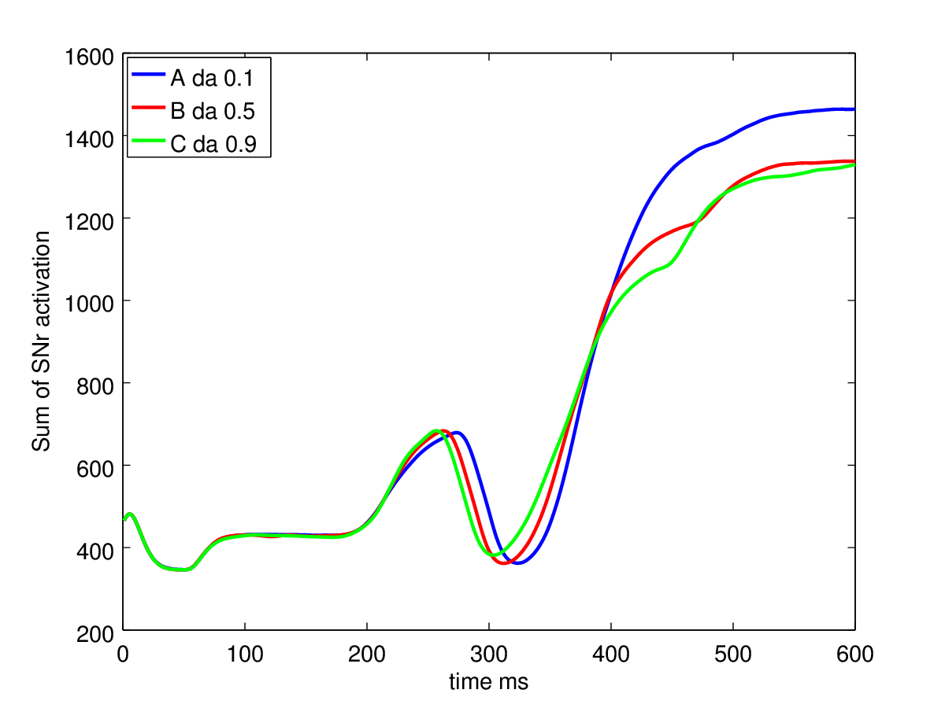
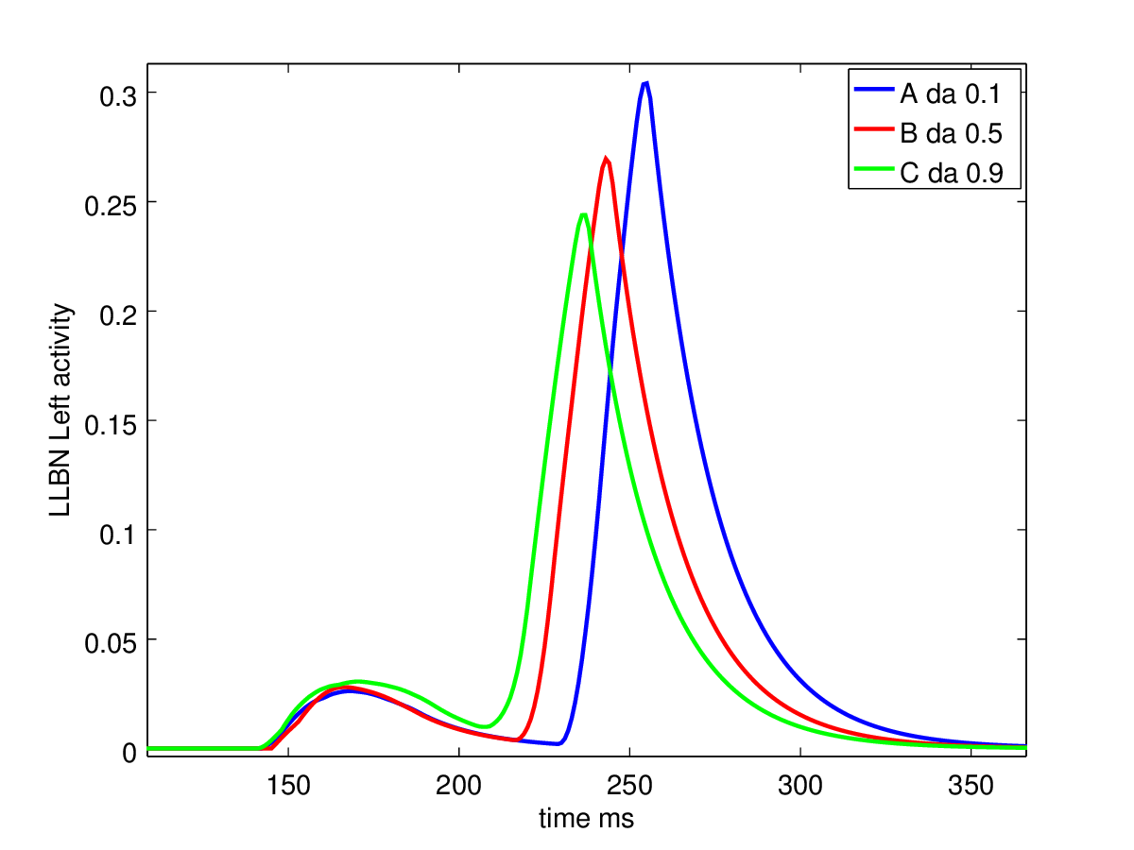
ans = 0.88837
octave:90> e50(21,36)
ans = 0.67835
And that when I re-run the model, the peak in sca is at 21,36 (verified by viewing A.sca(:,:,360)), although it DOES move to (21,37).
However, the final angle when running the model after training is about 3º short in both axes.
I think the only reason can be the dynamics, and maximum value of the peak in sca. I need to run the model with plane weights, as if during weight training and compare the inputs to llbn in both cases.
It may be that I have to increase the gain of the signal into sca, which is achieved with the parameters min and max in the SC_avg population in the model. These are currently set to 15 and 30, meaning that a sum of <15 in SC_deep will not cause any output at SC_avg, and as soon as the output in SC_deep is >30, SC_avg should be at its maximum.
Let's use write_plane_weights to modify explicitDataBinaryFile50 and 54 and see what's up - plot the llbns for plane weights vs. “shaped” weight maps. Result: Writing plane weights into the explicitDataBinaryFiles makes no difference - I still see significant undershoot.
Now I'm retraining using the scripts, just for the angle RX=-10; RY=10. It's still running, but a look at the log file suggests it's converging on similar values as before (e50 approx 0.7 and e54 approx 0.9). Yes, it finishes at 0.87547, 0.68206, -0.19348. So what's the difference when we run for real? I'm storing logs from these runs, though I probably need to increase the amount of logging - the “experiment 2” which the training is making use of (see run_simulation_multi.m) creates only minimal logging.
Ok, I've left the model in its post-training state (i.e. with the best plane weights). I've run both experiment 2 and experiment 0 using the same luminance.json file as for the training. I get similar results in each case. Let's now copy in the shaped weight maps and try again. Still working perfectly. Now lets mess with the luminances.json file and see if that affects the results.
Change:
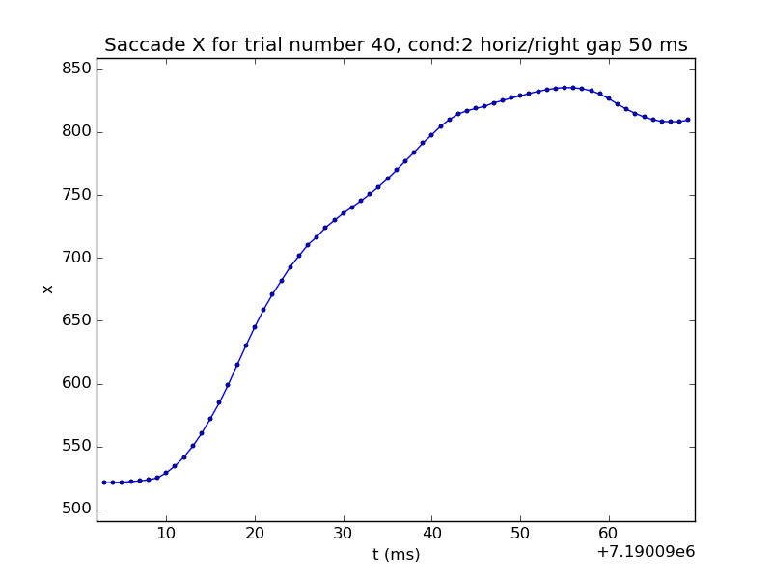
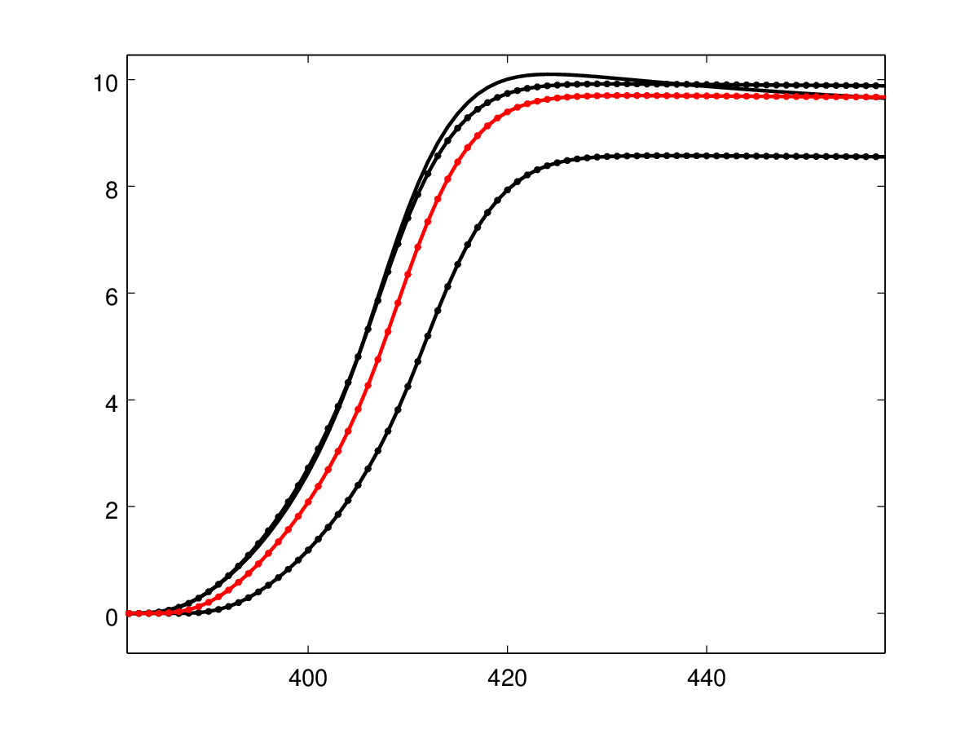
{"luminances":[{"shape":"cross","thetaX":-10,"thetaY":10,"widthThetaX":6,"widthThetaY":2,"luminance":0.2,"timeOn":0.12,"timeOff":0.6}]}
to:
{"luminances":[{"shape":"cross","thetaX":-10,"thetaY":10,"widthThetaX":6,"widthThetaY":2,"luminance":0.2,"timeOn":0.2,"timeOff":0.6}]}
To see if the “on time” has an effect. Result: It doesn't
Now change it to:
{"luminances":[{"shape":"cross","thetaX":-10,"thetaY":10,"widthThetaX":6,"widthThetaY":2,"luminance":0.4,"timeOn":0.12,"timeOff":0.6}]}
To see if luminance has an effect. Result: Big effect. End point (for RX) is now 13º rather than 10º. Here's the reason the model didn't appear to be working. It's down to the dynamics of the signal in SC_avg. The fact that any dynamics at all are permitted is causing the issue. The model will be accurate only for saccades to single cross shaped targets with dimensions 6 and 2 and luminance 0.2.
Here's the graph for rotation (octave messed it up for some reason, but it serves) and llbn_l:
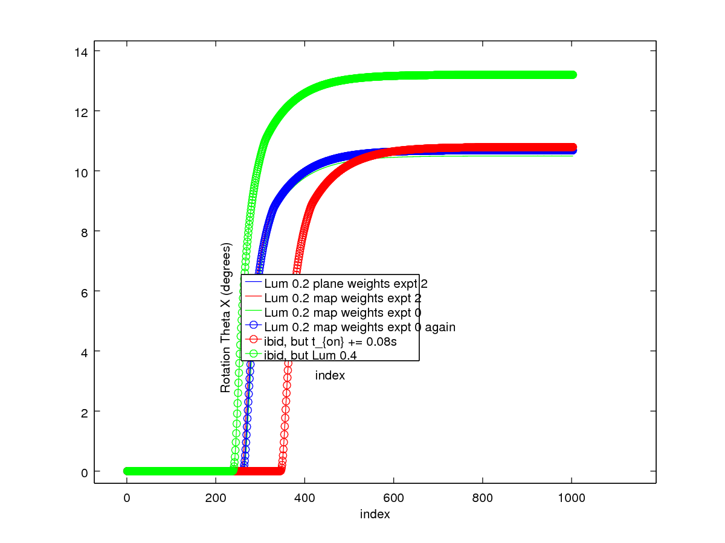
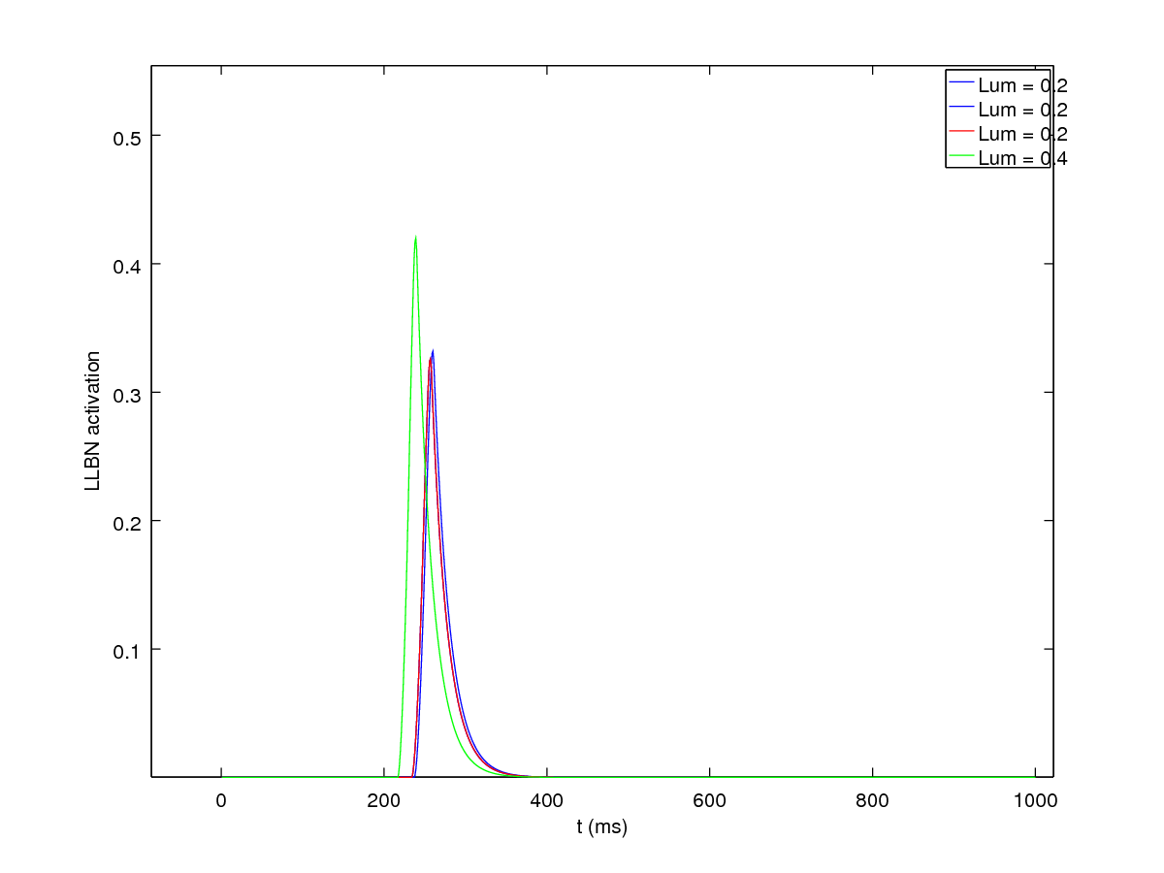
What solutions? 1) Make min==max (in the threshpass component, SC_avg) so that as long as there's ANY signal in SC deep, then there's a maximum spike in SC_avg. The inhibitory feedback goes back to SC_deep though, so we'll still see differing rates at which the SC_avg signal will be reduced to nil, depending on the size of the hump in SC_deep - the SC_avg signal would disappear when the SC_deep hump dropped back below its threshold (min). So, in addition to solution (1), we'll need inhibitory feedback into SC_avg as well. Let's try this, retraining for RX=-10, RY=10.
Modifying the threshpass population
I've added an “inhibit” input to threshpass, and connected the IBN inhibitory connections to this. Relevant changes are in commit 7ba3582. There's still some dynamics left in the LLBN signal, although less - doubling luminance changes the endpoint by about 0.7º in one axis. Will have to think about how to fix this up. Perhaps something in threshpass which, once the threshold has been exceeded, sets off a “pre-programmed” stimulation through to llbn, such that the dynamics of this stimulation is never changing.

20160120
To get over the problem of the dynamics affecting the saccade size, I've implemented a scheme to create a “stereotyped impulse” to feed into the LLBN neurons. The component which creates this signal is called “MuscleInputGen.xml” because it generates input for the muscle “channels”. It contains two first order differential equations; one which is fast and is sent as the output; the second is slower and is used to prevent repeat impulses over a short timescale. The population containing this component is called “ImpulseGen”. I tried connecting the “trigger” signal recurrently with all-to-all connectivity so that additional activity in SC_avg (say the centroid moves by a pixel) would not cause additional activity in ImpulseGen. However, this isn't having the desired effect. An alternative is to feed back to SC_avg and block everything there while there is activity in ImpulseGen.

20160121
I've added a feedback from ImpulseGen to SC_avg so that SC_avg is reduced to 0 as soon as there is activity in ImpulseGen. This seems to work - I now see a stereotyped output function appearing in the LLBNs. When a new hill of activity builds up in SC_deep, a new stereotyped output is generated in LLBNs. I'm going to try to confirm that I can train this network to an output now, but first I want to find out why I've had to reduce the timestep from 1 ms to 0.5 ms as a result of introducing the ImpulseGen population. For this, I'll return to the MuscleInputGen project which is the simplest implementation of the MuscleInputGen.xml component.
Ok, I did this, and that model now seems to work ok (when run on my office PC) with timesteps as long as 10 ms. Back to the OMM; can I restore my 1 ms timestep? Yes, seems fine, so long as I set 1 ms delays in the relevant connections (the recurrent connections in ImpulseGen and ImpulseGen->SC_avg).
On to training.

20160126
I separated the saccade generator part of the model into its own project; Oculomotor_SGonly. To do the weight training, I only need to inject input into this part of the model – I can mock up the output of the centroid component in the main model. I have to ensure that when a saccade has started, subsequent input into the SC_avg population does not cause a saccade. I've achieved this with some computationally costly all to all connections within the ImpulseGen populations and from ImpulseGen to SC_avg. At least one of these is not required, I hope. The problem is that the “spike” presented to SC_avg may move by a pixel as the hill of activity in SC_deep develops. I need the movement of the spike to NOT cause an additional impulse.
I've arranged the parameters in the SG circuitry so that it now produces sensible amplitude saccades for “model” input. I want to transfer that circuitry back into the main Oculomotor model so that I can verify if I need all of the all-to-all connections around ImpulseGen. After doing this, I can move to train the SG.
By commit 469d227 the Oculomotor model is now working – I can do a series of saccades and it looks fairly sensible – the saccade amplitudes are even relatively sensible.
Now weight training using rotations_weight_finder_stereotyped.m

20160211

Over the last few days I've been working on two things towards the goal of having a trained set of SC->LLBN weights.

The first is a Nelder-Mead algorithm to find the correct weight map. The second is an optimisation in SpineML_2_BRAHMS which speeds up alltoall connections with fixed parameters and no state variables.

The first I thought necessary because my gradient descent algorithm seemed not to be working after changing to a stereotyped input. This seemed a bit inexplicable, but I decided that it must be the fact that an activation of one muscle in the eye leads to rotations in all axes of the eye. I couldn't see a way to improve the process and so I moved on to implement the N-M algorithm, which took a couple of days work. Having done this, I now see rather noisy weight maps and I'm just re-visiting the gradient descent method, which thanks to the S2B speedup is now much faster (taking a few hours rather than 4 days as it used to!).

20160226
Going to try something more biological than the stereotyped input to the brainstem system. Going to try and compensate for luminance by using a signal from SC superficial/retina. Maybe have another population which integrates light input or rather doesn't allow it to decay too fast, and then modulate the output of SC_deep into the brainstem system.
I'll do this work in a new branch off Oculomotor. Let's call it Oculomotor_201602_luminance.

20160229
I've got two options (and two branches) for the luminance compensation. One is the already mentioned Oculomotor_201602_luminance; the other is Oculomotor_201602_lumcomp_arith.
The latter would leave the centroiding operation in place, and would use an integral of luminance to modulate the output from the LLBNs.
I noticed recently (while preparing slides for a lecture) that SC is innervated directly only from neurons of the temporal side of the retina. I need to find a good source for this information, but it suggests that within a single colliculus, it would be hard to use information incoming from the same colliculus as it doesn't cover the nasal side of the structure. Perhaps my luminance information/integral is coming in from LIP or SEF? It doesn't really matter for now; we're only trying to show that such a mechanism is required and can be implemented.
Reading Groh (2001) again, it would seem that the vector summation with saturation mechanism would circumvent the luminance problem - in this case, the luminance (or rather representation of attentional salience) WITHIN SC deep would contribute to the normalisation process.

20160304
Have spent a day or so (on Monday) implementing a luminance compensation scheme, which uses a delayed signal from SC superficial to feed a denominator into SC_avg. So, I'm dividing the “stick” which results from the centroid operation. This work in in branch Oculomotor_201602_lumcomp_arith. I named the population in which the signal from SC_sup is delayed “SC_buildup” which will probably cause grief at some point!
This does moderate the change in eye position which results from a change in luminance.
See in this image; the TOP blue trace (largest RotY at end) is luminance 0.2, da 0.5 and the red line is luminance 0.3, da 0.5. Note that for a larger luminance, a smaller saccade was produced (it was late, hence I coloured two lines blue):
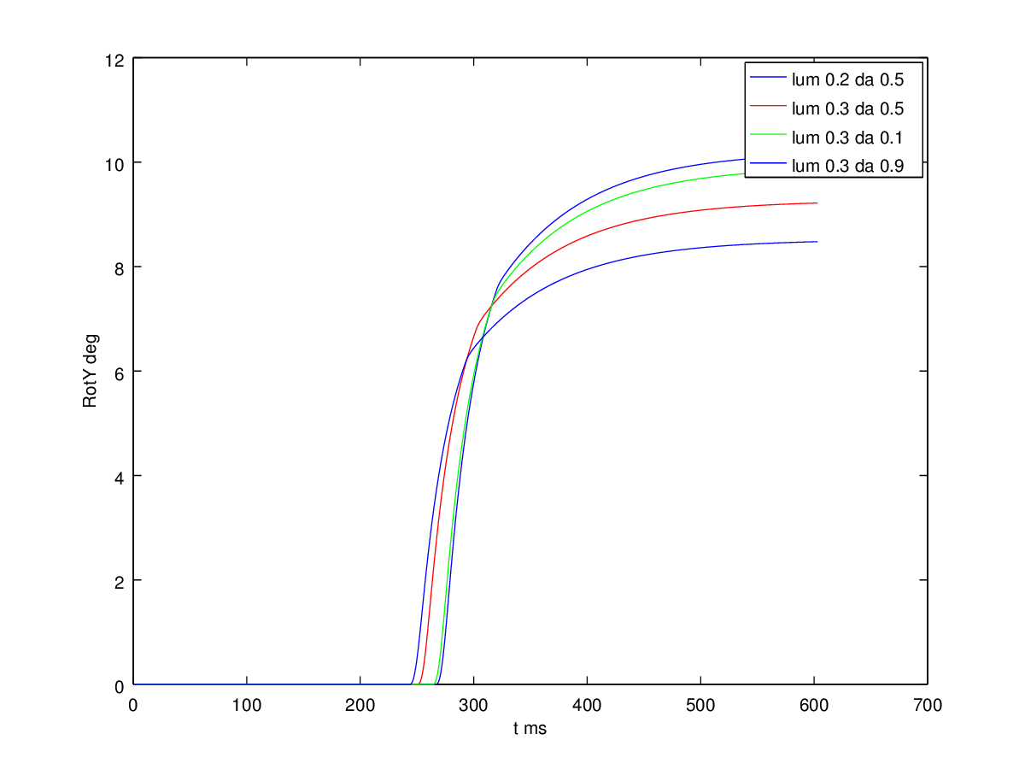
I'm using existing weight maps from SC_avg->LLBNs (NB: SC_avg is probably best named “LLBN” and what we have as LLBN are probably best labelled as another kind of EBN).
I've added a gain in SC_avg to allow me to get the system to work passably for some saccade (say 10º right) and then it'll not be too bad for other saccades and it saves me the trouble of weight training for the time being (which is rather a lot of work!).
Now, the idea of this was to allow Basal Ganglia to feed dynamics into the system. This is intended to allow the BG to contribute to hypometric saccades. Unfortunately, decreasing dopamine in this model correlates with increasingly hypermetric saccades:
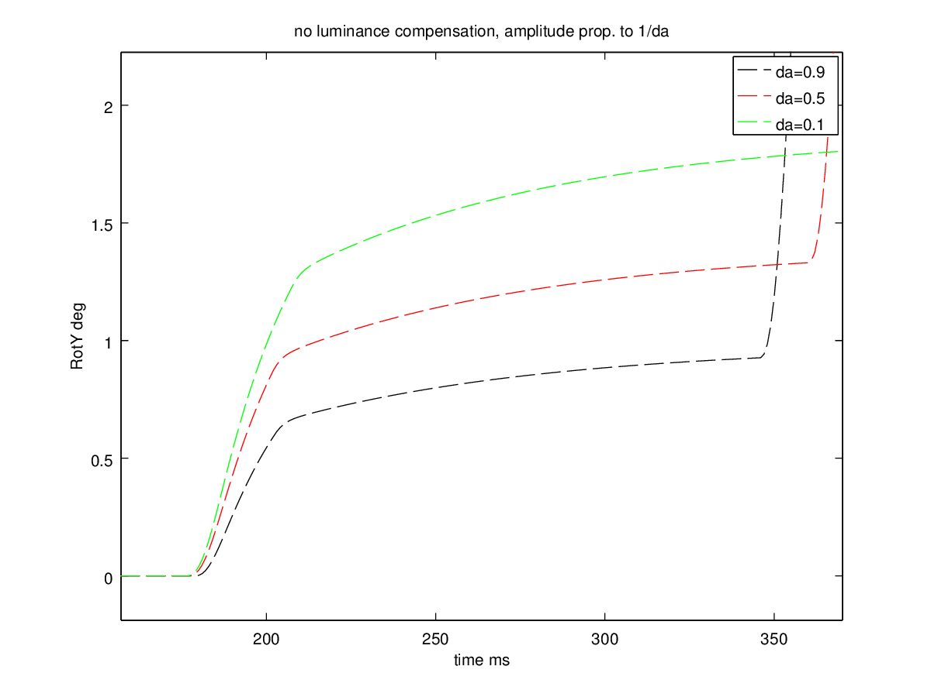
In the figure above, the luminance compensation was turned off (by setting 0 weight between SC_sup and SC_buildup). The same effect can be seen in the last but first figure for this day's entry, where in that case the luminance compensation was switched on (with 0.3 in the SCsup->SCbuildup weight).
It's hard to say where this behaviour comes from. Here are a couple of graphs:
Activity in SNr shows how the disinhibition is earlier for high da, but doesn't seem quite so high. Why does increased da lead to less disinhibition? It's worth remembering that the signal is SC_avg is the centroid of SC_deep and so contains a signal which is derived from the entire area of SC_deep.
Talked to Kevin about this. He suggested that the 1+da and 1-da in D1 and D2 MSNs is not sacrosanct. Changing to 0.2+da and 1-da makes it possible to give the BG a PD-like state. Now low dopamine saccades ARE hypometric.

20160330
Just after the easter break. During the easter holiday, have sped up the execution of this model by completing the all-to-all optimization code in SpineML_2_BRAHMS. I'm currently using branch NoTremor_Oculomotor_201603 there.
Now that I've got a mechanism to compensate for luminance, and I've got an argument for the centroiding scheme (to make the weight training tractable), I turned my attention to the rather slow saccades - or rather, the fact that the saccades approach the final target rather slowly, after a fast initial motion.
First of all, I spent an afternoon attempting to sort out the problems with Chris's latest biomechanical model. He has not been able to compile the brahms component version of this code (in the “chr” branch of the saccsim repository). I managed to get it to compile, but it crashes when the saccsim module is loaded by brahms. At this point, I have given up and returned to using Chris's older model which does not have the following improvements cf. the “chr” branch:
[13:46:09] Sebastian James: Out of interest, what are the technical improvements between the chr branch and the old branch I was using (about 18 months old now I guess)?
[13:46:39] Chris Papapavlou: First of all the Geometry of the muscles has changed.
[13:46:47] Chris Papapavlou: It is more accurate now.
[13:47:14] Chris Papapavlou: The muscle wrapping around the eyeball is more stable and correct also.
[13:47:41] Chris Papapavlou: And the used parameters are more close to the reality now as well.
[13:48:06] Sebastian James: Ok, so I do think I want to use this version, for sure.
Returning to the “brahms” branch (and incorporating some changes Chris made in a brahms_fixes branch), I decided to tweak parameters in the eye model to get a better trajectory. At the head of the brahms branch, saccsim parameters are now in saccsim/config/params_brahms.txt. In this file, I have tweaked viscosity down from 0.00045 to 0.00028, which allows the eyeball to approach the final target more quickly. The timescales seem to be quite realistic when compared with a sample trajectory. In the figures (left, blue is experimental data), both cover a time period of about 70 ms. Timescales are sensible. Model trajectories perhaps a little fast, but generally ok.
Today, I also changed the luminance compensation, taking a delayed signal from FEF now, rather than from SCs. I'm not yet sure I like this scheme. The problem is that the signal in FEF is affected by the thalamo-cortical-BG loop. Perhaps I should have another population like FEF to hold the luminance/contrast signal? That's food for tomorrow's thought.

20160407
Over recent days I spent time working on the question of saccade amplitude vs. luminance. I built an experiment to investigate saccade amplitude vs. luminance; see batch_scripts/expt_sacc_vs_luminance. This runs multiple simulations, with 6 runs for each luminance in a range from 0.2 to 1.6. NB: I had to put in a fixation luminance, else I would see many express saccades (of rather random sizes).
Once I'd figured out the issue with the fixation luminance, I found that the compensation mechanism was successfully fixing the variation of saccade size vs. luminance - without having had to do any tweaking of the gain/divisor etc. I got suspicious at this point and implemented a change in threshpass to allow me to turn the divisor off. I re-ran expt_sacc_vs_luminance and lo and behold, no dependence of saccade size on luminance value. The graph shows all the trajectories (in RotY vs. time) for the model at a range of target luminance values.
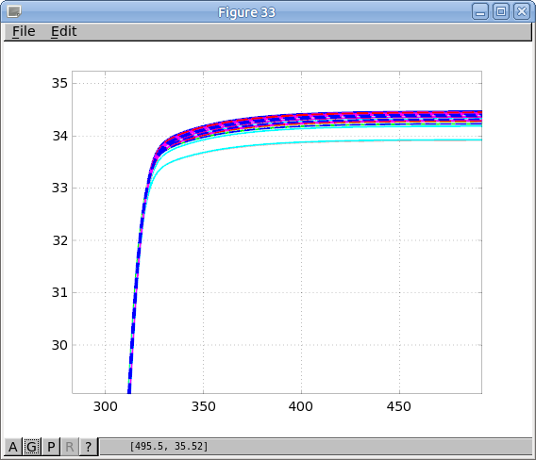
However, I clearly have the wrong weight map now, as a target at a larger amplitude no longer causes a larger amplitude saccade - the target dynamics at the larger amplitude must be so much smaller that even though the weight at this position is larger, the saccade is smaller.
That means it's time to weight train. Oh, I also recently much improved the code to find the end of the first saccade, so I'm hoping that the saccade training scheme will work well now. There are a few confounds. One is that I'm not sure that the weight training process can take into account the possibility that an express saccade may occur. Express saccades will not have a sensible amplitude in this model, as far as I know, and so any express saccades which occur ought to be ignored in the weight training.

20160413
Weight training is, as usual, proving to be problematic. With the changes to the network - the feedback which now only goes to SCdeep (and not to LLBN) and the changes in time constants in the brainstem, it seems that I'm having a hard time getting the gradient descent to converge or settle.
I've implemented a scheme which records the errors, weights and eye positions during the weight training (using the gradient descent scheme). Here's an example for RX-8, RY3:
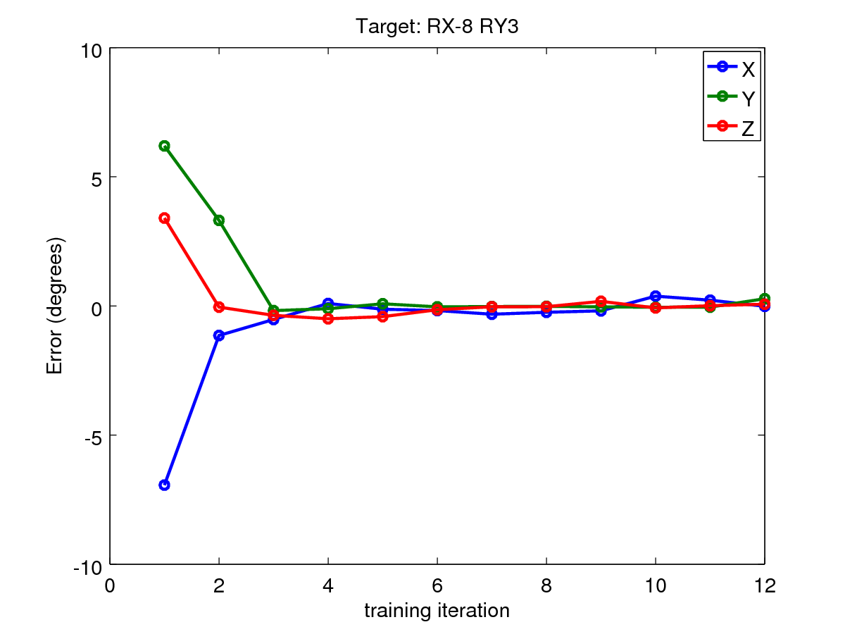
It gets close to 0 error very quickly, but then can't get close enough for the algorithm to complete, presumably finishing because it randomly ended up with suitable parameters at iteration 12.
Here's another:
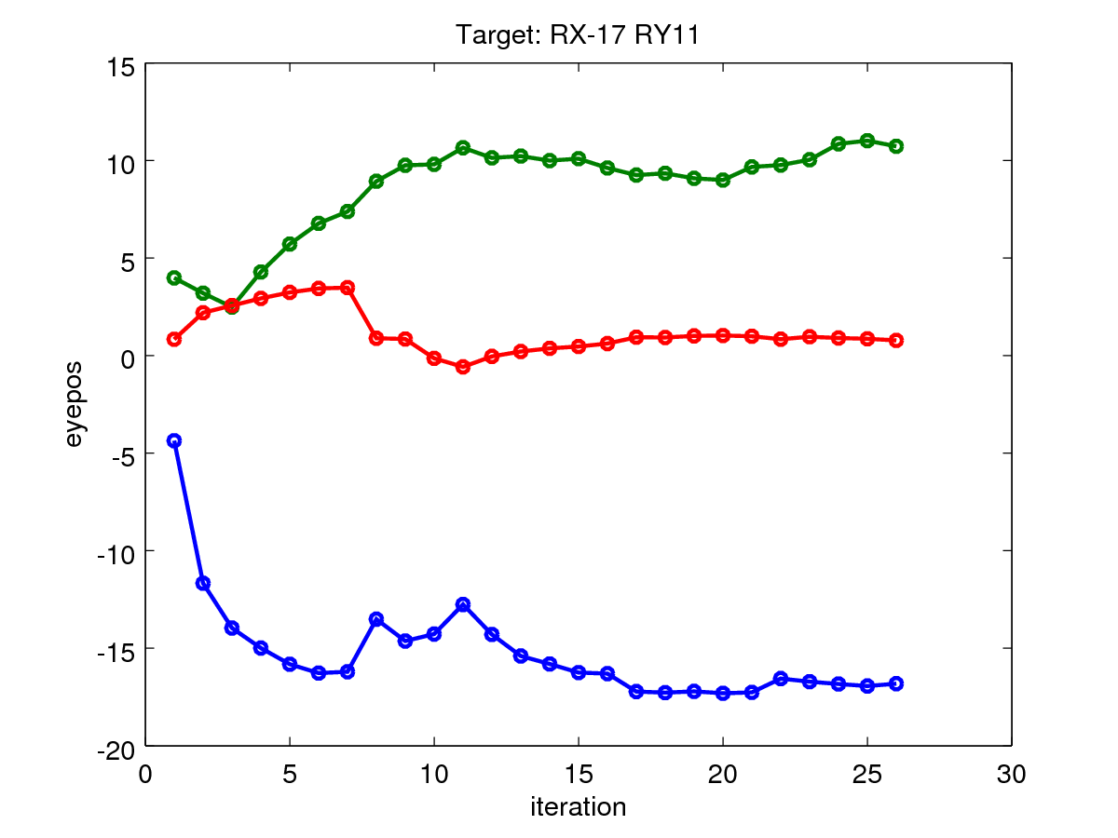
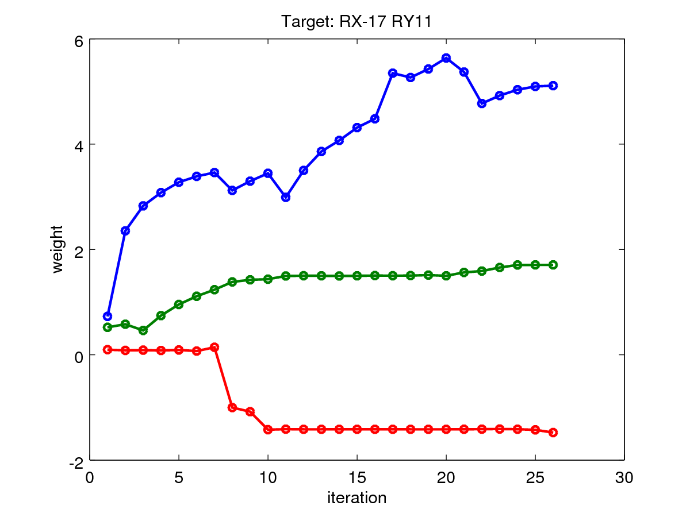
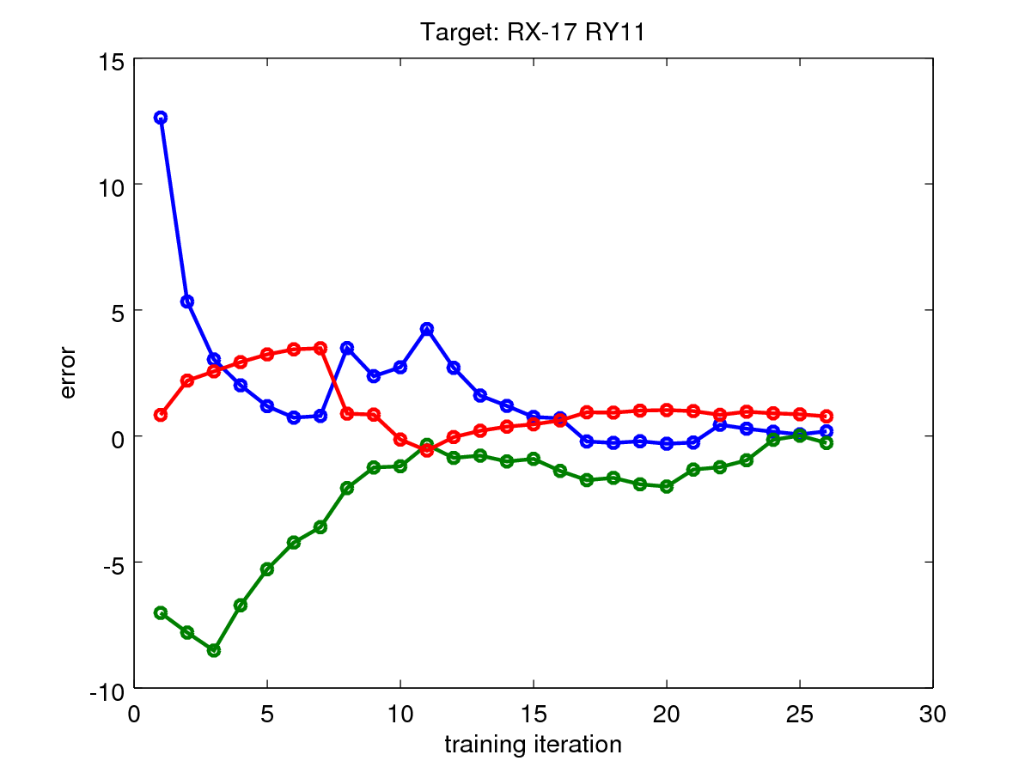
Associated eye pos and weight:

I seem to get different converging behaviours at different target locations. Some locations fail to converge for given learning rates. The learning rate above was either 0.4,0.2,0.2 or 0.7,0.7,0.7. That's set in the learning_rate variable in the rotations_weight_finder_centroid_3d.m script. Idiotically, I changed it during a run of run_weight_finding_3d_many.sh.
I'll write a script to quickly visualise throught the many RotConv_* files which are produced to try to get a feel for what the learning rate should be - perhaps it should vary depending on the region in the field of view.
I've done this; it's useful. I've added a scheme to show how the weights are calculated (there are various methods in the code to get around problems) to try to figure out why the training is not reliable.
Next thing to figure out is why the weight/amplitude relationship seems to be inverted for RX-18RY4 at the moment...

20160414
Trying to find out if the model is behaving sensibly and whether I can hand train to get close to RX-18,RY4. Running both on Iceberg and locally to get RX,RY,RZ for certain wX, wY, wZ settings. Using fixation and target luminances of 0.3.
Running with Oculomotor model at commit 2be842a and saccsim at commit f92e69c.
Create target luminance file with:
# PSY0001622
write_single_luminance ('~/omm/abrg_local/Oculomotor/luminances.json', -18, 4, 0.3, 0.3)
or
# Iceberg
write_single_luminance ('~/abrg_local/Oculomotor/luminances.json', -18, 4, 0.3, 0.3)
Run experiment 2 (the one used for weight training).
Run in Iceberg with (from octave):
[epa, epsd, epf, pp] = run_simulation_multi ('/home/pc1ssj/abrg_local/Oculomotor', output_dirs, 6, 1, 0)
Run on PSY0001622 with (from SpineML_2_BRAHMS dir):
./convert_script_s2b -m ~/omm/abrg_local/Oculomotor -e2
Target lum |  |  | Plane weights |  |  |  |  |  | Run on Iceberg |  |  | Run in office
thX | thY | thZ| | L50 | R52 | U53 | D54 | Z58 | Z57 | IX | IY | IZ | HX | HY | HZ
-18 | 4 | 0 | 1 | 0 | 0 | 1.6 | 0.1 | 0 | -7.6 | 6.1 | 1.5 | -7.4 | 6 | 1.2
-18 | 4 | 0 | 1 | 0 | 0 | 3.5 | 0.1 | 0 | -16 | 5.6 | 3.2 | -15.75 | 5.4 | 3
-18 | 4 | 0 | 0.8 | 0 | 0 | 4.5 | 0 | 0.1 | -18 | 4 | 3.4 | - | - | -
-18 | 4 | 0 | 0.8 | 0 | 0 | 4.5 | 0 | 0.3 | -18 | 4 | 3.3 | - | - | -
-18 | 4 | 0 | 0.8 | 0 | 0 | 4.5 | 0 | 2 | -15.7 | 5.3 | -1.1 | - | - | -
-18 | 4 | 0 | 0.8 | 0 | 0 | 4.5 | 0 | 1 | -17.2 | 4.7 | 1.5 | - | - | -

Note that once I'd verified that the single model and the Iceberg model are indeed doing more or less the same thing, I reverted to using just Iceberg.
Ok, so I am homing in on the right values above, by setting them manually.
In this case, it's clear that the Z weight has quite a significant effect on the X and Y rotations. I think this could be the root of the cause of the strange behaviour. My algorithm computes de/dw on a per-axis basis, but I really need the Jacobian matrix so that I know the partial de/dw_xyz.
Rather than try to estimate the Jacobian, I think I could make the z component learning rate much smaller than the x/y component learning rates so that the x and y weight updates should be less likely to be confused by the z weight update.
I did have 0.7,0.7,0.7. Let's try 0.7,0.7,0.1 now.
I found some more problems. One was the code I was using (from rotations_weight_finder_centroid_3d.m) to find the start of the saccade. I was using a find_peaktime() function, which had an LLBN threshold which was causing a problem. I have changed to using find_firstmotion() which uses the eye motion data instead. Then, in find_saccade_location, the LLBN threshold was also a problem, so here, I start from a large threshold and gradually reduce that threshold to ensure I get the “main” LLBN activity (and not any activity associated with a nascent express saccade).
The weight training now looks like it may be converging (it's running now on Iceberg for RX-18,RY4).
Update: Ok, it sort of converges, but then loses the convergence again. I think I may need to compute the Jacobian by varying the weights individually, measuring the partial de/dws so that I can then make a step in three dimensions. Perhaps I could have an assumed-orthogonal stage of the process, followed by this more involved Jacobian-using process when the convergence seems not to be occurring. This seems like it's tomorrows job.

20160415
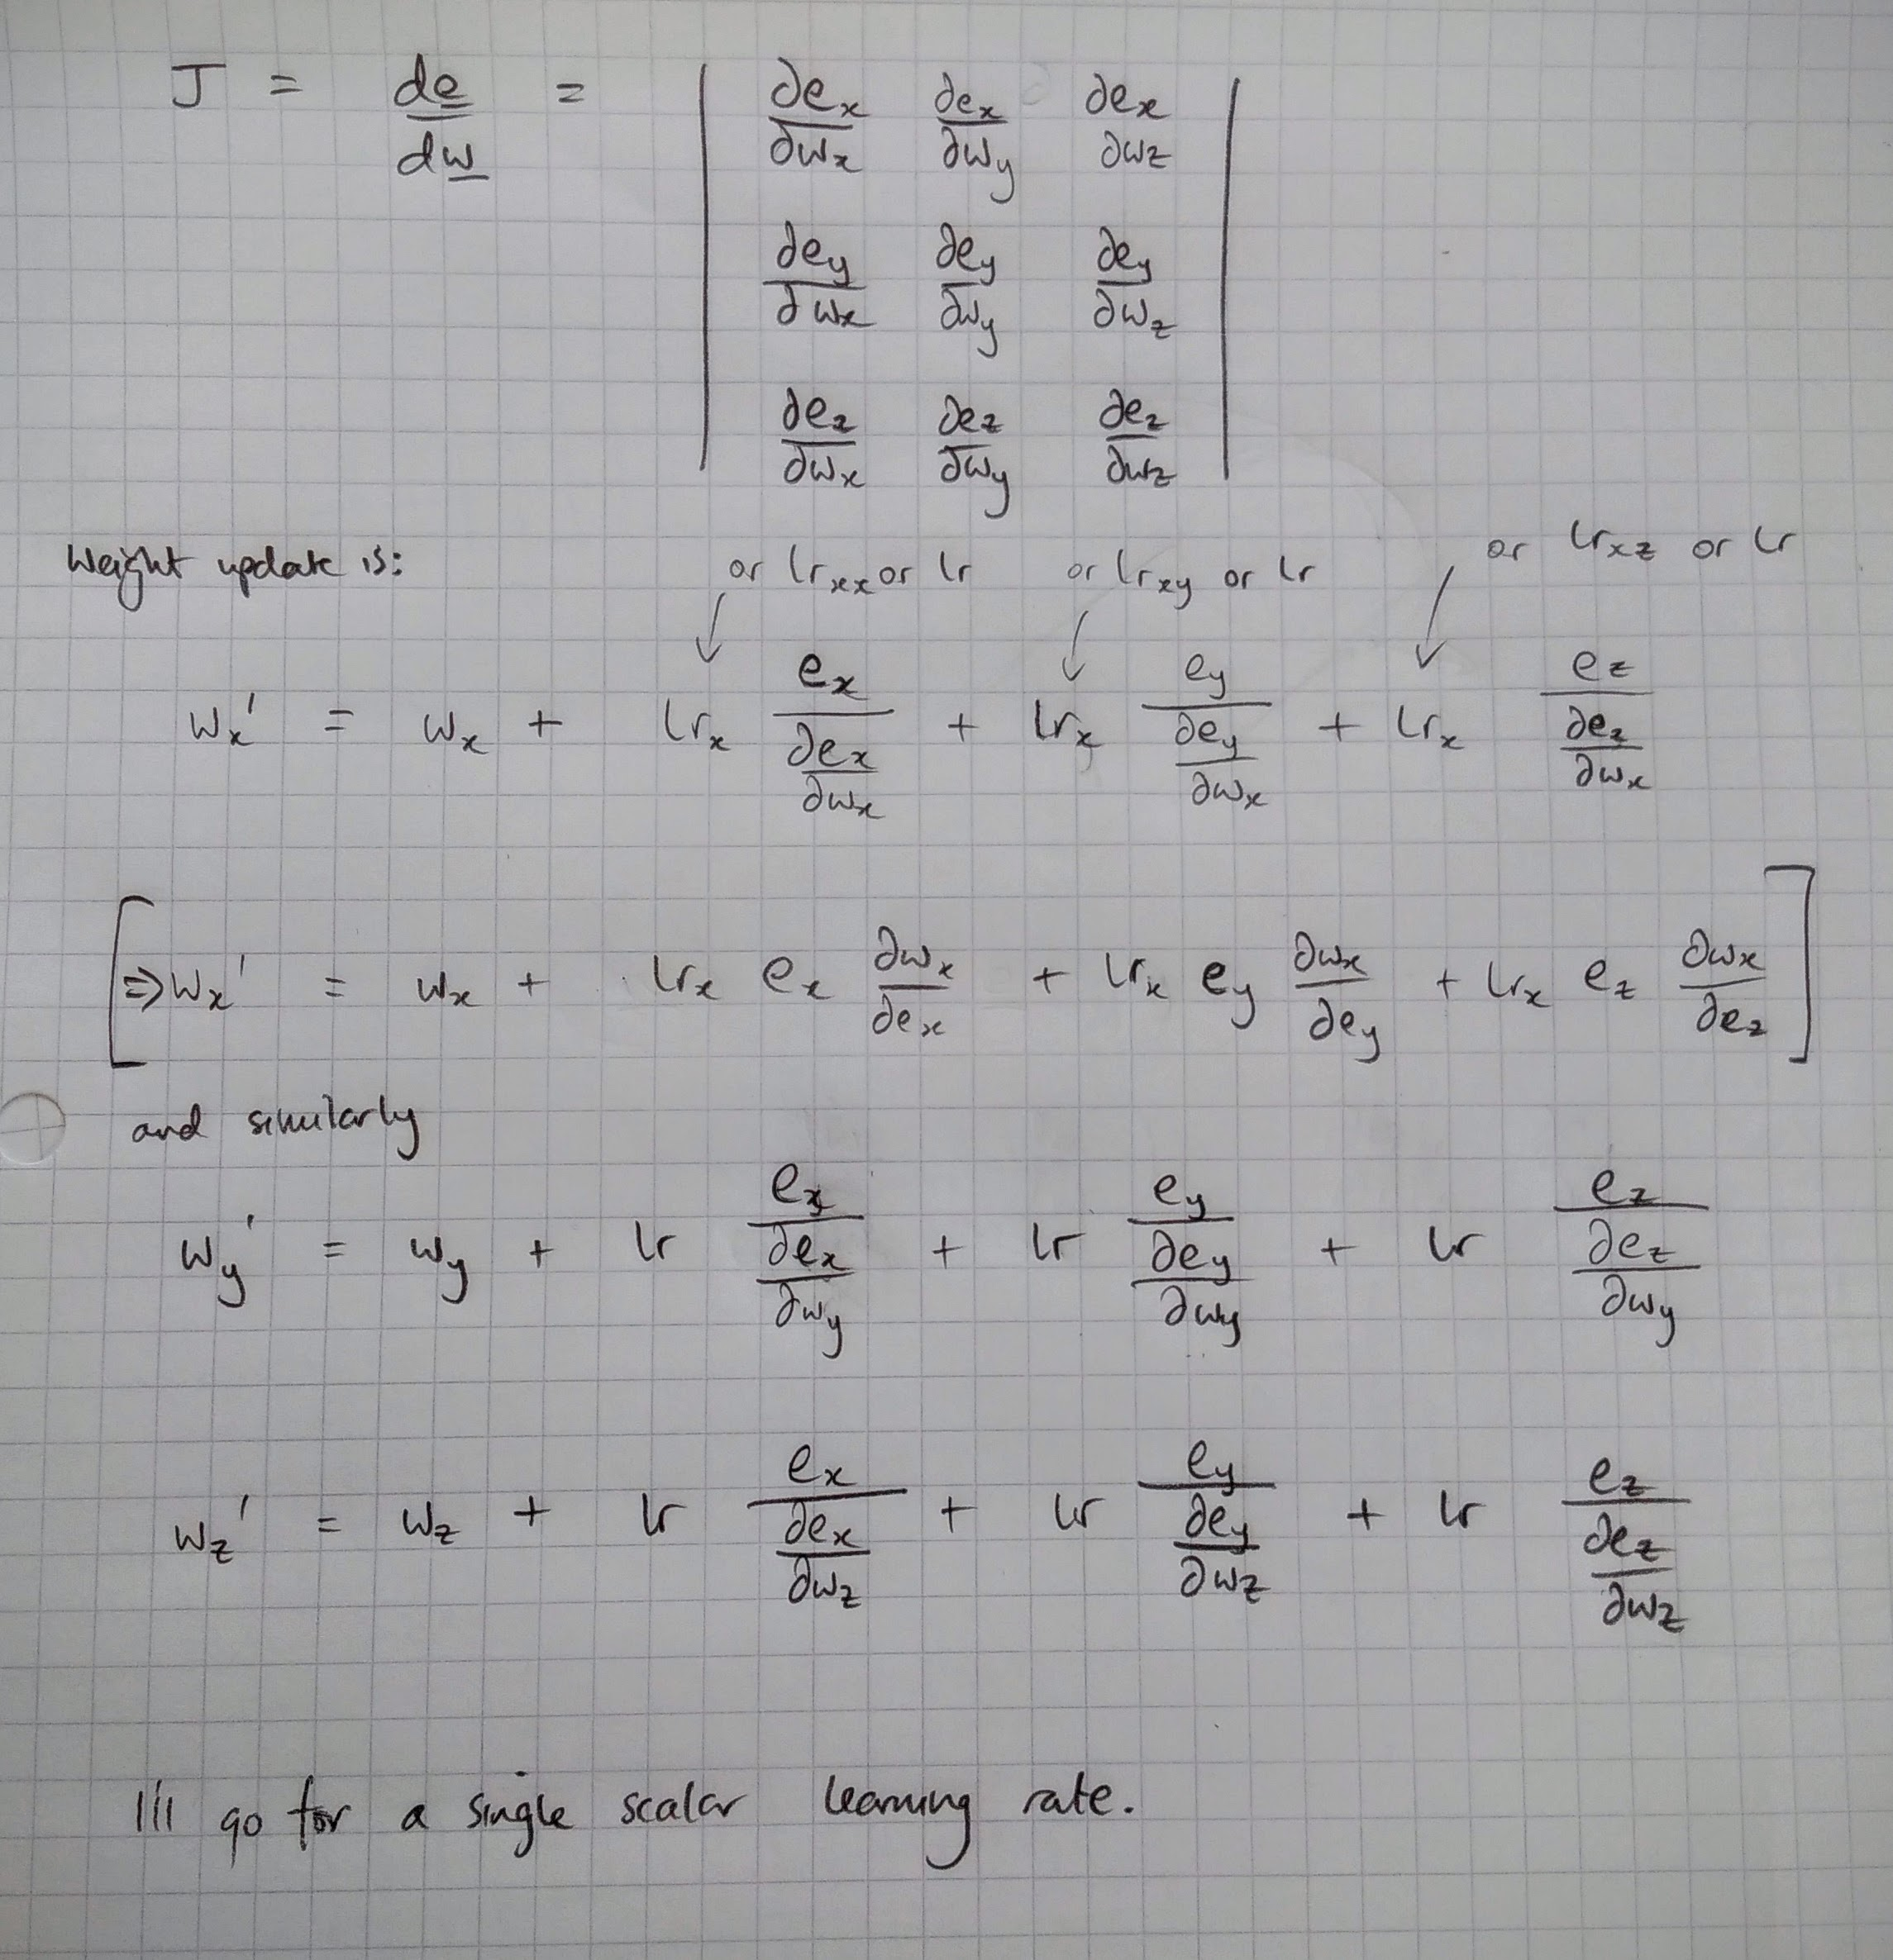
This gives the update rules. The Jacobian, J, has to be estimated by making small changes to the weights in turn and running the simulation once. See new code in rotations_weight_finder_centroid_3d.m.

20160421
I've spent this week working at the Jacobian method. I've had to improve the code quite a bit, particularly concentrating on code de-duplication and also on running the system on ace2, as iceberg as been flaky at times.
Much of the difficulty of implementing this scheme is in getting reliable results from the model runs. I've fixed, reintroduced and fixed bug after bug. Just now, I've noticed that run_simulation_multi.m is giving me peculiar results - viewing the graphs of RotX, RotY show close clustering around a solution, but the output of run_simulation_multi.m does not reflect this.
I'm still not quite sure of the Jacobian based gradient algorithm. I don't know whether to consider the magnitude of the error vector and use this to compute the next weight, or whether I really do need the full Jacobian. The code in find_jacobian.m has several options for J_r (dr/dw where r is the rotational position vector), J_e (de/dw, where e is the error vector) and dE/dw where E is the magnitude of the error.

2016-04-27
Kevin was asking why I'm doing the training again. One reason is that I previously trained without a fixation luminance, and am now training with one. Another is that I've made some changes to the brainstem model.
I've explored the error space for a RotX=10 RotY=10 saccade with respect to the 3 weights. See explore_error_manifold.m and explore_error_manifold.sh. Plotting either the magnitude of the error as a volume plot with respect to the three weights or the error vector shows that there is a solution to the system, but it may be difficult for a gradient descent process to converge if it does not start fairly close to the solution. The gradients further out may be too small to overcome the fact that there is noise in the end position for the saccade.

2016-05-13
I've reached the end of the road trying to train this version of the Oculomotor model. I think the gradients are too small and/or the noise in eye position is too great. I therefore need to retrace back to an older version of the model where I didn't make changes to a) the brainstem time constants b) the inhibitory feedback to LLBN populations. However, I STILL want to address the problem of the eye being rather slow to respond and so I will retrace back, but retain the viscosity parameter change in saccsim, the biomechanical eye model. I also made a lot of nice updates to the code in batch_scripts/include/ for running the simulation, finding the end of the motion, etc. and so I will manually bring those changes in.
So, as far as branches go, I am ending development on the branch Oculomotor_201603_sbg_update_jacobean and moving back to Oculomotor_201602_lumcomp_arith. There, I will disable the luminance compensation (temporarily) and create a new branch Oculomotor_201605_biomech_viscosity and attempt to re-train weights there (after bringing in all the nice new code changes).

2016-05-17
Having brought in all the code changes and modified rotations_weight_finder_centroid_3d.m accordingly (the version of rotations_weight_finder_centroid_3d.m in the Oculomotor_201603_sbg_update_jacobean branch had diverged too much) I am now running weight finding. I've updated the saccsim viscosity (saccsim/config/params_brahms.txt) to 0.00034 as 0.00028 was a bit too underdamped. I'm training with 4x4 rectangular targets, with a 0.5 luminosity fixation followed by a step to a 0.5 luminosity target (see write_single_luminance.m and search for fixlum in rotations_weight_finder_centroid_3d.m). I'm not presently using the existing weight map as a starting point for the training; I don't think it will make a very large difference to the training time and I have to figure out which pixels match up to which targetThetas (in practice and not just in theory). NUM_RUNS is set to 6 - the model is run 6 times to determine the mean rotations and their variances.
I'm going to move all the results of the weight training into a subdirectory in batch_scripts/weight_finding/ rather than storing it in lab_book, which leaves it a bit disjointed.

2016-05-20
For reference, the original “decent” weight map was obtained on 2015-09-29, see commit 54363d0e. These are the ones which I had when we went to Portugal.

2016-06-02
I found several problems in the weight training algorithm. One was to do with setting the correct luminance in the partial de/dw finding runs; that was the key problem. However, there are also problems with some simulations producing results on fastdata which then can't be accessed quickly in the main octave program, so I've coded in lots of wait & re-read routines to improve behaviour. I also tweaked the learning rate a little. I now see convergence to an apparent minimum, though it appears not to be the global minimum:
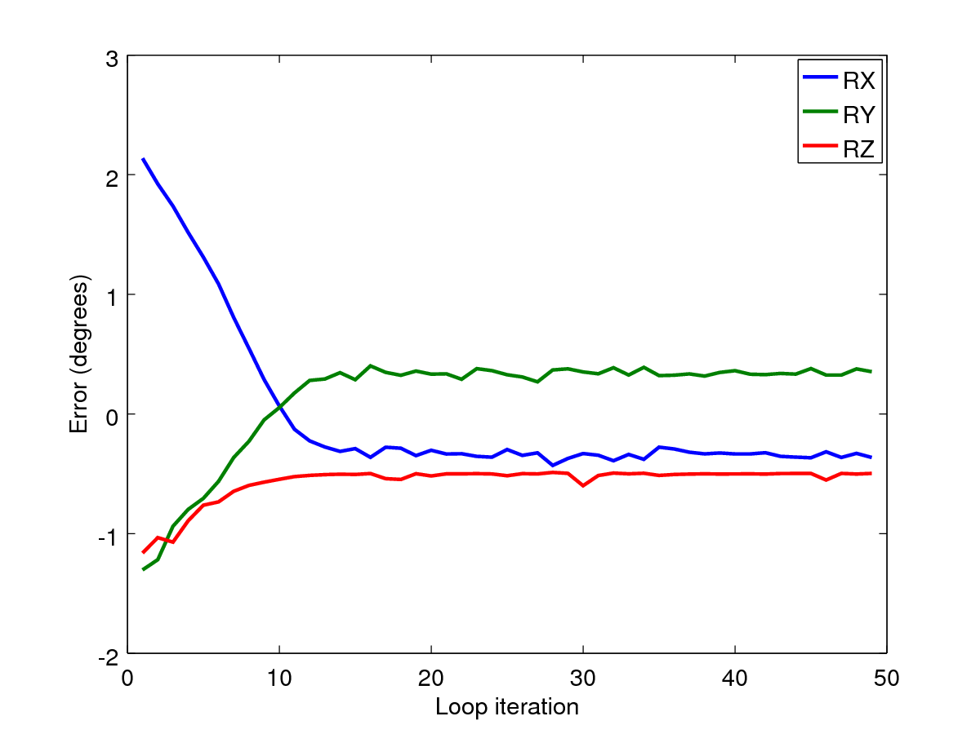
I also set the number of parallel runs in the partial de/dw finding runs (see find_dedw.m) the same as the number I used for finding the main error-for-a-given-weight-set. In this case, that was 8. For these results, see Oculomotor/batch_scripts/weight_finding/20160601/RotConv_RX4_RY-9.
I'll change the max loop count to be 25, rather than 50 now.
It may be that these errors (0.5 in any rotational direction) is more or less ok - we don't expect perfection; we have no cerebellar model.
I think it's possible to get closer to error = [ 0 0 0 ] because I can do this manually. Some sort of stochastic feature in the training algorithm or an adaptive learning rate may achieve this.
Could my stopping condition be the smoothed gradient of this error vs. loop?
I'll run another test for RX1, RY10, to see how the errors pan out there - perhaps the weight space has fewer local minima for certain eye locations.

20160627. Picking up the Oculomotor branch again
I need to produce a saccade response vs. dopamine result for deliverable 3.2.2. I'm going back to the Oculomotor branch, which contains the model as it was at Lisbon in October 2015. I added just the change of the dopamine parameters in the D1MSN population (see commit 141eab9). I'm running expt_sacc_vs_dopamine and will also run expt_sacc_vs_luminance, to see where we are with that.

20160718 Shunting connection errors
Have identified two errors in the model which are present in the following branches:
- Oculomotor_antisaccades_3BG
- Oculomotor_201605_biomech_viscosity
- Oculomotor_201603_sbg_update_jacobean
But NOT in
- Oculomotor_eyeless (which branches from the Oculomotor branch)
I made the first error; that of changing “SC_deep to SC_deep Synapse 0 postsynapse” to having a shunting input (output_dst_port="S") in commit 2ce3894414 on 20160304. That was in the Oculomotor_201602_lumcomp_arith branch. It should be a regular activation (output_dst_port="A")
I made the second mistake; changing “SC_sup to Thalamus Synapse 0 postsynapse” to having a shunting input (output_dst_port="S") in a separate commit ecaabb812 on 20160303. This should also be a regular activitaion (“A”) input.
Be sure to check these parameters in any future modelling work!
I've fixed these in the branches:
- Oculomotor_201605_biomech_viscosity
- Oculomotor_201603_sbg_update_jacobean
Jen has fixed in
- Oculomotor_antisaccades_3BG
It may be that changing these caused the weight training of the model to become more difficult.
It was in trying ot integrate the Oculomotor_eyeless non-SBG scheme into Oculomotor_antisaccades_3BG that we found this discrepancy and identified the mistake.

2016-07-21
Since finding the 20160718 Shunting connection errors, I'd like to see if the model will now train. Try the branch Oculomotor_201605_biomech_viscosity. I'll run some training on Iceberg.
...it didn't converge for the test angle I chose, so I'll make no further plans to re-train these weights and will go with those I already have.

2016-10-07
I've added a new population in the Oculomotor branch. This is called “DA value” and is fed into Str_D1 and Str_D2 so that the value of the DA parameter in those models can be made a little random from run to run to give us a suitable amount of output scatter. This was suggested by Peter Brown at the Amsterdam meeting. Now to tune this parameter to give scatter in range? There can easily be ± 1º of scatter - see for example Fig. 1 in Eye movement trajectories and what they tell us by Van der Stigchel et al (2006).
2016-10-10. The above isn't going to work. Even very wide variances of the DA parameter produce only small changes in the final angle. It might be possible to increase the effect that the DA parameter has by allowing more dynamics of the SC buildup to pass through into the SBG (i.e. to allow the height of the SC_avg 'pole of activity' to be larger and therefore its maximum to be achieved later), but as I don't believe in the mechanism driving the SBG, I don't really want to go down this route.
This brings me back to the original idea, which is to introduce arbitrary stochasticity into the position of the pole in the centroid-finding algorithm, which mechanism I have already implemented, but which I would prefer to omit as it provides no additional scientific value.

2017-05-09
For the Frontiers paper, I want to re-examine the connectivity between the SC and the SBG. In the work above, we tried hard to keep the dynamics of the signal in SC from affecting the saccade accuracy. We went so far as to introduce a non-neural centroiding component (hand-coded outside SpineCreator) which would pass through a single active pixel from SC_deep through to SC_avg. The mapping from SC_avg through to the LLBN neurons was then achievable and I spent a lot of time training those weights.
Given that the paper's focus is on what building models like these can teach us, I will revert back to a version of this model which sends input direct from SC_deep through to the LLBNs. I may fit a Tabareau style SC weight map and see how that works.
I probably still wish to present the centroiding version of the model, as with that version, I was able to show that a set of 6 maps for 3D rotations was trainable.
That means that I want two versions of the model in the repository, and I'll move the batch_scripts and lab_book subdirectories out of the model directory.

2017-05-31
After some reading of the relevant papers, and email correspondence with Benoit Girard & co. it seems there’s strong evidence for the activity in SC to be of a fairly even spatial extent, regardless of saccade eccentricity. This indicates a shortcoming in our model, which seems to be a fundamental block to being able to produce sensible weight mappings to the SBG.
I have introduced a logarithmic increase in the spread of the projective field into FEF and SC from the world input and, with the weight map that I computed with the centroided Scavg, I see a roughly linear relationship between target eccentricity and saccade eccentricity!
I then moved on to fixing the scripts to run the “experiments” on Iceberg. This took pretty much all of last week, but I am now able to run these and am ready to tweak the model to correct the balance between reflexive and express saccades in order to reproduce both Alex C’s results and then show our dopamine dependent results also.
I have a more unified scheme for the experiment scripts now; one set to run the experiments and then a second to make quick, octave plots (not publishable). I will need to extend these with a scheme to output csv files that can be rendered with Veusz for publication, but I think this is a fairly simple extension of what I have now.

2017-06-02
Experimenting with producing express or reflexive saccades. According to Alex’s paper, we should be able to induce either reflexive or express saccades by varying the relative strengths of the inputs to SC_sup and FEF_add_noise. If we input only to SC_sup, we should see express saccades, if we lesion Ret → SC_sup and allow input to FEF_add_noise, then we should see slower, reflexive saccades.
This doesn’t happen; no express saccades were evident. An express saccade should occur when activity in SC_sup drives activity in thalamus which then allows Snr to disinhibit SC_deep. As the model stood, the Snr inhibition to Thal was too strong and so SC_sup activity could not initiate a saccade.ad
To fix this I have done the following:
- Reduced FEF→STN weight from 6 to 1.
- Moved foveal mask across to keep the cross more fully masked (minor effect, not important)
- Widened the gaussian projection from SC_sup to SC_deep
- Increased the weight of the input from SC_sup to thalamus from 0.3 to 3
- Halved the inhibition of Thalamus (by Snr). One synapse changed from 2.5 to 1.25; the other changed from -0.5 to -0.25.

2017-06-05
One thing which is notably different when comparing Alex’s model and mine is that the latency difference between express and reflexive saccades in my model is barely 20 ms, and there is very little scatter. Alex’s paper suggests his model has much more scatter; see Fig. 12. which shows latency distributions with widths of about 100 ms. I’d like to understand this difference. I do have Alex’s model on Iceberg still, though I think there’ll be some re-configuration to do before it’ll work. I can’t work out in the code where the centroiding operation is carried out, or where there’s some sort of threshold to figure out when the saccade initiates.
Alex responded to an email about this:
“These are included in a single BRAHMS component, which is configured in ORIENT.m under SACCADIC GENERATOR - it is the emSGLP component (emulated Saccadic Generator: Log Polar). There is a state.threshold par for the level of the threshold - it looks as though that is the only parameter..”
Ok, there’s a lot of work to get that model to work, which I may take on, but I’d rather not.
For now, my model is looking rather sensible. I have a quasi-linear targetx-actualx relationship, which could be improved; I have the ability to make rather realistic looking distracted saccades, if I bring in a distractor luminance during the saccade – the activity in SC_sup makes its way into SC_deep as the region of the saccade is disinhibited during the saccade; Saccades to dual luminances do weird stuff, suggesting to me that competition between targets is resolved before FEF; Changes to targets, target eccentricity and so on all affect saccade accuracy, suggesting to me that there must be a clean indication of the target saccade “forwarded” to the cerebellum, which is then able to provide an additive, corrective signal to ensure the saccade arrives at destination.
To get this written up, I have a couple of things left to pay attention to: 1) The luminances used in the experiments. Esp. in the saccade vs. luminance experiment, I take the luminance beyond its max of 1 (world saturates at 1). So, I need to decide on a suitable fixation luminance = 0.2 and a “normal” target luminance = 0.3. I then need to tune the model to give me as linear a target/rotx graph as possible; I then need to re-do all the experiments, making sure they’re all for X rotations as my “standard” experiment paradigm.
Found there was a difference between the model on my laptop and the model running on Iceberg. Tracked this down to an out-of-date build of worldDataMaker on Iceberg.

2017-06-07
I was concerned about the apparent difference between the final angle reported by run_simulation_multi.m on Iceberg and single runs of the model on a single system. I tracked the disparity down to the way that the end of the saccade is determined - the mean of the x and y end saccade times was being chosen, which was resulting in an underestimate of the saccade size. Here's a graph to illustrate (Y rotn ends at 355, X rotn ends at about 390; so mean of 373 gives smaller X rotation than expected; 10.9 degrees rather than 12.1, black shows mean timestep and X rotation at this mean timestep):
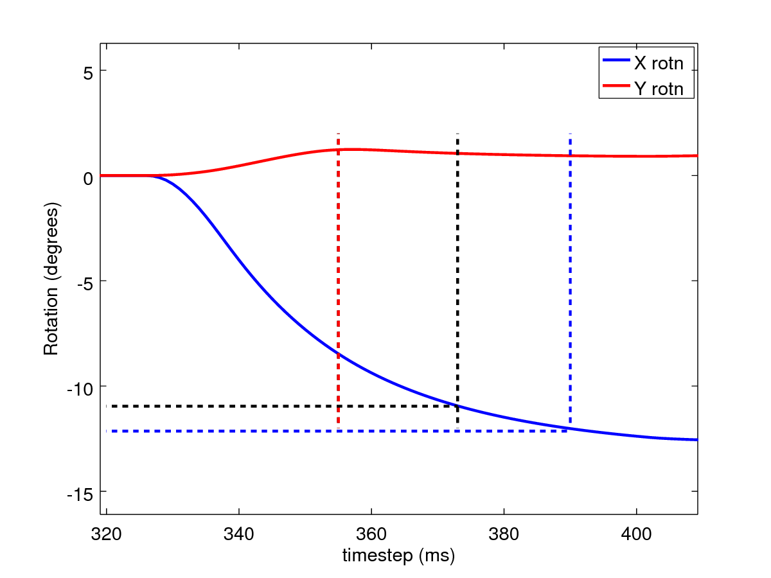
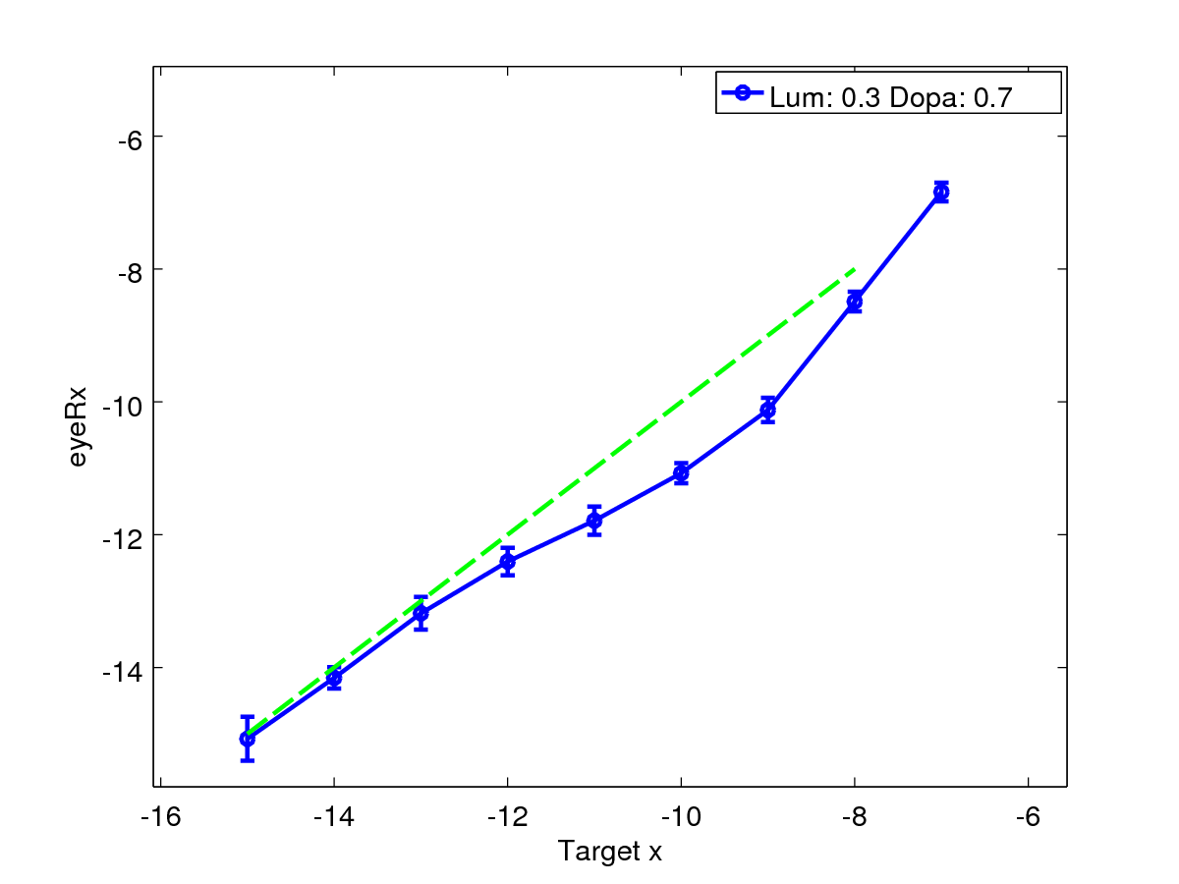
The solution I've adopted is to use endsacc_x if the x rotation is largest or endsacc_y if the y rotation is largest. See commit 4cea901. Now variability in X rotation is smaller across trials for the same target and there is a non-linearity evident in the graph, which will require me to investigate the widening gaussian maths (as I expected to do):

2017-06-08
I've looked at further widening the gaussian spread from FEF_add_noise to FEF. To compensate for the additional signal into STN as a result of the widening, and the consequent change to tonic levels of inhibition from SNr, I also reduced the overall weight of the connection (from 1 to 0.3, see git commit 08df1e0) as well as increasing the WF (weight factor) in the widening gaussian connection from 15 to 25 (also in 08df1e0).
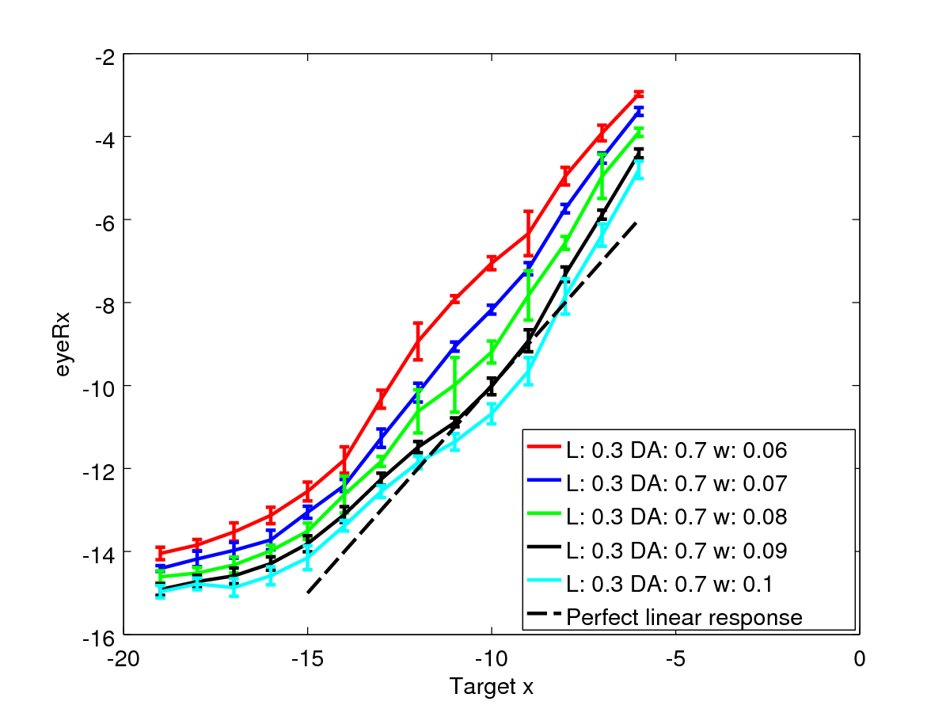
Initially I thought I'd got a beautiful straight line for eccentricity from -7 to -15 degrees, just offset from the perfect linear relationship between targetpos and actualpos. I then ran through several weights for the SCd to SCa to try to bring this nice straight line closer to perfection, but got this instead:
For SCd to SCa weight of 0.07, that's close to linear over the range of interest. The tail off at the extreme is the region where the hill of activity “falls off the edge” of the SC map – or rather where it falls off the edge of the area where the weight map has values.
I could do with another, linear way to increase the output of the model. Let's try the motor neurons, as they don't feed back to the rest of the model. The output of the motoneurons can be changed by adjusting the gain in their LIN components - that means changing the parameter m.
A change of the MN m parameter for the vertical MNs from 1 to 1.2 gets close.
I'd now like to get the model accurate in the horizontal plane as well. At the moment, it's both non-linear and also offset:

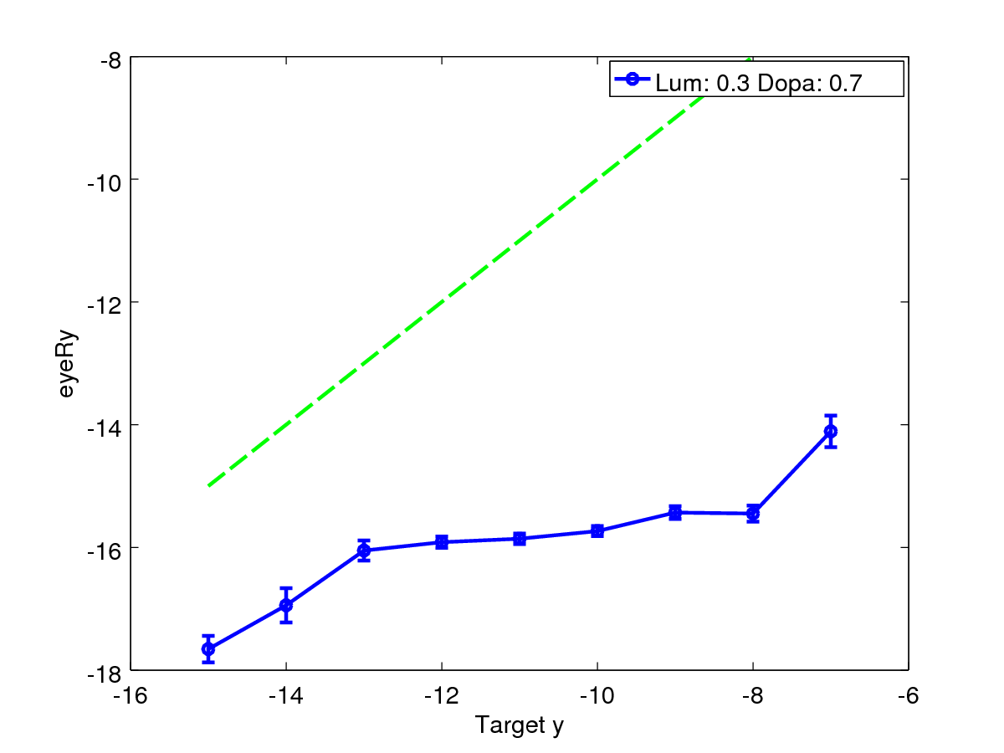
2017-06-12
I’ve been investigating the vertical (and oblique) parts of the eye movements, with a view to producing a model which is as good as it can be in the horizontal plane, and fairly good in the vertical plane also.
As I don’t want to upset the horizontal behaviour, I’m aiming to modify only the MN output gradient and then make tweaks to the weights into the LLBNs. Here is what I get:
It would seem that the MN up/down weights give a slight gradient change in eyeRx/target x; the SCA to LLBN weights make little gradient change. MN weight 0.8 along with a change in SCA to LLBN weights might get me close. See scripts plot_sacc_vs_t_mnupdown.m and plot_sacc_vs_t_scallbn.m.
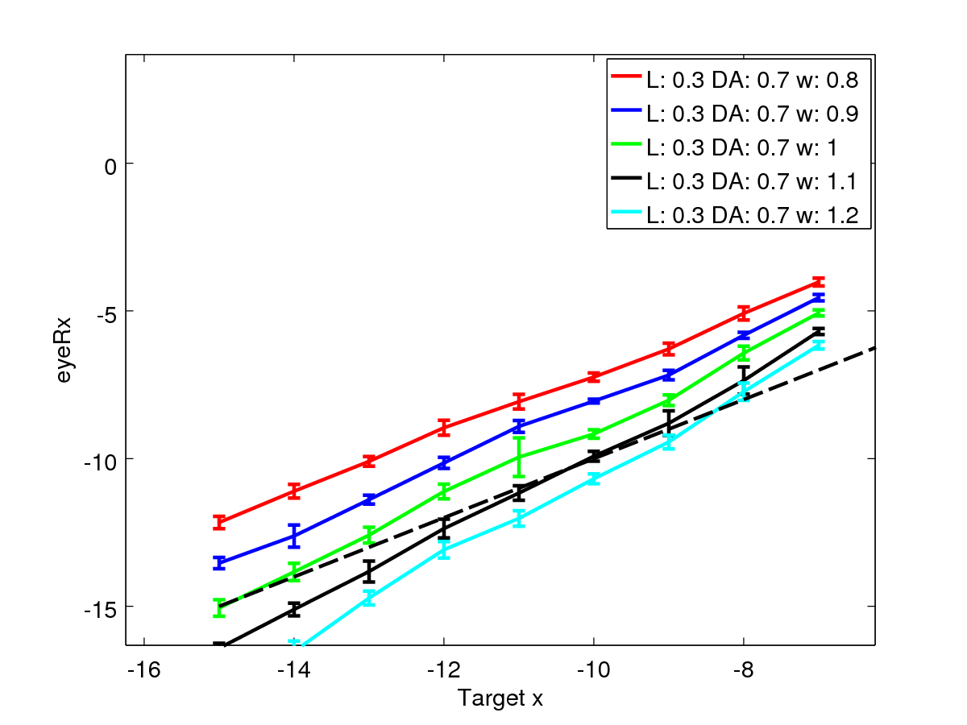
Illustration 1: MNup/down weights (actually gradient – the m parameter in the model component)
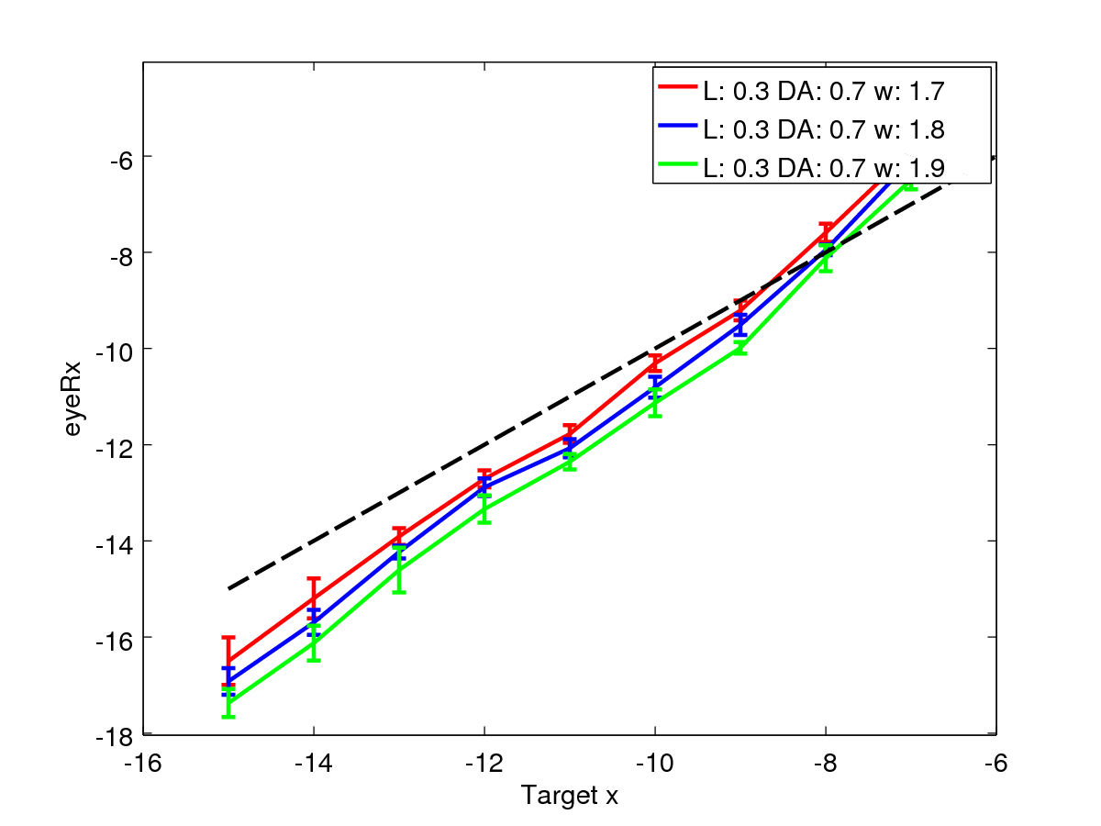
Illustration 2: SCA to LLBN weights

2017-06-15
Ok, so I have some rather odd behaviour going on when I get the model (Model5 at present, which is my “best of both horizontal and vertical” model) to make a saccade to a horizontal position and then return. It goes out ok, but then returns with a huge vertical component.
I’ve gone back to the weight maps to look at them and notice that there are a few extraneous values in these maps, which wouldn’t have affected the centroiding scheme much, but could cause large errors when passing activity directly form SCdeep.
I’m going to remove these values (by setting them to the mean of their neighbours) in Model5 to smooth out the weight maps.
Even with the improved weight maps, I still see the odd behaviour, which is due, I think to the additional width that is present in each of the weight maps. For reference, they look like this:
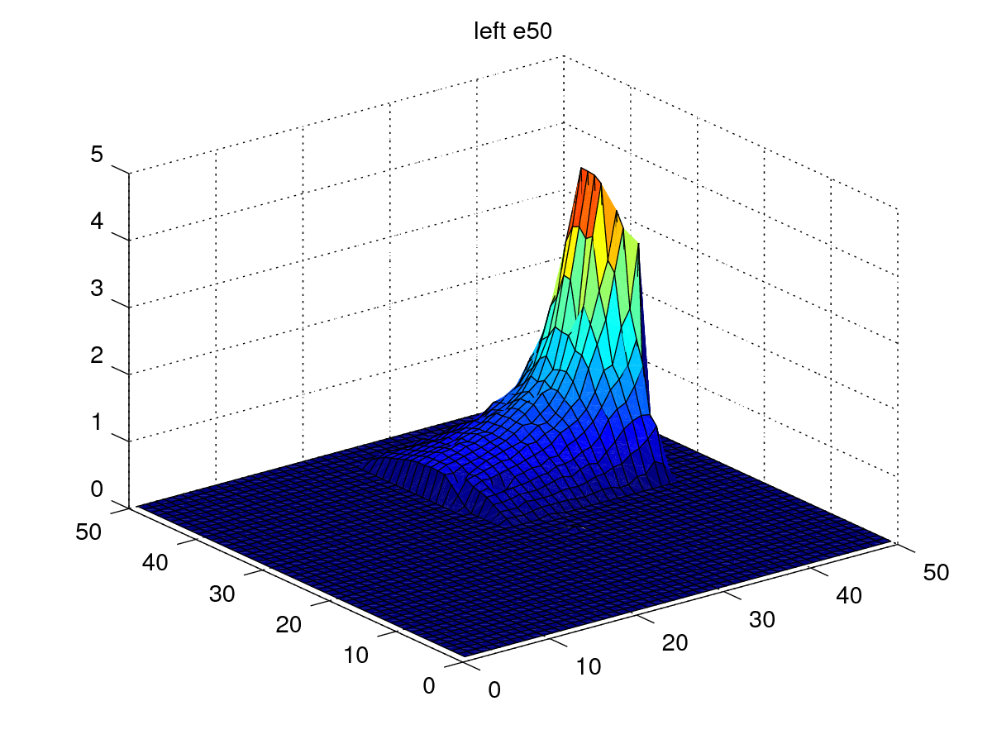
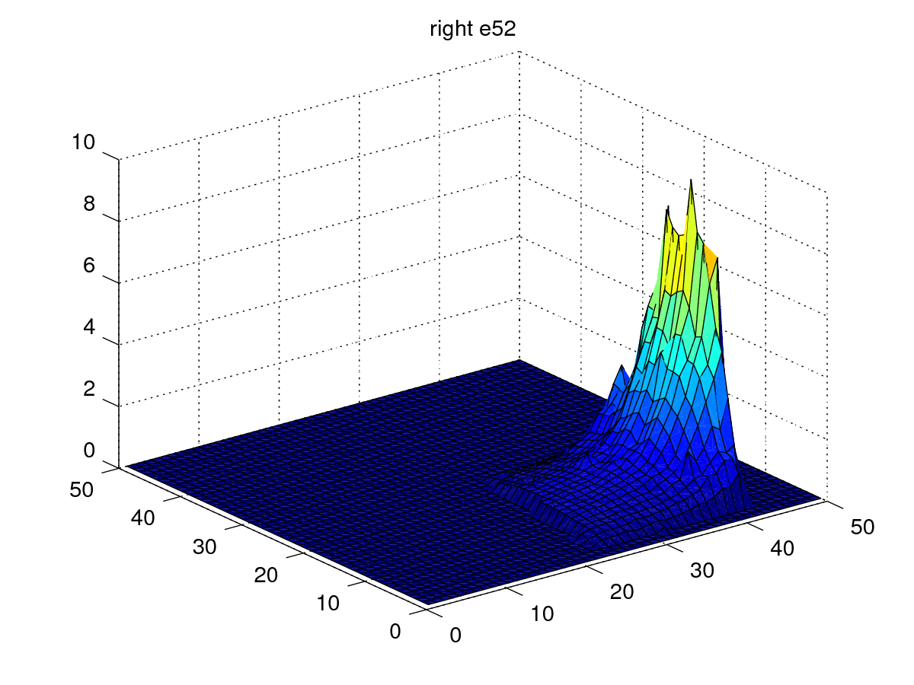
Up/down:
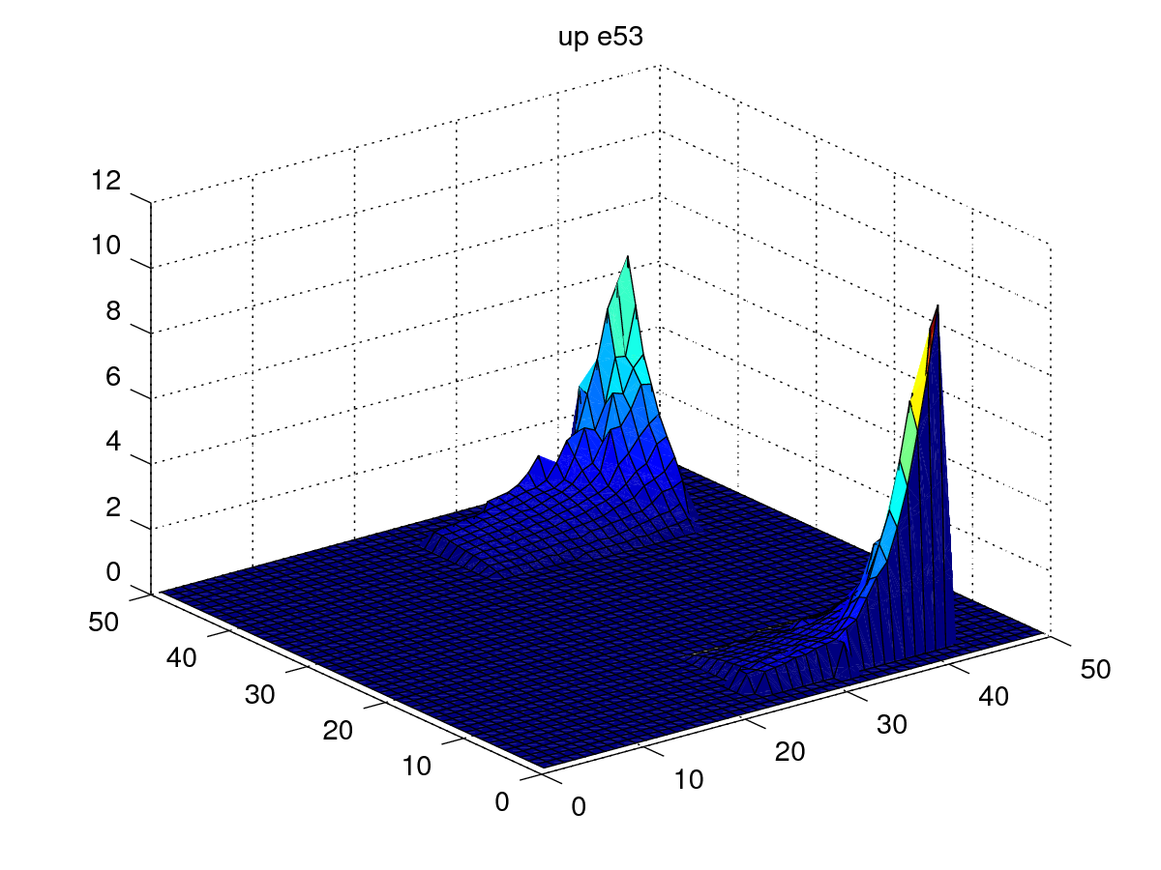
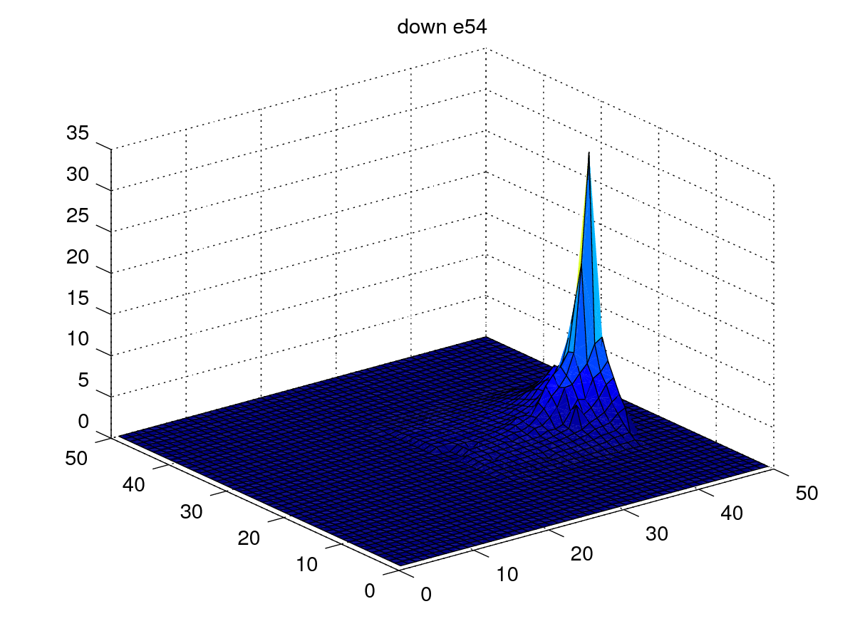
zminus looks like up, zplus looks like down, but scaled down:
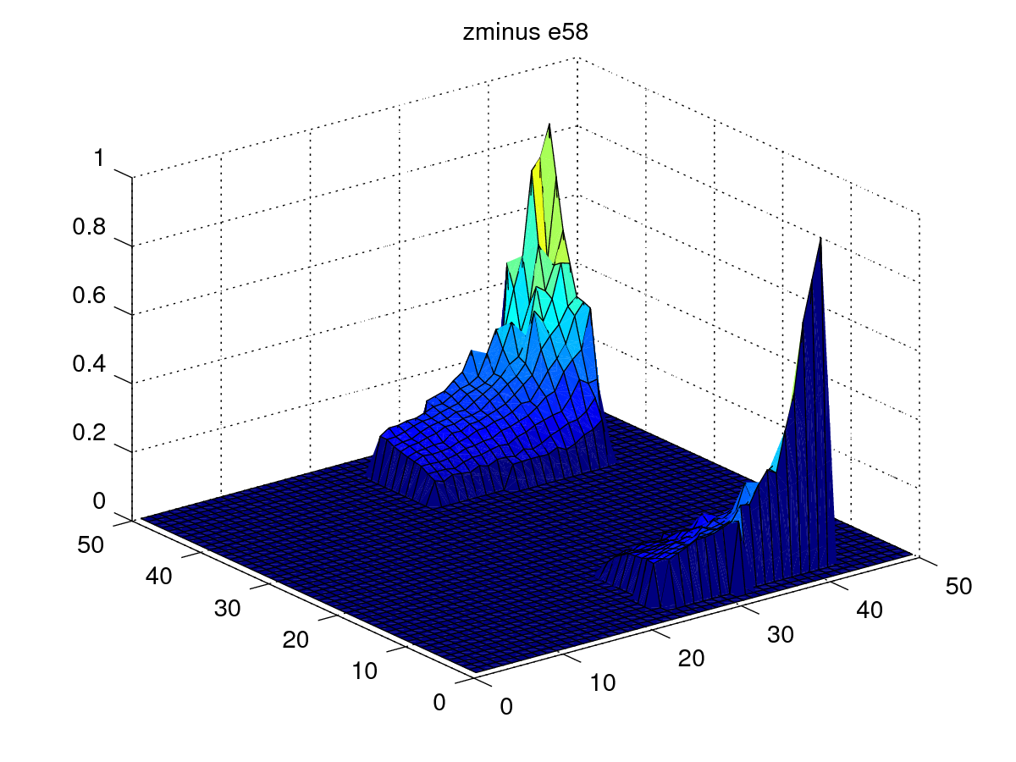
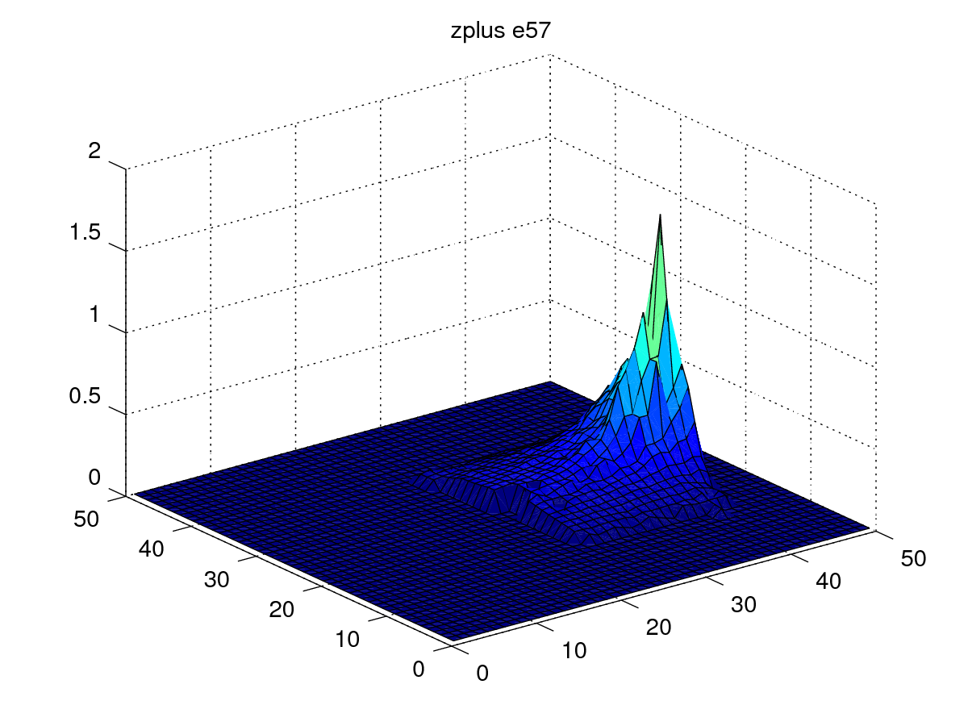
A couple of things are noticable. The peak of the mountains for up/down and z+/- are quite spiky, unlike the sine waves derived by Tabareau et al., although the left/right maps look quite sensible. The up/zminus mountains are shifted in from the edges of the map due to edge effects in the rest of the model.

Theoretical maps
I’ve also written batch_scripts/weight_theoretical/map_modelling.m which creates sine wave/double exponential weight maps where the double exp is matched to the computed maps which can now be viewed with the script/function load_sbgmaps(‘model_base_path’).
Here are the weight maps with a sine wave in the phi axis and a single exponential in the r axis:
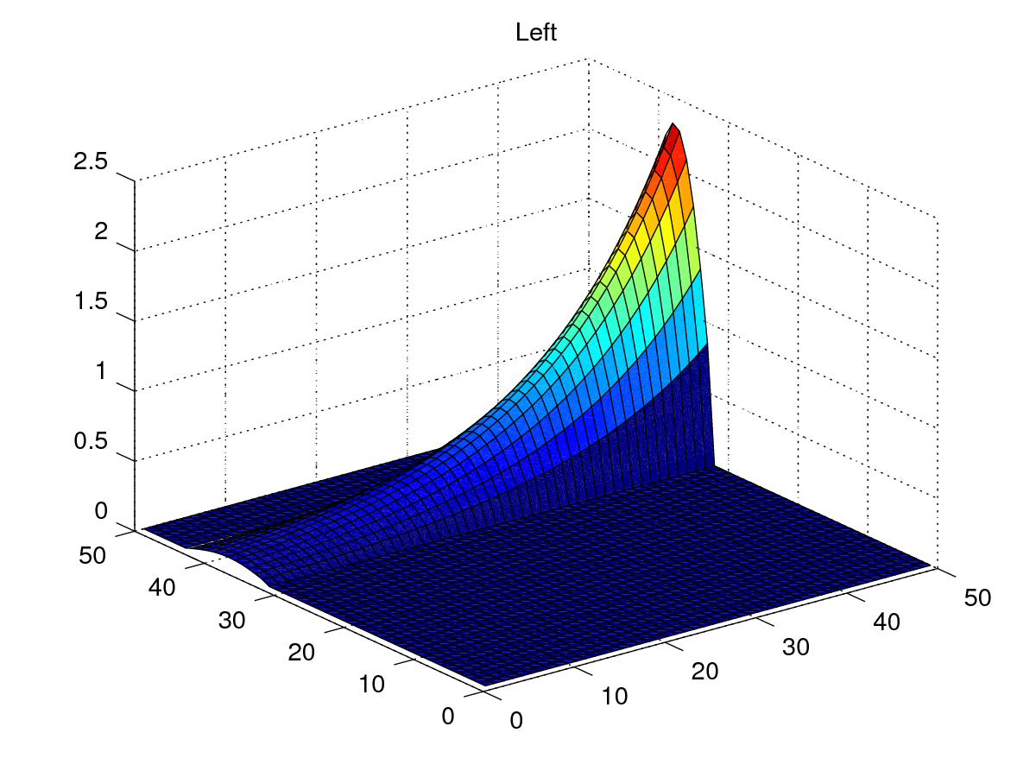
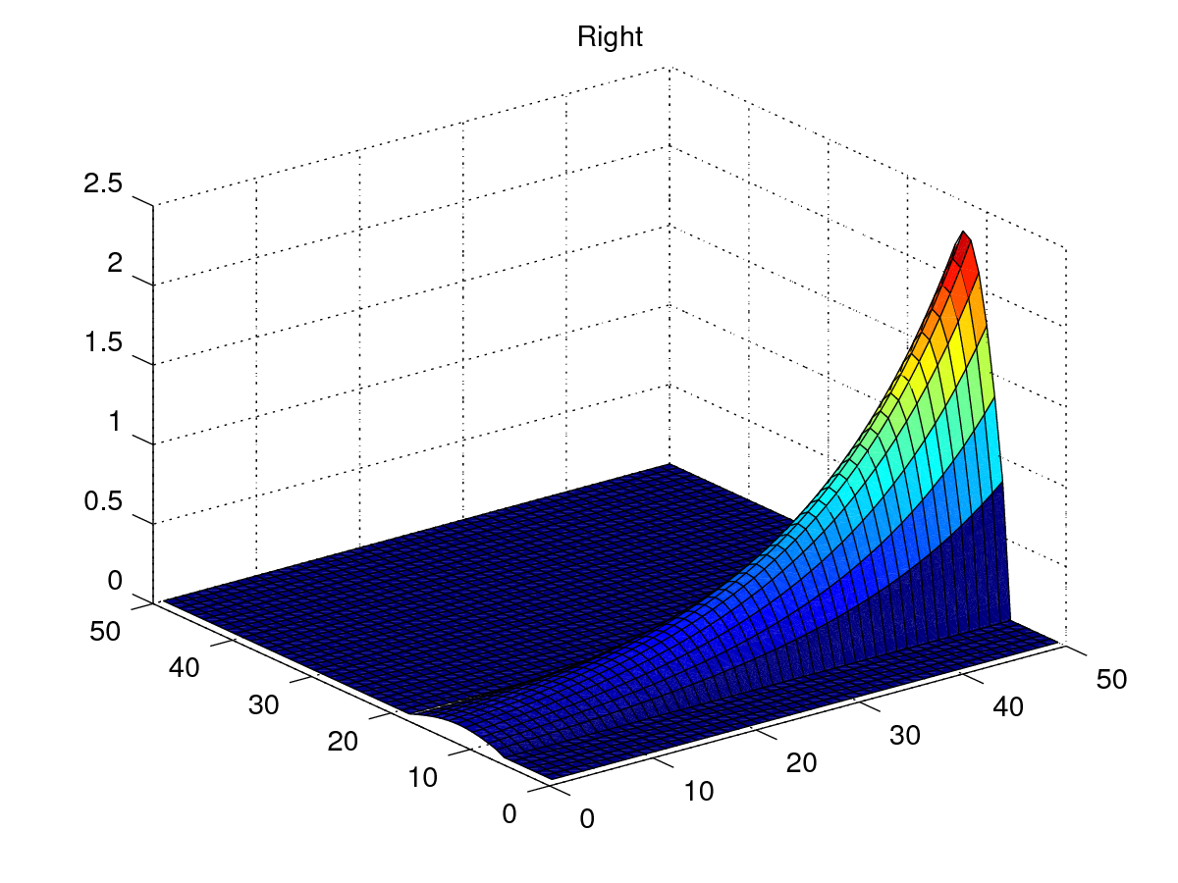
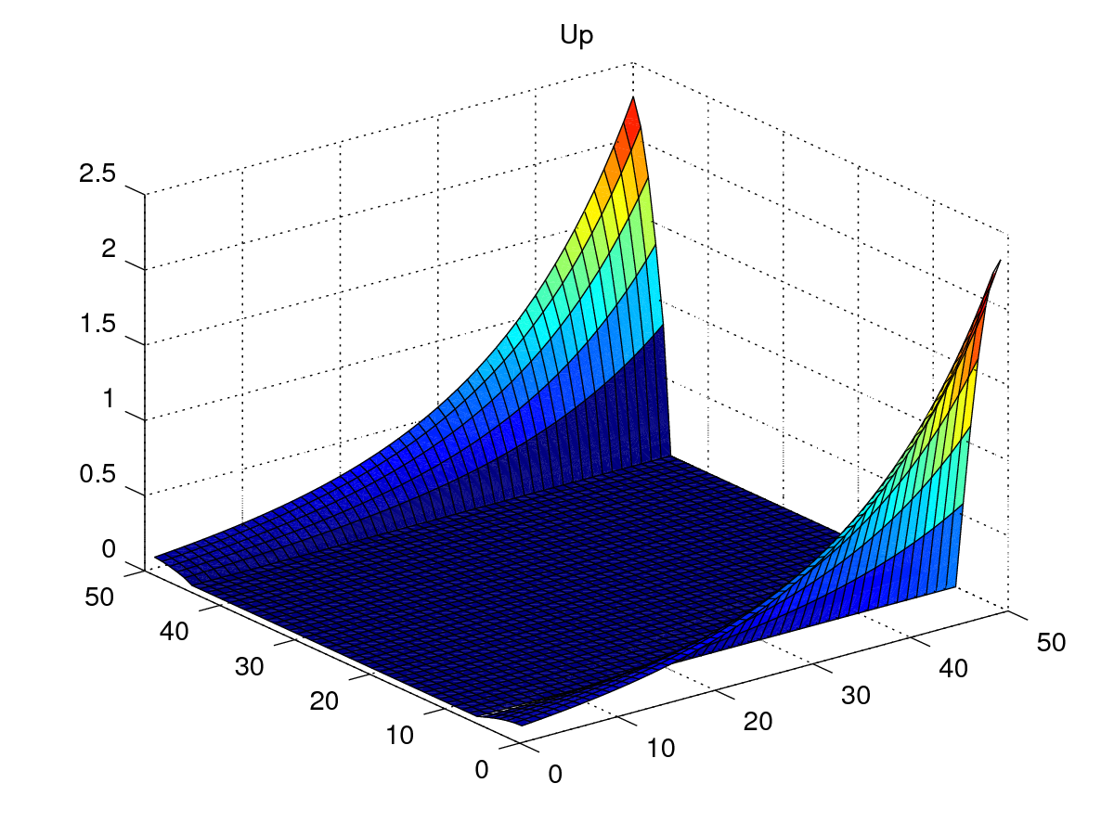
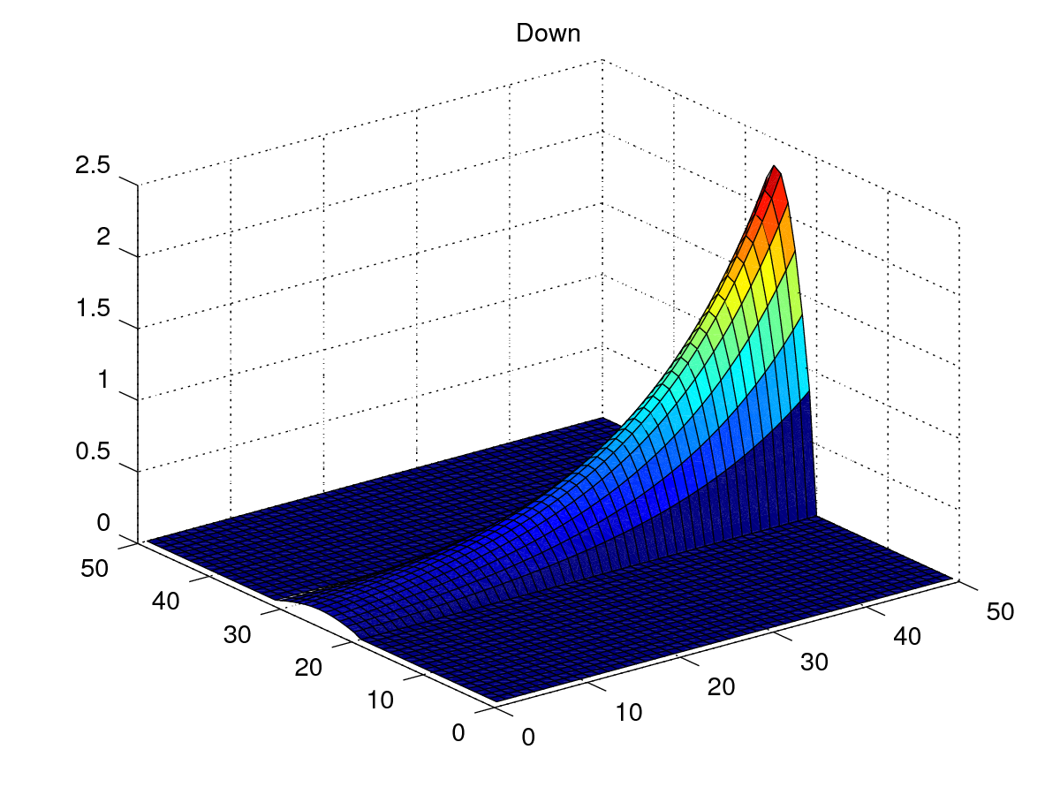
Up/down:
zminus/zplus maps are 1/10 of up/down maps. With a little manual experimentation, I found that a dual exponential fits the computed weight maps a bit better, but I’d like to find out if a single exp map gives more linear output from the model.
To avoid the complication of the edge effects, I’m not going to look at “up” movements when doing target x vs achieved x rotations, only down movements (-ve x rotations).

2017-06-16
Here’s a result for a single-exponential, theoretical SBG weight map. The exponential is y = exp(0.2 * (x-39)) where x is the r index in the map (1-50):
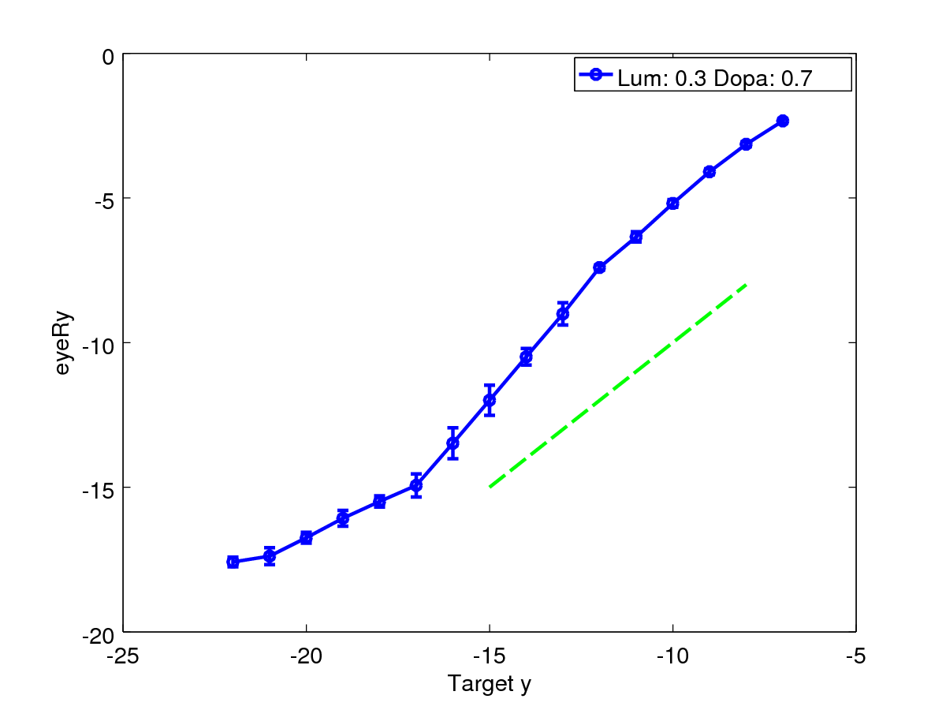
A corresponding result for a dual exponential is:
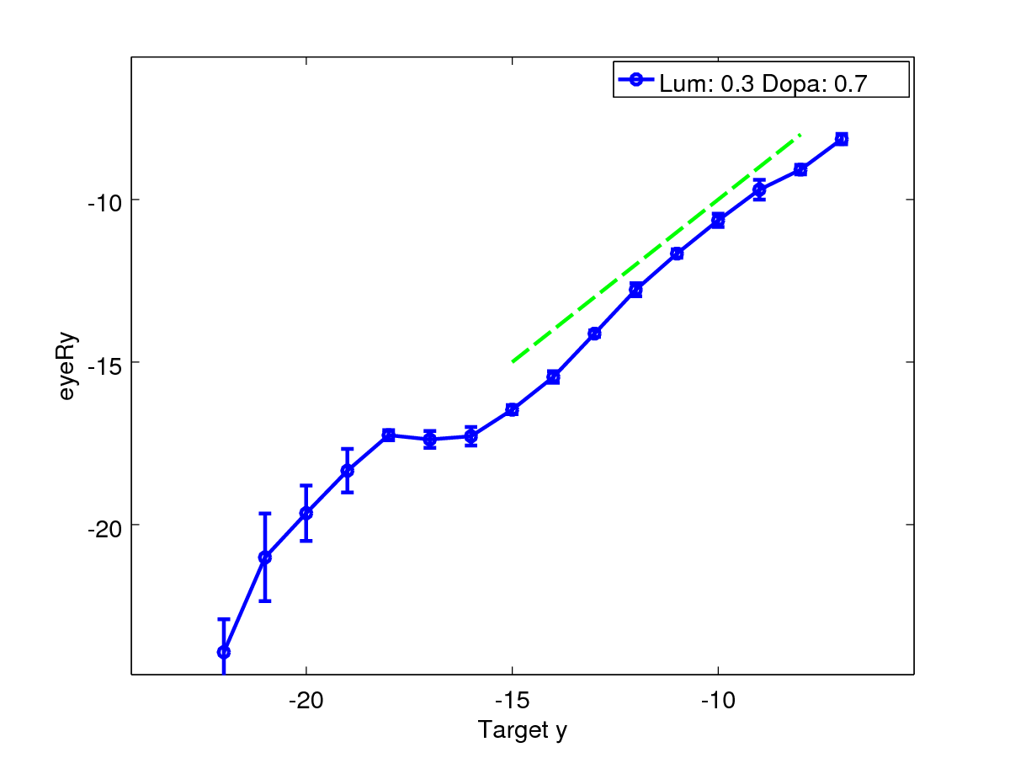
Neither is particularly linear! I’ll investigate the single exponential to see what the effect of varying the SCdeep→SCavg weight has with this SBG map.
Here are three results (For TModel1 in the repository at git commit 8927d2a):
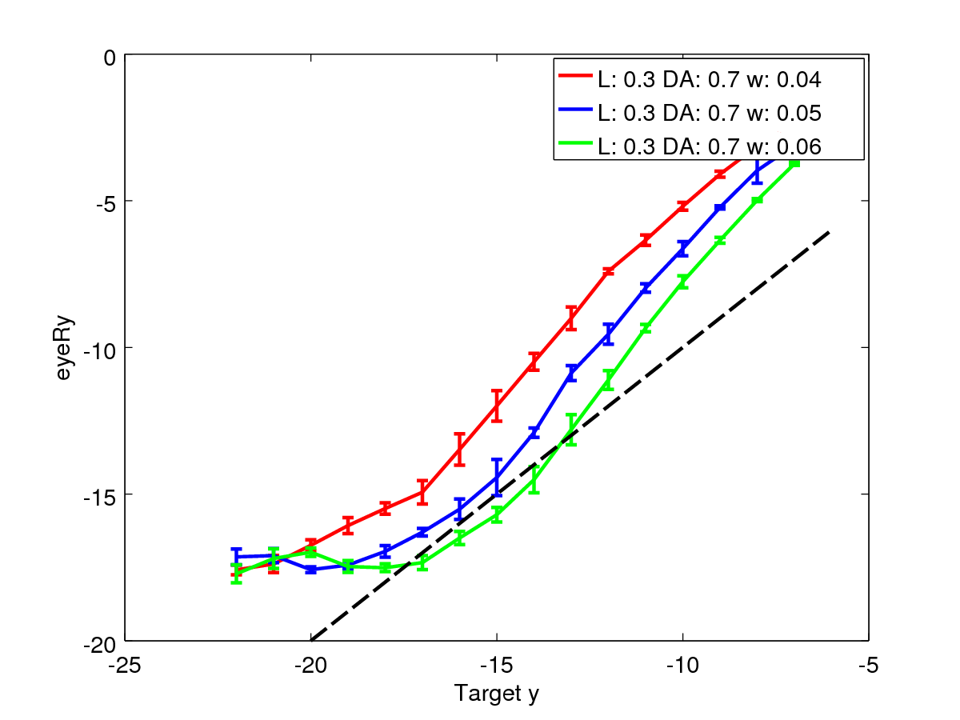
Illustration 3: Varying SC_deep to SC_avg weight
This suggests to me that the single exponential is becoming less effective at larger target y. The response is fairly linear at smaller target y.
Tabareau’s result assumes identical hills in SC for different targets. I don’t have that in place – my hills vary spatially and in terms of their temporal activity as r is varied. Hence the lack of linearity in these graphs for higher target y.
Next experiment: Hold scd-sca weight fixed; vary MN gradient.
BEFORE that, it has occurred to me that with the 1-1 weights, zero connection delay between scd and sca, I don’t need the inhibitory feedback to SCA that I had previously wired in. So, lets remove that and check the model’s response. Here it is, with the scd-sca weight at 0.6 (so compare with green in the previous graph):
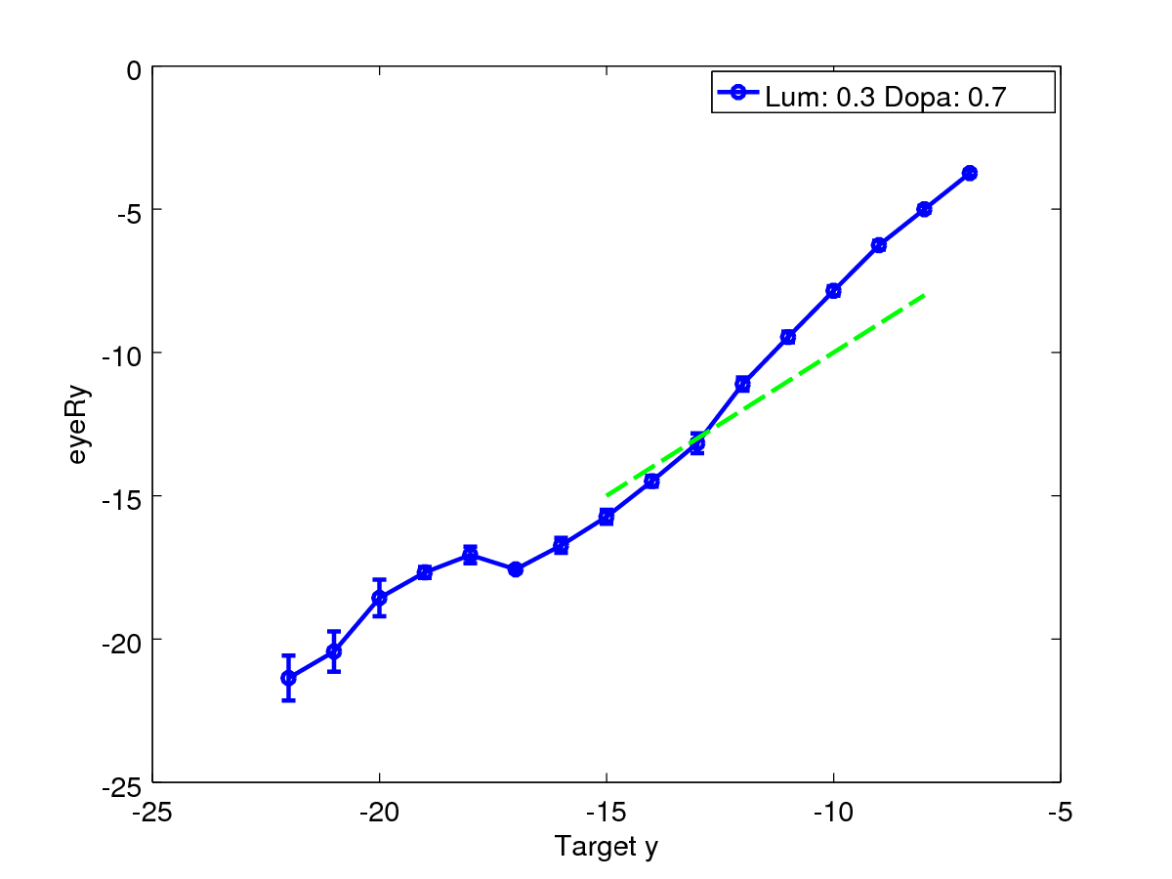
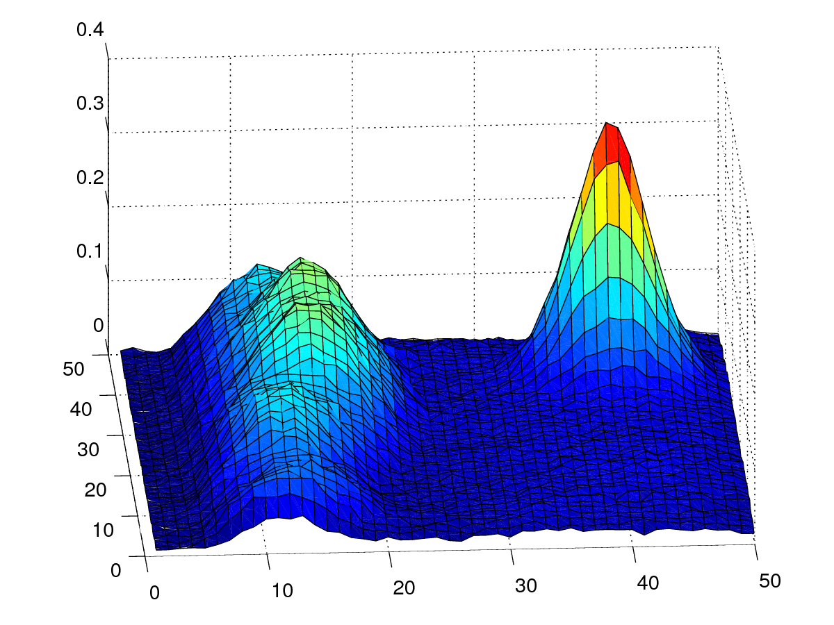
This is different enough that I feel I should re-run with a few different scd-sca weights. That was weight 0.06., lets do 0.05 and 0.04 again. What about the higher angles? We get edge effects there, too, as the hill of activity starts to fall off the edge. For example, here’s an FEF hill for a R=17deg movement (thetaX=0, thetaY=-17). Notice that the whole hill is on the map. This is probably the right limit for my eyeRy vs targy graphs. Ok, I’ll re-run with my range limited at 17degrees. Now I’m thinking about the Tabareau requirement that the hill be invariant in number of spikes. That corresponds to the integral of my hill of activity. This is given in the model by the activity in the LLBN neurons, which sum up activity in SCD. Here are two hills of activity in SCD, one at 17 and the other at 7 degrees.

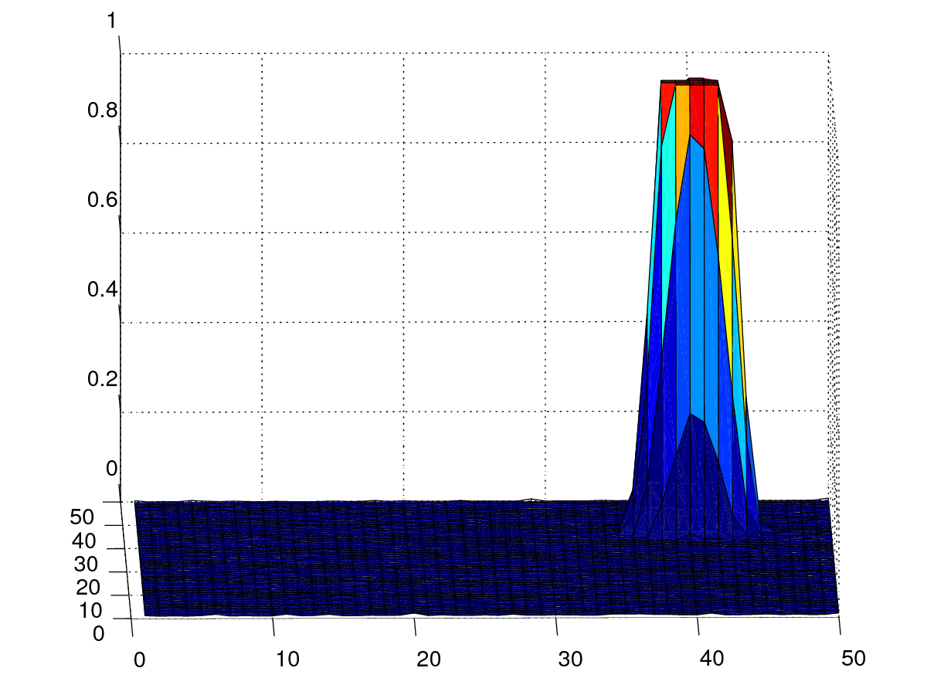
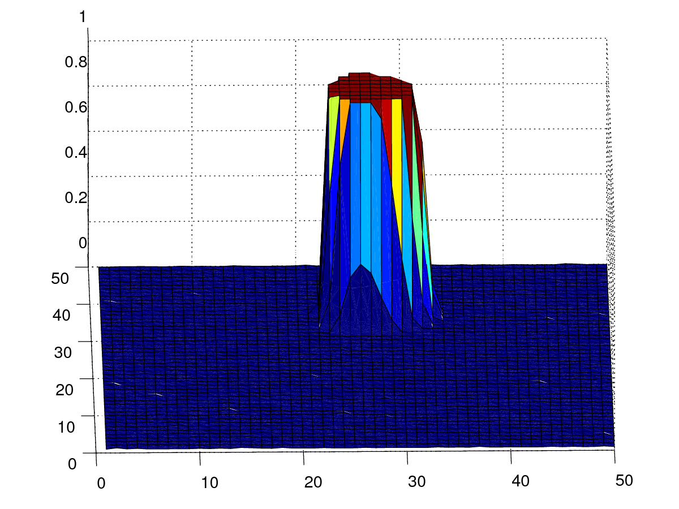
The corresponding LLBN activity profiles are:
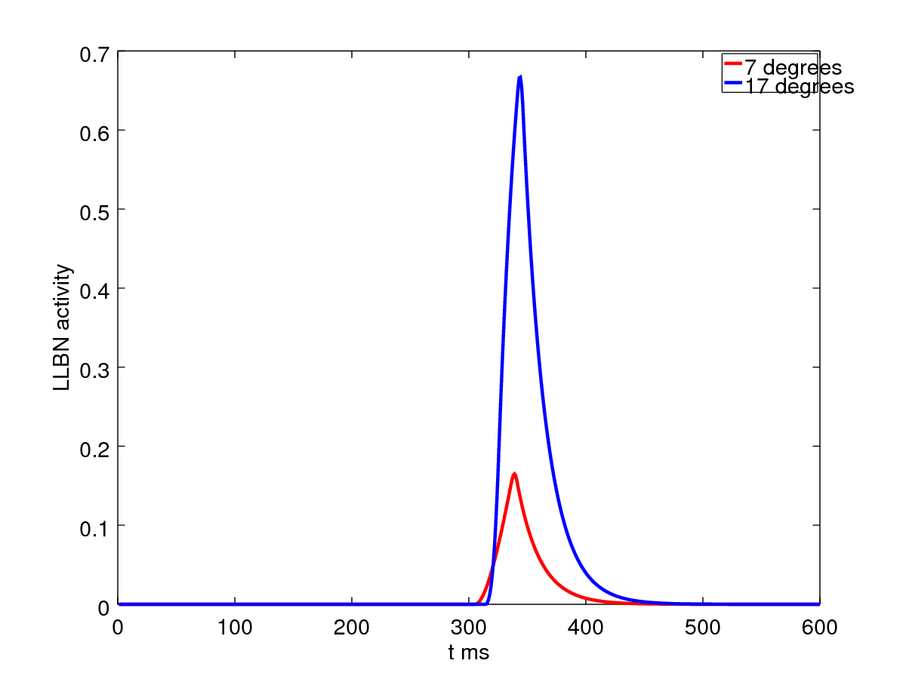
Note that the activity for the larger saccade is greater than for the smaller saccade – with the non-widening gaussian, this would not be true. To get equal LLBN activity for both saccade sizes, the widening gaussian should widen a bit less. I’ll tweak that feature to get similar LLBN activities for these two saccades (or perhaps 8 and 17).

20170704
Here are the results for the WideningGaussian script as I had it in late June. This is from TModel1 and the experiment expt_llbn_vs_targetpos.
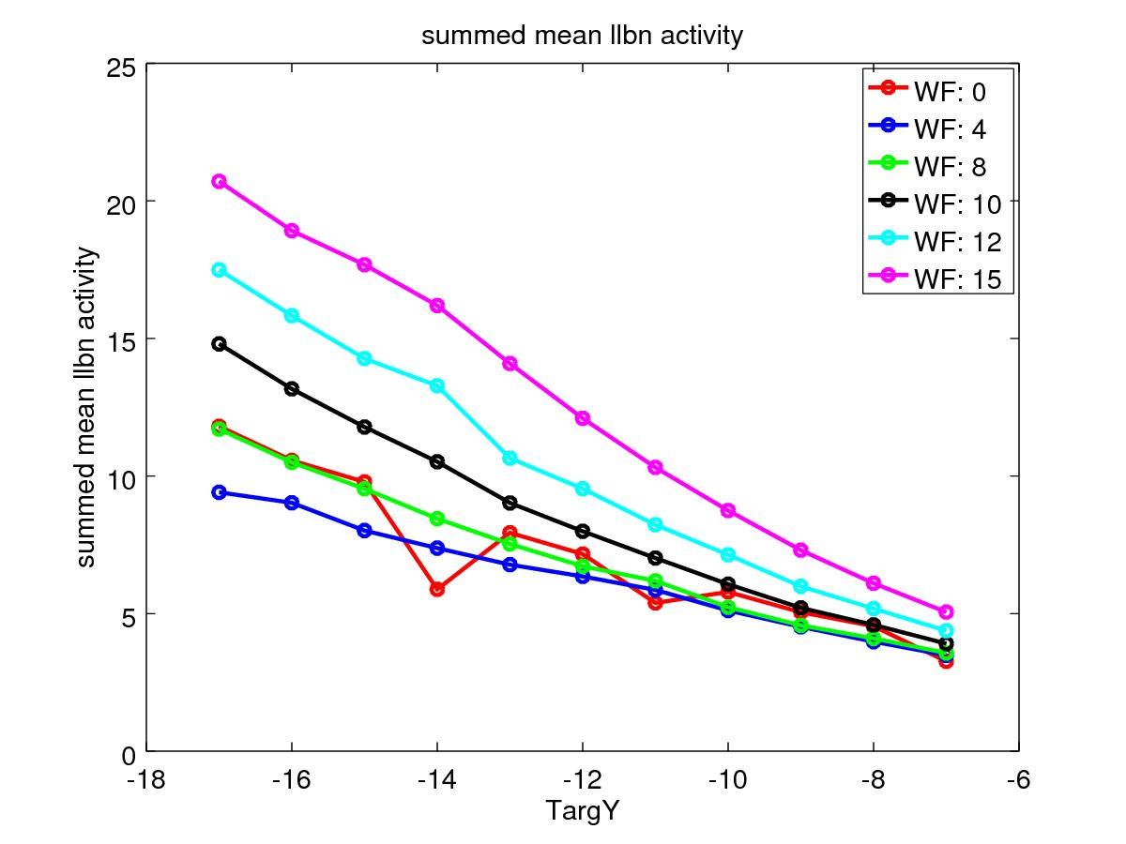
WF0 is the model with NO WideningGaussian - with the original regular Gaussians, not changing with r. It's almost the same as WF 8, and changing WF generally just makes things worse (I'm looking for a constant summed llbn activity wrt TargY here).
I've improved the normalisation of the WideningGaussian, and will try again. WF has gone away - there's only a single parameter - the constant sigma. As sigma is changed, the normalisation factors (normpower) will need to change to keep the effect of the widening field constant, so the above graph will have pairs of sigma, normpower, rather than a single changing parameter “WF”.
Actually, experimenting with the widening_gaussian.m octave script, I think that with the same norm power, sigma=45, 35 and 25 are all reasonable, so I'll start with investigating these three.

2017-07-05
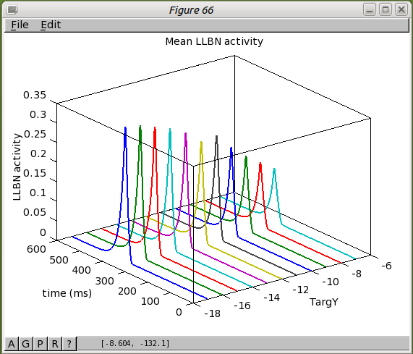
I have carried out the “WideningGaussian2” experiment (results in expt_llbn_vs_targetpos/results/WG2). It's the same story as above. In fact, looking at the regular GaussianKernel result (red/WF0 in the plot above), the for larger saccades, the summed SC_deep activity is already larger, so widening the gaussian would seem to be the opposite of what we want. Should I try NarrowingGaussian? Perhaps a 1to1 connection from FEF_add_noise to FEF would be a start? I'll do this. I'll put results in expt_llbn_vs_targetpos/results/O2O. Here they are:
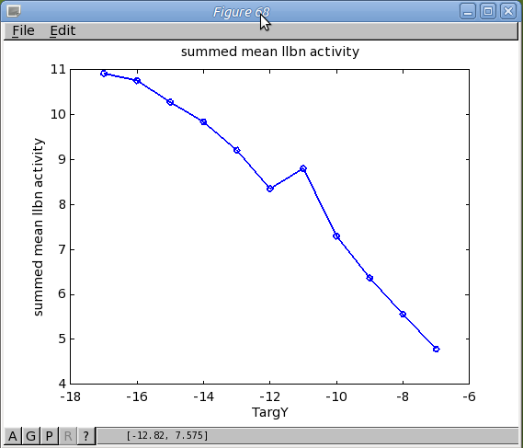

Quite similar to the GaussianKernel result. Lets look at the size of the FEF hill at -7 and -17 degrees, to see how much it differs. Here are the results:
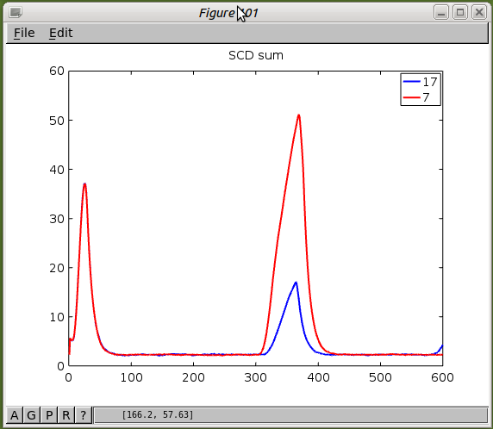
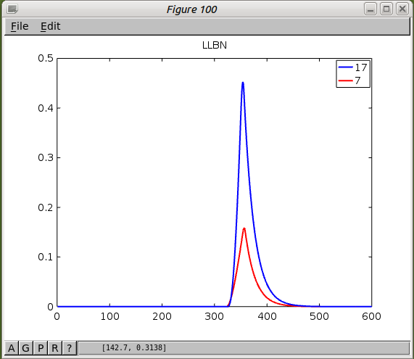
Oh no. LLBN does not generate a reliable sum of SC_deep, so I've been barking up the wrong tree again. The inhibitory feedback to LLBN distorts it. So I need to re-run my Widening Gaussian results with a dedicated SC_deep sum to see if WG will actually make a difference.
Here's results from the first run, where the WG was applied to, and varied for, the FEF_add_noise->FEF connection and for the SC_sup->SC_deep connections only.
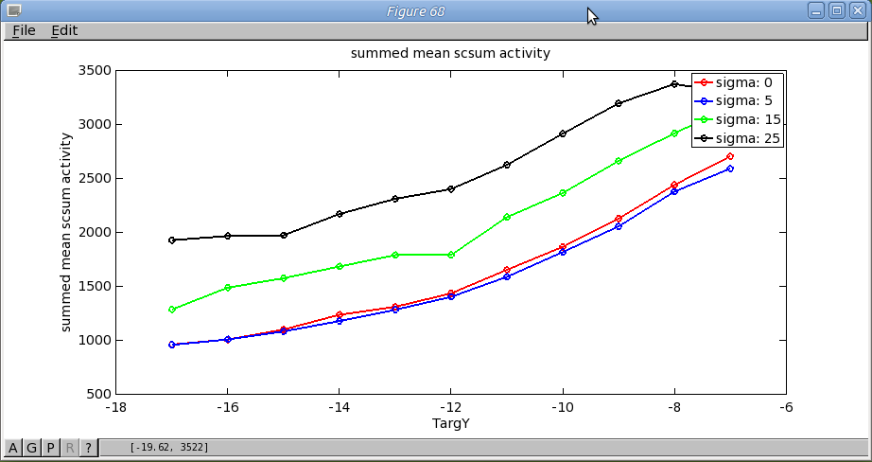
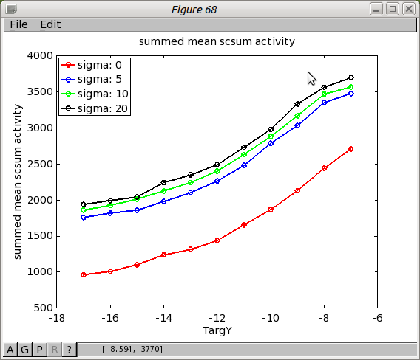
No change in the gradient with sigma changing, so this isn't going to achieve the goal of an even sized SC_deep hill.
Next I'm trying the widening gaussian in the SC_deep recurrent connection. Result, not much effect (sigma 0 here means the FEF one to one/SC gaussian result).
Now I'll try to modify the normpower parameter so that the strength of the connections become stronger with increasing r. I'll apply such a set of parameters to all three connections (FEF_add_noise->FEF,SCsup->SC_deep,SC_Deep recurr). Changing normpower from 1.5 to 0.8 results in weights increasing with r, so lets try that. I'll set sigma to 15 in all connections, but vary normpower from 0.8 up to 1.4 in 0.2 steps. Ok - I did 0.8 and it didn't seem to make any difference.
Then I had a Eureka moment (after looking at an omview of -7 and -17 saccades). The SC_sup to Thal connection feeds information into the BG in this model, and that connection was 1to1. Changing it to widening gaussian has resulted in much better behaviour:
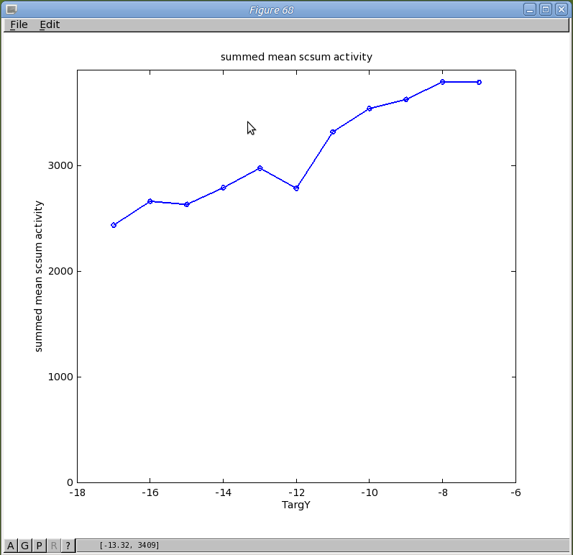
Now I wonder if the SC_deep recurrent and FEF to SC_deep connections that I had converted (without success) to widening gaussian are really required. I'll re-instate regular gaussians as in the old model for these.
I've done this as expt_scsum_vs_targetpos/results/WG5 and WG6. Results on one graph:
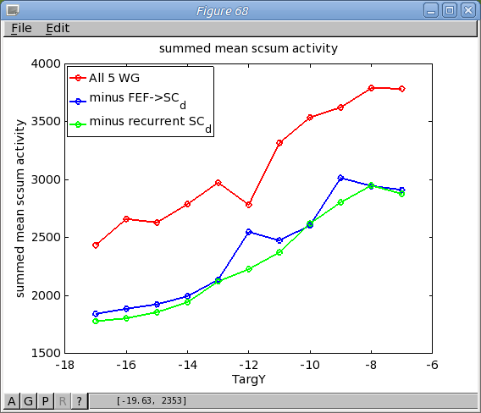
It seems the overall activity in SC_deep is modulated by the connectivity pattern in FEF->SC_d, but in a TargY-independent way. The connectivity pattern in the SC_d recurrent connection appears to be inconsequential. I'll do a similar graph replacing each of the remaining 3 widening gaussian connections. My hypothesis is that for reflexive saccades, the widening gaussian will be required from SC_sup->Thal and for FEF_add_noise->FEF and for express saccades, it'll be required for SC_sup->Thal and for SC_sup->SC_deep.

2016-07-06
I've now experimented with changing connectivity in 5 relevant connections. My hypothesis seems to hold for reflexive saccades, with the C_sup->Thal and FEF_add_noise->FEF connections having the largest effect on the summed mean SCdeep activity:
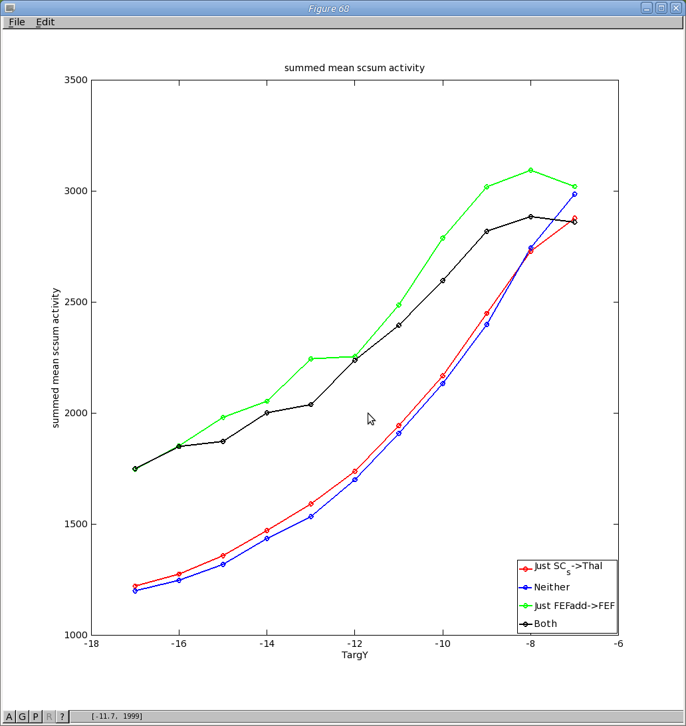
In this figure Just, Both or Neither refer to which connections are WideningGaussian. The black trace there is the flattest one, when both of these connections are WideningGaussian. For comparison, here are the latency and eyeRy graphs:
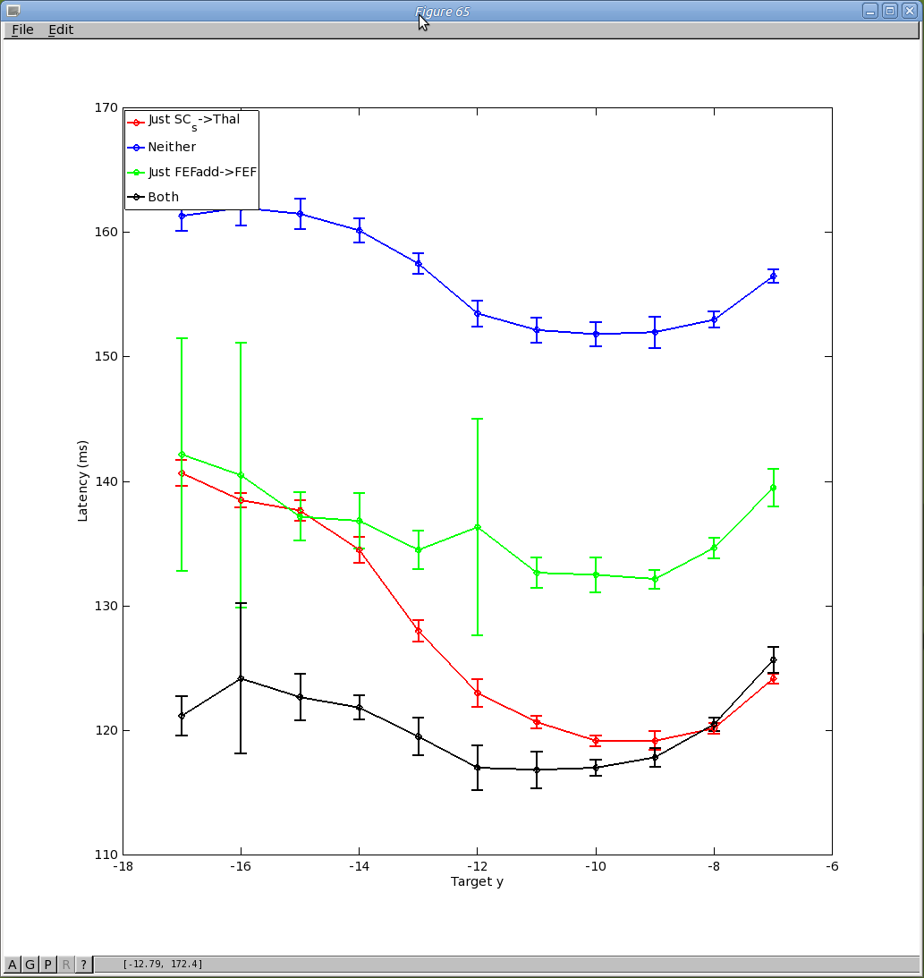
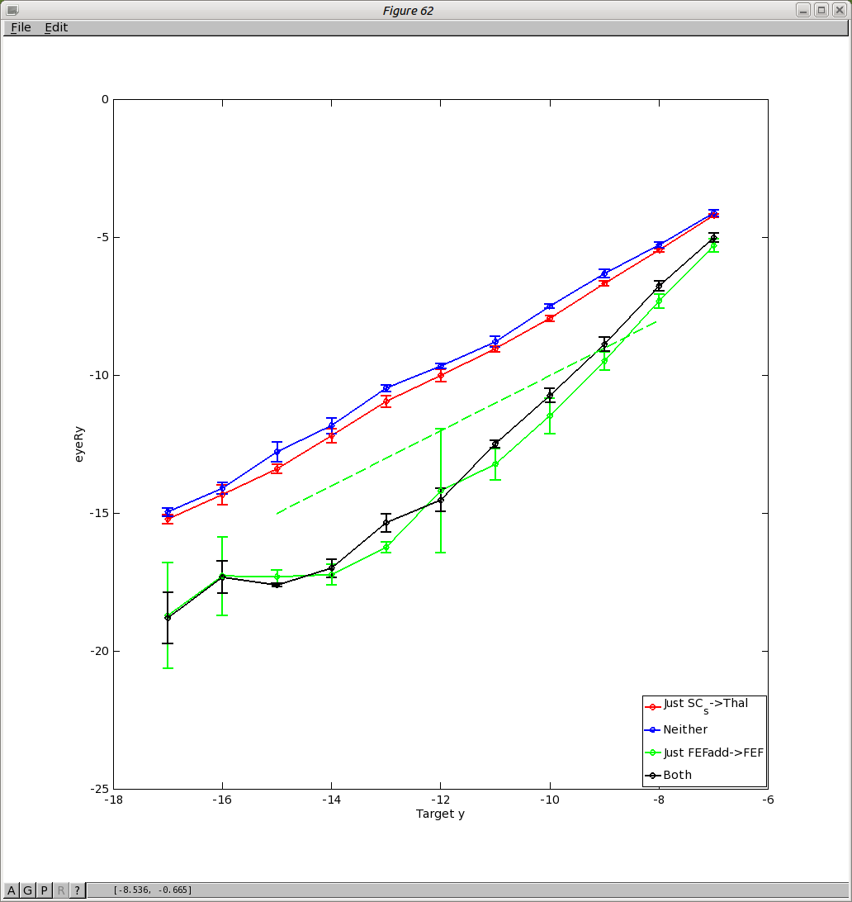
Now, recall why I was doing this. I think that to be able to make use of the theoretical weight maps, the hill of activity in SCdeep should be the same size from small eccentricities to large eccentricities. But a look at the graph for eyeRy, above (right hand panel), suggests that the eyeRy/target is most linear with no widening gaussians at all.
I'm going to see if I can find the widening parameters which give the flattest scsum vs. targetpos in any case, so now I'm going to put widening into the FEF_add_noise→FEF, SC_s→Thal and SC_s→SC_d and then vary the widening parameters on these connections.
Here's results for varying sigma. Note that the normfactor (0.5) is NOT the one that gives a well-normalised widening gaussian.
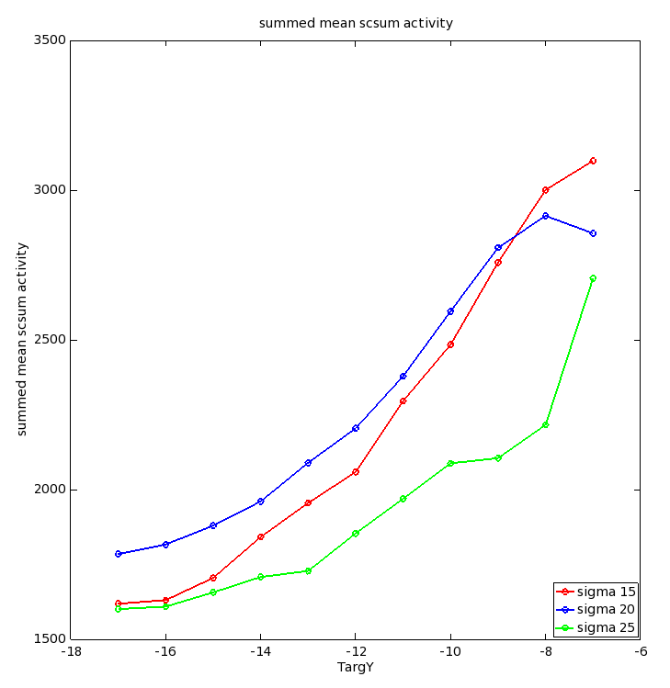
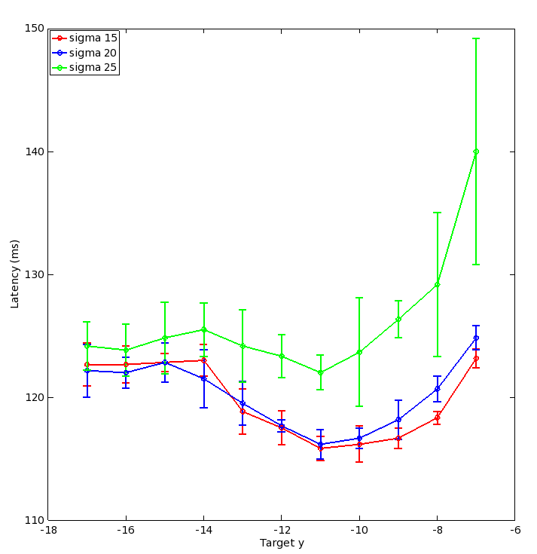
Sigma 25 gets rather close to an even sized hill. This is especially apparent in the time traces:
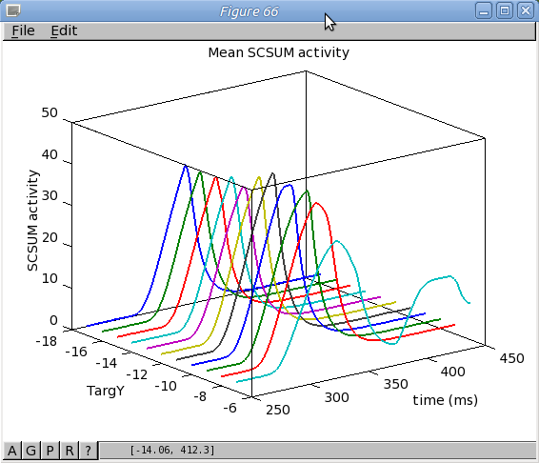
The trouble with the set of widening gaussian connections that I have here, is that they widen the hills in BG, which goes against Alex C & Kevin's arguments in the biorxiv paper for the reason for the hockey stick result. I still have something that looks a bit like the experimental data - see panel B in this reproduction of that paper's Fig 7, which is the exp. data:
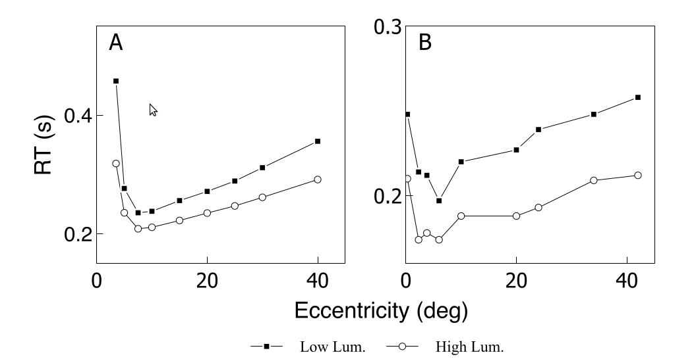
So, perhaps this invariant gaussian in the SC idea is not so useful, although experimentally, the hills are wide and don't vary all that much (need ref).
One other way of getting a more invariant sized hill in SC would be to put the Widening Gaussian on all connections INTO the SC deep - that means SC_sup->SC_deep, SNr->SC_deep and FEF->SC_deep. These would feed back into Thalamus, but only once the hill was building in SCd, so late in the process.
What to do now? First, because I used the not-very-well-normalised WG, I'm going to do a couple more experiments with my “SCs and FEF widening” model - currently TModel1, with the normfactor changed from 0.5 to 1.4. This should be a better comparison with the regular gaussian, whose overall summed projection weight does not vary with r.

2017-07-13
I am creating some different “theory models” (the name means it's a model with a theoretical weight map for SC->SBG).
TModel0 is the “theory model” with all Gaussian connectivity - essentially, the connectivity matches that in “Model1”.
TModel1 has widening gaussian connections for FEF_add_noise->FEF, SC_sup->SC_deep & SC_sup->Thalamus.
A new model, TModel2, could have widening gaussian connections INTO SC_deep.
On a further reading of Tabareau et al, I think I was mistaken in thinking that it requires a uniform SC hill of activity size. Nevertheless, experiment suggests that the hill is always a similar size; so perhaps to match theory I should do this thing in TModel2.
I just found something I should have found a long time ago. Here are my “best found maps”:

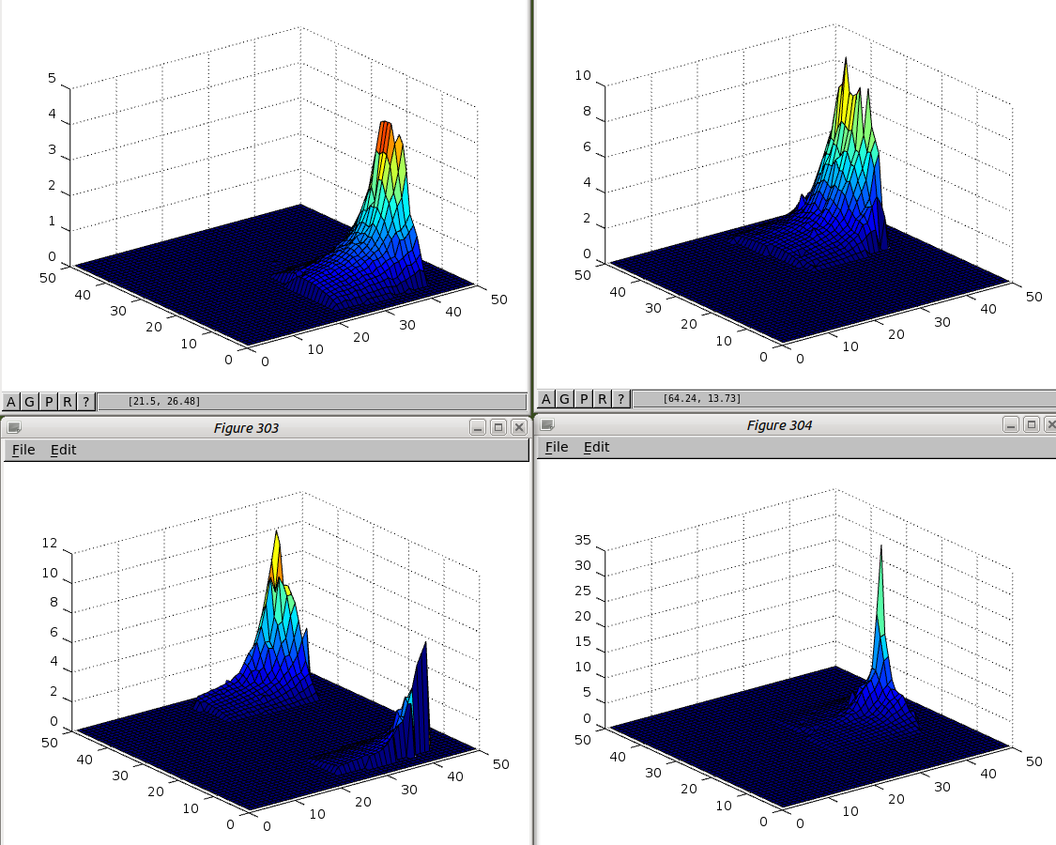
If I sum them together I get:
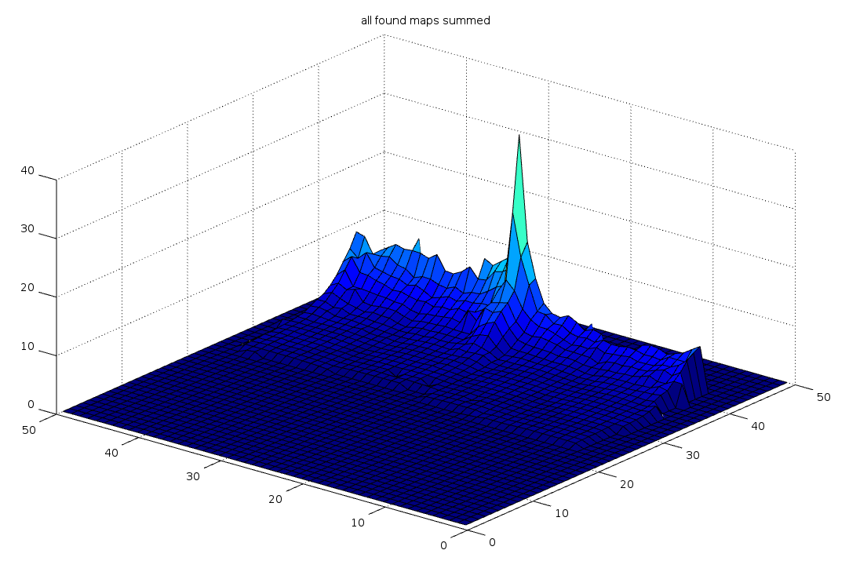
It's nearly flat! Interesting.

2017-07-14
Looking again at what it means for the weight maps to be sines and the relationship between the weight maps and the hill size. I moved to looking at the weights as a function of phi. I think that the amount by which the sine part of the weight map should overlap depends on the width of the hill of activity. See the script “sineandhump.m” for graphs. sineandhump(22,1) shows a situation where there is no overlap between the weight maps and a too-thin hill of activity. For phi=21, there is no signal to any of the up, right or down muscles so it can be seen that this configuration of weight map and hill width fails:
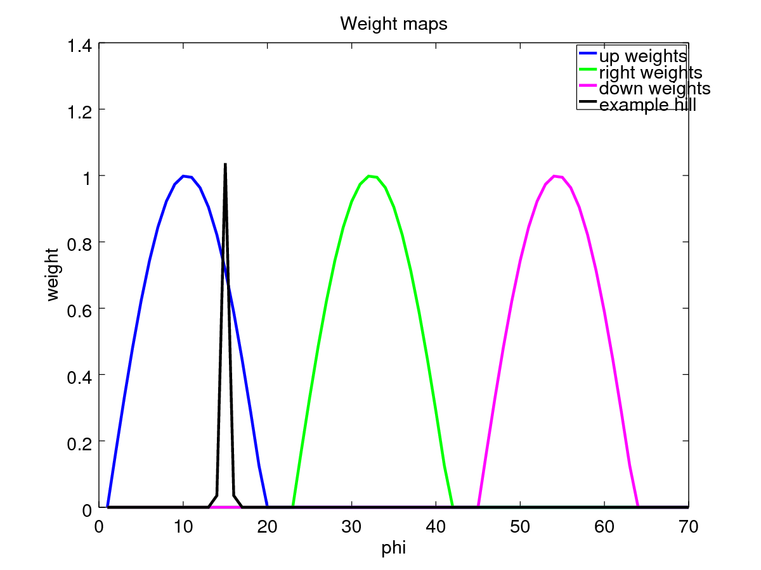
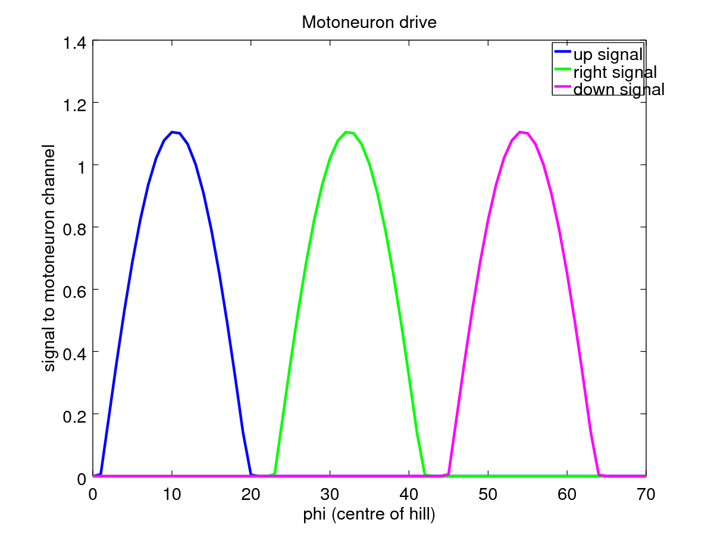
If we make the hill wider, we still see a big fall-off in signal for the “45º” movement (at phi=21), Here's sineandhump(22,5):
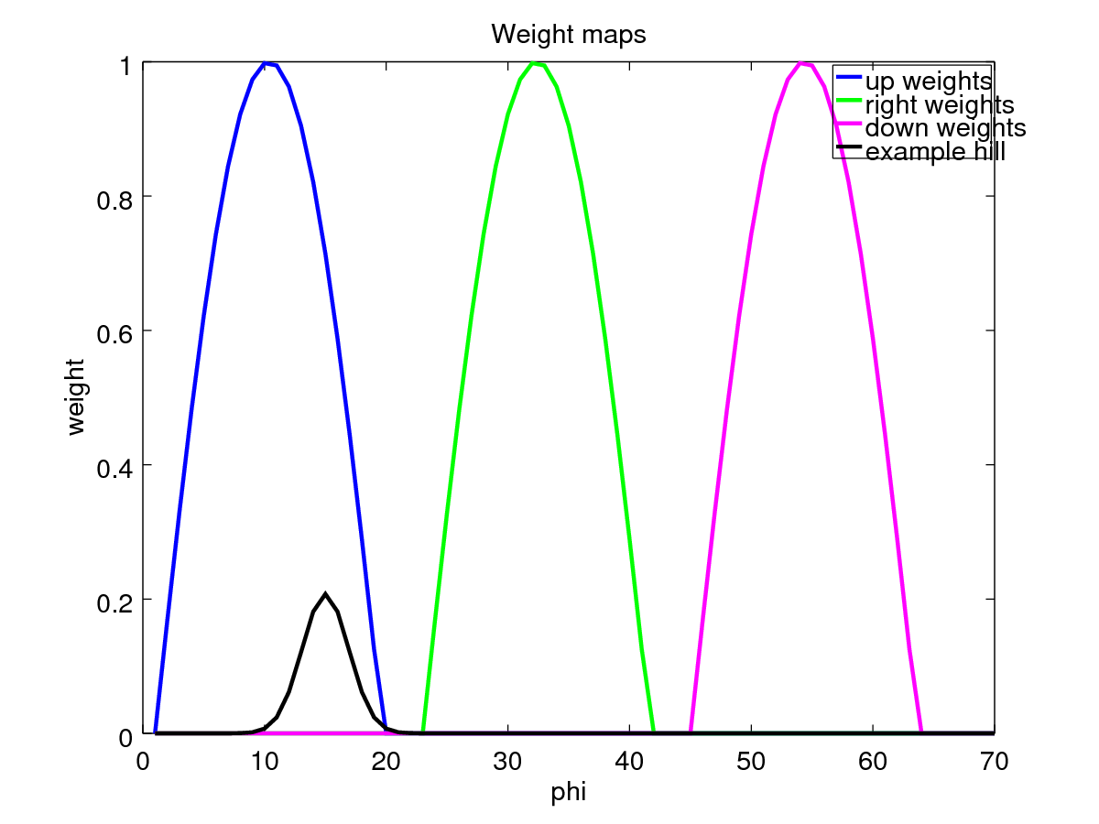
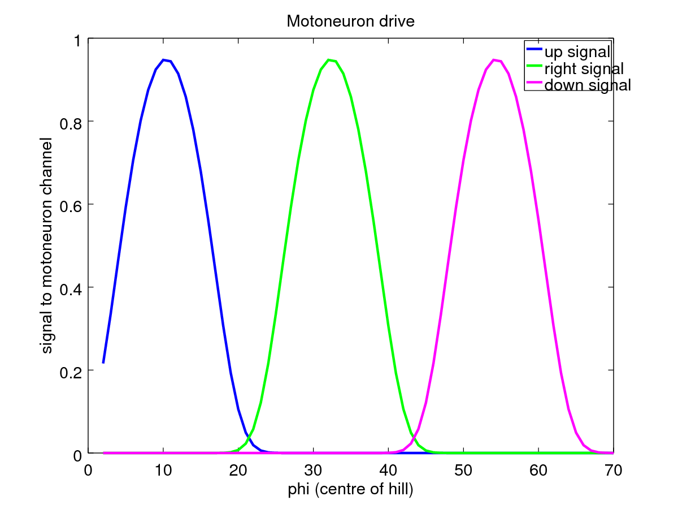
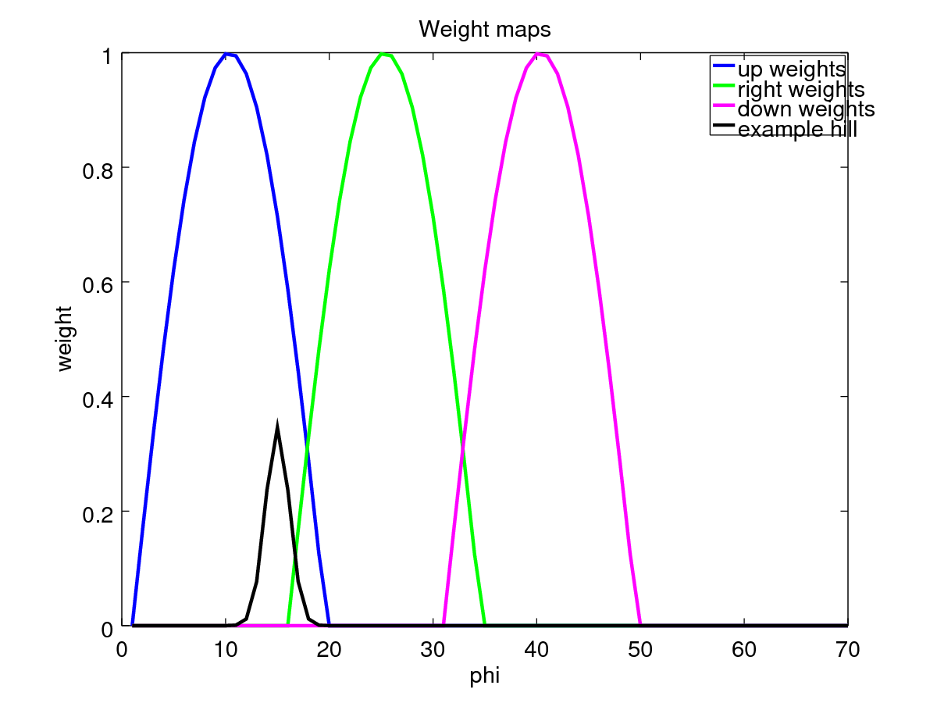
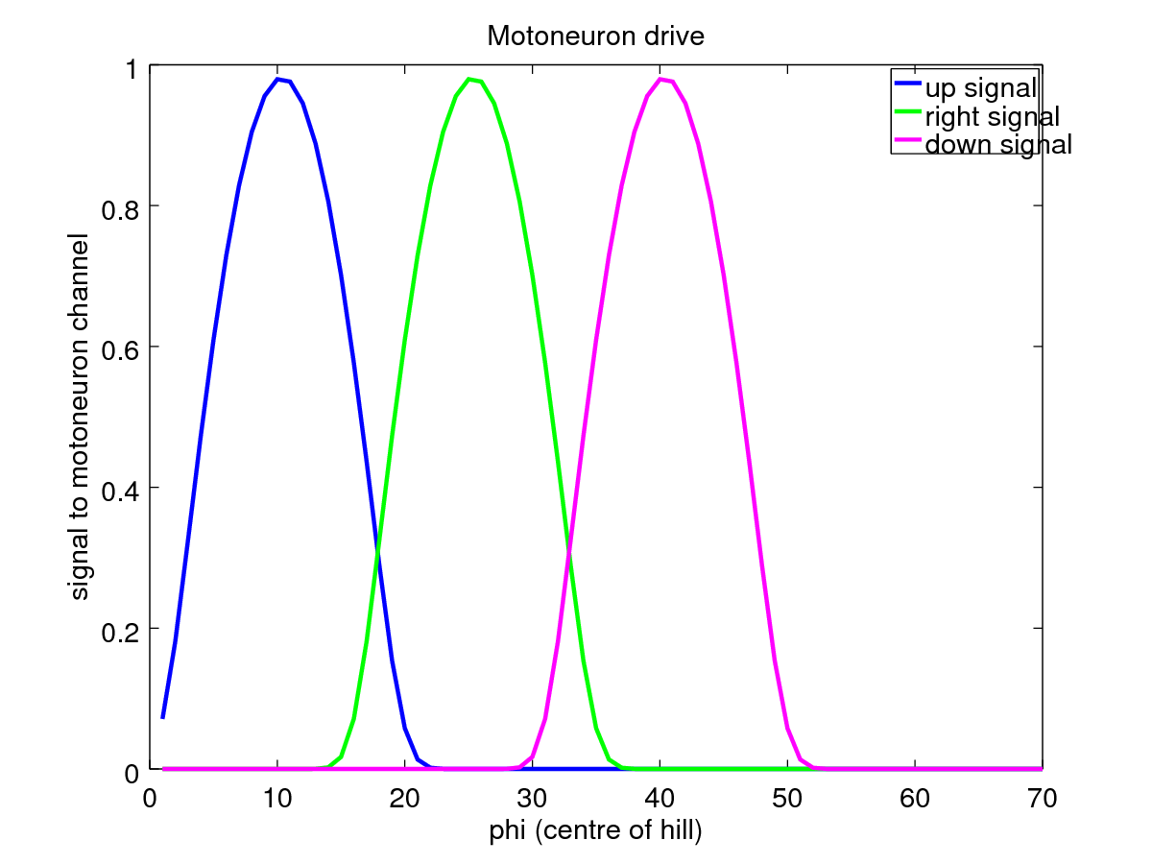
So I think it's clear that we need some overlap in the weight maps, but how much? sineandhump(15,3):

The problem here is that for phis that aren't exactly 25 (right-only), but are between about 21 and 29, there is no up or down signal, meaning that the eye movement would be right-only in that range. We could fix this by increasing the hill width; sineandhump(15,8):
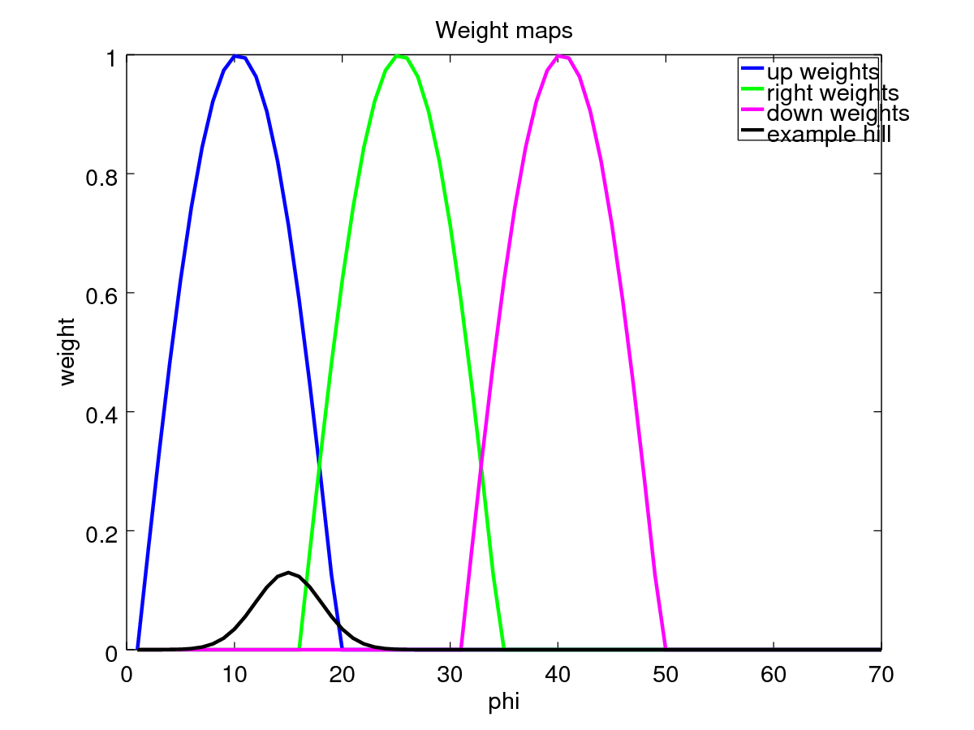
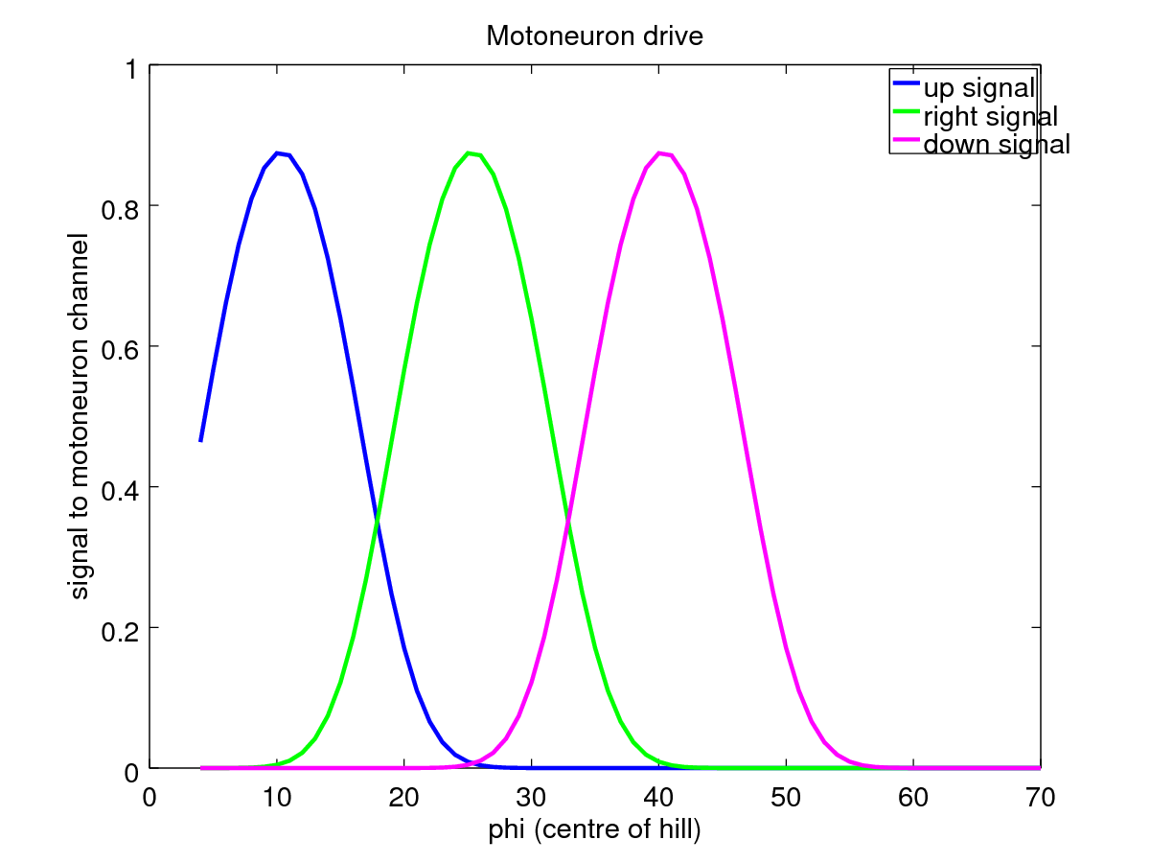
This looks rather good, because for a hump which encodes only right, we get no up or down signals, but we immediately get up/down signals as the right signal tails off.
However, what happens if the hill gets smaller as r increases, or larger as r decreases? It breaks. I have an argument for making the size of the hill of activity in SC invariance wrt r. I also have an argument for why we build a combined model - the existing model would fail (and I can say why) and building the combined model indicates that we need this even sized hill of activity.
So I need to decide how much to overlap my weight maps given the approximate size of the existing (though with width as a function of r) hills of activity in the model.

2017-07-17
The width of the gap between the sines, and in fact, the size of the sines is determined by the rough width of the hill of activity. Here’s one of the current hills for a -12, -12 rotation:
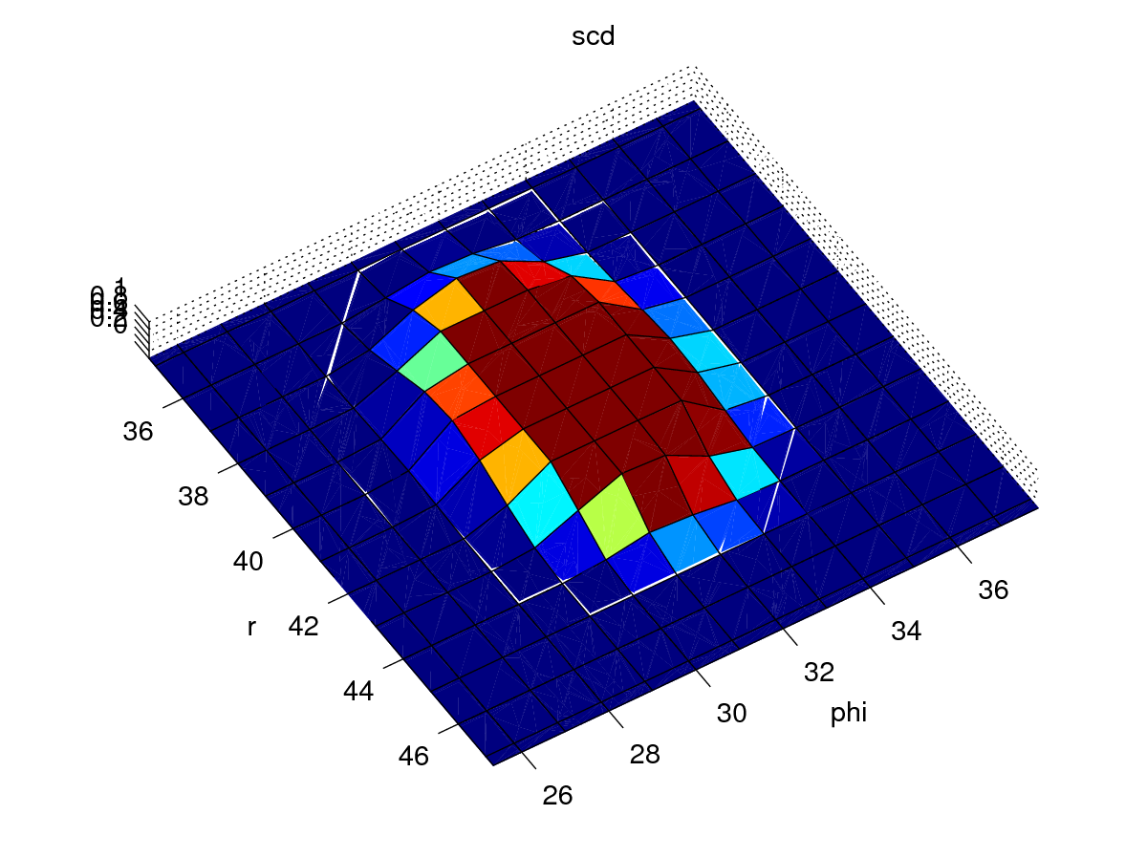
To get the right amount of output activity, the gap between the up/down sines should be roughly comparable with the hill width. If we consider just the up and down sines – that’s the one in the centre of the 50 pixel phi space, and the one that is divided by the edges, then we have two gaps of, lets say 6 pixels, leaving 38 pixels for the two (half)sines. See map_modelling2.m to see this coded up.
These are the resulting theoretical weight maps:
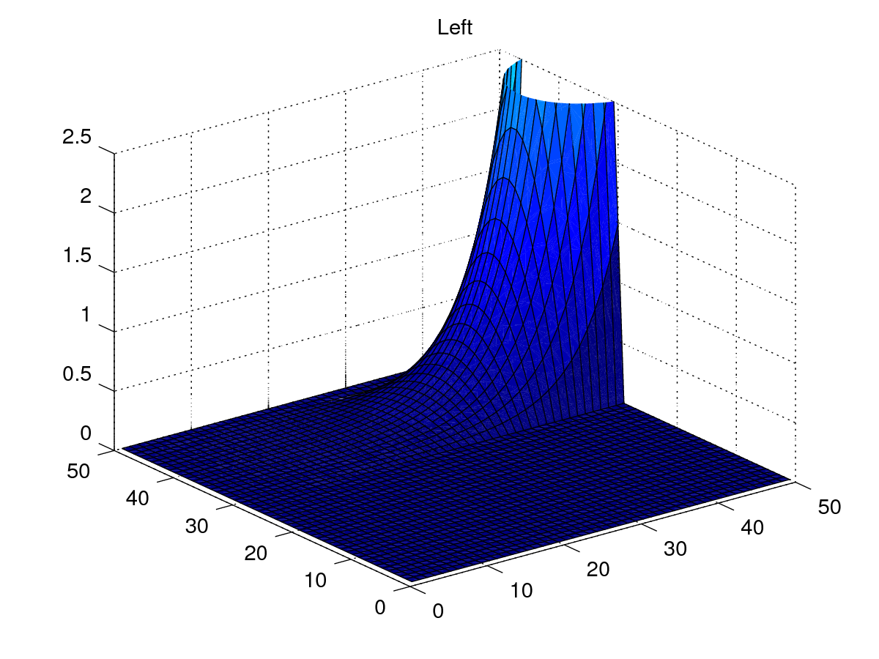
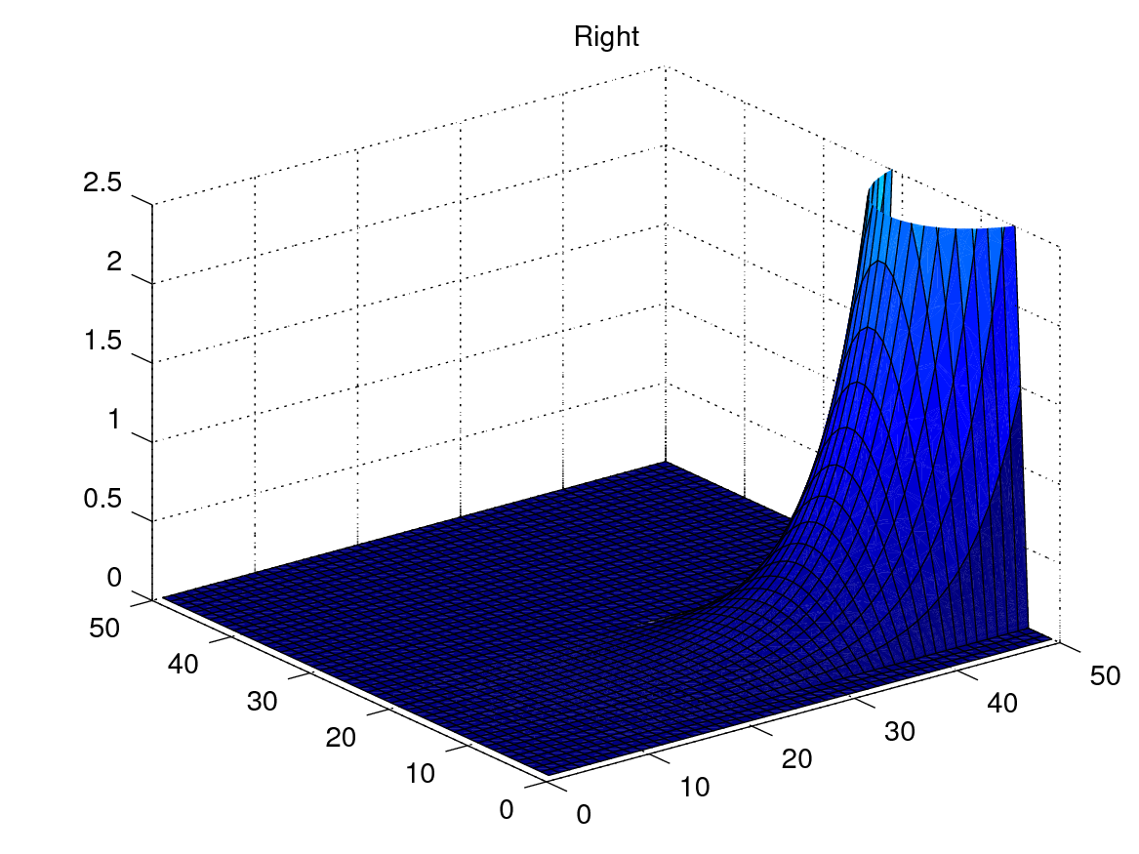
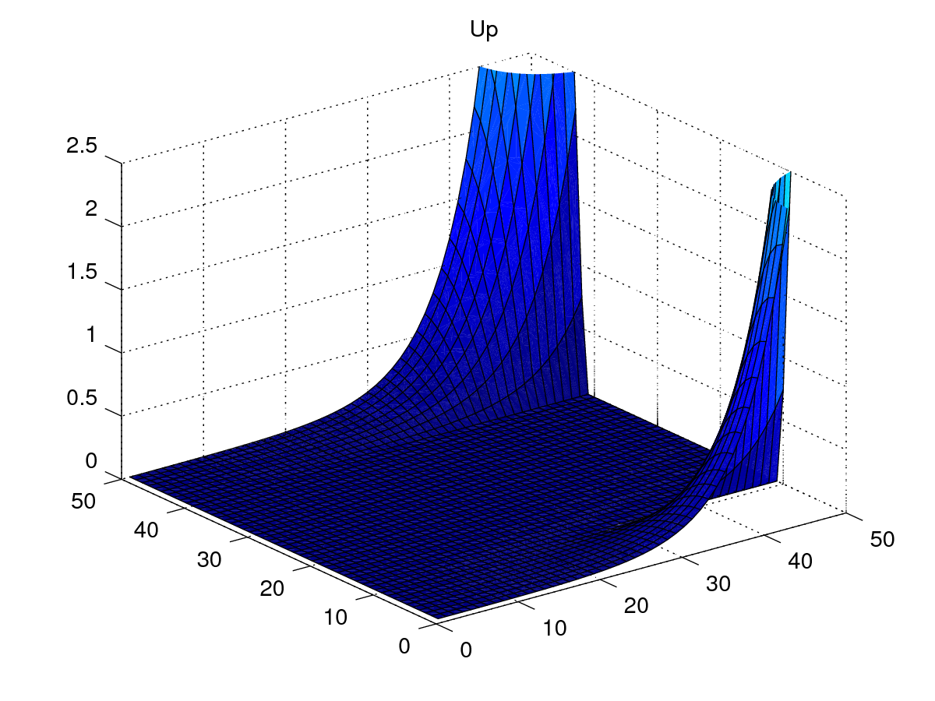
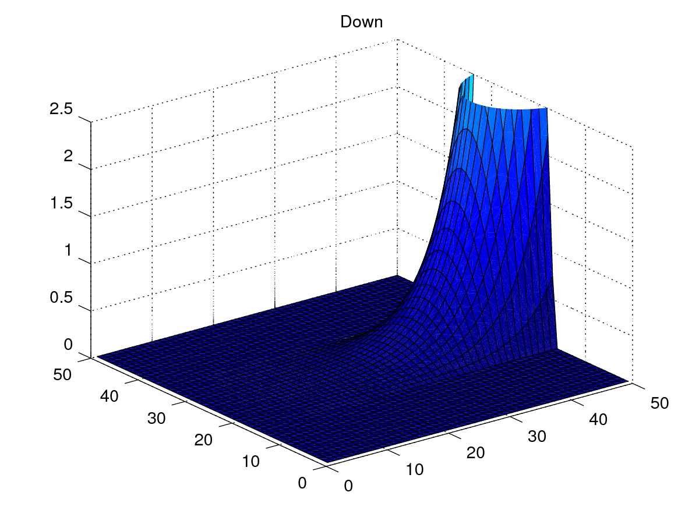
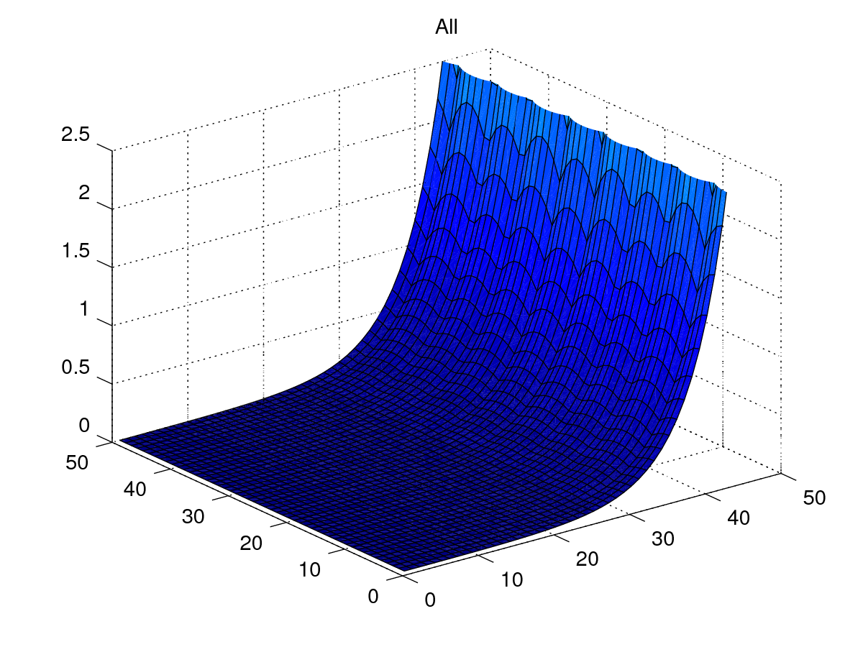
Out of interest, sum them to get a rather flat (in phi) graph:

2017-07-18
My next job is to determine the best parameters for the weight maps above, and for the other aspects of the SBG network.
Here’s what the sacc_vs_targetpos graphs look like:
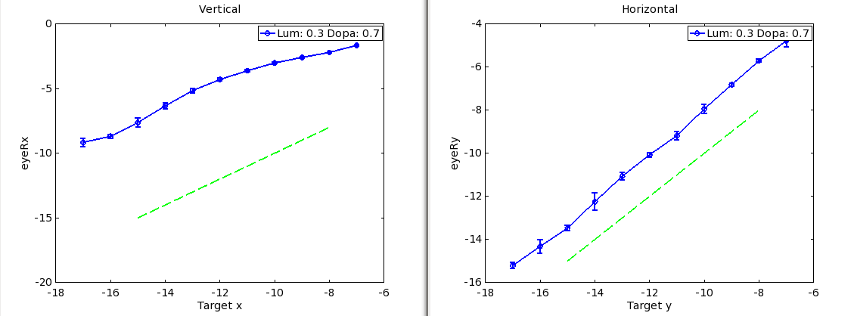
Quite close (and nicely linear) for horizontal movements, rather far (and less linear) for vertical. These are from TModel0 at git commit bb86833.
First, I will modify a scalaer multiplicative weight on the sbg weight map connections (the postsynapse weight on SC_avg→LLBN connections). I’ll tune this by hand to try to get the horizontal result closer.
A weight of 2.7 (instead of 2) seems close:
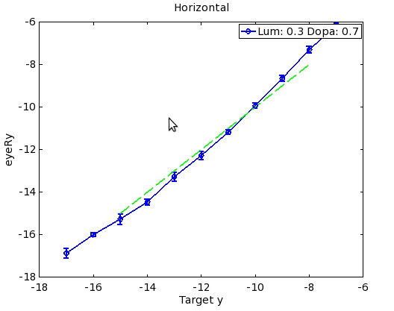
What about the vertical rotations? I'll change the up/down and z+/- weights together. Ok - so with the vertical weights at 8, then it all looked good. Then I did an example horizontal rotation on the PC and it rotated to -13degrees. Turns out this is because I was doing the expt_sacc_vs_targetpos(_horz) runs with a square as the fix and target. I've switched to a cross now, so I'll need to re-calibrate. I had set params to request a cross rather than a square, but I had missed some necessary changes in write_single_luminance_with_fix.m. See commit 02eaf1a. This raises an important point though - we're going to get different rotations for different target shapes & sizes with this model. A discussion point.

2017-07-19
Having sorted out the target shape, I've re-adjusted the SCavg->LLBN weights to get the following sacc_vs_targetpos graphs:
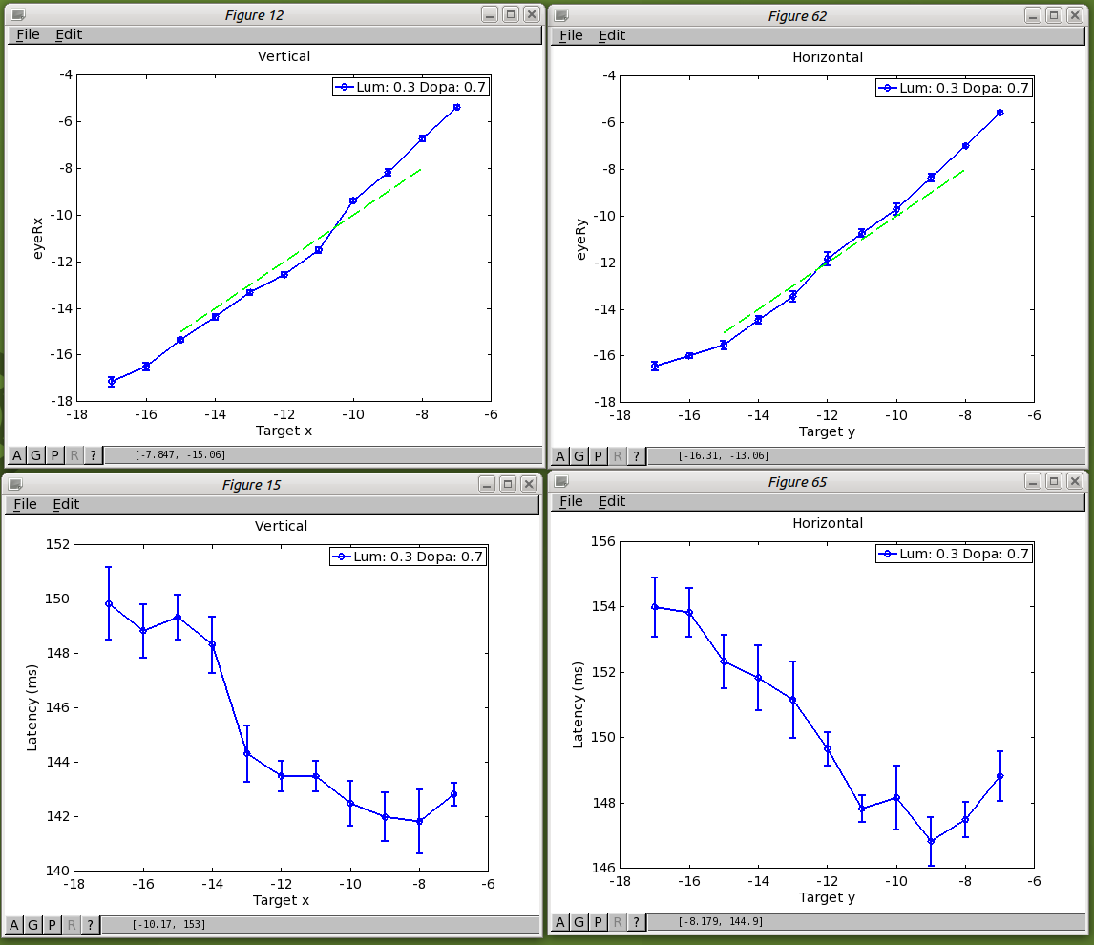
Weights as in commit 0c2a780 for TModel0 (horz 1.8, vert 6). Now what's the error surface going to look like? Going to need a new expt_error_surface to scan in 2D to build up error maps. However, first of all, let's do some oblique saccades.
First test, and they don't work! For a -7 Horz, -7 Vert target, I get -3.2, -10.5. For -10,-10, I get -5.4, -13.8. What about oblique? For this one it's about 1 degree. I'll turn off the oblique channel in SBG and see what kind of oblique rotations I see. With no z+/-, and a vertical movement to RotX=-10, there is a positive RotZ of about 1.5 degrees. With a large z+ weight of 40, there is a -ve RotZ of about -2 degrees. So z+ counters the oblique rotation of -ve RotX movements (movements down).
To find the right weights for z+/-, hand tune based on down/up movements.

2017-07-20
Meeting with Kevin. Suppose I write the paper based on TModel0; showing the results of this approach, along with the problems. The experiments/results I can show are:
- sacc_vs_targetpos_horz and sacc_vs_targetpos (vert) [sacc_vs_ means we get latencies and saccade size)
- sacc_vs_gap for horizontal saccades (could also do for vertical saccades if necessary)
- sacc_vs_luminance for horizontal saccades (also perhaps sacc_vs_target_shape/size)
- sacc_vs_dopamine for horizontal saccades
- An error surface over the range of saccades 7 deg to 17 deg – this’ll be a vector field (errRx, errRy, errRz vs TargX, TargY.
- saccade to dual stimuli (saccade averaging demonstration; this won’t work)

2017-07-21
I spent today working on weights_theoretical/map_modelling2.m. To get both rightwards, downwards and down-right saccades to work for an r of 10 degrees, I had to shift the sine waves of the weight maps by a factor of 0.65 or 1.8 at the crossing point of adjacent sines, but 1 at the apex of the sine. I did this by creating a parameterised sigmoid function and multiplying this function with the original sine function.
I’m now hoping that horizontal and vertical saccades will be roughly linear with increasing r, but oblique saccades will not.
I’ll then see if I can make a widening gaussian layer in SCdeep, which will improve the situation and that’ll be the paper.

2017-07-27
I’ve done a few things since the last post. I created a script to compute error surfaces, which shows that there errors are minimal along the pure RotX and RotY axes, then there’s a minimum at some point where the sines cross, which can be brought to the true 45deg axes with the sigmoidal “modifying” function described above. The modifying function may be useful, but it doesn’t remove the issue that between the horizontal/vertical and diagonals, there’s again an increase in the error function.
So, I want to concentrate on the “pure sine based weight maps”, and see if I can introduce an improvement in the error surface by widening the hill of activity in SC deep. There are a few issues to think about. If activity in SCdeep halts during a blink, then how does this work? I don’t think this rate coded model can address that issue. What about inhibition to reduce the hill of activity? Does this come from a circuit wihtin SC? This seems the neatest way to do it; right now I have hypothetical inhibitory feedback from the SBG culling activity in FEF, brainstem and thalamus. There’s a projection from SC to STN – a stop signal? See Coizet et al. (a Sheffield paper). However, these are digressions. The result I’m hoping for here is that the error surface is flatter with a widening gaussian related to the magnification factor. And here is the widening gaussian:
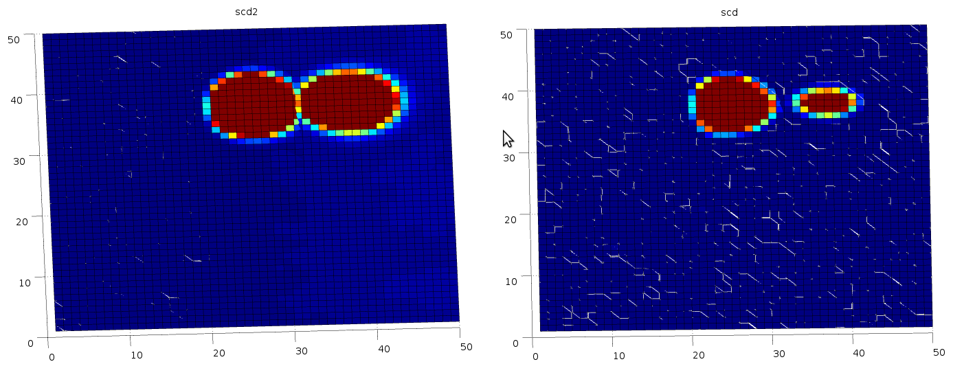
On the right is the signal in SCdeep. THis is two, superimposed signals, the small hill for a 14 degree rightwards saccade, the larger for a 6 degree rightwards saccade. On the left is this signal transformed via the WideningGaussian script, which widens by an amount which is scaled with the magnification factor. We see that the hills are roughly equally sized. Here’s the WideningGaussian graphs for the parameters I used (sigma_m=50, sigma_0=0.3, fovshift=20, E2=2.5, normpower=0):
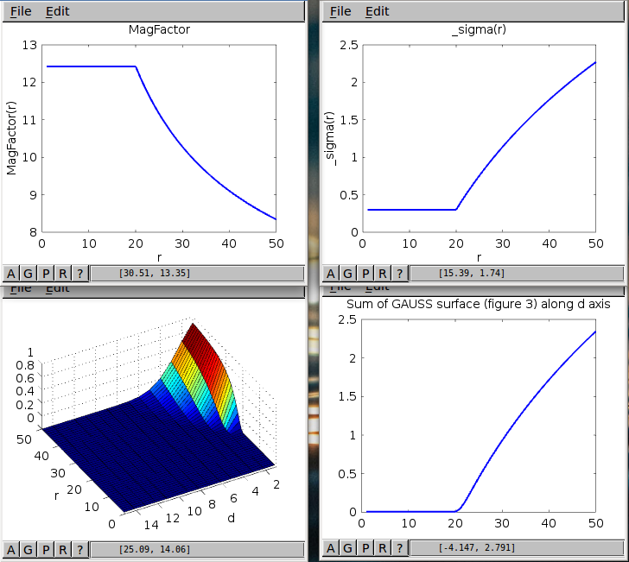
See commit 42514ed.
Note how the gain increases with r. This means that the expoential on the SBG will be different in TModel2, which has the widening gaussian when compared with TModel0, which does not. My next job is to change that to get the best horizontal accuracy I can.

2017-08-01
I finished the work on TModel0 and TModel2. Both had terrible error surfaces. It was clear that there being any sort of gap between the sines for up/down (or left/right) was problematic. I created TModel3 and TModel4 with “joined sines” and re-calibrated the exponentials for acceptable horizontal/vertical saccades. Now, the model with the widening gaussian in SC has a much better error surface. See plots in expt_errorsurf.
So the “final model” is now TModel4. I'm now producing graphs for the paper. The sacc vs luminance and sacc vs gap graphs demand that I run the model for a bit longer (1 s rather than 0.6 s) so that there is time for a 100 or 150 ms gap between fixation and target. I've made the changes to sacc_vs_luminance.sh and sacc_lat_vs_gap.sh.
I also noticed, from sacc_vs_luminance, that the saccade size saturates as luminance increases; I have parameterised the weight maps
Here are results for sacc vs luminance for step, gap and overlap:
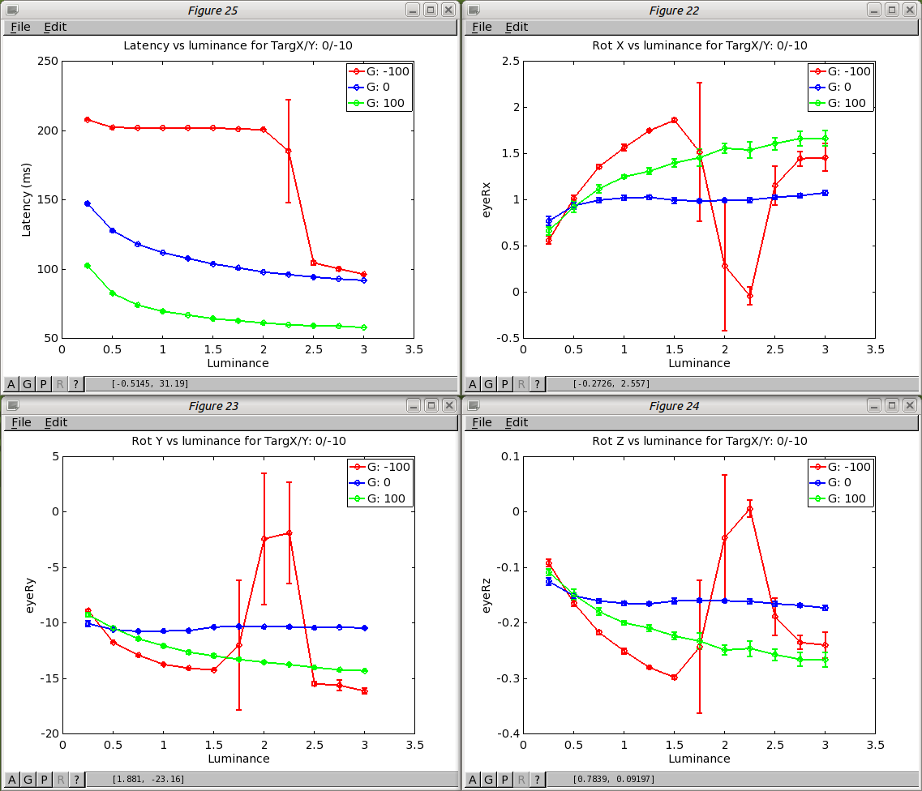
Peculiar for the overlap condition, no? There's a range of luminances in which the accuracy of the saccade is strongly affected, then it comes back at higher luminances. This is caused by a tiny saccade preceding the expected saccade. It's a transition from reflexive to express saccades. The fact that the saccade size is affected here, is really a bit of a red herring - in fact, following a very small saccade, the “proper” saccade which follows is about the right size:
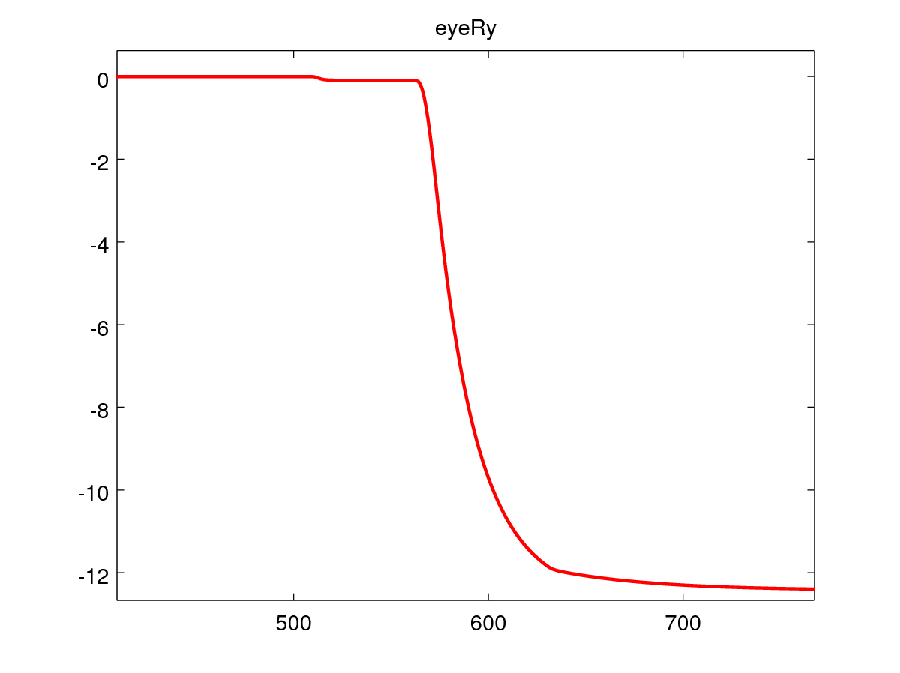
I think what this means is that at about 2.5 luminance, the system starts to work as if the fixation luminance was irrelevant - so it becomes like a gap experiment with an infinite gap.
Perhaps these sacc vs gap/luminance experiments will be more interesting with a different fixation luminance.
New experiments to run: sacc_vs_luminance in lesioned condition for express saccades. sacc_vs_luminance in lesioned condition for reflexive saccades.

